1. Importing data into SSMS via SQL Server Import/Export Wizard

2. Cleaning Data:

* Checking Data Types to make sure we get required data we Need.
* Columns Before type Conversion

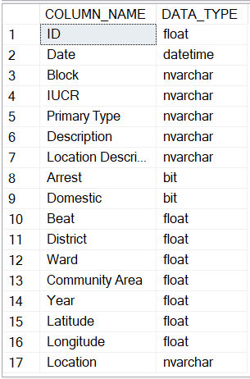

* The columns that needed to convert into correct type were
  + ID (Float to Int)
  + Arrest & Domestic (As there is no Boolean in MSSQL so converting Bit to Varchar (TRUE/FALSE or YES/NO) so that it could be more Readable for own sake)
  + Beat, District, Ward & Community Area (Float to Int)
  + YEAR (Float to int)
* After Conversion

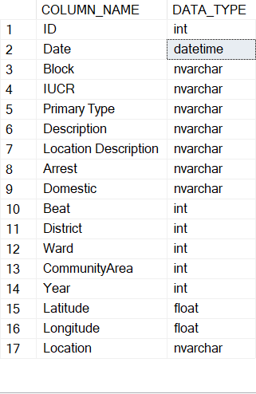

3. Analysis