User Manual

# **Directions**

1. Input the scores in the scoreboard.

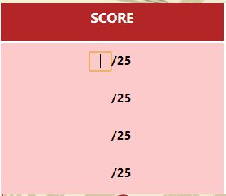

1. Click “Save”.



1. Click on “Next Contestants” and repeat.
2. After entering and saving the scores for the last pair of contestants, an “Upload” button should appear. Click “Upload”.



# **Button Functions**

|  |  |
| --- | --- |
|  | Next Picture |
|  | Previous Picture |
|  | Next Contestants |
|  | Previous Contestants |
|  | Save |
|  | Upload |

# **Known Bugs**

Images disappear for unknown reason

Scoresheets for Contestant #1 cannot be loaded on app start