Graphical User Manuel :
Computer Graphics Project
by Ewan C. Burns and Marc M. Fraser
(November 11, 2011)
Table of Contents
Abstract 1
1 Overview of all keyboard interactions 1
2 Mouse Interactions 2
2.1 Left Button Interactions 3
Figure i. Effects of x and y displacements of mouse when left button is held down 3
2.2 Right button interactions 3
3 Keyboard interactions 3
3.1 Exiting the program 3
3.2 Switching between scenes 3
3.2.1 Direct access scenes 4
Figure ii. Display of scenes printed when pressing the 'e', 'b', 'c', 'm', 'n', 'f' and 'I' keys 4
3.2.2 Toggle access scenes 4
3.3 Display options 5
3.3.1 Placing the origin 5
Figure iii. Example of printing the origin for the b initial 5
3.3.2 Showing the axes 5
Figure iv. Showing axes in “white background” mode 6
3.3.3 Switching between full polygon or empty polygons 7
Figure v. Full polygon mode (left) and empty polygon mode (right) 7
3.4 Model Animation 7
3.4.1 Jaw Animation 7
Figure vi. Model with closed (left) or open (right) jaw 7
3.4.2 Neck animation 8
Figure vii. Model balanced on two (left) or four (right) legs 8
3.4.3 Knee animation 8
Figure viii. Model with straight (left) or bent (right) neck 8
3.4.4 Animation : eating a leaf from the tree 9

Abstract
This User Manuel describes the different user interactions to which the animated model can responds, as part of Computer Graphics project by Ewan C. Burns and Marc M. Fraser.

1 Overview of all keyboard interactions
This section is a brief summary and description of all keys the user maybe be asked to used when running the animated model program. See section 3 for a more details on the keyboard functions.
- Escape : exits the program ;
- 's' : draws the animated model ;
- 'e' : draws an E ;
- 'c' : draws a C ;
- 'b' : draws a B ;
- 'm' : draws a M ;
- 'n' : draws a N ;
- 'f' : draws a F ;
- 'i' : draws all six of the above letters ;
- '/' : toggles through the 8 scenes above, as well as some other sub-sections of the full model ;
- 'o' : when showing individual initials, this button allows the user to view the origin of the initial ;
- 'a' : allows the user to toggle between a black or white background. The white background draws the main x, y and z axes ;
- 'x' : when in white background mode, draws the (x,y) axes ;
- 'y' : when in white background mode, draws the (y,z) axes ;
- 'z' : when in white background mode, draws the (x,z) axes ;
- 'l' : draws transparent polygons (opposed to 'L' key) ;
- 'L' : draws full polygons (opposed to 'l' key) ;
- 'j' : opens the jaw of the model (opposed to 'J' key) ;
- 'J' : closes the jaw of the model (opposed to 'j' key) ;
- 'k' : model jumps up on back legs (opposed to 'K' key) ;
- 'K' : model falls back down on front legs (opposed to 'k' key) ;
- 'h' : bends the neck of the model (opposed to 'H' key) ;
- 'H' : straightens the neck of the model (opposed to 'h' key) ;
- 'p' : starts a small animation.

2 Mouse Interactions
This section serves as a description of the various mouse interactions to which the animated model can respond.

2.1 Left Button Interactions
When the left mouse button is held down and the mouse moved in the x or y direction receptively, the angle from which the scene is viewed is rotated around the y or x axis respectively (see figure i below). This gives a “drag'n'drop” type movement to the camera.
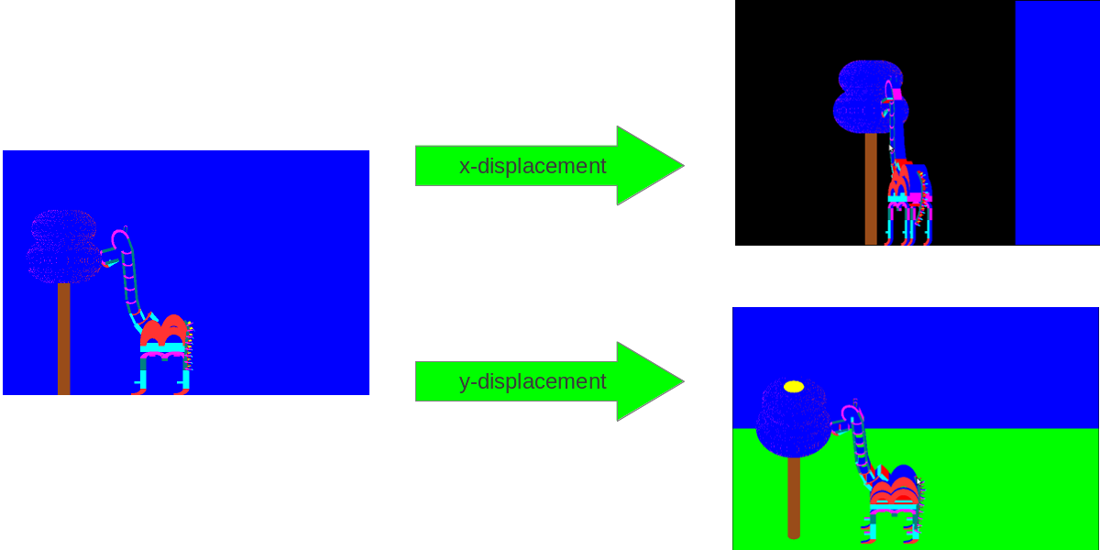
- Effects of x and y displacements of mouse when left button is held down

2.2 Right button interactions
A single press of the right button will exit the program (note that the exit is on release of the button).

3 Keyboard interactions
This section serves as a description of the various keyboard interactions to which the animated model can respond.

3.1 Exiting the program
Same as the releasing a click of the right mouse button, the program can also be exiting when the escape key is pressed.

3.2 Switching between scenes
We define the term “scene” in this context to be a view of different objects that the program is capable of producing at a single time. The user is able to ask the program to draw a variety of different scenes, which can be accessed in two ways : direct access or toggle access.

3.2.1 Direct access scenes
There are eights scenes that can be access directly through the keyboard, by simply pressing the corresponding buttons :
- pressing the 's' button allows the user to view the animated model (with background elements). This is the default setting, and is shown as part of figure i above ;
- as the model is made up of a combination of six letters (e,c,b,m,n and f), pressing the corresponding key (respectively 'e', 'c' ,'b', 'm', 'n' and 'f') will allow the user to view only the requested initial ;
- he user may also press the 'I' key to view all six initials simultaneously.
Figure ii (see below) shows the 7 other scenes (excluding the main scene shown in figure i, which can be displayed by pressing 's'). The central image is the scene displayed when the 'I' key is pressed. The letters on the the arrows are the letters to obtain the scene the arrow points to.
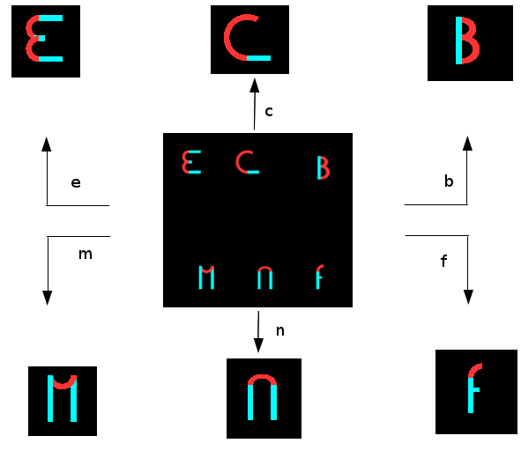
- Display of scenes printed when pressing the 'e', 'b', 'c', 'm', 'n', 'f' and 'I' keys

3.2.2 Toggle access scenes
Some of the other less important and/or commonly displayed scenes can be access by toggling through a list of all possible displays. To toggle between these scenes, the user must press the '/' key.

3.3 Display options
The user can change the scene slightly, in order to get a better view of how the objects are being printed.

3.3.1 Placing the origin
When drawing the individual initials, or when drawing all six simultaneously, the users has the option of showing the origin of the letters, i.e. where the matrix is centered when the function to draw the letter is called. This allows the user to better understand around which point the letter is created. This can be achieved by pressing the 'o' key. To remove the origin, press the 'o' key again. Note that when drawing the animated model, or toggling through its sub-sections, this option is not available. Figure iii shows and example of this functionality.
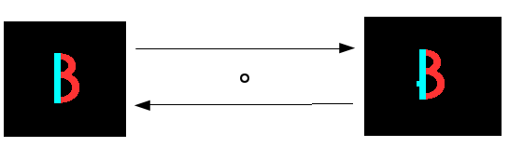
- Example of printing the origin for the b initial

3.3.2 Showing the axes
The user may wish to see where some of the main axes of the program are, in order to get a better understanding of where objects are placed (relative to each other or center of the 3D space). Pressing the 'a' key changes the background color to white, and also draws the x = 0, y = 0 and z = 0 axes, center of the 3D space (there point of intersection being the absolute center). Pressing the 'a' key again will reverted back to the default “black background mode”.
When in the “white background mode”, the user can choose to display more axes. To get a grid of axes in the (x,y) plain, the user can press the 'x' key. The 'y' key will draw a grid of axes in the (y,z) plain, and the 'z' key will draw a grid of axes in the (x,z) plain. Pressing these keys again suppress the associated grid of axes.
In figure iv, the central image shows the effect of the 'a' key on the display. The other displays can be obtained by pressing the associate 'x', 'y' or 'z' key.
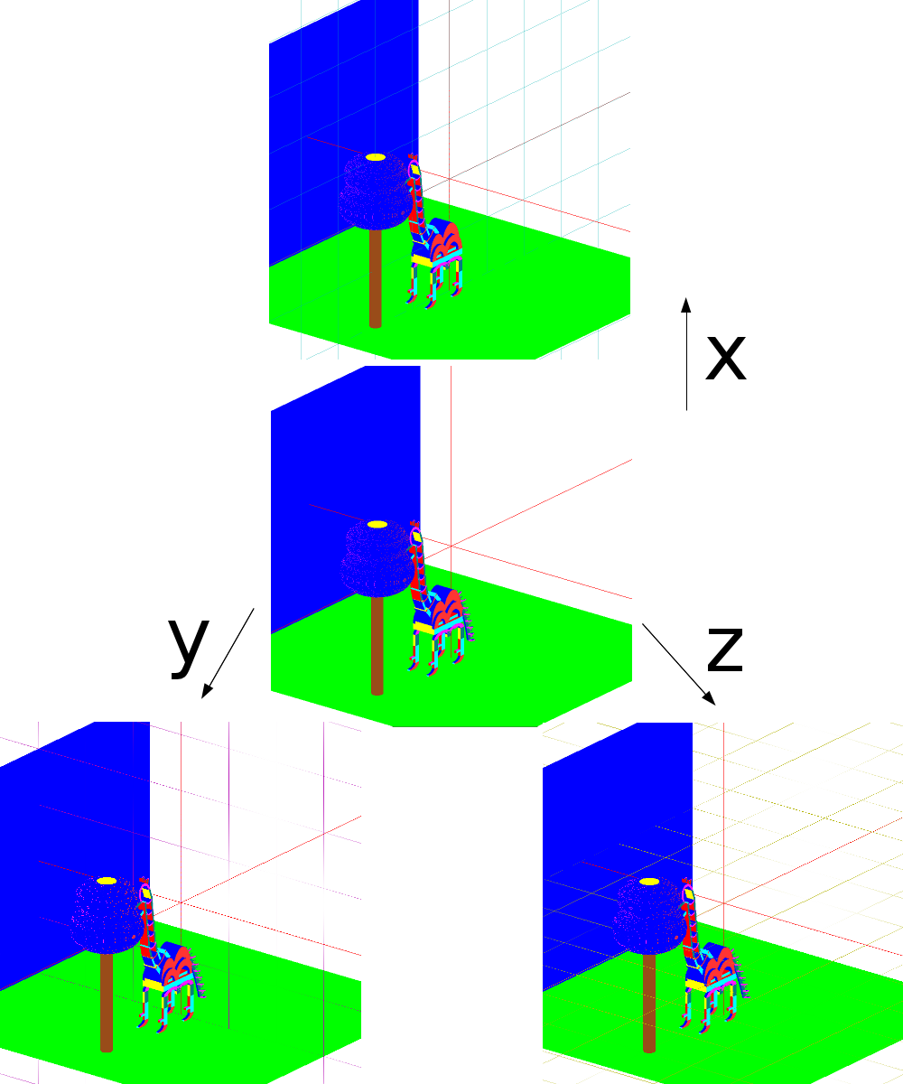
- Showing axes in “white background” mode

3.3.3 Switching between full polygon or empty polygons
By default, openGL polygons use linear interpolation to color the polygon. The color of the edge of a polygon is a linear interpolation of the colors of the two vertices's, and the color of the polygon is a linear interpolation of the edges. You can ask openGL to not do this second step of interpolation, and just show clear (or empty) polygons. By pressing 'l', the user can view the scenes with empty polygons. Pressing 'L' reverts back to the default full polygon state. This is illustrated by figure v below.
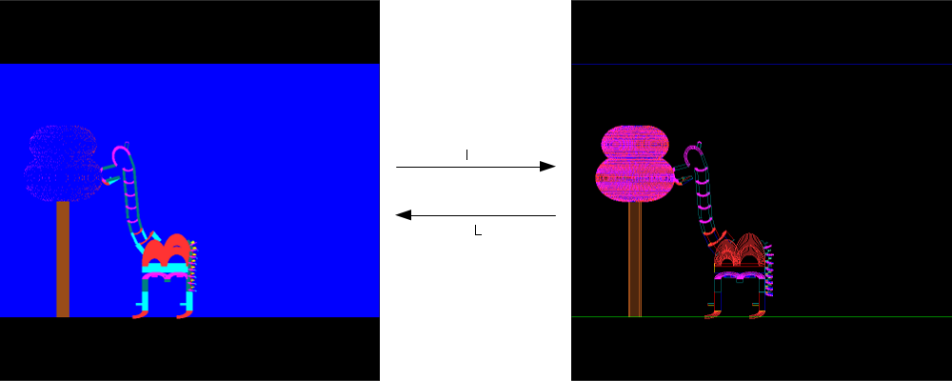
- Full polygon mode (left) and empty polygon mode (right)

3.4 Model Animation
As this is an animated model, certain keyboard interactions make modifications is the models posture. These as described below.

3.4.1 Jaw Animation
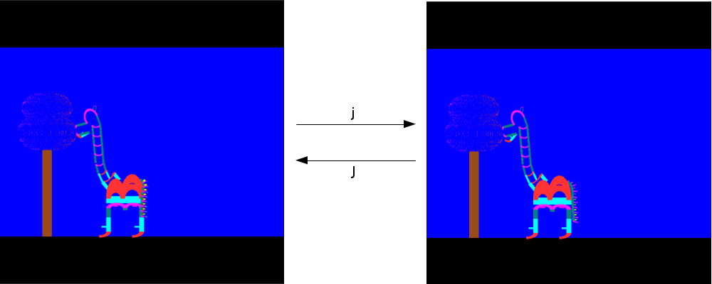
- Model with closed (left) or open (right) jaw
By pressing the 'j' key, the user can progressively open the model's jaw. The reverse action can be obtained using the 'J' key. The jaw has a range of motion of 20°, 0° being the default closed position. See figure vi for more information.

3.4.2 Neck animation
The 'h' key can be used to progressively tilt the base of the neck back, while bending the trunk of the neck forward. The reverse motion is obtain with the 'H' key. The neck can tilt up to 45° back, and the can range up to 90° of it's initial angle. See figure vii for more information.
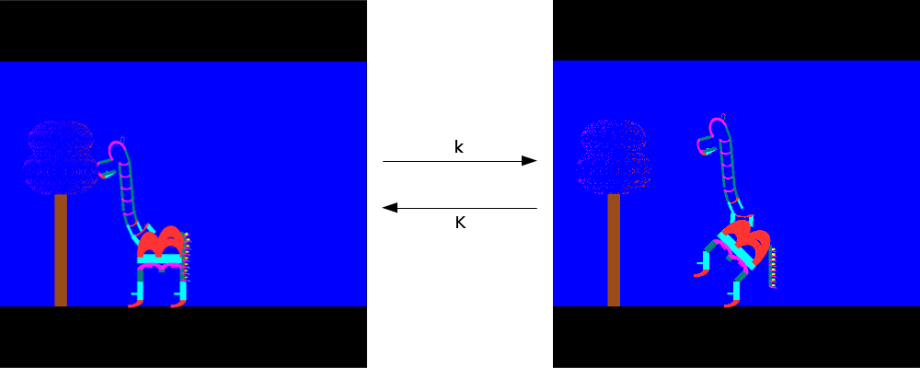
- Model balanced on two (left) or four (right) legs

3.4.3 Knee animation
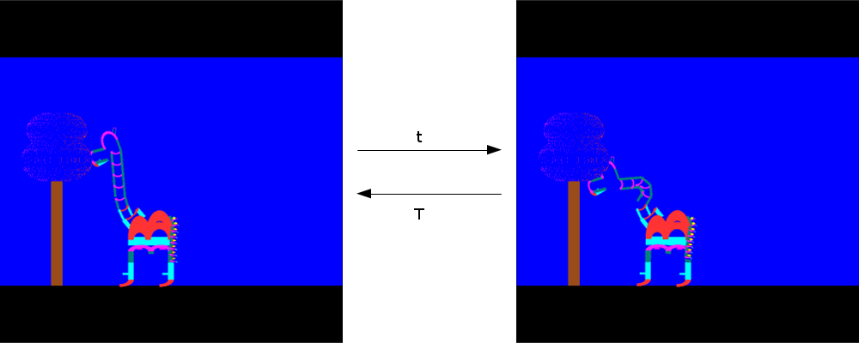
- Model with straight (left) or bent (right) neck
The 'k' key allows the model to progressively bend its back knee's backwards to a maximum of 45°, which gives the impression the models is balancing on its back legs. The reverse motion is obtain by pressing the 'K' key. See figure viii for more details.

3.4.4 Animation : eating a leaf from the tree
When pressing the 'p' key, the model enters a short a sequenced animation, which consist of the model falling back to it's default position, then jumping up to grab a leaf from the tree, before falling back down and chewing.

