For the Inventor project we selected standard steel from the Autodesk Material Library for elements of the mechanisms which transmit torque to guarantee that this segments have enough strength. These are shafts, gears, keys and retaining rings. The frame, bushings and cover plates and servomotor holder (aluminum sheet stamped in a press for two last-mentioned) was designed to be made of 6061 aluminum alloy selected from the same material library, because in the first place they should be lightweight and are not exposed to deformations. Bolted connections (bolts, nuts and washers) were composed of standardized elements.
Calculation-based assumptions lead to selection of SKF W 638/4 XR-2Z deep grove ball bearings in the place of contact between any bodies rotating relative to each other.
From simualtions we obtained required moments for driving palm and finger mechanism. For the base joint 3564_B brushless DC servomotor was selected and for the end joint 4490_B brushless DC servomotor.

In the table below we placed selected standardized elements

Element | Source
4490_B  brushless DC servomotor | https://fmcc.faulhaber.com/resources/img/EN_4490_B_FMM.PDF
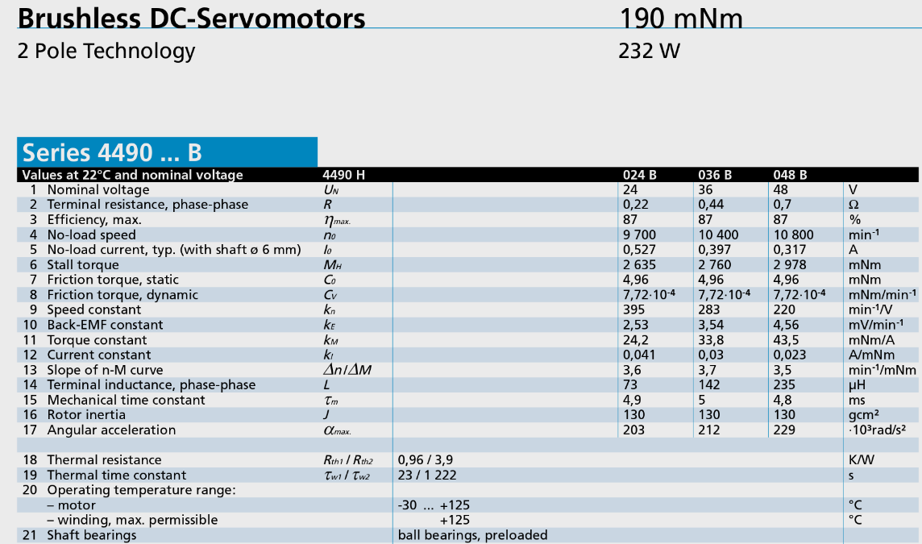

Element | Source
3564_B brushless  DC servomotor | https://fmcc.faulhaber.com/resources/img/EN_3564_B_FMM.PDF
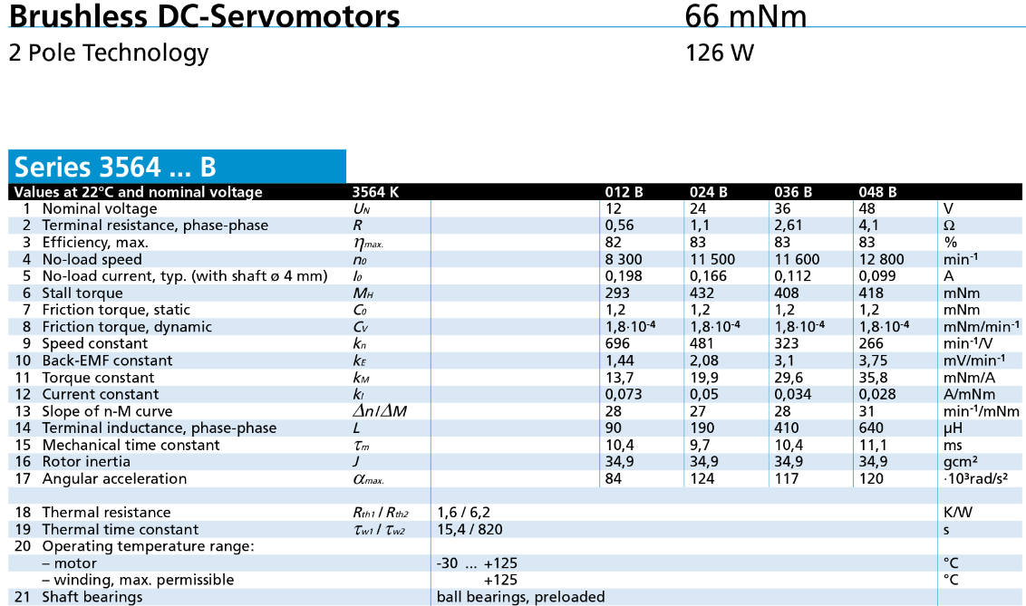
SKF W 638/4 XR-2Z  deep grove ball bearing | http://www.skf.com/group/products/bearings-units-housings/ball-bearings/deep-groove-ball-bearings/deep-groove-ball-bearings/index.html?designation=W%20638/4%20XR-2Z
