Gagujas, Michael

CS499 – Computer Science Capstone

August 4, 2024

Milestone Four: Databases

***Databases***

Enhancement #1 – Implement Firebase Authentication

Enhancement #2 – Allow Third-Party Sign In

1. Briefly describe the artifact. What is it? When was it created?

The artifact that I’ve selected to demonstrate my understanding of the databases category for my capstone project is an event tracking mobile application, which was used in CS360 – Mobile Architecture and Programming in March and April of 2024 during Term 24EW4.

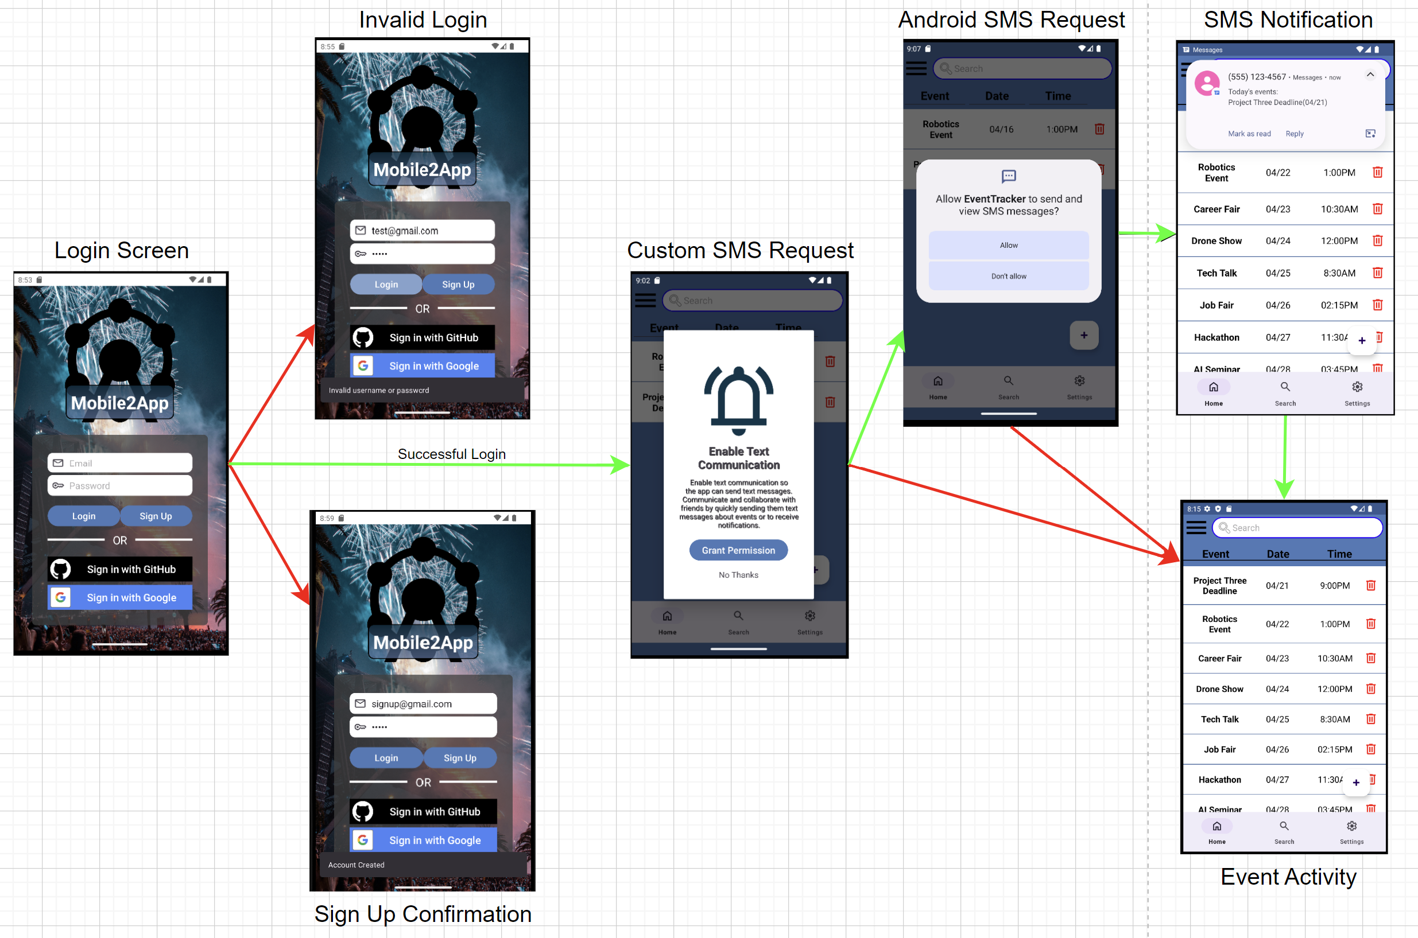

This artifact involves building a fully functional mobile application that allows a user to create a login, add events to a database, and, after receiving user permission, send SMS messaging notifications. It was built in Android Studio and follows the Model-View-ViewModel architectural pattern, where the application’s logic is separated from the user interface. The user interface is designed to be intuitive and user-friendly so that users can easily navigate through it and utilize its event management features. One of the key features of this application is its ability to send SMS notifications to remind users of their upcoming events with customization for when and how frequently notifications can be sent. Prior to this milestone, it utilized SQLite to read and write data like user credentials and event information directly from the ordinary disk files.

1. Justify the inclusion of the artifact in your ePortfolio. Why did you select this item? What specific components of the artifact showcase your skills and abilities in software development? How was the artifact improved?

I chose my event tracking mobile application artifact for my ePortfolio because it has a strong potential to demonstrate my proficiency in achieving the course outcomes for this class along with fulfilling my strong interest for building more complex and usable mobile applications. By transitioning from using SQLite to Cloud Firestore, I’ll be able to enhance the scalability and performance of my application while also allowing me to learn advanced concepts like data synchronization across multiple devices and how to handle offline scenarios (Moroney & Moroney, 2017, p.1). In addition, as a NoSQL Database, it gives me the opportunity to work with a flexible and schema-less data model that can be easily adapted to the changing needs of a mobile application. Another enhancement that I’m making involves activating the third-party login buttons from my login screen, which would allow users to sign in to my mobile application with their currently existing Google and GitHub accounts. But overall, I’ve successfully connected my Android Studio project with the FireBase app.

1. Did you meet the course objectives you planned to meet with this enhancement in Module One? Do you have any updates to your outcome-coverage plans?

For this enhancement, I definitely strengthened my artifacts security and developed a security mindset by understanding how Firebase Authentication can improve the security and reliability of my application. It demonstrated my ability to use well-founded and innovative techniques that professional companies utilize to protect user data and maintain application integrity. I’ve still only scratched the surface with its features and functionalities, but I look forward to improving its implementation once I submit the final project. Overall, there is a lot of room for improvement regarding fully applying my enhancements, but I feel confident and am excited to delve deeper into their concepts and build a worthwhile project that can captivate an employer’s attention.

1. Reflect on the process of enhancing and modifying the artifact. What did you learn as you were creating it and improving it? What challenges did you face?

For my enhancement regarding the databases category, I have improved the storage and security of user credentials by transitioning from the local SQLite to Firebase Authentication. My Android Studio project is successfully connected to the Firebase app, and users can successfully register and create secure passwords with their existing emails. Firebase Authentication provides a more secure system, as it uses a combination of secure hashing algorithms and token-based authentication to protect user credentials. To enhance the artifact, I made the register process more user friendly and intuitive by changing the Sign Up button, which originally took inputs from the login fields, and making it have its own Register activity so that users can clearly distinguish between the login and registration processes. Currently it has a basic layout as I was going for functionality first, but once a user inputs their email and custom password, they can successfully register their account and authenticate through Firebase. For this enhancement, I created an entirely new Register activity, which uses EditTexts and Buttons to create the simple user interface along with using Android’s Toast feature to notify users if their credentials are either empty or too short, or if their registration was a success or failure.

References

Moroney, L., & Moroney, L. (2017). An Introduction to Firebase. *The Definitive Guide to Firebase: Build Android Apps on Google's Mobile Platform*, 1-24.