Gagujas, Michael

CS499 – Computer Science Capstone

July 21, 2024

Milestone Two: Software Engineering and Design.

***Software Engineering and Design***

Enhancement 1 – Create LightSource classes to declutter main function

Enhancement 2 – Configuration file for magic numbers with shaders

Enhancement 3 – improve skybox performance and use encapsulation

Enhancement 4 – Add animated objects

1. Briefly describe the artifact. What is it? When was it created?

The artifact that I’ve selected to demonstrate my understanding of the software engineering and design category is my OpenGL Project from CS330 Computational Graphics and Visualizations.

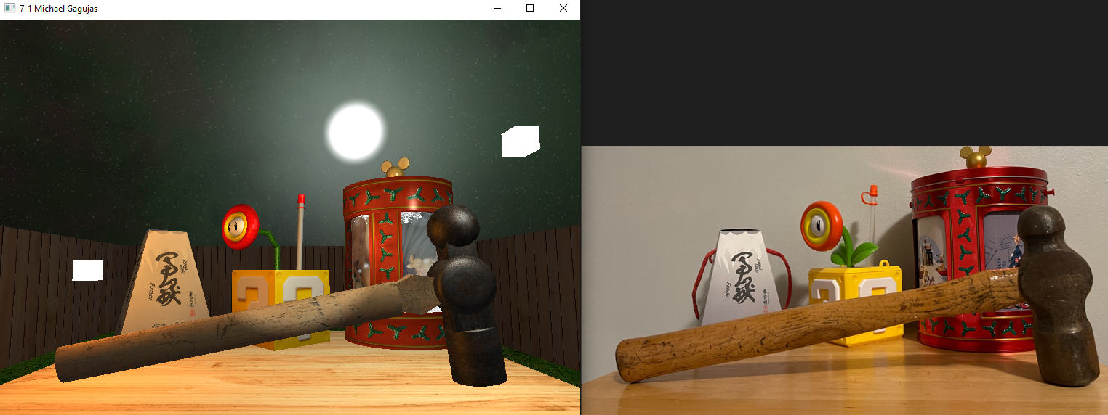This artifact involves recreating a 2D image as a 3D scene, and it effectively applies the use of textures and the Phong lighting model to create a realistic and visually appealing representation of a photo. It was completed in March 2024 during the 24EW3 term as my final project, and it was used to demonstrate my proficiency in generating accurate representations of three-dimensional objects and creating interactive graphics applications that respond to input devices.

1. Justify the inclusion of the artifact in your ePortfolio. Why did you select this item? What specific components of the artifact showcase your skills and abilities in software development? How was the artifact improved?

I’ve included my OpenGL project as an artifact in my ePortfolio because it has a strong potential to exemplify a majority of the five course outcomes, demonstrates my ability to apply theoretical concepts in a practical setting, and contains topics that I’ve been wanting to pursue. I selected this item because I enjoyed creating it, but also because I have a lot of ideas and concepts that I want to apply to it to make it better. The specific components of the artifact that showcase my skills and abilities in software development are the meshes class for applying algorithms to build and manipulate 3D shapes that represent a real-world object, the texture class for handling image files and demonstrating understanding of textures coordinates, and the shader class for demonstrating my ability to understand the graphics pipeline and how to manipulate it.

Overall, the project was improved in multiple ways that aligned with the software engineering and design category. For my first enhancement, I decluttered the main function and created reusable Light Classes that highlighted my understanding of object-oriented principles like polymorphism and encapsulation. By creating a LightSource parent class, and then deriving specific types of light sources such as PointLight, DirectionalLight, and SpotLight, I was able to encapsulate the properties and behaviors of different light sources while also making my code more maintainable and readable. In the future, this will make it easier to add, modify, and remove different types of light sources to build larger and more immersive scenes. In actuality, its implementation of separation of concerns has inspired me to further improve my project by reworking the SceneObjects class as an object for each class to better improve their reusability and modularity.

For my second enhancement, it involves the new Light classes, where I used a .ini configuration file to define the properties of each light source. This allows for a more flexible and dynamic approach to setting up the lighting in the scene, where there aren’t numerous magic numbers that make the code less readable. It also makes it possible to modify the lighting setup without having to change and recompile the code, which adds to its overall flexibility and adaptability. In addition, being able to utilize configuration files demonstrates my ability to work with external resources, which is incredibly common in a variety of projects.

For my third enhancement, which involves optimizing the skybox, I ran into significant issues where a lot of different strategies like organizing the code or restructuring it caused pieces of code to break. For this enhancement, I’m still working on an effective solution, but I decided on completing the other three enhancements before being stuck on just one. For my fourth and final enhancement for the software engineering and design category, I improved the complexity of my project and implemented 3D objects that were capable of moving inside of the scene. For now, I have a large sphere that is meant to represent a firefly, and it is capable of moving in a circle above the objects inside of my scene. This enhancement will be further developed in the algorithms and data structures category of my project, as it involves the use of complex algorithms to replicate the erratic movement that fireflies tend to move in.

1. Did you meet the course objectives you planned to meet with this enhancement in Module One? Do you have any updates to your outcome-coverage plans?

With regards to the course objectives, I feel that I have met them with the current enhancements that I’ve implemented, but I will also feel more confident in them once I polish the final product. I’ve used innovative skills and techniques to design solutions that accomplished goals through building classes that leverage object-oriented principles and effectively utilizing configuration files. By using matrix translations to replicate object movement, I was able to solve logic problems in software and demonstrate a clear understanding of algorithmic thinking. By restructuring components in my shader program and creating them as Light classes, I was able to address potential design flaws and increase the readability and maintainability of the code. Finally, I was able to clearly articulate different concepts, ideas, and accomplishments through this assignment.

1. Reflect on the process of enhancing and modifying the artifact. What did you learn as you were creating it and improving it? What challenges did you face?

Enhancing and modifying my artifact was an insightful and enjoyable process that allowed me to learn more about the intricacies and difficulties of software development and computer graphics. It gave me a hands-on experience for applying theoretical concepts to practical problems and strengthened my understanding of subject matters like object-oriented programming, matrix translations, and shader configurations. It also fostered my creativity and ability to think of innovative solutions as there were numerous times that I had to devise new approaches to overcome unexpected challenges. For example, restructuring the Lights class and removing global variables in my main.cpp file created a chain reaction of functions and components that needed to be modified to accommodate the changes. The restructuring process was a challenging task that required a deep understanding of the interdependencies within the codebase, but overall, it was a fun and rewarding process that revealed that I have a lot to improve on. Ultimately, I can’t wait to delve deeper into my artifacts, build an ePortfolio that demonstrates my marketability to potential employers, and continue to grow and develop as an aspiring software developer.