USING FUZZY K-MODES TO ANALYZE PATTERNS OF

SYSTEM CALLS FOR INTRUSION DETECTION

A Departmental Thesis Presented to the Faculty

of

The Department of Math and Computer Science

California State University, East Bay

In Partial Fulfillment

of the Requirements for the Degree

Master of Science in Computer Science

By

Michael M. Groat

December 2005
Abstract

Immunocomputing models computer systems after a body's natural immune system. Like a body's natural immune system, it attempts to detect, isolate, and remove foreign material or hacking attempts. Stide, an immunocomputing process model based on table lookup, has detected common intrusions in both artificial and live data in prior research. In our research, we investigated the value of using a more powerful process modeling technique. This process modeling technique, called fuzzy k-modes, clusters categorical patterns of system calls into centroids and memberships. These centroids and memberships then classify new process patterns as normal or abnormal. We obtained process patterns from an established data set for which stide results are known. Results for our data model were mixed. While acquiring the results, we established novel innovations aiding fuzzy k-modes. These novel innovations include a new index to test for data uniformity, a new logarithmic dissimilarity measure, a reduction in time complexity, and the failure to convert two well-known quantitative validity indexes to qualitative data.

USING FUZZY K-MODES TO ANALYZE PATTERNS OF SYSTEM CALLS FOR INTRUSION DETECTION

By
Michael M. Groat

Approved

__________________________
__________________________
__________________________

Date:

_______________________
_______________________
_______________________

Acknowledgments

I would like to thank my parents for all their love and support, without which I do not think this project could have finished. Thank you to the students in the AHAT Laboratory for their suggestions and comments, particularly Katja Hofmann, Stephan Iannce, Pete Krasnicki, and Nathan Speed. Thank you to my thesis committee, Dr. Holz, my advisor, for her invaluable input, guidance, and coordination, Dr. Suess for keeping me on track, and Dr. Nico for his valuable comments.
I would also like to thank the institutions that provided funding for this research, Chevron Texaco, and the Cal State East Bay Associated Students.

Table of Contents
Abstract ii
Acknowledgments iv
Table of Contents v
List of Figures vii
List of Tables viii
List of Equations ix
1. Introduction 1
2. Literature Review and Related Work 5
2.1. Patterns of System Call for Intrusion Detection Systems 5
2.2. Fuzzy Clustering Techniques 9
2.3. Fuzzy Clustering Validation Techniques 12
3. Background Discussion 16
3.1. Clusters, Centroids, Memberships and Categorical Data 16
3.2. Anomaly Intrusion Detection Systems Based on Patterns of System Calls 19
4. Experimental Design 24
4.1. Step 1: Recording System Calls 25
4.2. Step 2: Generating Training Data 26
4.3. Step 3: Building the Process-Data Model 28
4.3.1. The Fuzzy k-Modes Algorithm 30
4.3.1.1. Fuzzy k-Modes Dissimilarity Measure 31
4.3.1.1.1. A New Dissimilarity Measure 32
4.3.1.2. Fuzzy k-Modes Continued 35
4.3.1.3. Fuzzy k-Modes Step One: Initialization 37
4.3.1.4. Fuzzy k-Modes Step Two: Determine the Memberships Based on the Centroids 38
4.3.1.5. Fuzzy k-Modes Step Three: Determine the Centroids Based on the Memberships 39
4.3.1.5.1. Reduced Time Complexity in Step Three 40
4.3.1.6. Fuzzy k-Modes Step Four: Determine the New Memberships Based on the New Centroids 42
4.3.2. Building the Fuzzy k-Modes Process-Data Model 43
4.3.2.1. Building the Process-Data Model Step One - Find the Optimal Alpha 44
4.3.2.2. Building the Process-Data Model Step Two: Find the Optimal Number of Clusters 50
4.3.2.2.1. Kim’s Validity Index 51
4.3.2.2.2. Kwon’s Validity Index 53
4.3.2.2.3. Bezdek’s Partition Entropy Index 55
4.3.2.2.4. New Step: Using an Entropy Clustering Scheme 58
4.4. Step 4: Comparing Real Process-Data with the Process-Data Model 62
4.5. Step 5: Detecting Attacks 65
4.5.1. False Positives 66
5. The Data Set 68
6. Results 72
6.1. Fuzzy k-Modes Results 72
6.1.1. Live Inetd 73
6.1.2. Live Ps 74
6.1.3. Live Login 78
6.1.4. Synthetic LPR 79
6.2. Fuzzy k-Modes Results Overall 81
6.3. A New Uniform Measure 82
6.4. A New Dissimilarity Measure 82
6.5. Reducing the Time Complexity of the Fuzzy k-Modes Algorithm 85
6.6. Invalidity of Converting Quantitative Validity Indices 86
7. Future Work 87
7.1. Boiling Frog in the Pot Syndrome 87
7.2. Solving a Series of Non-Linear Equations 88
7.3. System Call Timing 89
7.4. Sensitivity of Fuzzy k-Modes 90
7.5. Fuzzy Grammatical Inference 90
7.6. Other Future Work 91
8. Conclusion 93
9. Annotated Bibliography 96
9.1. Analyzing Patterns of System Calls for Intrusion Detection 96
9.2. Fuzzy Clustering of Categorical Data 98
9.3. Fuzzy Clustering Validation 99
Appendix A: Kim’s Validity Index 101
Appendix B: Tsekouras’s Entropy Based Clustering Method 103
Appendix C: Tsekouras’s Validity Index 104
Appendix D: Code 106
Sequencer.java 106
Fuzzy_k_modes.pl 108
Compare_strings.pl 118
Appendix E: Raw Data 125
Live Inetd 125
Live PS 129
Live Login 141
Synthetic LPR 146

List of Figures
Figure 1: Intrusion signal. C is the centroids from the training strings. T is the training strings. N is the new strings. 3
Figure 2: Three clusters with centroids. X are the strings, C are the centroids. 17
Figure 3: Membership of a string. We take the distance to the nearest centroid as that string’s membership. In this case, it is .6. 18
Figure 4: Categorical distance. The distance between 000 and 111 is three. 19
Figure 5: Venn diagram of all possible sequences of system calls. Inside the state space lie two overlapping subsets, normal traces, and intrusion traces. 21
Figure 6: Five steps to determine intrusions based on patterns of system calls 21
Figure 7: Logarithmic curve of dissimilarity measure. If we have 2 strings of length 14 with 5 differences, we take the 5/14th position on the x axis and find the corresponding y value, .85. 34
Figure 8: Histogram of two data sets. There are 1000 elements per data set distributed over 12 classes. 46
Figure 9: Alpha stabilizes around 15 numbers of clusters 48
Figure 10: Effect of uniform distribution of memberships on intrusion signal 49
Figure 11: Kim's Index monotonically decreases of the number of clusters approaches n. 52
Figure 12: Kwon's Index semi-monotonically decreases as the number of clusters approaches n. 55
Figure 13: Intrusion signal versus number of clusters 57
Figure 14: Bezdek's and Kown's Validity Index versus number of clusters 57
Figure 15: Two new process-data classes A and N. Ts are the centroids from the training data. Ns are normal data strings. As are abnormal data strings. 63
Figure 16: Intrusion signal with old linear dissimilarity measure 83
Figure 17: Intrusion signal with new logarithmic dissimilarity measure 84

List of Tables
Table 1: Live inetd - intrusion signals 73
Table 2: Live PS - Intrusion signal – Homegrown 75
Table 3: Live PS - Intrusion signal – Recovered 75
Table 4: Live PS - self test signal 77
Table 5: Live Login - Intrusion signals 78
Table 6: Live login - Self test signals 79
Table 7: Synthetic LPR – Intrusion signals 80
Table 8: Total Results 81

List of Equations
Equation 1: Dissimilarity measure 31
Equation 2: Dissimilarity measure continued 31
Equation 3: New dissimilarity measure 34
Equation 4: Fuzzy k-modes equation 35
Equation 5: Fuzzy k-modes constraints 36
Equation 6: Updating the membership matrix 39
Equation 7: Updating the centroid matrix 40
Equation 8: Time complexity of M 41
Equation 9: Chi-Square Index 45
Equation 10: New uniform distribution measure 47
Equation 11: Adjusted Chi-Square Index 47
Equation 12: Kown's Published Validity Index 53
Equation 13: Our Converted Kwon's Validity Index 54
Equation 14: Bezdek's Partition Entropy Validity Index 56
Equation 15: Kim’s Validity Index: Overlap measure between two fuzzy clusters. 101
Equation 16: Kim’s Validity Index: Sigma in overlap measure 101
Equation 17: Kim's Validity Index: Total Inter Cluster Overlap 101
Equation 18: Kim's Validity Index: Overlap Measure 102
Equation 19: Kim's Validity Index: Separation Measure Similarity 102
Equation 20: Kim's Validity Index: Separtion Measure 102
Equation 21: Kim's Validity Index 102
Equation 22: Tsekouras's Entopy Based Clustering: Entopy value between two categorical objects. 103
Equation 23: Tsekouras's Entropy Based Clustering: Similarity Measure E 103
Equation 24: Tsekouras's Entropy Based Clustering: Total Entropy of a string to all other strings 103
Equation 25: Tsekouras's Validity Index - Global Compactness 104
Equation 26: Tsekouras's Validity Index - Global Compactness Continued 104
Equation 27: Tsekouras's Validity Index - Membership of a given string to a given centroid. 104
Equation 28: Tsekouras's Validity Index - Fuzzy Separation 104
Equation 29: Tsekouras's Validity Index 105

- Introduction

Computer security has become an increasingly vital field in computer science in response to the proliferation of private sensitive information. The media inundates us with stories of credit card, bank account, and social security information breached by computer hackers. A fast, secure, and reliable method is needed to detect these hackers and hacking attempts.
Computers can be protected against security threats using immunocomputing. Immunocomputing models computer systems after the animal immune systems, which detect, isolate, and remove foreign materials in a body. An immune system does not attack itself. A computer knowing what is itself should be able to detect and eradicate what is not itself, i.e., possible hacking or intrusion attempts.
We mimic the immune system through clustering. Our algorithm uses clustering to define what is “self” in a computer system. Isolation and removal are left for future research. We apply our clustering method to a new branch of immunocomputing that examines patterns in system calls.
Forrest, et. al. detected intrusions using short sequences of system calls. [1] Short sequences are stable enough to provide a good signature for ‘normal’ program behavior. A program’s stream of system calls is represented as several short sequences, or strings, of a particular length. These strings are analyzed by a mathematical model to determine normal patterns. The mathematical model compares new strings against its model and later classifies them as normal or abnormal. Deviation from the modeled normal behavior indicates a possible intrusion. One drawback to this method is the need to collect system calls from a program during a clean uninfected period. In addition, model training is computationally intensive.
We use a statistical method, fuzzy k modes, to model normal behavior, or the self. The fuzzy k modes algorithm models normal behavior into clusters centers or centroids. [14] It determines from a set of strings the most representative strings, or centroids. The centroids elaborate how the data is structured. A string’s distance from the centroids determines its degree of normalness. The distance to the nearest centroid is considered a string’s membership value. A string is considered more normal the closer it is to its nearest centroid. Hence, it will have a higher membership value. We then compare new strings against the memberships and cluster centers of the training strings. Memberships of new strings are found to the cluster centers of the training strings. Again, we take the distance to the nearest cluster center. In this way, the new strings’ memberships to the centroids from the training data are found and compared with memberships from the training strings. The differences of the training strings and new strings’ memberships determine the intrusion signal.
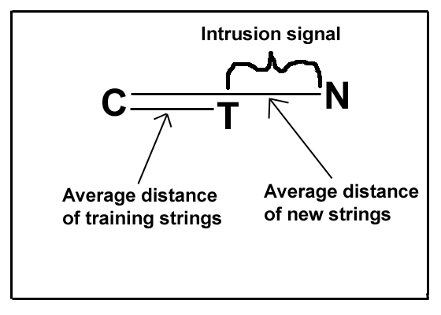
Figure 1: Intrusion signal. C is the centroids from the training strings. T is the training strings. N is the new strings.

Our results from this statistical method demonstrate that algorithms that are more sophisticated increase the accuracy of intrusion detection sufficiently to justify their additional computational cost, and, in particular, fuzzy logic improves detection capability. We obtained increased accuracy with certain processes enhancing the ability of our intrusion detection method to detect intrusions. In some cases, we were able to reduce both false positives and negatives. Fuzzy logic assists in determining how normal or abnormal new strings are. Fuzzy logic models the uncertainty in the data better and delay decision making to the point where we have most of our needed information. It seems natural to classify intrusions on a spectrum. Fuzzy logic is based on possibility theory instead of probability theory.
Our statistical modeling technique was tested using an established data set with published results for other modeling techniques. In this way, we can compare our method with other methods. The data set was collected by Stephanie Forrest and her collogues at the University of New Mexico. [1,2,3] It contains several million sequences of system calls from several processes, and has been tested with several process-data modeling techniques. [6,8,9,11]
This research has produced mixed results for detecting intrusions in four programs. We tested intrusion attempts in inetd, ps, login and LRP. Intrusions were successfully detected in LPR and inetd, and ps, yet only some of the intrusions were detected in login.
Auxiliary results have shown a more powerful algorithm of measuring uniform distribution in a set of data, the drawbacks of Kim's and Kwon’s validity index converted to categorical data, a new dissimilarity measure, and a reduction in the time complexity for the fuzzy k-modes algorithm. Each of these results will be explained further in the report.
In this paper, we first discuss current research in the literature, then shift to a background discussion on clusters, centroids, memberships, the difference between quantitative data and categorical data, and intrusion detection methods focusing on using patterns of system calls as an anomaly based intrusion detection method. Next, we discuss our experimental method, the way we went about trying to detect intrusions. Then we explain the data set and the different programs monitored for intrusions. Afterwards we will show our results followed by a conclusion.
- Literature Review and Related Work

We will review in the literature several topics that pertain to this research. These topics will seem somewhat unrelated because the research pulls from several areas of computer science. First, we will focus on Intrusion Detection Systems (IDS), particularly those that use patterns of system calls for anomaly intrusion detection. Next, our attention shifts to various fuzzy clustering techniques on categorical data. Finally, we discuss the current research on several validity techniques that work with fuzzy categorical data.

  - Patterns of System Call for Intrusion Detection Systems

Intrusion Detection Systems fall under two types, anomaly based detection, and misuse based detection. Misuse detection methods look for known intrusion signatures, while anomalous based detection looks for deviation from normal behavior. Our work focuses on anomaly based detection methods, particularly methods that use patterns of system calls.
One method of anomaly based intrusion detection examines patterns of system calls. The groundwork for research into patterns of system calls for anomaly based intrusion detection was presented by Stephanie Forrest, et al. [1] They showed that short sequences of system calls could be used as an observable for the detection of an intrusion. Abnormal behavior has a different pattern of system calls than normal behavior. Hence, any deviation from normal behavior is deemed abnormal. This is the first paper proving short-range correlations in a process’s system calls is stable enough to define a process’s behavior. They detected several common intrusions for the sendmail and lpr UNIX programs. This work is part of a broader research program attempting to study the natural immune system of animals. Dr. Forrest and her collogues want to apply the computational models of immune systems to computer systems.
Forrest et. al.’s work was continued in “Intrusion Detection using Sequences of System Calls.” [3] More data sets was used than in “A Sense of Self for Unix Processes.” They also show the rate of true positives on synthetic data and false positives on live data. Synthetic data consists of data collected artificially from test scripts, while live data comes from a working environment. A program called stide was used to build the databases of normal behavior, and suggested that sequences of system calls of length 6 were optimal in detecting intrusions.
Six was indeed showed to be the optimal length for sequences of system calls in the paper “’Why 6?’ Defining the Operational Limits of stide, an Anomaly-Based Intrusion Detector,” [4] Any sequences less than six will lose detection capability, while any sequences greater than six will lose computational efficiency. They used information theory and entropy limits and furthermore explain what types of intrusions stide can and cannot detect.
Taking the idea of six as the optimal sequence length, Eskin et al. experimented with dynamic window sizes. [5] Their research shows improved results by varying the sequence length according to computations based on entropy modeling methods. Additional research by Wespi et. al. looks also into using variable length sequences created with the biological based Teiresias Algorithm. [10] They compare their results against current techniques based on fixed-length patterns. Current research shows there is an advantage to using variable length patterns. Our research will use only fixed length patterns since establishing a precedent with fixed length patterns can lead to later research into variable length patterns.
Scientists have examined other process-data modeling techniques. Previously, researchers have used the stide program to build a database of normal behavior in analyzing patterns of system calls. Stide models process-data. Several different process-data modeling techniques were used and compared against each other in Lee et al.’s works. In their papers, they present process-data modeled as a rule-learning algorithm to classify normal and abnormal system call sequences. They trained their data on both normal and abnormal sequences, using both misuse and anomaly based intrusion detection methods. Additional work presented by Warrender et. al., compared stide against several other process-data modeling techniques. [6] Stide simply enumerates observed sequences. The other process-data modeling techniques compared against stide in Warrender’s paper were relative frequencies of different sequences, a rule induction technique, and Hidden Markov Models (HMMs). They concluded that methods weaker than HMMs are likely sufficient in detection accuracy. My work proposes fuzzy logic in a statistical clustering method as a new process-data modeling technique.
Another paper that examines an alternative process-data modeling technique is presented by Kosoresow et. al. [2] They modeled patterns of system calls as an automaton, creating them mostly by hand. Yet they use some automated computational methods. They did not publish any results of checking known intrusions against normal behavior.
Still other researchers have introduced other alternative process-data modeling techniques. A distributed agent approach is presented by Helmer et al. [9] Agents monitor more than just system call patterns. Different agents monitor different levels of the system. Helmer et al. developed a prototype using one agent that monitors just system call traces using the RIPPER learning algorithm with a feature vector technique. The prototype was tested on the sendmail trace from the University of New Mexico data set, the same data set we will be using.
All the research presented above detects intrusions; they do not handle an intrusion once it is detected. Reaction to intrusions, once detected, is explain by Anil Somayaji and Stephanie Forrest in their paper “Automated Response Using System-Call Delays.” They propose a way to delay system calls in a process that exhibit abnormal behavior. This delay interrupts the attacking part of the code to the point of non-functionality.
The above research focuses on sequences of system calls. Kang et. al, on the other hand, ignored the sequencing information [12] Instead they used the frequency of occurrence of system calls (a feature they call a “bag of system calls”) to build a process-data model of normal behavior. They also combine misuse and anomaly based intrusion detection methods by training the process-data model on both normal and abnormal data. Their method performed the same or better than conventional methods.

  - Fuzzy Clustering Techniques
Our process-data modeling technique uses fuzzy logic and statistical clustering. Patterns of system calls must be represented as a model of normal behavior. This model should extract the essence of correctness, or normalness, of a process.
Clustering methods group data by centers. Clustering techniques partition data into several clusters such that similar objects belong to the same cluster. The cluster centers represent the most normal of sequences, and deviations from the centers indicate behavior that is more abnormal. A good review of different clustering techniques and categories of clustering techniques is giving in Jain et. al’s survey paper “Data Clustering: A Review.” [13]
Fuzzy clustering involves fuzzy logic. Fuzzy logic defines what degree of normalcy a classifier should give to new process-data compared against the database. Fuzzy logic can better help represent the uncertainty that lies in the data. Hence, we look at fuzzy clustering techniques that can determine the true nature of the underlying data to help predict whether new sequences are abnormal or not, and to what degree.
In fuzzy clustering, each data element belongs to several partitions to certain degrees. Non-fuzzy clustering techniques generate different partitions to which data elements belong. These partitions are disjoint. In fuzzy clustering, the partitions are not disjoint.
Several previous attempts have tried to create a good fuzzy clustering algorithm.
A general high level partitioning fuzzy clustering algorithm called Fuzzy Clustering Algorithm (FCM) is presented by Jain, et al. Additionally, a generalization of the FCM algorithm was presented by Bezdek [15], while an adaptive variant for detecting circular and elliptical boundaries was presented by Dave. [16] These algorithms have failed when trying to work with large data sets.
In addition these algorithms focus on quantitative data. Our data consists of nominal qualitative data, data that is categorical such as the groups of colors, red, blue, black or types of cars, Ford, GM, Honda, Ferrari. System calls are numbered, for example, open is one, write is two, and read is three, etc., however, the numbers do not indicate ordering. The 6th system call is not twice as far as the third system call. Hence, the underlying data distribution is on a different dimension. We will be focusing on qualitative data, particularly fuzzy qualitative data.
In order to handle categorical or qualitative data, Ralambondrainy [17] represented multiple categorical attributes using binary attributes to indicate the presence or absence of a category. The binary values were then used in the well-known c-means algorithm. The number of binary values becomes very large when each attribute has many categories.
The complexity of the binary feature vector technique was reduced in the k-modes algorithm, introduced by Zhexue Huang in “Extensions to the k-means algorithm for clustering large data sets with categorical values.” It reduces the complexity by using a simple matching dissimilarity measure. The algorithm is very sensitivity to initialization.
The fuzzy version of the k-modes algorithm was first proposed by Zhexue Huang and Michael K. Ng in their paper “A Fuzzy k-Modes Algorithm for Clustering Categorical Data” as an extension for the fuzzy c-means algorithm. The fuzzy c-means algorithm is the most prominent fuzzy clustering algorithm [24] The fuzzy k-modes algorithm was developed to cluster large categorical data sets in data mining. They added the element of fuzzy logic to represent better the uncertainty found in the data set.
Unfortunately, the fuzzy k-modes algorithm gets stuck in local optima. [19,20,21,22] Several heuristics have been developed to find the global optima. One heuristic uses fuzzy centroids instead of the hard-type centroids [19] Another variation represents categorical data clusters with k-populations. [20] Still another way to find the global optimum is presented by Ng et al [21].. They use a Tabu search technique. Finally, different methods are compared in the paper presented by Benati et. al.[22] These methods include a random restart method, variable neighbor search, tabu search, and candidate list search. Note in our research the fuzzy k-modes algorithm is used without any special heuristic.

  - Fuzzy Clustering Validation Techniques

The fuzzy k-modes algorithm has a drawback. You must specify the number of clusters beforehand. We combat this drawback by running the fuzzy k-modes for several cluster sizes and picking the best one according to some criterion. This criterion is known as a validity index. Validity indexes measure the fitness of a partition scheme for a given data set. A validity index shows how closely a certain predefined number of clusters fit the underlying data set. Good validity scores indicate that the clusters closely model the underlying truth of nature of the data patterns. We use the validity indexes to determine how many clusters should be used in our process-data model.
Halkidi, et. al. present a good tutorial about cluster validity called “On Clustering Validation Techniques.” [23] They identify three approaches to investigate cluster validity. External criteria use a pre-defined structure for the data set, which reflects the intuitive understanding of the data. The results of the clustering algorithm are evaluated against this model. Internal criteria use the quantities of the vectors of the data set themselves. Relative criteria compare the structures of several clustering schemes together, usually using the same algorithm but with different parameters. The authors later identify two evaluation criteria for the selection of optimal clustering schemes: compactness, which involves how close the members of a certain cluster are to each other; and separation, which shows how far apart the clusters are from each other. We want to maximize both compactness and separation. We focus on relative criteria because we compare the same algorithm with different parameters. The parameter that varies in our case is the number of clusters.
Not only do we want to focus on relative validity criteria, we want to focus on fuzzy relative validity criteria. Fuzzy clustering validity indices seek clustering schemes where the dataset exhibits a high degree of membership in one cluster. Fuzzy validity indices divide into two general categories. One category uses only the membership values of the data sets to all clusters, and the second uses both the membership values and the underlying structure of the data set.
Bezdek first introduced in [24] the partition coefficient and the partition entropy coefficient. Although effective, these indices have several drawbacks. The indices tend to decrease or increase monotonically as the number of clusters increase. In these cases, you should take the point of maximum curvature on the graph. On the other hand, you can take the global minima in certain cases where the number of clusters is low, around the square root of the number of unique strings.
The other category of fuzzy clustering validation extracts the knowledge of the underlying structure of the data. The indices use distance as well as membership values. Various indices of this type include the Xie-Beni index [25], the Fukuyama-Sugeno index, and other indices proposed by Gath and Geva [26], which are based on hyper-volume and density. All these indices use some sort of distance measure to extract the underlying structure of the data.
The distance measures used with fuzzy clustering validation can work with qualitative data, quantitative data, or both. The literature contains little about fuzzy validation techniques on categorical data. Therefore, we tried to convert common validation techniques from quantitative data to qualitative data. We converted two common techniques, one proposed by Kwon et al., the other by Kim et al. Kwon’s index combats the tendency of the Xie and Beni index from monotonically decreasing when the number of clusters reaches the number of data points. Kim’s index is based on an overlap and separation measure. We chose Kim’s index because we felt that overlap was more important than compactness, and it was one of the newest indices.
A newer validity index for fuzzy qualitative data was found at the time of this writing. This index does not contain the problems of converting a known quantitative index to a qualitative index. The index is presented by Tsekouras et al. in their paper called “Fuzzy Clustering of Categorical Attributes and its Use in Analyzing Cultural Data.” The authors tackle the two problems that the fuzzy k-modes algorithm presents: 1) its sensitivity to initialization, and 2) the a priori knowledge of the number of clusters. They design a new three step categorical data-clustering algorithm that can determine the proper number of clusters for the fuzzy k-modes algorithm based on an entropy fuzzy clustering method, the fuzzy k-modes algorithm, and a new validity index. While we do not have all the technology to solve a perfect production working model of an intrusion detection system using fuzzy k-modes, new technology present by Tsekouras, et. al. takes us on the right step in that direction.
We have explored the literature that pertains to intrusion detection via patterns of system calls, fuzzy data clustering techniques of categorical data, and fuzzy clustering validation techniques. These are the most prevalent areas of research in these topics at the time of writing. We will continue with a detailed background discussion of intrusion detection methods that use patterns of system calls. Later we will discuss the fuzzy k-modes algorithm, and the validation techniques used to determine the optimal number of clusters for our process-data model.
- Background Discussion
Before we begin to dicsuss our experiment method we need to cover a background discussion on certain key concepts. These include what are clusters, centroids, memberships and the difference between quantitative and categorical data. We follow up with a detailed background discussion on intrusion detection systems that are based on patterns of system calls.

  - Clusters, Centroids, Memberships and Categorical Data

If we had a two dimensional state space of all possible sequences of system calls we would find groupings of similar objects. These groupings are called clusters. The following figure illustrates this concept. From the figure we see three clusters with the centers of the clusters marked as C. The centers are called centroids.

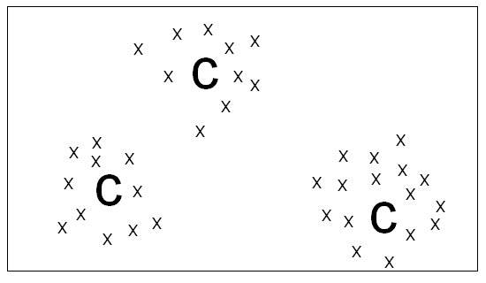
Figure 2: Three clusters with centroids. X are the strings, C are the centroids.

If we take the same two-dimensional state space and examine a particular string, we can assign a membership value to that string. The following figure illustrates how we accomplish this. For one particular string, lines are drawn to each centroid. The membership to each centroid is also listed. Note that memberships are inversely proportional to the distance away from the centroid. Larger distances denote smaller memberships. The membership to the closest centroid is assigned as that string’s membership. Thus, we would give a membership of .6 to the given string below.
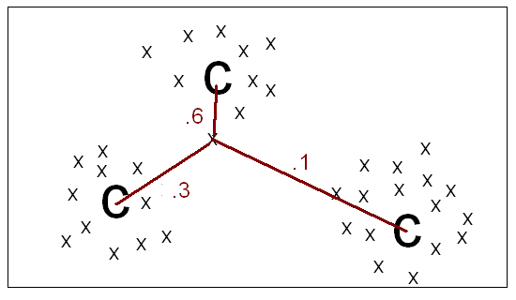
Figure 3: Membership of a string. We take the distance to the nearest centroid as that string’s membership. In this case, it is .6.

The previous two figures were based on quantitative data, data that has inherent distance associated with it. Our data is categorical. Categorical data is data such as different colors, red, blue or green, or different makes of cars, Ford, Honda, GM, and Ferrari. There is no inherent distance between categories. For example, the sixth system call is not twice as far as the third system car. The following figure illustrates the distance involved with categorical data. It contains eight strings with three attributes with two different categories for each attribute, zero, and one. Each string takes its place on one of the vertexes of the cube. To find the distance from one vertex to another, you travel along the shortest path along the edges. Therefore, the distance between 000 and 111 is three.

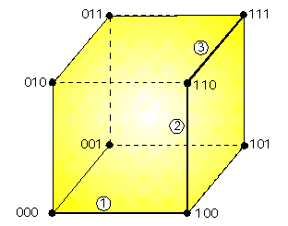

Figure 4: Categorical distance. The distance between 000 and 111 is three.

  - Anomaly Intrusion Detection Systems Based on Patterns of System Calls
Intrusion detection attempts to find viruses, worms, Trojan horses, or any type of hacking method one might use to gain access to any part of a computer system or systems. There are two types of intrusion detection methods, anomaly detection, and misuse intrusion detection. The former requires only knowledge of what is normal behavior while the latter requires knowledge of known attack patterns. We will be focusing on anomaly detection methods.
Previous research in anomaly based intrusion detection methods have shown that you can use short sequences of system calls from a program as an observable of what is normal behavior. [1] The patterns contained in system calls emitted by a process give a good signature of what is oneself, in immunocomputing terms. Any deviation from this known pattern indicates abnormal behavior. Note abnormal behavior does not necessarily mean an intrusion. The system may experience an error condition or an unsuccessful intrusion attempt, which would need the attention of the system administrator. Short sequences are used, as opposed to long or medium length sequences, because a program will execute mostly the same set of system calls once inside a subroutine, yet it will execute mostly in a random order between subroutines. Hence, we expect to see consistent patterns in short sequences. Using the patterns contained in short sequences of system calls we build a mathematical model of normal behavior. A new type of intrusion detection method has emerged that analyzes patterns in sequences of system calls.
This new type of intrusion detection flags all behavior that is outside of normal as abnormal. The following figure illustrates this concept. Within all the possible sequences of system calls, we find the sequences for normal traces. Additionally, within the same possible sequences lie the intrusion sequences. Abnormal and normal intrusions will overlap since not all of the code is infected. We attempt to classify all sequences that fall outside the normal traces sequences as abnormal.

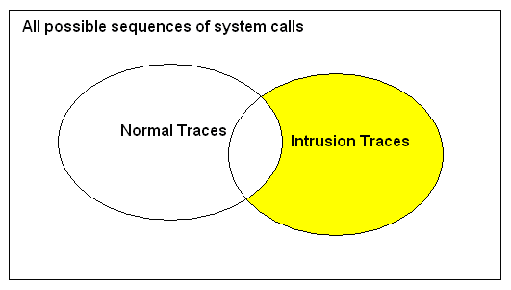
Figure 5: Venn diagram of all possible sequences of system calls. Inside the state space lie two overlapping subsets, normal traces, and intrusion traces.

Ideally, we want to monitor every program on a system, if we had an infinite amount of computational power, even the wide variant behavior of user programs. We currently focus on processes that have privileged root access. These processes are stable enough to gather a history and are strategically vital to the security of the system, since they have access to the most vulnerable parts of the system.
There are five main steps in the method of analyzing patterns in system calls for intrusion detection. [10] They are the following:

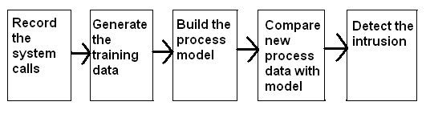
Figure 6: Five steps to determine intrusions based on patterns of system calls

We will now briefly discuss a little on each, saving the details for the section on Experimental Design.
In step one, we monitor a program and collect data on the stream of system calls that it emits. A collection program such as strace records the sequence of system calls of all processes of the program. It lists all system calls along with a process id. This data converts into the training data in step two.
Step two converts the data collected in step one into a meaningful form that can be feed into the process-data model. The form of the data usually depends on the type of process model used. Mostly it contains information about the sequences of the system calls, yet it does not have to be a straight list. In our case, we convert the data from step one into a set of strings, all of a particular length.
In step three, we build a process-data model of normal behavior. The process-data model contains information on normal behavior that is used in comparison with new process-data. In our case, the process-data model is the list of centroids and memberships collected from the fuzzy k-modes algorithm. The process-data model must represent the normalness of the data.
We compare new process-data against the process-data model in step four. New traces of system calls are converted into the same form as the training data, and compared with the process-data model. This comparison will analyze the new behavior looking for any anomalies. The results of the comparison are used in the next step to determine if we have an attack.
Finally, in step five, we set some hard limits on some type of intrusion index level obtained in step four. This step involves making decisions that will determine whether we have an attack.
These are the five steps used to analyze patterns of system calls for intrusions. In the next section, we will explain the details of how we execute each step.

- Experimental Design

We use the following five steps, explained in the previous section, for our experimental design,

1) Recording the system calls
2) Generating the training data
3) Building the process-data model
4) Comparing real process-data with the process-data model
5) Detecting attacks

Our work proposes that a more sophisticated step three will add greater accuracy in step five. We test our data using the test set from the University of New Mexico. We give our results later.
Our experiments consist of two types: intrusion tests, and self-tests. Intrusion tests test known intrusions, intrusion attempts, or error conditions against the training data. Self-tests test normal data against normal data. We feed the process model intrusion strings to test for false negatives, and normal strings to test for false positives.
We conducted the following steps for the self-test. We trained the process-data model on 50% of the normal data. Then we took the other 50% of the data and compared it with the process model. We did this twice. Because we focused on only the smallest data sets, they contained only enough data to split them up in half. Sometimes for a program, we tested for false negatives alone, as there was not enough data to perform self-tests.
We conducted the following steps for the intrusion tests. We trained 100% of the normal data and then compare it against new process-data that contains either intrusions, error conditions, or unsuccessful intrusions.
The next section describes the complete data set. We continue in detail in this section with the five steps used to test the data.

  - Step 1: Recording System Calls

The first step records or collects the system calls. The systems calls were collected with a special program used at the University of New Mexico, devised to speed the collection of data as opposed to using a program like strace. This special program emits two columns of data. The first column contains the process id, while the second column contains the system call number. System calls convert to numbers based on its position in the canonical ordered file syscall.h. We can deal with numbers easier than system call names. Process-data must be collected during a clean period where it is known no intrusions will infect the data. We convert the columns of process ids and system call numbers into the training data in the next step.
Note that a program might have several processes running. All child processes are traced in the program unless they execute a new program after a vfork. All child and parent process-data are merged together into the same process-data model.
We collect two types of data, synthetic data, and live data. Each program will fall under one of those two types. Synthetic data comes from an artificial test bed while live data comes from a real working environment. Synthetic training data should exhibit the broad range of behavior that is possible in live data. This means that the scripts that test the program should test all options of the program. This way we ensure that when we compare new data we are sure it will match the previous data no matter what options were used. Live data should be collected for a sufficient amount of time to include also a broad range of behavior.

  - Step 2: Generating Training Data

In step two, we generate the training data. We convert the data collected in step one to a set of strings of a particular length. The strings contain n system call numbers each. N is 6, 10, and 14 in our research. We chose these numbers based on previous research using entropy and information theory. Six was declared to be the optimal string length [4], any less and you loss accuracy, any more and you waste computational time. Previous research chose 10 to give a little extra accuracy and to account for a margin of error. [3,6] Hence, we chose 10 in addition to 6 to compare our research with previous research. We also chose 14 because we want to compare the affects of the fuzzy k modes algorithm on larger string sizes.
We create the strings by taking a sliding window across the stream of process ids and system calls explained in the previous section. For example, if the input file contained the following data:

1023 4
1024 5
1023 73
1023 42
1024 8
1024 8
1023 3
1024 5

We create the following 5 strings if we took our string length to be 2,

4, 73
5, 8
73, 42
42. 3
8, 8
8, 5

Only system calls from the same process id group together in the same strings. If we increase the length to three, we obtain the following four strings,

4, 73, 42
5, 8, 8
73, 42, 3
8, 8, 5

We do not include the extra system calls if it leaves us a string length less than n. Now we feed these set of strings into step three and create our process-data model.
  - Step 3: Building the Process-Data Model

We build the process-data model in step three by using the fuzzy-k modes algorithm to build cluster centers, or centroids, and memberships. The centroids and memberships are then used later in step four for comparison against new process-data. Building the process-data model consists of the following three steps.

- Fix the number of clusters then run fuzzy k-modes several times and choose the run with the optimal alpha
- Fix that alpha then run fuzzy k-modes several times and choose the run with the optimal number of clusters
- Take the memberships and centroids found with the best alpha and best number of clusters and use those for comparison with new process-data.

Our process-data model algorithm is supervised learning, unsupervised clustering. It is supervised learning in the sense that data is previously known to be normal or abnormal. It is unsupervised clustering because the number of clusters are not known a priori and we do not seed the clusters with known cluster centers. Note that every time we run the fuzzy k-modes algorithm we perform supervised clustering, because the number of clusters is known each time we run fuzzy k-modes. Yet the accumulation of running fuzzy k-modes several times is unsupervised clustering.
Fuzzy k-modes finds cluster trends in the data. It is a statistical method. The algorithm finds the representative cluster centers in the data, called centroids, and the distances of each string to each centroid. We assign a membership value to each string based on its distance to the nearest centroid. A membership near one would be close to the centroid while a membership closer to zero would be farther away. Memberships can take on the values of one and zero. The distances to all centroids must sum up to one. This is unexpected in the realm of fuzzy logic, since by fuzzy logic definition memberships to different fuzzy sets do not need to total to one.
Originally, we intended to use a fuzzy grammatical inference algorithm. This algorithm would train a neural network on a set of strings with their memberships. It creates a fuzzy automaton or an equivalent fuzzy regular language. Yet, we had to train the neural networks on a set of strings and their membership degrees. Step 2 did not provide the membership degrees. Somehow, we had to create membership values from the set of training strings. We thought we could use a statistical approach, finding cluster centers in the data state space, and take the distances of the strings to the cluster centers. Therefore, we shifted our focus of the thesis to the fuzzy k-modes algorithm. During the shift, we realized that the information contained in the string’s memberships would be enough information to classify new strings as either normal or abnormal. We decided to use the fuzzy k-modes algorithm alone to determine how new process-data should be classified.
Various other methods have been previously used in creation of process-data models. These techniques include pure statistical methods such as stide and frequency stide. More complicated methods include rule based approaches and hidden Markov models. Dr. Forrest concludes that the more computational intensive algorithms do not add significant accuracy in detecting intrusions for their relative computational cost. [6] In other words, it is not worth the extra effort to use a more complicated process-data model. Simpler methods provide relatively similar accuracy. If you have the extra computational power, you might achieve just slightly more accuracy with hidden Markov models, since they performed on average slightly better than the other compared methods. Fuzzy logic has not been used in the past as a data process model. We speculate that the inclusion of fuzzy logic might increase the accuracy and detection capability. No one method of modeling normal behavior has proved the most effective overall.
We will first explain the details of the fuzzy k-modes algorithm followed by the details of building our process-data model.

    - The Fuzzy k-Modes Algorithm

The fuzzy k-modes algorithm is a variation of the fuzzy c-means algorithm, which is a variation of the k-means algorithm. It is in the partitional squared error category of clustering algorithms.
The fuzzy k-modes algorithm consists of the following. We Let X = {x₁,x₂,…,x_{n}} exists as a set of n categorical objects. Each x is a string of system calls with p system calls. Formally, each string is described by a set of attributes A₁,A₂,…,A_{p}. The jth attribute (A_{j} where 1<=j<=p) is defined by a domain of categories which is denoted as DOM(A_{j}) = {a_{j}¹,a_{j}²,…,a_{j}^{q}_{j}}, where q_{j} is the number of categories for A_{j}. q_{j} will be the same for all j because each attribute A_{j} has the same number of categories, namely all the possible system calls. Hence, q_{j} is the total number of system calls for all j. The kth categorical object, or string, is described as x_{k} = [x_{k1},x_{k2},…,x_{kp}] where 1<=k<=n with x_{kj} a member of DOM(A_{j}) where 1<=j<=p). We now need a dissimilarity measure.

      - Fuzzy k-Modes Dissimilarity Measure

The following is the fuzzy k-modes dissimilarity measure. Let x_{k} = [x_{k1},x_{k2},…,x_{kp}] and x_{l} = [x_{l1},x_{l2},…,x_{lp}] be two categorical objects. Then the fuzzy k-modes matching dissimilarity measure between them would be defined as [14]

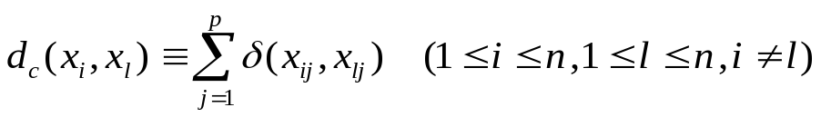
Equation 1: Dissimilarity measure

where

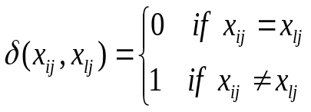
Equation 2: Dissimilarity measure continued

For example, if we had the following two strings,

3 5 10 5 7 4
3 7 10 2 3 4

We would have a dissimilarity value of 3 because there are 3 differences between the two strings, the 2nd, 4th and 5th positions.

        - A New Dissimilarity Measure

We created a new dissimilarity measure to help extract a better understanding of the underlying data. This similarity measure is based on a logarithmic scale and uses a normalizing function. We feel that a logarithmic measure is necessary due to the inherent makeup of the data. We will explain the theory behind the measure, then the measure itself. Later we will explain how this improves the detection signal in the results section.
There is a reason why we chose a logarithmic measure. The new measure is logarithmic to help determine a better understanding of the underlying data. We noticed that if two strings have a small dissimilarity it should rate high, and the more dissimilar two strings are then the less weight the measure should carry. In other words, greater weight should be giving to the first few dissimilarities, while less weight is given to the more dissimilarities they may share. There is more weight given to the second dissimilarity than to the tenth dissimilarity. Hence, the weight of the measure is logarithmic to the number of dissimilarities.
We feel this measure more closely fits to the underlying structure of the data. Slightly dissimilar strings should be flagged quickly in the fuzzy k-modes algorithm, whereas if they are dissimilar by many symbols then they should be flagged not as quickly. This goes along with the theory of how the stide program works. In the stide program, if two strings are off by just one symbol then they both are flagged as a mismatch. In our algorithm, we want a greater degree of mismatch in the first few dissimilarities, than between more dissimilarities.
You might ask why a logarithmic measure fits the data better. The data is more sensitive to strings that are slightly dissimilar than to strings that are very dissimilar. Once two strings hit a point where they have a certain number of dissimilarities, it should not matter that they have even more dissimilarities. A linear dissimilarity measure does not consider this. It gives an even weight to little dissimilarity as to much dissimilarity. Hence the old dissimilarity measure was showing a little of the correct information yet more of the incorrect information, while a logarithmic measure shows more of the correct information and less of the incorrect information. Information is the true state of nature of the underlying data. Therefore, this new dissimilarity measure represents the true state of nature better.
Now we will explain what the measure itself is. It follows a logarithmic curve between the points (0, 0) and (1, 1). The following figure shows a logarithmic curve to base one thousand between these two points. We want our measure to go through these two points. If two strings are equal then we want a value of zero. If all symbols are dissimilar in the strings then we want a value of one. We normalize the measure on string length, hence our values will range between zero and one. The x-axis divides into an equal number of parts based on the string’s length. For example, if two string’s length were fourteen, and there were five dissimilarities between the two strings, you would find the point 5/14 on the x-axis and the corresponding point on the curve on the y-axis would be the dissimilarity measure, in this case .85.

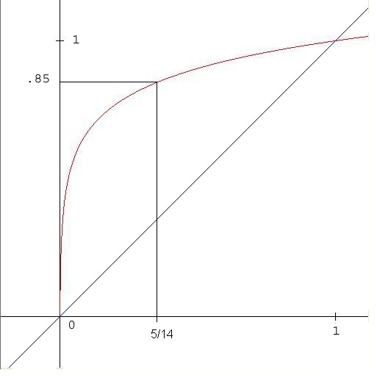
Figure 7: Logarithmic curve of dissimilarity measure. If we have 2 strings of length 14 with 5 differences, we take the 5/14th position on the x axis and find the corresponding y value, .85.

The equation for the new logarithmic measure is given below,

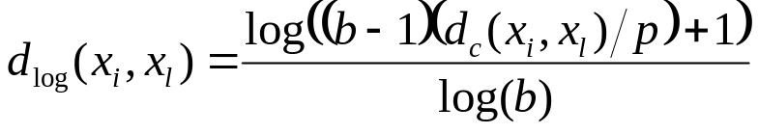
Equation 3: New dissimilarity measure

where p is the string length and b is a log factor that determines how steep the log curve is. We used a b of one thousand in our experiments. We figured anything less and the previous curve would be to linear. The results of the logarithmic measure are explained later in the results section.

      - Fuzzy k-Modes Continued

Now with the dissimilarity measure explained, the fuzzy k-modes in its simplicity consists of minimizing the following objective function,

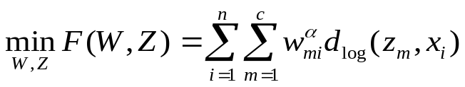
Equation 4: Fuzzy k-modes equation

where c is the number of clusters, and n is the number of data samples, or the number of strings, W is the membership matrix, Z is the centroid matrix, alpha is a fuzzifying factor, z is a centroid from Z, and x is a string from X, and d_{log} is the dissimilarity measure. The above equation (8) must follow the following constraints,

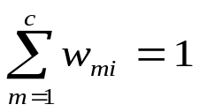
Equation 5: Fuzzy k-modes constraints

The membership matrix W consists of the membership of each string to each cluster. It is a c by n matrix. The centroid matrix Z is all the centroids. It is a c by p matrix, where p is the string length.
The string length is always constant for the fuzzy k-modes algorithm, which could be seen as a drawback. We have looked at other dissimilarity measures that can compare variable length strings.
The fuzzy k modes algorithm consists of using the above equations in the following steps, which will minimize the equation four. The algorithm consists of the following parts. Updating the memberships based on the centroids; and updating the centroids based on the memberships. This is the best solution for the unsolved problem of solving a system of non-linear equations, which is what equation four is. The steps are as follows.

Step one: Initialize parameters alpha and number of clusters. Seed the Centroid Matrix.
Step two: Determine W based on Z.
Step three: Determine Z¹ based on W. If F(W,Z¹) = F(W,Z) stop.
Step four: Determine W¹ based on Z¹. If F(W¹,Z¹) = F(W,Z¹) stop, otherwise set W = W¹ and Z = Z¹ and go to step three.

      - Fuzzy k-Modes Step One: Initialization

We initialize the number of clusters, alpha, and seed the centroid matrix Z in the first step. The original algorithm randomly seeded Z. This gave widely varied results, because the algorithm is very sensitive to initialization. We found a simpler way to seed Z that minimized the number of iterations through the algorithm and gave consistent results. This method minimized the algorithm’s sensitivity. We call it smart seeding of Z.
The smart seeding consists of choosing the most common symbols for each attribute or position in the strings, and assigning them to the centroids. If system call five appears the most in the first position in the strings then the first centroid's first symbol will be five. The second centroid consists of the second most common appearing symbols for each attribute. This way we seed the centroid matrix that results in the minimal amount of iterations through the algorithm. This is a quick fix to get around the sensitivity of the algorithm to initialization.
Note that this is a naïve method to seed Z, and a more robust algorithm was recently found after the literature review phase. In this more robust algorithm, an entropy based clustering scheme finds the best centroids used to initialize the fuzzy k-modes algorithm. We feel that since this is a published result it is the best way to initialize Z. Yet there are still some problems with this method. The number of clusters is depended on a beta parameter which is not known a priori.
We do not know whether a smart seeding of the centroid matrix guides the algorithm into a local maximum. Is the fuzzy k-modes algorithm sensitive to the smart seeding? We still have to determine that.
The second part to step one initializes the parameters alpha and the number of clusters. We find that in overall detection signal the algorithm is more sensitive to the parameter alpha, than the number of clusters. The number of clusters can very slightly without greatly affecting the intrusion signal, whereas alpha can only vary slightly. We choose arbitrary values for alpha and the number of clusters for each particular run of fuzzy k-modes, using some criteria in the end to choose the run with the best alpha and number of clusters.

      - Fuzzy k-Modes Step Two: Determine the Memberships Based on the Centroids

In the second step we let the centroids be fixed and then we find the memberships with the following equation,

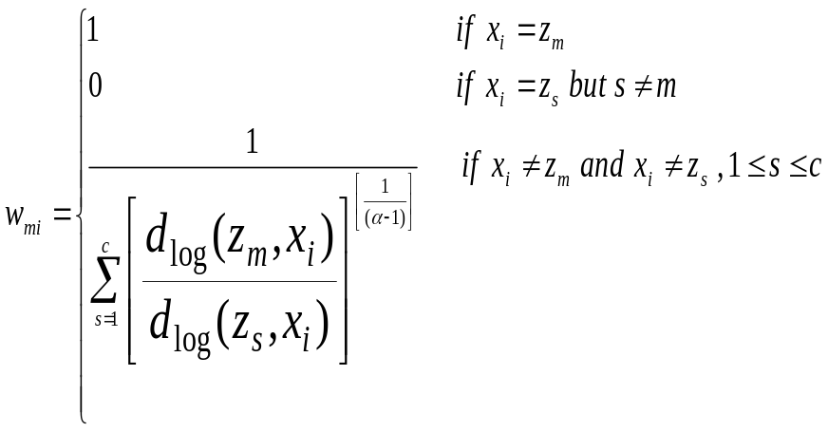
Equation 6: Updating the membership matrix

Where (1 ≤ i ≤ c , 1 ≤ k ≤ n)
For example, if a data string is equal to the current centroid we give it a membership value of one to that centroid. If the data string is equal to some centroid, but not the current centroid we give it a membership value of zero to that centroid. If the data string is not equal to any centroid we give it a membership value according to the equation given above.

      - Fuzzy k-Modes Step Three: Determine the Centroids Based on the Memberships

In the third step we let the membership matrix W be fixed then we find the centroid matrix Z with the k modes update method. We use the following equation to update z_{ij}, a member of Z.

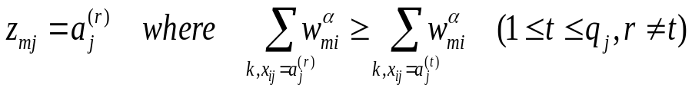
Equation 7: Updating the centroid matrix

What we are doing here is taking the sum of all the memberships of all the strings that have a certain system call in a certain position in the strings to a certain centroid. Then the system call that produces that greatest summation for that centroid’s position is picked for that position in the centroid.
After we determine the new centroid matrix based on the membership matrix we calculate F (equation 4) with the new centroids and memberships and compare it to F with the old centroids and memberships. If the equations are equal, we stop and we have our memberships and centroids. If not we continue to step four.

        - Reduced Time Complexity in Step Three

It should be noted that we reduced the time complexity of step three from O(cMn) to O(cpn), where n is the number of strings, c is the number of clusters, p is the string length and M is,

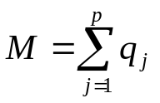
Equation 8: Time complexity of M

The old algorithm consisted of several iteration loops that run through all cluster centers, all data samples, all string length positions, and all categories in each string position. We created a new algorithm that just runs through, in fewer iterative loops; all cluster centers, all data samples, and all string length positions. We are not running through all categories in each string position. Hence, we reduced the time complexity from O(cpsn) to O(cpn) where s is the number of system calls, if each attribute has an equal number of categories.
We do this by running through the data matrix X to update an accumulation matrix that keeps track of the equation (7). The accumulation matrix is a c x p matrix of hash tables. Each hash position in the accumulation matrix updates the summation of membership value information. In this way, we do not have to run through the categories, or system calls. Then the accumulation matrix is sorted and we pick the highest value for each position in the centroids. The following algorithm in PERL illustrates this concept.

sub determine_centroids {
my @memberships = @_;
my @new_centroids;
my @accum;
foreach my $cluster_index (0..$num_of_clusters-1){
my $string_number = 0;
foreach my $string (@strings){
my $string_position = 0;
foreach my $syscall (@{$string}){
$accum[$cluster_index][$string_position]{$syscall}
+=$memberships[$cluster_index][$string_number]**$alpha;
$string_position++;
}
$string_number++;
}
}
foreach my $accum_for_cluster (@accum){
my @centroid;
foreach my $accum_for_string_pos (@{$accum_for_cluster}){
my @keys = sort { $$accum_for_string_pos{$b} <=> $$accum_for_string_pos{$a}
} keys %{$accum_for_string_pos};
push(@centroid,$keys[0]);
}
push(@new_centroids, \@centroid);
}
return @new_centroids;
}

      - Fuzzy k-Modes Step Four: Determine the New Memberships Based on the New Centroids

This is the same procedure as in step two, determining the memberships based on the centroids, except we use the new centroids to determine the new memberships. After we are done updating the new memberships, we compare F (equation 4) with the new membership matrix and the new centroids to F with the old memberships and new centroids. If they are equal, we stop and we have our centroids and memberships. If not, we set W = W¹ and Z = Z¹ and continue to step three.
Hence, we have our fuzzy-k-modes algorithm, which gives us our centroids and memberships. We continue with our algorithm to build the process-data model.
    - Building the Fuzzy k-Modes Process-Data Model

We use the fuzzy k-modes algorithm to train on normal data, building a process-data model. This involves running the fuzzy k-modes algorithm several times to obtain our model. It consists of the following three steps:

- Fix the number of clusters then run fuzzy k-modes several times and choose the run with the optimal alpha
- Fix that alpha then run fuzzy k-modes several times and choose the run with the optimal number of clusters
- Take the memberships and centroids found with the best alpha and best number of clusters and use those for comparison with new process-data.

First, we find an optimal value for alpha. Alpha is a very tricky parameter that has a tight range of one hundredth of a unit. If alpha is too high, we get all memberships that are close to one. If alpha is too low, we get memberships that clump near 1/k and one, where k is the number of clusters. It is important to choose the proper alpha.
In the second step, we run the fuzzy k modes algorithm for different number of clusters that range from two to some predefined value, such as the square root of the number of training strings. Fortunately, we do not have to run the algorithm for that many number of clusters since around 25 to 30 clusters we get repeated centroids. Repeated centroids indicate that we have too many clusters. We try not to have repeated centroids since it will throw off the membership values. Once we have the data for different number of clusters, we use an evaluation method to choose some optimal number of clusters.
In the third step we set aside the centroids and memberships to the centroids for comparison against new process-data. Since this step is self-explanatory, we do not elaborate on it. Now we will describe these three steps in further detail.

      - Building the Process-Data Model Step One - Find the Optimal Alpha

This first step determines the optimal alpha that is used in our final data model. Alpha is the fuzzifying factor in the algorithm. It fuzzifies how much each string belongs to the clusters. Low values mean the strings belong more to one single centroid. High values mean the string belongs to more centroids.
We ran the fuzzy-k-modes algorithm for different values of alpha in order to find the optimal alpha and picked the one that gives the best uniform distribution of memberships. Previous research has shown the optimal value for alpha is between one and two. A value of one reverts the algorithm to a hard k-modes algorithm. We ran fuzzy k modes for values of alpha from 1.01 to 1.20 in increments of .01. Later, we increase the upper limit to 1.30 as some of the data indicates that the optimal values of alpha might be higher. When we later changed our dissimilarity measure to a logarithmic measure, uniform memberships tended to appear with lower values of alphas. Hence, we focused on alpha that ranged between 1.005 and 1.10. This is because the logarithmic measure tends to shift the histogram of memberships more to the left, there by decreasing each membership. What we have found is that a value too low for alpha creates memberships that are all one, and a value too high for alpha creates memberships that cluster around 1/k where k is the number of clusters. Our assumption is that we want data with a uniform distribution of memberships.
Hence, we needed a way to test for the uniformity of memberships. We chose the Chi-Square Index with the number of classes set to 20, or k = 20. We give the equation below,

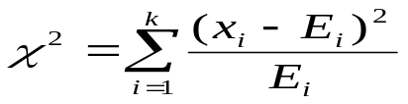
Equation 9: Chi-Square Index

where k is the number of classes, x is the number of data samples for a class, and E is the expected number of data samples for a class. E equals the total number of samples divided by the number of classes.
Unfortunately, we had to create a new index to test for data uniformity, due to an anomaly in the data that we will explain later. If we build a histogram of the distribution of memberships by listing the total number of memberships in each class we find two types of distributions. The chi-square index favors the first distribution, which we do not want to pick. The first distribution has a histogram where there are two spikes in the data and the rest of the ranges were very low. The second correct distribution has one class with a high spike and the rest of the ranges have higher values than the non-spiked classes of the first distribution. The following diagram illustrates the distributions. Each distribution has one thousand data samples spread over 12 classes.

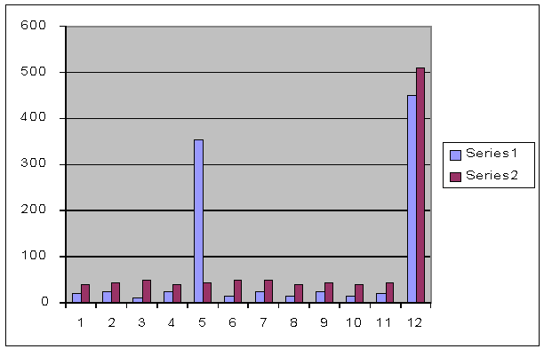
Figure 8: Histogram of two data sets. There are 1000 elements per data set distributed over 12 classes.

The chi-square index favored the distribution with the two spikes because a majority of the data was distributed more uniformly between the two spikes. The rest of the distributions for the other classes are all rather low, lower than the uniform distribution of the non-spiked classes in the second distribution. If you ignore the spikes, you see that we should favor the second distribution. Yet the chi square index favors the first distribution. Therefore, we had to make an adjustment.
In order to combat the anomaly between the two distributions we created the following chi-square adjustment factor. It takes the summation of the log base expected of the number of data points in that class of all classes divided by the number of classes. The final value should range between zero and one. Future research will show the proof for this. The equation is as follows:

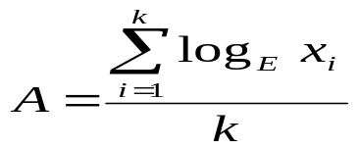
Equation 10: New uniform distribution measure

We try to maximize A. We then take the adjustment factor A and divide into the chi square index. We then get the following adjusted chi square equation.

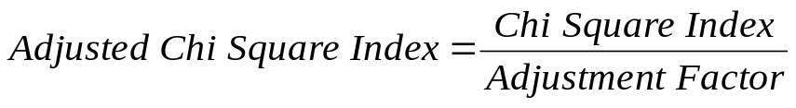
Equation 11: Adjusted Chi-Square Index

We try to minimize equation 11.
With this index, we can measure the memberships to get a proper alpha value. In other words, we pick alpha that gives the minimal chi square adjusted index.
We ran the fuzzy k modes algorithm for several values of alpha and chose the proper alpha according to the chi-square adjusted index. Unfortunately, you also need to initialize the fuzzy k-modes with an optimal number of clusters to find the optimal alpha. We do not know the optimal number of clusters. What should we use for the initial number of clusters when we try to find the optimal alpha? The following figure should answer this question. It shows the optimal alpha value for several cluster values. Again, the optimal alpha value is the one that gives the lowest adjusted chi square index. Here we see that if we choose the number of clusters to around 10 or 15 we are finding a stable value of alpha. For the following figure, we ran the fuzzy-k-modes algorithm for different values of alpha on a prototype data set for various numbers of clusters. The graph only shows the optimal alpha for each cluster value.

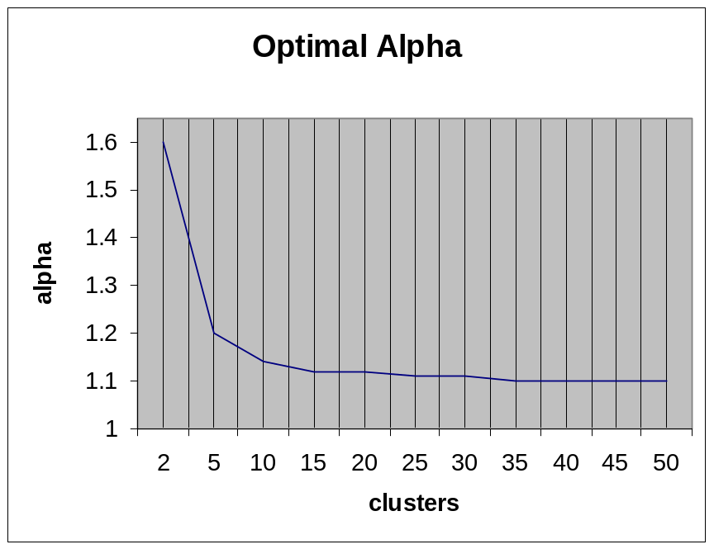
Figure 9: Alpha stabilizes around 15 numbers of clusters

With this data, we see alpha levels out around cluster number 10 with a stable value around 15. Hence, in order to choose the proper alpha we ran fuzzy k modes with the number of clusters set at fifteen.
How do we know if there is a correlation between the intrusion signal and the chi-square adjusted index? The next graph shown is typical of the data seen and it varies alpha with the number of clusters fixed. We show the adjusted chi square index for comparison.

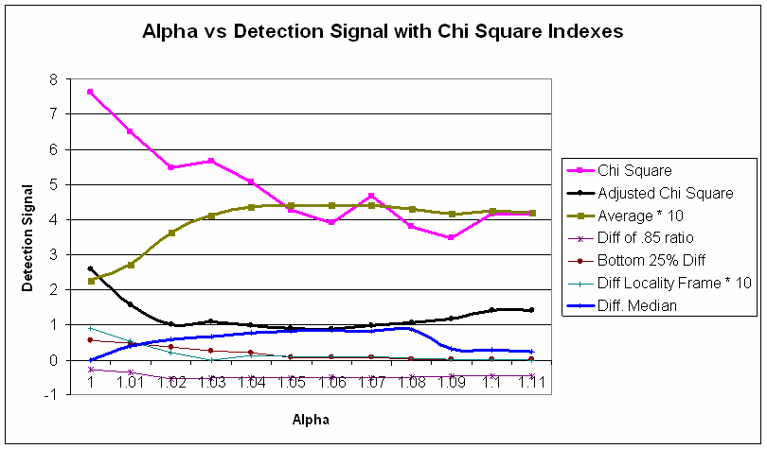
Figure 10: Effect of uniform distribution of memberships on intrusion signal

We see a correlation between the adjusted chi square index and the average difference of memberships. We also see a correlation with the difference of medians. For example the difference of the averages and the medians look like upside Us. The adjusted chi-square index looks like a right side up U. If you take the minimum value on the right side up U you find the maximum values on the upside down Us. This supports our assumption that we should look for the most uniform distributions of memberships which will correspond to the highest intrusion signal. It should be noted that at 1.05, we start to get repeated centroids and hence the curves start to level out. The regular chi square index keeps going and gives a minimum around 1.09. From this curve, we would choose the highest alpha where we do not get repeated centroids, 1.04.
Now we have chosen our optimal alpha value. With this value, we continue to step two to choose the optimal number of clusters.

      - Building the Process-Data Model Step Two: Find the Optimal Number of Clusters

To find the optimal number of clusters we used a brute force method. Future work could use a more sophisticated method that uses information and entropy theory. A method has been found at the time of this writing that uses an entropy based clustering scheme to initialize the fuzzy k-modes algorithm, yet it appears to have some problems. In the mean time, we ran the fuzzy k modes algorithm for different values of c (number of clusters) and chose the one with the best validity index.
Validity indexes show how well a clustering method works. It is used to compare different clustering methods, and in our case, the optimal number of clusters. We chose three different indexes to look at, Bezdek's partition entropy index, Kim's validity index, and Kwon's validity index. We will discuss briefly a little about each.

        - Kim’s Validity Index

First, we will discuss Kim’s Validity index. Unfortunately, this index did not work with our data. This could be due to an error in our implementation or due to the fact that we tried to use it with categorical data. Either way it produced a curve that approaches zero as the number of clusters approaches n. The following figure illustrates this concept.

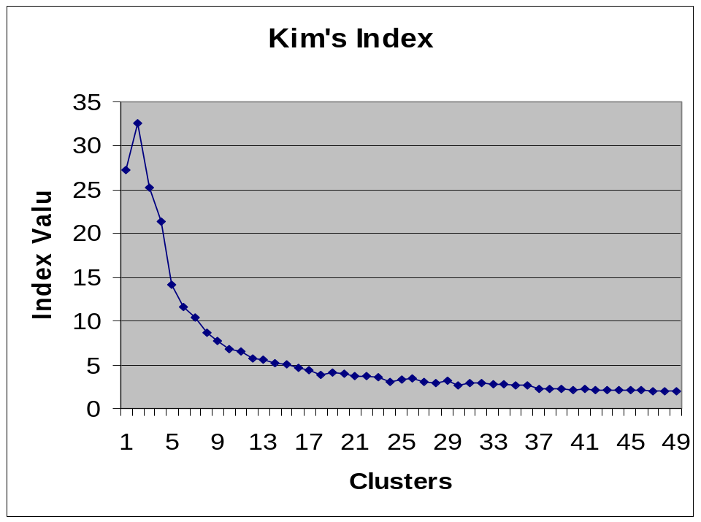
Figure 11: Kim's Index monotonically decreases of the number of clusters approaches n.

There was no overall global maximum with this curve. Could we take the point of maximum curvature of Kim's index? This appears to pick a low number of clusters. A low number of clusters, we believe, will greatly reduce the effectiveness of detecting intrusions. We did not use Kim’s validity index because of its tendency of monotonically decreasing with the number of clusters. The equations for Kim’s Validity index are given in Appendix A.

        - Kwon’s Validity Index

The next index we decided to test is Kwon’s validity index. It has a punishment factor to combat the effect of the curve approaching zero as the number of clusters approaches n. Yet because of the punishment factor, we believe, it gave an optimal number of clusters that are too high. Some numbers of clusters that Kwon’s index picked have repeated centroids. Additionally we found no correlation between this index and the optimal number of clusters, the values either were too low or too high and gave repeated centroids for the optimal number of clusters. There was no pattern in the data. Kwon’s validity index mostly decreased as the number of clusters increased. This may be due to our conversion of the index to categorical data. In the future, we suggest that you use the method proposed in [29].
The following is Kwon’s validity index equation,

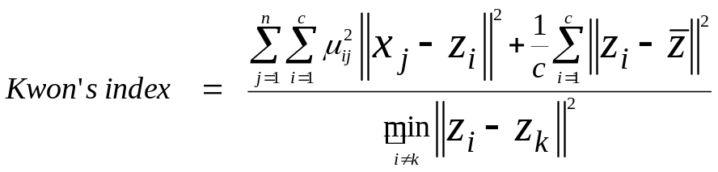
Equation 12: Kown's Published Validity Index

Where μ is a membership, x is a data point, z is a centroid, and z mean is the center of the centroids.
We converted this index to categorical data using the following equation,

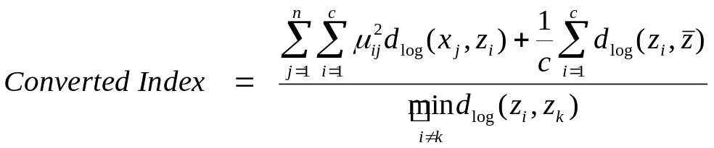
Equation 13: Our Converted Kwon's Validity Index

where z mean is the first centroid from the smart initialize centroids. In hindsight, this index may have worked better if we chose a z mean where we set the fuzzy k-modes algorithm to one cluster.
We feel this index did not give us any more information about the data set due to its tendency to decrease when the number of clusters increases. There was no overall global maximum. The following figure illustrates this concept.

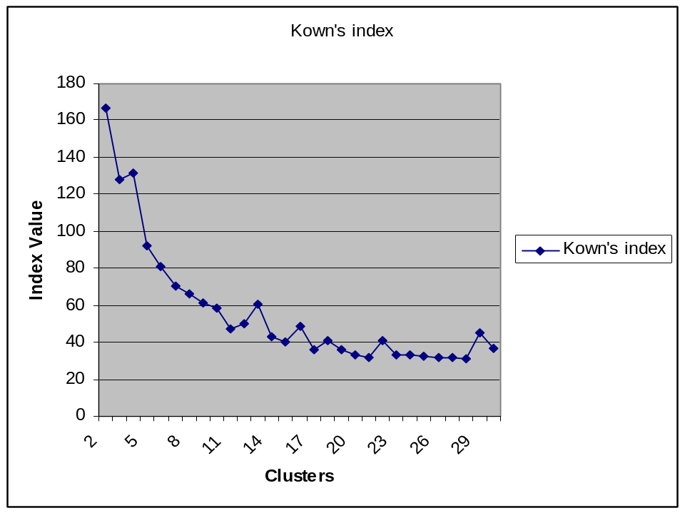
Figure 12: Kwon's Index semi-monotonically decreases as the number of clusters approaches n.

Occasionally Kwon’s index did choose 18 as the optimal number of clusters. Yet, do to the random nature of either choosing this value or semi-monotonically decreasing; we did not use this index.

        - Bezdek’s Partition Entropy Index

The last index we used was the older Bezdek's partition entropy index. It gave results that we intuitively feel is somewhat correct, although sometimes the results were varied, and the overall minimum gave us cluster values that had repeated centroids. At one point, we took the average of Kwon and Bezdek’s indices to find the optimal number of clusters. Yet we believe this is over-fitting. One of the tendencies we did find is the optimal number of clusters to center around 15 to 18. Any more and we get repeated centroids, any less and we lose the detection signal.
The following is the equation for Bezdek’s partition entropy index: It relies on membership information alone.

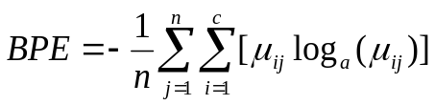
Equation 14: Bezdek's Partition Entropy Validity Index

where n is the number of data samples, c is the number of clusters, and μ is the membership of a string to a given centroid. We chose a to be the number of system calls. As long as a is kept constant between the number of clusters, Bezdek’s index will be proportional across all clusters.
We believe the proper choice of the number of clusters is not as import as the proper choice of alpha. We believe one could do fine with 16, 17, 19, or 20 as the number of clusters, while a slight variation in alpha will produce wild memberships. The following graph shows the detection signal across various numbers of clusters. Alpha is kept as a constant. It shows that any value near 18 will produce similar intrusion signals.

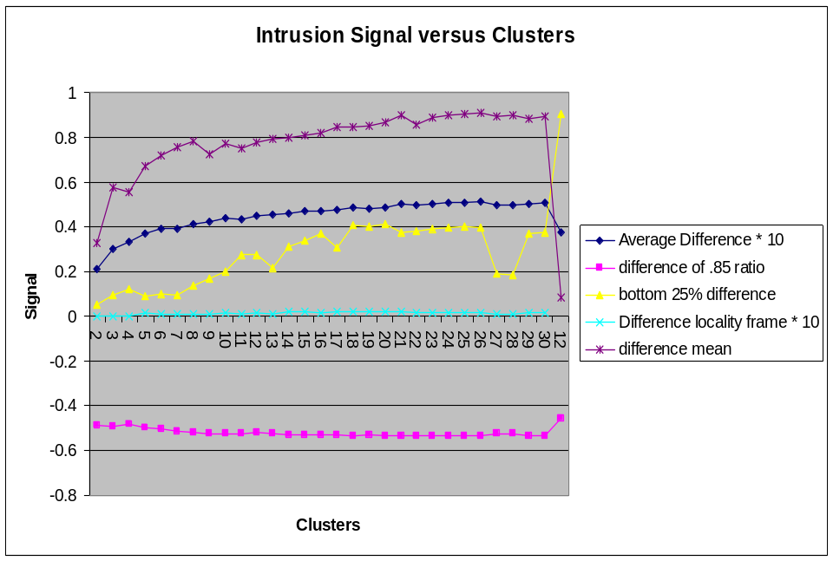
Figure 13: Intrusion signal versus number of clusters

For comparison, we will show the Bezdek and Kwon’s indices.

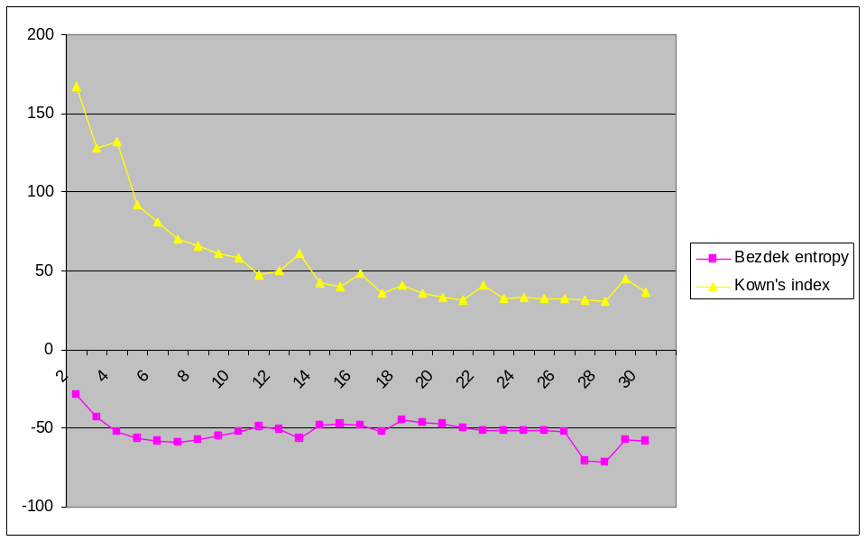
Figure 14: Bezdek's and Kown's Validity Index versus number of clusters

We notice that it is not as important to pick the most optimal number of clusters as long as we are in the general area. We could choose any value around 14 to 18 and still get the same intrusion signal. In the graph of Bezdek’s entropy, we see that the Bezdek index picks 18 as the optimal number of clusters, ignoring the left tail end of the curve. On the signal graph, we see the curves start to level out around 18. We start to see repeated centroids at around cluster number 21. This supports our assumption that we should pick the number of clusters just before we start to see repeated centroids. One interested feature to note is the dip in Bezdek’s index and the bottom 25% difference at cluster number 27.

        - New Step: Using an Entropy Clustering Scheme

We found that the adjusted chi square index gave minimal values that had repeated centroids, especially after moving to the logarithmic dissimilarity measure. Additionally the Bezdek partition entropy index also gave values that had repeated centroids. In these cases, we took the highest values that did not give repeated centroids. From the figures above, the detection signal starts to level out when repeated centroids start to occur. Taking the point just before seeing repeated centroids minimizes the computational effort and maximizes the detection signal. Yet, we did not feel comfortable with this procedure since it is still sensitive to initialization. What value do we fix the number of clusters when we want to find alpha. Moreover, what value do we fix alpha when we want to find the optimal number of clusters. As a compromise, we noticed that 18 appeared quite often as the optimal number of clusters. It may be possible that this is a magic number; just as six is the optimal number of string length of system calls. Therefore, when we tried to find the optimal alpha we set the number of cluster to 18. We took this a step further and noticed that 18 was near the square root of the number of unique strings in the data. Hence, we fixed the number of clusters to the square root of the number of unique strings in the data and tried to find the highest alpha that did not give repeated centroids.
Unfortunately, neither of these methods worked out in the end and the same problem of the fuzzy k-modes algorithm persisted, its sensitivity to initialization, and the a-prior knowledge of the number of clusters. We still believe the optimal alpha is the one that gives the most uniform distribution of memberships. Hence, we need a new method.
A new method has been found at the writing of this thesis. It involves an entropy based clustering scheme that finds the optimal number of clusters and helps with the initialization of the fuzzy k-modes algorithm. Future experimenting will be done with this method, as previous results are not positive with current methods. Details of the algorithm are given in Appendix B.
This algorithm finds c clusters and centroids for them, which can be used in step one of the fuzzy k-modes algorithm to further elaborate them. You still might have to use a brute force method to find the optimal alpha, yet we can fix the number of clusters in doing so. We feel the optimal alpha is the one that gives the most uniform distribution of memberships without giving repeated centroids. So far, we feel this is the best way to initialize the fuzzy k-modes algorithm as our current method of finding the optimal number of clusters does not work to well.
There is one problem with the entropy-based algorithm presented above. The number of clusters that the algorithm chooses is highly based on beta in step four. Since we do not know what to choose for beta, we are left with guessing. One can choose a beta that gives a certain number of clusters, say the square root of the number of unique strings, yet this is presuming that the underlying data is structured in that way. We do not know how the data is structured when we choose beta, hence this method of finding the optimal number of clusters is invalid, unless we have some type of a prior knowledge about what beta should be. Moreover, we do not.
Fortunately, the algorithm above comes with a validity index. It is not clear how this validity index is used in the three-step algorithm, since the first step should find the optimal number of clusters. We can use this validity index in addition to the Bezdek’s partition entropy index for determining the number of clusters. The details of Tsekouras’s Validity Index are given in Appendix C.
We can use this validity index in our determination of the optimal number of clusters, yet as before, we have to run different numbers of clusters and evaluate each. We also still need to find alpha.
Now, we are left with the same problem as before, how to find the optimal values for two non-linear parameters. In Tsekouras’s paper, they find the optimal number of clusters for various values of alpha, which they call m. Then they choose the number of clusters that appears in most of the values of alpha. We could use this brute force method and find the optimal number of clusters for various alphas, yet this is very clearly brute force and it appears random in just choosing a value that appears most often. Moreover, a simpler method must exist. We have to our advantage the knowledge that the optimal alpha should emit the most uniform distribution in memberships. With this knowledge, we can fix the number of clusters and find alpha, then fix alpha and find the optimal number of clusters. This method is sensitive to what we initially fix the number of clusters at to find alpha. Moreover, the number of clusters that are found in the second part is very sensitive to what we pick for alpha.
With this knowledge in hand, and with the behavior of previous data, we sometimes took a shortcut and guessed at values of alpha and the optimal number of clusters. If we guessed too high and got repeated centroids, we lowered the values. This is in part due to the time complexity of the algorithm, and the fact that it would take 16 to 24 hours to run for some of the larger data sets. If we used a pure brute force method such as in Tsekouras’s paper, the amount of hours would easily move up to 8,400 hours. That is just for one program at one string length. Of course, we could cut this down using our method of fixing the number of clusters, then fixing alpha. Yet our run time would be approximately 1,320 hours to find successfully the proper alpha and number of clusters, 20 different runs at 24 hours each to find the optimal alpha, and 35 different runs at different number of clusters to find the optimal number of clusters. Of course this is overestimation since one could cut down on the number of runs, for example we don’t need to run the algorithm for clusters of 2 or 3 or probably 4, and I’m sure after 8 or 9 runs for finding alpha we would run into repeated centroids, also the algorithm runs faster for lower number of clusters. So, if we conservatory cut the time in half we still have over 600 hours of computing time for a program like sendmail. Therefore, you can see why we sometimes guessed at a certain alpha and number of clusters. Obviously, there is still a lot of research to be done in this area.

  - Step 4: Comparing Real Process-Data with the Process-Data Model

We build an intrusion signal using the memberships and centroids from the process-data model along with the memberships of the new data strings. New data strings’ memberships are found to the centroids from the old data or training data using step 2 of the fuzzy k-modes algorithm, fixing the centroids then updating the memberships. We take the distance to the nearest cluster center as that string’s membership. Each string has a membership. We then compare the distances of the memberships of the old strings to the distances of the new strings’ memberships to obtain our intrusion signal.
The new strings should have a greater distance away from the centroids than the training strings, if the new strings are abnormal or intrusive. We expect to see strings that are abnormal further away from the centroids. Hence, their memberships will be lower. Conversely, we expect the distances of the new process-data to be closer to the trained centroids if the tested data exhibits mostly normal behavior. The next figure illustrates this example. The centroids found from the training strings are marked as T. We do not include the strings from the training data. We show two sets of new process-data. The ones marked N are closer to the centroids. The one’s marked A are further away from the centroids. You can see this by the lengths of the lines drawn from each data point to the nearest centroid. You will find on average longer lines for the A data. Hence, the N’s are classified as normal and the A’s are classified as abnormal.

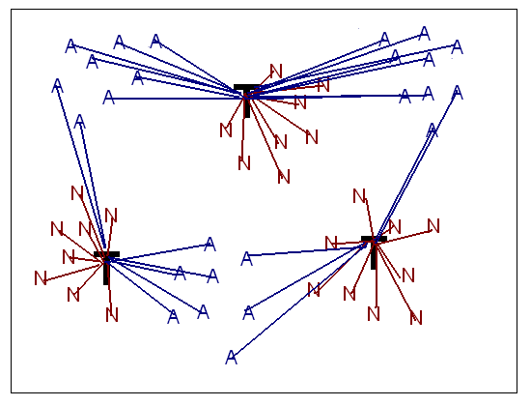
Figure 15: Two new process-data classes A and N. Ts are the centroids from the training data. Ns are normal data strings. As are abnormal data strings.

The following is our comparison algorithm.
- Find the distances of the training strings to the centroids found from the process-data model
- Find the distances of the new strings to the same centroids
- Take the differences of the distances

We first find the distances of the memberships for the normal or training strings. We take the following distances, the average membership, the median membership, the average membership of the bottom 25% of memberships, the ratio of strings below .85 to all strings, and the average minimum membership across 10 consecutive strings, called a locality frame.
These distances have logical sense behind them. An intruded program only has part of its code infected. Hence, we should find only some of the strings infected. Ideally, we want to look at the strings that are the most abnormal. In some of the cases, we want to ignore all the strings that are most normal and examine only the most abnormal strings. Therefore, we just look at the bottom 25% of memberships. We examine the median difference in memberships to get a better feel for how the data is distributed. Other times we look at the ratio of strings below .85 to all strings. By taking a ratio, we are modeling our detection signal after the stide program, which looks at a ratio of strings that have a membership of non-one to all strings. In the stide program, if any string does not match in the database it has an equivalent membership in our program of non-one. Finally, we examine the lowest average membership of 10 consecutive strings. This is to model the locality frame count in the stide program. We felt that an intrusion would group together in part of the code. Hence, intrusion strings would find a grouping of low memberships across a group of consecutive strings.
Next, we find the memberships for the new strings. These new strings will be classified as either normal or abnormal. We then find the memberships of the new strings using the centroids from the training data. Memberships are calculated to the centroids using step 2 of the fuzzy k-modes algorithm, fixing the centroids then updating the memberships. This calculates the memberships of a string to all centroids. The given membership for a new string will be the distance to the nearest centroid. Future research might want to consider all membership values. Again, we find the following distances of the new string’s memberships, the average, the median, the average of the bottom 25%, the ratio of strings below .85 to all strings, and the locality frame.
Now we take the differences of the distances. We subtract the distances of the new strings from the distances of the training strings to obtain our intrusion signal. The differences will range from negative one to one. In some programs a positive value was obtained, in other programs we obtained negative values. A value near zero means the training strings and the new strings are equidistant away from the centroids. A negative value means that the new process-data was closer to the centroids than the training data. In order to compare against stide we normalized our intrusion signal from negative one to one, to zero to one. In this way, .5 indicates normal behavior in fuzzy k-modes, while zero indicates normal behavior in stide.

  - Step 5: Detecting Attacks

Now that we have an intrusion signal, we need to detect the intrusion. This requires us to make some hard decisions. We need to put concrete limits on our intrusion index to determine what abnormal behavior is, or what normal behavior is. We need to pick boundaries on our intrusion signals.
It is hard to say or give a definite value in determining what an intrusion versus what is not is. It greatly varies across programs. So far, we have said a signal that is one and a half times the signal of a self-test is a good indication of an intrusion. Hence, a signal that is less than one and a half times the value of a self-test is a good indication of a false negative. Before we calculated one and a half times the maximum self test we subtract .5 from the signal, times the remainder by one and a half, then added back .5. In this way we get a signal that is showing the true difference between training data and the new strings. When self-tests are not available a good rule of thumb is values above point seven is highly intrusive, while values between .5 and .7 are possible intrusions. Results for each process are reported in the results section.

    - False Positives

We also tested the data for false positives. We took and trained the process model on 50% of the normal data and then compare it with the other 50% of the data. We did this twice for each different part of the training data. Some of the data contains only three processes, which makes it difficult to split up. So, we do not test for false positives for data such as the live inetd program which contains very little data.
We should expect a low false positive rate. Because the way false positives were reported in the previous research, we might not get to compare directly the results against each other. They reported deviations from normal behavior per system call recorded. We will report per process or per program monitored. Yet we can compare our results to the stide program. Results of false positives are contained in the results section.

- The Data Set

We used a well-known data set for our experiments. The well-known data set consisted of collections of traces of system calls from monitored processes along with well-known traces from intrusion attempts. The data set was collected at the University of New Mexico and the Massachusetts Institute of Technology. The time the data was collected ranges over a few minutes to several weeks depending on the program.
The data set consists of a process id and a system call number. Child processes were followed unless the program executed a vfork and then an exec. In other words, child processes were followed unless the program spawned a new program. The amount of system calls collected varies in each program. They may range from a few hundred to several million.
The collected data from each program is divided into two types, normal traces, and abnormal traces. Some abnormal traces might not be intrusions but error conditions or unsuccessful intrusions. This is important as a critical error condition or unsuccessful hacking attempt might still want to call attention to the system administrator.
The types of programs fall under one of two types, live and synthetic. Synthetic traces are created in an artificial environment from a test script that tries to run through all possible parts of the program. We obtain a varied collection of traces that include most types of normal behavior in this way. Live data contain traces taken from a real world-working environment. It should include all types of behavior that is encountered during normal use.
Synthetic data is not tested against itself for false positives. The results would be meaningless if we did, since synthetic data contains all range of data only once. Therefore, if we tested a part of itself against the other parts of itself it would always indicate an intrusion, since by its nature it would be different. Hence, we only tested live data for false positives.
We tested the fuzzy k-modes algorithm against the following four programs: live inetd, live login, live PS, and synthetic LPR. Inetd listens to network requests for services; login signs a user onto a system; ps reports process status; and LPR submits print requests. We chose these data sets because they are the smallest. We were having trouble with the space complexity of some of the data sets, because we ran out of virtual memory on the machines we were running them on. We later converted our data structures to disk instead of keeping them in virtual memory, and had success. We will now explain each program in detail.
The live inetd program was collected on a UNM computer that ran a modified Linux 2.0.35 kernel, which assisted in the collection of system call traces. The inetd program usually begins as a foreground process, which spawns a daemon process that runs in the background. The daemon process initiates children process that performs some tasks before executing some other type of program. Most child processes are identical. The normal data collected contains one trace of the startup process, a daemon process, and a representative child process. The intrusion that ran against the inetd program is a type of denial-of-service attack that ties up network resources. We see more of the system call requesting resources return abnormally and are re-issued as the program progresses into the attack. The intrusion data also contains a startup process, and a daemon process, yet contains several child process. Only the daemon process is expected to show any deviation from normal behavior.
Data for the live login and ps was collected on a single machine, which was also modified to collect easily system call traces. The version of the Linux kernel was 2.0.35.
The intrusion tested against these programs uses an older Linux root kit, which creates a “back door” to allow intruders in and hide their activities. The intrusions tested will vary greatly from the newer versions of login and ps ran because the root kit is fairly old. Therefore, a new intrusion was created that uses newer code. This version of the attack is called “homegrown.” Hence, there are two versions of the attack, homegrown and recovered. Login and ps contain 24 traces each. Yet, half of the login traces contain a single system call. They are not very useful, but are included for completeness. A number of intrusion traces have been collected from each of the versions of the Trojan code, homegrown and recovered. Some of the intrusions use the back door while others just contain normal users logging in. Ideally, we would like to detect the presence of such code right away, whether or not it is being used in an intrusion.
Data for Synthetic LPR was collected at UNM on a Sun SPARCstation running an un-patched SunOS version 4.14. The strace program collected the data. We tested the lprcp intrusion. The lprcp attack uses lpr to replace an arbitrary file with different contents. Older versions of lpr use only 1000 different names for printer queue files. The attack is based on this fact. Because old queue files are not removed before re-using them, the attack creates a 1001 name. The first trace of the attack places a symbolic link to the victim file in the queue. The middle trace attacks advance the lpr’s counter. The last trace overwrites the victim’s file with the attacker’s file. Note detection in any of the intrusion traces is a detection of the attack itself. Hence, we give results for the highest found intrusion signal for each trace.
There are several other programs collected with the UNM data, yet due to mainly space limitations, we did not test these.

- Results

We record our results for various intrusion traces in this section, in addition to self-tests. Moreover, we describe the various results found that improve our algorithms. We first start with the results we obtained from running the fuzzy k-modes algorithm for the various programs we tested. Next, we give our more theoretical results found from our research. This includes a new uniform measure, a new dissimilarity measure, and the reduction in the time complexity of the fuzzy k-modes algorithm, and the invalidity of trying to convert quantitative validity indices to qualitative validity indices.

  - Fuzzy k-Modes Results

As of the time of this writing, we have results for the live inetd, live login and ps, and synthetic LRP programs. The results contain the following intrusion signals: the difference in the average memberships, the difference in the mean, and the difference in the bottom 25% of memberships, the difference of the ratio of memberships below .85 to all memberships, and the difference in minimum locality frame.
We report our results along side the stide results. We list the locality frame and percentage of mismatches for the stide results. Stide is a basic lookup table method. Strings from the training data are put in the process-data model database. New strings are then looked up to see if they are in the database. If they are it is a match, if they are not it is a mismatch. The total number of mismatches is reported as the percentage mismatch. We convert the percentage to a decimal number between zero and one. The locality frame is the total number of mismatches in a window of 20 consecutive strings. It is a number that ranges between zero and twenty. We convert this number to range between zero and one.

    - Live Inetd

For the live inetd program, we obtained the following table.

Live inetd | Stide |  | Fuzzy k-Modes
String  Length | Locality  Frame | Mis-match | Median | Avg. | Bottom  25% | Locality  Frame | Ratio of .85
6 | 1.0000 | 0.5552 | 0.9234 | 0.7438 | 0.7048 | 0.5105 | 0.7672
10 | 1.0000 | 0.5829 | 0.9311 | 0.7429 | 0.6940 | 0.5161 | 0.7758
14 | 1.0000 | 0.6045 | 0.9164 | 0.7490 | 0.7254 | 0.5141 | 0.7848

Table 1: Live inetd - intrusion signals

We detect the intrusion successfully near the same level as stide. It is not fair to say that the maximum stide signal is .60 while the max fuzzy k-modes signal is .93. The fuzzy k-modes median signal is higher than the stide percentage of mismatch signal. On the other hand, the locality frame signal for fuzzy k-modes is somewhat lower. Fuzzy k-modes does not show any pattern associated with the intrusion signals and string lengths. It does show that we obtain maximum intrusion signals with string length of 10. On the other hand, stide shows a higher percentage of mismatches as the string length increases. This is an interesting observation. It is clear from the table that the fuzzy k-modes algorithm successfully detected the live inetd intrusion.
We did not test for false positives with the live inetd program, as we did not have enough data to conduct these tests. There are only about 500 system calls in the normal data.

    - Live Ps

Live ps was not as successful as inetd. The unsuccessfulness may be attributed to the fact that there are more attempts than just one. Additionally, not all the attacks use the available back door method. Although they just log in normally, they still use the code from the attack. Therefore, we want to detect all intrusion attempts, whether or not if they broke in. The following are the results from live ps for string length of 10,

Live ps | Stide |  | Fuzzy k-Modes
Trace  # | Locality  Frame | Mis-  Match | Median | Avg | Bottom  25% | Locality  Frame | Ratio of  .85
1 | 0.5000 | 0.0945 | 0.5008 | 0.5377 | 0.5686 | 0.5000 | 0.5579
2 | 0.5000 | 0.0903 | 0.5008 | 0.5328 | 0.5627 | 0.5000 | 0.5500
3 | 0.5000 | 0.0866 | 0.5008 | 0.5284 | 0.5581 | 0.5000 | 0.5427
4 | 0.5000 | 0.0831 | 0.5005 | 0.5244 | 0.5517 | 0.5000 | 0.5360
5 | 0.5000 | 0.0799 | 0.5002 | 0.5207 | 0.5467 | 0.5000 | 0.5298
6 | 0.5000 | 0.0308 | 0.5000 | 0.4788 | 0.4221 | 0.5000 | 0.4601
7 | 0.5000 | 0.0287 | 0.5000 | 0.4778 | 0.4197 | 0.5000 | 0.4583
8 | 0.5000 | 0.0301 | 0.5000 | 0.4705 | 0.3897 | 0.5000 | 0.4509
9 | 0.5000 | 0.0264 | 0.5000 | 0.4686 | 0.3825 | 0.5000 | 0.4482
10 | 0.5000 | 0.0642 | 0.5245 | 0.5640 | 0.5627 | 0.5000 | 0.6055
11 | 0.6500 | 0.0789 | 0.5268 | 0.5678 | 0.5687 | 0.5000 | 0.6097
12 | 0.7000 | 0.0924 | 0.5377 | 0.5703 | 0.5663 | 0.5000 | 0.6146
13 | 0.7000 | 0.0681 | 0.5000 | 0.5040 | 0.5171 | 0.5000 | 0.4989
14 | 0.7000 | 0.2150 | 0.6907 | 0.6153 | 0.6098 | 0.5000 | 0.6933
15 | 0.7000 | 0.0570 | 0.5000 | 0.5067 | 0.5175 | 0.5000 | 0.5086

Table 2: Live PS - Intrusion signal – Homegrown

Live ps | Stide |  | Fuzzy k-Modes
Trace  # | Locality  Frame | Mis-  match | Median | Avg. | Bottom  25% | Locality  Frame | Ratio of  .85
16 | 1.0000 | 0.1409 | 0.5008 | 0.5294 | 0.5495 | 0.5037 | 0.5500
17 | 1.0000 | 0.1346 | 0.5008 | 0.5248 | 0.5464 | 0.5037 | 0.5422
18 | 1.0000 | 0.1288 | 0.5005 | 0.5207 | 0.5394 | 0.5037 | 0.5350
19 | 1.0000 | 0.1235 | 0.5002 | 0.5169 | 0.5326 | 0.5037 | 0.5284
20 | 1.0000 | 0.1186 | 0.5001 | 0.5134 | 0.5256 | 0.5037 | 0.5224
21 | 1.0000 | 0.0569 | 0.5000 | 0.4742 | 0.4040 | 0.5037 | 0.4609
22 | 1.0000 | 0.0529 | 0.5000 | 0.4712 | 0.3921 | 0.5037 | 0.4536
23 | 1.0000 | 0.1191 | 0.5000 | 0.4982 | 0.4953 | 0.5037 | 0.4985
24 | 0.9500 | 0.2688 | 0.6879 | 0.6205 | 0.6133 | 0.5037 | 0.7035
25 | 1.0000 | 0.1004 | 0.5000 | 0.5025 | 0.5033 | 0.5037 | 0.5068
26 | 0.9500 | 0.1341 | 0.5455 | 0.5685 | 0.5636 | 0.5037 | 0.6157

Table 3: Live PS - Intrusion signal – Recovered

The values in red indicate a false negative. A value is a false negative if it is one and half times greater than the maximum signal in the self-test. The values in orange are also a false negative; yet because all the values are the same, this indicates some kind of signal, even though it is negative. We list and describe the self-test signals below. Looking at the graph above, we see fuzzy k-modes gives 10 false negatives. On the other hand, stide gives 17 false negatives. If we examine within homegrown intrusions and recovered intrusions we get a different picture. Homegrown attacks are harder to detect because the intrusion code is similar to the normal code. For homegrown intrusions, fuzzy k-modes gives 6 false negatives while stide gives 14 false negative. Stide detected only one homegrown intrusion. This makes fuzzy k-modes superior to stide. Note we start to see repeated values for the differences in the means and locality frame for fuzzy k-modes. This shows we are detecting some kind of signal, even if it is negative. The signal is very evident within homegrown processes and recovered processes, where the differences in locality frames are all the same within each. We see from the table above that the fuzzy k-modes algorithm is only partially successful at detecting the intrusion.
Let us now look at the self-tests for ps. We trained the fuzzy k-modes algorithm on one normal trace and tested the other normal trace. We then repeated the process in reverse, testing the other normal trace. We did not attempt to take 10 different 90% sections of the normal data, as the data was too small. We report our findings in the following table.

Live ps | Stide |  | Fuzzy k-Modes
Trace # | Locality  Frame | Mis-  match | Median | Avg. | Bottom  25% | Locality  Frame | Ratio of .85
1 | 0.5000 | 0.0094 | 0.5000 | 0.5012 | 0.4963 | 0.5000 | 0.4955
2 | 1.0000 | 0.0775 | 0.5000 | 0.5105 | 0.5143 | 0.5095 | 0.5177

Table 4: Live PS - self test signal

We notice that stide gives a false positive for the locality frame on trace 2. False positives are colored green. Fuzzy k-modes gives values around .5. At .5 the intrusion strings are equidistance from the training centroids as the training strings. This indicates normal behavior. All of the above tables for ps have been for string length 10.
We see different behavior for other string lengths of ps. We get one less false negative at string length 6 than at string length 10. On the other hand, we get all false negatives except two, if we increase the string length to 14. This result amazes us because it indicates some limit on string length for the fuzzy k-modes algorithm, while stide only improves, on the other hand, as string length increases. Theoretically, we could increase the stide string length until we get a length of the entire normal trace. Hence, we would have either a match or a mismatch. Therefore, we start to get over-fitting, if we increase stide string length beyond a certain point. Additionally, the theory of short sequences of system calls breaks down. Hence, stide also has an operational limit on string length. In conclusion, shorter string lengths improve the intrusion signal with fuzzy k-modes.

    - Live Login

We now shift our attention to the live login data. We find different results with live login. The following is a table for string length of 10.

Live  login | Stide |  | Fuzzy k-Modes
Trace  # | Locality  Frame | Mis-  match | Median | Avg. | Bottom  25% | Locality  Frame | Ratio of .85
Hm/1 | 0.0000 | 0.0000 | 0.5074 | 0.5008 | 0.5005 | 0.5000 | 0.5012
Hm/2 | 1.0000 | 0.1183 | 0.5611 | 0.5153 | 0.5026 | 0.4916 | 0.5162
Hm/3 | 0.0000 | 0.0000 | 0.5348 | 0.5039 | 0.5009 | 0.4885 | 0.5042
Hm/4 | 0.8000 | 0.0566 | 0.4601 | 0.4423 | 0.4696 | 0.4861 | 0.4153
Rc/5 | 1.0000 | 0.2095 | 0.4601 | 0.4586 | 0.4875 | 0.4998 | 0.4330
Rc/6 | 1.0000 | 0.2095 | 0.4601 | 0.4586 | 0.4875 | 0.4998 | 0.4330
Rc/7 | 1.0000 | 0.2386 | 0.4601 | 0.4662 | 0.4899 | 0.4998 | 0.4439
Rc/8 | 1.0000 | 0.1777 | 0.4601 | 0.4463 | 0.4844 | 0.4982 | 0.4151
Rc/9 | 1.0000 | 0.2386 | 0.4601 | 0.4662 | 0.4899 | 0.4998 | 0.4439

Table 5: Live Login - Intrusion signals

From this table, we see the Fuzzy k-modes algorithm does better with the harder to detect homegrown code, missing one out of the four, yet it fails to detect the easier recovered code, missing all of them. Fuzzy k-modes has failed in this respect. Yet, in other respects, it did detect two intrusions stide failed to detect. Again, we see repeated values in the signals. Some repeated values occur because the intrusion sequences are the same. This was found after careful examination of the data set. String lengths 6 and 14 give similar results, with about the same number of false negatives. The following table shows the self-test of live login for string length 10. Again, we trained one trace and tested the other, then reversed the process.

Live  login | Stide |  | Fuzzy k-Modes
Trace  # | Locality  Frame | Mis-  match | Median | Avg. | Bottom  25% | Locality  Frame | Ratio of  .85
1 | 0.4500 | 0.0031 | 0.5000 | 0.4999 | 0.4998 | 0.4971 | 0.5000
2 | 0.6500 | 0.0092 | 0.5020 | 0.5001 | 0.5002 | 0.5007 | 0.5000

Table 6: Live login - Self test signals

    - Synthetic LPR

Our final data set we present is that of synthetic LPR. The following table shows the results we collected.

Synth.  LPR | Stide |  | Fuzzy k-modes
String  Length | Locality  Frame | Mis-  match | Median | Avg. | Bottom  25% | Locality  Frame | Ratio  of .85
6 | 0.6500 | 0.0980 | 0.5995 | 0.5692 | 0.5453 | 0.5346 | 0.6046
10 | 1.0000 | 0.1625 | 0.7405 | 0.6024 | 0.5200 | 0.5155 | 0.6497
14 | 1.0000 | 0.2229 | 0.5136 | 0.5540 | 0.5968 | 0.5462 | 0.6001

Table 7: Synthetic LPR – Intrusion signals

We see several trends from these results. We see that 10 gives the highest intrusion signal with the exception of the differences in the bottom 25% and the minimum locality frame. While 14 for stide gives the highest intrusion level. If we look just at the differences in the bottom 25% and the locality fame, we see 14 gives the highest intrusion level for fuzzy k-modes. We are not quite sure which signal in fuzzy k-modes is the best to choose. It may be a combination of some. We do not have self-test data for synthetic LPR because the data set is rather small. For synthetic LPR we see that fuzzy k-modes does detect the intrusion, yet we would have to compare our results with self tests to determine if the true negatives are indeed true.
We have tested four different programs for fuzzy k-modes and have compared them against the stide program. In some cases fuzzy k-modes finds the intrusion such as in inetd, and in other cases it fails to find the intrusion as in live login. For live ps we see that fuzzy k-modes outperforms stide in terms of false negatives and false positives. We see similar results to stide for synthetic LPR. In the future, we need to test more data sets as we work out the time and space complexities.

  - Fuzzy k-Modes Results Overall

The following table shows our overall results for all the process that we tested against. In these results we see fuzzy k-modes performs better for the harder to detect homegrown code, yet fails on the easier to detect recovered code. We also list the highest signal obtained for each process in both stide and fuzzy k-modes. False negatives and positives are listed as the number out of the total number of processes.

 | Stide |  |  | Fuzzy k-Modes
Intrusions | False  Negatives | False  Positives | Highest  Signal | False  Negatives | False  Positives | Highest  Signal
Live inetd | 0/3 | - | 1.0 /  Locality | 0/3 | - | 0.9311 /  Median
Live ps –  homegrown | 14/15 | 1/2 | 0.7 /  Locality | 6/15 | 0/2 | 0.6933 /  Ratio of .85
Live ps –  recovered | 3/11 | 1/2 | 1.0 /  Locality | 4/11 | 0/2 | 0.7035 /  Ratio of .85
Live login –  homegrown | 2/4 | 0/2 | 1.0 /  Locality | 1/4 | 0/2 | 0.5611 /  Median
Live login –  recovered | 0/5 | 0/2 | - /  Locality | 5/5 | 0/2 | 0.4998 /  Locality
Synthetic LPR | 0/3 | - | 1.0 /  Locality | 0/3 | - | 0.7405 /  Median

Table 8: Total Results

  - A New Uniform Measure

We found a new measure to test for uniformity. This new measure handles spikes in the data better. We called this measure the Chi-Square Adjusted index.

  - A New Dissimilarity Measure

We also found a new dissimilarity measure that better represents the data set. The new logarithmic dissimilarity measure changes the behavior of the detection signal versus the number of clusters. Before the signal would initially rise to some maximum and then show random behavior after the maximum. With the new measure, the signal keeps rising until it reaches a point where repeated centroids start to occur. This is seen in a graph of detection signal versus number of clusters. The following graph illustrates the detection signal under the old linear measure. It plots the difference in average memberships for two different alphas. From this graph, we see the intrusion signal rise to a maximum then exhibits random behavior after that maximum. The data was taken from the live inetd program with string length set to six.

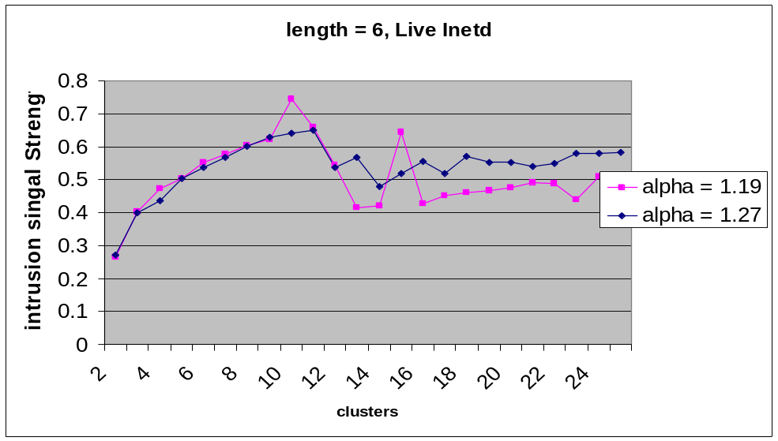
Figure 16: Intrusion signal with old linear dissimilarity measure

The next graph is from the same program and the same intrusion. It shows the behavior of the intrusion signal with the logarithmic measure. Instead of seeing a spike in the beginning, the graph continues to a point where it flattens out. The point where it flattens out is the point where the fuzzy k-modes algorithm starts to give repeated centroids. The fuzzy k-modes algorithm gives repeated centroids when there are too many clusters.

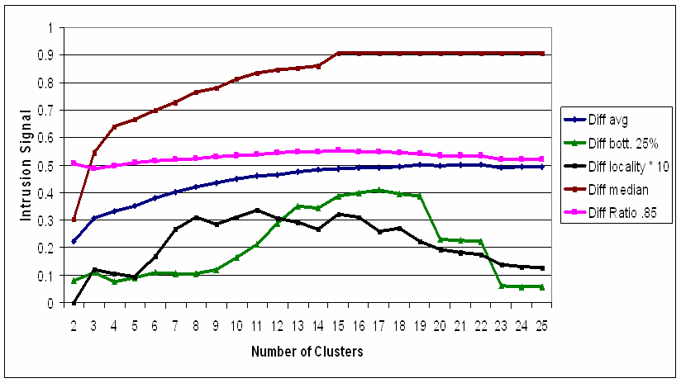
Figure 17: Intrusion signal with new logarithmic dissimilarity measure

From this figure, we note that the intrusion signals are more robust to the number of clusters. Particularly the difference in the median is the most robust. It does not fluctuate wildly as in the intrusion signals for the linear measure. With the logarithmic measure, we see more stable intrusion signals peaking right before we start to see repeated centroids. Note that repeated centroids occur in the figure above around 21 numbers of clusters. From the intrusion signal above we can see how the logarithmic measure provides more stable values, and we note that they peak around the optimal number of clusters that Bezdek’s partition entropy index gives, 18.
There is little difference in the maximum intrusion signal between a logarithm measure and a linear measure. The logarithmic measure gives intrusion signals that are slightly lower, yet this is expected, since the histogram of the distribution of memberships is slightly shifted to the left. Otherwise, we see almost exactly the same level of intrusion signal between the linear measure and the logarithmic measure.
From these two graphs, we find that the logarithmic measure works better. What is happening beneath the hood is the logarithm measure is displaying more less of the false information than the linear measure. Hence, we see better graphs when we use the logarithmic measure. More of the correct information is getting across. We believe the logarithmic measure gives a better feel for the true underlying representation of the data.

  - Reducing the Time Complexity of the Fuzzy k-Modes Algorithm

We have reduced the time complexity of the fuzzy k-modes algorithm from O(cMn) to O(cpn) where M is explained in equation (8), c is the number of clusters, n is the number of data samples, and p is the length of the strings. This should hold where the max q_{j}log(q_{j}) is greater than n, because the sorting part of the new algorithm has time complexity cpMAX(q_{j}log(q_{j})) for 1≤j≤p. This is an improvement where if all attributes had the same number of categories we would have, with the old algorithm, time complexity cpq_{j}n. Now we have time complexity cpn. The number of categories no longer plays a role in the time complexity.

  - Invalidity of Converting Quantitative Validity Indices

We have tried unsuccessfully to convert quantitative validity indices to qualitative validity indices. We looked at Kim and Kwon’s validity indices for quantitative data. We replaced their dissimilarity measure with the dissimilarity measure used for fuzzy k-modes. We found that the indices either monotonically or semi-monotonically decreased as the number of samples approached the number of data points. Hence, we conclude that these measures are not meant for conversion.

- Future Work

More work can continue off the previous research. Various topics come to mind. First, we need to account for the fact that the system is always changing. This is what we call the frog in the boiling pot syndrome. Next, work can continue on both the method that we use and the method the fuzzy k-modes algorithm use in solving a system of non-linear equations. Furthermore, we should examine system call timing, the time between system calls. Additionally, we can refine the sensitivity the fuzzy k-modes algorithm has to initialization such as the problem with the a-prior knowledge of the number of clusters. Finally, we can take our work one-step further and obtain fuzzy grammars by training neural networks on the training strings and their memberships.

  - Boiling Frog in the Pot Syndrome

The frog in the boiling pot syndrome is a very venerable psychology experiment. When you take a frog and put it immediately in a boiling pot, it will jump out. Yet, if you take the same frog, and put it in room temperature water and slowly turn the heat up, it will not jump out and die. This is because the frog cannot detect the small changes in water temperature. In much the opposite way, we want our intrusion detection system to detect the small changes in program behavior, yet not react to them. Only when there is major change in the system, will the classifier classify an anomaly.
Future work should focus on the more unstable programs such as those that run in user space. Building off our work, the researcher may want to create centroids that shift over time. Any major shift of the centroids would indicate an intrusion, while minor shifts are expected and indicative of normal behavior. It would be easy to shift the centroids as new strings are trained on the normal behavior. Part of the problem is to make sure the new strings that shift the centroids are not themselves abnormal strings. This presents more of a problem in a real-working environment.
Building a variable intrusion detection system does have it merits, especially in systems that change over time, and those that have many users. Monitoring programs in user space is probably the more difficult as those programs vary the most. Researchers will have to put hard limits on what types of variability are considered safe, while not compromising the effectiveness of the intrusion detection system.

  - Solving a Series of Non-Linear Equations

The solution for a system of non-linear equations currently is an unsolved problem in the field. Solving this problem would have far reaching affects not only in computer security but also through out many disciplines.
We have twice tried to solve a system of non-linear equations. The first is in the fuzzy k-modes algorithm, when we try to find the minimum value of F(Z,W). Many researchers have tried to avoid the local optima and find a more true global optima. A breakthrough in this area would help many researchers. The second time is when we try to find the optimal values for alpha and the number of clusters. A breakthrough in this area would help our efforts and increase detection accuracy.
It may not be for a while until we can solve this problem. In the mean time, we have the current solution of fixing one parameter and finding the optimal value for the other, then reverse the process. While this method is popular, it has been proven to get stuck in local optima. Until we find a solution, we are left with our current methods.

  - System Call Timing

Timing is another area of research that has not been look at previously. Timing is the information found between the system calls. Dr. Forrest has looked at research that tries to disrupt attacking code by delaying system calls. Yet no research has examined the information in timing to detect intrusions.
Various ways to examine timing could include the length between certain system calls or groups of system calls. You could also look at timing information between every second, third, or fourth system call. There are many ways to examine this problem. Timing information may essentially provide the extra information needed to accurately detect intrusions successfully, and reduce false positives.

  - Sensitivity of Fuzzy k-Modes

A current draw back of the fuzzy k-modes algorithm is its sensitivity to initialization, particularly what we choose for the initial centroids. One additional problem is the a-prior knowledge of the number of clusters. These two problems must be solved in order for the fuzzy k-modes algorithm to be effective. Previous attempts, such as TseKouras’s paper, have presented novel approaches to solve this problem, yet we feel, have fallen short. We have tried to look at validity indices to solve this problem and we feel these have promising results, yet they are very computationally intensive. You must run they algorithm for various numbers of clusters and find the best according to some criteria. Methods that are more effective can and must be found.

  - Fuzzy Grammatical Inference

Further research can involve fuzzy grammatical inference. Memberships found with the fuzzy k-modes algorithm along with the strings can be fed into a neural network to build a fuzzy grammar or automaton that can then be used as an acceptor of the language of normal behavior. There is abundant research in the industry about how to both build the proper neural network and how to either extract the information or convert it to an acceptor. Fuzzy grammatical inference, for its computational cost, might provide the extra accuracy needed to classify successfully intrusions.

  - Other Future Work

Additional future work can look at the memberships to all centroids instead of just examining the membership to the nearest centroid. This might include extra information that might aid in the detection process. Furthermore, we should examine the validity index by Tsekouras, et. al. and determine how well this indicates the optimal number of clusters. Perhaps this index will match the information from Bezdek’s partition entropy index and predict optimal number of clusters around 15 to 18. In addition, instead of finding the minimum average across 10 consecutive strings for the fuzzy k-modes locality frame we could use the minimum median across 10 consecutive strings, called a median locality frame.
Other futher work should examine the smart seeding of the fuzzy k-modes algorithm. Does this smart seeding get stuck in local optimum? We should investigate whether this is true or not. Various method can be implored to accomplish this, such as randomizing the first 4 centroids or comparing various runs with the Tsekouras Validity Index. Either way we need to know whether this smart seeding does reduce the amount of runs through the algorithm or if it picks values further away from the global optimum.

- Conclusion

Fuzzy k-modes is an immunocomputing method that analyzes normal behavior and looks for any deviations from normal behavior. In this way it can determine what is part of itself and what is not part of itself. Training the fuzzy k-modes algorithm on known types of intrusions would be unsuccessful, since viruses and computer threats by their nature are always constantly changing. The fuzzy k-modes intrusion detection method would only be successful for those particular intrusions, leaving itself open to other methods of attacks. Training the fuzzy k-modes algorithm on normal behavior allows the intrusion detection method to extrapolate to what is abnormal behavior, thus preventing possible intrusion attempts.
There are several conclusions that we draw from out work. In the first conclusion, the fuzzy k-modes algorithm fails to present itself as the overall optimal solution for all monitored programs. Hence, we deduce that fuzzy k-modes is not the best overall process-data modeling technique. Additionally, the computational cost further devalues the worth of the algorithm. For certain programs, it may be worth the cost, depending on the costs associated with false negatives and/or false positives. In most situations, the stide program gives similar or comparable results with less time complexity.
The second conclusion we draw concerns the value of adding fuzzy logic to the process-data model. Because we get a general range of values in our intrusion signal, we can deduce the degree of intrusion. Yet stide also gives a general degree of intrusion just by pure percentage. We can see no extra value that fuzzy logic alone brings to the table. Yes, we can determine the degree of intrusions, but we can do the same thing with the stide program, or any other type of process-data modeling technique.
There are several pros and cons for using our algorithm for intrusion detection. The pros include a fast running time once the data has been trained and better accuracy for some processes. The cons include a long learning time, and you must have a guaranteed clean period to collect training data.
One result we find is that fuzzy k-modes seems to work better with the more difficult code to detect, such as the homegrown code in ps and login. The additional sensitivity of fuzzy k-modes for the extra computational cost is justified in these subtle intrusions. It should be noted that fuzzy k-modes performs better with the harder to detect code. We agree with Dr. Forrest that no one solution performs the best. Yet in certain situations, it would be beneficial to run fuzzy k-modes over a simpler process-data model such as stide. For example, national defense and mission critical systems would benefit with fuzzy k-modes because they would be more of a target while ordinary companies with little exposure would do fine with just stide.
What is it about certain processes that fuzzy k-modes does better than stide, and why does stide do better than fuzzy k-modes? In some of the tested intrusions only unsuccessful intrusion attempts were tried. These intrusion attempts did not break into the system there by altering the code much. Additionally we speculate that certain intrusion attempts deviate greatly from the given centroids, while other intrusions have code that is similar or close to the centroids. But the question remains, why does stide or fuzzy k-modes perform better. This could lie in the fact that stide only looks for deviations from what is in its table, while fuzzy k-modes analyzes the entire amount of strings. In other words, the centroids are chosen based on whether or not certain strings appear many times in the training strings. Stide just takes into account if it appears at all. Therefore the differences between stide and fuzzy k-modes lies in the fact that fuzzy k-modes incoporates the frequency of occurrences of a sample string in the training set. Stide just notes whether the string occurred. This information can have an effect on the intrusion signals. In some processes, the extra information of the frequency of occurrences can have an effect on the intrusion signal, giving a higher signal than stide. In other processes, it does not matter how frequently certain strings occurred, just that they occurred or not. What we find is that for certain intrusions, the abnormal strings may occur many times, giving fuzzy k-modes an advantage, whereas if the abnormal strings occur only a few times, this would give stide an advantage. This is only speculation, as further research would have to be conducted to prove why each process performs better than the other in certain situations.
Several questions remain, such as; can this series of algorithms be used on the fly? Can it run in real time? How much data is enough to give an accurate intrusion? Can we use the algorithm on variable length strings? These questions must be answered in order to create a real working model.
- Annotated Bibliography

  - Analyzing Patterns of System Calls for Intrusion Detection

- Forrest, S., Hofmeyr, S. A., Somayaji, A., & Longstaff, T.A. (1996). A Sense of Self for UNIX Processes. Proceedings of 1996 IEEE Symposium on Computer Security and Privacy, pp. 120-128.

Seminal work which first introduced that short sequences of system calls can be used to determine a process’ behavior. Several intrusions were tested and detected.

- Kosoresow, A., Hofmeyr, S. A. (1997). Intrusion Detection via System Call Traces. IEEE Software, pp. 35-42.

Two of Dr. Forrest students present the possibility of modeling patterns of system calls as an automaton.

- Hofmeyr, S. A., Forrest, S., Somayaji, A. (1998) Intrusion Detection using Sequences of System Calls. Journal of Computer Security. pp. 151-180.

This paper continues “A Sense of Self for Unix Processes” by using more data sets and publishes the results of true positives versus false positives.

- Tan, K., Maxion, R. (2001) “Why 6?” Defining the Operational Limits of stide, an Anomaly-Based Intrusion Detector. In Proceedings of the IEEE Symposium on Security and Privacy, May 2002, pp. 188-201

It defines why 6 is the optimal number for sequence length in stide through information theory and entropy limits. They further explain the limitations of what type of intrusions stide can detect.

- Eskin, E., Lee, W. Stolfo, S. J. (2001) Modeling System Calls for Intrusion Detection with Dynamic Window Sizes. Proceedings of the DARPA Conference and Exposition on Information Survivability. DISCEZ ’01. June 2001

An interesting theory that sequence length is dependent on underlying behavior on individual processes. They use an entropy modeling method to find the optimal sequence length for different process, varying the window size of stide.

- Warrender, C., Forrest, S., Pearlmutter, B. (1999) Detecting Intrusions Using System Calls: Alternative Data Models. IEEE Symposium on Security and Privacy. pp. 133-145

The authors analyze the performance of several process-data modeling techniques. They compare stide against frequency stide, a rule based method, and Hidden Markov Models. Their conclusion states that a less complex method than HMM should suffice.

- Somayaji, A., Forrest, S. (2000) Automated Response Using System-Call Delays. In Proceedings of the 9th USENIX Security Symposium, Denver, CO, August 14-17, 2000

This paper presents a way to prevent malicious code from executing once detected by delaying system calls.

- Lee, W., & Stolfo, S. (1998) Data Mining Approaches for Intrusion Detection. In Proceedings 1998 7th USENIX Security Symposium, January 1998

A rule based learning algorithm was used as an alternative method to model process-data for intrusion detection via patterns of system calls.

- Helmer, G. G., Wong, J. S. K., Honavar, V., Miller, L. (1998) Intelligent Agents for Intrusion Detection. In Proceedings, IEEE Information Technology Conference, pp. 121-124, Syracuse, NY, September 1998

Distributed agents are proposed to monitor several layers of a computer system. They develop a prototype that monitors system call traces using RIPPER, a rule based learning algorithm with feature vectors

- Wespi, A., Dacier, M., Debar, H. (1999) An Intrusion-Detection System Based on the Teiresias Pattern-Discovery Algorithm. In Proceedings of EICAR ’99, Aalborg, Denmark, February/March 1999. European Institute for Computer Anti-Virus Research. ISBN 87-987271-0-9
.
The authors use the biological based Teiresias algorithm to create variable length sequences of system calls used to train a classifier of normal or abnormal process behavior.

- Lee, W., Stolfo, S., Chan, P. K. (1997) Learning Patterns from UNIX Process Execution Traces for Intrusion Detection. In AAAI Workshop: AI Approaches to Fraud Detection and Risk Management, pp. 50-56. AAAI Press, July 1997

Earlier work by Lee and Stolfo on rule based learning algorithm as an alternative data model to intrusion detection via patterns of system calls. They train their data on both normal and abnormal sequences of the sendmail program.

- Kang, D. K., Fuller, D., Honavar, V. (2002) In Proceedings of the 2002 IEEE Workshop on Information Assurance and Security, United States Military Academy, West Point, NY, June 2002

Sequence information is ignored in this work and the process-data model is built using only the frequencies of occurrences of system calls. The classifier was trained on both normal and abnormal data.

  - Fuzzy Clustering of Categorical Data

- Jain, A., Murty, N., (1999) Data Clustering: A Review. ACM Computing Surveys vol. 31 no. 3, September 1999

- Huang, Z., Ng, M. (1999) A Fuzzy k-Modes Algorithm for Clustering Categorical Data. IEEE Transactions on Fuzzy Systems vol. 7 no. 4 pp. 446-452, August 1999

This work first introduces the fuzzy k-modes algorithm, which is an extension to the fuzzy c-means algorithm.

- Bezdek, J., (1981) Pattern Recognition with Fuzzy Objective Function Algorithms. Plenum Press, New York, NY

Bezdek presents a generalized version of the Fuzzy Clustering Algorithm (FCM).

- Dave, R. (1992) Generalized fuzzy C-shells clustering and detection of circular and elliptic boundaries. Pattern Recognition. vol 25. pp. 713-722.

Dave presents a fuzzy clustering algorithm for data that contains circular and elliptical boundaries.

- Ralambondrainy, H. (1995) A Conceptual Version of the K-Means Algorithm. Pattern Recognition Letters vol. 16, no. 11. pp. 1147-1157

The categorical version of the fuzzy c-means algorithm was introduced that used binary values or feature vectors. A 0 or 1 would mean the absence or presence of a category in an attribute.

- Huang, Z. (1998) Extensions to the k-Means Algorithm for clustering large data sets with categorical values. Data Mining Knowledge Discovery, vol. 2, no. 3, September 1998

Huang first introduces the non-fuzzy version of fuzzy k-modes.

- Kim, D. W., Lee K. H., Lee, D. (2004) Fuzzy Clustering of Categorical Data using Fuzzy Centroids. Pattern Recognition Letters, vol. 25, 2004

The fuzzy k-modes algorithm is extended using fuzzy centroids instead of hard type centroids.

- Kim, D. W., Lee, K. Y., Lee, D., Lee, K. H. (2005) A k-Populations Algorithm for Clustering Categorical Data. Pattern Recognition: The Journal of the Pattern Recognition Society.

The fuzzy k-modes algorithm is extended using a k-populations method instead of the hard-type centroids.

- Ng., M. K., Wong, J. C. (2002) Clustering Categorical Data Sets Using Tabu Search Techniques. Pattern Recognition: The Journal of the Pattern Recognition Society. vol. 35

The authors describe using the tabu search method to move away from local optima to the global optima.

- Benati, S. (2003) Categorical Data Fuzzy Clustering: An Analysis of Local Search Heuristics. Dipartimento di informatica e Studi Aziendali

This paper tries to find the best heuristic that solves the problem of fuzzy clustering getting stuck in local optima. Several heuristics are compared to each other.

  - Fuzzy Clustering Validation

- Halkidi, M., Batistakis, Y., Vazirgiannis, M. (2001) On Cluster Validation Techniques. Journal of Intelligent Information Systems, vol. 17 no. 2, 3. pp. 107-145

A good survey paper on data clustering and validation techniques.

- Bezdek, J.C., Ehrlich, R., & Full, W. (1984). FCM: Fuzzy C-Means Algorithm. Computers and Geoscience, vol. 10, no. 2-3, pp. 191-203.

While the Fuzzy C-Means algorithm was introduced, it also first introduces the Bezdek partition coefficient and the Bezdek partition entropy coefficient.

- Xie, X.L., and Beni, G. (1991) Validty Measure for Fuzzy Clustering. IEEE Transactions on Pattern Analysis and Machine Intelligence, 13(4), 841-846

The “compactness and separation validity function” is first introduced.

- Gath, I., & Geva, A.B. (1989) Unsupervised Optimal Fuzzy Clustering. IEEE Transactions on Pattern Analysis and Machine Intelligence, 11(7), 773-781

Fuzzy validity indices are introduced based on the concepts of hyper volume and density.

- Kwon, S.H. (1998) Cluster validity index for fuzzy clustering, Electon. Lett. 34(22) (1998) 2176-2177

Kwon proposes a fuzzy cluster validation technique that elimates Xie and Beni index from monotonically decreasing when the number of clusters reaches the number of data points.

- Kim, D.W., Lee, K. H., Lee, D. (2004) On Cluster Validity Index for Estimation of the Optimal Number of Fuzzy Clusters. Pattern Recognition: The Journal of the Pattern Recognition Society. vol. 37 (2004) pp. 2009-2025

The authors propose a fuzzy clustering validation technique based on overlap and separation.

- Tsekouras, G. E., Papageorgiou, D., Kotsiantis, S., Kalloniatis, C., Pintelas, P. (2004) Fuzzy Clustering of Categorical Attributes and its Use in Analyzing Cultural Data. International Journal of Computational Intelligence. Vol. 1 no. 2 (2004) pp 147-151

A categorical data clustering algorithm is presented which improves upon the limitations of the fuzzy k-modes algorithm, particularly the problems of initialization and a prior knowledge of the number of clusters. They present a three step algorithm which first uses an entropy based fuzzy clustering technique, the fuzzy k-modes algorithm, and a novel newly presented validity index.

Appendix A: Kim’s Validity Index
The following is Kim’s index.

“We obtain the overlap value between two fuzzy clusters at each point of membership degree (μ) before computer the total inter-cluster overlap. The overlap function f(μ) at a given membership degree μ between two fuzzy clusters F_{p} and F_{q} is defined as” [28]

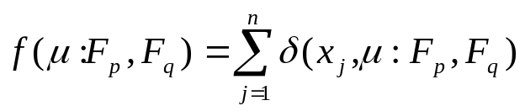
Equation 15: Kim’s Validity Index: Overlap measure between two fuzzy clusters.

Where μ is a variable and δ is given below,

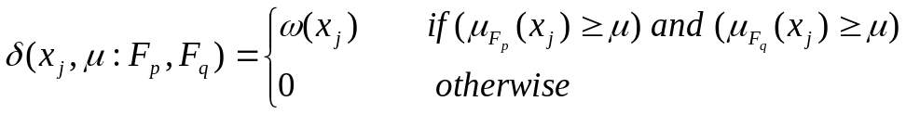
Equation 16: Kim’s Validity Index: Sigma in overlap measure

μ_{Fp}(x_{j}) is the membership of string x_{j} to fuzzy cluster F_{p}.

“δ(x_{j},μ:F_{p},F_{q}) determines whether two clusters are overlapped at the membership degree μ for data point x_{j}.” [28]

ω(x_{j}) is a step wise function assigning values accordingly. The function equals 0.1 if μ_{Fi}(x_{j}) ≥ 0.8, 0.4 if 0.7 ≤ μ_{Fi}(x_{j}) ≤ 0.8, and 0.7 if 0.6 ≤ μ_{Fi}(x_{j}) ≤ 0.7 for any F_{i} a member of F. Otherwise, ω(x_{j}) is assigned a value of 1.0.
Now, the total inter cluster overlap P(F_{p},F_{q}) between F_{p} and F_{q} is defined as,

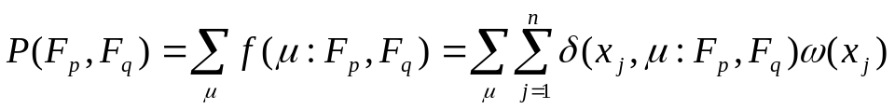
Equation 17: Kim's Validity Index: Total Inter Cluster Overlap

The overlap measure is defined as,

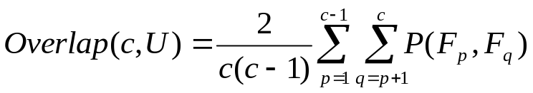
Equation 18: Kim's Validity Index: Overlap Measure

Where U is a pattern matrix and c is the number of clusters..
Now for the separation measure, the similarity S(F_{p},F_{q}) is defined as,

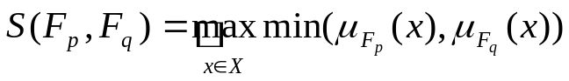
Equation 19: Kim's Validity Index: Separation Measure Similarity

Then, the separation measure Sep(c,U) is defined as,

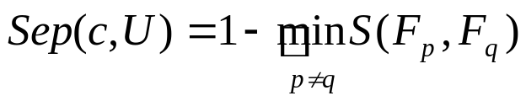
Equation 20: Kim's Validity Index: Separtion Measure

Now the algorithm calls for a normalization function, which we decided to skip. The reason is that overlap and separation are on two different scales. Yet if we hold the same scale through all are clusters, then we can compare one number of clusters to another. In hindsight, we believe we should have normalized our values. Instead, we used the following equation for our Kim’s validity index.

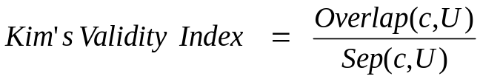
Equation 21: Kim's Validity Index

Appendix B: Tsekouras’s Entropy Based Clustering Method

The entropy based clustering method is described as follows. The entropy value between two categorical objects x_{k} and x_{l} is given as,

Equation 22: Tsekouras's Entopy Based Clustering: Entopy value between two categorical objects.

where k is not equal to l and E_{kl} is a similarity measure between x_{k} and x_{l} given as,

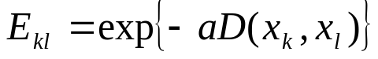
Equation 23: Tsekouras's Entropy Based Clustering: Similarity Measure E

where a is a design parameter and the function D can either the linear or logarithmic dissimilarity measure for the fuzzy k-modes algorithm.
Now the total entropy of a string x_{k} to all the other strings would be described as,

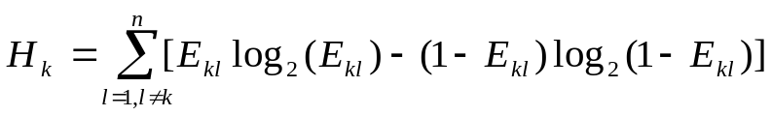
Equation 24: Tsekouras's Entropy Based Clustering: Total Entropy of a string to all other strings

Usually a good value for a is (0, 1). Now using the above equations use the following steps with c set to 0,

Step 1) Determine the total entropies for all strings using equation (23).
Step 2) Set c = c+1.
Step 3) Find the string with the least entropy value and assign that as centroid to
the c-th fuzzy cluster.
Step 4) Remove from all the strings those strings that have a similarity to the
string found in step 3 greater than beta and assign them to the c-th cluster.
Step 5) If there are no more strings stop, else go to step 2.

This algorithm finds the optimal number of clusters and the optimal centroids to seed the fuzzy k-modes algorithm with.

Appendix C: Tsekouras’s Validity Index
The following is the validity index present by Tsekouras. The global compactness is defined as,

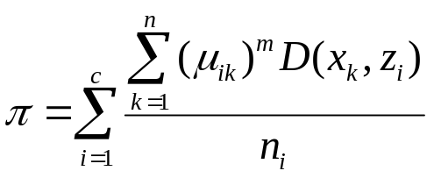
Equation 25: Tsekouras's Validity Index - Global Compactness

where,

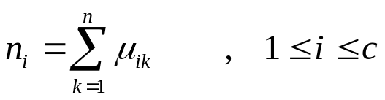
Equation 26: Tsekouras's Validity Index - Global Compactness Continued

The membership function of the i^{th} cluster center to the rest of the cluster centers is given as follows,

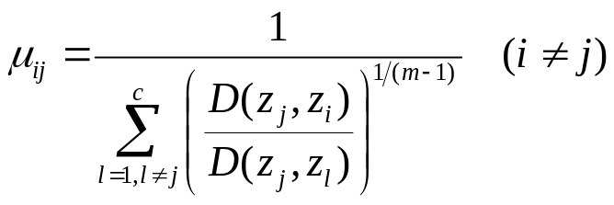
Equation 27: Tsekouras's Validity Index - Membership of a given string to a given centroid.

Now, fuzzy separation is defined as,

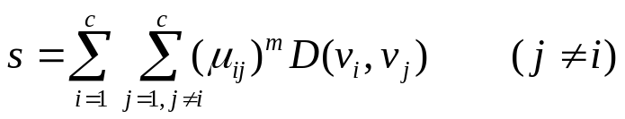
Equation 28: Tsekouras's Validity Index - Fuzzy Separation

Finally, we define the validity index as the ratio between the global compactness and the fuzzy separation.

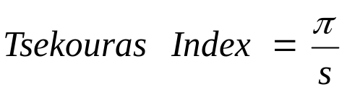
Equation 29: Tsekouras's Validity Index

Appendix D: Code

Sequencer.java

// Michael Groat
// California State University, East Bay
// Computer Science Department
// Master's Thesis
// 5/27/05
// Dr. Hilary Holz - Advisor
// usage: java Sequencer <seqlentgh> <inputfile>
//
// Program Description: This program takes the input file of process ids
// along with the system calls and converts them to <seqlength> length
// strings. Input file contains two columns, the first is process ids
// the second are system call numbers. The output is a set of strings.

import java.util.*;
import java.io.*;

class Sequencer{

private int length;
private String inputfile;
private Hashtable myhash;

public static void main(String args[]){
Sequencer MySequencer = new Sequencer(args[0],args[1]);
MySequencer.run_algorithm();
}

public Sequencer(String seqlength,String file){
length = Integer.parseInt(seqlength);
inputfile = file;
myhash = new Hashtable();
}

public void run_algorithm(){

String line;
String process_id;
String system_call;
try{
BufferedReader in = new BufferedReader(new FileReader(inputfile));

while((line = in.readLine())!= null){
StringTokenizer tokenizer = new StringTokenizer(line);
process_id = tokenizer.nextToken();
if(process_id.compareTo("-1") == 0){
System.out.println("Error");
System.exit(0);
}
system_call = tokenizer.nextToken();
add_system_call(process_id,system_call);
}
}catch(Exception e){
System.out.println("Error: Exception");
System.exit(0);
}

}// end run_algorithm

private void add_system_call(String process, String system_call){
Vector calls;
int i;

if(myhash.containsKey(process)){
// process is in hashtable
calls = (Vector)myhash.get(process);
calls.addElement(system_call);
if(calls.size() == length){
for(i=0;i<length;i++){
System.out.print(calls.elementAt(i));
if(i != length - 1)System.out.print(" ");
}
System.out.println("");
calls.removeElementAt(0);
}
}else{
// process is not in hashtable
calls = new Vector();
calls.addElement(system_call);
myhash.put(process,calls);
}
}

}// end class Sequencer

Fuzzy_k_modes.pl

#!/perl/bin
##############################################################################
# Michael Groat
# California State University, East Bay
# Computer Science Department
# Master's Thesis
# 5/27/05
# Dr. Hilary Holz - Advisor
#
# File: Fuzzy_k_modes.pl
# Program: Fuzz_k_modes
# Program Description: This program takes a set of strings and outputs the
# the set of strings with membership values to the nearest centroid.
# It also calculates the squ_square of the distribution of the
# memberships, the Bezdek partition entropy, and Kwon's and Kim's validity
# indices. It also outputs the centroids and memberships to each
# centroid. This program follows the fuzzy k-modes algorithm.
# Usage: perl fuzzy_k_modes.pl clusters symbols string_length alpha
# chi_square_Classes log_base input_file >> output_File
# Input: List of string
# Output: See above
#
##############################################################################

use strict;
use warnings;
use POSIX;
use storable;

my @strings; # string data
my $num_of_clusters; # number of cluster
my $num_of_syscalls; # number of symbols
my $string_length; # string length
my $alpha; # alpha
my $chi_square_classes; # number of buckets for chi_square
my $log_base;

# initialize variables
$string_length = $ARGV[2];
$num_of_clusters = $ARGV[0];
$num_of_syscalls = $ARGV[1];
$alpha = $ARGV[3];
$chi_square_classes = $ARGV[4];
$log_base = $ARGV[5];

# Get strings
open(INFILE, $ARGV[6]) or die "Can't open input file: $!";
my $line;
while($line = <INFILE>){
my @string = split(/\s/,$line);
push(@strings, \@string);
}
close INFILE;

# run_algorithm
my $iterations = 0;
my @Centroids;
smart_initialize_centroids();
my @mean_vector = @{$Centroids[0]};
my @New_Centroids;
#my @Memberships;
#my @New_Memberships;
my $previous_F = 0;
my $done = 1;
my $F1;
my $F2;
determine_memberships(@Centroids);
#@Memberships = map{[@$_]}@New_Memberships;
#exit 0;
my $F3;
my $F4;

while($done){
determine_centroids();
$F1 = F(\@New_Centroids);
$F2 = F(\@Centroids);
print "F(W,Z+1) is $F1, F(W,Z) is $F2\n";
if($F1 == $F2){
determine_memberships(@New_Centroids);
output_data(\@New_Centroids,$iterations);
$done = 0;
last;
}
my $commandoutput = 'del Memberships.txt';
determine_memberships(@New_Centroids);
$F3 = $F1;
$F4 = F(\@New_Centroids);
print "F(W+1,Z+1) is $F4, F(W,Z+1) is $F3\n";
if (($F4 == $previous_F)||($F4 == $F3)||($F4 == $F2)){
output_data(\@New_Centroids,$iterations);
$done = 0;
}
@Centroids = map{[@$_]}@New_Centroids;
#@Memberships = map{[@$_]}@New_Memberships;
$previous_F = $F2;
$iterations++;
}

sub smart_initialize_centroids {
my @return_centroids;
my @accumulator; # holds symbol information
# build a hash of most frequently occuring symbols for each of
# string position, Then take top num_of_clusters for each Z
# put data into accumulator
foreach my $string (@strings) {
my $string_position = 0;
foreach my $syscall (@{$string}){
$accumulator[$string_position ]{$syscall} += 1;
$string_position++;
}
}
# sort accumulator
my @sorted_accumulator;
for my $string_position (0..$string_length-1){
@{$sorted_accumulator[$string_position]} = sort {$accumulator[$string_position]{$b} <=> $accumulator[$string_position]{$a}} keys %{$accumulator[$string_position]};
}
# pick top k symbols for each j and put into Z
for my $cluster (0..$num_of_clusters-1){
# build the ith centroid
my @centroid;
for my $string_position (0..$string_length-1){
push(@centroid,$sorted_accumulator[$string_position][$cluster]);
}
$Centroids[$cluster] = [@centroid];
}
}

sub determine_memberships {

open(MEMBERSHIPSFILE,">Memberships.txt") or die "Can't open memberships file: $!";
my $power = 1.0/($alpha - 1.0);

my $string_number_index = 0;
foreach my $string (@strings){
# see if string is equal to any centroids
my $cluster_index = 0;
my $virgin = 0;
foreach my $centroid (@_){
#print "@($centroid}";

if(compare_two_vectors($string,$centroid)==1){
#string is equal to a centroid determine memberships
#to all clusters, 1 will be 1 the rest 0.
for my $cluster_index_2 (0..$num_of_clusters-1){
if ($cluster_index_2 == $cluster_index){
#$New_Memberships[$cluster_index_2][$string_number_index] = 1;
print MEMBERSHIPSFILE "1 ";
} else {
#$New_Memberships[$cluster_index_2][$string_number_index] = 0;
print MEMBERSHIPSFILE "0 ";
}
}
print MEMBERSHIPSFILE "\n";
$virgin = 1;
last;
}
$cluster_index++;
}
if($virgin == 1){
$string_number_index++;
next;
}

#add up memberships of one string to all clusters when string is not
# equal to any centroids
$cluster_index = 0;
foreach my $centroid (@_){
my $term = 0;
my $numerator = similarity_measure($centroid,$string);
my $membership = -1;
foreach my $centroid2 (@_){
#print "@{$centroid2} and @{$string}\n";
my $denominator = similarity_measure($centroid2,$string);
my $temp_term = ($numerator/$denominator)** $power;
if($temp_term == 0){
$temp_term = .00000001;
}
$term += $temp_term;
}
$membership = 1/$term;
if($membership == 1){
$membership = 1 - ($num_of_clusters*(.00000001));
}
if($membership == 0){
$membership = .00000001;
}
# TODO: check if term is infinity;
#$New_Memberships[$cluster_index][$string_number_index] = $membership;
print MEMBERSHIPSFILE "$membership ";
$cluster_index++;
undef $term;
undef $numerator;
undef $membership;
}
print MEMBERSHIPSFILE "\n";
$string_number_index++;
}
close MEMBERSHIPSFILE;
}

sub compare_two_vectors {

my $string_position = 0;
foreach my $syscall (@{$_[0]}){
if( $syscall != ${@{$_[1]}}[$string_position]) {
undef $string_position;
return 0;
}
$string_position++;
}
undef $string_position;
return 1;
}

sub similarity_measure {

my $term = 0;
my $string_position = 0;
foreach my $syscall (@{$_[0]}){
if ($syscall != ${@{$_[1]}}[$string_position]){
$term += 1;
}
$string_position++;
}
undef $string_position;
return log((($log_base - 1)*($term/$string_length)) + 1)/log($log_base);
}

sub determine_centroids {

my @accum;
open (MEMBERSHIPSIN,"Memberships.txt") or die "Can't open memberships file to read: $!";

my $string_number = 0;
foreach my $string (@strings){
my $line;
$line = <MEMBERSHIPSIN>;
my @memberships = split(/\s/,$line);
foreach my $cluster_index (0..$num_of_clusters-1){
my $string_position = 0;
foreach my $syscall (@{$string}){
$accum[$cluster_index][$string_position]{$syscall} += $memberships[$cluster_index]**$alpha;
$string_position++;
}
}
$string_number++;
}
close MEMBERSHIPSIN;

#go through accum to pick out centroids

my $cluster_index = 0;
foreach my $accum_for_cluster (@accum){
my $string_pos_index = 0;
foreach my $accum_for_string_pos (@{$accum_for_cluster}){
my @keys = sort { $$accum_for_string_pos{$b} <=> $$accum_for_string_pos{$a}
} keys %{$accum_for_string_pos};
$New_Centroids[$cluster_index][$string_pos_index] = $keys[0];
$string_pos_index++;
}
$cluster_index++;
}
undef @accum;
}

sub F{

open (MEMBERSHIPSIN,"Memberships.txt") or die "Can't open memberships file to read 2: $!";

my $term = 0;
my $string_number = 0;
foreach my $string (@strings){
my $line = <MEMBERSHIPSIN>;
my @memberships = split(/\s/,$line);
my $cluster_index = 0;
foreach my $centroid (@{$_[0]}){
$term += ($memberships[$cluster_index]**$alpha)*similarity_measure($centroid,$string);

$cluster_index++;
}
$string_number++;
}
return $term;
close MEMBERSHIPSIN;
} #end F

sub output_data {
#my @W = @{$_[0]};
my @Z = @{$_[0]};
my $iterations = $_[1];

#my @memberships;
#my @my_array;

print "Writtern by Michael Groat\n";
print "Number of iterations are: $iterations\n";
print "\n";
print "Centroids are:\n";
foreach my $centroid (@Z){
print "@{$centroid}\n";
}
print "Strings with membership values:\n";

open(MEMBERSHIPSIN,"Memberships.txt") or die "Can't open memberships file to read3: $!";

my $string_number = 0;
foreach my $string (@strings){
print "@{$string}\t\t";
# determine which highest membership goes with string
my $line = <MEMBERSHIPSIN>;
my @memberships = split(/\s/,$line);
my $membership = 0;
foreach my $l (0..$num_of_clusters-1){
if($memberships[$l] > $membership){
$membership = $memberships[$l];
}
}
#push(@memberships, $membership);
print "$membership\n";
$string_number++;
}

close(MEMBERSHIPSIN);

chi_square_test();
bezdek_entropy();
#kwon_index(\@Z);
#kim_index(\@Z);

my $user;
my $system;
my $cuser;
my $csystem;
($user,$system,$cuser,$csystem) = times;
my $totaltime = $user + $system;
print "Time is $totaltime";

}

sub chi_square_test {

#my @memberships = @_;
my $expected = scalar(@strings)/$chi_square_classes;
my @classes;

my $class_number;

# initial classes;
for my $i (0..$chi_square_classes-1){
$classes[$i] = 0;
}

# build classes
#foreach my $membership (@memberships){
open (MEMBERSHIPSIN,"Memberships.txt") or die "Can't open read file 4: $!";

for(my $i = 0;$i < scalar(@strings);$i++){
my $line = <MEMBERSHIPSIN>;
my @memberships = split(/\s/,$line);
my $membership = 0;
foreach my $mem (@memberships){
if($mem > $membership){
$membership = $mem;
}
}

$class_number = floor($membership*$chi_square_classes);
if ($class_number == 20){
$class_number = 19;
}
$classes[$class_number] += 1;
}
close MEMBERSHIPSIN;

my $sum = 0;

foreach my $class (@classes){
$sum += (($class - $expected)**2)/$expected;
}
print "Chi square is $sum\n";
print "Classes are @classes\n";

my $sum2;
foreach my $class (@classes){
$sum2 += log($class + 1)/log($expected);
}
$sum2 = $sum2/$chi_square_classes;

my $myindex = $sum/$sum2;
print "My index (to minimized) is $myindex\n";

}

sub bezdek_entropy {
#my @memberships = @_;
my $sum = 0;

open (MEMBERSHIPSIN,"Memberships.txt") or die "can't open read file 5:$!";
for(my $i = 0; $i < scalar(@strings);$i++){
my $line = <MEMBERSHIPSIN>;
my @memberships = split(/\s/,$line);
foreach my $membership (@memberships){
my $temp;
if($membership == 0){
$temp = 0;
}else{
$temp = $membership*(log($membership)/log($num_of_syscalls));
}
$sum += $temp;
}
}
print "Bezdek entropy is $sum\n";
}

#kwon's index still left to optimize
sub kwon_index {
my @W = @{$_[0]};
my @Z = @{$_[1]};

my $i;
my $j;
my $numerator = 0;

for($i=0;$i<$num_of_clusters;$i++){
for($j=0;$j<@strings;$j++){
$numerator += ($W[$i][$j]**2)*similarity_measure($strings[$j],$Z[$i]);
}
}

my $temp_numerator = 0;
for($i=0;$i<$num_of_clusters;$i++){
$temp_numerator += similarity_measure($Z[$i],\@mean_vector);
}
$temp_numerator = $temp_numerator/$num_of_clusters;

$numerator += $temp_numerator;

my $denominator = 999999999999999999;
my $c;

for($i=0;$i<$num_of_clusters-1;$i++){
for($c=$i+1;$c<$num_of_clusters;$c++){
my $temp_min= similarity_measure($Z[$i],$Z[$c]);
if (( $temp_min < $denominator)
&&(compare_two_vectors($Z[$i],$Z[$c])== 0)){
$denominator = $temp_min;
}
}
}
my $index = $numerator/$denominator;
print "Kown's index is $index\n";
}

#kim's index still left to optimize
sub kim_index {
my @W = @{$_[0]};
my @Z = @{$_[1]};

my $overlap = 0;
my $seperation = 0;
my $p;
my $q;
my $i;
my $term = 0;

for($p=0;$p<$num_of_clusters-1;$p++){
for($q=$p+1;$q<$num_of_clusters;$q++){
for($i=0;$i<@strings;$i++){
my $small_x = $W[$p][$i];
my $y = $W[$q][$i];
my $min;
if ($small_x <= $y){
$min = $small_x;
} else {
$min = $y;
}
my $omega;
if(($small_x >= .8)||($y>=.8)){
$omega = .1;
} elsif((($small_x >= .7)&&($small_x < .8))
||(($y >= .7)&&($y<.8))){
$omega = .4;
} elsif((($small_x >= .6)&&($small_x < .7))
||(($y >= .6)&&($y<.7))){
$omega = .7;
} else {
$omega = 1.0;
}
$term += $min*$omega*$omega;
}
}
}
$overlap = (2.0/($num_of_clusters*($num_of_clusters - 1)))*$term;

my $verymin = 99999999999999999999999;
for($p=0;$p<$num_of_clusters-1;$p++){
for($q=$p+1;$q<$num_of_clusters;$q++){
my $max = 0;
for($i=0;$i<@strings;$i++){
my $small_x2 = $W[$p][$i];
my $y = $W[$q][$i];
my $min;
if($small_x2 <= $y){
$min = $small_x2;
}else{
$min = $y;
}
if ($min > $max){
$max = $min;
}
}
if($max < $verymin){
$verymin = $max;
}
$max = 0;
}
}
$seperation = 1 - $verymin;
my $index = $overlap/$seperation;
print "Kim's index is $index\n";
}

Compare_strings.pl

#!/perl/bin
##############################################################################
# Michael Groat
# California State University, East Bay
# Computer Science Department
# Master's Thesis
# 5/27/05
# Dr. Hilary Holz - Advisor
#
# File: Compare_strings.pl
# Program: Compare_strings
# Program Description: This program takes the training file from the fuzzy
# k_modes program and the set of intrusion strings and gives the
# intrusion signals.
# usage: perl Compare_strings.pl normal_results_file abnormal_strings
# clusters stringlength alpha ignore_factor
# Input: results file from fuzzy k-modes, intrusion strings, parameters from
# the fuzzy k-modes program - numofclusters, stringlength, alpha.
# ignore factor is the point where the ratio of strings below that point
# to all strings is taken.
# Output: The intrusion signals, diff in ave, median, bottom 25%, ratio of .85
# and minimum locality frame
#
##############################################################################

use strict;
use warnings;
use POSIX;

open(INFILE1,$ARGV[0]) or die "Can't open normal input file: $!";
open(INFILE2,$ARGV[1]) or die "Can't open abnormal input file: $!";

my $line;
my @normal_centroids;
my @normal_highest_memberships;
my @abnormal_highest_memberships;
my @abnormal_strings;
my @normal_strings;
my $num_of_clusters = $ARGV[2];
my $string_length = $ARGV[3];
my $alpha = $ARGV[4];
my $ignore_factor = $ARGV[5];
my $chi_square_classes = 20;
my $log_base = 1000;

# get centroids and memberships for normal data
while($line = <INFILE1>){
if($line =~ m/Centroids are:/){
for my $i (0..$num_of_clusters-1){
$line = <INFILE1>;
my @centroid = split(/\s/,$line);
push(@normal_centroids,\@centroid);
#print "Inside loop\n";
}
}
if($line =~ m/\t\t([01]\.*\d*)$/){
push(@normal_highest_memberships,$1);
}
}
close INFILE1;

#get average membership.

my @twenty_memberships_normal;
my $min_twenty_memberships = 1;
my $average_normal_1 = 0;
my $average_normal_2 = 0;
my $ignore_counter = 0;
foreach my $membership (@normal_highest_memberships){
$average_normal_1 += $membership;

if(@twenty_memberships_normal < 10){
push(@twenty_memberships_normal, $membership);
} else {
#get average
my $temp_sum = 0;
foreach my $mem (@twenty_memberships_normal){
$temp_sum += $mem;
}
$temp_sum = $temp_sum / 10;
if ($temp_sum < $min_twenty_memberships){
$min_twenty_memberships = $temp_sum;
}
shift(@twenty_memberships_normal);
push(@twenty_memberships_normal,$membership);
}

if($membership < $ignore_factor){
$ignore_counter++;
#$average_normal_2 += $membership;
}
}

#get average membership of bottom 25
my @percent25_average_memberships = sort(@normal_highest_memberships);
my $index25 = floor($#normal_highest_memberships / 4);
@percent25_average_memberships = @percent25_average_memberships[0..$index25];
my $sum3 = 0;
foreach my $membership (@percent25_average_memberships){
$sum3 += $membership;
}
$sum3 = $sum3 / scalar(@percent25_average_memberships);

#get mean
my $normal_mean;
my @mean_array = sort(@normal_highest_memberships);
if (scalar(@mean_array)%2 == 0){
# even number in array
$normal_mean = ($mean_array[scalar(@mean_array)/2] + $mean_array[scalar(@mean_array)/2 - 1])/2;
} else {
#odd number in array
$normal_mean = $mean_array[floor(scalar(@mean_array)/2)];
}

$average_normal_1 = $average_normal_1 / scalar(@normal_highest_memberships);
$average_normal_2 = $ignore_counter/scalar(@normal_highest_memberships);

print "Average of normal memberships to normal centroids is $average_normal_1\n";
print "Average of ignored percentage is $average_normal_2\n";
print "Average of bottom 25% to normal centroids is $sum3\n";
print "Average of locality frame is $min_twenty_memberships\n";
print "Mean of normal memberships is $normal_mean\n";

#get average membership of abnormal strings to normal centroids

while($line = <INFILE2>){
my @temp_array = split(/\s/,$line);
push (@abnormal_strings,\@temp_array);
}

#figure out membership functions from strings
my @strings = @abnormal_strings;

my @abnormal_memberships = determine_memberships(@normal_centroids);

#now get highest membership to nearest centroid

for(my $i = 0; $i < scalar(@strings); $i++){
my $membership = -1;
foreach my $memberships_to_one_cluster (@abnormal_memberships){

#print "$$memberships_to_one_cluster[$i], i is $i";

if($$memberships_to_one_cluster[$i] > $membership){
$membership = $$memberships_to_one_cluster[$i];
}
}
push(@abnormal_highest_memberships, $membership);
}

#now get average from abnormal memberships
my $average_abnormal_1 = 0;
my $average_abnormal_2 = 0;
my $abnormal_ignore_counter = 0;
my @twenty_memberships_abnormal;
my $min_twenty_average_abnormal = 1;
foreach my $membership (@abnormal_highest_memberships){
$average_abnormal_1 += $membership;

if(@twenty_memberships_abnormal < 10){
push(@twenty_memberships_abnormal, $membership);
} else {
#get average
my $temp_sum = 0;
foreach my $mem (@twenty_memberships_abnormal){
$temp_sum += $mem;
}
#print scalar(@twenty_memberships_abnormal) . "\n";
$temp_sum = $temp_sum / 10;
if ($temp_sum < $min_twenty_average_abnormal){
$min_twenty_average_abnormal = $temp_sum;
}
shift(@twenty_memberships_abnormal);
push(@twenty_memberships_abnormal, $membership);
}

if ($membership < $ignore_factor){
$abnormal_ignore_counter++;
#$average_abnormal_2 += $membership;
}
}

#now get average of bottom 25%
my @percent25_abnormal_memberships = sort(@abnormal_highest_memberships);
my $abnormalindex25 = $#abnormal_highest_memberships / 4;
@percent25_abnormal_memberships = @percent25_abnormal_memberships[0..$abnormalindex25];
my $sum4 = 0;
foreach my $membership (@percent25_abnormal_memberships){
$sum4 += $membership;
}
$sum4 = $sum4 / scalar(@percent25_abnormal_memberships);

#get abnormal mean
my $abnormal_mean;
my @abnormal_mean_array = sort(@abnormal_highest_memberships);
if (scalar(@abnormal_mean_array)%2 == 0){
# even number in array
$abnormal_mean = ($abnormal_mean_array[scalar(@abnormal_mean_array)/2] + $abnormal_mean_array[scalar(@abnormal_mean_array)/2 - 1])/2;
} else {
#odd number in array
$abnormal_mean = $abnormal_mean_array[floor(scalar(@abnormal_mean_array)/2)];
}

$average_abnormal_1 = $average_abnormal_1 / scalar(@abnormal_highest_memberships);
$average_abnormal_2 = $abnormal_ignore_counter/scalar(@abnormal_highest_memberships);

print "Average abnormal membership to normal centroids is $average_abnormal_1\n";
print "Average ignored percentage is $average_abnormal_2\n";
print "Average bottom 25% of abnormal strings to normal cent. is $sum4\n";
print "Average in abnormal locality frame is $min_twenty_average_abnormal\n";
print "Abnormal Mean is $abnormal_mean\n";

my $diff1 = $average_normal_1 - $average_abnormal_1;
my $diff2 = $average_normal_2 - $average_abnormal_2;
my $diff3 = $sum3 - $sum4;
my $diff4 = $min_twenty_memberships - $min_twenty_average_abnormal;
my $diff5 = $normal_mean - $abnormal_mean;

print "Difference is $diff1\n";
print "Difference of percentage of strings below $ignore_factor to all strings is (should be -) $diff2\n";
print "Bottom 25% difference is $diff3\n";
print "Different of locality frames is $diff4\n";
print "Difference of mean is $diff5\n";

chi_square_test(@abnormal_highest_memberships);

sub determine_memberships {

my @centroids = @_;
my @memberships;
my $power = 1.0/($alpha - 1.0);

my $string_number_index = 0;
foreach my $string (@strings){
# see if string is equal to any centroids
my $cluster_index = 0;
my $virgin = 0;
foreach my $centroid (@centroids){
if(compare_two_vectors($string,$centroid)==1){
#string is equal to a centroid determine memberships
#to all clusters, 1 will be 1 the rest 0.
for my $cluster_index_2 (0..$num_of_clusters-1){
if ($cluster_index_2 == $cluster_index){
$memberships[$cluster_index_2][$string_number_index] = 1;
} else {
$memberships[$cluster_index_2][$string_number_index] = 0;
}
}
$virgin = 1;
last;
}
$cluster_index++;
}
if($virgin == 1){
$string_number_index++;
next;
}

#add up memberships of one string to all clusters when string is not
# equal to any centroids
$cluster_index = 0;
foreach my $centroid (@centroids){
my $term = 0;
my $numerator = d_sub_c($centroid,$string);
my $membership = -1;
foreach my $centroid2 (@centroids){
my $denominator = d_sub_c($centroid2,$string);
my $temp_term = ($numerator/$denominator)** $power;
if($temp_term == 0){
$temp_term = .00000001;
}
$term += $temp_term;
}
$membership = 1/$term;
if($membership == 1){
$membership = 1 - ($num_of_clusters*(.00000001));
}
if($membership == 0){
$membership = .00000001;
}
# TODO: check if term is infinity;
$memberships[$cluster_index][$string_number_index] = $membership;
$cluster_index++;
}
$string_number_index++;
}
return @memberships;
}

sub compare_two_vectors {

my @e = @{$_[0]};
my @f = @{$_[1]};
my $string_position = 0;
foreach my $syscall (@e){
if( $syscall != $f[$string_position]) {
return 0;
}
$string_position++;
}
return 1;
}

sub d_sub_c {
my @r = @{$_[0]};
my @s = @{$_[1]};
my $term = 0;
my $string_position = 0;
foreach my $syscall (@r){
if ($syscall != $s[$string_position]){
$term += 1;
}
$string_position++;
}
return log((($log_base - 1)*($term/$string_length)) + 1)/log($log_base);
}

sub chi_square_test {

my @memberships = @_;
my $expected = scalar(@memberships)/$chi_square_classes;
my @classes;

my $class_number;

# initial classes;
for my $i (0..$chi_square_classes-1){
$classes[$i] = 0;
}

# build classes
foreach my $membership (@memberships){
$class_number = floor($membership*$chi_square_classes);
if ($class_number == 20){
$class_number = 19;
}
$classes[$class_number] += 1;
}

my $sum = 0;

foreach my $class (@classes){
$sum += (($class - $expected)**2)/$expected;
}
print "Chi square is $sum\n";
print "Classes are @classes\n";

my $sum2;
foreach my $class (@classes){
$sum2 += log($class + 1)/log($expected);
}
$sum2 = $sum2/$chi_square_classes;

my $myindex = $sum/$sum2;
print "My index (to minimized) is $myindex\n";

}

Appendix E: Raw Data

Live Inetd

String Length 6

<Training Strings> Clusters 10, alpha 1.01

F(W,Z+1) is 229.694693632882, F(W,Z) is 257.184258922092
F(W+1,Z+1) is 213.638140189321, F(W,Z+1) is 229.694693632882
F(W,Z+1) is 191.468671606699, F(W,Z) is 213.638140189321
F(W+1,Z+1) is 188.792103940456, F(W,Z+1) is 191.468671606699
F(W,Z+1) is 179.08596746715, F(W,Z) is 188.792103940456
F(W+1,Z+1) is 178.931917258073, F(W,Z+1) is 179.08596746715
F(W,Z+1) is 172.992356231555, F(W,Z) is 178.931917258073
F(W+1,Z+1) is 165.980927515058, F(W,Z+1) is 172.992356231555
F(W,Z+1) is 164.856086218516, F(W,Z) is 165.980927515058
F(W+1,Z+1) is 164.723959715387, F(W,Z+1) is 164.856086218516
F(W,Z+1) is 164.723959715387, F(W,Z) is 164.723959715387
Writtern by Michael Groat
Number of iterations are: 5

Centroids are:
6 6 6 6 6 6
102 102 102 102 102 126
102 126 126 5 108 90
126 126 5 108 90 3
126 5 108 90 3 19
108 90 3 19 6 91
90 3 19 6 91 102
5 108 90 3 19 6
3 19 6 91 102 102
67 67 67 67 67 67
Strings with membership values:
90 125 125 106 5 90 0.391697688716431
125 125 106 5 90 6 0.226513805152824
125 106 5 90 6 5 0.226513805152824
<Strings left out for brevity>
6 6 6 6 6 6 1
6 6 6 6 6 6 1
6 6 6 6 6 11 0.999999999995041
Chi square is 6505.33079847909
Classes are 0 0 11 1 5 9 0 5 0 33 0 0 15 0 0 0 2 5 12 428
My index (to minimized) is 15825.6833351158
Bezdek entropy is -23.0006493750565
Kown's index is 116.589601475886
Kim's index is 3.27848887937065
Time is 5.702

<Results for daemon process, String length 6, Clusters 10, alpha 1.01>

Average of normal memberships to normal centroids is 0.907598002696023
Average of ignored percentage is 0.153992395437262
Average of bottom 25% to normal centroids is 0.631792588374448
Average of locality frame is 0.151647988611708
Mean of normal memberships is 1
Average abnormal membership to normal centroids is 0.634858106632565
Average ignored percentage is 0.5056
Average bottom 25% of abnormal strings to normal cent. is 0.151579868055904
Average in abnormal locality frame is 0.1
Abnormal Mean is 0.616479886117084
Difference is 0.272739896063458
Difference of percentage of strings below .85 to all strings is (should be -) -0.351607604562738
Bottom 25% difference is 0.480212720318543
Different of locality frames is 0.0516479886117084
Difference of mean is 0.383520113882916
Chi square is 1430.2
Classes are 0 0 75 57 46 20 1 18 0 35 0 0 64 0 0 0 0 58 47 204
My index (to minimized) is 2464.27821115424

String Length 10

<Training Strings> Clusters 15, alpha 1.03

F(W,Z+1) is 241.148341463667, F(W,Z) is 244.503151219699
F(W+1,Z+1) is 235.768048217786, F(W,Z+1) is 241.148341463667
F(W,Z+1) is 209.274752315129, F(W,Z) is 235.768048217786
F(W+1,Z+1) is 205.776223563173, F(W,Z+1) is 209.274752315129
F(W,Z+1) is 178.395752847448, F(W,Z) is 205.776223563173
F(W+1,Z+1) is 164.933977138473, F(W,Z+1) is 178.395752847448
F(W,Z+1) is 139.742206025102, F(W,Z) is 164.933977138473
F(W+1,Z+1) is 138.069637633587, F(W,Z+1) is 139.742206025102
F(W,Z+1) is 132.311760241345, F(W,Z) is 138.069637633587
F(W+1,Z+1) is 127.436250724922, F(W,Z+1) is 132.311760241345
F(W,Z+1) is 127.464604248441, F(W,Z) is 127.436250724922
F(W+1,Z+1) is 127.307577634908, F(W,Z+1) is 127.464604248441
F(W,Z+1) is 127.178072334284, F(W,Z) is 127.307577634908
F(W+1,Z+1) is 126.691425860892, F(W,Z+1) is 127.178072334284
F(W,Z+1) is 119.721686582232, F(W,Z) is 126.691425860892
F(W+1,Z+1) is 118.674631034053, F(W,Z+1) is 119.721686582232
F(W,Z+1) is 117.329532537775, F(W,Z) is 118.674631034053
F(W+1,Z+1) is 116.454882595922, F(W,Z+1) is 117.329532537775
F(W,Z+1) is 115.604821986111, F(W,Z) is 116.454882595922
F(W+1,Z+1) is 108.311244509298, F(W,Z+1) is 115.604821986111
F(W,Z+1) is 108.311244509298, F(W,Z) is 108.311244509298
Writtern by Michael Groat
Number of iterations are: 10

Centroids are:
6 6 6 6 6 6 6 6 6 6
90 3 19 6 91 102 102 102 102 126
19 6 91 102 102 102 102 126 126 5
102 126 126 5 108 90 3 19 6 91
126 5 108 90 3 19 6 91 102 102
102 102 126 126 5 108 90 3 19 6
91 102 102 102 102 126 126 5 108 90
102 102 102 102 126 126 5 108 90 3
5 108 90 3 19 6 91 102 102 102
126 126 5 108 90 3 19 6 91 102
102 102 102 126 126 5 108 90 3 19
108 90 3 19 6 91 102 102 102 102
3 19 6 91 102 102 102 102 126 126
3 19 6 91 102 102 102 126 126 5
6 91 102 102 102 102 126 126 5 108
Strings with membership values:
90 125 125 106 5 90 6 5 3 90 0.142143443956464
125 125 106 5 90 6 5 3 90 90 0.142143443956464
125 106 5 90 6 5 3 90 90 90 0.137758321245891
106 5 90 6 5 3 90 90 90 90 0.133635663413317
<Strings left out for brevity>
6 6 6 6 6 6 6 6 6 6 1
6 6 6 6 6 6 6 6 6 11 0.999970213172255
Chi square is 6322.18677042802
Classes are 0 11 38 6 9 0 3 5 2 3 0 2 4 1 1 1 3 6 2 417
My index (to minimized) is 13109.2226264755
Bezdek entropy is -41.8650782809454
Kown's index is 52.7303667712182
Kim's index is 4.27356098011894
Time is 23.124

<Results for daemon process, String length 10, Clusters 15, alpha 1.03>

Average of normal memberships to normal centroids is 0.867490516585976
Average of ignored percentage is 0.173151750972763
Average of bottom 25% to normal centroids is 0.472016476939468
Average of locality frame is 0.0987308169534535
Mean of normal memberships is 1
Average abnormal membership to normal centroids is 0.381740887836098
Average ignored percentage is 0.72463768115942
Average bottom 25% of abnormal strings to normal cent. is 0.0840336570271352
Average in abnormal locality frame is 0.0666666666666667
Abnormal Mean is 0.137758321245891
Difference is 0.485749628749878
Difference of percentage of strings below .85 to all strings is (should be -) -0.551485930186658
Bottom 25% difference is 0.387982819912332
Different of locality frames is 0.0320641502867868
Difference of mean is 0.862241678754109
Chi square is 2282.92914653784
Classes are 0 113 210 61 35 2 4 5 3 7 0 2 2 1 1 1 3 1 2 168
My index (to minimized) is 4090.4609748159

String Length 14
<Training Strings> Clusters 15, alpha 1.02

F(W,Z+1) is 239.698076352087, F(W,Z) is 243.186537443907
F(W+1,Z+1) is 232.088387340201, F(W,Z+1) is 239.698076352087
F(W,Z+1) is 205.994095418912, F(W,Z) is 232.088387340201
F(W+1,Z+1) is 197.49491504753, F(W,Z+1) is 205.994095418912
F(W,Z+1) is 192.778422614747, F(W,Z) is 197.49491504753
F(W+1,Z+1) is 190.914291662529, F(W,Z+1) is 192.778422614747
F(W,Z+1) is 172.211912530902, F(W,Z) is 190.914291662529
F(W+1,Z+1) is 164.982629723156, F(W,Z+1) is 172.211912530902
F(W,Z+1) is 157.827388195249, F(W,Z) is 164.982629723156
F(W+1,Z+1) is 157.799209064924, F(W,Z+1) is 157.827388195249
F(W,Z+1) is 157.039059008884, F(W,Z) is 157.799209064924
F(W+1,Z+1) is 156.190295487697, F(W,Z+1) is 157.039059008884
F(W,Z+1) is 156.170078311069, F(W,Z) is 156.190295487697
F(W+1,Z+1) is 156.158557973507, F(W,Z+1) is 156.170078311069
F(W,Z+1) is 155.703012261866, F(W,Z) is 156.158557973507
F(W+1,Z+1) is 155.644007012232, F(W,Z+1) is 155.703012261866
F(W,Z+1) is 153.959260362923, F(W,Z) is 155.644007012232
F(W+1,Z+1) is 153.882877989346, F(W,Z+1) is 153.959260362923
F(W,Z+1) is 146.744100787032, F(W,Z) is 153.882877989346
F(W+1,Z+1) is 146.724382532074, F(W,Z+1) is 146.744100787032
F(W,Z+1) is 146.280641646565, F(W,Z) is 146.724382532074
F(W+1,Z+1) is 142.929217367226, F(W,Z+1) is 146.280641646565
F(W,Z+1) is 136.582507546074, F(W,Z) is 142.929217367226
F(W+1,Z+1) is 136.580595644777, F(W,Z+1) is 136.582507546074
F(W,Z+1) is 135.728360380685, F(W,Z) is 136.580595644777
F(W+1,Z+1) is 135.281653726571, F(W,Z+1) is 135.728360380685
F(W,Z+1) is 135.340752552305, F(W,Z) is 135.281653726571
F(W+1,Z+1) is 135.234845998172, F(W,Z+1) is 135.340752552305
F(W,Z+1) is 133.309915530256, F(W,Z) is 135.234845998172
F(W+1,Z+1) is 126.196410158394, F(W,Z+1) is 133.309915530256
F(W,Z+1) is 126.196410158394, F(W,Z) is 126.196410158394
Writtern by Michael Groat
Number of iterations are: 15

Centroids are:
6 6 6 6 6 6 6 6 6 6 6 6 6 6
102 102 126 126 5 108 90 3 19 6 91 102 102 102
126 126 5 108 90 3 19 6 91 102 102 102 102 126
90 90 90 90 90 90 90 90 125 125 125 125 125 125
126 5 108 90 3 19 6 91 102 102 102 102 126 126
3 19 6 91 102 102 102 102 126 126 5 108 90 3
91 102 102 102 102 126 126 5 108 90 3 19 6 91
102 102 102 126 126 5 108 90 3 19 6 91 102 102
102 126 126 5 108 90 3 19 6 91 102 102 102 102
102 102 102 102 126 126 5 108 90 3 19 6 91 102
19 6 91 102 102 102 102 126 126 5 108 90 3 19
108 90 3 19 6 91 102 102 102 102 126 126 5 108
102 126 126 5 108 90 3 19 6 91 102 102 102 126
5 108 90 3 19 6 91 102 102 102 102 126 126 5
6 91 102 102 102 102 126 126 5 108 90 3 19 6
Strings with membership values:
90 125 125 106 5 90 6 5 3 90 90 90 90 6 0.108907121202492
125 125 106 5 90 6 5 3 90 90 90 90 6 125 0.108907121202492
125 106 5 90 6 5 3 90 90 90 90 6 125 91 0.181334675908596
<Strings left out for brevity>
6 6 6 6 6 6 6 6 6 6 6 6 6 6 1
6 6 6 6 6 6 6 6 6 6 6 6 6 11 0.999999999043875
Chi square is 6294.33466135458
Classes are 0 10 19 6 10 11 4 0 4 3 1 0 4 1 4 1 3 4 5 412
My index (to minimized) is 12318.0329733013
Bezdek entropy is -36.1843053317156
Kown's index is 104.491741718028
Kim's index is 3.28183868471753
Time is 44.405

<Results for daemon process, String length 14, Clusters 15, alpha 1.02>

Average of normal memberships to normal centroids is 0.883392087658159
Average of ignored percentage is 0.161354581673307
Average of bottom 25% to normal centroids is 0.53541945736518
Average of locality frame is 0.0948755049414151
Mean of normal memberships is 1
Average abnormal membership to normal centroids is 0.385401274636423
Average ignored percentage is 0.73095623987034
Average bottom 25% of abnormal strings to normal cent. is 0.0847105472284597
Average in abnormal locality frame is 0.0666666666666667
Abnormal Mean is 0.16721798322707
Difference is 0.497990813021736
Difference of percentage of strings below .85 to all strings is (should be -) -0.569601658197034
Bottom 25% difference is 0.450708910136721
Different of locality frames is 0.0282088382747485
Difference of mean is 0.83278201677293
Chi square is 1961.96272285251
Classes are 0 131 121 145 11 15 5 0 8 4 1 0 3 1 3 0 3 1 3 162
My index (to minimized) is 3518.31006245491

Live PS

String Length 10

<Training Strings> String Length 10, Clusters 10, alpha 1.02

F(W,Z+1) is 5146.26768498133, F(W,Z) is 5425.63369255826
F(W+1,Z+1) is 4895.417222149, F(W,Z+1) is 5146.26768498133
F(W,Z+1) is 3604.72872717906, F(W,Z) is 4895.417222149
F(W+1,Z+1) is 3334.6409270987, F(W,Z+1) is 3604.72872717906
F(W,Z+1) is 3333.31371445074, F(W,Z) is 3334.6409270987
F(W+1,Z+1) is 3330.3052959457, F(W,Z+1) is 3333.31371445074
F(W,Z+1) is 3328.45631075575, F(W,Z) is 3330.3052959457
F(W+1,Z+1) is 3325.34786223597, F(W,Z+1) is 3328.45631075575
F(W,Z+1) is 3247.76238472813, F(W,Z) is 3325.34786223597
F(W+1,Z+1) is 2881.69512102193, F(W,Z+1) is 3247.76238472813
F(W,Z+1) is 2881.69512102193, F(W,Z) is 2881.69512102193
Writtern by Michael Groat
Number of iterations are: 5

Centroids are:
3 6 5 3 6 106 5 3 6 5
5 3 6 5 5 3 6 5 3 6
6 106 5 3 6 5 3 6 106 5
106 106 106 106 106 106 106 106 106 106
90 90 90 90 90 90 125 125 125 125
4 4 4 4 4 4 4 4 4 4
106 5 3 6 5 5 3 6 5 3
106 5 3 6 5 3 6 106 5 3
6 5 3 6 106 5 3 6 5 3
3 6 106 5 3 6 5 3 6 106
Strings with membership values:
90 125 106 5 90 6 5 3 90 90 0.909087177028336
125 106 5 90 6 5 3 90 90 90 0.89191486648007
106 5 90 6 5 3 90 90 90 90 0.751236231736706
<Strings left out for brevity>
4 4 4 4 4 4 4 4 4 4 1
4 4 4 4 4 4 4 4 4 4 1
4 4 4 4 4 4 4 4 4 4 1
4 4 4 4 4 4 4 4 4 1 0.999999984444417
Chi square is 55173.0526315789
Classes are 0 0 80 102 73 168 100 156 140 132 68 101 48 105 101 63 39 74 145 4233
My index (to minimized) is 73446.178544123
Bezdek entropy is -485.280449163674
Kown's index is 2492.61588709535
Kim's index is 65.4668298540513
Time is 131.718

<Results, Trace 1> String Length 10, Clusters 10, alpha 1.02

Average of normal memberships to normal centroids is 0.85626580811706
Average of ignored percentage is 0.248987854251012
Average of bottom 25% to normal centroids is 0.442922328908716
Average of locality frame is 0.191925783039986
Mean of normal memberships is 0.999999957779065
Average abnormal membership to normal centroids is 0.780910715374903
Average ignored percentage is 0.364820846905537
Average bottom 25% of abnormal strings to normal cent. is 0.305742100951178
Average in abnormal locality frame is 0.191925783039986
Abnormal Mean is 0.998354458044313
Difference is 0.0753550927421571
Difference of percentage of strings below .85 to all strings is (should be -) -0.115832992654525
Bottom 25% difference is 0.137180227957538
Different of locality frames is -1.94289029309402e-016
Difference of mean is 0.00164549973475225
Chi square is 1792.34853420195
Classes are 0 0 6 11 8 12 10 12 13 4 4 6 5 6 11 4 0 6 13 176
My index (to minimized) is 2475.22783301328
<Results, Trace 2> String Length 10, Clusters 10, alpha 1.02

Average of normal memberships to normal centroids is 0.85626580811706
Average of ignored percentage is 0.248987854251012
Average of bottom 25% to normal centroids is 0.442922328908716
Average of locality frame is 0.191925783039986
Mean of normal memberships is 0.999999957779065
Average abnormal membership to normal centroids is 0.790655077487095
Average ignored percentage is 0.348909657320872
Average bottom 25% of abnormal strings to normal cent. is 0.317568116795393
Average in abnormal locality frame is 0.191925783039986
Abnormal Mean is 0.998354458044313
Difference is 0.0656107306299645
Difference of percentage of strings below .85 to all strings is (should be -) -0.0999218030698601
Bottom 25% difference is 0.125354212113323
Different of locality frames is -1.94289029309402e-016
Difference of mean is 0.00164549973475225
Chi square is 2006.04049844237
Classes are 0 0 6 11 8 12 10 12 13 4 4 6 5 6 11 4 0 6 13 190
My index (to minimized) is 2810.16108008673

<Results, Trace 3> String Length 10, Clusters 10, alpha 1.02

Average of normal memberships to normal centroids is 0.85626580811706
Average of ignored percentage is 0.248987854251012
Average of bottom 25% to normal centroids is 0.442922328908716
Average of locality frame is 0.191925783039986
Mean of normal memberships is 0.999999957779065
Average abnormal membership to normal centroids is 0.799393996134341
Average ignored percentage is 0.334328358208955
Average bottom 25% of abnormal strings to normal cent. is 0.326796650735467
Average in abnormal locality frame is 0.191925783039986
Abnormal Mean is 0.998354458044313
Difference is 0.0568718119827184
Difference of percentage of strings below .85 to all strings is (should be -) -0.0853405039579431
Bottom 25% difference is 0.116125678173249
Different of locality frames is -1.94289029309402e-016
Difference of mean is 0.00164549973475225
Chi square is 2224.10447761194
Classes are 0 0 6 11 8 12 10 12 13 4 4 6 5 6 11 4 0 6 13 204
My index (to minimized) is 3157.91649534471

<Results, Trace 4> String Length 10, Clusters 10, alpha 1.02

Average of normal memberships to normal centroids is 0.85626580811706
Average of ignored percentage is 0.248987854251012
Average of bottom 25% to normal centroids is 0.442922328908716
Average of locality frame is 0.191925783039986
Mean of normal memberships is 0.999999957779065
Average abnormal membership to normal centroids is 0.807431798099287
Average ignored percentage is 0.320916905444126
Average bottom 25% of abnormal strings to normal cent. is 0.339449513551123
Average in abnormal locality frame is 0.191925783039986
Abnormal Mean is 0.99898757400728
Difference is 0.0488340100177728
Difference of percentage of strings below .85 to all strings is (should be -) -0.071929051193114
Bottom 25% difference is 0.103472815357593
Different of locality frames is -1.94289029309402e-016
Difference of mean is 0.0010123837717847
Chi square is 2446.01432664756
Classes are 0 0 6 11 8 12 10 12 13 4 4 6 5 6 11 4 0 6 13 218
My index (to minimized) is 3517.59436261362

<Results, Trace 5> String Length 10, Clusters 10, alpha 1.02

Average of normal memberships to normal centroids is 0.85626580811706
Average of ignored percentage is 0.248987854251012
Average of bottom 25% to normal centroids is 0.442922328908716
Average of locality frame is 0.191925783039986
Mean of normal memberships is 0.999999957779065
Average abnormal membership to normal centroids is 0.81484960432038
Average ignored percentage is 0.308539944903581
Average bottom 25% of abnormal strings to normal cent. is 0.349500540179417
Average in abnormal locality frame is 0.191925783039986
Abnormal Mean is 0.999603819290247
Difference is 0.0414162037966797
Difference of percentage of strings below .85 to all strings is (should be -) -0.0595520906525691
Bottom 25% difference is 0.0934217887292988
Different of locality frames is -1.94289029309402e-016
Difference of mean is 0.000396138488817921
Chi square is 2671.32506887052
Classes are 0 0 6 11 8 12 10 12 13 4 4 6 5 6 11 4 0 6 13 232
My index (to minimized) is 3888.39504785901

<Results, Trace 6> String Length 10, Clusters 10, alpha 1.02

Average of normal memberships to normal centroids is 0.85626580811706
Average of ignored percentage is 0.248987854251012
Average of bottom 25% to normal centroids is 0.442922328908716
Average of locality frame is 0.191925783039986
Mean of normal memberships is 0.999999957779065
Average abnormal membership to normal centroids is 0.898587873234158
Average ignored percentage is 0.169230769230769
Average bottom 25% of abnormal strings to normal cent. is 0.598652166755643
Average in abnormal locality frame is 0.191925783039986
Abnormal Mean is 1
Difference is -0.0423220651170981
Difference of percentage of strings below .85 to all strings is (should be -) 0.0797570850202429
Bottom 25% difference is -0.155729837846927
Different of locality frames is -1.94289029309402e-016
Difference of mean is -4.22209349704161e-008
Chi square is 3884.66153846154
Classes are 0 0 3 5 4 5 5 6 6 3 2 4 2 4 4 2 0 3 6 261
My index (to minimized) is 7061.91503883872

<Results, Trace 7> String Length 10, Clusters 10, alpha 1.02
Average of normal memberships to normal centroids is 0.85626580811706
Average of ignored percentage is 0.248987854251012
Average of bottom 25% to normal centroids is 0.442922328908716
Average of locality frame is 0.191925783039986
Mean of normal memberships is 0.999999957779065
Average abnormal membership to normal centroids is 0.900721124147363
Average ignored percentage is 0.16566265060241
Average bottom 25% of abnormal strings to normal cent. is 0.603467857012133
Average in abnormal locality frame is 0.191925783039986
Abnormal Mean is 1
Difference is -0.0444553160303037
Difference of percentage of strings below .85 to all strings is (should be -) 0.0833252036486025
Bottom 25% difference is -0.160545528103417
Different of locality frames is -1.94289029309402e-016
Difference of mean is -4.22209349704161e-008
Chi square is 4011.97590361446
Classes are 0 0 3 5 4 5 5 6 6 3 2 4 2 4 4 2 0 3 6 268
My index (to minimized) is 7342.79184863298

<Results, Trace 8> String Length 10, Clusters 10, alpha 1.02

Average of normal memberships to normal centroids is 0.85626580811706
Average of ignored percentage is 0.248987854251012
Average of bottom 25% to normal centroids is 0.442922328908716
Average of locality frame is 0.191925783039986
Mean of normal memberships is 0.999999957779065
Average abnormal membership to normal centroids is 0.915337425542987
Average ignored percentage is 0.150717703349282
Average bottom 25% of abnormal strings to normal cent. is 0.663456794771333
Average in abnormal locality frame is 0.191925783039986
Abnormal Mean is 1
Difference is -0.0590716174259275
Difference of percentage of strings below .85 to all strings is (should be -) 0.0982701509017298
Bottom 25% difference is -0.220534465862617
Different of locality frames is -1.94289029309402e-016
Difference of mean is -4.22209349704161e-008
Chi square is 5326.01913875598
Classes are 0 0 3 5 4 5 5 6 6 3 4 4 2 6 4 2 4 3 6 346
My index (to minimized) is 9691.11972084145

<Results, Trace 9> String Length 10, Clusters 10, alpha 1.02

Average of normal memberships to normal centroids is 0.85626580811706
Average of ignored percentage is 0.248987854251012
Average of bottom 25% to normal centroids is 0.442922328908716
Average of locality frame is 0.191925783039986
Mean of normal memberships is 0.999999957779065
Average abnormal membership to normal centroids is 0.91898565286882
Average ignored percentage is 0.145374449339207
Average bottom 25% of abnormal strings to normal cent. is 0.677839427741457
Average in abnormal locality frame is 0.191925783039986
Abnormal Mean is 1
Difference is -0.0627198447517601
Difference of percentage of strings below .85 to all strings is (should be -) 0.103613404911805
Bottom 25% difference is -0.234917098832742
Different of locality frames is -1.94289029309402e-016
Difference of mean is -4.22209349704161e-008
Chi square is 5889.78854625551
Classes are 0 0 3 5 4 5 5 6 6 4 4 5 2 7 4 2 4 3 6 379
My index (to minimized) is 10804.536725157

<Results, Trace 10> String Length 10, Clusters 10, alpha 1.02

Average of normal memberships to normal centroids is 0.85626580811706
Average of ignored percentage is 0.248987854251012
Average of bottom 25% to normal centroids is 0.442922328908716
Average of locality frame is 0.191925783039986
Mean of normal memberships is 0.999999957779065
Average abnormal membership to normal centroids is 0.728316257199825
Average ignored percentage is 0.459893048128342
Average bottom 25% of abnormal strings to normal cent. is 0.317574627860858
Average in abnormal locality frame is 0.191925783039986
Abnormal Mean is 0.950981070883383
Difference is 0.127949550917235
Difference of percentage of strings below .85 to all strings is (should be -) -0.21090519387733
Bottom 25% difference is 0.125347701047857
Different of locality frames is -1.94289029309402e-016
Difference of mean is 0.0490188868956817
Chi square is 924.550802139038
Classes are 0 0 5 6 6 6 3 5 6 33 3 2 2 2 5 2 0 1 5 95
My index (to minimized) is 1337.6141348294

<Results, Trace 11> String Length 10, Clusters 10, alpha 1.02

Average of normal memberships to normal centroids is 0.85626580811706
Average of ignored percentage is 0.248987854251012
Average of bottom 25% to normal centroids is 0.442922328908716
Average of locality frame is 0.191925783039986
Mean of normal memberships is 0.999999957779065
Average abnormal membership to normal centroids is 0.720639301046366
Average ignored percentage is 0.468421052631579
Average bottom 25% of abnormal strings to normal cent. is 0.305506143924018
Average in abnormal locality frame is 0.191925783039986
Abnormal Mean is 0.946402472108621
Difference is 0.135626507070693
Difference of percentage of strings below .85 to all strings is (should be -) -0.219433198380567
Bottom 25% difference is 0.137416184984698
Different of locality frames is -1.94289029309402e-016
Difference of mean is 0.053597485670444
Chi square is 908.947368421053
Classes are 0 0 4 8 8 6 3 5 6 33 3 2 2 2 5 2 0 1 5 95
My index (to minimized) is 1310.8152267684

<Results, Trace 12> String Length 10, Clusters 10, alpha 1.02

Average of normal memberships to normal centroids is 0.85626580811706
Average of ignored percentage is 0.248987854251012
Average of bottom 25% to normal centroids is 0.442922328908716
Average of locality frame is 0.191925783039986
Mean of normal memberships is 0.999999957779065
Average abnormal membership to normal centroids is 0.715677586158995
Average ignored percentage is 0.478260869565217
Average bottom 25% of abnormal strings to normal cent. is 0.310243096493459
Average in abnormal locality frame is 0.191925783039986
Abnormal Mean is 0.924674671132703
Difference is 0.140588221958064
Difference of percentage of strings below .85 to all strings is (should be -) -0.229273015314205
Bottom 25% difference is 0.132679232415257
Different of locality frames is -1.94289029309402e-016
Difference of mean is 0.0753252866463625
Chi square is 856.434782608696
Classes are 0 0 4 8 5 5 3 8 7 34 3 2 1 2 4 2 0 1 5 90
My index (to minimized) is 1242.67204906555

<Results, Trace 13> String Length 10, Clusters 10, alpha 1.02

Average of normal memberships to normal centroids is 0.85626580811706
Average of ignored percentage is 0.248987854251012
Average of bottom 25% to normal centroids is 0.442922328908716
Average of locality frame is 0.191925783039986
Mean of normal memberships is 0.999999957779065
Average abnormal membership to normal centroids is 0.848290217562215
Average ignored percentage is 0.246808510638298
Average bottom 25% of abnormal strings to normal cent. is 0.408748290782164
Average in abnormal locality frame is 0.191925783039986
Abnormal Mean is 0.999999957779065
Difference is 0.00797559055484465
Difference of percentage of strings below .85 to all strings is (should be -) 0.00217934361271427
Bottom 25% difference is 0.0341740381265518
Different of locality frames is -1.94289029309402e-016
Difference of mean is 2.22044604925031e-016
Chi square is 2223.8085106383
Classes are 0 0 4 8 5 3 3 8 7 3 3 3 2 3 4 2 0 3 5 169
My index (to minimized) is 3614.997597294

<Results, Trace 14> String Length 10, Clusters 10, alpha 1.02

Average of normal memberships to normal centroids is 0.85626580811706
Average of ignored percentage is 0.248987854251012
Average of bottom 25% to normal centroids is 0.442922328908716
Average of locality frame is 0.191925783039986
Mean of normal memberships is 0.999999957779065
Average abnormal membership to normal centroids is 0.62570212817149
Average ignored percentage is 0.635514018691589
Average bottom 25% of abnormal strings to normal cent. is 0.223301572994195
Average in abnormal locality frame is 0.191925783039986
Abnormal Mean is 0.618531010757381
Difference is 0.23056367994557
Difference of percentage of strings below .85 to all strings is (should be -) -0.386526164440577
Bottom 25% difference is 0.219620755914521
Different of locality frames is -1.94289029309402e-016
Difference of mean is 0.381468947021684
Chi square is 168.700934579439
Classes are 0 0 4 7 5 6 6 9 6 5 2 3 2 2 3 4 4 2 4 33
My index (to minimized) is 182.920967436494

<Results, Trace 15> String Length 10, Clusters 10, alpha 1.02

Average of normal memberships to normal centroids is 0.85626580811706
Average of ignored percentage is 0.248987854251012
Average of bottom 25% to normal centroids is 0.442922328908716
Average of locality frame is 0.191925783039986
Mean of normal memberships is 0.999999957779065
Average abnormal membership to normal centroids is 0.842786641593208
Average ignored percentage is 0.26615969581749
Average bottom 25% of abnormal strings to normal cent. is 0.407906135871791
Average in abnormal locality frame is 0.191925783039986
Abnormal Mean is 0.999999853541065
Difference is 0.0134791665238522
Difference of percentage of strings below .85 to all strings is (should be -) -0.0171718415664784
Bottom 25% difference is 0.0350161930369249
Different of locality frames is -1.94289029309402e-016
Difference of mean is 1.04238000120382e-007
Chi square is 2292.66539923954
Classes are 0 0 4 8 5 3 3 9 9 5 3 6 2 5 5 3 0 4 7 182
My index (to minimized) is 3572.67635100667

<Results, Trace 16> String Length 10, Clusters 10, alpha 1.02

Average of normal memberships to normal centroids is 0.85626580811706
Average of ignored percentage is 0.248987854251012
Average of bottom 25% to normal centroids is 0.442922328908716
Average of locality frame is 0.191925783039986
Mean of normal memberships is 0.999999957779065
Average abnormal membership to normal centroids is 0.797561444107603
Average ignored percentage is 0.348993288590604
Average bottom 25% of abnormal strings to normal cent. is 0.344020975179031
Average in abnormal locality frame is 0.184468856174375
Abnormal Mean is 0.998354458044313
Difference is 0.0587043640094567
Difference of percentage of strings below .85 to all strings is (should be -) -0.100005434339592
Bottom 25% difference is 0.0989013537296846
Different of locality frames is 0.00745692686561109
Difference of mean is 0.00164549973475225
Chi square is 927.375838926174
Classes are 0 0 2 6 3 4 5 4 6 1 3 5 2 3 6 2 0 3 6 88
My index (to minimized) is 1301.9539515575

<Results, Trace 17> String Length 10, Clusters 10, alpha 1.02

Average of normal memberships to normal centroids is 0.85626580811706
Average of ignored percentage is 0.248987854251012
Average of bottom 25% to normal centroids is 0.442922328908716
Average of locality frame is 0.191925783039986
Mean of normal memberships is 0.999999957779065
Average abnormal membership to normal centroids is 0.806634676845232
Average ignored percentage is 0.333333333333333
Average bottom 25% of abnormal strings to normal cent. is 0.350226433461838
Average in abnormal locality frame is 0.184468856174375
Abnormal Mean is 0.998354458044313
Difference is 0.0496311312718274
Difference of percentage of strings below .85 to all strings is (should be -) -0.0843454790823212
Bottom 25% difference is 0.092695895446878
Different of locality frames is 0.00745692686561109
Difference of mean is 0.00164549973475225
Chi square is 1036.30769230769
Classes are 0 0 2 6 3 4 5 4 6 1 3 5 2 3 6 2 0 3 6 95
My index (to minimized) is 1484.21683039378

<Results, Trace 18> String Length 10, Clusters 10, alpha 1.02

Average of normal memberships to normal centroids is 0.85626580811706
Average of ignored percentage is 0.248987854251012
Average of bottom 25% to normal centroids is 0.442922328908716
Average of locality frame is 0.191925783039986
Mean of normal memberships is 0.999999957779065
Average abnormal membership to normal centroids is 0.814928613519507
Average ignored percentage is 0.319018404907975
Average bottom 25% of abnormal strings to normal cent. is 0.364084072604204
Average in abnormal locality frame is 0.184468856174375
Abnormal Mean is 0.99898757400728
Difference is 0.0413371945975526
Difference of percentage of strings below .85 to all strings is (should be -) -0.0700305506569633
Bottom 25% difference is 0.0788382563045119
Different of locality frames is 0.00745692686561109
Difference of mean is 0.0010123837717847
Chi square is 1147.30674846626
Classes are 0 0 2 6 3 4 5 4 6 1 3 5 2 3 6 2 0 3 6 102
My index (to minimized) is 1674.19672012561

<Results, Trace 19> String Length 10, Clusters 10, alpha 1.02

Average of normal memberships to normal centroids is 0.85626580811706
Average of ignored percentage is 0.248987854251012
Average of bottom 25% to normal centroids is 0.442922328908716
Average of locality frame is 0.191925783039986
Mean of normal memberships is 0.999999957779065
Average abnormal membership to normal centroids is 0.822539520114724
Average ignored percentage is 0.305882352941176
Average bottom 25% of abnormal strings to normal cent. is 0.377730647083826
Average in abnormal locality frame is 0.184468856174375
Abnormal Mean is 0.999588245603495
Difference is 0.033726288002336
Difference of percentage of strings below .85 to all strings is (should be -) -0.0568944986901644
Bottom 25% difference is 0.0651916818248897
Different of locality frames is 0.00745692686561109
Difference of mean is 0.000411712175569567
Chi square is 1260.11764705882
Classes are 0 0 2 6 3 4 5 4 6 1 3 5 2 3 6 2 0 3 6 109
My index (to minimized) is 1871.38915456316

<Results, Trace 20> String Length 10, Clusters 10, alpha 1.02

Average of normal memberships to normal centroids is 0.85626580811706
Average of ignored percentage is 0.248987854251012
Average of bottom 25% to normal centroids is 0.442922328908716
Average of locality frame is 0.191925783039986
Mean of normal memberships is 0.999999957779065
Average abnormal membership to normal centroids is 0.829548434097889
Average ignored percentage is 0.293785310734463
Average bottom 25% of abnormal strings to normal cent. is 0.391640113073087
Average in abnormal locality frame is 0.184468856174375
Abnormal Mean is 0.999786876090951
Difference is 0.0267173740191705
Difference of percentage of strings below .85 to all strings is (should be -) -0.0447974564834512
Bottom 25% difference is 0.0512822158356292
Different of locality frames is 0.00745692686561109
Difference of mean is 0.000213081688113959
Chi square is 1374.52542372881
Classes are 0 0 2 6 3 4 5 4 6 1 3 5 2 3 6 2 0 3 6 116
My index (to minimized) is 2075.34156668419
<Results, Trace 21> String Length 10, Clusters 10, alpha 1.02

<Results, Trace 22> String Length 10, Clusters 10, alpha 1.02

Average of normal memberships to normal centroids is 0.85626580811706
Average of ignored percentage is 0.248987854251012
Average of bottom 25% to normal centroids is 0.442922328908716
Average of locality frame is 0.191925783039986
Mean of normal memberships is 0.999999957779065
Average abnormal membership to normal centroids is 0.913881166303911
Average ignored percentage is 0.156171284634761
Average bottom 25% of abnormal strings to normal cent. is 0.658633855452323
Average in abnormal locality frame is 0.184468856174375
Abnormal Mean is 1
Difference is -0.0576153581868513
Difference of percentage of strings below .85 to all strings is (should be -) 0.0928165696162514
Bottom 25% difference is -0.215711526543608
Different of locality frames is 0.00745692686561109
Difference of mean is -4.22209349704161e-008
Chi square is 4974.33501259446
Classes are 0 0 2 6 3 4 5 4 6 3 4 7 2 6 6 2 2 3 6 326
My index (to minimized) is 9071.25929828922

<Results, Trace 23> String Length 10, Clusters 10, alpha 1.02

Average of normal memberships to normal centroids is 0.85626580811706
Average of ignored percentage is 0.248987854251012
Average of bottom 25% to normal centroids is 0.442922328908716
Average of locality frame is 0.191925783039986
Mean of normal memberships is 0.999999957779065
Average abnormal membership to normal centroids is 0.859973782025893
Average ignored percentage is 0.246031746031746
Average bottom 25% of abnormal strings to normal cent. is 0.45236331165788
Average in abnormal locality frame is 0.184468856174375
Abnormal Mean is 0.999999957779065
Difference is -0.00370797390883337
Difference of percentage of strings below .85 to all strings is (should be -) 0.00295610821926612
Bottom 25% difference is -0.00944098274916449
Different of locality frames is 0.00745692686561109
Difference of mean is 2.22044604925031e-016
Chi square is 2404.8253968254
Classes are 0 0 2 7 4 6 4 4 7 1 5 7 2 3 6 2 2 3 5 182
My index (to minimized) is 3854.9703514882

<Results, Trace 24> String Length 10, Clusters 10, alpha 1.02

Average of normal memberships to normal centroids is 0.85626580811706
Average of ignored percentage is 0.248987854251012
Average of bottom 25% to normal centroids is 0.442922328908716
Average of locality frame is 0.191925783039986
Mean of normal memberships is 0.999999957779065
Average abnormal membership to normal centroids is 0.615345057017944
Average ignored percentage is 0.655913978494624
Average bottom 25% of abnormal strings to normal cent. is 0.216353339325201
Average in abnormal locality frame is 0.184468856174375
Abnormal Mean is 0.624285417151317
Difference is 0.240920751099115
Difference of percentage of strings below .85 to all strings is (should be -) -0.406926124243612
Bottom 25% difference is 0.226568989583515
Different of locality frames is 0.00745692686561109
Difference of mean is 0.375714540627748
Chi square is 122.268817204301
Classes are 0 0 3 6 7 6 7 6 4 1 3 3 1 2 4 3 5 2 4 26
My index (to minimized) is 129.409809388915

<Results, Trace 25> String Length 10, Clusters 10, alpha 1.02

Average of normal memberships to normal centroids is 0.85626580811706
Average of ignored percentage is 0.248987854251012
Average of bottom 25% to normal centroids is 0.442922328908716
Average of locality frame is 0.191925783039986
Mean of normal memberships is 0.999999957779065
Average abnormal membership to normal centroids is 0.851242795267234
Average ignored percentage is 0.262548262548263
Average bottom 25% of abnormal strings to normal cent. is 0.436356438546838
Average in abnormal locality frame is 0.184468856174375
Abnormal Mean is 0.999999957779065
Difference is 0.00502301284982587
Difference of percentage of strings below .85 to all strings is (should be -) -0.0135604082972504
Bottom 25% difference is 0.00656589036187821
Different of locality frames is 0.00745692686561109
Difference of mean is 2.22044604925031e-016
Chi square is 2304.01158301158
Classes are 0 0 2 7 3 5 6 5 9 3 5 6 2 4 7 3 1 4 6 181
My index (to minimized) is 3560.42055617349

<Results, Trace 26> String Length 10, Clusters 10, alpha 1.02

Average of normal memberships to normal centroids is 0.85626580811706
Average of ignored percentage is 0.248987854251012
Average of bottom 25% to normal centroids is 0.442922328908716
Average of locality frame is 0.191925783039986
Mean of normal memberships is 0.999999957779065
Average abnormal membership to normal centroids is 0.719347995973843
Average ignored percentage is 0.480446927374302
Average bottom 25% of abnormal strings to normal cent. is 0.31578003615272
Average in abnormal locality frame is 0.184468856174375
Abnormal Mean is 0.909087177028336
Difference is 0.136917812143217
Difference of percentage of strings below .85 to all strings is (should be -) -0.23145907312329
Bottom 25% difference is 0.127142292755996
Different of locality frames is 0.00745692686561109
Difference of mean is 0.0909127807507295
Chi square is 807.927374301676
Classes are 0 0 3 7 7 5 4 5 6 31 4 2 2 2 6 2 0 1 5 87
My index (to minimized) is 1140.11144558657

<Results self test trace 1>

Average of normal memberships to normal centroids is 0.844905511554977
Average of ignored percentage is 0.249014972419228
Average of bottom 25% to normal centroids is 0.437728733239556
Average of locality frame is 0.192369237561914
Mean of normal memberships is 0.999999853541065
Average abnormal membership to normal centroids is 0.847231742466733
Average ignored percentage is 0.23998114097124
Average bottom 25% of abnormal strings to normal cent. is 0.445176349933989
Average in abnormal locality frame is 0.192369237561914
Abnormal Mean is 1
Difference is -0.00232623091175599
Difference of percentage of strings below .85 to all strings is (should be -) 0.00903383144798775
Bottom 25% difference is -0.00744761669443283
Different of locality frames is -1.94289029309402e-016
Difference of mean is -1.46458934979776e-007
Chi square is 15440.4049976426
Classes are 0 0 27 49 38 62 44 50 42 18 27 17 24 36 32 37 6 229 46 1337
My index (to minimized) is 21144.5674261599

<Results self test trace 2>

Average of normal memberships to normal centroids is 0.814068260437695
Average of ignored percentage is 0.294200848656294
Average of bottom 25% to normal centroids is 0.327711682168271
Average of locality frame is 0.164401949902478
Mean of normal memberships is 0.999363003065153
Average abnormal membership to normal centroids is 0.793172596860162
Average ignored percentage is 0.329655897031784
Average bottom 25% of abnormal strings to normal cent. is 0.299109748334152
Average in abnormal locality frame is 0.14538287289402
Abnormal Mean is 0.999363003065153
Difference is 0.020895663577533
Difference of percentage of strings below .85 to all strings is (should be -) -0.0354550483754894
Bottom 25% difference is 0.0286019338341195
Different of locality frames is 0.0190190770084583
Difference of mean is 4.44089209850063e-016
Chi square is 29446.7483582874
Classes are 0 0 132 115 82 145 190 55 76 169 23 30 68 1 53 61 55 31 35 2486
My index (to minimized) is 40486.4430297643

Live Login

String Length 10

<Training Strings> String Length 10, Clusters 21, Alpha 1.03

F(W,Z+1) is 5144.92595755591, F(W,Z) is 5175.22586582993
F(W+1,Z+1) is 5113.71792034007, F(W,Z+1) is 5144.92595755591
F(W,Z+1) is 5095.76572559386, F(W,Z) is 5113.71792034007
F(W+1,Z+1) is 5079.3552327431, F(W,Z+1) is 5095.76572559386
F(W,Z+1) is 5050.64489650339, F(W,Z) is 5079.3552327431
F(W+1,Z+1) is 5037.99220374517, F(W,Z+1) is 5050.64489650339
F(W,Z+1) is 4983.10484414608, F(W,Z) is 5037.99220374517
F(W+1,Z+1) is 4963.00983177524, F(W,Z+1) is 4983.10484414608
F(W,Z+1) is 4917.5975134419, F(W,Z) is 4963.00983177524
F(W+1,Z+1) is 4906.45525724474, F(W,Z+1) is 4917.5975134419
F(W,Z+1) is 4875.72540497506, F(W,Z) is 4906.45525724474
F(W+1,Z+1) is 4866.48547188994, F(W,Z+1) is 4875.72540497506
F(W,Z+1) is 4823.88121759823, F(W,Z) is 4866.48547188994
F(W+1,Z+1) is 4822.18309127186, F(W,Z+1) is 4823.88121759823
F(W,Z+1) is 4822.23717866602, F(W,Z) is 4822.18309127186
F(W+1,Z+1) is 4821.85783115965, F(W,Z+1) is 4822.23717866602
F(W,Z+1) is 4817.29852241135, F(W,Z) is 4821.85783115965
F(W+1,Z+1) is 4816.75502258289, F(W,Z+1) is 4817.29852241135
F(W,Z+1) is 4816.77849051754, F(W,Z) is 4816.75502258289
F(W+1,Z+1) is 4816.35893040277, F(W,Z+1) is 4816.77849051754
F(W,Z+1) is 4816.23842251767, F(W,Z) is 4816.35893040277
F(W+1,Z+1) is 4815.85001945182, F(W,Z+1) is 4816.23842251767
F(W,Z+1) is 4814.26154683896, F(W,Z) is 4815.85001945182
F(W+1,Z+1) is 4812.92695188645, F(W,Z+1) is 4814.26154683896
F(W,Z+1) is 4809.99972301056, F(W,Z) is 4812.92695188645
F(W+1,Z+1) is 4809.66346472829, F(W,Z+1) is 4809.99972301056
F(W,Z+1) is 4809.66346472829, F(W,Z) is 4809.66346472829
Writtern by Michael Groat
Number of iterations are: 13

Centroids are:
6 6 6 6 6 6 6 6 6 6
13 13 13 13 13 13 13 13 13 13
90 106 5 90 6 5 3 90 90 90
3 6 91 76 75 24 5 108 90 3
5 3 3 3 3 5 3 3 3 3
90 90 6 6 91 106 5 90 6 5
5 5 3 3 3 3 3 5 3 3
5 5 106 106 106 106 6 6 6 6
67 67 67 67 67 67 67 67 67 67
3 90 90 90 6 125 91 3 90 90
5 90 6 5 3 90 90 90 6 125
5 141 141 141 141 141 106 6 3 3
3 3 6 91 5 108 90 3 3 6
106 5 90 6 5 3 90 90 90 6
6 5 5 108 90 3 3 6 91 5
90 6 5 3 90 90 90 6 125 91
90 3 106 5 90 6 5 3 90 90
6 5 3 90 90 90 6 125 5 3
6 125 3 106 5 90 6 5 3 90
5 3 90 90 90 6 125 91 3 90
6 6 6 6 6 6 6 6 5 3
Strings with membership values:
90 125 106 5 90 6 5 3 90 90 0.999930189704142
125 106 5 90 6 5 3 90 90 90 0.99993110815729
106 5 90 6 5 3 90 90 90 6 1
5 90 6 5 3 90 90 90 6 5 0.999895354875089
<Strings left out for brevity>
6 106 4 67 67 67 67 67 23 12 0.584413870996019
106 4 67 67 67 67 67 23 12 2 0.620289024876817
4 67 67 67 67 67 23 12 2 67 0.850630946319893
67 67 67 67 67 23 12 2 67 114 0.850630946319893
Chi square is 38681.2387889825
Classes are 24 585 1201 471 348 247 293 60 144 123 109 95 97 12 108 198 174 84 123 4290
My index (to minimized) is 45708.7469476917
Bezdek entropy is -2139.21590175646
Kown's index is 2125.32012892931
Kim's index is 127.408513241843
Time is 1379.89

<Results, Trace 1> String Length 10, Clusters 21, Alpha 1.03

Average of normal memberships to normal centroids is 0.647613766692788
Average of ignored percentage is 0.488162986569542
Average of bottom 25% to normal centroids is 0.119782337914675
Average of locality frame is 0.0734545965781051
Mean of normal memberships is 0.920180830479068
Average abnormal membership to normal centroids is 0.64592074114563
Average ignored percentage is 0.490489130434783
Average bottom 25% of abnormal strings to normal cent. is 0.118775338252532
Average in abnormal locality frame is 0.0734545965781051
Abnormal Mean is 0.905418273964129
Difference is 0.00169302554715811
Difference of percentage of strings below .85 to all strings is (should be -) -0.00232614386524016
Bottom 25% difference is 0.00100699966214259
Different of locality frames is -1.38777878078145e-017
Difference of mean is 0.014762556514939
Chi square is 3219.38043478261
Classes are 2 50 101 40 29 20 25 5 12 10 9 8 8 1 9 17 15 7 10 358
My index (to minimized) is 4179.57410998143

<Results, Trace 2> String Length 10, Clusters 21, Alpha 1.03

Average of normal memberships to normal centroids is 0.647613766692788
Average of ignored percentage is 0.488162986569542
Average of bottom 25% to normal centroids is 0.119782337914675
Average of locality frame is 0.0734545965781051
Mean of normal memberships is 0.920180830479068
Average abnormal membership to normal centroids is 0.616937148647194
Average ignored percentage is 0.520547945205479
Average bottom 25% of abnormal strings to normal cent. is 0.11459666431574
Average in abnormal locality frame is 0.0901887590101548
Abnormal Mean is 0.797887444051072
Difference is 0.0306766180455942
Difference of percentage of strings below .85 to all strings is (should be -) -0.032384958635937
Bottom 25% difference is 0.00518567359893482
Different of locality frames is -0.0167341624320498
Difference of mean is 0.122293386427996
Chi square is 3112.39227895392
Classes are 2 60 117 50 40 26 24 6 12 12 11 8 8 3 10 17 12 7 13 365
My index (to minimized) is 3966.06803961886

<Results, Trace 3> String Length 10, Clusters 21, Alpha 1.03

Average of normal memberships to normal centroids is 0.647613766692788
Average of ignored percentage is 0.488162986569542
Average of bottom 25% to normal centroids is 0.119782337914675
Average of locality frame is 0.0734545965781051
Mean of normal memberships is 0.920180830479068
Average abnormal membership to normal centroids is 0.639885895018285
Average ignored percentage is 0.49665327978581
Average bottom 25% of abnormal strings to normal cent. is 0.118035170379357
Average in abnormal locality frame is 0.0964635651220192
Abnormal Mean is 0.850630946319893
Difference is 0.00772787167450317
Difference of percentage of strings below .85 to all strings is (should be -) -0.00849029321626749
Bottom 25% difference is 0.00174716753531733
Different of locality frames is -0.0230089685439141
Difference of mean is 0.0695498841591751
Chi square is 3153.69611780455
Classes are 2 49 108 41 29 21 25 6 12 11 9 8 9 1 9 16 15 8 12 356
My index (to minimized) is 4061.00382628635

<Results, Trace 4> String Length 10, Clusters 21, Alpha 1.03

Average of normal memberships to normal centroids is 0.647613766692788
Average of ignored percentage is 0.488162986569542
Average of bottom 25% to normal centroids is 0.119782337914675
Average of locality frame is 0.0734545965781051
Mean of normal memberships is 0.920180830479068
Average abnormal membership to normal centroids is 0.762968519171614
Average ignored percentage is 0.318658280922432
Average bottom 25% of abnormal strings to normal cent. is 0.180685295803089
Average in abnormal locality frame is 0.101333758492429
Abnormal Mean is 1
Difference is -0.115354752478826
Difference of percentage of strings below .85 to all strings is (should be -) 0.169504705647111
Bottom 25% difference is -0.060902957888414
Different of locality frames is -0.027879161914324
Difference of mean is -0.079819169520932
Chi square is 3702.16142557652
Classes are 1 20 33 19 24 10 10 1 7 6 2 1 11 1 2 2 2 6 8 311
My index (to minimized) is 5707.88105789445

<Results, Trace 5> String Length 10, Clusters 21, Alpha 1.03

Average of normal memberships to normal centroids is 0.647613766692788
Average of ignored percentage is 0.488162986569542
Average of bottom 25% to normal centroids is 0.119782337914675
Average of locality frame is 0.0734545965781051
Mean of normal memberships is 0.920180830479068
Average abnormal membership to normal centroids is 0.730374389752704
Average ignored percentage is 0.354114713216958
Average bottom 25% of abnormal strings to normal cent. is 0.144750787884691
Average in abnormal locality frame is 0.0738000499520537
Abnormal Mean is 1
Difference is -0.0827606230599164
Difference of percentage of strings below .85 to all strings is (should be -) 0.134048273352585
Bottom 25% difference is -0.0249684499700162
Different of locality frames is -0.00034545337394859
Difference of mean is -0.079819169520932
Chi square is 3009.1246882793
Classes are 2 19 37 22 19 9 6 0 8 6 2 2 3 1 1 2 3 3 0 256
My index (to minimized) is 4924.04175680409

<Results, Trace 6> String Length 10, Clusters 21, Alpha 1.03

Average of normal memberships to normal centroids is 0.647613766692788
Average of ignored percentage is 0.488162986569542
Average of bottom 25% to normal centroids is 0.119782337914675
Average of locality frame is 0.0734545965781051
Mean of normal memberships is 0.920180830479068
Average abnormal membership to normal centroids is 0.730374389752704
Average ignored percentage is 0.354114713216958
Average bottom 25% of abnormal strings to normal cent. is 0.144750787884691
Average in abnormal locality frame is 0.0738000499520537
Abnormal Mean is 1
Difference is -0.0827606230599164
Difference of percentage of strings below .85 to all strings is (should be -) 0.134048273352585
Bottom 25% difference is -0.0249684499700162
Different of locality frames is -0.00034545337394859
Difference of mean is -0.079819169520932
Chi square is 3009.1246882793
Classes are 2 19 37 22 19 9 6 0 8 6 2 2 3 1 1 2 3 3 0 256
My index (to minimized) is 4924.04175680409

<Results, Trace 7> String Length 10, Clusters 21, Alpha 1.03

Average of normal memberships to normal centroids is 0.647613766692788
Average of ignored percentage is 0.488162986569542
Average of bottom 25% to normal centroids is 0.119782337914675
Average of locality frame is 0.0734545965781051
Mean of normal memberships is 0.920180830479068
Average abnormal membership to normal centroids is 0.715220695679213
Average ignored percentage is 0.375903614457831
Average bottom 25% of abnormal strings to normal cent. is 0.140004146276702
Average in abnormal locality frame is 0.0738000499520537
Abnormal Mean is 1
Difference is -0.0676069289864246
Difference of percentage of strings below .85 to all strings is (should be -) 0.112259372111711
Bottom 25% difference is -0.0202218083620273
Different of locality frames is -0.00034545337394859
Difference of mean is -0.079819169520932
Chi square is 2908.32530120482
Classes are 2 20 41 24 22 8 8 1 8 5 3 2 4 1 1 2 4 3 0 256
My index (to minimized) is 4589.277541403

<Results, Trace 8> String Length 10, Clusters 21, Alpha 1.03

Average of normal memberships to normal centroids is 0.647613766692788
Average of ignored percentage is 0.488162986569542
Average of bottom 25% to normal centroids is 0.119782337914675
Average of locality frame is 0.0734545965781051
Mean of normal memberships is 0.920180830479068
Average abnormal membership to normal centroids is 0.754936780396201
Average ignored percentage is 0.318302387267905
Average bottom 25% of abnormal strings to normal cent. is 0.151050129785383
Average in abnormal locality frame is 0.0770465731636225
Abnormal Mean is 1
Difference is -0.107323013703413
Difference of percentage of strings below .85 to all strings is (should be -) 0.169860599301638
Bottom 25% difference is -0.0312677918707086
Different of locality frames is -0.00359197658551746
Difference of mean is -0.079819169520932
Chi square is 3159.92307692308
Classes are 1 23 31 15 17 6 6 0 5 4 3 1 2 0 0 3 3 2 1 254
My index (to minimized) is 5527.15895738283

<Results, Trace 9> String Length 10, Clusters 21, Alpha 1.03

Average of normal memberships to normal centroids is 0.647613766692788
Average of ignored percentage is 0.488162986569542
Average of bottom 25% to normal centroids is 0.119782337914675
Average of locality frame is 0.0734545965781051
Mean of normal memberships is 0.920180830479068
Average abnormal membership to normal centroids is 0.715220695679213
Average ignored percentage is 0.375903614457831
Average bottom 25% of abnormal strings to normal cent. is 0.140004146276702
Average in abnormal locality frame is 0.0738000499520537
Abnormal Mean is 1
Difference is -0.0676069289864246
Difference of percentage of strings below .85 to all strings is (should be -) 0.112259372111711
Bottom 25% difference is -0.0202218083620273
Different of locality frames is -0.00034545337394859
Difference of mean is -0.079819169520932
Chi square is 2908.32530120482
Classes are 2 20 41 24 22 8 8 1 8 5 3 2 4 1 1 2 4 3 0 256
My index (to minimized) is 4589.277541403

<Results self test trace 1>

Average of normal memberships to normal centroids is 0.629105902916617
Average of ignored normal memberships to normal centroids is 0.292793148556283
Average of bottom 25% to normal centroids is 0.136587415373339
Average of locality frame is 0.0991602704146002
Average abnormal membership to normal centroids is 0.629377959087963
Average ignored abnormal membership to normal centroids is 0.293053504293172
Average bottom 25% of abnormal strings to normal cent. is 0.136891951795615
Average in abnormal locality frame is 0.0991602704146003
Difference is -0.000272056171346291
Ignored difference is -0.000260355736888707
Bottom 25% difference is -0.000304536422276375
Different of locality frames is -1.38777878078145e-017

<Results self test trace 2>

Average of normal memberships to normal centroids is 0.649248194644598
Average of ignored normal memberships to normal centroids is 0.313929095171858
Average of bottom 25% to normal centroids is 0.140546564052008
Average of locality frame is 0.106686408037074
Average abnormal membership to normal centroids is 0.648834959203738
Average ignored abnormal membership to normal centroids is 0.31318193375518
Average bottom 25% of abnormal strings to normal cent. is 0.139948578849208
Average in abnormal locality frame is 0.106686408037074
Difference is 0.000413235440860138
Ignored difference is 0.000747161416678244
Bottom 25% difference is 0.000597985202799967
Different of locality frames is -6.93889390390723e-017

Synthetic LPR

String Length 6

<Training Strings> String Length 6, Clusters 19, Alpha 1.02

F(W,Z+1) is 2036.80507443727, F(W,Z) is 2112.57912718314
F(W+1,Z+1) is 1929.6228629113, F(W,Z+1) is 2036.80507443727
F(W,Z+1) is 1841.75890330957, F(W,Z) is 1929.6228629113
F(W+1,Z+1) is 1836.45380863698, F(W,Z+1) is 1841.75890330957
F(W,Z+1) is 1817.29379442134, F(W,Z) is 1836.45380863698
F(W+1,Z+1) is 1397.69221994705, F(W,Z+1) is 1817.29379442134
F(W,Z+1) is 1051.04005330281, F(W,Z) is 1397.69221994705
F(W+1,Z+1) is 990.743178515538, F(W,Z+1) is 1051.04005330281
F(W,Z+1) is 990.743178515538, F(W,Z) is 990.743178515538
Writtern by Michael Groat
Number of iterations are: 4

Centroids are:
2 2 2 2 2 2
3 3 3 3 3 3
104 104 106 105 104 104
5 4 2 66 5 5
4 2 66 5 4 2
106 105 104 104 106 105
105 104 104 106 105 104
66 66 4 2 66 66
2 5 50 27 4 27
5 5 5 4 2 2
27 167 167 167 167 167
5 5 56 7 56 119
100 50 88 100 143 128
5 5 19 19 19 19
3 2 3 2 3 2
2 3 2 3 2 3
5 2 5 5 5 5
93 100 5 112 19 93
104 106 105 104 104 106
Strings with membership values:
4 2 66 66 4 138 0.994387344595913
2 66 66 4 138 66 0.390403494988522
66 66 4 138 66 5 0.995855599971345
<Strings left out for brevity>
9 9 9 9 5 3 0.125885814105519
9 9 9 5 3 5 0.412417290557855
9 9 5 3 5 5 0.801069206754212
Chi square is 17262.9881002975
Classes are 0 73 87 88 23 56 27 113 95 35 0 0 6 32 24 27 52 80 36 1499
My index (to minimized) is 24210.9854945756
Bezdek entropy is -322.918792367196
Kown's index is 498.19100186519
Kim's index is 19.3510838832431
Time is 96.483

<Results left out for bevity>

String Length 10

<Training Strings> String Length 10, Clusters 14, Alpha 1.02

F(W,Z+1) is 2088.66772178821, F(W,Z) is 2104.48787500359
F(W+1,Z+1) is 2027.76771335225, F(W,Z+1) is 2088.66772178821
F(W,Z+1) is 1957.24256319478, F(W,Z) is 2027.76771335225
F(W+1,Z+1) is 1952.85174080246, F(W,Z+1) is 1957.24256319478
F(W,Z+1) is 1950.5198626196, F(W,Z) is 1952.85174080246
F(W+1,Z+1) is 1902.40891505192, F(W,Z+1) is 1950.5198626196
F(W,Z+1) is 1237.47347839496, F(W,Z) is 1902.40891505192
F(W+1,Z+1) is 1216.15005200655, F(W,Z+1) is 1237.47347839496
F(W,Z+1) is 1215.60570087123, F(W,Z) is 1216.15005200655
F(W+1,Z+1) is 1215.1255335369, F(W,Z+1) is 1215.60570087123
F(W,Z+1) is 1214.12457451973, F(W,Z) is 1215.1255335369
F(W+1,Z+1) is 1213.60880683711, F(W,Z+1) is 1214.12457451973
F(W,Z+1) is 1207.48395312895, F(W,Z) is 1213.60880683711
F(W+1,Z+1) is 1206.94646544913, F(W,Z+1) is 1207.48395312895
F(W,Z+1) is 1206.80001266223, F(W,Z) is 1206.94646544913
F(W+1,Z+1) is 1206.61074006714, F(W,Z+1) is 1206.80001266223
F(W,Z+1) is 1206.56258522985, F(W,Z) is 1206.61074006714
F(W+1,Z+1) is 1206.36664570165, F(W,Z+1) is 1206.56258522985
F(W,Z+1) is 1206.12541669353, F(W,Z) is 1206.36664570165
F(W+1,Z+1) is 1205.59243462058, F(W,Z+1) is 1206.12541669353
F(W,Z+1) is 1205.32956987051, F(W,Z) is 1205.59243462058
F(W+1,Z+1) is 1205.13177452894, F(W,Z+1) is 1205.32956987051
F(W,Z+1) is 1204.65195970764, F(W,Z) is 1205.13177452894
F(W+1,Z+1) is 1204.44631085869, F(W,Z+1) is 1204.65195970764
F(W,Z+1) is 1204.44631085869, F(W,Z) is 1204.44631085869
Writtern by Michael Groat
Number of iterations are: 12

Centroids are:
2 3 2 3 2 3 2 3 2 3
2 3 2 3 2 3 2 3 2 3
104 104 106 105 104 104 106 105 104 104
5 5 5 4 2 66 5 5 5 5
3 2 5 5 4 2 5 2 5 2
106 105 104 104 106 105 104 104 106 105
106 105 104 104 106 83 59 4 2 2
4 2 66 66 66 5 4 2 66 66
2 2 5 5 5 4 27 66 5 5
5 4 2 66 5 5 5 4 2 66
50 27 4 27 167 167 167 167 5 5
3 2 3 2 3 2 3 2 3 2
100 5 112 19 5 19 100 5 88 100
5 5 5 4 2 66 5 5 5 5
Strings with membership values:
4 2 66 66 4 138 66 5 23 45 0.658044204415901
2 66 66 4 138 66 5 23 45 4 0.299336621697873
<Strings left out for brevity>
105 104 104 106 9 9 9 9 5 3 0.08434301312807
104 104 106 9 9 9 9 5 3 5 0.352539604447211
104 106 9 9 9 9 5 3 5 5 0.246303715443686
Chi square is 9753.06473888649
Classes are 0 22 133 180 159 96 73 85 222 62 32 18 13 35 9 0 18 32 13 1115
My index (to minimized) is 12829.5787703815
Bezdek entropy is -467.927886148663
Kown's index is 385.988729018989
Kim's index is 44.7586510047569
Time is 175.437

<Results left out for bevity>

String Length 14

<Training Strings> String Length 14, Clusters 20, Alpha 1.01

F(W,Z+1) is 2094.79124706312, F(W,Z) is 2100.50844235858
F(W+1,Z+1) is 2073.56915533435, F(W,Z+1) is 2094.79124706312
F(W,Z+1) is 2007.13040218337, F(W,Z) is 2073.56915533435
F(W+1,Z+1) is 1997.6784418427, F(W,Z+1) is 2007.13040218337
F(W,Z+1) is 1933.73160418454, F(W,Z) is 1997.6784418427
F(W+1,Z+1) is 1920.32277695615, F(W,Z+1) is 1933.73160418454
F(W,Z+1) is 1216.12675179262, F(W,Z) is 1920.32277695615
F(W+1,Z+1) is 1128.45674299777, F(W,Z+1) is 1216.12675179262
F(W,Z+1) is 1075.49179099243, F(W,Z) is 1128.45674299777
F(W+1,Z+1) is 1072.39112002394, F(W,Z+1) is 1075.49179099243
F(W,Z+1) is 1061.71754300046, F(W,Z) is 1072.39112002394
F(W+1,Z+1) is 1061.23459989607, F(W,Z+1) is 1061.71754300046
F(W,Z+1) is 1061.38644696934, F(W,Z) is 1061.23459989607
F(W+1,Z+1) is 1061.09368483531, F(W,Z+1) is 1061.38644696934
F(W,Z+1) is 1059.95005911657, F(W,Z) is 1061.09368483531
F(W+1,Z+1) is 1059.36413375152, F(W,Z+1) is 1059.95005911657
F(W,Z+1) is 1060.08150449939, F(W,Z) is 1059.36413375152
F(W+1,Z+1) is 1059.914723089, F(W,Z+1) is 1060.08150449939
F(W,Z+1) is 1059.98969828738, F(W,Z) is 1059.914723089
F(W+1,Z+1) is 1059.82346802549, F(W,Z+1) is 1059.98969828738
F(W,Z+1) is 1059.835916357, F(W,Z) is 1059.82346802549
F(W+1,Z+1) is 1059.78176133322, F(W,Z+1) is 1059.835916357
F(W,Z+1) is 1059.78176133322, F(W,Z) is 1059.78176133322
Writtern by Michael Groat
Number of iterations are: 11

Centroids are:
3 2 3 2 3 2 3 2 3 2 3 2 3 2
2 3 2 3 2 3 2 3 2 3 2 3 2 3
104 104 106 105 104 104 106 105 104 104 106 105 104 104
5 5 4 50 27 2 5 4 2 66 5 5 5 5
104 106 105 104 104 106 105 104 104 106 105 104 104 106
106 105 104 104 106 105 104 104 106 105 104 104 106 105
105 104 104 106 105 104 104 106 105 104 104 106 105 104
4 66 66 5 4 4 66 66 66 5 4 2 66 66
50 4 27 27 88 167 167 167 5 5 4 4 2 2
2 5 4 27 66 5 4 2 66 66 66 5 4 2
2 2 2 2 2 2 27 27 27 27 167 167 167 167
4 2 5 4 18 2 5 5 4 50 27 2 5 4
127 66 5 93 100 5 112 19 93 19 100 50 88 100
27 2 19 4 127 66 5 93 100 5 112 19 93 19
66 5 4 2 66 66 66 5 4 2 66 66 5 5
5 5 4 4 2 18 3 5 5 56 56 119 119 3
18 2 5 5 4 50 27 2 5 4 127 2 5 93
50 27 2 19 4 127 2 5 93 100 5 27 2 93
104 104 104 104 4 2 2 2 2 2 2 2 2 27
5 4 50 66 5 5 4 50 27 2 5 4 2 66
4 50 27 2 5 4 50 27 5 5 4 127 2 5
Strings with membership values:
4 2 66 66 4 138 66 5 23 45 4 27 66 5 0.962598694307052
2 66 66 4 138 66 5 23 45 4 27 66 5 4 0.856955022901442
66 66 4 138 66 5 23 45 4 27 66 5 4 2 0.979995158747739
66 4 138 66 5 23 45 4 27 66 5 4 2 66 0.999753528804362
<Strings left out for brevity>
105 104 104 106 105 104 104 106 9 9 9 9 5 3 0.999878709938932
104 104 106 105 104 104 106 9 9 9 9 5 3 5 0.998395198750064
104 106 105 104 104 106 9 9 9 9 5 3 5 5 0.980246723337838
Chi square is 23609.6882946076
Classes are 0 27 24 54 51 48 43 33 42 27 12 24 1 30 21 15 40 23 54 1712
My index (to minimized) is 33419.6635796054
Bezdek entropy is -199.431136086388
Kown's index is 751.296418798207
Kim's index is 8.43293720609539
Time is 413.531

<Results left out for bevity>

No frogs were used or hurt for this thesis.

