Insert your name, centre number and candidate number into the header above.
Save this evidence document as evidence_ followed by your centre number_ candidate number. For example: evidence_ zz999_9999
Screenshots or program listings must be copied into appropriate cells in the following tables.
Examiners must be able to read the contents including any screenshots without the use of a magnifying glass. Answers that are not readable or missing will not be awarded any marks.
Save this evidence document at regular intervals, for example, every 10 minutes.
Question 1
Part 1(a)
{Copy and paste program code listing for question 1(a) here}

class Node:
#DECLARE data : INTEGER
#DECLARE nextNode: INTEGER
def __init__(self):
self.data = 0
self.nextNode = -1

Part 1(b)
{Copy and paste program code listing for question 1(b) here}

#DECLARE startPointer : INTEGER
#DECLARE emptyList : INTEGER
linkedList = [Node() for _ in range(10)]
data = [1,5,6,7,2,0,0,56,0,0]
pointers = [1,4,7,-1,2,6,8,3,9,-1]
for index in range(len(data)):
linkedList[index].data = data[index]
linkedList[index].nextNode= pointers[index]
startPointer = 0
emptyList = 5

Part 1(c)(i)
{Copy and paste program code listing for question 1(c)(i) here}

def outputNodes(linkedlist, startpointer):
print(linkedlist[startpointer].data)
next = linkedlist[startpointer].nextNode
while next != -1:
print(linkedlist[next].data)
next = linkedlist[next].nextNode

Part 1(c)(ii)
{Copy and paste the screenshot for question 1(c)(ii) here}

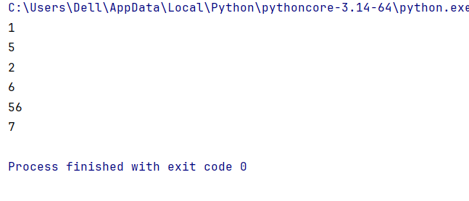

Part 1(d)(i)
{Copy and paste the program code listing for question 1(d)(i) here}
def addNode(mylist,emptyP, startp):
thisdata = int(input("Enter Data to insert in list: "))
insert = False
index = startp
thisnode = emptyP
if emptyP< 0 or emptyP > len(mylist):
return False
else:
mylist[emptyP].data = thisdata
emptyP = mylist[emptyP].nextNode
insert = False
while insert == False:
if mylist[index].nextNode == -1:
mylist[index].nextNode = thisnode
insert = True
else:
index = mylist[index].nextNode
return True

Part 1(d)(ii)
{Copy and paste program code listing for question 1(d)(ii) here}

outputNodes(linkedList, startPointer)
Inserted = addNode(linkedList,emptyList, startPointer)
if Inserted == True:
print("Value has been inserted.")
else:
print("List is full.")
outputNodes(linkedList, startPointer)

Part 1(d)(iii)
{Copy and paste the screenshot for question 1(d)(iii) here}

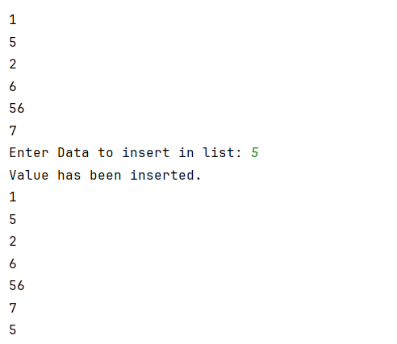

Question 2
Part 2(a)
{Copy and paste program code listing for question 2(a) here}

#DECLARE arrayData : ARRAY[0:9] OF INTEGER
global arrayData
arrayData = []
values = [10,5,6,7,1,12,13,15,21,8]
for insert in range(10):
arrayData.append(values[insert])

Part 2(b)(i)
{Copy and paste program code listing for question 2(b)(i) here}

def linearSearch(searchVal):
index = 0
while index < 10:
if searchVal == arrayData[index]:
return True
else:
index = index +1
return False

Part 2(b)(ii)
{Copy and paste program code listing for question 2(b)(ii) here}

inputVal = int(input("Enter a value to search: "))
if linearSearch(inputVal) == True:
print("Value was found.")
else:
print("value is not in the array.")

Part 2(b)(iii)
{Copy and paste the screenshots for question 2(b)(iii) here}

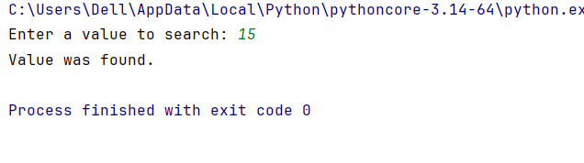

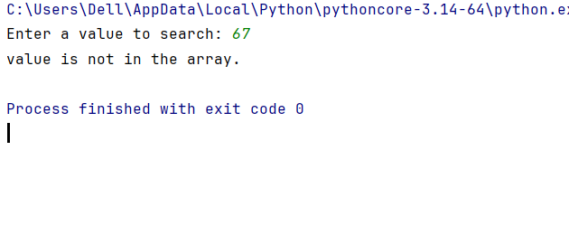

Part 2(c)
{Copy and paste program code listing for question 2(c) here}

def bubbleSort():
for x in range(len(arrayData),0, -1):
for y in range(x-1):
if arrayData[y] < arrayData[y+1]:
temp = arrayData[y]
arrayData[y] = arrayData[y+1]
arrayData[y + 1] = temp

Question 3
Part 3(a)
{Copy and paste program code listing for question 3(a) here}

class TreasureChest:
#DECLARE question: STRING
#DECLARE answer : INTEGER
#DECLARE points : INTEGER
def __init__(self, qstn, answer, pts):
self.__question = qstn
self.__answer = answer
self.__points = pts

Part 3(b)
{Copy and paste program code listing for question 3(b) here}

global arrayTreasure
arrayTreasure = []
def readData():
global arrayTreasure
try:
with open("TreasureChest.txt", 'r') as file:
for index in range(5):
thisquestion = file.readline().strip()
thisanswer = int(file.readline().strip())
thispoints = int(file.readline().strip())
arrayTreasure.append(TreasureChest(thisquestion, thisanswer,thispoints))
except FileNotFoundError:
print("The accessed file could not be found.")

Part 3(c)(i)
{Copy and paste program code listing for question 3(c)(i) here}

def getQuestion(self):
return self.__question

Part 3(c)(ii)
{Copy and paste program code listing for question 3(c)(ii) here}

def checkAnswer(self, userAnswer):
if userAnswer == self.__answer:
return True
else:
return False

Part 3(c)(iii)
{Copy and paste program code listing for question 3(c)(iii) here}

def getPoints(self, attempts):
if attempts ==1:
return self.__points
elif attempts == 2:
return self.__points // 2
elif attempts > 4:
return 0
else:
return self.__points // 4

Part 3(c)(iv)
{Copy and paste program code listing for question 3(c)(iv) here}

readData()
Qnum = int(input("Enter a question number(1-5): "))
print(arrayTreasure[Qnum -1].getQuestion())
ThisAnswer = int(input("Answer: "))
attempts = 1
Correct = arrayTreasure[Qnum -1].checkAnswer(ThisAnswer)
while not(Correct):
ThisAnswer = int(input("Try again: "))
attempts = attempts +1
Correct = arrayTreasure[Qnum - 1].checkAnswer(ThisAnswer)
print(f"User got: {arrayTreasure[Qnum -1].getPoints(attempts)} points.")

Part 3(c)(v)
{Copy and paste screenshots of the two tests for question 3(c)(v) here}

