Max M Hanson (u0985911)

Professor Ladislav Kavan

CS 4600

18 October 2019

Assignment 3 Writeup

Here’s a high-level description of the algorithm I implemented for part 1.

For each triangle (**t**) on the teapot: compute the surface normal (**s-t**) for that triangle, add **s-t** to the normal vector of each vertex on the triangle, and increment the number of surface-normals added to each vector. After this, for each normal vector (**n**): divide **n** by the number of surface-normals previously added to **n**.

After this, each normal vector is the average of the surface normals of each triangle touching the corresponding vertex. The result of this algorithm is shown below.

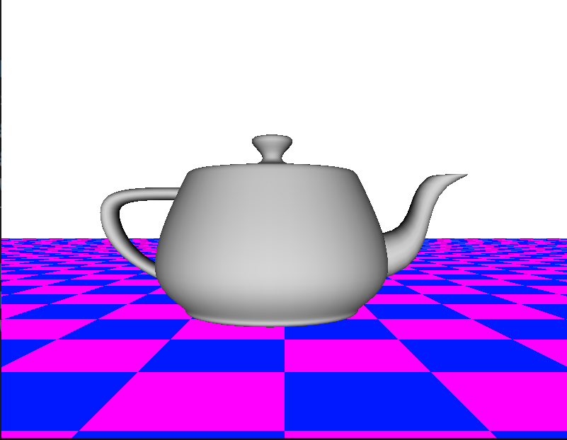

To complete this part, I referenced [this](https://www.khronos.org/opengl/wiki/Calculating_a_Surface_Normal) webpage (<https://www.khronos.org/opengl/wiki/Calculating_a_Surface_Normal>) to see how to compute surface normals of triangles.

To complete part 2, I referenced [this Wikipedia article](https://en.wikipedia.org/wiki/Transformation_matrix#Rotation) for rotation transformations (<https://en.wikipedia.org/wiki/Transformation_matrix#Rotation>) to get a matrix for rotating 2D points. By tinkering with this matrix on paper, I was able to adapt it to 3D to rotate 3D points around the y-axis. I did this by experimenting with positioning the trig functions in different spots and combining the result with the identity matrix.

I coded up the resulting matrix and added the distance in the same position as before to get a combination transformation that translates the teapot away from the camera and rotates it.

After this, I set the angle of rotation to be a function of time. This results in the rotation you can see on [this YouTube video](https://www.youtube.com/watch?v=rVgXFtTmPR0&feature=youtu.be) (<https://www.youtube.com/watch?v=rVgXFtTmPR0&feature=youtu.be>).

To complete part 3, I started with a basic call to glOrtho, as described in the assignment. After that, I tweaked the parameters until I got the sides of the teapot to roughly stay the same when switching between orthogonal and perspective projection modes. The values of left, right, bottom, top I settled on is -1.25, 1.25, -0.9, 0.9, respectively. Below are screenshots of the two modes that result from what I did above.

