Homework 7: Databases
In this homework, you will be populating a database table with information about Pokemon (we have provided the cache data in pokemon.json) and writing code to fetch data from the table that you create.
Pokemon, short for ‘pocket monsters’ (TIL), is a video game series from Nintendo with a corresponding card game, television show, and several movies. Pokemon are creatures with special abilities that can be caught and taught to battle by Pokemon Trainers. Each pokemon has a unique level of stats that affect their fighting ability, including hit points (HP), speed, attack power, and defense power. Many Pokemon can evolve into new forms from gaining battle experience. Every pokemon has a type, some have more than one, that defines what type of abilities they can use (such as water, fire, or grass). Pokemon are most often caught by players to battle other pokemon, but other activities exist for players and pokemon to take part in such as fashion shows!
We have provided code for the following:
- read_data_from_file(): To read the cache data in pokemon.json
- set_up_database(): To create an SQLite database and set up the ‘connection’ and ‘cursor’
- set_up_types_table(): To create/setup one of the SQLite tables for you. This table is called ‘Types’. Run the starter code and then check the structure of the ‘Types’ table using the DB Browser!
These functions are provided for you. PLEASE DO NOT CHANGE THEIR CODE.
When done with the assignment, your database will have two tables. First table Pokemon will be based on the code you wrote to create and fill it. Second table Types will be the one already provided for you.
We have also provided test cases that will pass if the functions are written correctly. Do NOT edit the test cases in any way.
Note: For extra credit, you will have to uncomment the test_pokemon_fastest_of_type() function, and pass all the test cases within it.

Tasks
- build_pokemon_table(data, cur, conn): This function takes 3 arguments as input: the data (written in JSON format), the database cursor, and the database connection object. It returns nothing. It should iterate through the data present in pokemon.json and create a table Pokemon with the following columns:
- pokemon_id (datatype: integer and Primary key)
- name (datatype: text)
- type1_id (datatype: integer)
- type2_id (datatype: integer or NULL)
- health_points (datatype: integer)
- speed (datatype: integer)
- attack (datatype: integer)
- spl_attack (datatype: integer)
- defense (datatype: integer)
- spl_defense (datatype: integer)
The function then loads all data present in pokemon.json into this table.
Note that some pokemon only have one type. In these cases, the value of type2_id for that pokemon should be NULL in the database.
Hint: To find the type1_id and type2_id values for each pokemon, you will first have to look up data in the Types table we create for you. See setUpTypesTable() and the ‘Types’ table itself in the DB Browser to get a better understanding.
Expected table in DB Browser (refresh database to view this):
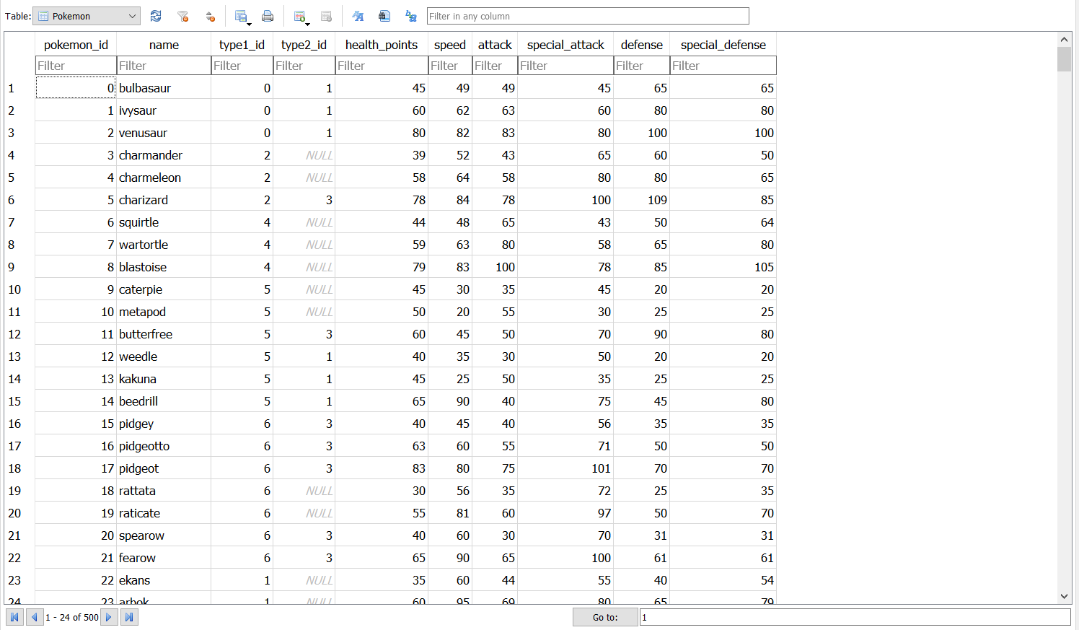
- pokemon_in_defense_range(defense_min, defense_max, cur): This function takes three arguments as input: defense_min value, defense_max value, and the database cursor. It selects all pokemon which have a defense value inside that range (inclusive). It returns a list of tuples, each tuple containing a pokemon_id, name, and defense.
For example, a pokemon named ‘test’, having a defense stat of 45 would be included in the returned values if the function was called as pokemon_in_defense_range(40, 50, cur).
Example output for pokemon_in_defense_range(40,55, cur):
[(0, 'bulbasaur', 65), (3, 'charmander', 43), (10, 'metapod', 55),...(498, 'pignite', 55)]

- balanced_pokemon_above_speed_min(speed_min, cur): This function takes two arguments as input: A minimum speed value and the database cursor. It selects all "balanced" pokemon with a speed level above the speed_min value. For the purpose of this function, a "balanced pokemon" is defined as a pokemon with a defense value equal or higher than the attack value.
Note: pokemon that match the speed_min value should be included in the results
It returns a list of tuples, each tuple containing a pokemon_id, name, defense, attack, and speed.
Example output for balanced_pokemon_above_speed_min(40, cur):
[(0, 'bulbasaur', 49, 49, 45), (1, 'ivysaur', 63, 62, 60), (2, 'venusaur', 83, 82, 80), (6, 'squirtle', 65, 48, 43),..]

- pokemon_with_defense_difference(defense_difference, cur): The function takes two arguments as input: the defense_difference(int), and the database cursor. It selects all the pokemon when the difference in the defense and the special_defense is greater than defense_difference. It then returns a list of tuples.
It returns a list of tuples, each tuple containing the pokemon name, defense, special_defense and difference.
Expected Output for pokemon with difference > 15:
[('bulbasaur', 49, 65, 16), ('ivysaur', 63, 80, 17,... ('palkia', 100, 120, 20)]

- pokemon_by_type_value(type_value, cur): This function takes two arguments as input: a type value and the database cursor. It selects all pokemon which match that type and returns a list of tuples. Each tuple should contain a pokemon_id, name, and their type1 and type2 values.
Note that the pokemon may match the type value as either their first or second type in the database. Additionally, the returned type1 and type2 values should be the text values of the types and not the id numbers.
Hint: You have to use a JOIN for this task.
Example output for pokemon_by_type_value("grass", cur):
[(0, 'bulbasaur', 'grass', 'poison'), (1, 'ivysaur', 'grass', 'poison'), (2, 'venusaur', 'grass', 'poison'), … (496, 'serperior', 'grass', None)]
Extra Credit (6 points)
pokemon_fastest_of_type(type, cur): This function takes two arguments as input: a pokemon type and the database cursor. It selects the pokemon of the specified type with the highest speed value. In the case of multiple pokemon with the same highest speed, all such pokemon should be returned.
The function returns a list of tuples, with each tuple containing the pokemon name, type (passed into the function), and speed value.
Remember that some pokemon may have 2 types (type 1 and type 2). Make sure that the type returned matches what has been passed into the function (this can be seen in test_pokemon_fastest_of_type())
Example output for pokemon_fastest_of_type("ghost", cur):
[('froslass', ‘ghost’, 110), ('gengar', 'ghost', 110)]
Make sure to uncomment the function test_pokemon_fastest_of_type() for this portion of the homework. Your extra credit code must pass the commented test cases to receive credit.

Grading Rubric
- build_pokemon_table(): - 15 Points
  - 5 points for creating all 10 columns in the table (using the correct data type for each column)
  - 5 points for entering all 500 pokemon in the table
  - 5 points for properly using NULL when an entry does not have a second type value

- pokemon_in_defense_range() - 10 points
  - 5 points for correctly selecting the pokemon based on stated criteria
  - 5 points for returning the list of tuples with the correct column values in each tuple
- balanced_pokemon_above_speed_min() - 10 points
  - 5 points for correctly selecting the pokemon based on stated criteria
  - 5 points for returning the list of tuples with the correct column values in each tuple
- pokemon_with_defense_difference() - 10 points
  - 5 points for returning a list of tuples of pokemon at the defense difference
  - 5 points for returning the list of tuples with the correct column values in each tuple

- pokemon_by_type_value() - 15 points
  - 5 points for correctly using a JOIN to get each pokemon’s type for their corresponding type_id
  - 5 points for correctly selecting the pokemon based on stated criteria
  - 5 points for correctly returning the list of tuples with the correct column values in each tuple

