Would you like to learn
what the sumerians really thought about Hematite?
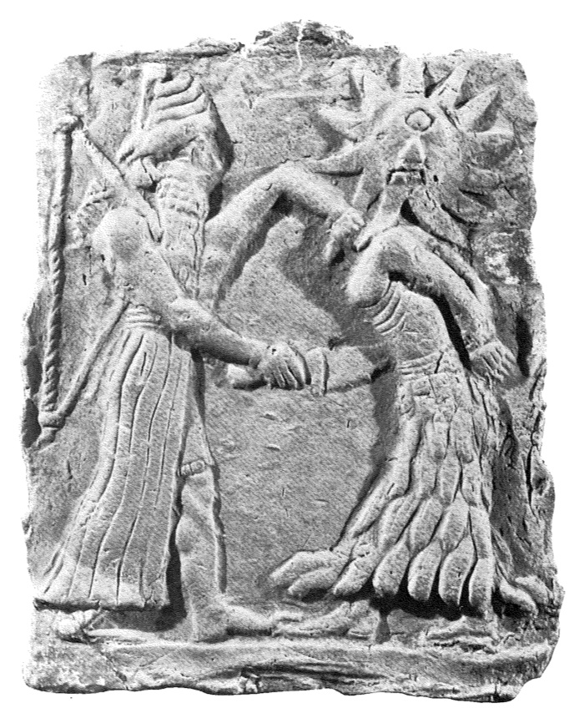
Then consider joining the Astronomy Department’s Obscure Ancient Languages Group

Mondays during Lunchtime this Summer in Room 301

We will learn the basics of the Sumerian Language and Cuneiform Script
and read a translation of a “Geologically Interesting” Sumerian myth,
where a god fights a volcano (maybe) and lectures rocks (yes, rocks)

No experience or knowledge of Ancient Languages is needed!

if you are interested,
e-mail mmhedman@astro.cornell.edu

