* **Preparing Environment and deploy files:**

1. **Install Xampp then Open Xampp and open admin page**

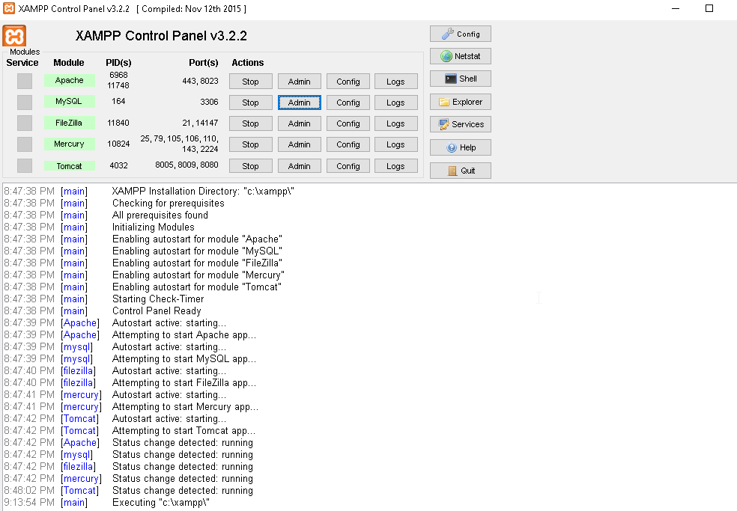

1. **To create SQL Lite files open the XAMPP shell as the following :**

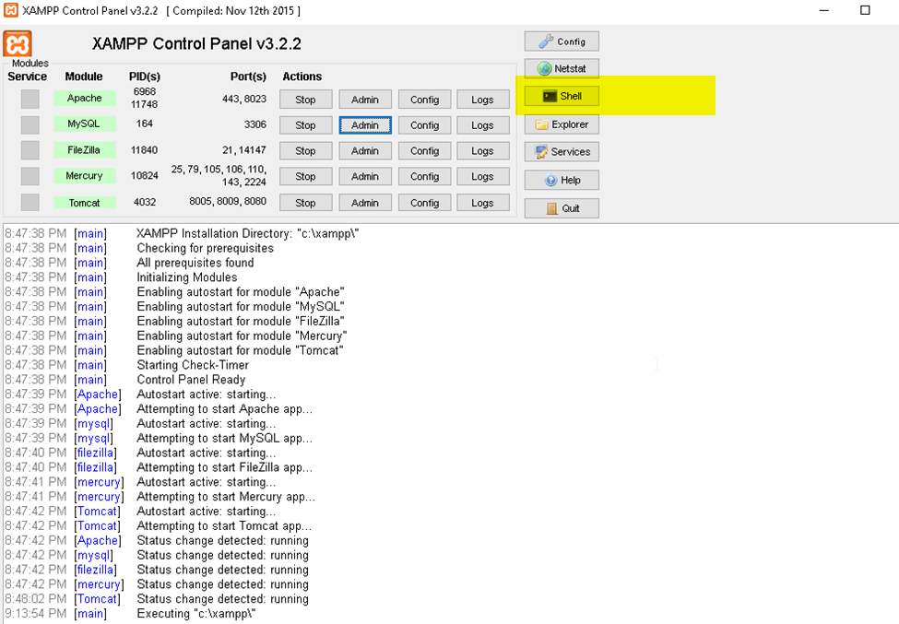

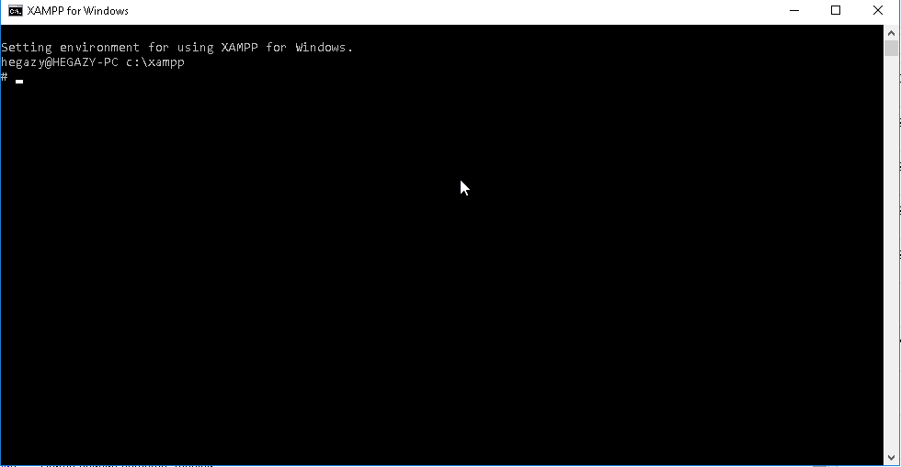

1. **Got to XAMPP/INSTALLATION/PATH/htdocs**



1. **From command prompt create a DB called appointments using command :**

**Sqlite3 appointments.sq3**



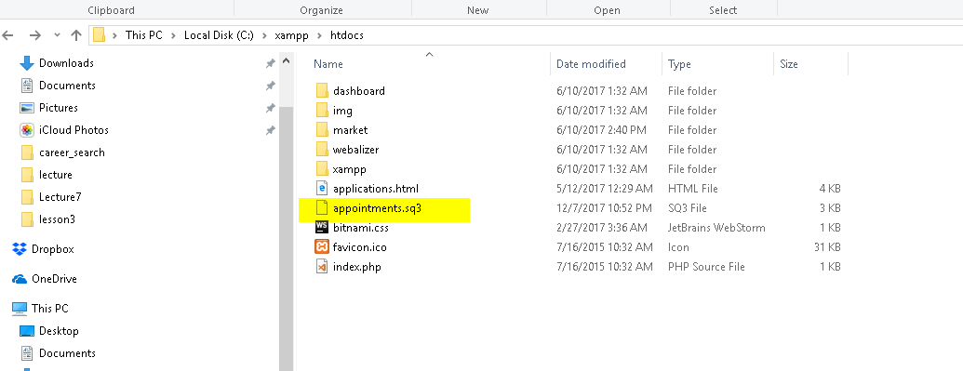

1. **CREATE the table from the SQLlite manager as the following :**

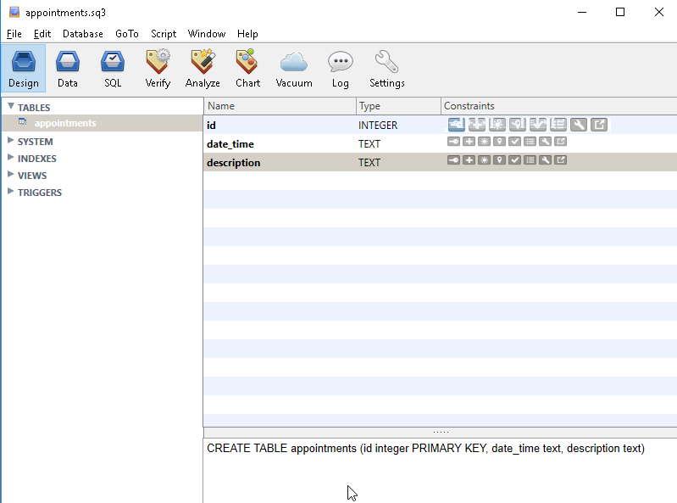

1. **Open the DB using SQLLITE manager to view data and make sure that the GUI inserted records after testing the application GUI:**

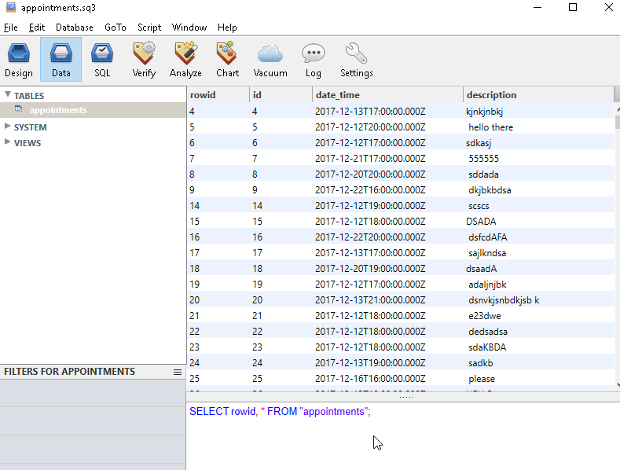

1. **Deploy the application to the XAMPP server under xampp/installation/directory/path /htdocs**

* **Running the application**

1. **Open the application using the following URL** [**http://localhost:port/**](http://localhost:port/)

**Where the port is your port number configured on XAMPP**

**And because the page name is index.html , it will be opened without specifying the html file name .**

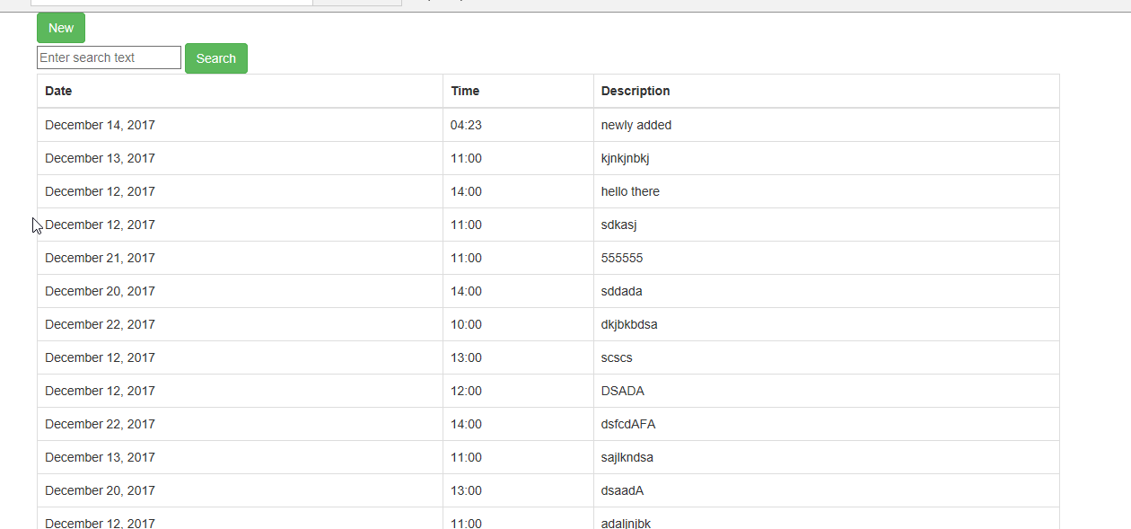

1. **If the user click new then click add without filling data and time the page will show error**

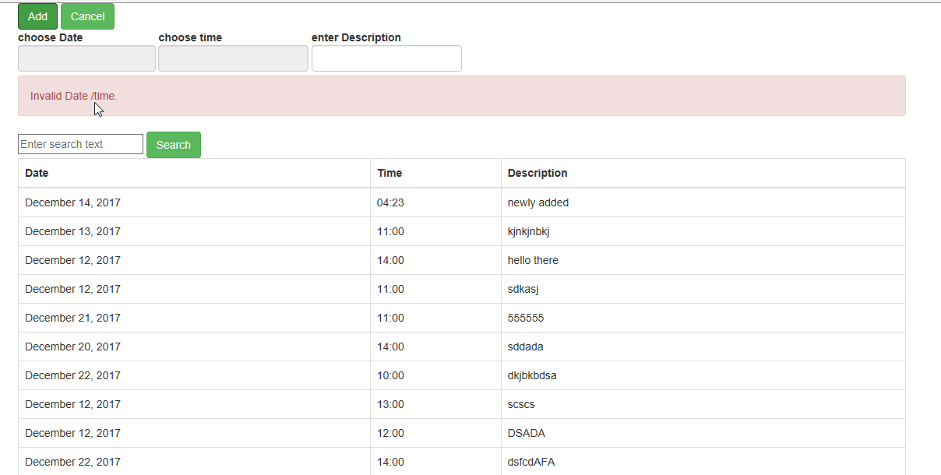

1. **Date time will start from today’s date and for past days will be disabled and user cannot select it .**

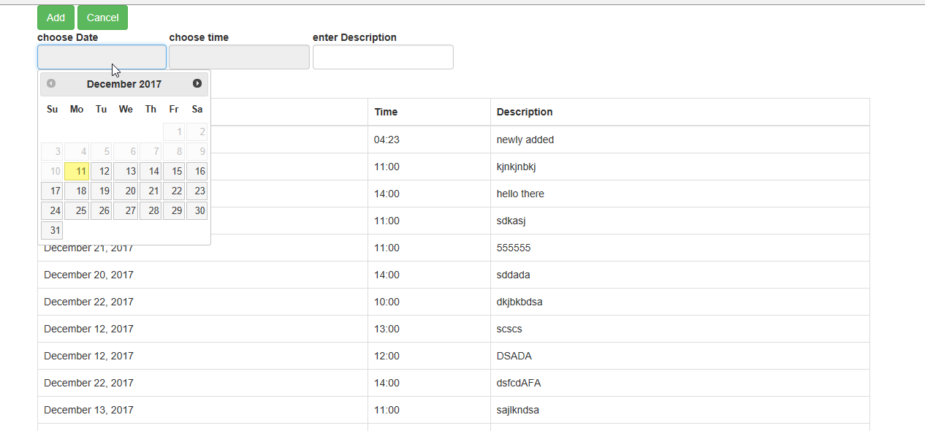

1. **for accessibility if user clicked on the label even outside the date time picker text box the date picker will appear**



1. **If user clicked time the time will appear the time to be chosen is configured from 09:00 AM to 20:00 and can be changed by changing from the javascript file .**

**$('.timepicker').timepicker({**

**timeFormat: 'HH:mm',**

**interval: 60,**

**minTime: '09',**

**maxTime: '20:00',**

**defaultTime: '11',**

**startTime: '09:00',**

**dynamic: false,**

**dropdown: true,**

**scrollbar: true**

**});**

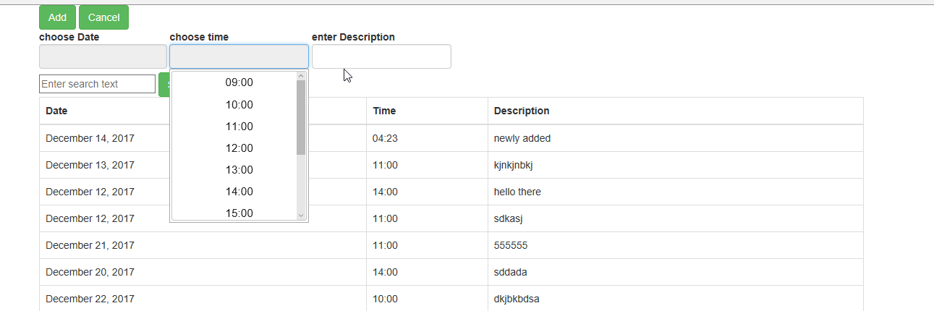

1. **When the user click search the result will appear in the same page using ajax as required**

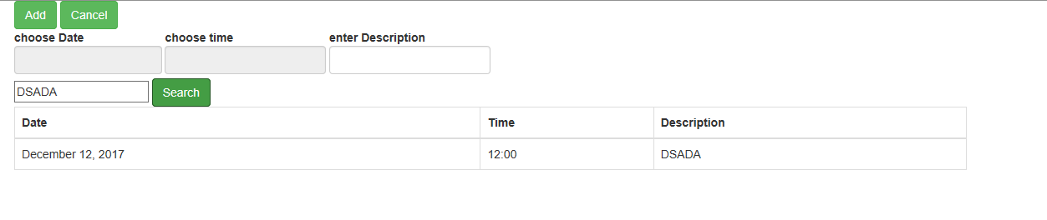

1. **User can add any appointment**

