Conservation Efforts Database Footprinter 2.1

User Help Manual

Matt Heller ([matthew_heller@fws.gov](mailto:matthew_heller@fws.gov)), Conservation Efforts Database Development Team, USFWS Region 6 Science Applications

Created 3/28/2018

Table of Contents

Purpose 1

Creating an Area (polygon) Using the Drawing Tool(s) 1

Deleting an Existing Area (polygon) 2

Uploading a Shapefile to Import/Load Areas (polygons) 3

# Purpose

The purpose of this document is to provide brief instructions to create, update, and delete the spatial area representations of conservation efforts within the CED (Conservation Efforts Database). This document does not provide help for other CED tools.

# Creating an Area (polygon) Using the Drawing Tool(s)

1. Click the Start Drawing button

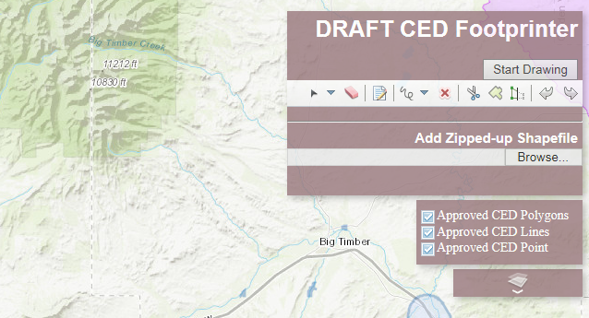

1. Click the Down Arrow on the toolbar and select one of the polygon editing tools

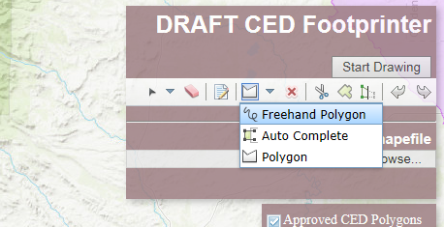

1. Follow the instructions displayed with the mouse pointer

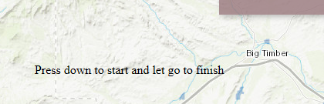 OR 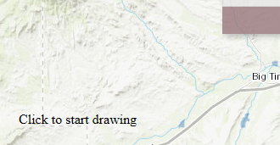 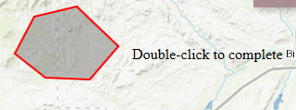

1. A read only information popup will display. If the polygon should be saved, close the popup by clicking the “x” in the upper right. **Or** if the polygon is **not** to be saved, click the Delete button.

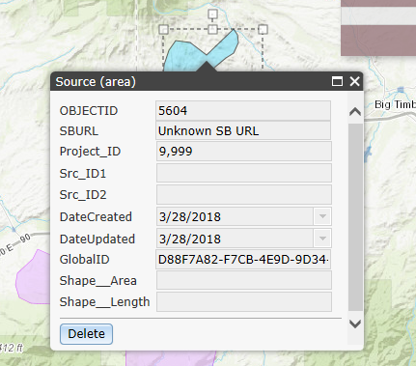

# Deleting an Existing Area (polygon)

1. Click the New selection tool

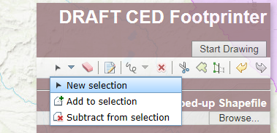

1. Hold the mouse button 🡪drag a selection box over the features to delete

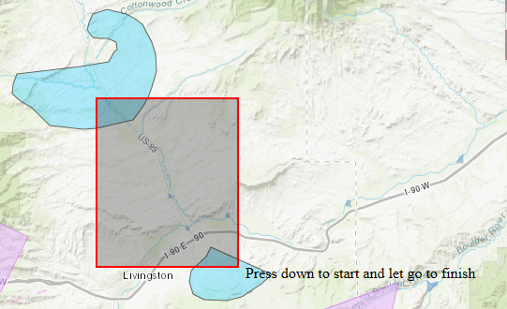

1. Click the delete tool/button

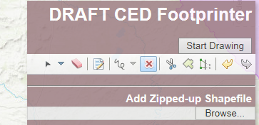

Or

1. If no tool in the toolbar is active/selected, double click an area (polygon)

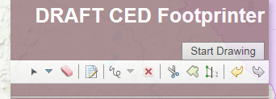 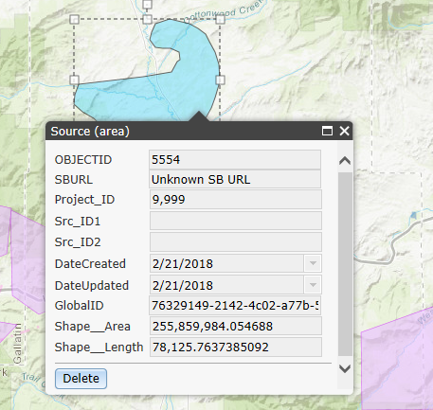

1. Click the Delete button on the popup window



# Uploading a Shapefile to Import/Load Areas (polygons)

1. Verify a source shapefile is free of topological errors and compress to a zip file

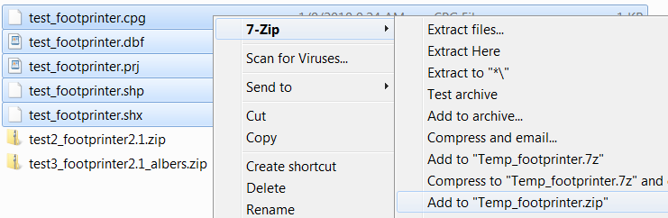

1. Click the Browse... button

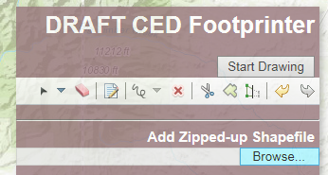

1. Browse to a .zip file 🡪select the .zip file 🡪 click Open

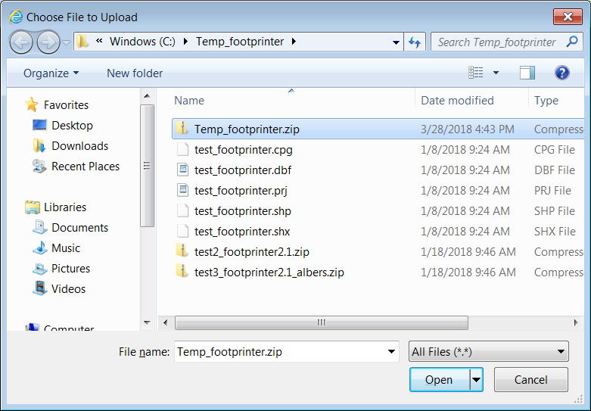

1. A read only information popup will display. If the area (polygon) looks good and should be saved, close the popup by clicking the “x” in the upper right. **Or** if the polygon is **not** to be saved, click the Delete button.

