In the index.html file 🡪Scroll down to the content

<div id="navigation">

<form id="NavigationForm">

Add some text like the following

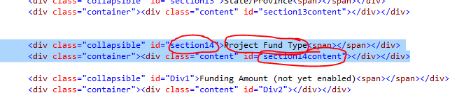

Go to the MH_UniqueSetup.js file 🡪returnEvents function 🡪 switch statement

Edit the following

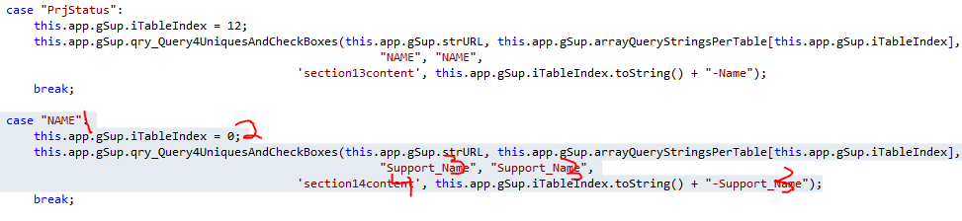

1. Add the file name from the previous case condition
2. Add the index number of the table from the rest endpoint <https://www.sciencebase.gov/arcgis/rest/services/Catalog/530fdba2e4b0686a920d1eea/MapServer>
3. Add the fieldname from the rest endpoint

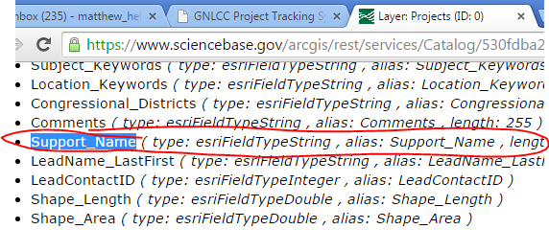

1. From the index.html file – add the collapsaible ID