De-normalized project (snpc)



Project Contacts





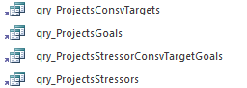

Process gdb

Dissolve C:\Projects\Project Tracking\GIS\Prjs4AGS.gdb\projects based on projected

Run all the .txt exports

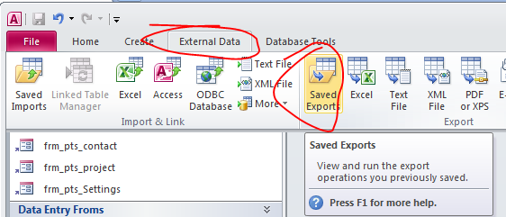

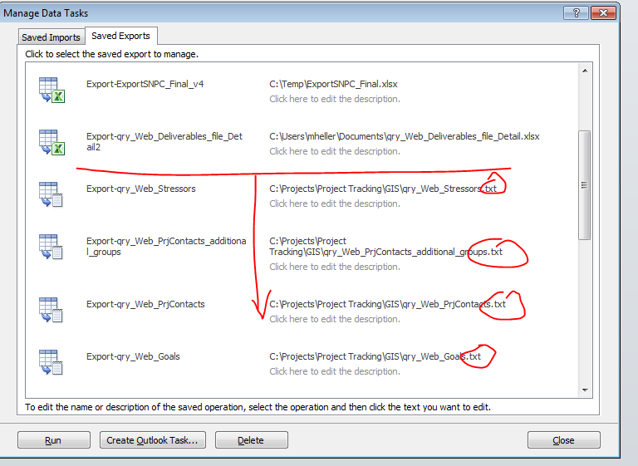

Import the txt files except the 2 deliv files

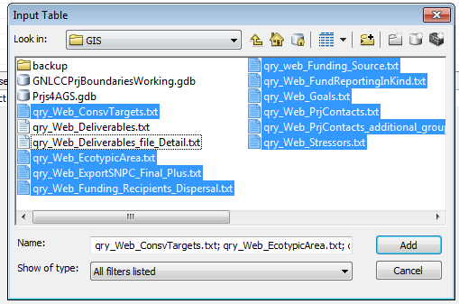

Rename and replace all but the 2 deliverable files

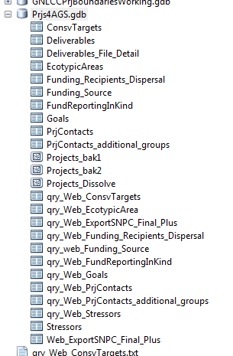🡪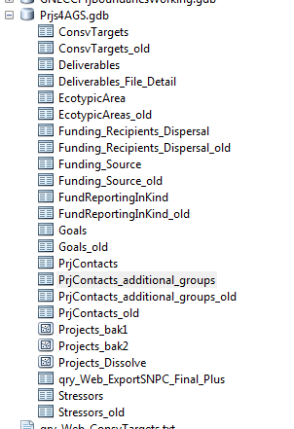🡪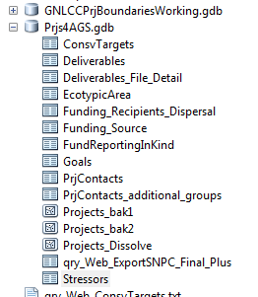

Delete existing records from the deliverable tables

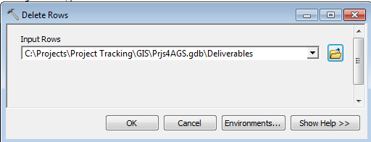

Import from qry_web_deliverables.txt and qry_web_deliverables_file_detail.txt

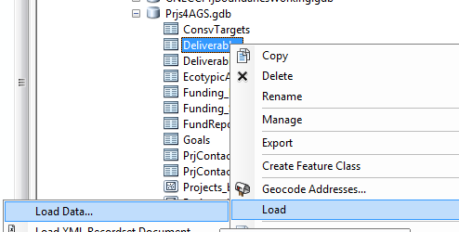

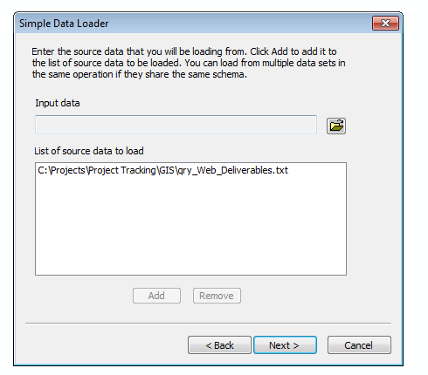

Join the qry_Web_ExportSNPC_Final_Plus table with Projects_Dissolve

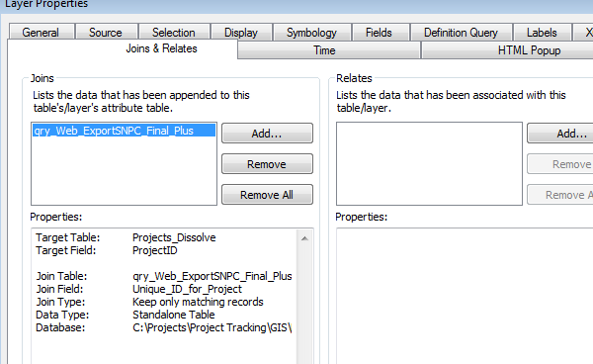

Turn off the visibility of a few fields

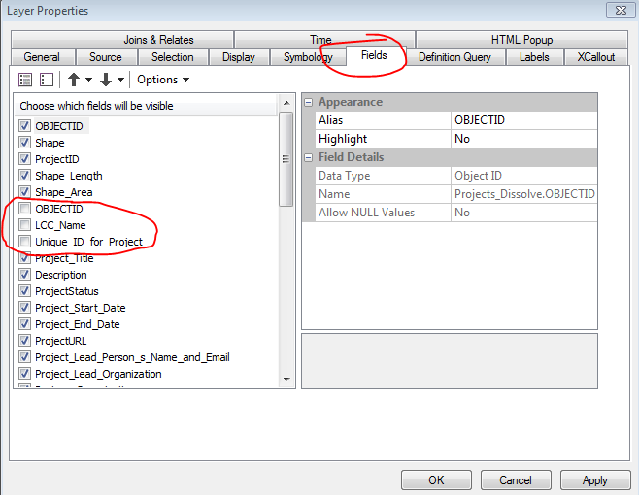

Export the FC to a new Projects featureclass

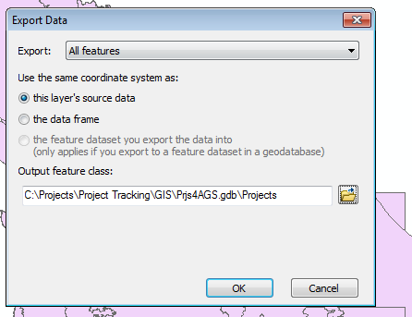.

Set symbology similar to this screenshot and verify the non-spatial tables are alphabetic order

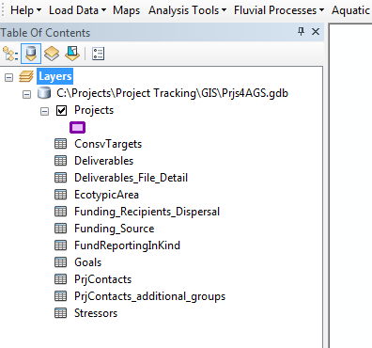

Update the service cataloged at…

https://www.sciencebase.gov/catalog/item/530fdba2e4b0686a920d1eea