Copy all the file needed from

C:\Apps_Programming\Website\PTS\GNLCC_PTS

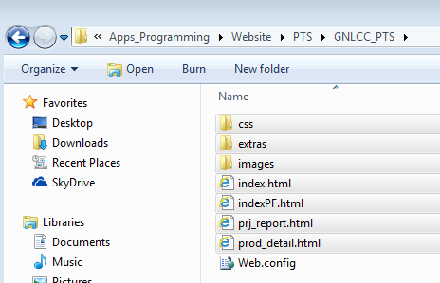

To

C:\Apps_Programming\Website\mmheller.github.com\mmheller.github.com

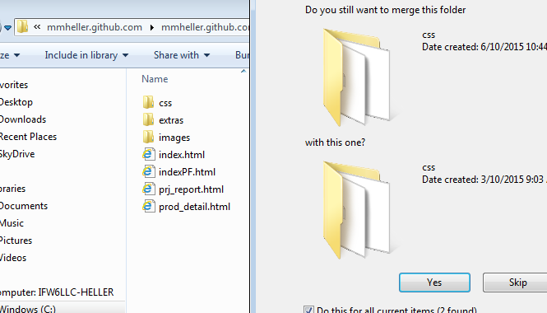

Open GitHub desktop app

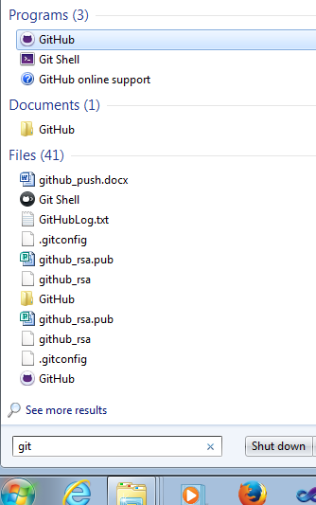

Select a repo that has changes and difference symbol, then enter a title of change and click Commit to master

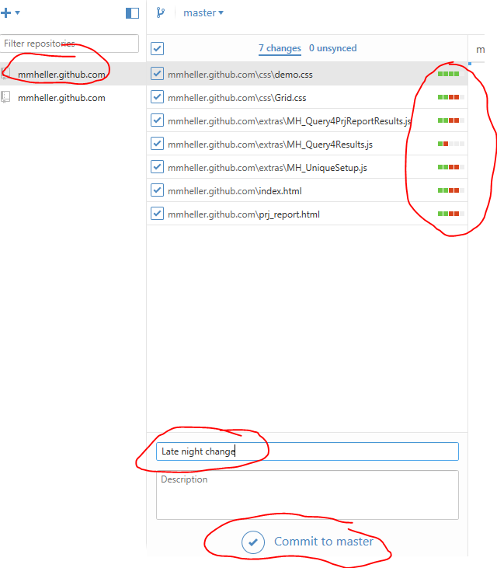

Click sync changes

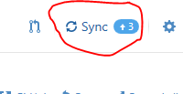

11:31