CPU Scheduling Implementation

Kyler Finn, Morgan Houston, Haley Walston, Jordan Wright

1. Introduction:  
   In this project, we analyze round robin scheduling and multilevel queue scheduling in CPUs and show how they can be formulated and displayed.
2. Scheduling Technique  
   1. Round Robin scheduling – each process is assigned a fixed time slot in a cyclic way.

2. Multilevel queue scheduling – partitions the ready queue into several separate queues.

Gantt chart – visual chart that shows the procedure of process scheduling.

1. Running the program – Upon running the program, a table is displayed detailing the process’s data for each scheduling technique. A GUI is implemented to allow the user to change the time quantum and calculate the Gantt chart, average turnaround time, and average waiting time.
2. Source Code  
   [Paste Image screenshots for source code. Also, submit the source file]

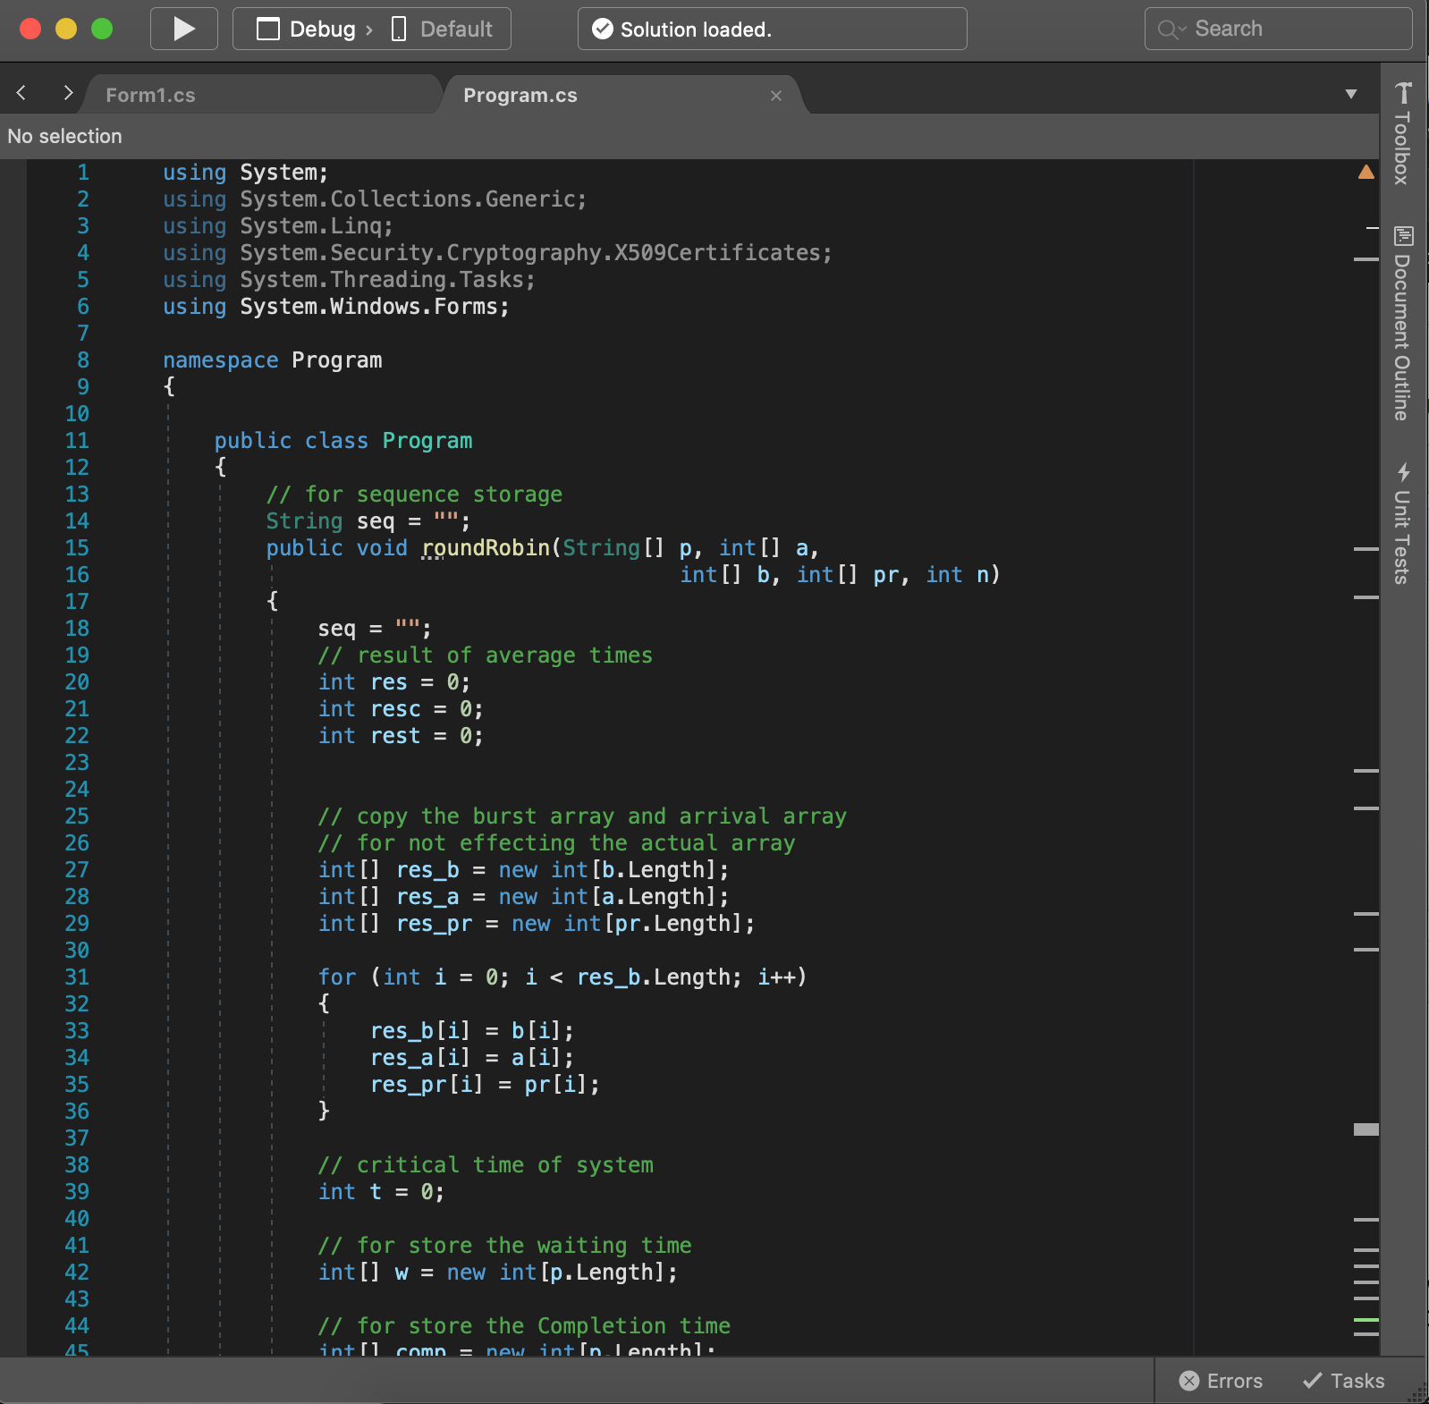

1. Output

[Screenshots]

References(s)

----------------------------------------------------------------------------------------

https://www.geeksforgeeks.org/program-round-robin-scheduling-set-1/

Operating System Concepts 9th Edition – Abraham Silberschatzk, Peter Baer Galvin, Greg Gagne

Work done by each member of the group

Kyler Finn – RR scheduling, merge branch, minor fixes

Morgan Houston – Base file, tables, calculations, readme file

Haley Walston –

Jordan Wright – Canvas group, Project Report write-up