CPU Scheduling Implementation

By:

Kyler Finn, Morgan Houston, Haley Walston, & Jordan Wright

1. **Introduction**

In this project, we analyze the round robin and multilevel queue scheduling schemes. By scheduling these process’ we can see their turnaround times and waiting times. In our program, you can change the time quantum by clicking the ‘+’ and ‘-‘ buttons. You will see the time quantum label change by a value of 1. You can then calculate the average waiting and turnaround times for that time quantum. You can reset the program and calculate another time quantum to see the difference.

1. **Scheduling Techniques**

We used the Round Robin scheduling with preemptive priority to schedule the first set of processes.

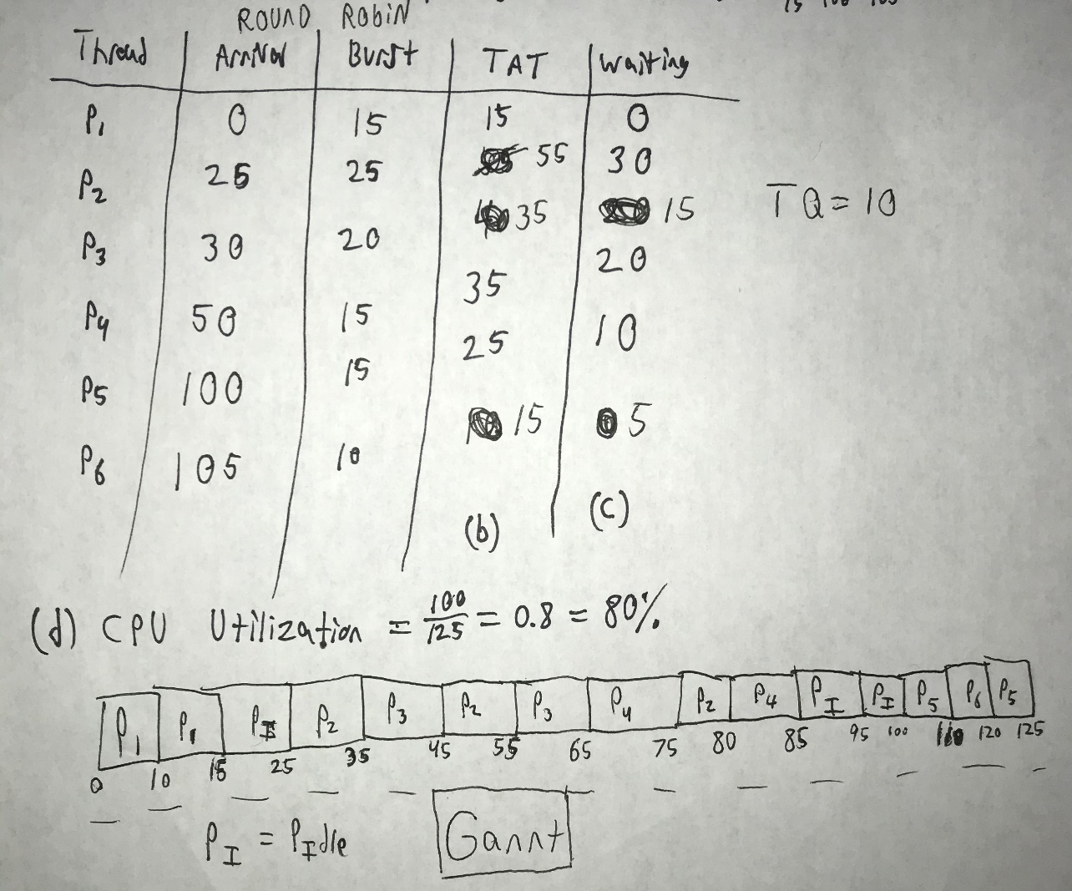

The next scheduling technique we used is multilevel queue with two queues, both using round robin scheduling.

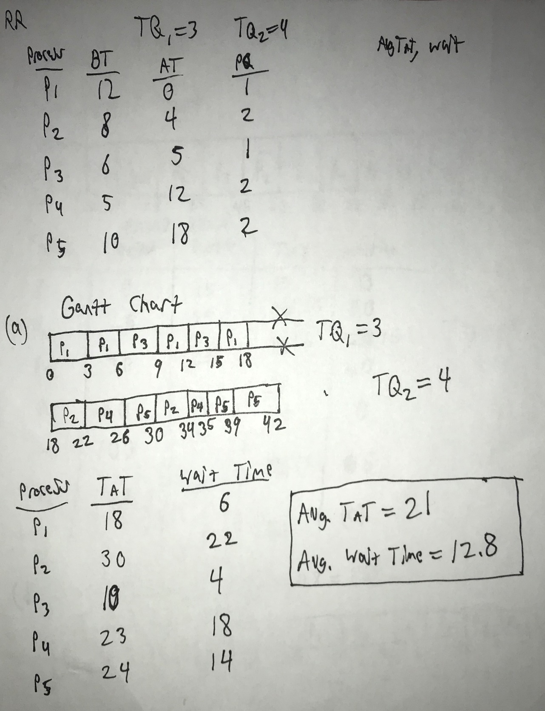

1. **Running the program**

When the program starts, a list of processes and their arrival times, burst times, and priority is displayed for each scheduling technique. We use Round Robin and Multilevel Queue scheduling schemes to schedule these processes. You can change the time quantum for either, by using the '+' and '-' buttons on the left. Press the calculate button to see the Gannt chart, average turnaround and the average waiting time of the process list. Reset button will clear the Gannt chart and average data.

1. **Source Code**

<https://github.com/mmhousto/Program>

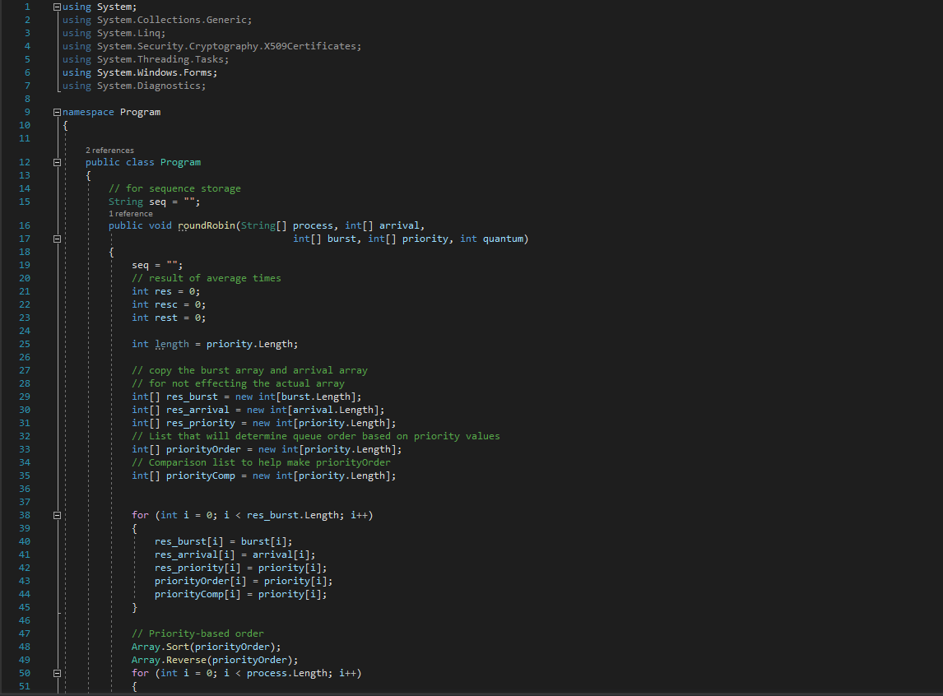

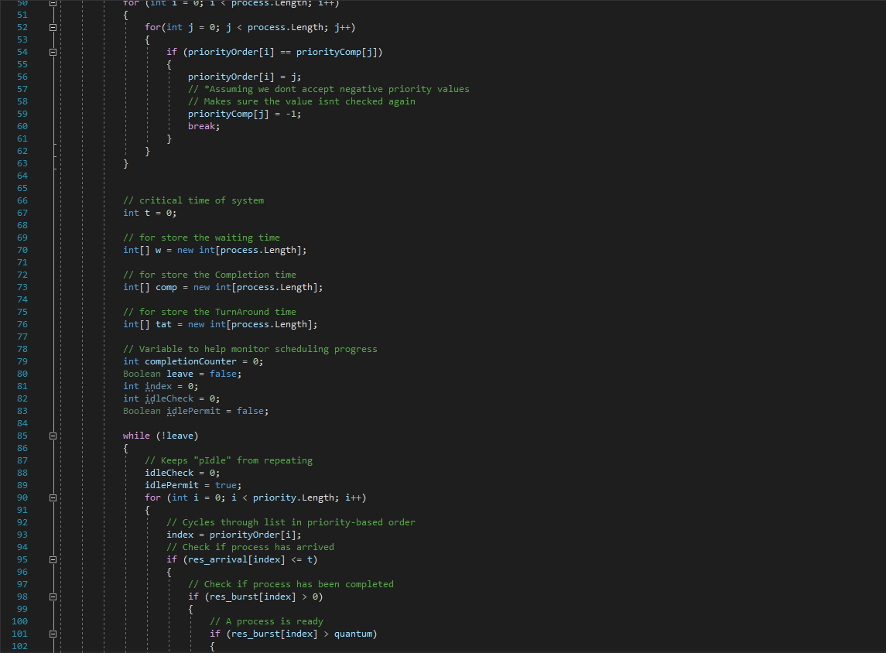

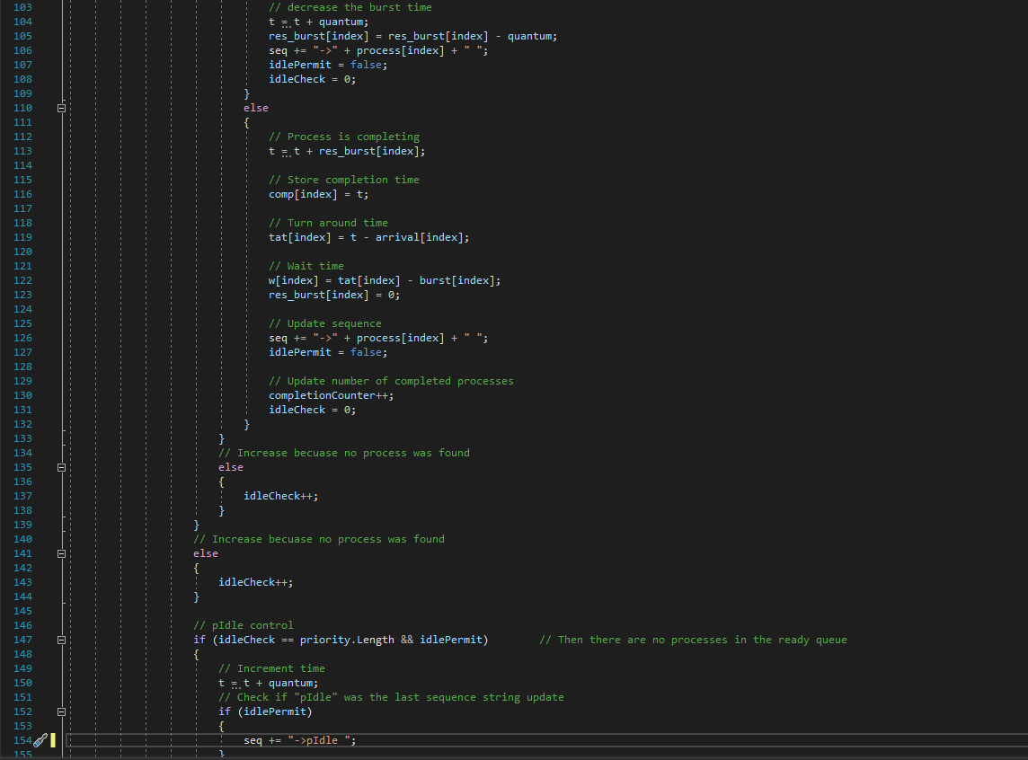

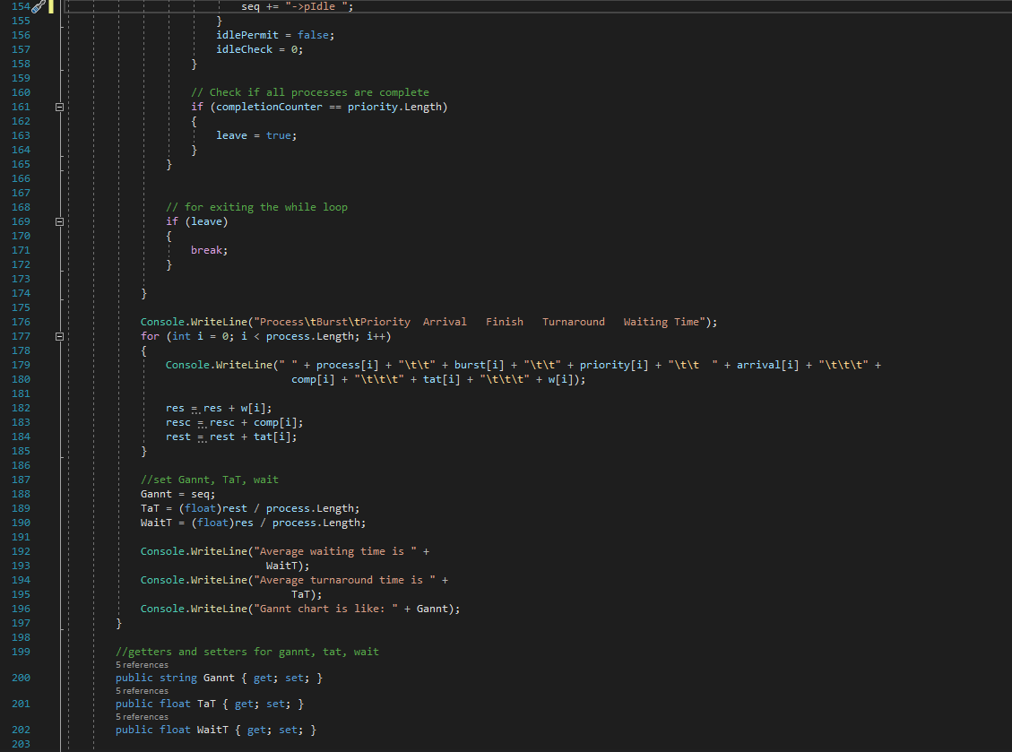

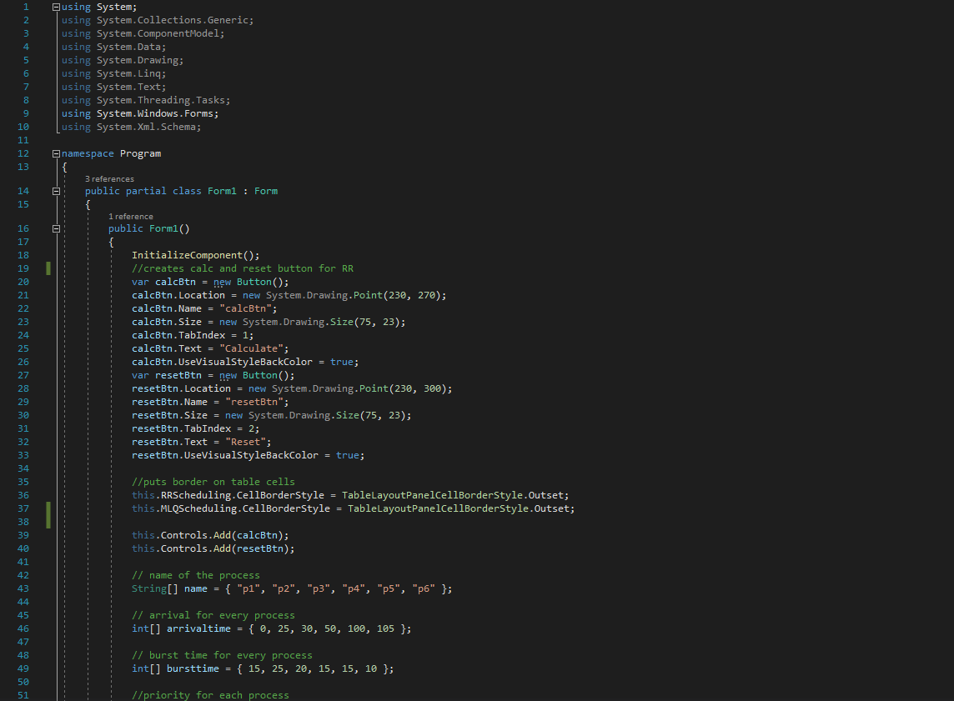

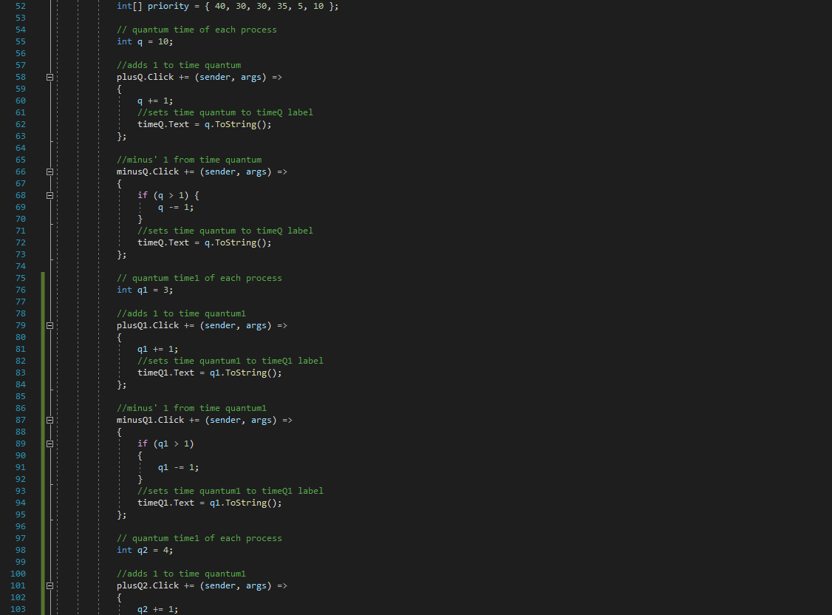

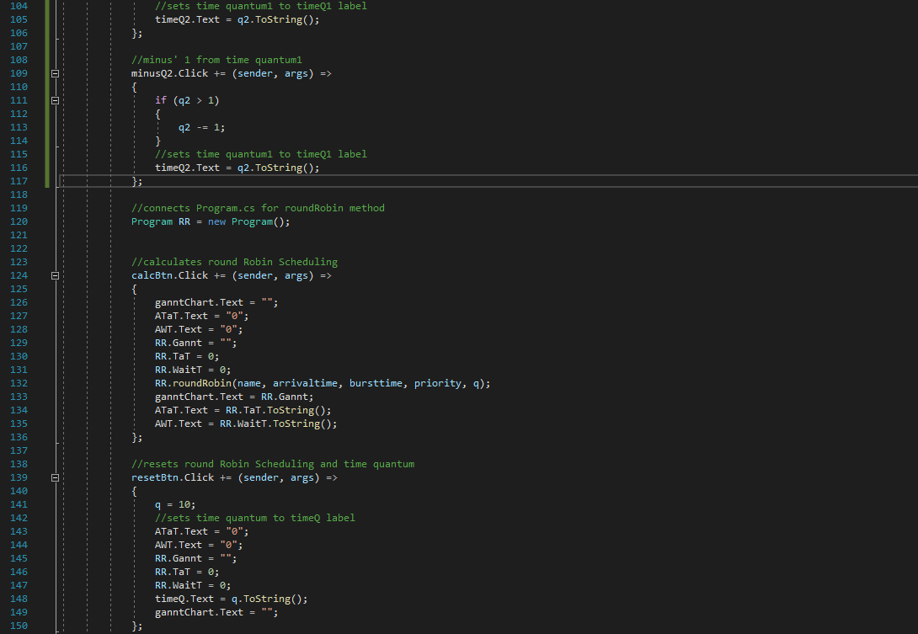

1. **Output**

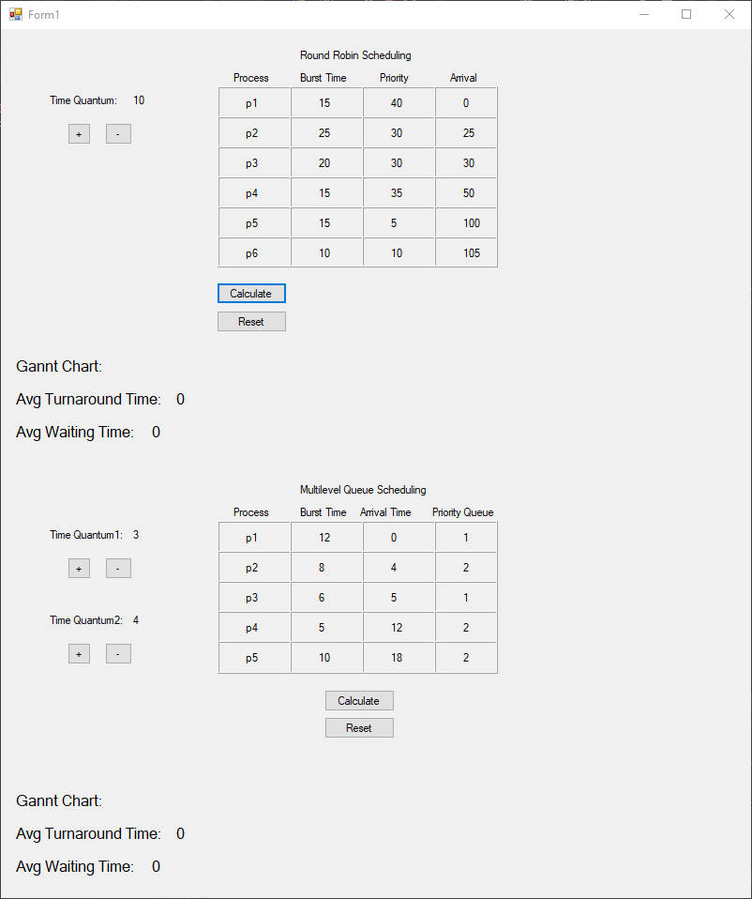

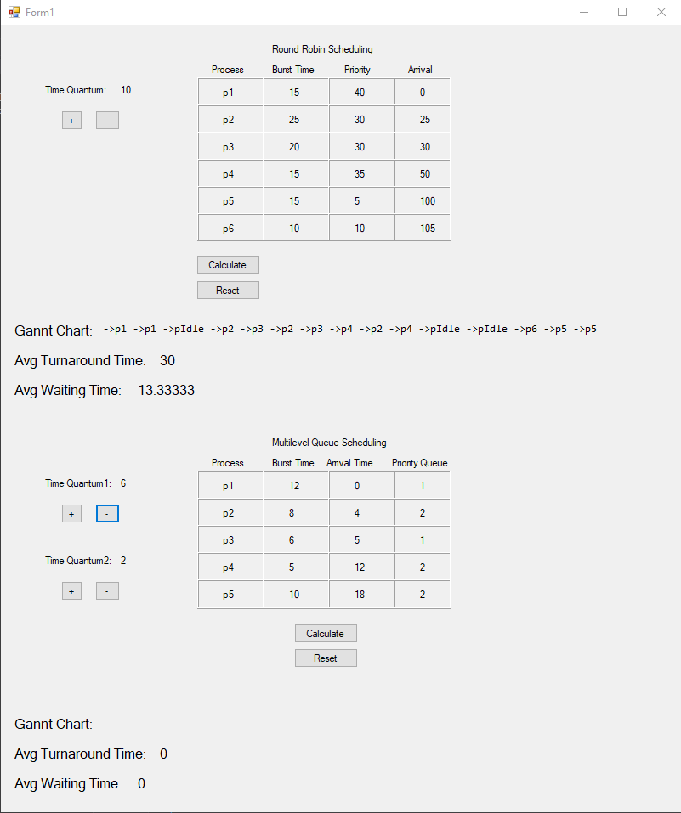

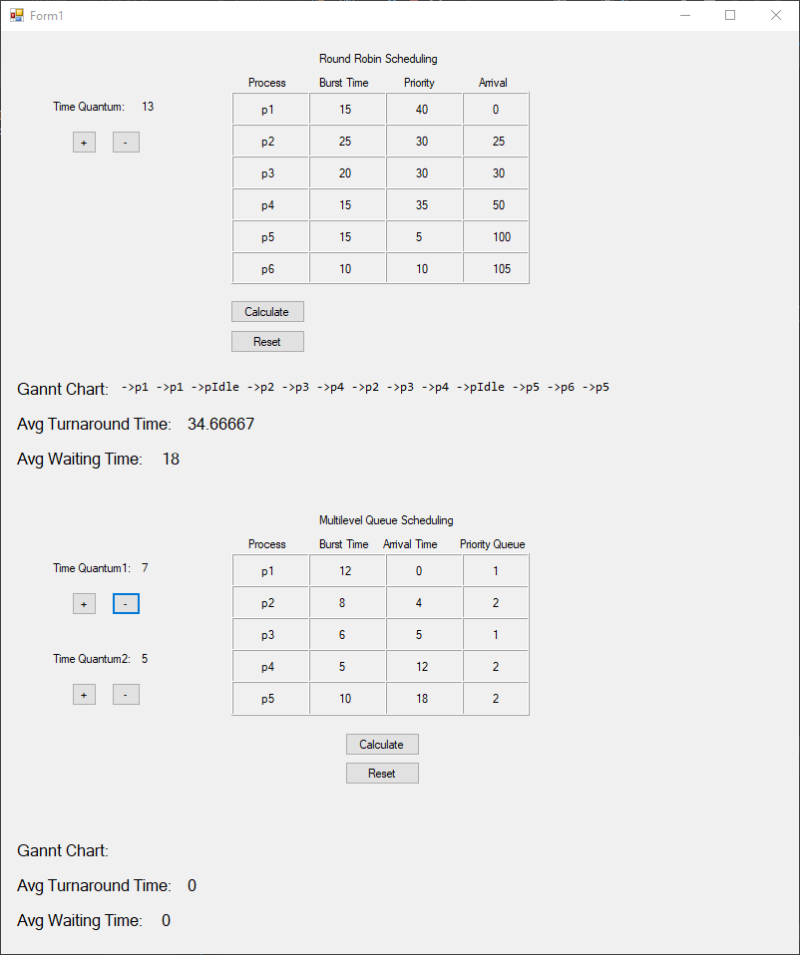

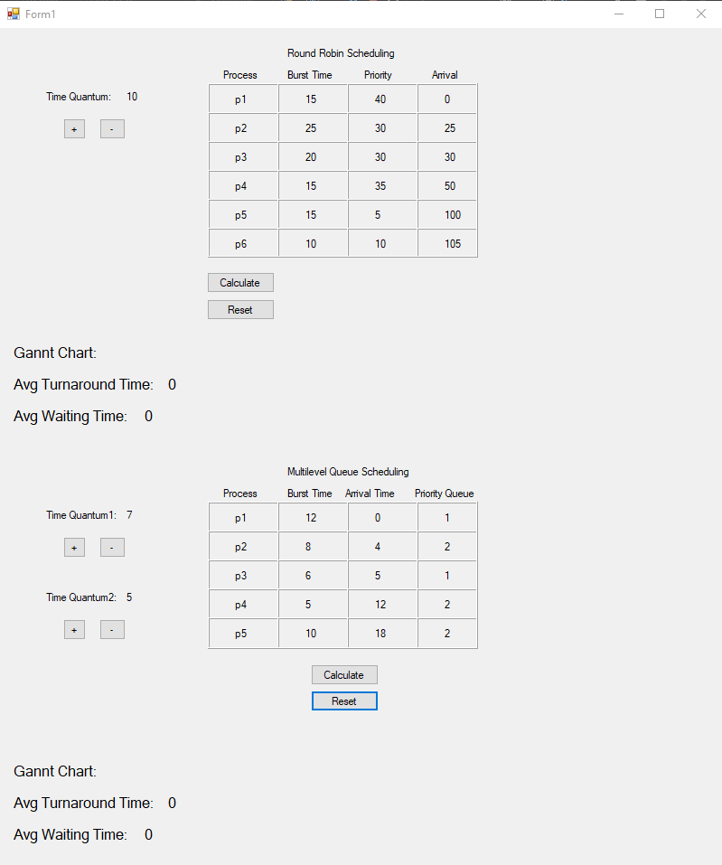

References

<https://www.geeksforgeeks.org/round-robin-scheduling-with-different-arrival-times/?ref=rp>

Operating System Concepts 9th Edition – Abraham Silberschatzk, Peter Baer Galvin, Greg Gagne

Work Done

**Kyler Finn:** Fixed the round robin function to display better data. Worked on the multilevel queue scheduling algorithm.

**Morgan Houston:** Created base project file, set up tables, found starting round robin function, made readme file.

**Haley Walston:** Sent the initial email, to the professor, of who was in our group. As of right now, has not added anything to the C# project.

**Jordan Wright:** Created canvas group and a rough draft project report.