Melissa Allee

Intro to C#

Assignment 2

September 20, 2015

# Assignment 2

Figure

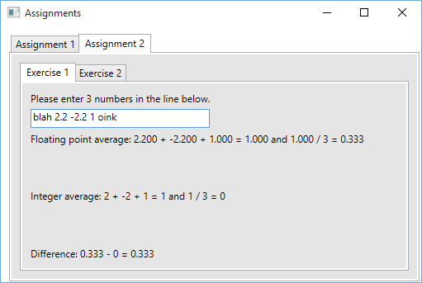

Figure 1 shows the user may enter 3 numbers. The program ignores text. The floating point average, integer average, and the floating point difference between the floating point average and the integer average is displayed.

Figure

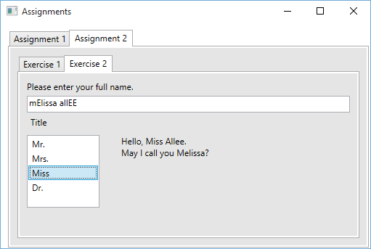

Figure 2 demonstrates exercise two. The user may enter their name (case does not matter). They may also select a title. If no title is selected, the program displays “Hello, mister (or misses) Last Name” instead of the title string and last name, as shown in Figure 3 below.

Figure

