**Battle Royale**

Game Instructions

# Setting up the grid

The cards are arranged in a diamond shape, with a height and width of 7 cards, face up. The arranged map should look like this:

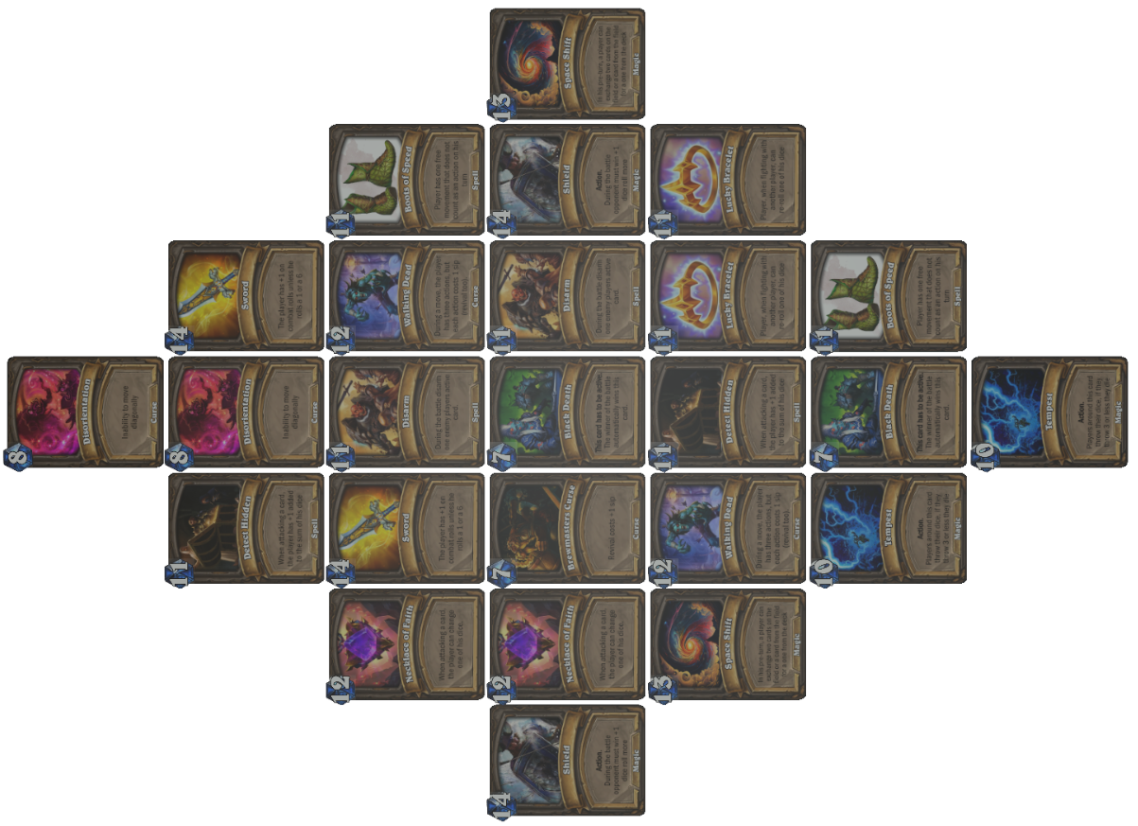

Image 1: Look of the grid

# 2. Before the game starts

Before setting up, all players roll a die, and the player with the highest number goes first. If any of the players roll the same number, those players roll the dice again until one gets a higher result. Each player must position themselves on the outer edge of the grid (see image 2). The player with the highest roll goes first.

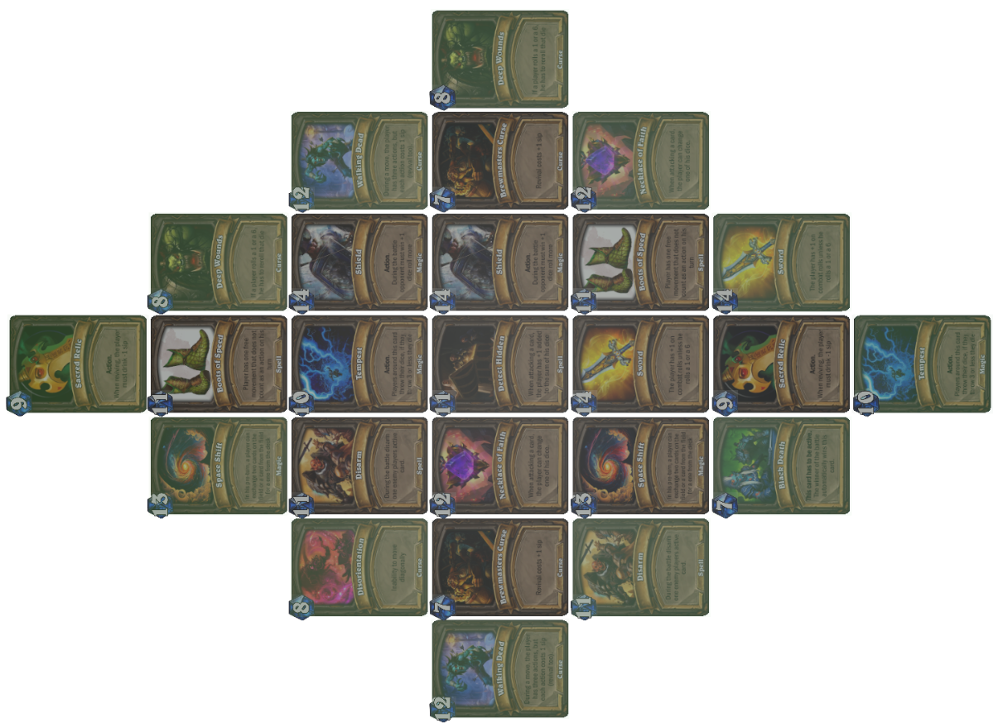

Image 2: Outer layer of the grid with slightly greener color

# During a turn

Every turn you have actions and movements. Possible actions are: attacking a card, or attacking another player and resurrecting. You can also have cards that give you movement so you don't use your actions.

# 3.1 Movement

The player can move to any squares adjacent to the square they are on, including diagonal movement. Therefore, the player can move in 8 directions (unless they are at the edge of the grid). Moving consumes one action or one movement, It is also possible to move through squares occupied by other players.

3.2 Cards

Players start the game without any cards. By winning cards, they attempt to strengthen their position to more easily win other cards and defeat opponents. A player can have a maximum of 3 active cards at any time. Each subsequent card a player wins is set aside(except for some „Curse“ cards which you have to equip immediately) in a way that opponents cannot see it. A player cannot choose to have 2 active cards if they possess more, for example, if they have a third card with an effect they don't like, they must have it active. Active cards modify the player's turn, so with certain cards, a player can have an additional, movement or influence the player's rolls (+1 to the dice sum...). Using an active card does not consume an action. At the beginning of their turn, before any action, a player can exchange one card from the deck with one active card.

Example of how cards should look in front of a player with 3 active cards, and others turned around on the right side.

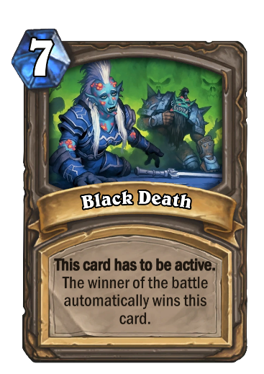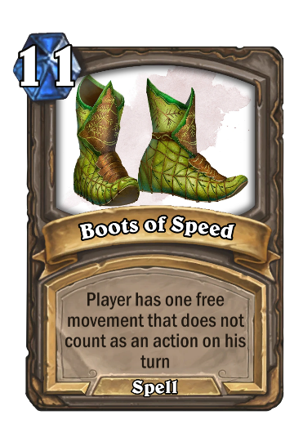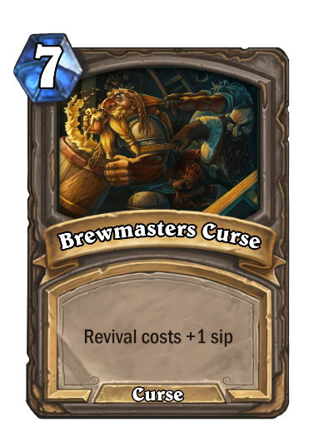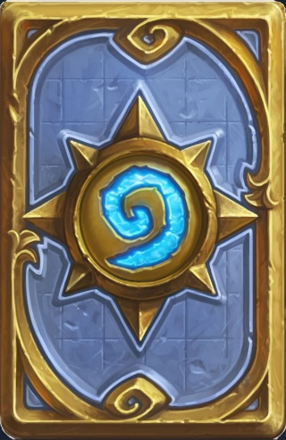

Image 3: Look of the cards in front of the player

# 3.3 Attacking a card

Worth of the card is printed in the left top corner. You have to get that value or higher by rolling 3 dice to „win“ the card. If the player fails to win the card, he „dies“ and has to move to one of the adjacent cards. If he wants to resurrect he has to use one of his available actions. Rolling 3 dice and getting the same number on all three, always results in winning a card .

# 3.4 Attacking a player

When two living players find themselves on the same square, and it is one player's turn, it is possible to initiate a mutual battle. Attacking another player costs one action.

The battle takes place by both players simultaneously rolling one die each. The higher number wins, and if the roll results in a tie, it doesn't count for either player. The game is played until one player wins three rounds(or more if the player has a shield).

The player who wins the battle remains alive on the grid, while the loser must choose one of the adjacent squares to move to and die there (symbolically speaking, "go die").

The winner takes: one random card from the loser that was active, or a certain card if for instance the loser had „Black Death“ equiped).

Under the previously mentioned conditions, players can only initiate attacks if they have at least one card. If a player has no cards, they can attack other players by always rolling two dice and taking the value of the lower die.

3.5 Resurrection

When a player dies (either due to a battle with another player or a failed attack on a card), they must be resurrected before they can perform any other actions. Resurrection requires consuming alcoholic beverages (See Table 1). If a player has an additional action in the turn in which they died, they can resurrect themselves during that turn. Otherwise, they must wait until the next turn to initiate the resurrection.

| **Drink** | **Number of sips for resurrection** |
| --- | --- |
| Pure strong liquor (>20% alcohol in the total volume of liquid in the glass) | 1 sip |
| Strong liquor mixed with non-alcoholic beverage; only wine (>10% alcohol in the total volume of liquid in the glass) | 2 sips |
| Beer, bamboo, lovranski (a combination of spirits and non-alcoholic beverage), etc. (<10% alcohol in the total volume of liquid in the glass) | 3 sips |

Table 1: Resurrection price list

# End of the game

The game can end in one of the two ways:

a) All cards on the map are won, and their values are summed up.

b) If there is only one card on the map, and the player with the most cards has 4 more cards than the player with the second-highest number of cards (e.g., one player has 9 cards, and no other player has more than 5 cards). In that case, the game continues until the last card is won.

Additional rules:

* When only cards with values 13 and 14 remain on the map, the values for all cards on the map are reduced to 12.
* When there is only one card on the map, all players must move towards it by the fastest route and attempt to attack it every turn, including attacking other players on that card.
* When only one card is on the map and multiple players are alive on that card, it is sufficient to defeat just one player to attack the card, assuming the player has actions remaining for that turn.

Top of Form