COVID_hypothesis_testing
Matthew Miller
2025-04-13

Read the hospital data:
hospital_data <- read_csv("data/Hospitals_gdb_771050112109123987.csv")
## Rows: 8340 Columns: 34
## ── Column specification ────────────────────────────────────────────────────────
## Delimiter: ","
## chr (25): ID, NAME, ADDRESS, CITY, STATE, ZIP, ZIP4, TELEPHONE, TYPE, STATUS...
## dbl (9): OBJECTID, POPULATION, LATITUDE, LONGITUDE, NAICS_CODE, TTL_STAFF, ...
Read the COVID-19 data:
covid_data <- read_csv("data/total_cases_by_county.csv")
## Rows: 3217 Columns: 4
## ── Column specification ────────────────────────────────────────────────────────
## Delimiter: ","
## chr (2): state, COUNTY
## dbl (2): COUNTYFIPS, total_cases
Preprocess hospital data and hospital data, ensuring the join column is the same data type:
hospital_density <- hospital_data %>%
count(COUNTYFIPS, name = "hospital_count")
covid_data <- covid_data %>%
mutate(COUNTYFIPS = as.character(COUNTYFIPS))
hospital_density <- hospital_density %>%
mutate(COUNTYFIPS = as.character(COUNTYFIPS))
Join by county (using FIPS code)
combined_data <- covid_data %>%
inner_join(hospital_density, by = "COUNTYFIPS")
Visualize the data
ggplot(combined_data, aes(x = hospital_count, y = total_cases)) +
geom_point() +
geom_smooth(method = "lm", se = TRUE) +
labs(title = "COVID-19 Cases vs Hospital Density",
x = "Hospitals per County",
y = "Total COVID-19 Cases")
## `geom_smooth()` using formula = 'y ~ x'
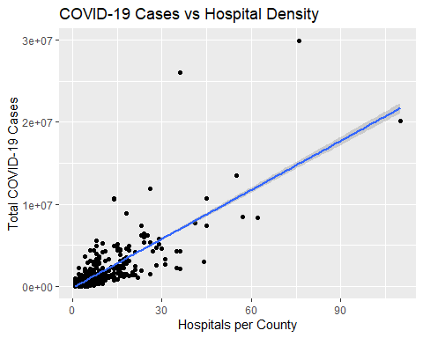
Test hypothesis
model <- lm(total_cases ~ hospital_count, data = combined_data)
summary(model)
##
## Call:
## lm(formula = total_cases ~ hospital_count, data = combined_data)
##
## Residuals:
## Min 1Q Median 3Q Max
## -5636992 -127006 9835 84079 19023744
##
## Coefficients:
## Estimate Std. Error t value Pr(>|t|)
## (Intercept) -179747 18289 -9.828 <2e-16 ***
## hospital_count 199001 2938 67.728 <2e-16 ***
## ---
## Signif. codes: 0 '***' 0.001 '**' 0.01 '*' 0.05 '.' 0.1 ' ' 1
##
## Residual standard error: 774100 on 2318 degrees of freedom
## Multiple R-squared: 0.6643, Adjusted R-squared: 0.6642
## F-statistic: 4587 on 1 and 2318 DF, p-value: < 2.2e-16
confint(model)
## 2.5 % 97.5 %
## (Intercept) -215610.3 -143882.7
## hospital_count 193238.7 204762.4
This p-value of less than 2.2e-16 falls outside of our confidence interval of 2.5-97.5%, indicating that we should reject the null hypothesis and accept the alternative hypothesis. That is, the data indicates a relationship between hospital density and total number of COVID-19 cases in 2020.

