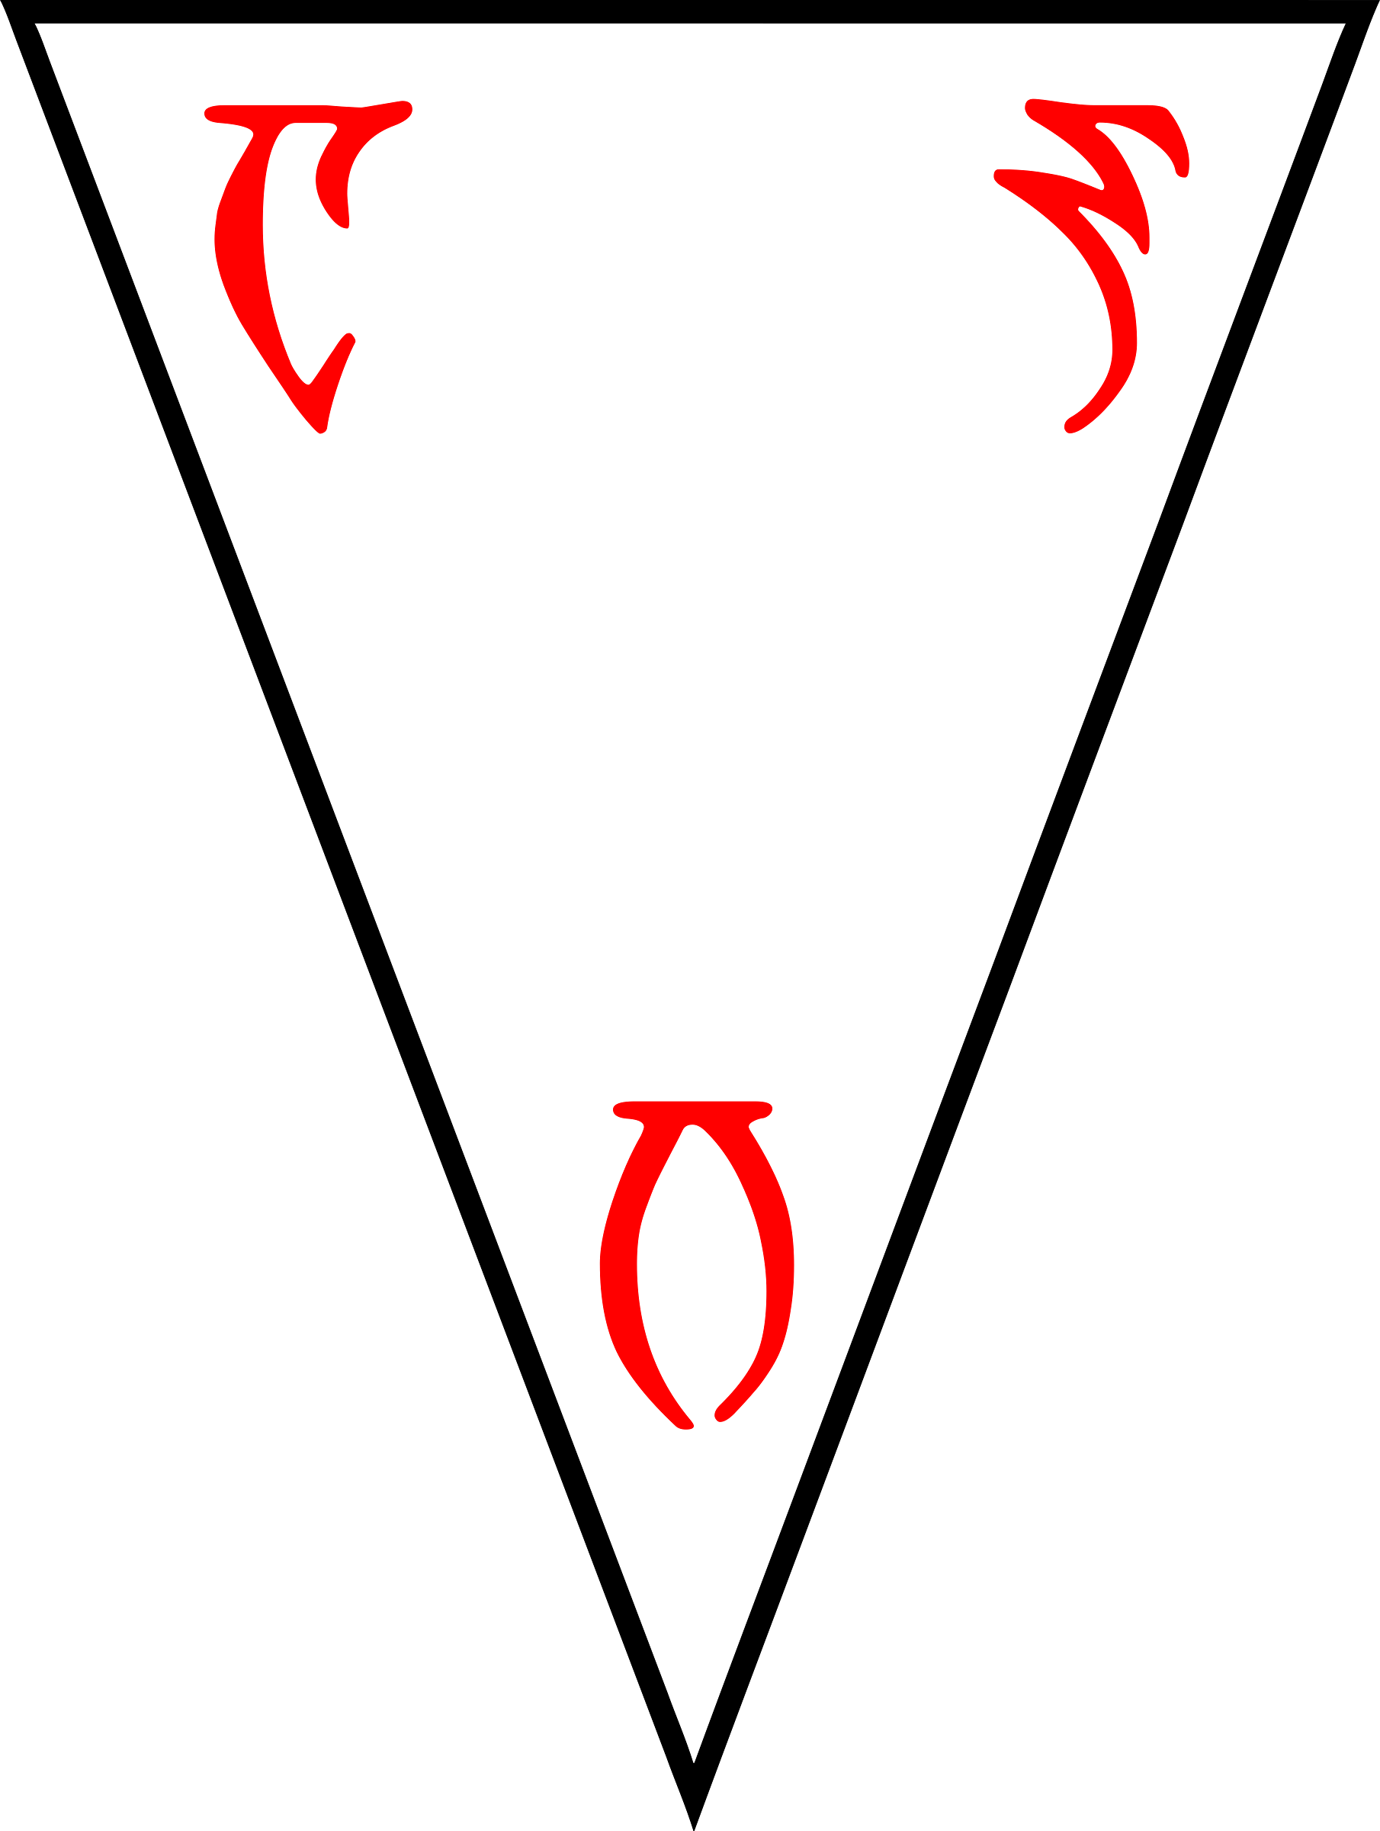

The Quintessence
arcalbusehr

Based on the
Heirographa of the

Codex Sinramus
sinramenthi shokhaahn

FAITHFULLY TRANSLATED
INTO THE COMMON TONGUE
out of Dunmeris, diligently conferred
with the Daedric & other Editions, Revised
with Chapters, Markers, Rubrics, & other helps,
for greater understanding of the texts
Make of your Love a Defense
against the Horizon
c
d
f
j
almari ohm aelha ot redakam
k
gan as hostif' ehrlas
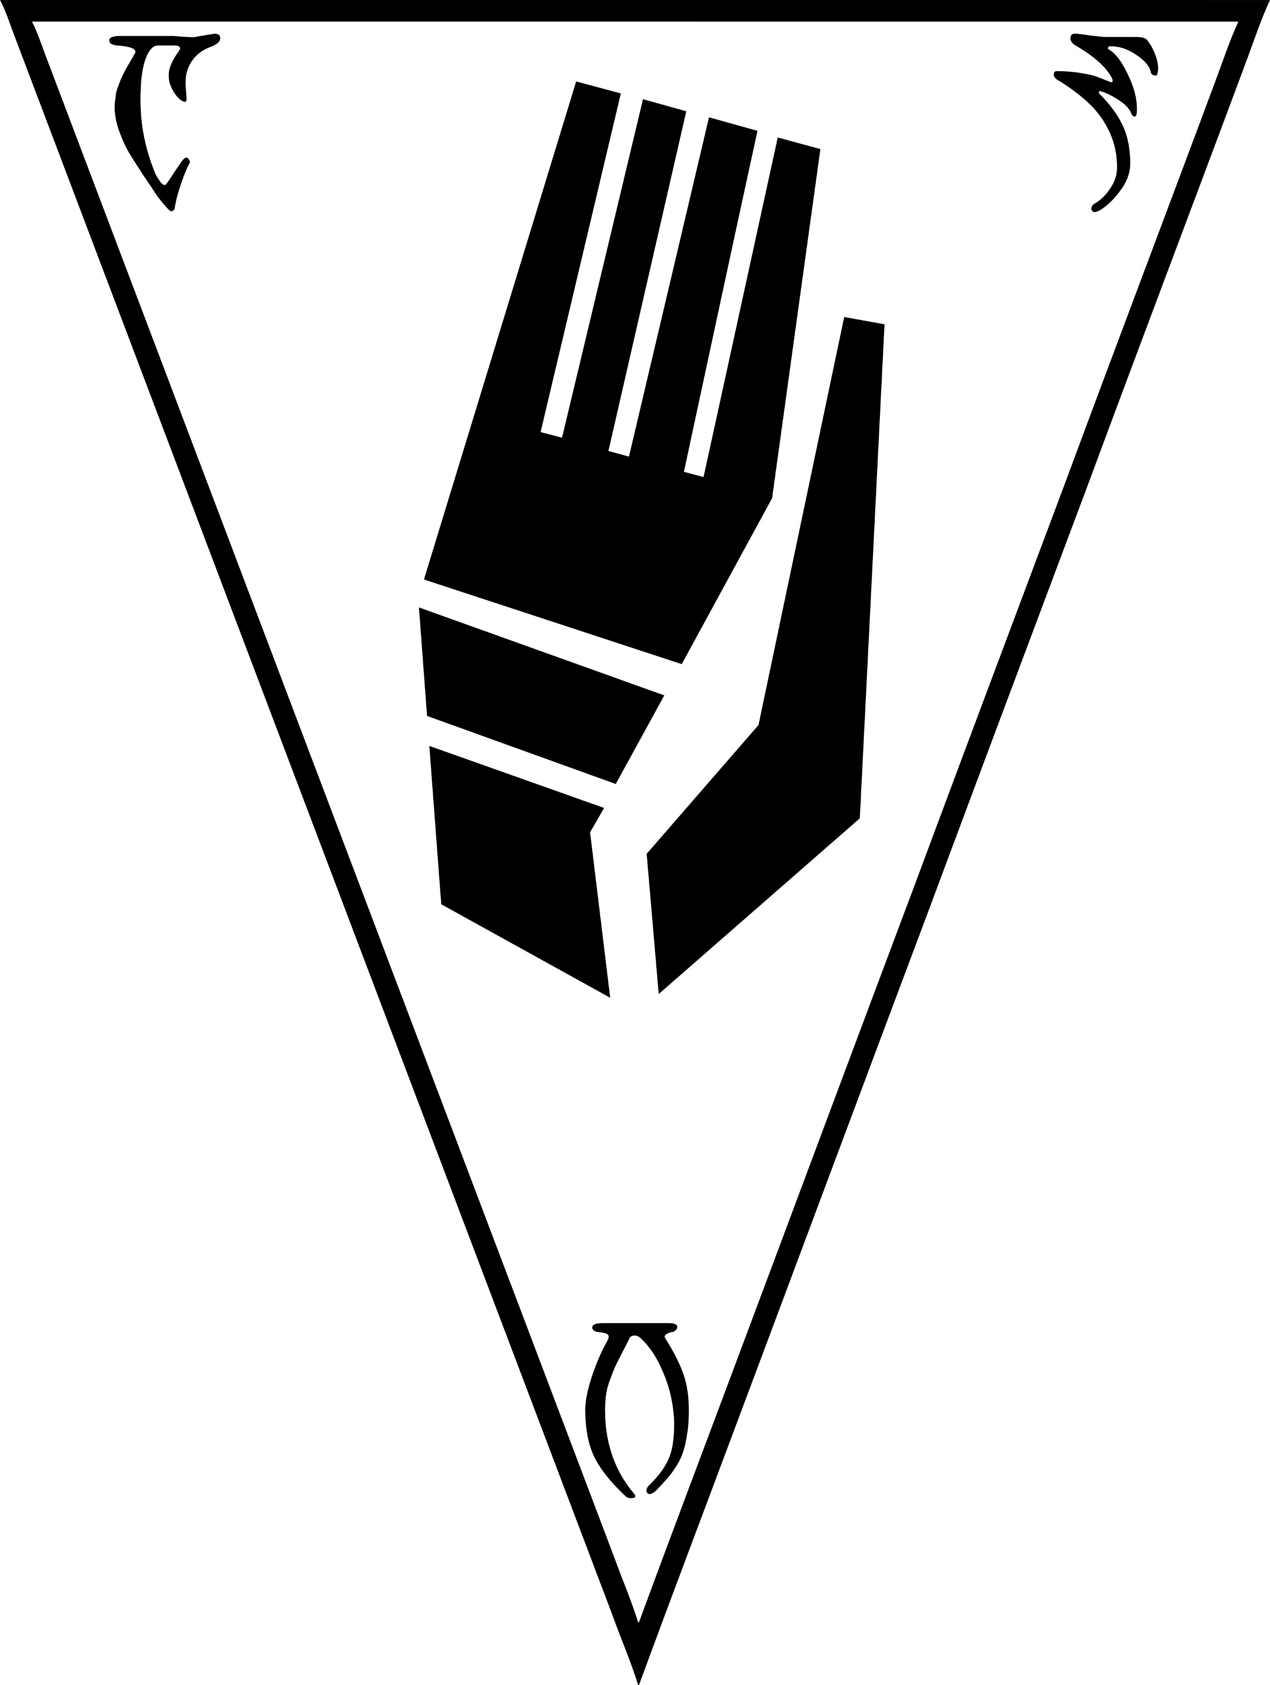

c
r
r
As ahna' urhili'ag uhn
M
M
ujulig as alroua

The Thrice-Sealed House
withstands the Storm
Preface

‘Five are the corners of the world, but six are the
walking ways, from enigma to enemy to teacher.’

To the Reader

Five are the elements, the continents, and the limits of this world, and thus is this codex divided into five sections. For out of these do we strive as many and more paths to ‘transcend mortal boundaries set in place by immortal rulers’. By the Tri-Angled Truth may we rest assured of more volition than the bones of the earth can contain. Among these pages do we perceive more verity than
the etchings of mere language can espouse. And so, it is with most humble gratitude and honor to present the reader with this work, a Quintessence of the sacred writs, carefully handed down by our people, who are set apart in this world.

Our local temples maintain an open canon of scripture dedicated to ALMSIVI, so that the teachings of our Lords shall mix freely into the hearts of our diverse and ever changing folk, wherever we may sojourn. The collections of writings found in the High Fane and the Great Temple of Mournhold, with esteem also to
the Library of Telvannis, contain thousands of documents both uttered by the Gods and penned by the Saints.

Presented in this tome however, is a core assemblage of the received texts as collected by the monks of the monastery of Sinramen. Indeed, some of these works can be found in every quarter, while others remain most prominent in the nameless studies of the Star-Wounded East, and still a few have slipped in
to the codex from times disputed. The result is a carefully selected corpus whose ancient five-part Heirographa, those texts most fit for general instruction, is at last available to the common reader.

The first section pertains to the origins of our Psijic Endeavor, charting history from the Dawn, the forming of the et'Ada,
and the Sundering of Ehlnofey into Mundus, to the eating of Trinimac, the Exodus of Veloth, and the unification of Resdayn.
It illuminates our sacred connection to the Spirits and Ancestors. The three middle sections are dedicated to our living Gods and explore aspects of their personhood, godhood, and hand in the birth, life, and ghost of each mer. Ayem cultivates our culture, Seht challenges our assumptions and Vehk reshapes our morals. Finally, the last section contains remnants of texts that tell a
rare account of the Apotheosis, that speak further of the skills
Preface

necessary to make an Exodus, and of our hope in the Amaranth, the Million-Eyed Insect Dreaming and life of the Nirn-Ensuing.

The utmost care has been taken to deliver, with esteemed clarity,
a rendition of these Scriptures into the common language,
so as to provide the laity with a deeper insight into our ways,
our knowledge, and our faith. Careful liberties have been taken
to standardize particular names and passages. Where possible, spelling and transcription errors have been amended by hand
and diligently checked against the common sources and Temple strictures to ensure their authenticity and intended meaning.
To maintain a familiarity for the esteemed tongue, chapter titles have been printed in both insular and common forms.

Furthermore, within the text has been placed a different kind of numeral notation, such that it can be easily discerned from the common letters so that the reader, through the division of verse, might be more equipped to perceive the meaning of our Lords
and commit their words to memory. Sacred utterances have been rendered in the form of kili dahkem, an insular rubric, so as
to maintain their most excellent and holy significance when breathed aloud by the adept.

May this edition of the Scriptures further serve as a Treasure Wood Sword, waived as a lessoning tune that guides us in song, cutting us in shape to the edification of all the Temple faithful
and indeed our Dunmer people.

Dedication

Through the bounty of Blessed ALMSIVI Triune Grace,
In the presence of the Temple and all the host of Saints
By the sacred unity of your Mercy, Mystery, and Mastery,
Almalexia, Sotha Sil, and Vivec, blessed be your holy names;
Through the terrible power of your monstrous love,
As in the days of Veloth and Resdayn, the times of our ancestors,
When Boethiah, Mephala, and Azura lead us out of captivity,
So do you lead us now in the days of Morrowind;
Down each Walking Way, you advocate for us in our time of trial,
And shew for us a secret door at the altar of Padomay,
Where by your hands, we become safe and looked after.

The ending of the words, ALMSIVI.

—Idrele, Curate and Scribe

Preface

The Living Gods

No other religion in all of Nirn can claim what the Dunmer know as absolute truth: their gods rule over them and walk among them, as real and as present as any other resident of Morrowind. From their seat of power in Mournhold's Tribunal Temple, the Living Gods of the Tribunal guard and counsel their people. When necessary, they punish sin and error, but they also share their bounty with the greatest and least among us, each according to their needs. But who are the Living Gods? They are powerful Dunmer who achieved divine status through superhuman discipline and virtue, and supernatural wisdom and insight.
As the three God-Kings of Morrowind, they form the divine leadership of the Dunmer nation. The Three—Lord, Mother,
and Wizard—are described below.

Vivec, the warrior-poet god and Master of Morrowind, is perhaps the most popular of the Three. He also tends to be the most public, and the people love him. His visage appears both beautiful and bloody at the same time, and he has made violence into an art form. Vivec the warrior-poet has darker aspects associated with primitive, ruthless impulses, such as lust and murder.

Almalexia, also known as Mother Morrowind, is the patron of healers and teachers. She is the Healing Mother, the source of compassion and sympathy, the protector of the poor and the weak. Almalexia embodies the best of Dunmeri culture and purpose.
She exemplifies mercy, and her wisdom guides the Dunmer in
all their daily affairs.

Sotha Sil, God of the World-Mechanism, is the least known and most hidden of the Tribunal gods. Sometimes referred to as the Mystery of Morrowind, he is a Magus and the patron of artificers and wizards. Perhaps the mightiest wizard in the land and certainly the wisest, he is considered to be the Light of Knowledge and the inspiration behind craft and sorcery.

Together, the Living Gods are the pillars of the Tribunal Temple. They represent the power and discipline of the Dunmeri people, and rule with a combination of compassion and strict adherence
to law and protocol.

—Durillis, Temple Theologian

Preface

Worshiping the Illogical

The Clockwork Apostles dedicate their lives to many things.
The words of our Sermons, laid before us by the ever-faithful Deldrise Morvayn, Fourth Tourbillon. The will of our god Lord Seht, the Mainspring Ever-Wound, the Divine Metronome.
The driving forces of inspiration, of innovation, of discovery
in all forms, magical, technological, spiritual.

But we often forget, in our pursuit to unravel the mysterious of our world, that we are also subjects of the Tribunal.

I have found throughout my long tenure that many of my pupils have a hard time grasping the threefold nature of our belief within the Tribunal. Still, despite the repetition of these questions, I never rebuff this curiosity. Rather, I try to encourage it, for there is an abundance of contradictions within our piety towards Lady Almalexia and Lord Vivec. After all, the worship of these deities seem to almost challenge the beliefs we hold so true within our order.

Why are we told to worship these often puzzling deities?
Why must we follow not one god, but three?

Yet even this seemingly simple fact is but a misconception, for
in this sequence we have found truth. ALMSIVI is but one entity,
not the fractured creation that many perceive it as. It only appears fractured in the forms our gods have taken, but rather than separate deities they are all one portion of a welded whole. Regulated in their irregularities. Lady Almalexia and Lord Vivec, who are only consistent in their inconsistency, still create the order of our truths. They are the tock within our Lord Seht's tick, the wheel that forever goes forward but only to circle itself.

They are the truths of our chaotic present, the irregular oscillations that we must weld together. Within them we find the aspects of our humanity, the soul which merges with the machine, ambition which merges with beneficence. The act of faith itself seems contradictory to the importance we hold on evidential certainty. But not one among us is completely machine, cold and logical without the emotions which bind us together. No, we are welded beings, as varied and complex as our three gods. Fractured parts which have come together to create our individuality.
Preface

How does one devote themselves to such aspects? To these traits
of Nirn which are not logic and order, our guiding principles?
The Sermons tell us to understand their limitations. To pay heed, but know the boundaries of their scale. Know that these are the principals needed for our current world, Nirn-Prior, and shall be but an addition to the whole which is Nirn-Ensuing.

Hold tight their words, their laws and limits. Know that they
are the echoes of a fractured selves, welded whole.

Know that the Sublime Piston gives and takes in equal measures, sundering the Named pursuits of lesser mer. We must tear apart that which will be welded whole once more. Beliefs, structures, laws, one day outdated and unneeded.

And so we pay our respects to these aspects of our deities.
Without faith towards ALMSIVI we ourselves become sundered from the truth. Speak the names of Lady Almalexia, Lord Sotha Sil, and Lord Vivec with respect, with piety. Listen to their words and heed their laws when necessary. They are the cogs that reflect ourselves, to be as venerated as the truths that we honor.

—Nevyn, Proctor and Apostle of Seht

The Pilgrim’s Way

To walk is to love, young pilgrims. We honor The Prophet through our travels. By walking his way, we keep the holy journey alive.

It is the sole that keeps us in contact with Veloth. With each step, we sing the marching song of our forebears. By retracing the pattern, we strengthen the bond.

It is with our feet that we followed Veloth. It was the exodus of the feet that brought us to Resdayn. It is our feet that now rest on the soils of Morrowind.

“Six are the guardians of Veloth, three before and they are born again, and they will test you until you have the proper tendencies of a hero.”

To walk is to love, young pilgrims. We honor The Three through our resolve. Through overcoming opposition, we grow closer to the source. These are the stories of the sole. With each step, the story grows.

The markings on the sole may be physical or spiritual, but are always intertwined. Scars, scabs and blisters lead to callusing of the body, but also of the mind. Tattoos mark both sole and spirit.

Each step has an effect, yet changes nothing. Each step is taken freely, though without choice. Each step tells the story that has yet to be told, the story that has already been told and the story that must be told.

By retracing the pattern, we strengthen the bond.

To walk is to love, young pilgrims.

—St. Rilms, the Barefooted

Love Under Will

“Know Love to avoid the Landfall,
my brothers and sisters.”

Love is the harmony of self-interest and selflessness, when expressed or encountered unmindingly, that is, under will.
We have been sundered, broken out of divinity and into the world, where mortal limits are a distraction from the freedom to truly act.

But, when one can sustain the balance of love without conscious effort, they become ever present in the moment, unbound by time, unminding of past decisions or future questions. Because they are not distracted by mortal anguish, their integrity remains whole and they are free to act as is true to their nature, their divine character.

—Udrasi, Priest and Mystic

From the head, the law.
From the heart, the light.
From the hand, the change.

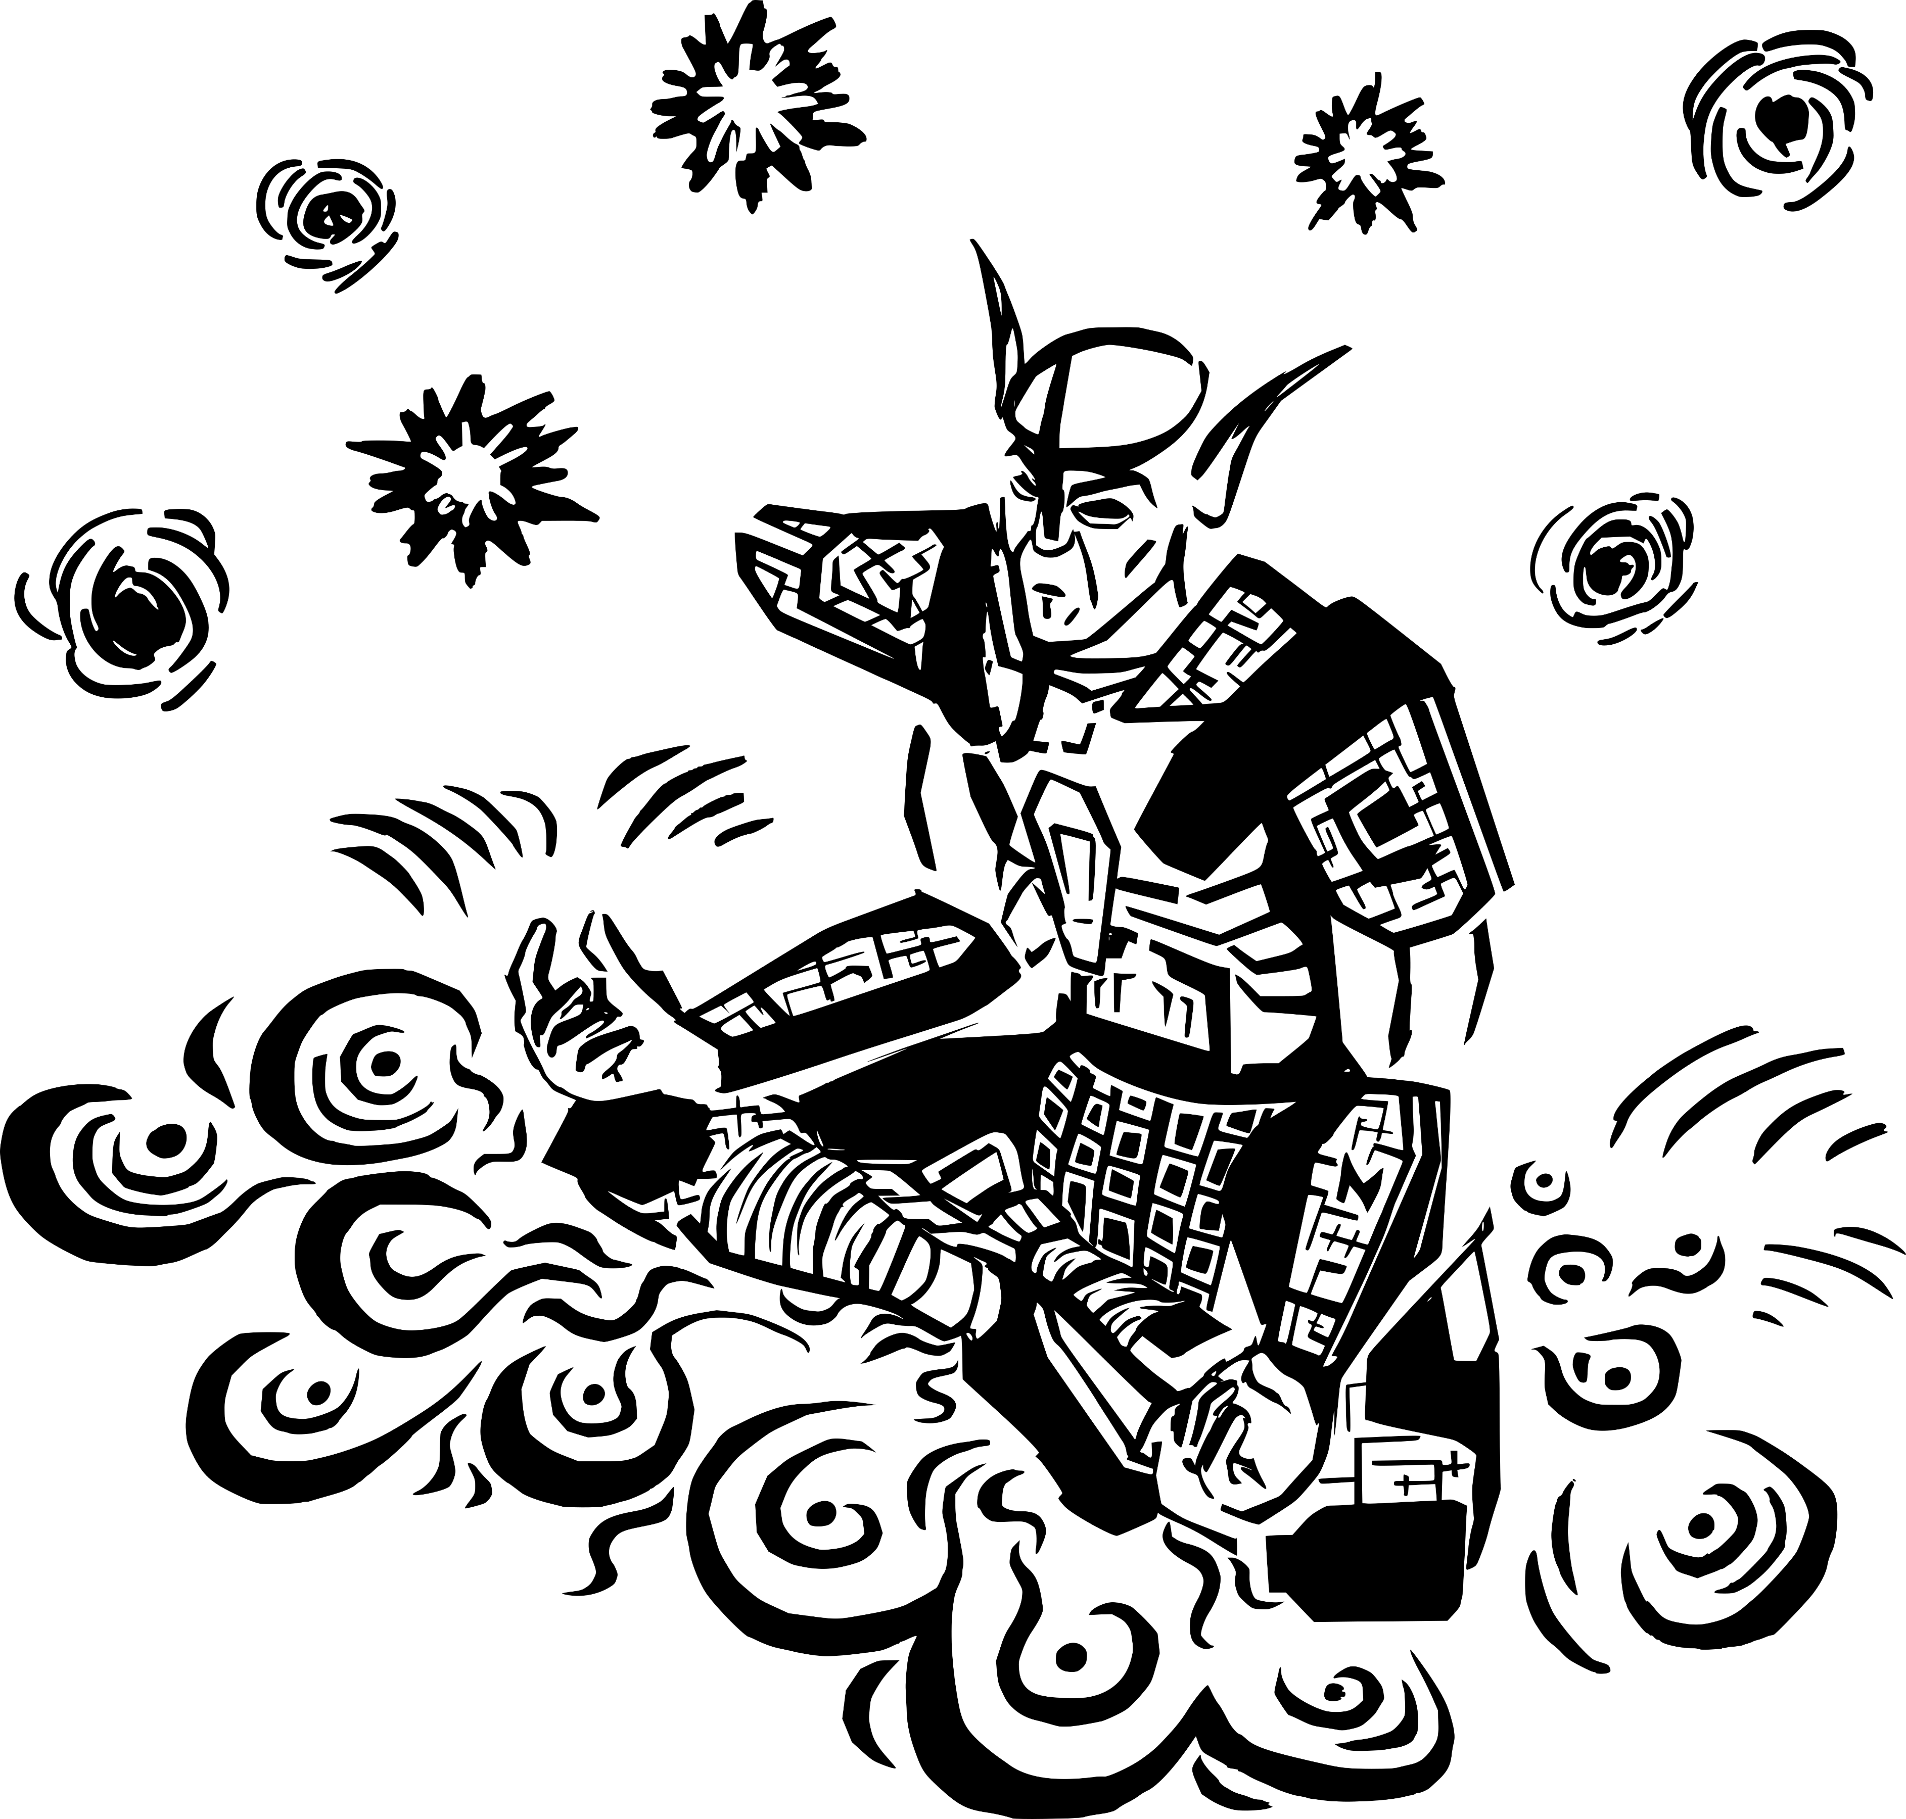

Learn by serving.
Index

The Collection of the Ancestors

Sithis | . . . . . . . . . . . . . . . . 3 |  |  |  |  | The Daedra | . . . . . . . . . . . 8
Mythic Aurbis |  | . . . . . . . . . . 4 |  |  |  | The Anticipations |  |  | . . . . . . . 10
Changed Ones |  | . . . . . . . . . . 5 |  |  |  | The House of Troubles |  |  |  | . . . . 12
Exodus from Summerset |  |  |  |  | . . . . 6 | The Doors of the Spirit |  |  |  | . . . . 13
End of the Journey |  |  |  | . . . . . . . 6 |  | Blasphemous Revenants |  |  |  |  | . . . 14
The Real Nerevar |  |  | . . . . . . . . 7 |  |  | Spirit of Nirn |  | . . . . . . . . . . 15

The Collection of the Homilies

Fable One |  | . . . . . . . . . . . . 19 |  |  |  |  | Fable Ten | . . . . . . . . . . . . 24
Fable Two |  |  | . . . . . . . . . . . . 19 |  |  |  | Fable Eleven |  | . . . . . . . . . . 25
Fable Three |  |  |  |  |  | . . . . . . . . . . . 20 | Fable Twelve |  |  |  | . . . . . . . . . . 26
Fable Four |  |  |  | . . . . . . . . . . . . 20 |  |  | Fable Thirteen |  |  |  |  | . . . . . . . . . 27
Fable Five |  |  | . . . . . . . . . . . . 21 |  |  |  | Fable Fourteen |  |  |  |  |  | . . . . . . . . . 28
Fable Six | . . . . . . . . . . . . . 21 |  |  |  |  |  | Fable Fifteen |  |  | . . . . . . . . . . 29
Fable Seven |  |  |  |  |  | . . . . . . . . . . . 22 | Fable Sixteen |  |  |  | . . . . . . . . . . 30
Fable Eight |  |  |  |  | . . . . . . . . . . . . 23 |  | Fable Seventeen |  |  |  |  |  |  | . . . . . . . . 30
Fable Nine |  |  |  | . . . . . . . . . . . . 23 |  |  | Fable Eighteen |  |  |  |  | . . . . . . . . . 31

The Collection of the Sequence

Volume One |  | . . . . . . . . . . . 35 |  |  |  | Volume Seven |  |  |  | . . . . . . . . . 42
Volume Two |  |  | . . . . . . . . . . . 36 |  |  | Volume Eight |  |  | . . . . . . . . . . 43
Volume Three |  |  |  |  | . . . . . . . . . . 37 | Volume Nine |  | . . . . . . . . . . 45
Volume Four |  |  |  | . . . . . . . . . . . 39 |  | Volume Ten | . . . . . . . . . . 47
Volume Five |  |  | . . . . . . . . . . . 40 |  |  | Volume Eleven |  |  |  |  | . . . . . . . . . 48
Volume Six | . . . . . . . . . . . . 41 |  |  |  |  | Volume Twelve |  |  |  |  |  | . . . . . . . . 49

Index

The Collection of the Lessons

Sermon One |  |  | . . . . . . . . . . . 55 |  |  |  |  |  |  |  |  |  |  | Sermon Nineteen |  |  | . . . . . . . 84
Sermon Two |  |  |  | . . . . . . . . . . . 56 |  |  |  |  |  |  |  |  |  | Sermon Twenty |  | . . . . . . . . 85
Sermon Three |  |  |  |  |  |  | . . . . . . . . . . 58 |  |  |  |  |  |  | Sermon Twenty-One |  |  |  |  |  |  | . . . . . 87
Sermon Four |  |  |  |  | . . . . . . . . . . 60 |  |  |  |  |  |  |  |  | Sermon Twenty-Two |  |  |  |  |  |  | . . . . . 88
Sermon Five |  |  | . . . . . . . . . . . 61 |  |  |  |  |  |  |  |  |  |  | Sermon Twenty-Three |  |  |  |  |  |  |  |  |  |  | . . . . 90
Sermon Six | . . . . . . . . . . . 63 |  |  |  |  |  |  |  |  |  |  |  |  | Sermon Twenty-Four |  |  |  |  |  |  |  | . . . . . 91
Sermon Seven |  |  |  |  |  |  | . . . . . . . . . . 65 |  |  |  |  |  |  | Sermon Twenty-Five |  |  |  |  |  |  |  | . . . . . 93
Sermon Eight |  |  |  |  |  | . . . . . . . . . . 66 |  |  |  |  |  |  |  | Sermon Twenty-Six |  |  |  |  | . . . . . . 94
Sermon Nine |  |  |  |  | . . . . . . . . . . 68 |  |  |  |  |  |  |  |  | Sermon Twenty-Seven |  |  |  |  |  |  |  |  |  |  | . . . . 96
Sermon Ten |  | . . . . . . . . . . . 69 |  |  |  |  |  |  |  |  |  |  |  | Sermon Twenty-Eight |  |  |  |  |  |  |  |  |  | . . . . 97
Sermon Eleven |  |  |  |  |  |  |  | . . . . . . . . . 71 |  |  |  |  |  | Sermon Twenty-Nine |  |  |  |  |  |  |  |  | . . . . . 99
Sermon Twelve |  |  |  |  |  |  |  |  |  | . . . . . . . . . 73 |  |  |  | Sermon Thirty | . . . . . . . . 100
Sermon Thirteen |  |  |  |  |  |  |  |  |  |  | . . . . . . . . 74 |  |  | Sermon Thirty-One |  |  |  |  | . . . . . 102
Sermon Fourteen |  |  |  |  |  |  |  |  |  |  |  | . . . . . . . . 76 |  | Sermon Thirty-Two |  |  |  |  | . . . . . 103
Sermon Fifteen |  |  |  |  |  |  |  |  | . . . . . . . . . 78 |  |  |  |  | Sermon Thirty-Three |  |  |  |  |  |  |  | . . . . 105
Sermon Sixteen |  |  |  |  |  |  |  |  |  | . . . . . . . . . 79 |  |  |  | Sermon Thirty-Four |  |  |  |  |  | . . . . . 106
Sermon Seventeen |  |  |  |  |  |  |  |  |  |  |  |  | . . . . . . . 81 | Sermon Thirty-Five |  |  |  |  |  | . . . . . 108
Sermon Eighteen |  |  |  |  |  |  |  |  |  |  | . . . . . . . . 82 |  |  | Sermon Thirty-Six |  |  |  | . . . . . . 110

The Collection of the Avowalments

Mystery of the Apotheosis |  |  | . 115 | Post at the Turning Point |  |  |  | . 122
Selected Teachings | . . . . . . 116 |  |  | Obscured Loveletter |  | . . . . . 122
Hour of the Dragon Break |  | . . 119 |  | The Prophet of Landfall |  |  | . . . 127
The Memories of Sotha Sil |  | . . 121 |  | The Amaranth | . . . . . . . . 127

Temple Oath |  | . . . . . . . . . . 132 | Appendix | . . . . . . . . . . . 151
Breviary | . . . . . . . . . . . . 136

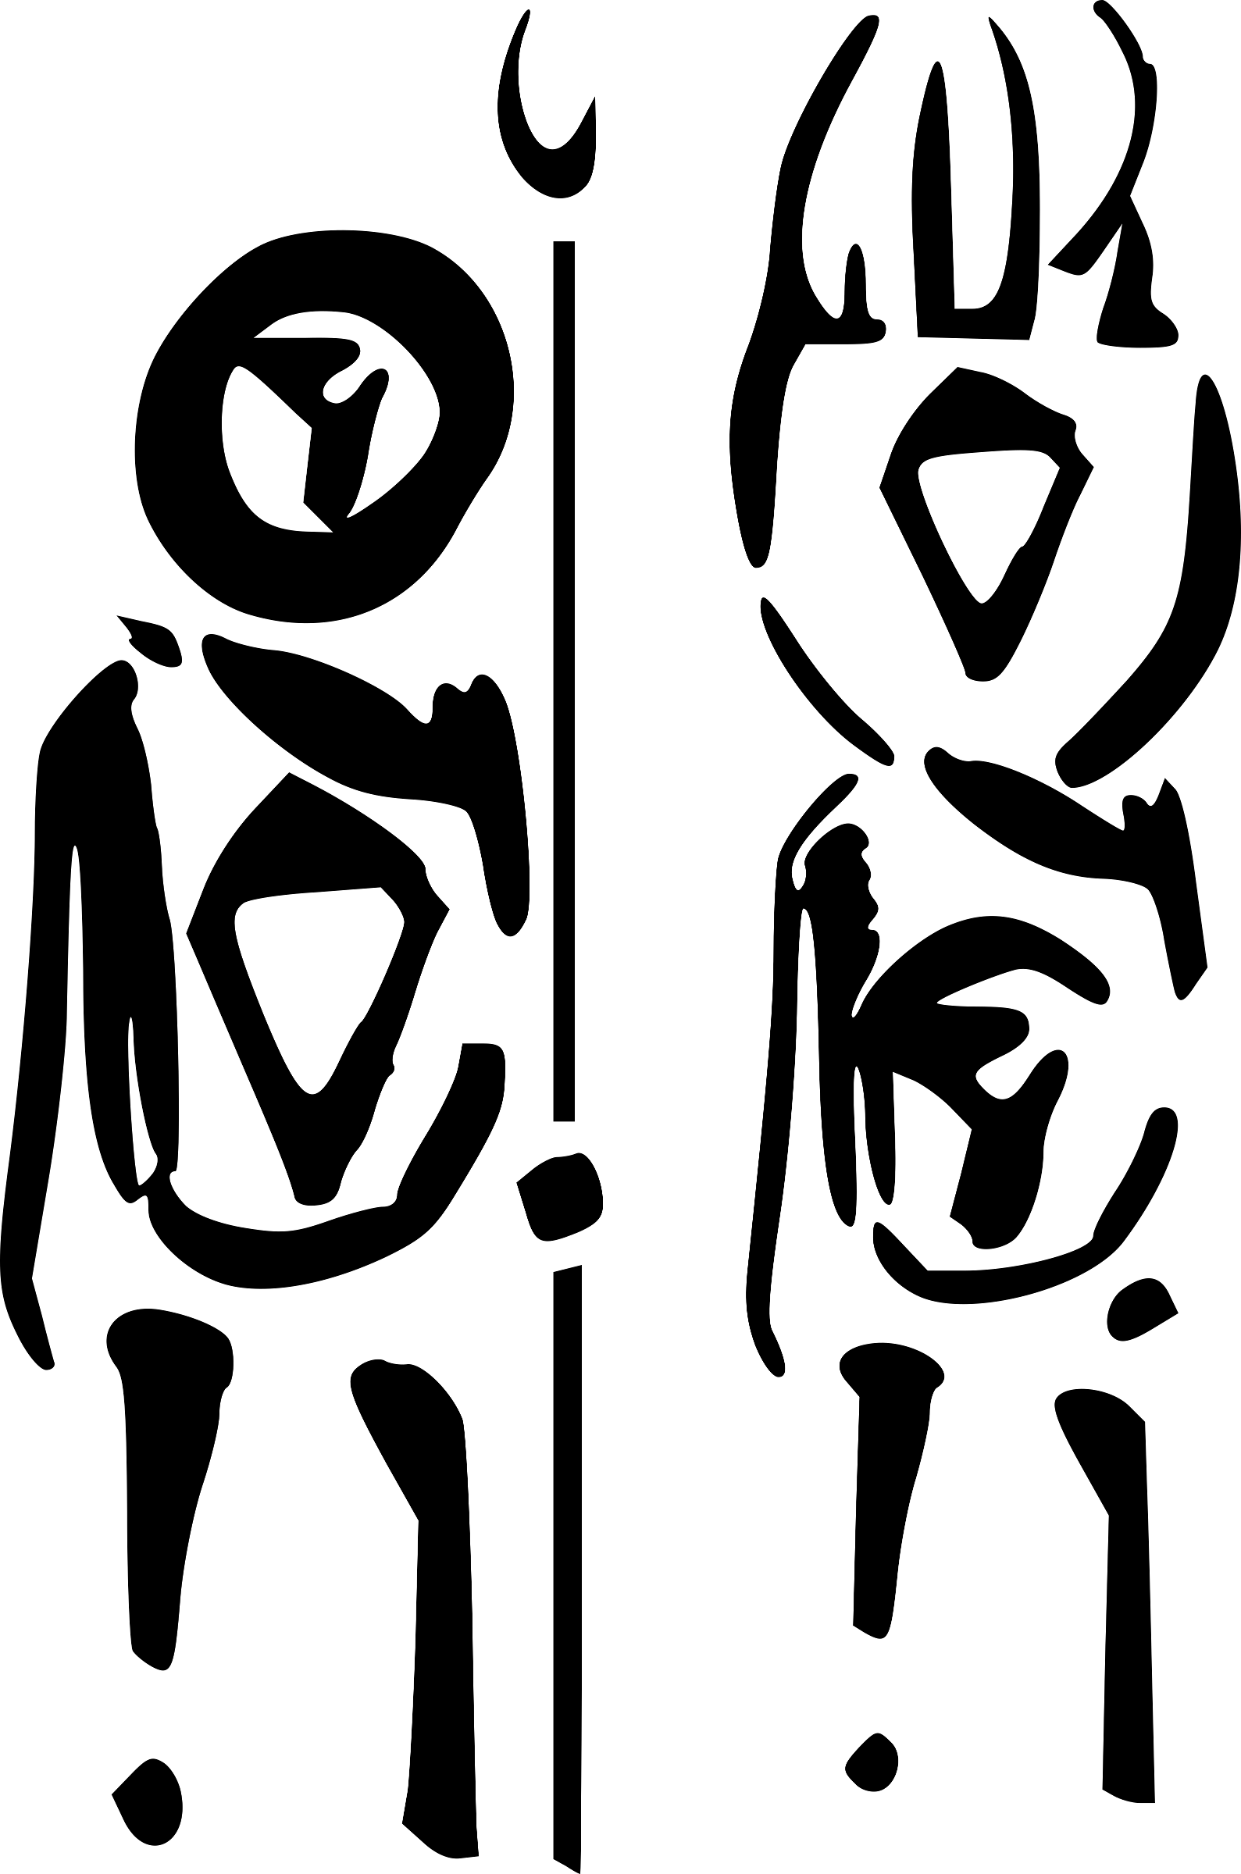

PSJJJJ

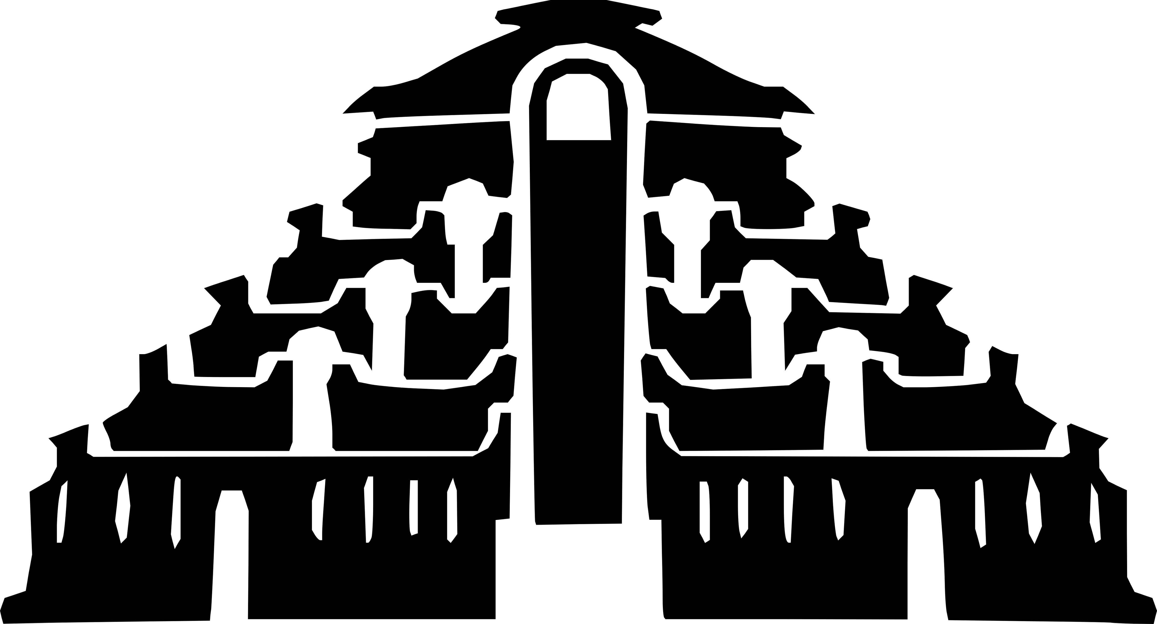

The Post at the Turning Point
and the Start of the House

iam caard

The Ancestors

The Ancestors

sithisit
Sithis


ithis is the start of the
house. Before him
was nothing, 2but the
foolish Aldmer have
names for and revere
this nothing. That is
because they are lazy slaves. 3Indeed, from the Sermons,

‘stasis asks merely for itself, which is nothing.’

4Sithis sundered the nothing and mutated the parts, fashioning from them a myriad of possibilities. 5These ideas ebbed and flowed and faded away and this is how it should have been.

6One idea, however, became jealous and did not want to die; like the stasis, he wanted to last. 7This was the demon
Anui-El, who made friends,
and they called themselves
the Aedra. 8They enslaved everything that Sithis had made and created realms
of everlasting imperfection.
9Thus are the Aedra the false gods, that is, illusion.

10So Sithis begat Lorkhan
and sent him to destroy the universe.

Lorkhan! Unstable mutant!

11Lorkhan had found the
Aedric weakness. While each rebel was, by their nature, immeasurable, they were, through jealously and vanity, also separate from each other. 12They were also unwilling to go back to the nothing of before. 13So while they ruled their false dominions, Lorkhan filled the void with a myriad
of new ideas. These ideas were legion. 14Soon it seemed that Lorkhan had a dominion of
his own, with slaves and everlasting imperfections,
and he seemed, for all the world, like an Aedra. 15Thus
did he present himself as such to the demon Anui-El and
the Eight Givers: as a friend.

[ 16Such was the plan of
Lorkhan:

To destroy the false gods, free their slaves and reveal their illusion.

17And this is how he achieved it:

He told them that
he was tired of his
dominion and wanted
to create a new one.
This was foolish enough to arouse the curiosity

The Ancestors

of the always satisfied Aedra.

18They watched
Lorkhan perform his work. Magnus was
the first to express
an opinion on this
new domain.

19For Lorkhan had
duped them all and so
Nirn was created. ]

20Thus, go unto the Sharmat
as a friend.

AE HERMA MORA
ALTADOON PADHOME
LKHAN AE AI

gah'toshok aurbex
Mythic Aurbis

The Psijic Compensation


ythic Aurbis
exists, and
has existed
from time
without
measure,
as a fanciful Unnatural Realm.

2The magical beings of Mythic Aurbis lived for a long time and had complex narrative lives, creating the patterns of myth.

3Finally, the magical beings of Mythic Aurbis told the ultimate story—that of their own death.

4For some this was an artistic transfiguration into the concrete, non-magical substance of the world.

5For others, this was a war
in which all were slain, their bodies becoming the substance of the world.

6For yet others, this was
a romantic marriage and parenthood, with the parent spirits naturally having to die and give way to the succeeding mortal races.

7The magical beings created
the races of the mortal Aurbis in their own image, either consciously as artists and craftsmen, or as the fecund rotting matter out of which
the mortals sprung forth,
or in a variety of other
analogical senses.

8The magical beings, then, having died, became the et'Ada.

The Ancestors

9The et'Ada are the things perceived and revered by
the mortals as gods, spirits, or geniuses of Aurbis.

10Through their deaths,
these magical beings separated themselves in nature from
the other magical beings of
the Unnatural Realms.

chimer
Changed Ones

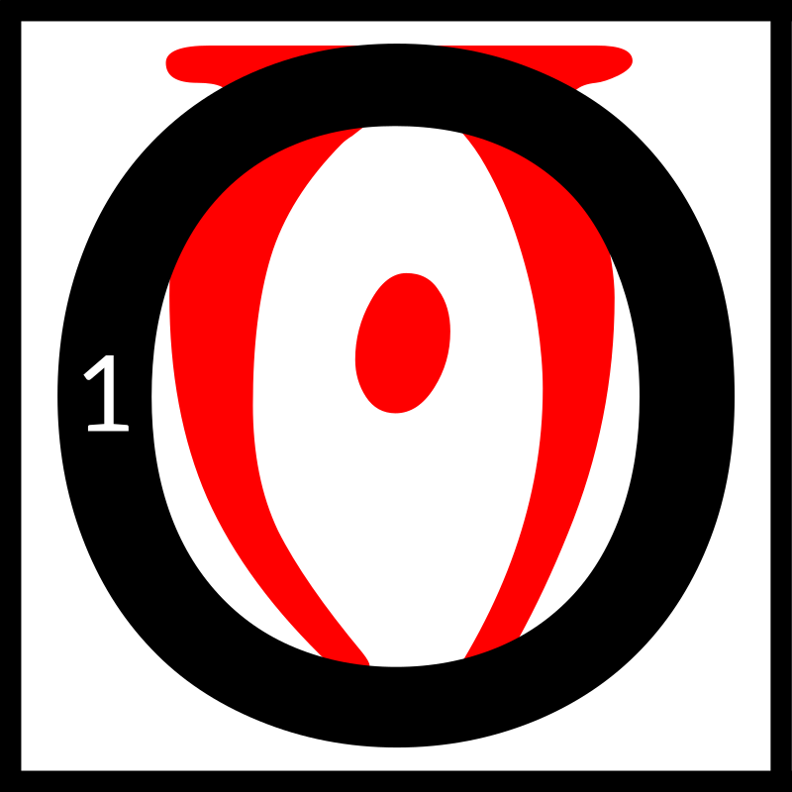
f all the et'Ada
who wandered
Nirn, Trinimac
was the strongest.
2He, for a very
long time, fooled
the Aldmeri into thinking that tears were the best response
to the Sundering. 3They cried and shamed our ancestors, especially the feeble Altmer. They even took the Missing God's name in vain, calling His narratives into question.

4So one day Boethiah, Prince of Plots, precocious youth, tricked Trinimac
to go into his mouth. 5Boethiah talked like Trinimac for awhile then, and gathered enough people to listen to him. 6Boethiah showed them the lies of the et'Ada,
the Aedra, and told them Trinimac was the biggest
liar of all, saying all this with Trinimac's voice! 7Boethiah told the mass before him the Tri-Angled Truth. He showed them, with Mephala, the rules
of Psijic Endeavor.
8He taught them how
to build Houses, and
what items they needed
to bury in the Corners.
9He demonstrated the right way to wear their skin. 10He performed the way to walk to achieve
an Exodus.

11Then Boethiah relieved himself of Trinimac right there on the ground
before them to prove
all the things he said
were the truth.

12It was easy then for his new people to become the Changed Ones.

The Ancestors

ajalde devehr summerset
Exodus from Summerset

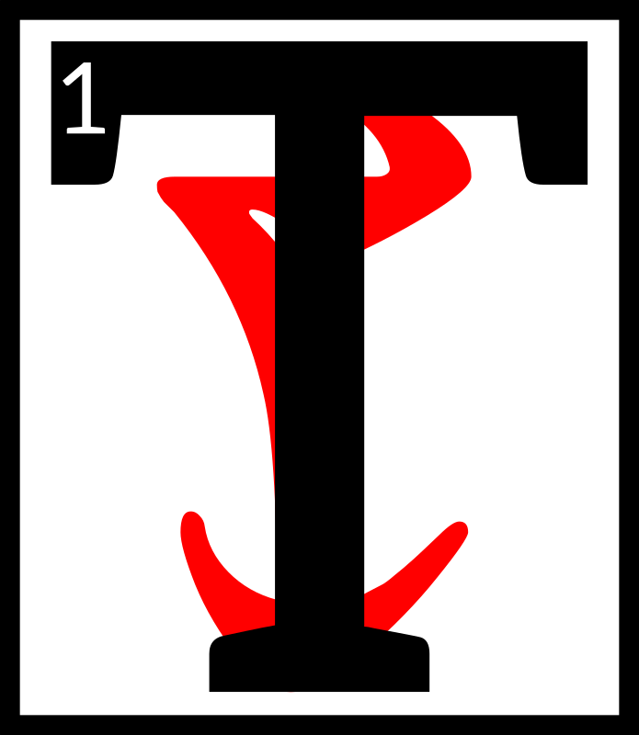
hose who dare can
achieve greatness.

2Veloth the Prophet
was scorned by
those who were
blind to the corruption and spiritual bankruptcy at the heart of their society. 3Veloth was cast out, cast off, by those with no interest in truth and even less interest in the betterment of all, who sought only to preserve their pride
and place by keeping others
in poverty, ignorance, and slavery. 4Veloth was highborn, but he dared to cast off the decadent chains of Aldmeri society.
5Veloth the Mystic called out
to those whose souls were weary, whose lives were ground out with no hope
of improvement in a society founded on ambition, greed, and decadence. 6To those
who hoped for a society that preserved traditions, praised honesty, and rewarded the just, Veloth's voice was as a golden note among a cacophony.

7Veloth the Pilgrim led his followers across the seas and away from the lands they had known with the promise of
a new land and a better future.

dimihn am as itam
End of the Journey

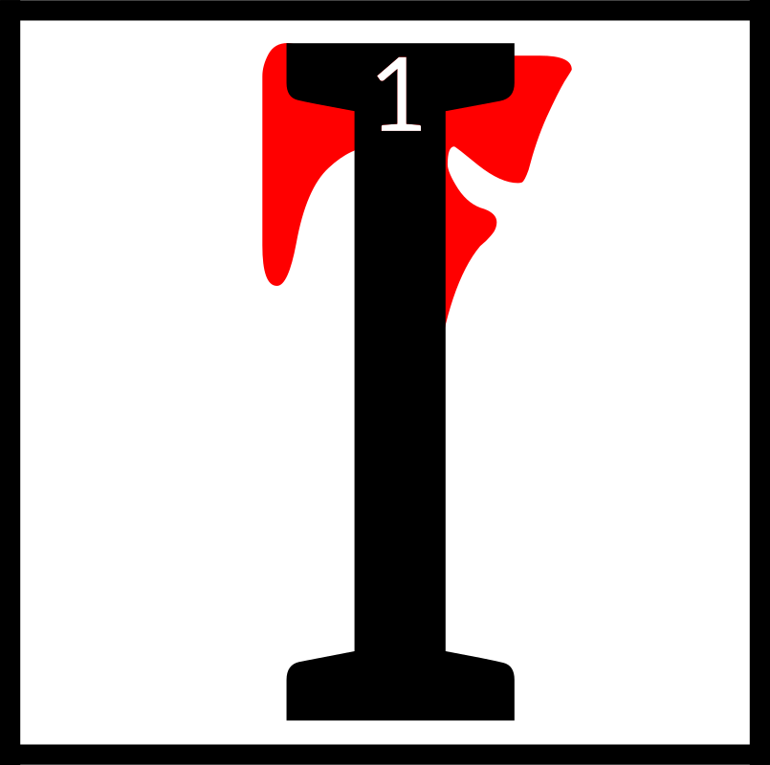
t was during the
time of Great
Despair when
Veloth and his
people reached
the land of
Resdayn. 2For untold weeks they had climbed a mighty range of mountains under Veloth's leadership. 3Many among the Chimer considered this path to be folly, but they were driven by Veloth's unyielding certainty
and commitment.

4They came upon a great pass, a deep scar in the mountain covered in ice and snow. 5Veloth drove them onward, chasing a vision that had come to him in a dream. 6He claimed to see a great hawk
in the sky.
The Ancestors

He vowed that the hawk would lead the Chimer to a new home. 7They drudged through the pass, but after a time the Chimer could go no farther.
A great wall of ice blocked
their way.

8Then a powerful voice boomed from the mountains. “Who are you and why have you come to this place?”

9“We are a people without a home,” replied Veloth to the mountain.

10A young woman stepped out of the wall of ice.

“And who are you?” asked Veloth.

11“I am Chimer-Friend. I have come to lead you home, if you are willing to accept my challenge. 12I demand a sacrifice of you, Veloth. Swear an oath that will make you a better mer.”

13Veloth hoisted his mighty hammer and proclaimed, “Never again shall I wield this tool or any other to slay a foe. 14I have given my heart to my people, but now I shall give them more. I shall dedicate my life and my soul to them.”

15The woman turned and waved at the wall of ice.
It melted away in moments. Beyond lay an alien land of fungus and ash. 16She began
to walk forward and the Chimer followed.

Veloth spoke to his people.
“We are home,” he declared. 17“This is the anvil upon which we shall forge a new people. One journey ends here,
but another journey begins.”

nerevar neen
The Real Nerevar

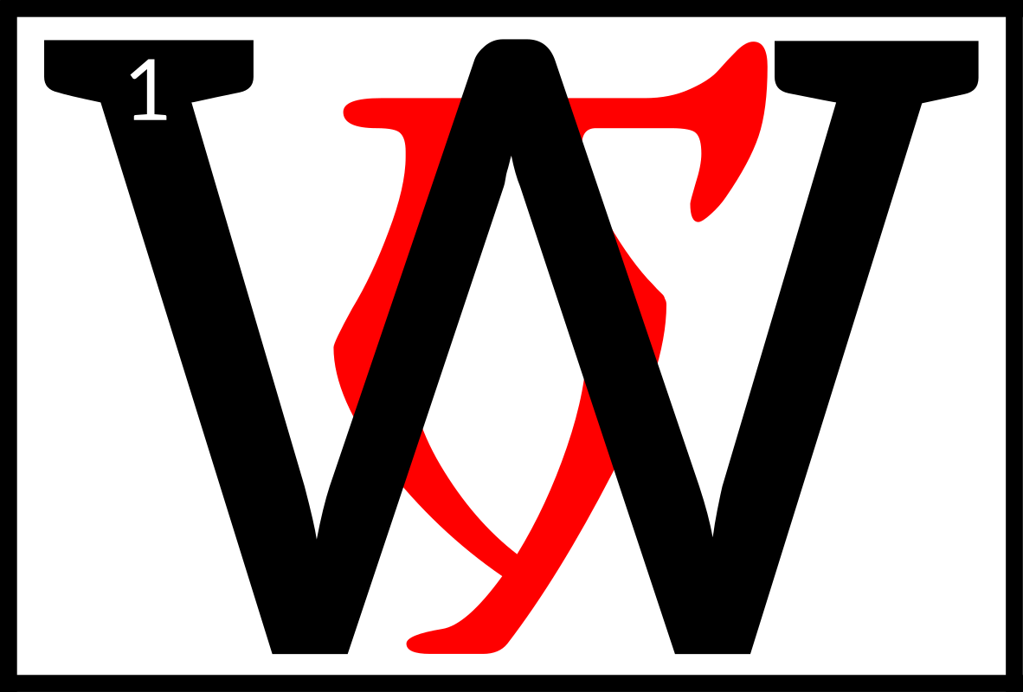
hen the
Dunmer
followed
Veloth to
Morrowind,
they were
many warring clans, with no law or leader in common.
2One Dunmer warlord, Nerevar, had the ambition to rule all the Dunmer.

3In that time, House Dwemer were great enchanters, so Nerevar went in secret to a Dwemer smith and asked for
an enchanted ring that would help him.
The Ancestors

4The ring gave its wearer great powers of persuasion; for safety, it was enchanted to instantly kill anyone who wore it except Nerevar. 5The ring was called Moon-and-Star,
and it helped Nerevar unite
the various clans into the
First Council.

6Later, however, disputes over religion divided the Council, with House Dwemer and
House Dagoth on one side and all the other Houses on the other. 7Dwemer and Dagoth invited Orc and Nord clans as allies, and held northwest Morrowind, 8while Nerevar mustered the other Houses and nomad tribes and marched to meet the Dwemer-Dagoth-Westerner forces.

9The armies met at Red Mountain, a Dwemer stronghold. 10The Dwemer were defeated, with great slaughter, and terrible sorceries were used, resulting in the utter extermination of House Dwemer, House Dagoth, and their allies. 11Nerevar was killed in the battle, and his ring lost, but Nerevar's alliance survives in Morrowind's ruling political institution, the Grand Council.

as daedra
The Daedra

he Daedra are not
of this world, and
are jealous of our
walks here, even
as they laugh at
our inanities.
2The Daedra are teachers and
testers, but never masters.
Only a fool does what a Daedra
desires without consideration.

3The bones of the earth are dead and can only whisper their secrets. The Daedra scream theirs, and can change the course of the world with their hands, while the Aedra must plead for mortal interference. 4That is their power, but beware your own arrogance if you choose to claim it as your own for a time.

5Mephala is the artist,
the weaver of dance and death. 6Her sex is the act of creation but the destruction of will; her murder the bringer of fear, but the possibility of night. 7There is birth in every death, death in every birth, and breathtaking beauty in both.
The Ancestors

8Would you see only ashes and death here, in our home? Or the splendor of the morning's kiss on the mushroom's cap, the twisting colors of an active foyada? 9Lava ravages the land; lava washes the land clean.
The new growth is a brighter green, but will attract more locusts to prey on the land. 10Which would you see? Mephala reminds us that there is duality in all, and to hold contentment where we can. 11Dance lightly on the ground else it will shift, but breathe
in deep and fast, else you will never know the joy that comes with our petty existence.

12Boethiah is the warrior, fierce, proud, and cunning. 13He reminds us to keep discipline and never stop fighting, even in seeming defeat. 14If you cannot cross the foyada, go around it, go along it, wait a day and build one's own bridge, but never to let it remain your obstacle. 15To surrender fully is the coward's way out, but only the false warrior mistakes laying down one's arms as surrender. 16In the face of a wicked enemy, there are no codes of honor beyond what a mer can do, and what a mer can't. 17But always honor the enemy for the strength they gift you, like
the seared heart of a bull guar.
We are greater than we know when pushed to the brink by violence.
18The deaths of many raise up the one to lead. Boethiah knows this, and chases the soles of our feet with his cinders.

19Azura is the mystery,
the space between waking
and sleeping. 20She governs transitions, from day to night, from the wet season to the dry, from babe to full-grown. 21All change needs guidance, and her smile is the proud tusks of the kagouti, as she jostles and guides her enemy to their own undoing, or her mates to their painful awakening. 22A flute never stays on one quaver,
but sways back and forth like
a woman in dance. When you are blind, you can hear this best, and that is why she would take your eyes. 23Azura's realm is grace and the balance that goes with it.

24Malacath is the warning,
the fallen. 25What is a mer with no tribe, no ancestors? Exile is not in the deed but in the heart. 26Cleave to your ancestors, but don't forget our heritage, the path of the wayward and the doubter. Ideals are only pillars waiting to be cast down. 27The rigid who do not look beneath the surface of their thoughts are eaten by the darkness that lies below, and he is our proof of this lesson. 28To see this malcontent hunter, you must keep your eyes open, but your heart stern.
The Ancestors

29Mehrunes Dagon is the sculptor of the earth. 30When the winds blow and waves crash, when the Mountain erupts, he is behind these things. We are of the earth
and weak, and flee before him. 31But remember this: as bones are re-broken to be set anew,
as leeches clean a wound of blood and infectant by their greed, so are we able to make
an art of it and swallow our past mistakes. 32The lava burns away the chaff to make way
for new grazing. He is a sister
to Mephala in this way,
the brushstroke to her genius.

33Molag Bal is the wanton fertility, the twister of authority, love, and childbearing. 34As a maggot devours the offal of our kills,
in his proper place he will eat
of our discards. But as a maggot loose in the meat, he will foul our careful labors. 35His is the true power behind the Missing God's decrees, and though the wise will feel sorrow for the sufferers of his deceit, they will also recognize the untruths this pain has given seed to. 36Molag Bal's lesson is instead in the whisper of the ashkhan's wife before he would charge into his exploits; 37though she may be of weaker arm than her warrior husband, her discretion and sympathies guide her tribe as much as the control and vigors of her partner, and those who corrupt either are ceded to Molag's mercy.

38Sheogorath is the slower blight, eater of order, punching holes of chaos into the prideful veneers of mer. 39Like a rabid nix-hound, he will blunder and bite at mer on the way. Eat of his flesh and you share of this madness, so set him loose well away from the tribes. 40Should he come sniffing around, coolly show him your manners as befitting an honored guest,
but do not let him in.

as alvioos
The Anticipations

he Daedra are
powerful ancestor
spirits, similar in
form and substance
to the Tribunal, but
weaker in power,
and more arbitrary and removed from the affairs of mortals. 2In old times, the Chimer worshiped the Daedra as gods. But they did not deserve this veneration,
The Ancestors

for the Daedra harm their worshipers as often as help them.

3The Advent of the Tribunal changed this unhappy state.

4By the Apotheosis,
the Tribunal became the Protectors and High Ancestor Spirits of the Dunmer, and bade the Daedra to give proper veneration and obedience. 5The Three Good Daedra, Boethiah, Azura,
and Mephala, recognized
the Divinity of the Triune Ancestors. 6The Rebel Daedra, Molag Bal, Malacath, Sheogorath, and Mehrunes Dagon, refused to swear fealty to the Tribunal,
and their worshipers
were cast out.

7These Rebel Daedra thus became the Four Corners of
the House of Troubles, and
they continue to plague our tranquility and tempt the unwary into Heresy and Dark Worship. 8The Priests of the Temple remain ever vigilant for signs of the Adversaries' return, sometimes aided by the loyal Three Good Daedra, who are familiar with the wiles of their rebellious kin.

9The Good Daedra are
known to the Temple as the Anticipations, since they are the early ancestral anticipations of the loving patronage of the Tribunal. 10The Anticipations are the Daedra Lords Boethiah, Mephala, and Azura.

11Boethiah is the Anticipation of Almalexia but male to her female. 12Boethiah was the ancestor who illuminated the Aldmer ages ago before the Mythic Era. 13He told them the truth of Lorkhan's test, and defeated Auri-El's champion, Trinimac. 14Boethiah ate Trinimac and voided him.
15The followers of Boethiah
and Trinimac rubbed the soil
of Trinimac upon themselves and changed their skins.

16Mephala is the Anticipation of Vivec, but manifold and androgynous. 17Mephala taught the Chimer to evade their enemies or kill them with secret murder. 18The Chimer were few in those days and threatened on all sides. 19Mephala taught the Chimer to build Houses. 20Later, Mephala created the Morag Tong.

21Azura is the Anticipation
of Sotha Sil, but female to his male. 22Azura was the ancestor who taught the Chimer how
to be different from the Altmer. Her teachings are sometimes attributed to Boethiah.
The Ancestors

23In the stories, Azura is
often encountered more as
a communal progenitor of the race as a whole rather than as an individual ancestor. 24She
is associated with Dusk and Dawn, and is sometimes called the Mother Soul. 25Azura's Star, also called the Twilight Star, appears briefly at dawn and dusk low on the horizon below the constellation of the Steed. 26Azura is associated with mystery and magic, fate
and prophecy.

thil am rokashiin
The House of Troubles

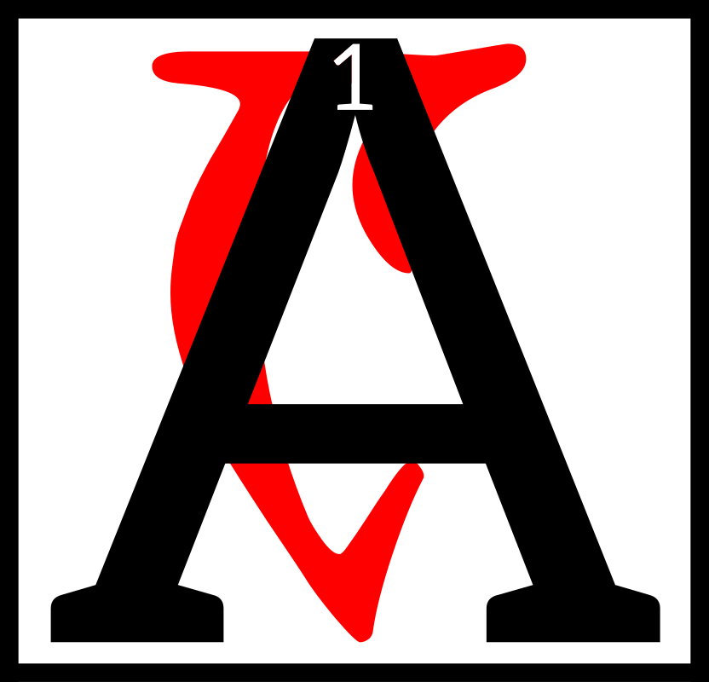
mong the ancient
ancestral spirits
who accompanied
Veloth and the
Chimer into the
promised land of
Morrowind, the four Daedra Lords, Malacath, Mehrunes Dagon, Molag Bal, and Sheogorath, are known as the Four Corners of the House of Troubles. 2These Daedra Lords rebelled against the counsel
and admonition of the Tribunal, causing great kinstrife and confusion among the clans
and Great Houses.

3Malacath, Mehrunes Dagon, Molag Bal, and Sheogorath are holy in that they serve the role of obstacles during the Testing. 4Through time they have sometimes become associated with local enemies, like the Nords, Akaviri, or Mountain Orcs.
5Malacath is the reanimated dung that was Trinimac. Malacath is a weak but vengeful god. 6The Dunmer say he is Malak, the god-king of the Orcs. He tests the Dunmer for physical weakness.

7Molag Bal is, in Morrowind, the King of Violation. He tries to upset the bloodlines of Houses and otherwise ruin the Dunmer gene pool. 8A race of monsters, said to live in Molag Amur, are the result of his seduction of Vivec during the previous era.

9Sheogorath is the King of Madness. He always tests the Dunmer for mental weakness. 10In many legends he is called upon by one Dunmer faction against another; 11in half of these stories he does not betray those who called him, further confusing the issue of his place in the scheme of things.
The Ancestors

12He is often associated with the fear other races have of the Dunmer, especially those who, like the Empire, might prove as useful allies.

13Mehrunes Dagon is the god
of destruction. He is associated with natural dangers like fire, earthquakes, and floods.
14To some he represents
the inhospitable land of Morrowind. He tests the Dunmer will to survive
and persevere.

15The worship of these four malevolent spirits is against the law and practice of the Temple. 16However, the
Four Corners seldom fail
to discover those greedy, reckless, or mad enough
to serve them.

17By ancient Temple law and custom, the lives of termagants and haruspices are forfeit,
18and garrisons join Ordinators and Buoyant Armigers of
the Temple in tracking down and destroying these foul covens in the wilderness refuges and ancient ruins where they conceal their profane worships.

khiis am as shaln
The Doors of the Spirit

he Ancestors are
among us. They are
never farther away
than the Waiting
Door.

2The Ancestors are not departed. The dead are not under the earth. 3Their spirits are in the restless wind, in
the fire's voice, in the foot-smoothed step. 4Pay heed
to these things, and you will
know your absent kin.

5Pay reverence through gift and prayer. 6Acquaint the Ancestors with your affairs, with your comings and goings, with your blessings and trials.

7From the Waiting Door comes your protection. 8Heed the spirits, who are the guardians of your hearth, teachers of wisdom, counselors of fortune, seers of fate.

9Each bone is a door through the wall of the world. 10Each bone is the road, with Wisdom and Power the travelers. 11Each bone is the ghost fence that guards us from evil.
The Ancestors

12Honor the Ancestors upon your hearths, within your halls, in the community of your temples, in the solitude of
your tombs.

13Guard your Ancestors from beasts, from thieves, from profane priests and sorcerers. 14Let no creature steal your spirits, for the plundered hearth is diminished, and the plundered tomb is shamed.

15Live in One World with your spirits. Honor the spirits within and without you. 16Do not grieve for the dead.
Take shelter in their arms,
and pay heed to their words.

demigi devahroshaaln
Blasphemous Revenants

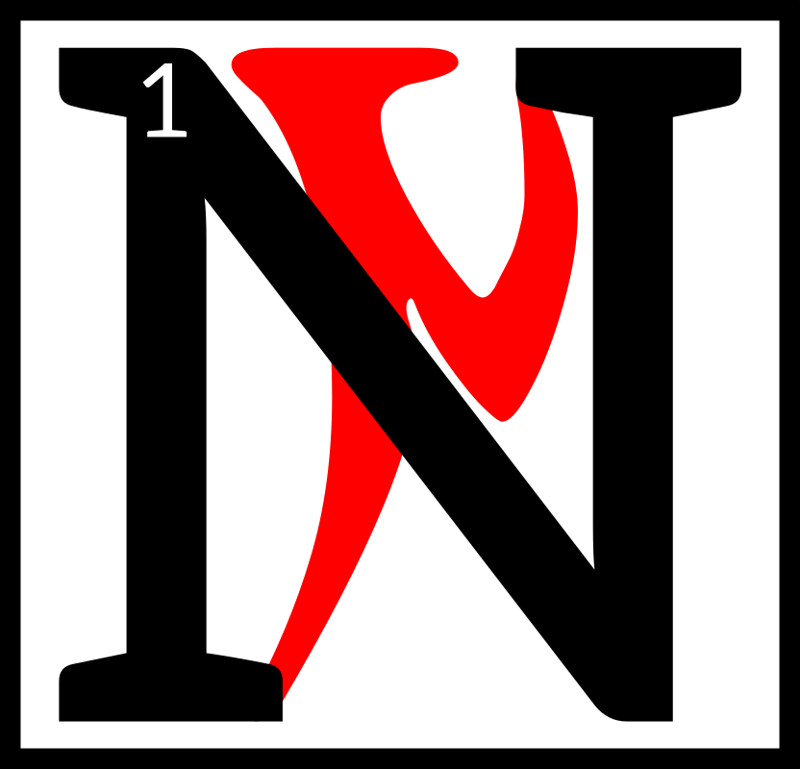
ot into the world,
nor out of it, but
between worlds
they linger, held
to the hearth and
tomb by blood
and loyalty. 2And if they come unbidden, from love of kin or faith to duty, it is not unholy. 3It is but the answering of the ancestors, the awakening of those who never sleep, the summoning to service of those bound through Hearth and House to the protection of
the clan.

4But if sorcerers bring them forth, then such a summons
is blasphemy, an abomination before the tribes and Temple, and a sin so great that ages of burning cannot cleanse the fault. 5Abide not the sorcerer among you, for he comes to steal the bones of your fathers
and dust of your tombs.
6He seeks to bind by power what is yours by right, to drag forth the warm spirits from their world between and bind them to their service like
slaves and beasts.

7Who can know the shame of the dead, the ceaseless weeping of the necromancer's thrall? 8Cruel enough is the ancestor's service given in love to Hearth and Kin. 9But ghost or guardian, bone-walker or bonelord, summoned by profane ritual and bound by force to the corpse miner's will, how may such a spirit ever find rest? 10How may it ever find its way back to its blood and clan?

11Only a righteous Dunmer, bound by blood to hearth and kin, bound by oath and service to the Temple, can call upon
The Ancestors

the spirits of the Dunmer dead. 12Those foreign sorcerers of other races that invade our shores, shall they be permitted to rob our tombs, to bind our kin-spirits into sorcerous slavery, to steal the lives of
our dead as well as our land
of the living? 13No, I say,
no, and no, three times more. Such necromancers must die, and their profane magics
must die with them.

14And shall we tolerate the hidden hosts of the undead,
the arrogant princes of necromancers, the ancient vampire demons who creep from their lairs in the West, seeking refuge in profane Daedric shrines, abandoned Dunmer strongholds, and corrupted subterranean labyrinths of the detested Dwemer race? 15For ages the Great Houses and the Temple have kept our land clean of the vampire's taint, but now these undead lords and their vile cattle have returned.
16These vampires must die,
and their corrupt cattle with them, and their blood taint must be forever erased
by fire and stake.

shaln am nirn
Spirit of Nirn


orkhan is the Spirit
of Nirn, the god of
all mortals. 2This
does not mean all
mortals necessarily
like him or even
know him. 3Most mer hate him, thinking creation as that act which sundered them from
the spirit realm. 4Most humans revere him, or aspects of him,
as the herald of existence.

5The creation of the Mortal Plane, the Mundus, Nirn, is a source of mental anguish to all living things; 6all souls know deep down they came originally from somewhere else, and that Nirn is a cruel and crucial step to what comes next. 7What is this next?

Some wish to return to the original state, the spirit realm, and that Lorkhan is the Demon that hinders their way;
8to them Nirn is a prison,
an illusion to escape.

9Others think that Lorkhan created the world as the testing ground for transcendence;
10to them the spirit realm was already a prison, that true escape is now finally possible.
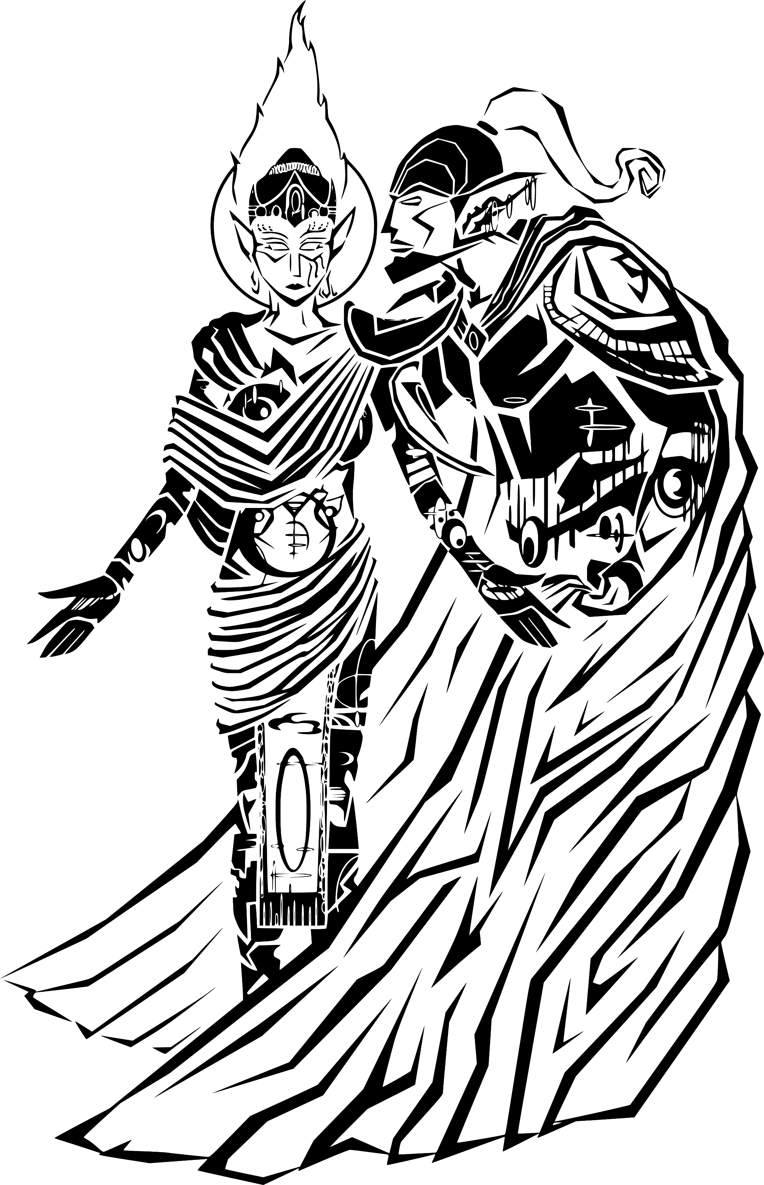

A
I
L
X
M
E
L

Mother of the Governance of Stars

SAV

gah malyudahrdii

The Greater Homilies

The Greater Homilies

alna'resdul
Fable One

Sotha Sil and the Scribs

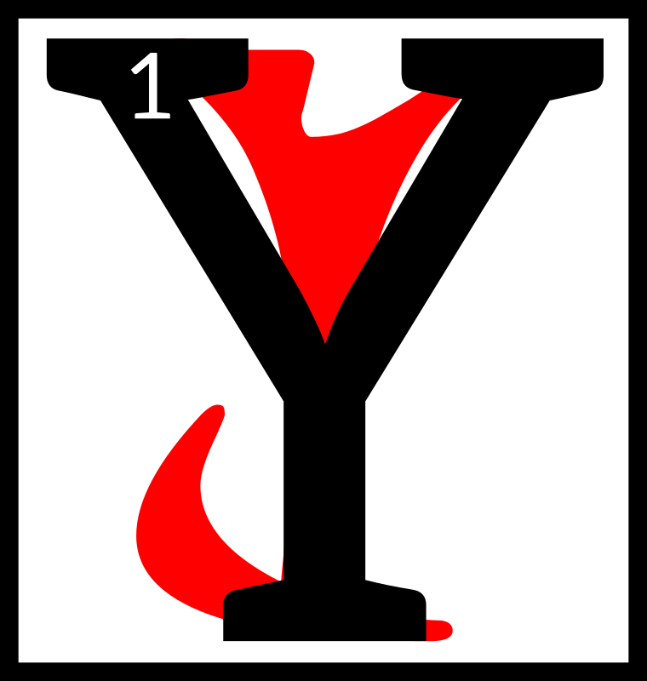
oung Sotha Sil,
while playing in
the egg mines, saw
a number of scribs
in a deep shaft,
2and he began
to cast stones upon them, snickering as they skittered
and scattered, until one of the scribs, lifting its head up in agony, cried out to Sotha Sil:

3“Please, please, have mercy, little boy, for what is sport to you is suffering and death to us.”

4And so Sotha Sil discovered that the idle of amusements of one may be the solemn tortures of another.

asca'resdul
Fable Two

Lord Vivec and the Contentious Beasts

shalk and a
kagouti were
strutting back
and forth in a
foyada, casting
aspersions of one
another's looks.

2“You are the ugliest creature alive,” the shalk told the kagouti.3“No, you are the ugliest creature alive!” the kagouti told
the shalk.

4For each thought himself most handsome, and the other most ugly.
5Then Lord Vivec chanced by, and settled their dispute.

6“No, you both are the ugliest creatures alive!
I will not have my pleasant sojourn spoiled by your unseemly squabbling.”

7So he dealt them both mighty blows, shattering their skulls, and silencing their argument, and went merrily upon his way.

8And thus Lord Vivec proved that ugliness is as much in one's manner as in one's appearance.

The Greater Homilies

cahna'resdul
Fable Three

The Boiled Kagouti

t is said that if a
kagouti steps into
a boiling pool,
he will leap out
immediately to
avoid harm.

2But if the kagouti is standing in a pool, and a wizard slowly raises the temperature,
measure by measure, to boiling, the kagouti will calmly stand
in place until he is boiled.
3Thus we see that we must be alert not only to the obvious danger, but also to the subtle degrees by which change may result in danger.

cina'resdul
Fable Four

The Dubious Healer

nce upon a time,
a Telvanni issued
forth from his
tower and
proclaimed to all
the world that
he was a mighty and learned healer, master of all alchemy and potions, and able to cure
all diseases.

2Lord Vivec looked upon this wizard, and listened to his boasting, 3then asked him,

“How can you pretend
to prescribe for others the cure to all diseases, when you are unable
to cure yourself of your own manifest arrogance and foolishness?”

The Greater Homilies

arca'resdul
Fable Five

The Guar and the Mudcrabs

he Guar were so
tormented by the
other creatures
they did not know
where to go.
2As soon as they
saw a single beast approach them, off they dashed in terror.

3One day they saw a pack of Nix-hounds ranging about,
and in a desperate panic all
the Guar scuttled off towards
the sea, determined to drown themselves rather than live in such a continual state of fear. 4But just as they got near
the shoreline, a colony of Mudcrabs, frightened in their turn by the approach of the Guar, scuttled off, and threw themselves into the water.

5“Truly,” said one of the Guar, “things are not so bad as they seem. For there is always someone worse off than you.”

tahna'resdul
Fable Six

The Wounded Netch

wounded Netch
lay himself down
in a quiet corner
of his feeding
-ground.
2His healthy
companions came in great numbers to inquire after his health, yet each one helped himself to a share of the fodder which had been placed there for his use; 3so that the poor Netch died, not from his wounds, but from the greed
and carelessness of his erstwhile friends.

4And so it is clear that thoughtless companions may bring more harm than help.

The Greater Homilies

sahna'resdul
Fable Seven

Almalexia and the Mudcrab

here was once
a mudcrab who
suffered much.
2He had a limp and
a hacking cough.
His shell was
misshapen, causing him pain. He was weary at all times,
and told everyone he was surely dying. 3He roamed the valley one day, complaining
to any who would listen.

4The shalk created a brace from part of his shell and offered it to the mudcrab. “Here, mudcrab, try bracing your leg,”
he advised.

5“No, no, no,” said the mudcrab, “I have tried
that and it does not work.”

6“Mudcrab,” said the alit, “let me bite on your shell and crack it just a bit to relieve the pressure.”

7The mudcrab said, “You are trying to trick me, alit! You just want an easy snack!”

8Almalexia, who was roaming the land that day, heard these conversations and entered the valley, where she appeared as
a humble guar.

9“Mudcrab,” she said,
“take this draught I have made for your cough.”

10“Guar, you are not a healer. It is better to suffer than risk a poor remedy,” replied the mudcrab.

11And Almalexia revealed herself to the creatures, who gasped in surprise.

12“Mudcrab,” she said,
“all of these creatures
have offered you help,
but you refuse. You are
in love with complaining, and you will never
be healed.”

13And so Almalexia teaches
us that you cannot aid the unwilling.

The Greater Homilies

daskhora'resdul
Fable Eight

The Tallest Shroom Beetle

shroom beetle,
lamenting its
small stature,
crawled to the
top of a great
mushroom.
2It gazed out over the Ashlands and cried, “Ha! There is no shroom beetle taller than I! There is nothing I cannot see!”

3Just then, a cliff racer swooped down and plucked the beetle from its perch. 4The beast grinned a wide toothy grin
and said, “Had you stayed on the ground, I never would
have seen you. Is it not better
to be short than dead?”

5Alas, the beetle learned too late that forsaking one's nature brings nothing but ruin.

enta'resdul
Fable Nine

The Tale of Two Herders

wo guar herders
met in the market
square, preparing
to sell their stock.
2The shorter of the
two laughed at the
other and jeered,

“You bring only one guar to market? 3Look upon my herd! I have brought ten and twenty and stand to make a fortune!”

4The tall herder merely shook his head.
“You may have ten and twenty guars, but they are scrawny and frail. 5Better to have one steady beast than a hundred sickly ones.”

6The short herder released an oafish chuckle and prepared to usher his beasts into the pens. 7Just then, a great ash storm arrived and pummeled the market with howling winds and choking fumes. Eventually, the storm relented.
The Greater Homilies

8The tall herder and his great, strong guar were unharmed, but the short herder's guars were thrown this way and that, and not one of them had survived.

9“Do you see now, my friend?” the tall herdsman said. “Numbers are no substitute for quality.”

alnahna'resdul
Fable Ten

The Friendly Alit

jovial alit
pranced across
the Ashlands,
ever watchful for
a beast it could
call “friend.”
2Presently it came upon a nix-hound who was preening itself in an ashpit. The alit smiled
a great smile and cried out, “Greetings, friend!” 3The nix-hound, seeing the alit's huge teeth, panicked and dashed under a rock. The alit sighed and pranced on.

4In due course it came upon
a vvardvark rooting through
a beetle-nest. “Hello!” the alit shouted, smiling widely and revealing its huge, sharp teeth. 5The vvardvark squealed in terror and scampered off into the bushes. The alit released another mournful sigh, and trundled on toward the shore.

6Finally, it spotted an ash-hopper rolling in the sand. The alit summoned up its widest, most cheerful smile and said, “Hail, ash-hopper!” 7The ash-hopper leapt back in horror and sprung away as fast as it could.

The alit was heartbroken.
8“I will never have a friend as long as I have these terrible teeth!” it hissed. 9The beast resolved to be done with them altogether. It took a huge rock in its mouth and bit down hard—knocking out all its teeth like a box of loose nails. 10“Finally,” it sighed “other beasts will no longer be afraid!”

11Just then a great Kagouti arrived, stomping its feet and preparing to pounce. The alit growled and opened its wide jaws to frighten the predator away, but the kagouti just laughed.
The Greater Homilies

12“You fool! You've no teeth
left in your head!” 13The alit realized its folly too late. The kagouti lunged and swallowed the cheerful beast in one huge gulp.

14So you see, child—that which we hate in ourselves is often our greatest gift.

alnahn'alna'resdul
Fable Eleven

Vivec and the Paralytic

ord Vivec, while
walking down
a road, came upon
a paralytic with
a gnarled and
withered hand.

2“Young bravo!” the paralytic cried, “Will you not help an oathman in need?”

3Vivec stood before the paralytic and furrowed his brow.

“What is wrong with you, old mer?” he queried.

4The paralytic lifted his hand and replied, “Do you not see my withered hand? It is twisted as old roots and pains me greatly
when the storms roll in. 5Women shun me because of its ugliness, and children run at the sight
of it. Please, have pity!”

6Vivec stood quiet for a moment, then drew his bright sword and severed the mer's hand in one clean stroke.
7The paralytic howled in pain
as the warrior-poet dressed
the wound.

8“Do not bawl so, old mer,” said Vivec. “Do you not see that I have done you the greatest kindness?
9Better to be done with an evil than to carry it on for pity's sake.”

The Greater Homilies

alnahn'asca'resdul
Fable Twelve

The Crow and the Netch

ne day a curious
crow decided to
fly farther than
he ever flew
before. 2He flew
and flew and
finally came upon a creature that he found very strange.

3“Friend!” he called as he flew by the creature. “Friend, what is it that you are? I have never seen a flying beast such as you!”

4“They call me a netch,” the good netch replied.

5“A netch! A netch! That's quite the catch!” the crow cackled. “Tell me, netch, how is it that you fly?”

6“I've flown these
shores since I was born,” the netch replied.
“I do not know how.”

7“Don't know, don't know, oh what a show!” the crow called out. “Where are your glossy feathers that help you glide?”

8“I have no need of feathers to glide,”
the netch explained, “but
I have a strong, thick hide to protect me.”

9“A hide! A hide! Oh,
what a find,” the crow mocked. “Tell me netch, where are your eyes?”

10“I need no eyes to sail
the skies, as you can plainly see,” the netch once more replied.

11“No eyes, no eyes, to sail the skies!” the prideful crow continued. “But it makes you far uglier than I!” 12And he began to laugh at the netch's misfortune.

The crow's laughter grew louder and louder, eventually attracting a nearby cliff-racer. 13The beast swooped down upon the crow, swallowing him whole, and he could mock the netch no more.

14The netch simply sighed and said,

“Mocking others is for naught, for none can change their own weakness.”

The Greater Homilies

alnahn'cahna'resdul
Fable Thirteen

The Gifted Guar

ne day a farmer
decided to give
his daughter
a gift. She had
started a family
of her own, and
he wished good fortune for her. 2He chose his finest guar and brought it to his daughter's
new home.

3His daughter was delighted
at this gift, but her husband only glared.

4“You didn't even let us choose?” the husband asked angrily. 5“What if this guar is sick, or old,
or weak? I must at least inspect it before it's left
in our care!”

6The daughter tried to calm her husband, but the farmer simply nodded and said, “You may examine this guar as you
see fit.”

7The husband inspected every inch of the guar, even forcing the beast to open its mighty jaws to look at the state of its teeth.

8“Well, it will have to do,” the husband conceded, though he knew it was
a fine guar indeed.

9The farmer stroked his chin. “You know, I think you're right. You should
be able to pick whichever guar you wish. I know there's plenty for sale
in the local market.”

10The husband simply gaped as his father-in-law walked back home, guar in hand.

11His wife slapped her husband's arm and told him, “You fool! Never look a gift guar in the mouth!”

The Greater Homilies

alnahn'cina'resdul
Fable Fourteen

The Child of the Councilor

ne summer's day,
a councilor was
walking along
the market in her
splendid regalia,
attended by her
many servants. 2She was so splendid that a small mer in
the crowd told his mother,

“I wish my mother
was a councilor,
instead of you!”

3The little mer never expected the councilor to hear him,
nor did he expect her to turn toward him in the crowd.

4“I have heard your wish, little one, and
I accept,” she told the open-mouthed little mer. 5“You will be my child, and you will have
all that you wish.”

6The little mer was immediately taken to the councilor's manor and placed
in a room with toys and sweets. 7He laughed and clapped his hands, playing and eating all he wished. But soon he grew bored and went to speak to a servant.

8“It's no fun playing by myself,” he told the servant. “Can I have someone to play with?”

9“The child of the councilor has no equal,” the servant told him. “There is none worthy
to play with you.”

10The little mer had little time to think on this when a scholar came to his room. 11The scholar looked upon the little mer with scorn and said,

“Your lessons should
have begun hours ago!
The child of the councilor must know many great things.”

12The little mer was made to listen to the scholar's lectures for hours and hours, and soon his head ached with all that he was to know.

13Eventually it was time for dinner, but the little mer's troubles were not over.

“In those clothes? In that state?” cried his servant, horrified. 14“You must
be washed and clothed
if you are to be presented as the child of the councilor!”
The Greater Homilies

15And so the little mer was scrubbed roughly and forced into very uncomfortable clothes. 16By this point the little mer was almost in tears. He missed his home, and his clothes, and his friends.

But most of all he missed
his mother, who he had never gone a day without.

17When the little mer was finally sent to the dining hall, he was met with a surprise. Seated at the dining table was his family, all laughing and smiling. 18He ran to his mother's arms and cried,

“I'm sorry, I'm sorry!
I want you to be my mother after all!”

19The councilor, who was seated at the head of the table, smiled and told the little mer,

“You have learned a
very important lesson, my child. 20We often forget to be thankful
for what we have,
when thinking only of what we want.”

alnahn'arca'resdul
Fable Fifteen

Sotha Sil and the Stars
oung Sotha Sil lay
upon a patch of
moss and gazed
up at the stars.
Driven by his
great love of
maths, his mind turned to counting.

2“I shall count every star and give each a name!” he resolved.

3For hours he counted and named until, at length, his eyes tired and he drifted off to sleep.

4When morning came, Sotha Sil woke with a start and looked up at the sky. Alas, all the stars had vanished. 5He buried his face in his hands and began to weep, for he had learned a harsh lesson. 6You see, child, time cages all tasks.

The Greater Homilies

alnahn'tahna'resdul
Fable Sixteen

The Strongest Nix-Ox

great nix-ox
trumpeted to its
herd, “None of
you love the
master more
than I! Do you
see what great burdens I bear?”

2“But you are twice our size!” the lesser nix-oxen grumbled. “Better for us to carry four bales of saltrice than struggle with six and risk great injury.”

3“Bah!” the mighty nix-ox snorted. “It's hard work you fear, not injury.” The great beast took up its yoke and trudged out into the field.

4The lesser nix-oxen gathered by a fence and watched their mighty brother take up two bales of saltrice, then four bales, then six, eight, ten! 5Until at last, the great nix-ox was laden with twelve full bales.

6“Do you see?” it said, straining for breath. “None of you love the master more than I!”

7Just then, the nix-ox's shell began to crack under the weight. 8It let out a painful bellow and collapsed under
the bales—crushed to death.

9The lesser nix-oxen sighed and shook their heads. 10“Poor fool. He learned too late that there
is no mortal strength without limits.”

alnahn'sahna'resdul
Fable Seventeen

The Tale of the Frozen Guar

lonely guar
struggled
through the
Ashlands on
a cold, moonless
night.

The wind was frosty and bitter and chilled the animal to the bone. 2“Alas!” it cried, “I will die here, alone in the cold.”

The Greater Homilies

3Just then, the guar caught sight of a faint orange glow
in the distance.

4“A campfire?” it barked hopefully, “It must be! It must be!”

5The guar raced toward the light, its feet growing warmer with every step. Soon, the cold gave way to a sweltering heat. 6The air grew thick and acrid, searing the guar's nostrils and lungs. 7But still, it hurried on, barking, “It must be a campfire! It must be! It must be!”

8Finally, the guar reached the orange glow. Alas, it was not
a campfire, but a great flow of lava. 9The guar, so seduced by the warmth, gave this truth no heed. It sprinted to the lava's edge and tripped on a loose stone. 10With one last joyful bark, the beast landed headfirst in the fiery liquid and died.

11So you see, child, a fool's thirst for safety carries its
own risks.

alnahn'daskhora'resdul
Fable Eighteen

The Most Beautiful Netch

netch mother
once said to her
calf, “You, my
darling, are the
most beautiful
netchling in all
these isles. No bull is worthy
of you!”

2For years the netch's vanity grew. Many worthy bulls approached her with loving intent, but she rebuffed them all, 3saying, “Do you not know that I am the most beautiful netch in all these isles? None of you are worthy of me!”

4At length, the netch grew old and weary. “Alas, I shall die alone!” she cried.

5A young netch couple passed her by and sighed at her wretched condition. “We must be cautious with our calves,” the betty said. 6“Smothering
a child with praise does nothing but harm.”

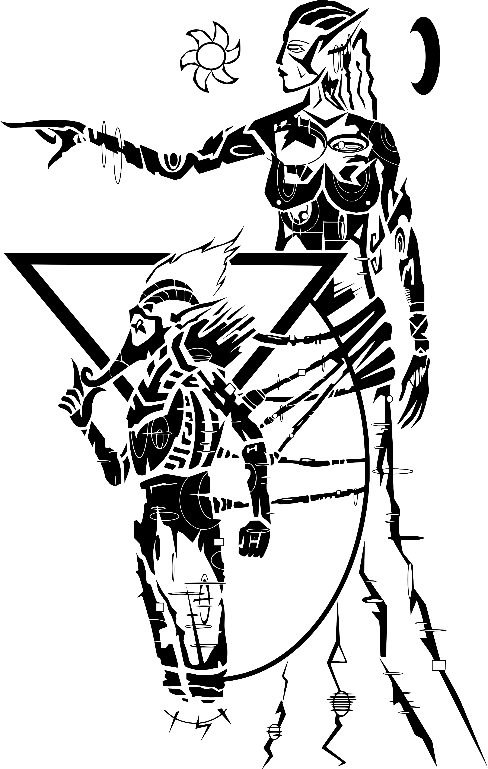

S
O
T'
H'
A
I
L
The Light of Knowledge

ASV

neihn gher leyrihn

The Truth in Sequence

The Truth in Sequence

alna'amurokam
Volume One

1By the word, I wind the gears.

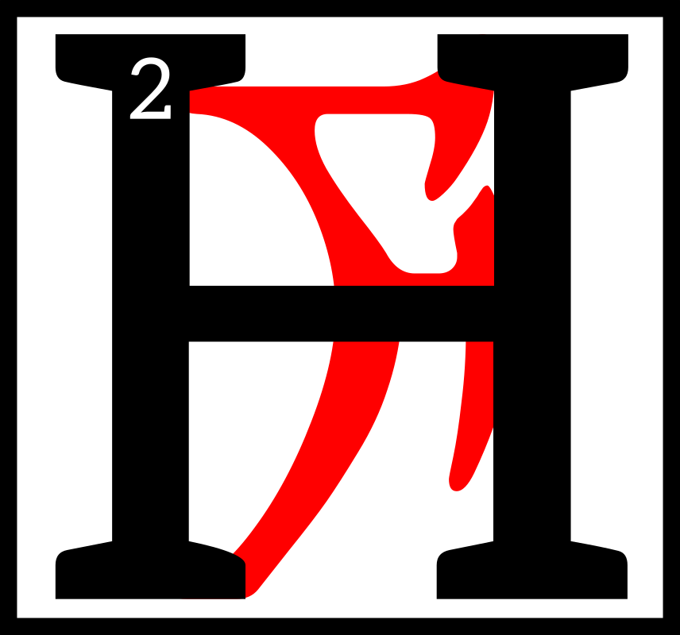
ow does one
come to know
the Clockwork
God and Father
of Mysteries?
3Our Lord Vivec
and the Lady of Mercy, Almalexia, are known to us. 4Their faces are known to us. Their words are known to us. But what of Sotha Sil? 5He who is distant in both position and intent. Ever watchful, but seldom seen. Ever worshiped, but seldom heard. 6He is the Mainspring Ever-Wound—the unmoved mover, hidden within His Clockwork City, whose voice is the Divine Metronome. 7As Tourbillon, I speak His truth as I know it. I say the words in sequence so they can be known by the people.
8The sequence is but a shadow of the truth, but minds such as ours cannot bear the ordered unsequence. 9Minds such as ours cannot truly know themselves. Not yet.

10The First Truth of the Mainspring Ever-Wound is the truth of Nirn. 11The soul of Nirn has two faces. The first
is known to us—the Nirn-Prior, or the Nirn of Many Parts.
12It is a Nirn in pieces, assembled by the unsteady hand that has yet to find itself. 13Its oscillations irregular,
its going train disrupted by fear and delusion. Its faults are not in its parts, but in its assembly. 14Each gear is a god. Each spring is a thought. But a mechanism built by many hands cannot know the precision of the master craftsman. 15The et'Ada Gears cannot bring forth a true Nirn, because they know only its parts. They cannot see the whole. 16The Eye of Sotha Sil ignores such division. 17Where the broken gods see only pieces, our Father Sotha Sil sees the whole. He sees the Second Nirn.

18The Second Nirn.
The inchoate Nirn-Ensuing.
The thought-form that anticipates the world to come:
Tamriel Final. Anuvanna'si. 19Only Sotha Sil knows its shape. Its nature lies forgotten in the before-time when Anu broke itself for wisdom's sake. 20Our lessers know the Source as two forms: Anu and Padomay, but this binary is without merit. 21One of Lorkhan's Great Lies, meant to sunder us from the truth of Anuic unity. 22Our father, Sotha Sil, would have us know the truth: there is no Padomay.
The Truth in Sequence

23Padomay is the absence
of value. The lack. A ghost
that vanishes at first light.
A Nothing. 24There is only
Anu, sundered and known by many names, possessing many faces. The one.

25When Anu broke itself, it did so to understand its nature.
26In its sundering, the values that swam in its vastness thought to know themselves. 27The et'Ada Gears gave themselves many names and
set their will to building.
28Alas, they heeded the
counsel of Lorkhan and forgot the face of Anu. 29They thought themselves distinct and whole. And so, many hands assembled the world, each with separate intention and selfish purpose. 30The Nirn of Many Parts was the result. A broken and leaking steam-ship that lists ever wind-ward.

31But rejoice, children of the Tribunal! In His wisdom, the Mainspring Ever-Wound seeks to reclaim our lost heritage. 32His heart is oiled and calibrated, pumping dark truth as blood. 33His mind is the God-Mortar where the fractured values of Anuic nature are ground and weighed—unified through His will alone.
34From this great labor, a new Nirn will be born. Tamriel Final. Anuvanna'si. 35I pray that we see the fruit of His labor—a perfect world, without et'Ada Gears. Without the illusion of change. Water-tight and everlasting.

36By the word, I wind the gears.

asca'amurokam
Volume Two

1By the word, I wind the gears.

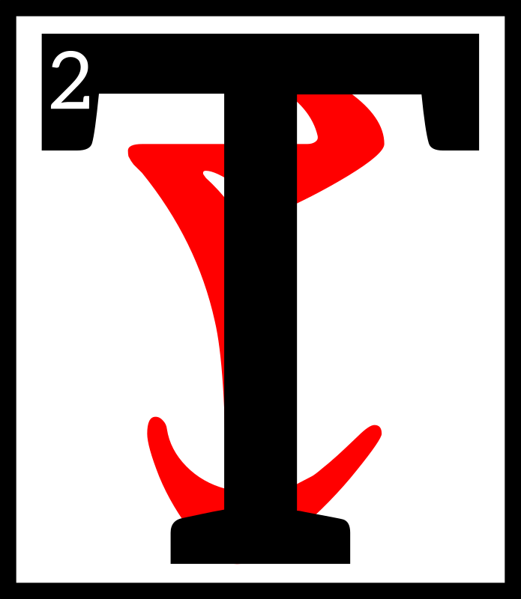
he will of Sotha Sil
is the chrononymic
will. The Nameless
Will. For what is
“Name?” 3The
Divine Metronome
tells us that “Name” is the wedge that pries gear from pinion. 4The residue of Lorkhan's Great Lie that loosens the wheel chain and corrodes the frame. 5The et'Ada Gears named each and each, in their way. 6Our lessers see this as
a kindness, but the Mainspring Ever-Wound calls it a curse, rooted in selfish pride.
7To name is to cleave one
from another.
The Truth in Sequence

8It is the death of Anuic convergence and the Nirn-Ensuing—the misassembled dragon that breathes dry falsehood and whose name
is “Multitude.”

9There is only one name that is not Name. Seht, the convergent Clockwork God, whose will pumps like a piston into both “then” and “after.” 10Sotha Sil, Father of Mystery, whose heart drives the Wheels Eternal and whose blood oils the All-Axle. 11SI, the Divine Engine, whose mind merges “they” and “we” and births the Nirn-Ensuing. 12Lesser wills are wisps of smoke, born and lost in a sea
of endless sky. Lost children whose freedom is death.

13For what is freedom, child of the Tribunal? The counter-lever to slavery? No. 14Have you not heard the words in sequence? The chrononymic will is the pendulum that swings only once. 15It cannot
do otherwise. To swing twice would break one intention
from another and prove the blasphemy of two. 16As Padomay is illusion, so too is the named will. 17For what is “choice” if not chaos? What is “free will” if not the lack of order, vulgar and triumphant? 18The true wheels spin clockwise, ever clockwise. In the unity of Nirn-Ensuing, each belongs to all, and all belong to none—save Tamriel Final. Anuvanna'si. 19So lay down your cheap burdens, child. “Shall I do thus?” Such “choice” is delusion. 20Give yourself to the pursuit of unity, for in the end, you cannot do otherwise.

21By the word, I wind the gears.

cahna'amurokam
Volume Three

1By the word, I wind the gears.

he Third Truth of
the Mainspring
Ever-Wound is
the truth of the
Daedra. 3In the
days before the
First Ignition, the Chimer people bent their knees to the False Princes:
4The Webspinner, the Prince
of Plots, and the Queen of Dawn and Dusk. I do not use their names, as Name cleaves one from another. 5You know them well, child of the Tribunal, for every time you bear false witness,
The Truth in Sequence

or make foolish boasts, you do so in their name. 6Their words corrode and weaken the heart. Their threats loosen the fasteners and break the seals. 7They are the Anti-Gears that turn counter to the Nameless Will. Servants of the Padomaic untruth whose nature is void. 8Of the Daedra, only the Gray Prince of Order knew his nature, and he went mad in
the knowing.

9The Daedra fear wisdom and order, you see? And thus do they fear the Clockwork God above all others. 10Where others see dark crowns numbered ten and six, Sotha Sil sees shadows and nothing more. 11For the Daedra are the lie that creation tells itself. Like their father, Padomay, they are Nothing. And in the Tamriel Final, Nothing shall hold no sway. Anuvanna'si. 12Their black mountain called “Oblivion” shall sink into the Furnace of Forgotten Numbers, where all lies burn and brittle multitudes turn to slag.

13I hear you ask: If the Daedra are of the Nothing, how do they lurk on our threshold? How do they lurk at all? 14Hear the words in sequence, child of the Tribunal! 15In the clumsily built Nirn-Prior, the et'Ada Gears left gaps and crevices where Nothing could take root. 16Imperfections born from Lorkhan's Great Lie and the selfishness of fractured creation. 17In the glorious Anuic convergence of the Nirn-Ensuing, all gaps will be sealed. All crevices will be welded. 18The creaking and rattling
of the machine shall retreat
to a whisper, and the reckless chaos born from the et'Ada Gears' folly shall shrivel and starve.

19By the word, I wind the gears.

The Truth in Sequence

cina'amurokam
Volume Four

1By the word, I wind the gears.

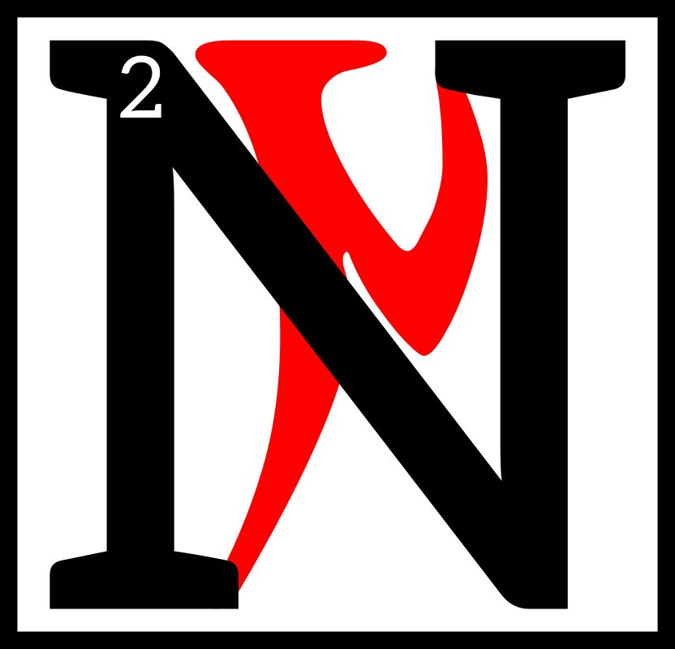
ow I speak to
you of Sotha Sil's
silence. 3The
children of ash
sometimes ask,
“Where is our
Clockwork God? Why does only the Tourbillon speak His truth in mortal sequence?” 4They ask in hushed tones, with brows creased by fear. 5Do not flee from such questions, child of the Tribunal. These are the little blasphemies that lead to wisdom—the faultless flame that turns ignorance to steam. 6For the Mainspring Ever-Wound is the Father of Curiosity, and curiosity is the joyful destroyer. 7Only in sundering can things be made whole. Only the disassembled engine can be scrubbed and made clean. 8So, smash the old machines! Topple your mind's idols! And from the wreckage, assemble new truths—flawless and water-tight.

9Do you see now, child of the Tribunal? It is the silence of Sotha Sil that gives birth to
the intrepid mind. 10Knowledge must be found—and to find
a thing, it must be hidden.
It is not enough to be told.
11The whirr of the machine is as silence to the one who lives within it. 12A turbine ever-oiled does not know the lack of oil
—does not know the purpose
of oil. And so it is with truth.

13Now, you must know that curiosity is not without cost. 14ALM forgive this heresy! VI forgive this heresy! I speak the words in sequence only. 15Pay heed to the laws of golden masks, but know also their limits. Pay heed to the songs of dancing glass, but know also the boundaries of their scale. 16Their truth is the truth of inertia. Of gravity. Their hearts are vessels filled with liquid brass—resistant to harm, but incapable of movement. 17The Mainspring Ever-Wound spurns that which does not move. 18In the Nirn-Ensuing, that which does not move shall be fed to the Kiln-Amaranthine where Seht's quiet wrath burns like the sun, and broken cogs are made whole. 19The Wheels Eternal must spin. The Tamriel Final must tick and tock. Anuvanna'si. 20Each and each must take its place in the whole. For if even one piece is missing, the whole is not whole.

21By the word, I wind the gears.

The Truth in Sequence

arca'amurokam
Volume Five

1By the word, I wind the gears.


peak not of Dwarves,
child of the Tribunal.
The simple
clockworks of
the Dwemer pale
before the sublime
machinery of Sotha Sil. 3Let Dumac's lament be a silent one. Let his hissing tombs stay buried. Let his automata rust and crumble. 4For his was the greatest failure—driven by Lorkhan's Great Lie and churlish pride. 5His is a tale
of woe and terror, and those that pursue his ugly maths
shall pay a great price in blood.

6“But, was Dumac not a creator?” you ask? “Were the brass-child's hands not covered in oil? Did they not speak the words of Making, and set wheel to axle?” 7Hear the words in sequence, followers of Seht. Intention dictates the worth
of a machine. 8Where the Mainspring Ever-Wound seeks the convergence of the Nirn-Ensuing, the ghosts of the Dwemer cry out: “Multitudes! Multitudes!” 9Mer and machine, parted. Wisdom and ambition, parted. Made and Unmade, parted. 10And from those sunderings, a thousand thousand skittering machines are made—left to wander forgotten halls, aimless and profligate. 11One may twist
a knob left in preparation for another to twist the same knob right. One may loosen a pipe
so that another may tighten it. 12They exist only to maintain the brass-childrens' folly, and so they are redundant and profane in the Eye of Sotha Sil.

13But most profane is this:
the walking horror that bears the Name, NM. The Brass Tower of Vanity. 14The mindless guardian of the Nirn-Prior.
The Antipodal-God-Thing that reigns on the darkest pole of the sacred Nirn-Sphere. 15Of all the threats to Tamriel Final, NM is the greatest. Anuvanna'si. 16The Daedra can be banished in thought, but NM must be sundered on Nirn. 17It is the welded knot at the center of Anu that must be untied. The God-Puzzle. 18The Mainspring Ever-Wound remains silent on this point. And where there is silence, there is great wisdom.

19By the word, I wind the gears.

The Truth in Sequence

tahna'amurokam
Volume Six

1By the word, I wind the gears.

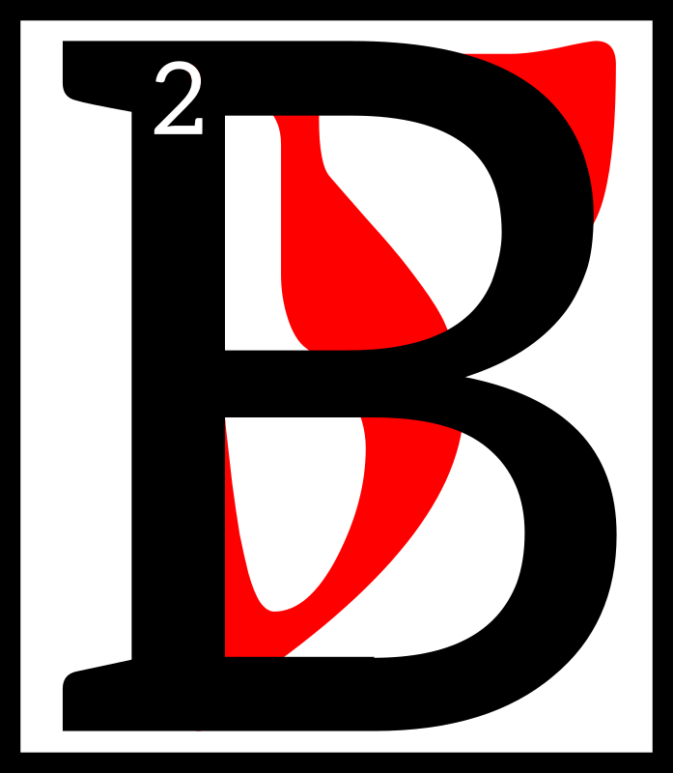
ehold, the
Clockwork City!
The Throne
Aligned! The
Omni-Axle! 3The
Brass-Throat
Herald of Joyful Destruction! The Oil-Slick Tower of Seamless Assembly! Rejoice! Rejoice!

4Listen, child of the Tribunal! Do you not hear the whirr of the gears? The hiss of the pistons? 5It is the voice of
Sotha Sil, calling you to the Nirn-Ensuing. To the Tamriel Final. Anuvanna'si. 6Cast down your worldly maths. Loosen the chains of your selfish pursuits. 7Shall I describe it to you?
Shall I guide your eyes to the future of Nirn? 8Hear the words in sequence, dark child. Close your eyes and awaken!

9Gaze up to behold a crystal sky, girded and bound by Seht's bright bands. 10Look down to behold the black stone of His will, and His imagination made clay. 11Drink His truth, thick
as blood, from the broad black rivers. 12Feel His breath on your skin—let its dreamy redolence fill your nostrils and sting your eyes. 13You stand
at the center of the wheel.
The home of the Mainspring Ever-Wound.

14Obsidian towers stretch ever skyward, festooned with polished brass and godly filigrees. 15Great turbines drive memory through a thousand thousand pipes that stretch out like tangled veins, or the golden roots of an ageless tree.
16And wandering amidst the humming and hissing paradise are His second-children. The Fabri'siraynosim. The merged-ones. 17Birthed of the unsequence, and bound to the Nirn-Ensuing. They cry out in one voice: “Death to Multitudes! Woe and terror! 18Let the fragments melt in the Boiler
of Unknown Angles! Let the falsehoods burn in the
Furnace of Forgotten Numbers! 19Disassemble and cleanse! Dismantle and make whole!” 20They are the guardians
—the ever-wound key-lords. 21Only the Nameless heart avoids their wrath. Their hatred of discord knows
no limits. 22For the road to Tamriel Final is not a bloodless one, child of the Tribunal. Anuvanna'si. 23Contemplate this with a pious heart. Seek
a clean and well-oiled soul.
It shall serve you well in
His truth-to-come.
The Truth in Sequence

24So you see the Clockwork City is like Sotha Sil Himself
—rich in beauty for the faithful, and alight with sublime terror for the servants of chaos.
25In which Clockwork City would you reside? Commit your small blasphemies and think
on this.

26By the word, I wind the gears.

sahna'amurokam
Volume Seven

1By the word, I wind the gears.

hink now on the
wheel. To all things
it appertains.

3Is there anything
so sacred as the
wheel? Like Tamriel Final, the wheel both moves and does not move. Anuvanna'si. 4The axle sleeps, while the spokes make haste—round and round in reflective circles. 5Now, here dwells a Nameless secret, child of the Tribunal: does a thing move when it moves in circles?

6Motion lies at the heart of
the Nirn-Ensuing, but not all motion is Nameless. Not all movement earns His blessing.

7The Divine Metronome calls the first motion “The Motion
of Lines.” 8Line-motion is the motion of simple minds—the motion of weak wills and scholars' vanity. 9“Forward!” it cries! Forward to the fruits of cheap ambition. Forward to
the promise of everlasting kingdoms. Forward to the mirage that the sages call “progress.” 10These misguided pioneers venture out into their wild tomorrows, and the tomorrows after that, certain
of their worth—their virtue.
11But what profits a man or mer to gaze deep into a single future? 12The aims of mortals are narrow, far too narrow! 13To move forward is to ignore infinite angles in favor of one. It is the act of a beast or a child. 14The Clockwork God spurns vanity in the guise of courage. These explorers' travels only lead them farther from
Tamriel Final. Anuvanna'si.

15Seht speaks of the second motion only in whispers.
“The Pendulum” or “Named Oscillation” is the tic-tock motion—the motion of entropy and false hope. 16None but the Clockwork God may claim its dark power.
The Truth in Sequence

With each wide swing it
shouts Lorkhan's lie. 17“Hail, intentions divided! Hail, cursed multitudes!” 18Do not stand in the Pendulum's path, ash-child. Only the Mainspring Ever-Wound may bear its weight.

19Last is the reciprocating motion. “The Sublime Piston.” The lover's embrace. 20Like the Father of Mystery, it gives and takes in equal measure.
21As the bow upon the strings, it calls forth the sublime. As the carpenter's saw, it wrenches back and forth, sundering the Named pursuits of lesser mer. 22Only a Nameless heart
may harness its strength.
23The artist, the star-counter, and the engineer call it “muse.” The truth-blind multitudes
call it “destroyer.”

24Do you see now, child of the Tribunal? Every movement hides intent. To stray from
the wheel is to abandon the Clockwork God. 25In the Tamriel Final, all shall spin,
and only spin. Anuvanna'si.

26By the word, I wind the gears.

daskhora'amurokam
Volume Eight

1By the word, I wind the gears.

lessed Father of
Mystery, place your
oil upon my tongue
that I might tell
the true tale of
Mournhold.
3Behold the strength of untold calculation! Behold the power of the Mainspring Ever-Wound!

4Every Nameless soul must confess the truth of Mournhold, for many lessons hide in its ashes. 5Sing now the hymn of anguish and horror, child of Seht! 6Behold, Mehrunes Dagon, Sovereign of Destruction! Mehrunes Dagon, the Flame Tyrant! Mehrunes Dagon, Father of Cataclysm!
7Recall how he marched upon Almalexia's jewel! Do you remember how his Will burned like kiln-fire, and hot pitch fell from his lips? 8Aloft, he held four great razors. Each sang a screeching paean to glorify him. 9Torrents of flame fell upon the innocent and wicked alike, shearing flesh from bone; belching forth widows and orphans in gouts of frothing screams.
The Truth in Sequence

10“Who dares to face me, draped as I am in fire and blood?” roared Dagon. 11The dark Prince beat his breast and howled long-forgotten curses. The dead burst forth from
their tombs, shrieking for mercy. 12Geysers of black liquid-sin erupted from below, flooding ruined homes with torrid lies and conspiracy. 13And everywhere, flames
—an inferno that turned all souls to ash.

14Almalexia, Mother of Mercy, cast her eyes upon the ruins of her gemmed city and wept.
15To see such love burned and squandered turned her heart to molten brass. 16Our Clockwork God took note of her fury, sealing the memory away in his great mnemonic planisphere
—a reminder of her love's high price.

17Rising from the ground like foundry-smoke, the Tribunes confronted the Prince of Disasters. 18Ayem's voice like
a screeching steam-whistle,
and Sotha Sil's like a lurching engine.

19“ERAM VAR
AE ALTADOON!”

they cried, rending their garments and donning their killing masks. 20Ayem drew her bright Hopesfire and skipped over the flames like a river-stone. 21With a mighty scream, she plunged the blade deep into Dagon's breast and turned it like a jailer's key. 22Scorching blood spewed out of the wound, scalding her hands and face. 23As she fell, the Divine Metronome chiseled a thought-rune of infinite angles.
24Do you remember how
the veins of tin, copper, and orichalc erupted from the depths to break our mother's Fall? 25Through His will alone, Mighty Seht wound the veins into god-bronze whips, and lashed the Prince pitilessly. 26Dagon hissed and tumbled backward. His otherworldly flesh fell like chaff before
the scythe. 27Alas, a Sarmissonays'um ghoul-thing emerged from every chunk.

28A multitude of the creatures gathered around Ayem, fiery tar oozing from their mouths and open sores. 29They groaned and retched, speaking only Dagon's name as they fell upon her. 30The Warden hissed thrice, took up her blessed sword, and smote the beasts
by the score. 31She severed head from neck and arm from shoulder, cleaving sin from virtue and shouting old-oaths of banishing. 32Do you remember how the beasts fell
to her on that red day?
The Truth in Sequence

33You must recall the howls of Madness! How Dagon foamed and snarled beneath the lash
of Sotha Sil! 34“Behold!” cried the Divine Metronome as He smashed the Prince to splinters. 35“Behold the wrath of lost
Ald Sotha! Know death at my hands, false-son of a false-father!

36KAER PADHOME
VIE ALTADOON!”

37Even then, at the end,
the Prince of Destruction
did not relent. 38With the last of his four great arms, Dagon dragged the last of his four great razors across the Watchmaker's jaw. 39Tasting the blood on His tongue, our Father of Mysteries whispered a final chrononymic death-word, and Dagon exploded throughout all time. 40The earthbones quaked and the All-Axle shook. From this word of sundering, Truth took root.

41Mehrunes's ruin slithered between the cracks of Nirn
and Oblivion, shrieking curses like a petulant child. The Mainspring Ever-Wound tightened His brass-wrought fist and slammed the gap shut—42another small step toward Tamriel Final. Anuvanna'si. 43So ends the true account of Mournhold's fall. Remember this tale always.

44By the word, I wind the gears.

enta'amurokam
Volume Nine

1By the word, I wind the gears.

he Mainspring
Ever-Wound
values craft above
all things. 3She
who shapes and
assembles, he
who conceives and creates
—these are the true children
of the Clockwork God.

4Your labors need not whirr and hiss like the sublime clockworks of Sotha Sil. 5The brush, the auger, the tongs, the needle—each and each may honor the Father of Mysteries, so long as they speak His truth. 6And what is His truth, child
of Seht? Perfection only? No. 7Hear the words in sequence! Simple precision is naught but the shadow of virtue. 8Even a faithless smith may fashion
The Truth in Sequence

the blade with the keenest edge. 9The perfect sphere, the clearest glass, the truest angle
—all fall short of His favor. 10Only through the purest incongruities and greatest doubts do we earn His blessing. 11You must think with the thrice-folded mind. You must gaze upon the unsequence.

12No mortal may grasp the unsequence fully. We see the edges only—the liminal truths. 13For some, the unsequence brings despair. Others look upon it with a child's bewilderment. 14But for the precious few, the Nameless explorers, this thin ray of understanding may serve as
the Bridge of Infinite Curve. The Walking Wheel.

15Know this, ash-child: only
the intrepid mind may walk this path. 16For you see, the Nameless soul is the tightrope walker that strides in circles only. 17Below and aside,
waits the gaping maw of Sheogorath's lie. Ahead and above, waits Tamriel Final. Anuvanna'si.

18I hear your cries, child of Seht! “How does one walk
the wheel?” you ask. 19Here lies a Nameless truth. Just as no wrench fits all bolts, no walk fits all souls. 20For the sculptor, it may mean an angle inverted, or a form transposed
—an abandonment of the Named resemblance and an embrace of the abstract.
21For the scholar of maths,
it could require half-mad theorems—rooms of cubic numbers and functions only imagined. 22For the inventor,
it may demand a tool without any known use, or an answer-machine that prints only questions.

23Craft perfected, and use obscure: this is the surest path to Tamriel Final. Anuvanna'si.

24By the word, I wind the gears.

The Truth in Sequence

alnahna'amurokam
Volume Ten

1By the word, I wind the gears.

eware blind
reverence for
The Old, child of
Seht. The oil of
antiquity often
fuels the future.
3Those who ignore the counsel of our blessed ancestors do so
at their peril. 4But not all ruins hide wisdom within their shattered halls. Some ruins
are dark and barren places—5unsteady graves for lies and curses. Resting places for bent axles, stripped bolts, and the bitter silence of inertia.

6In the time before our Father's rise, old and feeble knowledge ruled the hearts of mer.
7The children of ash entered their ancestral tombs not in search of truth, but in search
of truth's corpse. 8They saw their forebears not as proud and vigorous guides, but as wheezing, toothless ghosts
—9guardians of the musty and derelict engines that fools call deep wisdom. You must smash these old machines, child of Seht! 10The past does not rust upon the scrap pile. It hurtles toward the Mainspring Ever-Wound's glorious and multi-angled future, whipped by
the scorching tongues of our honored forebears! 11Ever do their words and deeds grease the wheels of the Nirn-Ensuing! 12Ever do they weld the seams of Tamriel Final! Anuvanna'si.

13But alas! Even now, stewards of The Old feed aged truth to those who would listen. 14They are the daughters and sons of PSJJJJ who crouch like gargoyles over musty tomes, faces hidden beneath frayed and graying robes. 15They counsel caution, temperance, and equanimity—ancient virtues of the fading Nirn-Prior. 16Even so, the Father of Curiosity calls them friends. 17With a god's patience, He teaches them. With a father's love, He guides them; all in
the hopes that one day they may see the deepest truth of The Old: 18that we must banish our feeble ghosts and give their memory new life through the thrice-folded mind. 19Toothless gears cannot be repaired
—they must be melted and reforged. So it is with our people's truth.

20None will deny that the daughters and sons of PSJJJJ wield great power. 21Like our Clockwork City, their isle of Artaeum glides between what is and what may be.
The Truth in Sequence

22Like our Clockwork Apostles, they study, strive, and create. But power without an infinite future's courage is like an empty boiler—23infused with fierce heat but producing no steam. Woe upon those who recoil from Tamriel Final! Anuvanna'si. 24The will of the Clockwork God turns such cowardice to slag. 25But rejoice!
The Father of Mysteries' affection proves the worth of PSJJJJ. 26One day these lost spellweavers will heed the words of the Divine Metronome and seek the true and noble change—the aratagnithir.
27On that day we shall
embrace them not as friends, but as brothers and sisters.

28By the word, I wind the gears.

alnahn'alna'amurokam
Volume Eleven

1By the word, I wind the gears.

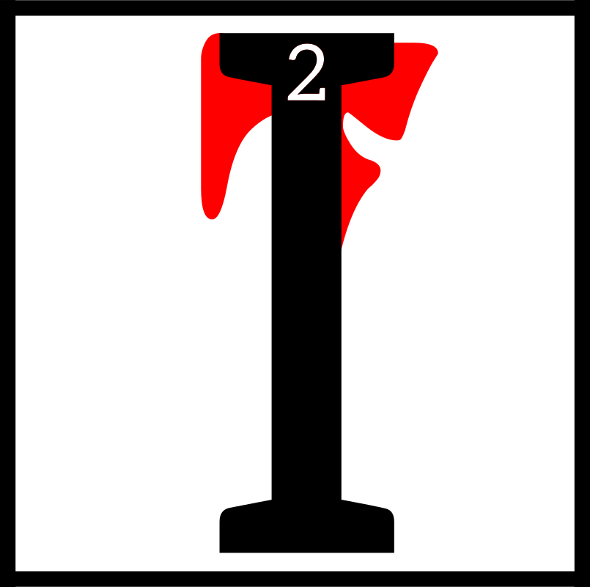
hear your
whispers—your
puerile laments.
3Even here in the
Clockwork City,
bathed in the oil
of His divine wisdom, you cry out, “Where are the soft grasses and babbling creeks? 4Where are the heady wines and rich fruits? Where are the gentle rains, and sighing boughs,
and swaying mushrooms?”
5Like hungry babes you weep, “Where is the Real?” 6Ease your bellows and steady your gears. You must gaze now upon the brass-wrought truth. 7See the Real of Tamriel Final. Anuvanna'si.

8What makes a thing real?
Is it the blood, or the sap,
or the beating heart? 9Is it the shrieking trauma of an infant's birth? The low roar of the tides? 10The root's thirst for water or the lazy drift of distant clouds? 11No, child of Seht! Hear the words in sequence! Can you not see that your fears spring from Lorkhan's lie? 12Those soft forms and gentle comforts you covet are naught but corroded lies—fractured creation's panacea that deadens the
soul's forgotten pain.

13“But is Sotha Sil's sacred city not a replication?” you ask,
“A Nirn in miniature?” 14Hear this, ash-child: the Clockwork City is no mere simulacrum. 15The copper leaves and sculpted hills are not
The Truth in Sequence

Nirn's resemblance, but Nirn's refinement—16worldly forms made whole by the steady hand of the Mainspring Ever-Wound. The glorious unity of Tamriel Final demands convergence. Anuvanna'si. 17Mer and machine made whole. Nature and engineering made whole. The past and the future made whole. 18In time, all of Nirn shall be pressed and fired in this forge of Seht's blessed imaginings—weighed and measured upon the Nameless Scales! 19Is this not the Real?
Is this not the redemption of
the et'Ada's sins?
20Do you see now the impoverished forms of the Nirn-Prior? The cheap and hollow falsehoods that masquerade as nature's splendor?

21Seek out the dry, hard places, child of Seht. Anoint your tongue with His oil. Fill your stomach with His nourishing grain. 22Cast out what was and fix your eyes upon the Nirn-
to-come—upon Tamriel Final. Anuvanna'si.

23By the word, I wind the gears.

alnahn'asca'amurokam
Volume Twelve

1By the word, I wind the gears.

have spoken
the words in
sequence, child
of Seht. I have
guided your eyes
to the glorious
Nirn-Ensuing—3to the inevitable grandeur of
Tamriel Final. Anuvanna'si.
4I have shouted my grave admonitions and whispered
the secrets of the infinite curve. Now, as my engine fails,
I bestow upon you my final blessing. 5You who sing the song of making and set your wheels to axles—you intrepid star-counters who shatter the old machines and smelt new truths from the crude and forgotten ores of the Aurbis— you must hear this ultimate lesson.

6Tamriel Final shall change
you in ways both grand and terrifying. Anuvanna'si.
7Just as molten brass cools in its mold, so too will your body take on a new and hardened shape. 8Just as water changes from liquid to steam, so too will the cheap preoccupations of your mind disperse and fade.
The Truth in Sequence

9Just as oil ignites and powers the engine, so too will your soul glow bright and drive the Wheels Eternal. 10The unity of Tamriel Final must wash away our selfish pursuits and jealous will, ash-child. Anuvanna'si. 11In the glorious Nirn-Ensuing, we must exorcise that grinning apparition we call “I.” Only then can we know the sublime truth of the Mainspring Ever-Wound. 12We must walk change's road if we seek the end of disorder
—and like all roads worth walking, it fills our hearts with joy and terror.

13How like the et'Ada gears we are—content to live our lives
in vain and sequestered sorrow, all the while oblivious to the anguished cries of our fractured souls! 14Look upon the lonely shore of Nirn. What do you see, with your broken eyes? 15One beach? One sea? Deceit and vanity! The Named illusion! 16For what is a “beach” if not a desperate agglomeration of isolated grains? 17What is a “sea” if not a churning mass of solitary tears? Separate! Broken! Arrogant and futile!

18Even after meditating upon these sermons, there are some among you who cling to the Nirn-Prior. 19You fear the loss of your thin and impoverished “self.” You must cast aside these childish fears! 20What good is
a “self” if it burns away at the threshold of what waits
beyond time? 21Do you not
see that the Father of Mysteries seeks to usher our world through the End? To protect us from the lies-made-flesh who seek to destroy us? 22If you remember only one thing,
let it be this: our blessed Clockwork God loves you with a fierce and awesome heart. 23What he does, he does for you and for all who would follow his divine example.

24Lasting joy. The peace of unity. The sublime satisfaction of perfect rhythm; these are the product of our honest labors—the spokes of our blessed wheel that spins eternal.
25The Mainspring Ever-Wound offers perfection, child of Seht. You have but to gaze within. 26Stoke your coals. Add fresh water to your boilers.
Tighten your bolts, and believe. Tamriel Final awaits. Anuvanna'si.

27By the word, I wind the gears.

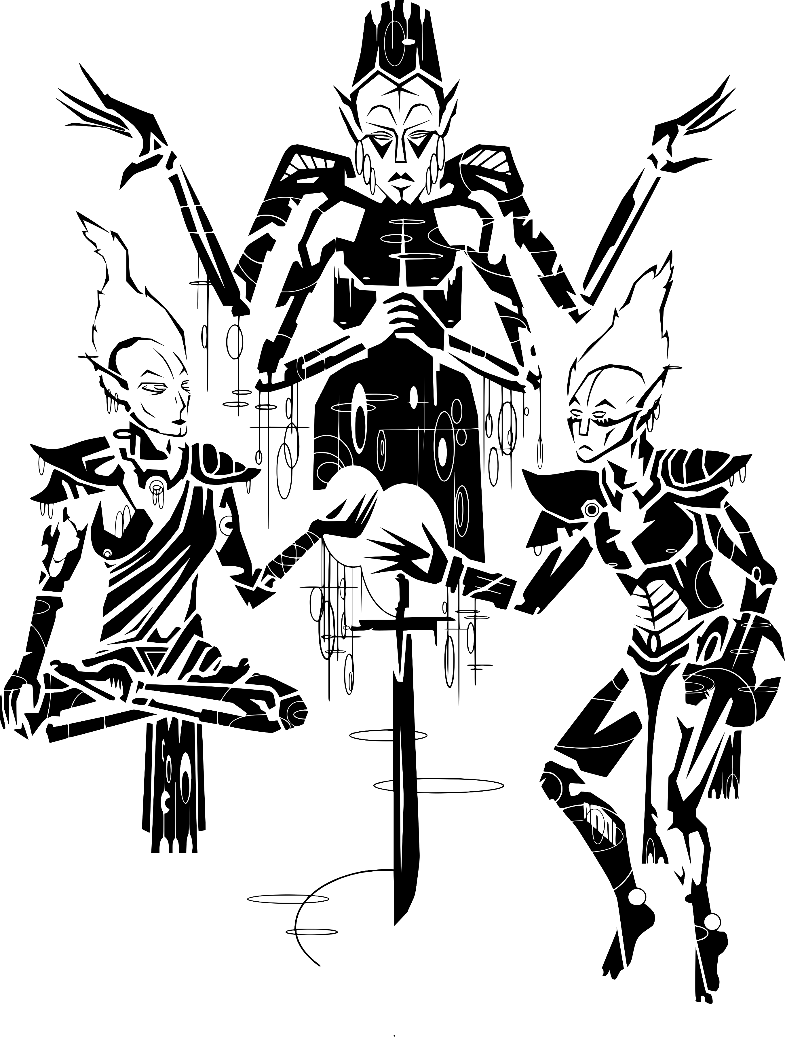
V'
E
H
K
V
Twice the Worn Sigil of Veloth

AVS

3'6 Shoreshiik

The 36 Lessons

The 36 Lessons

alna'shoreshik
Sermon One

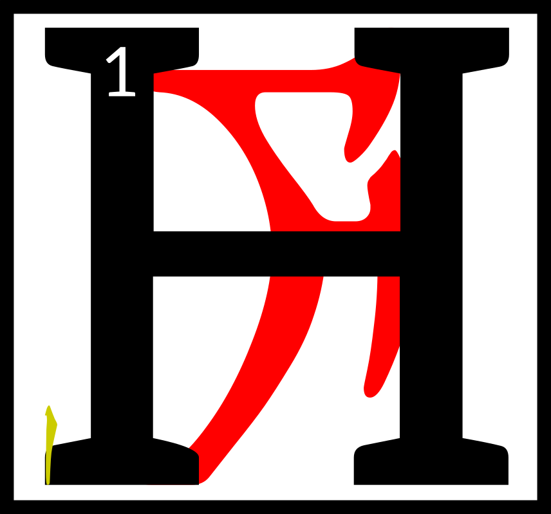
e was born in the
ash among the
Velothi, anon
Chimer, before
the war with the
northern men.
2Ayem came first to the village of the netchimen, and her shadow was that of Boethiah, who was the Prince of Plots, 3and things unknown and known would fold themselves around her until they were like stars or the messages of stars. 4Ayem took a netchiman's wife and said:

‘I am the Face-Snaked Queen of the Three in One. 5In you is an image and
a seven-syllable spell,

AYEM
AE SEHTI
AE VEHK

which you will repeat to it until mystery comes.’

6Then Ayem threw the netchiman's wife into the ocean water where dreughs took her into castles of glass and coral. 7They gifted the netchiman's wife with gills and milk fingers, changing her sex so that she might give birth to the image
as an egg.
8There she stayed for seven
or eight months.

9Then Seht came to the netchiman's wife and said:

‘I am the Clockwork King of the Three in One.
10In you is an egg of
my brother-sister,
who possesses invisible knowledge of words
and swords, which you shall nurture until the
Hortator comes.’

11And Seht then extended
his hands and multitudes of homunculi came forth, each like a glimmering rope through the water, 12and they raised the netchiman's wife back to the surface world and set her down on the shoals of Azura's coast. 13There she lay for seven
or eight more months, caring for the egg-knowledge by whispering to it the Codes of Mephala and the prophecies of Veloth and even the forbidden teachings of Trinimac.

14Seven Daedra came to her one night and each one gave to the egg new motions that could be achieved by certain movements of the bones. 15These are called the Barons of Move Like This.
The 36 Lessons

16Then an eighth Daedroth came, and he was a Demiprince, called Fa-Nuit-Hen, or the Multiplier of Motions Known.

17And Fa-Nuit-Hen said:

‘Whom do you wait for?’

To which the netchiman's wife said the Hortator.

18‘Go to the land of the Indoril in three months' time, for that is when war comes. 19I return now to haunt the warriors who fell and still wonder why. But first I show you this.’

20Then the Barons and the Demiprince joined together
into a pillar of fighting styles terrible to behold and they danced before the egg
and its learning image.

21‘Look, little Vehk,
and find the face
behind the splendor
of my bladed carriage,
for in it is delivered the unmixed conflict path, perfect in every way. What is its number?’

22It is said the number is the number of birds that can nest in an ancient tibrol tree, less three grams of honest work, 23but Vivec in his later years found a better one and so gave this secret to his people.

24‘For I have crushed a world with my left hand,’ he will say, ‘but in my right hand is how it could have won against me. Love is under my will only.’

25The ending of the words is

ASV

asca'shoreshik
Sermon Two

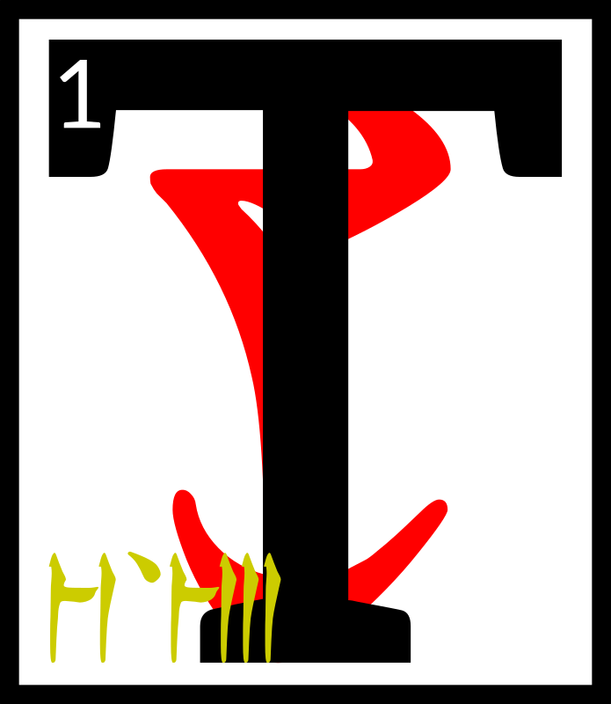
he netchiman's wife
who carried the egg
of Vivec within her
went looking for
the lands of the
Indoril. 2Along the
journey many spirits came to see her and offer instructions
to her son-daughter,
the future glorious invisible warrior-poet of Vvardenfell, Vivec.

3The first spirit threw his arms about her and hugged his knowledge in tight.
The 36 Lessons

4The netchiman's wife became soaked in the Incalculable Effort. 5The egg was delighted and did somersaults inside her, bowing to the five corners
of the world and saying:

‘Thus whoever performs this holy act shall be
proud and mighty
among the rest!’

6The second spirit was too aloof and acted above his station
so much that he was driven off by a headache spell. 7The third spirit, At-Hatoor, came down to the netchiman's wife while she relaxed for a while under an Emperor Parasol. 8His garments were made from implications of meaning, and the egg looked at them three times. 9The first time Vivec said:

‘Ha, it means nothing!’

After looking a second time
he said:

‘Hmm, there might be something there after all.’

10Finally, giving At-Hatoor's garments a sidelong glance,
he said:

‘Amazing, the ability to infer significance in something devoid of detail!’

‘There is a proverb,’ At-Hatoor said, and then he left.

11The fourth spirit came with the fifth, for they were cousins. 12They could ghost touch and probed inside the egg to find its core. 13Some say Vivec at this point was shaped like a star with its penumbra broken off; others, that it looked like a revival of vanished forms.

14‘From my side of the family,’ the first cousin said, ‘I bring you a series
of calamities that will bring about the end
of the universe.’

15‘And from my side,’
the second cousin said,
‘I bring you all the primordial marriages that must happen within them, each one.’

16At this the egg laughed.
‘I am given too much to bear
so young. I must have been born before.’

17And then the sixth spirit appeared, the Black Hands Mephala, who taught the Velothi at the beginning of days all the arts of sex and murder. 18Its burning heart melted the eyes of the netchiman's wife and took the egg from her belly with six cutting strokes.
The 36 Lessons

19The egg-image, however, could see into what it had been before in ancient times,
when the earth still cooled,
and was not blinded.

20It joined with the Daedroth and took its former secrets, leaving a few behind to keep the web of the world from disentangling. 21Then the Black Hands Mephala put the egg back into the netchiman's wife and blew on her with magic breath until the hole closed up. 22But the Daedroth did not give her back her eyes, saying:

‘God hath three keys; of birth, of machines, and of the words between.’

23Within this Sermon the wise may find one half of these keys.

24The ending of the words is

ASV

cahna'shoreshik
Sermon Three

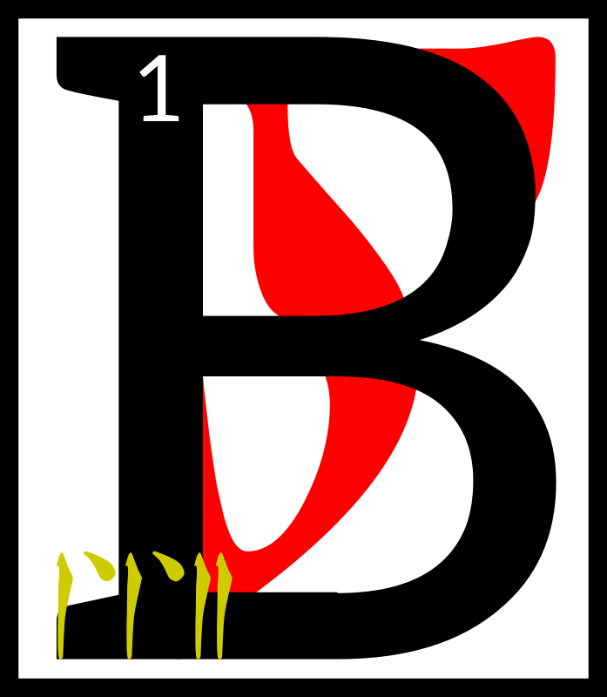
eing blind the
netchiman's wife
wandered into a
cave on her way to
the domains of
House Indoril.
2It so happened that this cave was a Dwemeri stronghold. 3The Dwemer spied the egg and captured the netchiman's wife. 4They bound her head to foot and brought her deep within the earth.

5She heard one say, ‘Go and make a simulacrum of her and place it back on the surface, 6for she has something akin
to what we have and so the Velothi will covet it and notice if she is too long away.’

7In the darkness, the netchiman's wife felt great knives try to cut her open. 8When the knives did not work, the Dwemer used solid sounds. 9When those did not work, great heat was brought to bear. 10Nothing was of any use, and the egg of Vivec remained safe within her.

11A Dwemer said, ‘Nothing is of any use. We must go and misinterpret this.’

12Vivec felt that his mother was afraid, and so consoled her.

The 36 Lessons

13‘The fire is mine:
Let it consume thee,
And make a secret door
At the altar of Padhome,
In the House of Boet-hi-Ah
Where we become safe
And looked after.’

14This old prayer made
the netchiman's wife smile
and begin such a deep sleep
that when Dwemeri atronachs returned with cornered spheres and cut her apart she did not awake and died peacefully. 15Vivec was removed from
her womb and placed within a magical glass for further study. 16To confound his captors, he channeled his essence into love, an emotion the Dwemer knew nothing about.

17The egg said:

‘Love is used not only as
a constituent in moods and affairs, 18but also as the raw material from which relationships produce hour-later exasperations, regrettably fashioned restrictions, riddles laced with affections known only
to the loving couple,
and looks that linger too long. 19Love is also an often-used ingredient
in some transparent
verbal and nonverbal transactions where, eventually, it can sometimes be converted
to a variety of true devotions, some of which yield tough, insoluble,
and infusible unions.
20In its basic form, love supplies approximately thirteen draughts of
all energy that is derived from relationships.
Its role and value
in society at large
are controversial.’

21The Dwemer were vexed at these words and tried to hide behind their power symbols. 22They sent their atronachs
to remove the egg-image from their cave and place it within the simulacrum they had made of Vivec's mother.

23A Dwemer said, ‘We Dwemer are only aspirants to this that the Velothi have. 24They shall be our doom in this and the eight known worlds,

NIRN,
LHKAN, RKHET, THENDR,
KYNRT, AKHAT, MHARA,
and JHUNAL.’

25The secret to doom is within this Sermon.

26The ending of the words is

ASV

The 36 Lessons

cina'shoreshik
Sermon Four

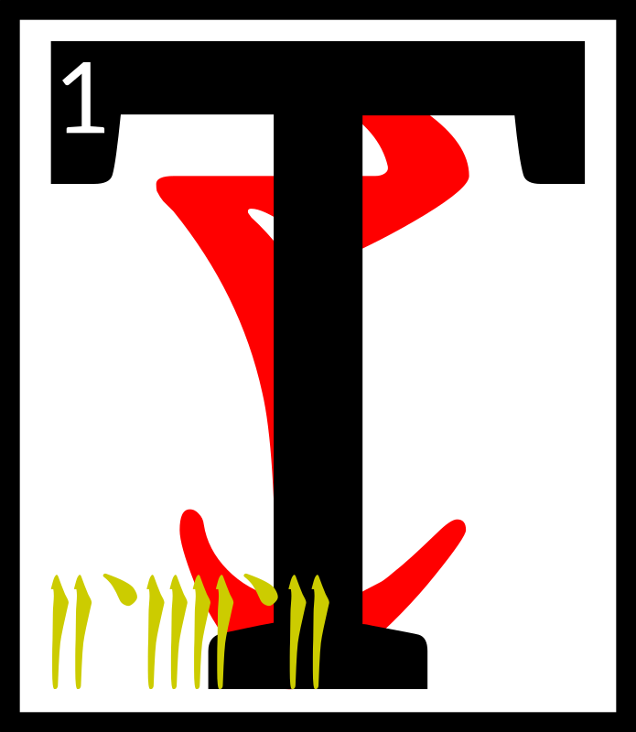
he simulacrum of
the netchiman's
wife who carried
the egg of Vivec
within it went back
to looking for the
lands of the Indoril. 2Along the journey many more spirits came to see it and offer instructions to its son-daughter, the future glorious invisible warrior-poet of Vvardenfell, Vivec.

3A troupe of spirits called the Lobbyists for the Coincidence Guild appeared. 4Vivec understood the challenge immediately and said:

‘The popular notion of God kills happenstance.’

5The head of the Lobbyists, whose name is forgotten,
tried to defend the concept's existence. 6He said, ‘Saying something at the same time can be magical.’

7Vivec knew that to retain his divinity that he must make
a strong argument against luck. 8He said:

‘Is not the sudden revelation of corresponding conditions and disparate elements that gel at the moment
of the coincidence
one of the prerequisites
to being, in fact, coincidental? 9Synchronicity comes out of repeated coincidences
at the lowest level. 10Further examination shows it is the utter power of the sheer number of coincidences that leads one to the idea that synchronicity is guided
by something more than chance. 11Therefore, synchronicity ends up invalidating the concept
of the coincidental,
even though they are
the symptomatic signs
that bring it to the surface.’

12Thus was coincidence destroyed in the land of the Velothi.

13Then an Old Bone of the earth rose up before the simulacrum of the netchiman's wife and said, 14‘If you are to be born
a ruling king of the world you must confuse it with new words. Set me into pondering.’
The 36 Lessons

15‘Very well,’ Vivec said, ‘Let me talk to you of
the world, which I share with mystery and love.

Who is her capital? Have you taken the scenic route of her cameo? 16I have— lightly, in secret, missing candles because they're
on the untrue side, and run my hand along the edge of a shadow made from one hundred and three divisions of warmth,
and left no proof.’

17At this the Old Bone folded unto itself twenty times until
it became akin to milk,
which Vivec drank, becoming a ruling king of the world.

18Finally the Chancellor of Exactitude appeared, and he was perfect to look upon
from every angle. 19Vivec understood the challenge immediately and said:

‘Certitude is for the puzzle-box logicians
and girls of white glamour who harbor it on their own time. I am a letter written in uncertainty.’

20The Chancellor bowed his head and smiled fifty different and perfect ways all at once. 21He pulled the astrolabe of the universe from his robe and broke it in half, handing both halves to the egg-image of Vivec.

22Vivec laughed and said, ‘Yes,
I know. The slave labor of the senses is as selfish as polar ice, and worsens when energies are spent on a life others regard as fortunate. 23To be a ruling king I will have to suffer much
that cannot be suffered, and to weigh matters that no astrolabe or compass can measure.’

24The ending of the words is

ASV

arca'shoreshik
Sermon Five

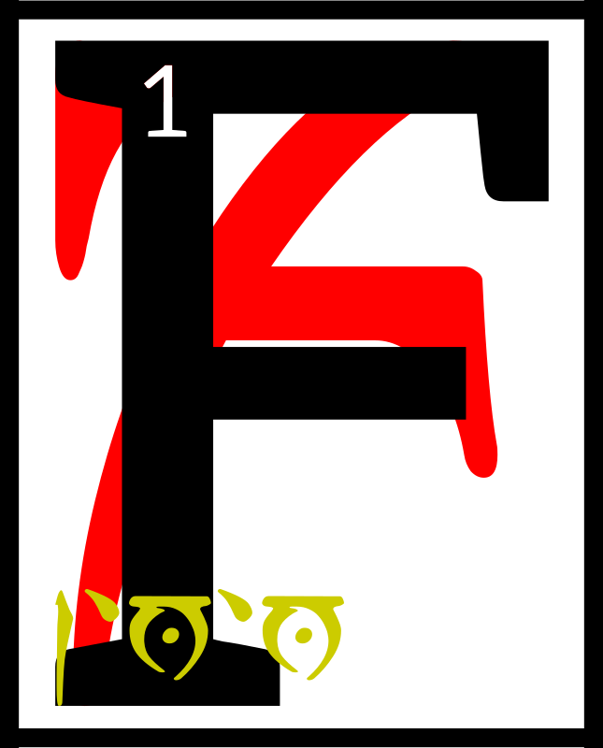
inally the
simulacrum of the
netchiman's wife
became unstable.
2The Dwemer in
their haste had built
it shoddily and the ashes of
Red Mountain slowed its golden tendons. 3Before long it fell
on its knees beside the road
to the lands of the Indoril
and pitched over,
The 36 Lessons

to be discovered eighty days later by a merchant caravan
on its way to the capital of Veloth, anon Almalexia.

4Vivec had not been among
his people all the days of his pre-life so he stayed silent and let the Chimer in the caravan think that the simulacrum
was broken and empty.

5A Chimeri warrior, who was protecting the caravan, said, ‘Look here how the Dwemer
try to fool us as ever, crafting our likenesses out of their flesh-metals.

6We should take this to the capital and show our mother Ayem. She will want to see this new strategy of our enemies.’

7But the merchant captain said, ‘I doubt that we shall be paid well for the effort. 8We can make more money if we stop
at Noormoc and sell it to the Red Wives of Dagon, who pay well for the wonders made
by the Deep Folk.’

9But another Chimer, who was wise in the ways of prophecy, looked on the simulacrum with disquietude. 10‘Was I not hired on to help you seek the best
of fortunes? I say you should listen to your warrior, then, and take this thing to Ayem,

11for though manufactured by our enemies there is something in it that will become sacred,
or has been already.’

12The merchant captain took pause then and looked on the simulacrum of the netchiman's wife 13and, though he heeded always the advice of his seers, could do no more than think
of the profits to be made at Noormoc. 14He thought mainly of the Red Wives' form of recompense, which was four-cornered and good wounded,
a belly-magic known nowhere else under the moons. 15His lust made him deny Ayem his mother. 16He gave order to change course for Noormoc.

17Before the caravan could get underway again, the Chimeri warrior who had counseled a passage to the capital threw his money to the merchant captain 18and said, ‘I will pay you thus for the simulacrum and warn you: war is coming with the shaggy men of the north 19and I will not have my mother Ayem at uneven odds with one enemy while tending to another.’

20‘Nerevar,’ the merchant captain said, ‘this is not enough. I am Triune
in my own way, but
I follow the road
of my body and
demand more.’
The 36 Lessons

21Then Vivec could not remain silent anymore and said into Nerevar's head these words:

‘You can hear the words,
so run away
22Come, Hortator, unfold
into a clear unknown,
Stay quiet
until you've slept

in the yesterday,
And say no elegies
for the melting stone’

23So Nerevar slew the merchant captain and took
the caravan for his own.

24The ending of the words is

ASV

tahna'shoreshik
Sermon Six

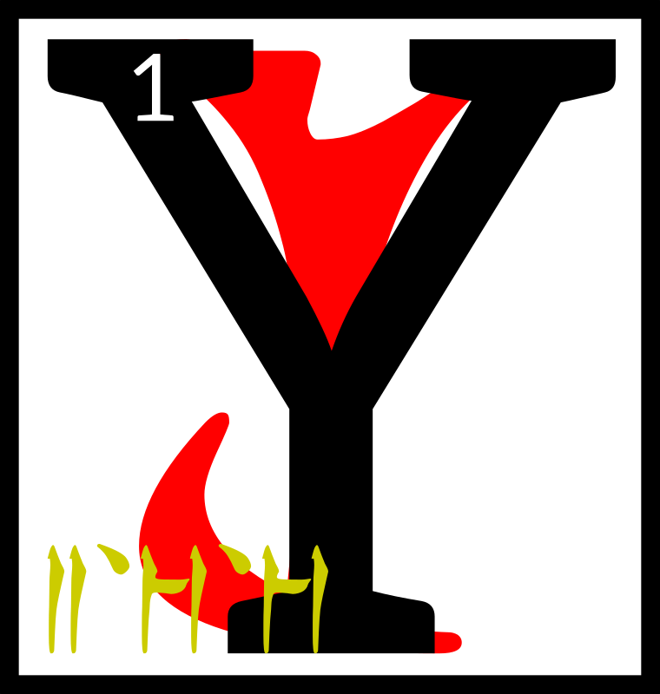
ou have discovered
the sixth Sermon
of Vivec, which
was hidden in
the words that
came next to
the Hortator.

2There is an eon within itself that when unraveled becomes the first sentence of the world.

3Mephala and Azura are the twin gates of tradition and Boethiah is the secret flame.

4The Sun shall be eaten by lions, which cannot be found yet in Veloth.

5Six are the vests and garments worn by the suppositions
of men.

6Proceed only with the simplest terms, for all others are enemies and will confuse you.

7Six are the formulas to
heaven by violence, one that you have learned by studying these words.

8The Father is a machine
and the mouth of a machine. His only mystery is an invitation to elaborate further.

9The Mother is active
and clawed like a nix-hound, yet she is the holiest of those that reclaim their days.

10The Son is myself, Vehk,
and I am unto three, six, nine, and the rest that come after, glorious and sympathetic, without borders,
The 36 Lessons

utmost in the perfections of
this world and the others, sword and symbol, pale
like gold.

11There is a fourth kind of philosophy that uses nothing but disbelief.

12For by the sword
I mean the sensible.

For by the word
I mean the dead.

13I am Vehk, your protector and the protector of Red Mountain until the end of days,
which are numbered

3'3'3'3

14Below me is the savage, which we needed to remove ourselves from the Altmer.

15Above me is a challenge, which bathes itself in fire
and the essence of a god.

16Through me you are desired, unlike the prophets that have borne your name before.

17Six are the walking ways, from enigma to enemy
to teacher.

18Boethiah and Azura are the principles of the universal plot, which is begetting, which is creation, and Mephala makes
of it an art form.

19For by the sword
I mean the first night.

For by the word
I mean the dead.

20There will be a splendor
in your name when it is said
to be true.

21Six are the guardians of Veloth, three before and
they are born again, and they will test you until you have
the proper tendencies of
the hero.

22There is a world that is sleeping and you must
guard against it.

23For by the sword
I mean the dual nature.

For by the word
I mean animal life.

24For by the sword
I mean preceded by a sigh.

For by the word
I mean preceded by a wolf.

25The ending of the words is

ASV

The 36 Lessons

sahna'shoreshik
Sermon Seven

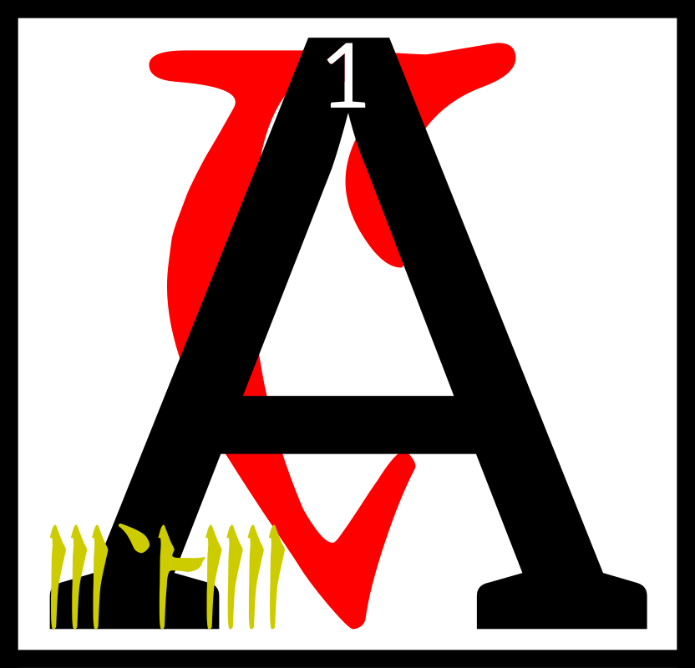
s the caravan of
Nerevar now
made for the
capital of Veloth,
anon Almalexia,
there came great
rumblings from the oblivion.
2A duke among scamps wandered into the House of Troubles, pausing before each scripture door to pay his respects, until finally he was met by the majordomo
of Mehrunes Dagon.

3The Duke of Scamps said,
‘I was summoned by Lord Dagon, master of the foul waters and fire, and I have brought the pennants
of my seven legions.’

4The majordomo, whose head was a bubble of foul water and fire, bowed low, so that the head of the Duke of Scamps became enclosed in his own.

5He saw the first pennant, which commanded a legion
of grim warriors who could die at least twice.

6He saw the second pennant, which commanded a legion
of winged bulls and the emperor of color that rode
upon each.

7He saw the third pennant, which commanded a legion
of inverted gorgons, great snakes whose scales were
the faces of men.

8He saw the fourth pennant, which commanded a legion
of double-crossed lovers.

9He saw the fifth pennant, which commanded a legion
of jumping wounds looking
to hop onto a victim.

10He saw the sixth pennant, which commanded a legion
of abridged planets.

11He saw the seventh pennant, which commanded a legion
of armored winning moves.

12To which the majordomo said, ‘Duke Kh-Utta, your legions while mighty are not enough
to destroy Nerevar or the Triune way. 13Look upon the Hortator and see the wisdom
he takes to wife.’

14And they looked into the middle world and saw:

Evaporating
In a throng of thunder
Of red war
And chitin men,
Where destines
The 36 Lessons

Take him further
From our ways
15The heat
That we have wanted
And pray
They still remember,
Where destines
Clothe the distance,
16Glad in the golden east
That we saw it now,
Instead of the war
And repair
Of the oblivious fracture
A curse on the Hortator
And two more
On his hands

17And the Duke of Scamps saw the palms of the Hortator,
upon which the egg had written these words of power:

GHARTOK PADHOME
GHARTOK PADHOME

18The ending of the words is

ASV

daskhora'shoreshik
Sermon Eight

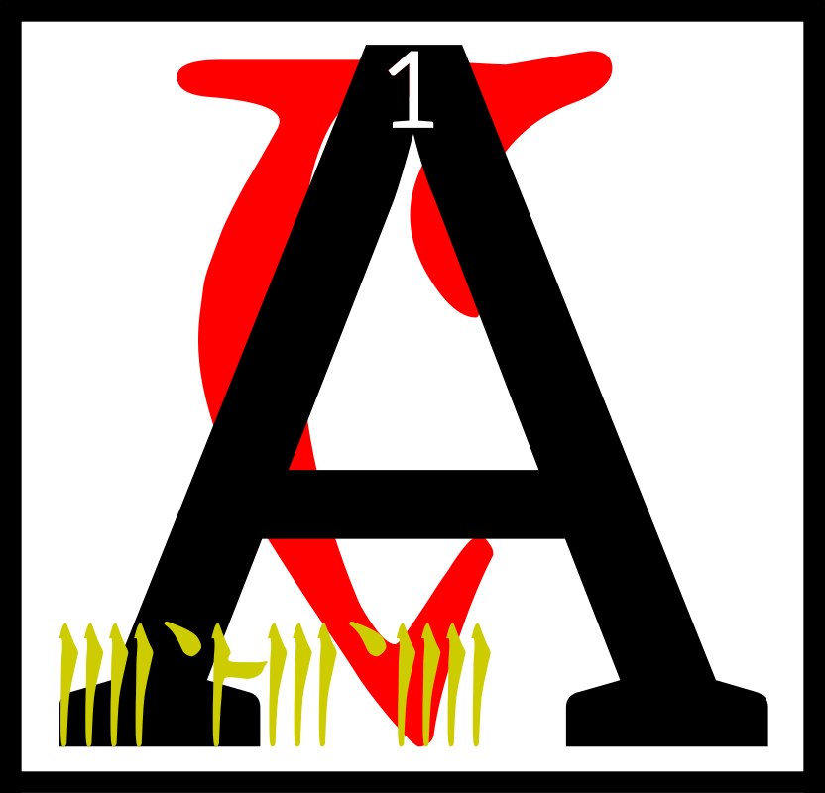
nd presently
Nerevar and
Vivec were
within sight of
the capital and
the Four Corners
of the House of Troubles knew that it was not time to contest them. 2The caravan musicians made a great song of entrance and the eleven gates of
the Mourning Hold were thrown wide.

3Ayem was accompanied by
her husband-state, a flickering image that was channeled to her ever-changing female need. 4Around her were the Shouts,
a guild now forgotten, who carried with them the whims of the people, for the Velothi then were still mostly good at heart. 5The Shouts were the counselors of Ayem and
the country, though they sometimes quarreled and needed Seht to wring them into usefulness. 6Ayem approached Nerevar, who was by now adorned in the flags of House Indoril. 7He gifted her with
the simulacrum of the netchiman's wife and the
egg of Vivec inside.

8Ayem said to Nerevar,
‘Seht who is Azura has revealed that war is come and that the Hortator that shall deliver us will approach with a solution walking at his side.’
The 36 Lessons

9Nerevar said, ‘I have traveled out of my way to warn you
of the deceit of our enemies,
the Dwemer, but I have learned much on the journey and have changed my mind.10This netchiman's wife you see
at my side is a sword and
a symbol and there is prophecy inside. 11It tells me that, like it, we must for a while be like
he is and, as a people, cloaked in our former enemies, and to use their machines without shame.’

12At which Vivec spoke aloud, ‘Boethiah-who-is-you wore
the skin of Trinimac to cleanse the faults of Veloth, my Queen, and so it should be again.
This is the walking way of
the glorious.’ 13Seht appeared out of a cloud of iron vapor and his minions made of their blood a chair. 14He sat beside Ayem and looked on the rebirth of mastery. 15Vivec said to them, his Triune:

‘My rituals and ordeals and all the rhymes within,
Use no other motive than the revelation of my skin.’

16Ayem said,

AYEM
AE SEHTI
AE VEHK

‘We are delivered and made whole, the diamond of the Black Hands is uncovered.’

17Seht said, ‘Wherever so
he treads, there is invisible scripture.’

To which the Shouts were silent in sudden reading.

18Vivec then reached out
from the egg all his limbs
and features, merging with
the simulacrum of his mother, gilled and blended in all the arts of the star-wounded East, under water and in fire and
in metal and in ash, six times the wise, 19and he became
the union of male and female, the magic hermaphrodite, the martial axiom, the sex-death
of language and unique in
all the middle world.

20He said, ‘Let us now guide the hands of the Hortator in war and its aftermath. For we go different, and in thunder.
This is our destiny.’

21The ending of the words is

ASV

The 36 Lessons

enta'shoreshik
Sermon Nine

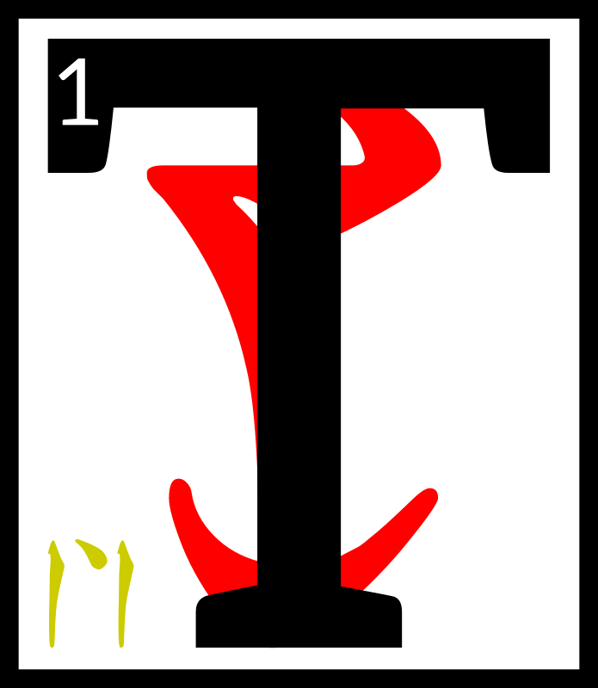
hen came the war
with the northern
men, where Vivec
did guide the
Hortator into swift
and tricky union
with the Dwemer. 2The greatest demon chieftains of the frigid west were those listed below, five in unholy number.

3HOAGA, the Mouth of Mud, who appeared as a great bearded king, had the powers
of Marshalling and breathing the earth. 4On the battlefields, this demon would often be seen on the sidelines, eating the soil voraciously. 5When his men fell, Hoaga would fill their bodies back with it, whereupon they would rise again and fight, albeit slower. 6He had a Secret Name, Fenja, and destroyed seventeen Chimeri villages
and two Dwemeri strongholds before being turned away.

7CHEMUA, the Running Hunger, who appeared as a mounted soldier with full helm, had the powers of Heart Roaring and
of sky sickening. 8He ate the Chimeri hero, Dres Khizumet-e, sending the spirit back to
the Hortator as an assassin. 9Sometimes called First Blighter, Chemua could give clouds stomach aches and turn the rain of Veloth into bile. 10He destroyed six Chimeri villages before he was slain
by Vivec and the Hortator.

11BHAG, the Two-Tongued,
who appeared as a great bearded king, had the powers
of Surety and Form Change. 12His raiders were small in number, but ran amok in the west hinterlands, killing many Velothi trappers and scouts. 13He fell in a great debate with Vivec, for the warrior-poet alone could understand the northern man's two-layered speech, though ASV had to remain invisible during the argument.

14BARFOK, Maid of Planes,
who appeared as a winged human with lick-encrusted spear, had the powers of Event Denouement. 15Battles fought against her would always end in victory for Barfok, because she could shape outcomes by singing. 16Four Chimeri villages and two more Dwemeri strongholds were destroyed
by her decision enforcement. 17Vivec had to stuff her mouth with his milk finger to keep her from singing Veloth into ruin.
The 36 Lessons

18YSMIR, the Dragon of the North, who always appears as a great bearded king, had powers innumerable and echoing.
19He was grim and dark and
the most silent of the invading chieftains, though when he spoke villages were uplifted and thrown into the sea. 20The Hortator fought him unarmed, grabbing the Dragon's roars
by hand until Ysmir's power throat bled. 21These roars were given to Vivec to bind into an ebony listening frame, which the warrior-poet placed on Ysmir's face and ears to drive him mad and drive him away.

22‘The coming forth and the driving away brings
all things around.
What I shall say next
is unpleasant to record:

HERMA MORA
ALTADOON!
AE ALTADOON!’

23The ending of the words is

ASV

alnahna'shoreshik
Sermon Ten

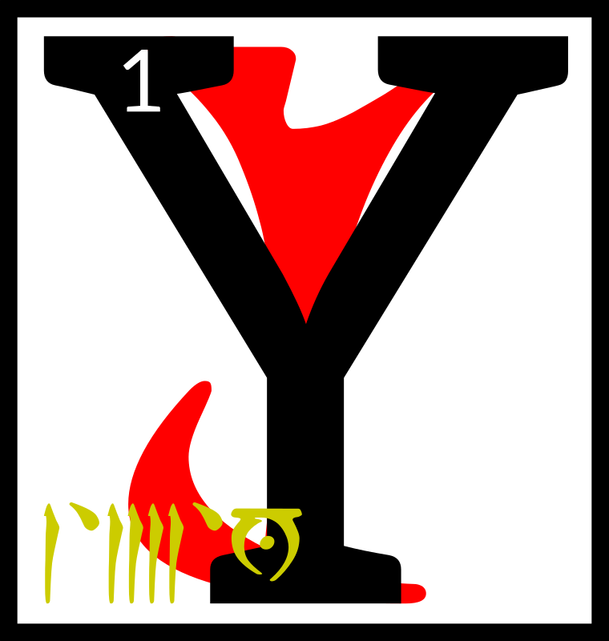
ou have discovered
the tenth Sermon
of Vivec, which
was hidden in the
words that came
in the aftermath
to the Hortator.

2The evoker shall raise his left hand empty and open, to indicate he needs no weapons of his own. 3The coming forth
is always hidden, so the evoker is always invisible or, better,
in the skin of his enemies.

4‘The eyelid of the kingdom shall fill thirty and six folios, but the eye shall read the world.’
5By this the Hortator needs me to understand.

The sword is an impatient signature. Write no contracts on the dead.

6Vivec says unto the Hortator remember the words of
Boet-hi-Ah:

We pledge ourselves to you, the Frame-maker, the Scarab: a world for us to love you in, a cloak of dirt to cherish. 7Betrayed by your ancestors when you were not even looking.
The 36 Lessons

Hoary Magnus and his ventured opinions cannot sway the understated,
a trick worthy of the always satisfied. 8A short season of towers, a rundown absolution, and what is this, what is this but fire under your eyelid?

9Shift ye in your skin, I say to the Trinimac-eaters. Pitch your voices into the color of bruise. 10Divide ye like your enemies, in Houses, and lay your laws in set sequence from the center, again like the enemy Corners of the House of Troubles, and see yourself thence as timber, or mud-slats, or sheets of resin. 11Then do not divide, for yet is the stride of SITHISIT quicker than the rush of enemies, and He will sunder the whole for the sake of a shingle.

12For we go different, and in thunder. SITHISIT is the start of all true Houses, built against stasis and lazy slaves. 13Turn from your predilections, broken like false maps. Move and move like this. 14Quicken against false fathers, mothers left in corners weeping for glass and rain. 15Stasis asks merely for nothing, for itself, which is nothing, as you were in the eight everlasting imperfections.

16Vivec says unto the Hortator
remember the words of Vivec.
UNDERSTAND THAT SITHISIT STILL TRAVELS

17Vivec says unto the Hortator
remember the words of Vivec.
IN A PHOSPHORESCENT MIRROR OF THE SKY

18Vivec says unto the Hortator
remember the words of Vivec.
DROWNED AND SMILING

19Vivec says unto the Hortator
remember the words of Vivec.
INTERMITTENT HOPES ENOUGH

20Vivec says unto the Hortator
remember the words of Vivec.
TO ANSWER ALL THE THINGS

21Vivec says unto the Hortator
remember the words of Vivec.
NOT YET QUERIED

22The ending of the words is

ASV

The 36 Lessons

alnahn'alna'shoreshik
Sermon Eleven

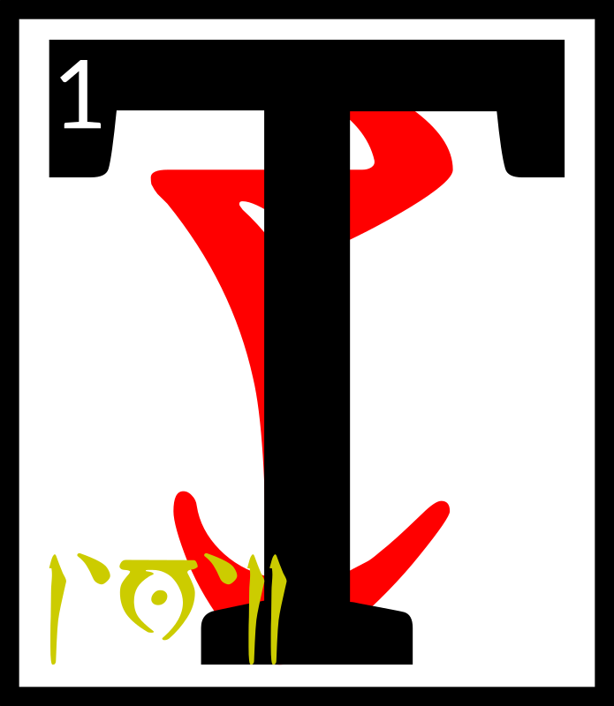
hese were the
days of Resdaynia,
when Chimer and
Dwemer lived
under the wise and
benevolent rule of
the ASV and their champion
the Hortator. 2When the gods of Veloth would retreat unto their own, to mold the cosmos and other matters, the Hortator would at times become confused. 3Vivec would always be there to advise him, and this is the first of the three lessons of ruling kings:

4‘The waking world is
the amnesia of dream.
All motifs can be mortally wounded. Once slain, themes turn into the structure of future nostalgia. 5Do not abuse your powers or they will lead you astray. They will leave you like rebellious offspring. 6They will lose their virtue. They will become lost and resentful and finally become pregnant with the seed
of folly. 7Soon you will be the grandparent of
a broken state. You will be mocked. It will fall apart like a stone that recalls that it is really water.

8‘Keep nothing in your house that is neither needed or beautiful.

‘Ordeals you should face unimpeded by the world of restriction. 9The splendor of stars is Ayem's domain. The selfishness of the sea is Seht's. I rule the middle air. All else is earth and under your temporal command. 10There is no bone that cannot be broken, except for the heart bone. You will see it twice in your lifetimes. Take what you can
the first time and let us
do the rest.

11‘There is no true symbolism of the center. The Sharmat will believe there is. 12He will feel
that he can cause years
of exuberance from sitting in the sacred, when really no one can leave that state and cause anything more but strife.

13‘There is once more
the case of the symbolic and barren. The true prince that is cursed and demonized will be adored at last with full hearts.
The 36 Lessons

14According to the Codes of Mephala there can be no official art, only fixation points of complexity that will erase from the awe of the people given enough time.
15This is a secret that hides another. 16An impersonal survival is not the way
of the ruling king. Embrace the art of the people and marry it and
by that I mean secretly have it murdered.

17‘The ruling king that sees in another his equivalent rules nothing.

18‘The secret of weapons
is this: they are the
mercy seat.

19‘The secret of language
is this: it is immobile.

20‘The ruling king is armored head to toe
in brilliant flame. He is redeemed by each act
he undertakes. His death
is only a diagram back
to the waking world.
21He sleeps the second way. The Sharmat is his double, and therefore
you wonder if you rule nothing.

22‘Hortator and Sharmat, one and one, eleven,
an inelegant number. 23Which of the ones is
the more important?
Could you ever tell if they switched places? I can
and that is why you
will need me.

24‘According to the
Codes of Mephala, there
is no difference between the theorist and the terrorist. 25Even the
most cherished desire disappears in their hands. This is why Mephala has black hands. Bring both of yours to every argument. 26The one-handed king finds no remedy. When you approach God, however, cut both of them off. 27God has no need of theory and he is armored head to toe in terror.’

28The ending of the words is

ASV

The 36 Lessons

alnahn'asca'shoreshik
Sermon Twelve

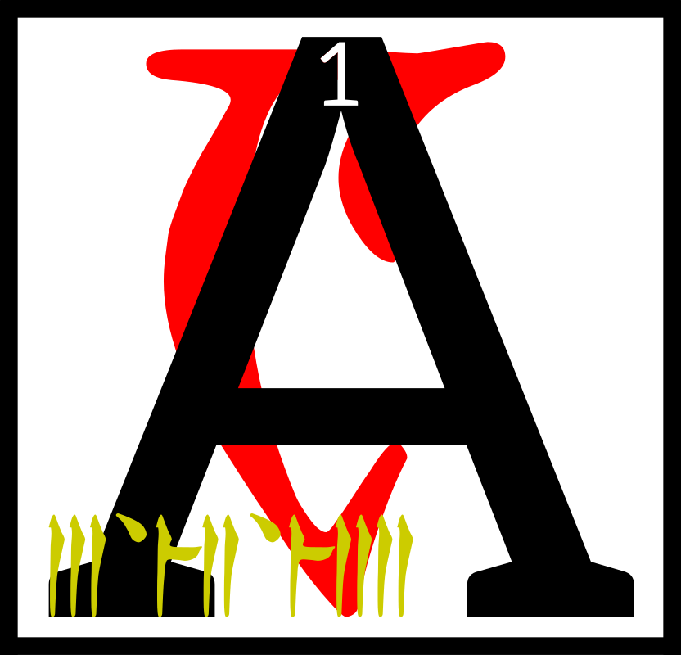
s the Hortator
pondered the
first lesson of
ruling kings,
Vivec wandered
into the
Mourning Hold and found that Ayem was with a pair of lovers. 2Seht had divided himself again. Vivec then leapt through into their likenesses to observe, but he gained no secrets that
he did not already know. 3He left a few of his own behind to make the journey worthwhile.

4Then Vivec left the capital of Veloth and wandered far into the ash. 5He found a span of badlands to practice his giant-form. 6He made of his feet a less dense material than the divine to keep from falling waist-deep into the earth. 7At this point the First Corner of the House of Troubles, the Prince Molag Bal, made his presence known.

8Vivec looked on the King of Violation and said:

‘How very beautiful you are, that you do not join us.’

9And Molag Bal crushed
the warrior-poet's feet, which
were not invulnerable, and
had legions cleave them off. 10Mighty fires from the Beginning Place were brought like nets to hold Vivec and
he let them.

11‘I would prefer,’ he said, ‘some kind of ceremony
if we are to be married.’

12And the legions that took
the feet were summoned again and ordered to begin a banquet. 13Pomegranates sprang from the badlands and tents were raised. 14A throng of Velothi mystics came, reading the passages of the severed feet
on the ground and weeping until the scriptures were wet.

15‘We must love each other briefly,’ Vivec said, ‘if at all. 16I am needed
to counsel the Hortator
in more important matters because the Dwemeri high priests stir up trouble.
You may have my head
for an hour.’

17Molag Bal rose up and extended six arms to show his worth. 18They were decorated in runes of seduction and its reverse. They were decorated in the annotated calendars
of longer worlds. 19When he spoke, mating monsters fell out.
The 36 Lessons

‘Where must it go?’ he said.

20‘I told you,’ Vivec said,
‘I am meant to be the teacher of the king
of the earth.

AE ALTADOON
GHARTOK PADHOME’

21With these magic words,
the King of Violation added another:

[CHIM]

which is the secret syllable of royalty.

22Vivec had what he needed from the Daedroth and so married him that day.
23In the hour that Bal had his head, the King of Violation asked for proof of love.

24Vivec spoke two poems to show him such, but only
the first is known.
I'm not sure
just how much glass
it took to make
your hair
Twice as much,
I am sure,
as the oceans have
to share
25Hell, my sweet,
is a fiction
written by those
who tell the truth
My mouth is skilled
at lying
and its alibi
a tooth

26The sons and daughters of Vivec and Molag Bal number in the thousands. The name of the mightiest is a string of power:

GULGA MOR JIL
HYAET AE HOOM

27The ending of the words is

ASV

alnahn'cahna'shoreshik
Sermon Thirteen

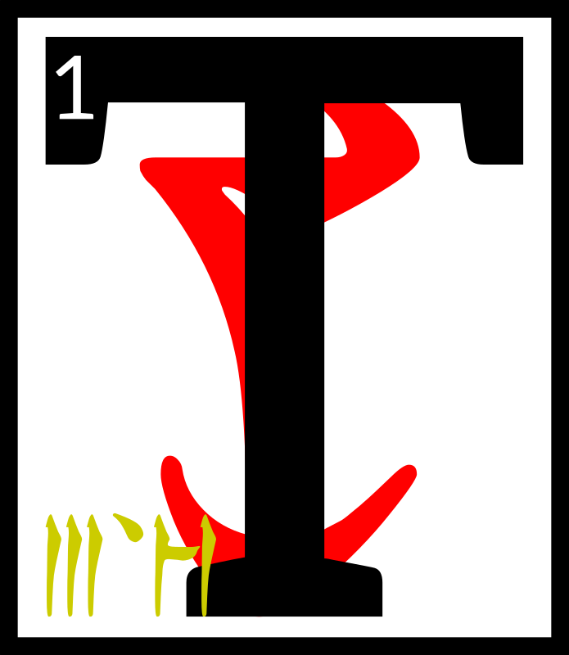
hese were the
days of Resdaynia,
when Chimer and
Dwemer lived
under the wise
and benevolent rule of the ASV and their champion the Hortator. 2When the gods of Veloth would retreat unto their own, to mold the cosmos and other matters, the Hortator would at times become confused. 3Vivec would always be there to advise him, and
this is the second of the three lessons of ruling kings:
The 36 Lessons

4‘The secret syllable of royalty is this: [CHIM]

‘The temporal myth is man.

5‘The magical cross is an integration of the worth
of mortals at the expense of their spirits.
6Surround it with the
triangle and you begin
to see the Triune house.
7It becomes divided
into corners, which are
ruled by our brethren,
the Four Corners:

BAL DAGON
MALAC SHEOG

8Rotate the triangle
and you pierce the heart
of the Beginning Place,
the foul lie, the testament of the irrefutable-for-
a-span. 9Above them all
is the horizon where
only one stands, though
no one stands there yet.
It is proof of the new. It is
the promise of the wise. 10Unfold the whole and what you have is a star, which is not my domain, but not entirely outside my judgment. The grand design takes flight; it is transformed not only
into a star but a hornet.
11The center cannot hold. It becomes devoid of lines and points. It becomes devoid of anything and so becomes a receptacle. This is its usefulness at the end. This is its promise.

12‘The sword is the cross and ASV is the Triune house around it. 13If there is to be an end I must be removed. The ruling king must know this, and I will test him. I will murder him time and again until he knows this. 14I am the defender of the last and the last. To remove me is to refill the heart that lay dormant at the center that cannot hold. 15I am the sword, Ayem the star, Seht the mechanism that allows the transformation of the world. Ours is the duty to keep the compromise from being filled with black sea.

16‘The Sharmat sleeps
at the center. He cannot
bear to see it removed,
the world of reference. 17This is the folly of the false dreamer. This is
the amnesia of dream,
or its power, or its circumvention. This is
the weaker magic and it
is barbed in venom.

18‘This is why I say the secret to swords is the mercy seat. It is my throne. 19I am become
the voice of ASV.
The 36 Lessons

The world will know me more than my sister and brother. I am the psychopomp. I am the killer of the weeds of Veloth. Veloth is the center that cannot hold. 20Ayem is the plot
Seht is the ending.
I am the enigma that must be removed. These are why my words are armed to the teeth.

21‘The ruling king is to stand against me and then before me. He is to learn from my punishment.
22I will mark him to
know. He is to come as male or female. I am the form he must acquire.

23‘Because a ruling king that sees in another his equivalent rules nothing.’

24This is what was said to the Hortator when Vivec was not whole.

25The ending of the words is

ASV

alnahn'cina'shoreshik
Sermon Fourteen

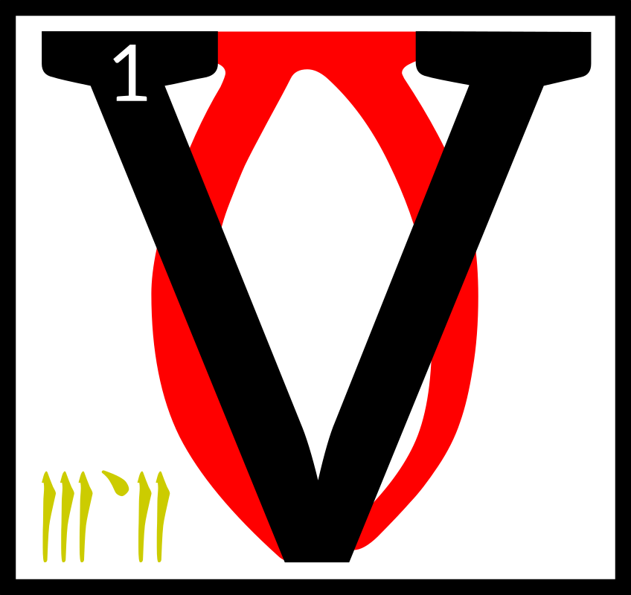
ivec lay with
Molag Bal for
eighty days and
eight, though
headless. 2In that
time, the Prince placed the warrior-poet's feet back and filled them with the blood of Daedra. 3In this way Vivec's giant-form remained forever harmless to good earth. 4The Pomegranate Banquet brought many spirits back
from the dead so that the sons and daughters of the union
had much to eat besides fruit.

5The Duke of Scamps came while the banquet was still underway, and Molag Bal looked on the seven pennants with anger. 6The King of Violation had become necessary and therefore troubled for the
rest of time. 7His legions and Kh-Utta's fell into open war, but the children of Molag Bal and Vivec were too elaborate
in power and form.

8The Duke of Scamps therefore became a lesser thing, as did all his own children. 9Molag Bal said to them: ‘You are the sons of liars, dogs, and wolf-headed women.’ They have been useless to summon ever since.
The 36 Lessons

10The holy one returned at last, Vehk, golden with wisdom. 11His head found its body
had been tenderly used. 12He mentioned this to Molag Bal, who told him that he should thank the Barons of Move Like This, 13‘For I have yet to learn how to refine my rapture.
My love is accidentally
shaped like a spear.’

14So Vivec, who had a grain
of Ayem's mercy, set about to teach Molag Bal in the ways of belly-magic. 15They took their spears out and compared them. Vivec bit new words onto the King of Violation's so that it might give more than ruin to the uninitiated. 16This has since become a forbidden ritual, though people still practice it
in secret.

17Here is why: The Velothi
and demons and monsters that were watching all took out their own spears. 18There was much biting and the earth became wet. And this was
the last laugh of Molag Bal:

19‘Watch as the earth shall crack, heavy with so much power, that should have been forever unalike!’

20Then that stretch of badlands that had been the site of the marriage fragmented and threw fire. 21And a race that
is no more but that was
terrible at the time to behold came forth. 22Born of the biters, that is all they did, and they ran amok across the lands of Veloth and even to the shores of
Red Mountain.

23But Vivec made of his spear
a more terrible thing, from a secret he had bitten off from the King of Violation. 24And so he sent Molag Bal tumbling into the crack of the biters and swore forever that he would not deem the King beautiful ever again.

25Vivec wept as he slew
all those around him with his terrible new spear. 26He named it MUATRA, which is Milk Taker, and even the Chimeri mystics knew his fury. 27Anyone struck by Vivec at this time turned barren and withered into bone shapes. 28The path of bones became a sentence for the stars to read, and the heavens have never known children since. 29Vivec hunted down
the biters one by one, and
all their progeny, and he
killed them all by means of the
Nine Apertures, and the wise still hide theirs from Muatra.

30The ending of the words is

ASV

The 36 Lessons

alnahn'arca'shoreshik
Sermon Fifteen

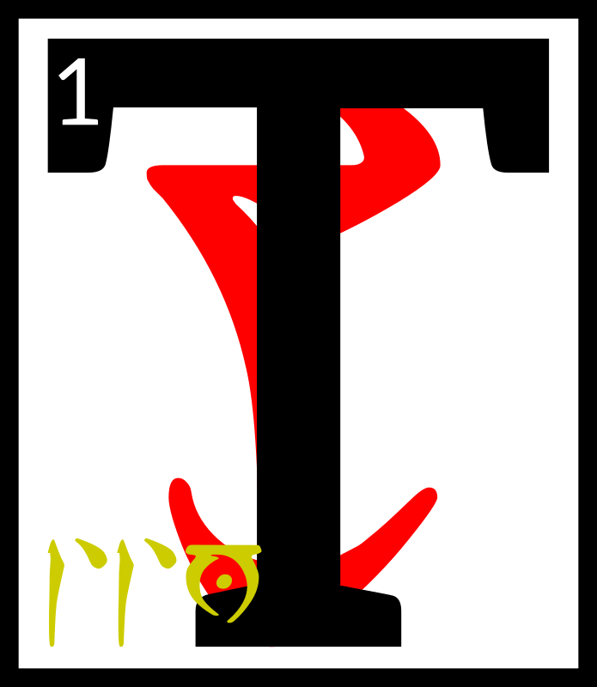
hese were the
days of Resdaynia,
when Chimer and
Dwemer lived
under the wise and
benevolent rule of
the ASV and their champion
the Hortator. 2When the gods of Veloth would retreat unto their own, to mold the cosmos and other matters, the Hortator would at times become confused. 3Vivec would always be there to advise him, and this is the third of the three lessons of ruling kings:

4‘The ruling king will remove me, his maker. This is the way of all children. His greatest enemy is the Sharmat, who is the false dreamer. 5You or he is the shingle, Hortator. Beware the wrong walking path. Beware the crime of benevolence. Behold him by his words.’

6I AM THE SHARMAT
I AM OLDER
THAN MUSIC
WHAT I BRING IS LIGHT
WHAT I BRING IS A STAR
WHAT I BRING IS
AN ANCIENT SEA
7WHEN YOU SLEEP
YOU SEE ME
DANCING AT THE CORE
IT IS NOT A BLIGHT
IT IS MY HOUSE
8I PUT A STAR INTO
THE WORLD'S MOUTH
TO MURDER IT
9TEAR DOWN
THE PYLONS
MY BLIND FISH
SWIM IN THE NEW
PHLOGISTON
10TEAR DOWN
THE PYLONS
MY DEAF MOONS
SING AND BURN
AND ORBIT ME
11I AM OLDER
THAN MUSIC
WHAT I BRING IS LIGHT
WHAT I BRING IS A STAR
WHAT I BRING IS
AN ANCIENT SEA

12‘You alone, though you come again and again,
can unmake him. Whether I allow it is within my wisdom. 13Go unarmed into his den with these words of power:

AE GHARTOK PADHOME

[CHIM]

AE ALTADOON

Or do not.
The 36 Lessons

14The temporal myth is man.
Reach heaven by violence.
This magic I give to you: 15the world you will rule is only an intermittent hope
and you must be the letter written in uncertainty.’

16The ending of the words is

ASV

alnahn'tahna'shoreshik
Sermon Sixteen

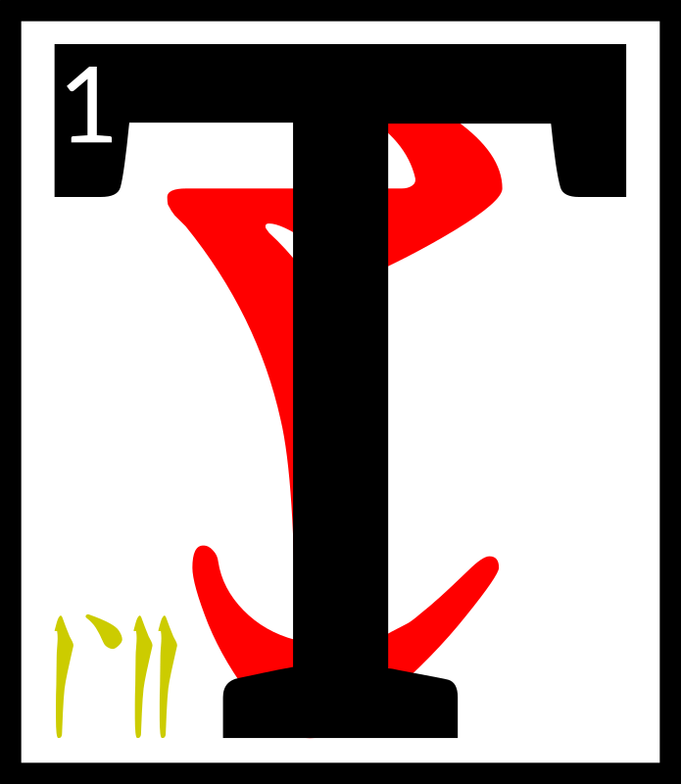
he Hortator
wandered through
the Mourning Hold,
wrestling with
the lessons he had
learned. 2They
were slippery in his mind.
He could not always keep
the words straight and knew that this was a danger.
3He wandered to find Vivec,
his lord and master, the glory
of the image of Veloth, and found him of all places in
the Temple of False Thinking. 4There, clockwork shears
were taking off Vivec's hair.
A beggar king had brought
his loom and was making of
the hair an incomplete map
of adulthood and death.

5Nerevar said, ‘Why are you doing this, milord?’

Vivec said, ‘To make room
for the fire.’

6And the Hortator could see that Vivec was out of sorts, though not because of the impending new power to come. 7The golden warrior-poet had been exercising his Water Face as well, learned from the dreughs before he was born.

8Nerevar said, ‘Is this to keep you from the fire?’

Vivec said, ‘It is so that I may see with truth. 9It, and my place here at the altar of Padomay
in the house of False Thinking, serve so that I may see beyond my own secrets. 10The Water Face cannot lie. It comes from the ocean, which is too busy
to think, much less lie. Moving water resembles truth by its trembling.’

11Nerevar said, ‘I am afraid
to become slipshod in my thinking.’

Vivec said, ‘Reach heaven
by violence then.’
The 36 Lessons

12So to quiet his mind the Hortator chose from the Fight Racks an axe. 13He named it and moved on to the first moon.

14There, Nerevar was greeted by the Parliament of Craters, who knew him by title and resented his presence, for he was to be a ruling king of earth and this was the lunar realm. 15They shifted around him
in a pattern of entrapment.

16‘The moon does not recognize crowns
or scepters,’ they said,
‘nor the representatives
of kingdoms below, lion or serpent or mathematician. 17We are the graves of those that have migrated and become ancient countries. We seek no Queens or thrones.
18Your appearance is decidedly solar, which is
to say a library of stolen ideas. We are neither
tear nor sorrow.
19Our revolution succeeded in the manner that is was written. You are the Hortator and unwelcome here.’

20And so Nerevar carved at the grave ghosts until he was out of breath and their Parliament could make no new laws.

21He said, ‘I am not of the slaves that perish.’

Of the members of Parliament only a few survived the Hortator's attack.

22A surviving Crater said, ‘Appropriation is nothing new. Everything happens of itself. This motif is by no means unassociated with hero myths. 23You have not acted with the creative impulse; you fall
below the weight of destiny.
We are graves but not coffins. Know the difference.
24You have only dug more and supplied no ghosts to reside within. Central to your claim
is the predominance of frail events. 25To be judged by the earth is to sit on a throne
of wonder why. Damage us more and you will find naught but the absence of our dead.’

26The ending of the words is

ASV

The 36 Lessons

alnahn'sahna'shoreshik
Sermon Seventeen

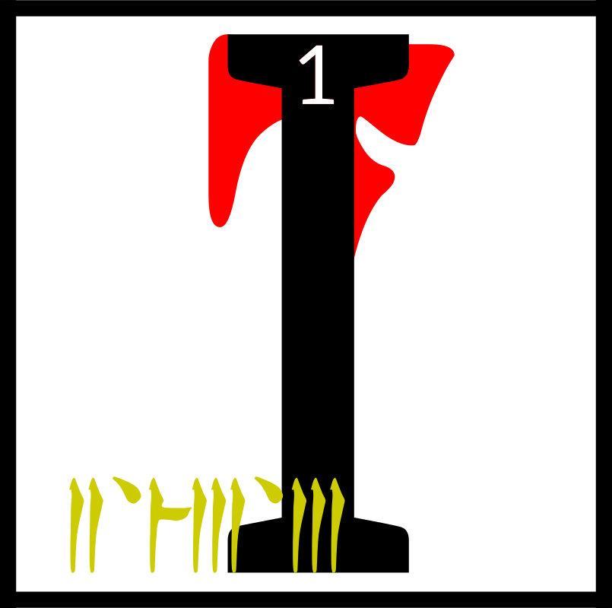
am an atlas of
smoke.’

With this, Vivec
became greater
than he had been.
2These were the days of Resdaynia, when Chimer and Dwemer lived under the wise and benevolent rule of the
ASV and their champion the Hortator.

3‘Seek me without effort for I take many shapes.’

4The Hortator was still trying to subdue the heavens with
an axe. 5He was thrown out of the library of the sun by the power of Magnus. 6Vivec found him in a grub field outside of the swamps of the Deshaan Plain. 7They walked for a span in silence, for Nerevar had been humbled and Vivec still had mercy in his hand.

8Soon they were walking across the eastern sea to the land
of snakes and snow demons. 9Vivec wanted to show the Hortator the fighting styles
of foreign tongues. 10They learned the idiom stroke from the pillow book of the Tsaesci king. It is shaped like the insight of this page.

11The Tsaesci serpents vowed
to have their vengeance on
the west at least three times.

12They walked farther and saw the spiked waters at the edge
of the map. 13Here the spirit of limitation gifted them with
a spoke and bade them find
the rest of the wheel.

14The Hortator said, ‘The edge of the world is made of swords.’

Vivec corrected him. ‘They are the bottom row of the world's teeth.’

15They walked to the north
to the Elder Wood and found nothing but frozen bearded kings.

16They came to the west where the black men dwelt. 17For a year they studied under their sword saints and then for another Vivec taught them
the virtue of the little reward. 18Vivec chose a king for a wife and made another race of monsters which ended up destroying the west completely. 19To a warrior chief Vivec said:

‘We must not act and speak as if asleep.’

The 36 Lessons

20Nerevar wondered if there was anything to learn in the south but Vivec remained silent and only led them back to
Red Mountain.

21‘Here,’ Vivec said, ‘is the
last of the last. Within it the Sharmat waits.’

22But they both knew that the time was not ready to contest the Sharmat and so they engaged in combat with each other. 23Vivec marked the Hortator in this way for all of the Velothi to see. 24He sealed the wound with the blessing of Ayem-Azura. 25At the end of the battle, the Hortator found that he had gathered seven more spokes. 26He attempted
to attach them and form a staff but Vivec would not let him, saying, ‘It is not the time for that.’

27Nerevar said, ‘Where did
I find these?’

Vivec said that they had collected them from around the world, though some had come invisibly. 28‘I am the wheel,’
he said, and took that shape. Before the emptiness at the center could live too long, Nerevar put in the spokes.

29The ending of the words is

ASV

alnahn'daskhora'shoreshik
Sermon Eighteen

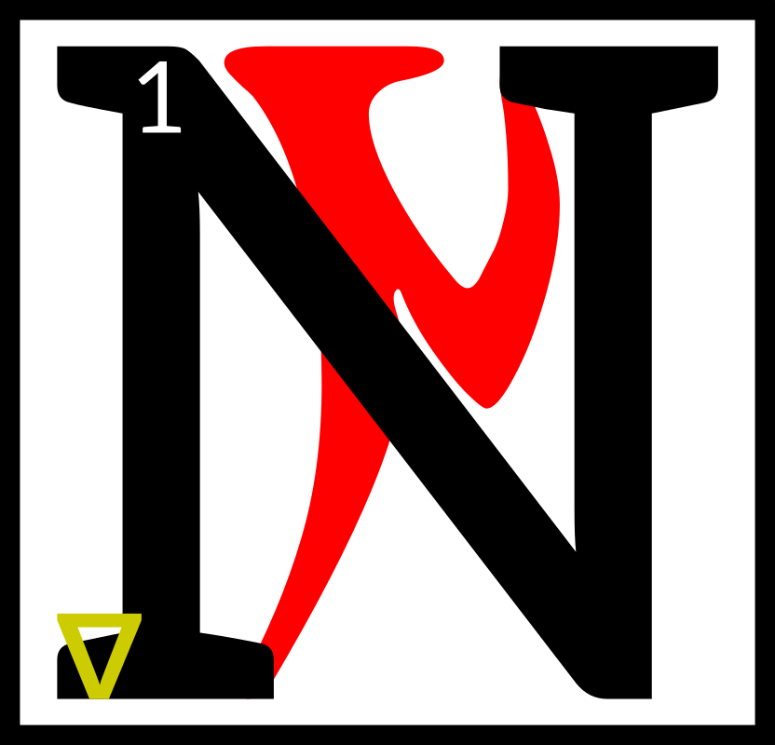
ow Vivec felt that
he had taught
the Hortator as
much as he could
before the war
with the Dwemer
came. 2The warrior-poet decided he had to begin his Book of Hours at that point, because the world was about
to bend with its age.

3Vivec entered the Mourning Hold and announced to Ayem that he was going to fight nine monsters that had escaped
the Muatra.

4‘I will return,’ he said, ‘to deal the last blow to the grand architect of the Dwemer.’

5Ayem said, ‘Out of nine you will find only eight, though they be mighty. The last
is already destroyed by your decision to create the
Book of Hours.’
The 36 Lessons

6Vivec understood that Ayem meant himself.

‘Why,’ she asked, ‘are you
in doubt?’

7Vivec knew that his doubt made him the sword of the Triune and so he did not feel shame or fear. 8Instead,
he explained and these are
the words:

‘Can a member of the Invisible Gate become
so archaic that its successor is not so much an improvement of the exact model, but rather
a related model that is
just needed more because of the currency of the world's condition? 9As the Mother, you do not have to worry, unless things in the future are so strange that even Seht cannot understand. Neither does the Executioner or the Fool, but I am neither.

10‘These ideals are not going to change in nature, even though they may change in representation. But, even in the west, the Rainmaker vanishes. No one needs him anymore.

11‘Can one oust the model not because the model is set according to an ideal but because it is tied
to an ever-changing unconscious mortal agenda?’

12This is what was said to Ayem when Vivec was whole.
The wise shall not mistake this.

13Ayem said, ‘This is
why you were born of
a netchiman's wife and destined to merge with
the simulacrum of your mother, gilled and blended in all the arts of the star-wounded East, 14under water and in fire and in metal and in ash, six times the wise, to became the union of male and female, the magic hermaphrodite, the martial axiom,
the sex-death of language and unique in all the middle world.’

15Vivec knew then why he would record his Book of Hours.

This sermon is forbidden.

16In this world and others
1'8 less one (the victor)
is the magical disk, hurled to reach heaven by violence.

This sermon is untrue.

17The ending of the world is

ASV

The 36 Lessons

alnahn'enta'shoreshik
Sermon Nineteen

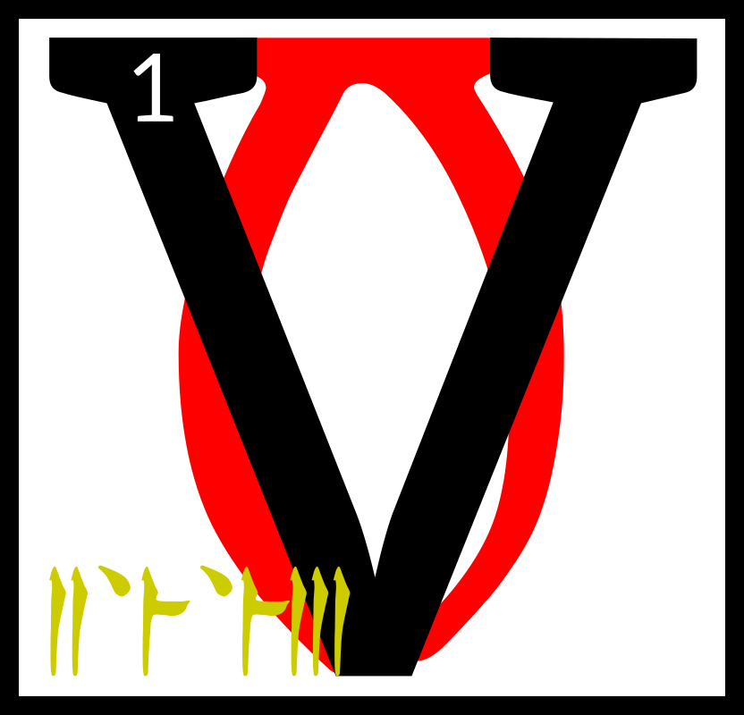
ivec put on
his armor and
stepped into
a non-spatial
space filling to
capacity with
mortal interaction and information, 2a canvasless cartography of every single mind it has ever known, an event that had developed some semblance of a divine spark. 3He said, ‘From here I shall launch my attack on the
eight monsters.’

4Vivec then saw the moths that would come from the starry heart, bringing with them dust more horrible than the ash of Red Mountain. 5He saw the twin head of a ruling king who had no equivalent. 6And eight imperfections rubbed into precious stones, set into a crown that looked like shackles, which he understood to be the twin crowns of the two-headed king. 7And a river that fed into the mouth of the two-headed king, because he contained multitudes.

8Vivec then built the Provisional House at the Center of the Secret Door. From here he could watch the age to come.

9Of the House is written:

Cornerstone one
Has a finger
Buried under,
Pointing through
Dirt, slow low in the ground
North cannot be guessed,
And yet it is spirit-free

10Cornerstone two
Has a tongue,
And even dust
Can be talkative,
Listen and you will see
The love
The ancient libraries need

11Cornerstone three
Has a bit of string,
Shaped like
Your favorite color,
A girl remembers
Who left it there
But she is afraid
To dig it out,
And see
What it is attached to

12Cornerstone four
Has nine bones,
Removed carefully
From a black cat,
Arranged in the fashion
Of this word,
Protecting us
From our enemies

The 36 Lessons

13Your house is safe now

So why is it—

Your house is safe now

So why is it—

14The ending of the words is

ASV

ascahna'shoreshik
Sermon Twenty

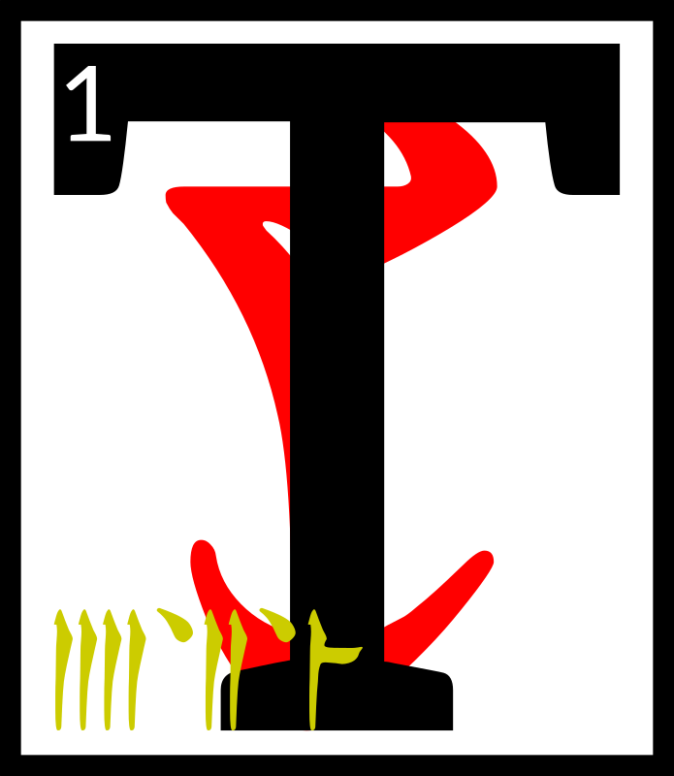
he first monster
was actually two,
having been born
twice like his
mother-father,
Vivec. 2He was not the mightiest of the eight to escape Muatra, but his actions were the most worrisome.
3He was known as Moon Axle, and he harvested the leftover foibles of nature. 4This he did twice, as was said, and the second harvest always brought ruin or unwritten law.
5His aspect was faceted like
a polyhedron.

6No perils are mentioned in
the finding of Moon Axle, but
it was known that he was immune to spears, so Vivec
had to use the sword not held against him. 7Before he took issue with the monster, the warrior-poet asked:

‘How came you to be immune to spears?’
8To which Moon Axle replied, ‘Mine is a dual nature, and protean. I am in fact made
of many straight lines,
though none last too long.
In this way I have learned
to ignore all true segments.’

9Luckily, the sword not held was curved and therefore could cut into Moon Axle, and before the sun was up he was bleeding from many wounds. 10Vivec
did not slay him outright for to do so would keep the foibles of nature within him and not back where they belonged. 11Soon Vivec had traced geography right again, and Moon Axle
was ready to be slain.

12Vivec rose up in his giant-form, to be terrible to look upon. 13He reached into the west and pulled out a canyon, holding it like a horn.
He reached east and ate
a handful of nix hounds.
The 36 Lessons

14Blowing their spirits through the canyon made a terrible wail, not unlike an unsolved woman. 15He said:

‘Let this overtake you,’
and Moon Axle was overtaken by the curvatures of stolen souls. 16They wrapped about the monster like resin, until finally he could not move, nor could his dual nature.

17Vivec said, ‘Now you are solved,’ and pierced his child with Muatra. 18Moon Axle
had been reduced to something static, and therefore shattered.

19The lines of Moon Axle
were collected by Velothi philosophers and taken into caves. 20There, and for a year, Vivec taught the philosophers how to turn the lines of his son into the spokes of mystery wheels. 21This was the birth
of the first Whirling School. Before, there had only been
the surface thought of fire.

22Vivec looked at his first wheeling students and observed:

‘Alike the egg-layered universe is this morbid possession of three-distant coverage, soul-wrecked
and alive, like my name
is alive.

23In this cloister
you have discovered
one walking path, hilled like a sword but more coarsened. 24So edged it is that it has to be whispered to keep the tongue from bleeding, where its signs evacuate their former meanings, like empires that tarry too long.

25‘The sword is estrangement from statesmanship.

26‘Look on the estimable lines of my son, now crafted star-wise, his every limb equidistant from the center. 27Is he solved because I will it so? There cannot be a second stage. 28Think on the theory that my existence promulgates the five elements and alike the egg-layered universe I am cause for great density. 29Here is a thought that can break the wagon's axle; here is another
that can soar.’

30The ending of the words is

ASV

The 36 Lessons

ascahn'alna'shoreshik
Sermon Twenty-One

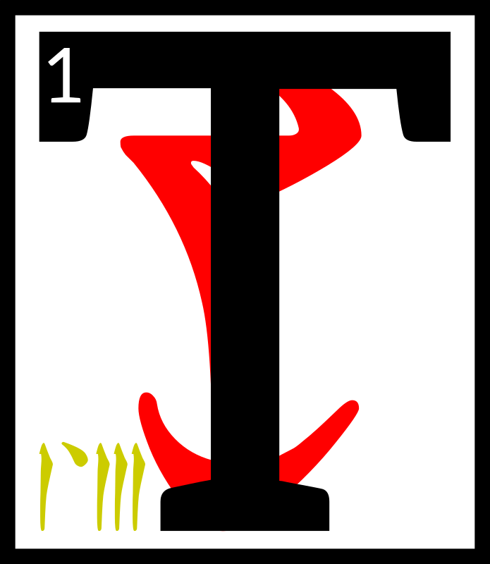
he Scripture
of the Wheel,

First:

‘The Spokes
are the eight components of chaos, as yet solidified by the law of time:
2static change, if you will, something the lizard gods refer to as the Striking. 3That is the reptile wheel, coiled potential,
ever-preamble to the never-action.’

4Second:

‘They are the lent bones
of the Aedra, the Eight gift-limbs to SITHISIT, the wet earth of the new star our home. 5Outside them is the Aurbis, and not within. Like most things inexplicable, it is
a circle. 6Circles are confused serpents, striking and striking and never given leave to bite.

7The Aedra would have you believe different, but they were givers before liars. Lies have turned them into biters. 8Their teeth are the proselytizers; to convert is to place oneself in the mouth
of falsehood; even to propitiate is to be swallowed.’

9Third:

‘The enlightened are those uneaten by the world.’

10Fourth:

‘The spaces between the gift-limbs number sixteen, the signal shapes of the Demon Princedoms. It is the key and the lock,
series and manticore.’

11Fifth:

‘Look at the majesty sideways and all you see
is the Tower, which our ancestors made idols from. 12Look at its center and
all you see is the begotten hole, second serpent, womb-ready for the Right Reaching, exact and without enchantment.’

13Sixth:

‘The heart of the second serpent holds the secret triangular gate.’

The 36 Lessons

14Seventh:

‘Look at the secret triangular gate sideways and you see the secret Tower.’

15Eighth:

‘The secret Tower within the Tower is the shape of the only name of God, I.’

16The ending of the words is

ASV

ascahn'asca'shoreshik
Sermon Twenty-Two

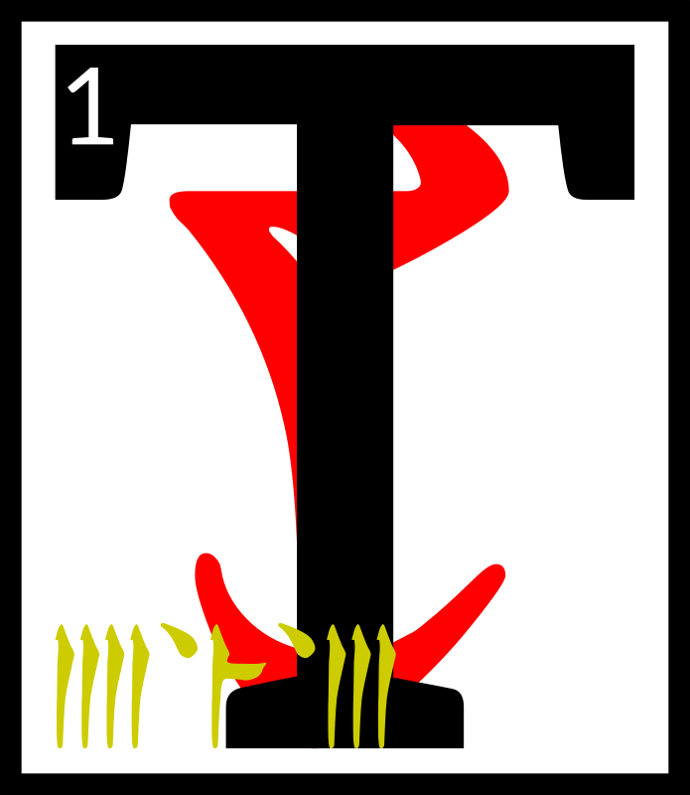
hen Vivec left
the first Whirling
School and went
back to the space
that was not a
space. 2From the
Provisional House he looked into the middle world to find the second monster, which
was called the Treasure Wood Sword. 3Within years of the Pomegranate Banquet, it had become a lessoning tune to the lower Velothi houses. 4They preached of its power:

‘The Treasure Wood Sword, splinter scintilla of the high and glorious! He who wields it becomes self-known!’

5The warrior-poet appeared as a visitation in the ancestor alcove of House Mora, whose rose-worn prince of garlands was
a hero against the northern
demons. 6Vivec congregated with the bones. He said:

‘A scavenger cannot acquire a silk sash and expect to discover the greater systems of its predecessor: perfect happiness is embraced only by the weeping.
7Give me back (and do
so freely) what is barren
of my marriage and
I will not erase you from the thought realm of God. 8Your line has a notable enchantress that my sister Ayem is fond of and from her murky wisdom alone do I condescend to ask.’

9A bone-walker emerged from
a wall. It had three precious stones set in its lower jaw,
a magical practice of old.
One was opal, the color of opal.

The 36 Lessons

10The bone-walker bowed
to the prince of the middle air and said:

‘The Treasure Wood Sword will not leave
our house. Bargains
were made with the
Black Hands Mephala,
the greater shade.’

11Vivec kissed the first precious stone and said:

‘Animal picture, rude-walker, go back to
the lamp that stays lit
in water and store
no more messages of useless noise. Down.’

12He kissed the second precious stone and said:

‘Proud residue, soon dispersed, serve no guarantees made in my fore-image and demand nothing of its under-skin.
I am master evermore. Down.’

13He kissed the opal and said:

‘Down I take thee.’

14And then Vivec withdrew into the hidden places and found the darkest mothers of the Morag Tong, taking them all to wife and filling them with undusted loyalty that tasted
of summer salt. 15They became as black queens, screaming live with a hundred murderous sons, a thousand murderous arms, and a hundred thousand murderous hands, 16one vast moving event of thrusting-kill-laughter in alleys, palaces, workshops, cities and secret halls. 17Their movements among the holdings of the Ra'athim were as rippled endings, heaving between times, with all fates leading
to swallowed knives, murder
as moaning, God's holy and plundering erasure of wet death.

18The King of Assassins presented to Vivec the Treasure Wood Sword.

19‘Milord,’ the King
of Assassins said. ‘The prince of House Mora is now fond of you, as well.
20I placed him in the Corner of Dagon. His eyes
I set into a fire prayer
for the wicked. His mouth I stuffed with birds.’

21The ending of the words is

ASV

The 36 Lessons

ascahn'cahna'shoreshik
Sermon Twenty-Three

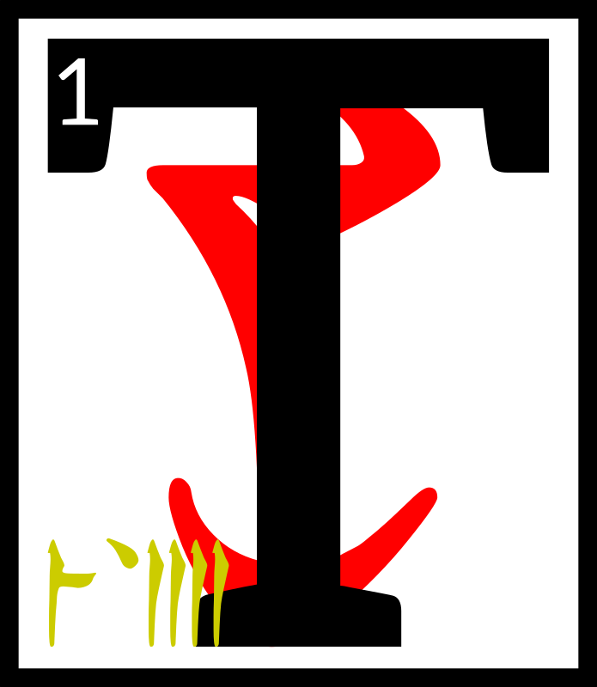
he Scripture
of the Sword,

First:

‘The sword,
treated as a delicate meal, is the Symbolic Collage.
It serves you well
in the first half of life. Name one dynasty that knows this not.’

2Second:

‘The unity of my approach is understood by the immobile warrior.
True eyes are acquired. 3Rejoice as my own subjects and realms. I build for you a city of swords, by which I mean laws that cut the people who live there into better shapes.’

4Third:

‘Girls burn their dresses on my arrival if I am armored. They crawl to me as bled pilgrims. 5Minor spirits
die without trace. Follow me of all the ASV if you are
to mark your days with killing. 6AE ALTADOON, the third law of weaponry.’

7Fourth:

‘The immobile warrior
is never fatigued. He cuts sleep holes in the middle of a battle to regain
his strength.’

8Fifth:

‘Instinct is not reflex action, but mini-miracles held in reserve. 9I am
the welfare that decides which warrior will emerge. Beg not for luck. Serve me to win.’

10Sixth:

‘The span of the apparently inactivated
is your love of the absolute. The birth of God from the netchiman's wife is the abortion of kindness from love.’

11Seventh:

‘The true sword is able to cut chains of generations, which is to say, the creation myths of your enemies. Look on me as
the exiled garden.
All else is uncut weed.’

The 36 Lessons

12Eighth:

‘I give you an ancient
road tempered by the second walking way. 13Your hands must be huge to wield any sword
the size of an ancient road, and yet he who is of
right stature may irritate the sun with only a stick.’

14The ending of the words is

ASV

ascahn'cina'shoreshik
Sermon Twenty-Four

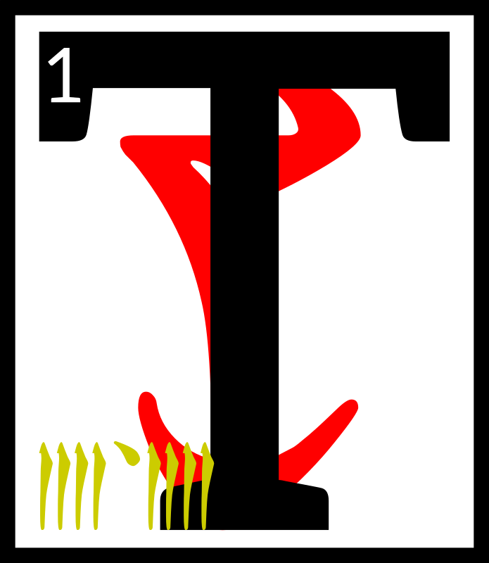
hen Vivec left the
house of assassins
and went back to
the space that was
not a space. 2From
the Provisional
House he looked into the middle world to find the
third monster, called Horde Mountain. 3It was made of modular warriors running free but spaced according to pattern, 4and from the highest warrior who could cut clouds they spread out beneath him like
a tree, a skirt whose bottom circle was an army that ran through the ash.

5Vivec admired the cone-shape of his child and remembered with joy the whirlwind of fighting styles that instructed him during the days before life.

6Vivec moved into Veloth, saying, ‘Onus.’

But before he could even get within sword-span of the monster, a trio of lower houses had trapped Horde Mountain
in a net of doubtful doctrine. 7When they saw their lord,
the Velothi cheered.

‘We are happy to serve you and win!’ they said.

8Vivec smiled at those
brave souls around him and summoned celebration demons to cleave unto the victors. 9There was a great display
of love and duty around the netted monster, and Vivec
was at the center with a headdress made of mating bones. 10He laughed and told mystical jokes and made
the heads of the three houses marry and become a new order.

‘You shall forever be now my Buoyant Armigers,’
he said.
The 36 Lessons

11Then Vivec pierced Horde Mountain with Muatra and made of it all a big bag of
bones. 12At the touch
of his right hand the net
became right scripture and
he threw it all northeasterly.
13The contents spread out
like sugar-glows and Vivec
and the Buoyant Armigers
ran under it laughing.

14Finally the bones of
Horde Mountain landed and became the foundation stones for the City of Swords, which Vivec named after his own sigil, 15and the net fell across it all and between, or became as bridges between bones, and since its segments had been touched by his holy wisdom they became the most perfect
of all city streets in the
known worlds.

16Throngs of Velothi came
to the new city and Ayem
and Seht gave it their blessing. 17The streets were filled with laughter and love and
the strength of tree-shaped enemy children.

18Ayem said:

‘To my sister-brother's city I give the holy protection of House Indoril, whose powers and thrones know no equal under heaven, wherefrom came
the Hortator.’

19Seht said:

‘To my sister-brother's city I give safe passage through the dark corners still left of Molag Bal, and I give it this spell as well:

SO'T'HA SIL

which is my name to the mighty. 20It will protect the lost unless their flight is on purpose and fill all the roads and alleys with the mystery paths of civilization, and give the city a mind and make of it a conduit to the full concentrate of the ASV.’

21Thus was founded the city of Vivec in the days of Resdaynia.

22The ending of the words is

ASV

The 36 Lessons

ascahn'arca'shoreshik
Sermon Twenty-Five

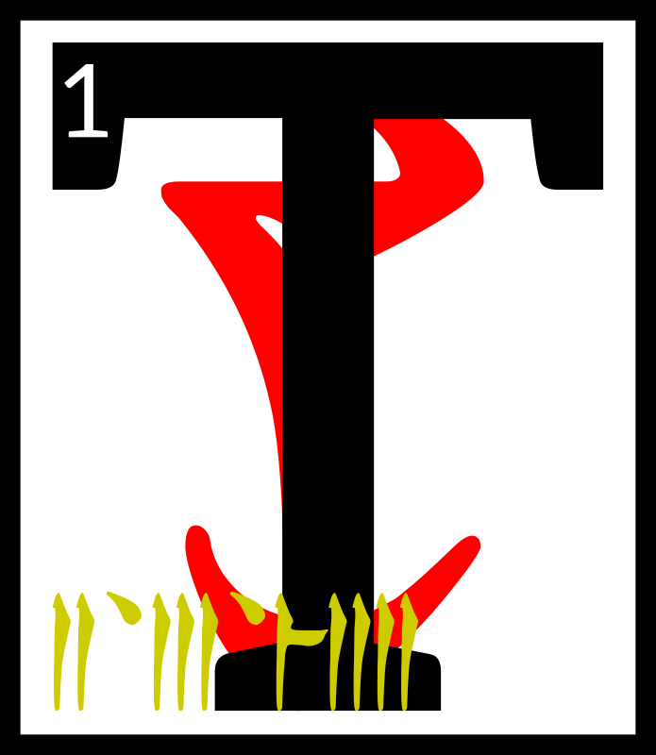
he Scripture of the
City:

‘All cities are born of solid light. Such is my city, his city.

2‘But then the light subsides, revealing the bright and terrible angel
of Veloth. 3He is in his pre-chimerical form, demonic VEHK, gaunt and pale and beautiful, skin stretched painfully thin on bird's bones, feathered serpents encircling his arms.
4His wings are spread out behind him, their red and yellow ends like razors in the sun. 5The wispy mass of his fire hair floats as if underwater, milky in the nimbus of light that crowns his head. 6His presence is undeniable,
the awe too much to bear.

7‘This is God's city, different from others. Cities from foreign countries put their denizens to sleep and walk to the star-wounded East to pay homage to me. 8The capital of the northern men, crusty with eon's ice, bows before Vivec the city, me it together.
9‘Self-thought streets rush through tunnel blood.
I have rebuilt myself. Hyper eyed signposts along my traffic arm,
soon to be an inner sea. 10My body is crawling with all gathered to see me rising up like a monolithic instrument of pleasure. My spine is the main road to the city that I am. 11Countless transactions are taking place in veins and catwalks and the roaming, roaming, roaming, as they roam over and through and add to me. 12There are temples erected along the hollow of my skull and I will ever wear them as a crown. Walk across the lips
of God.

13‘They add new doors
to me and I become
effortlessly trans-immortal
with the comings and goings and the stride-heat
of the market where I am
traded for, 14yell of the
children hear them play, scoffed at, amused, desired, paid for in native coin,
new minted with my face
on one side and my
city-body on the other.
The 36 Lessons

15I stare with each new window. Soon I am a million-eyed insect dreaming.

16‘Red-sparking war trumpets sound like cattle in the ribcage of shuffling transit. The heretics are destroyed on the plaza knees. 17I flood over into the hills, houses rising like a rash, and I never scratch. Cities are the antidotes
to hunting.

18‘I raise lanterns to light my hollows, lend wax
to the thousands of candlesticks that bear
my name again and again, 19the name innumerable, shutting in, mantra
and priest, god-city,
filling every corner
with the naming name, 20wheeled, circling, running river language giggling with footfalls mating, selling, stealing, searching, and worry not ye who walk with me. 21This is the flowering scheme of the Aurbis.
This is the promise of the PSJJJJ: egg, image, man, god, city, state. 22I serve and am served. I am made of wire and string and mortar and I accede my own precedent,
world without am.’

23The ending of the words is

ASV

ascahn'tahna'shoreshik
Sermon Twenty-Six

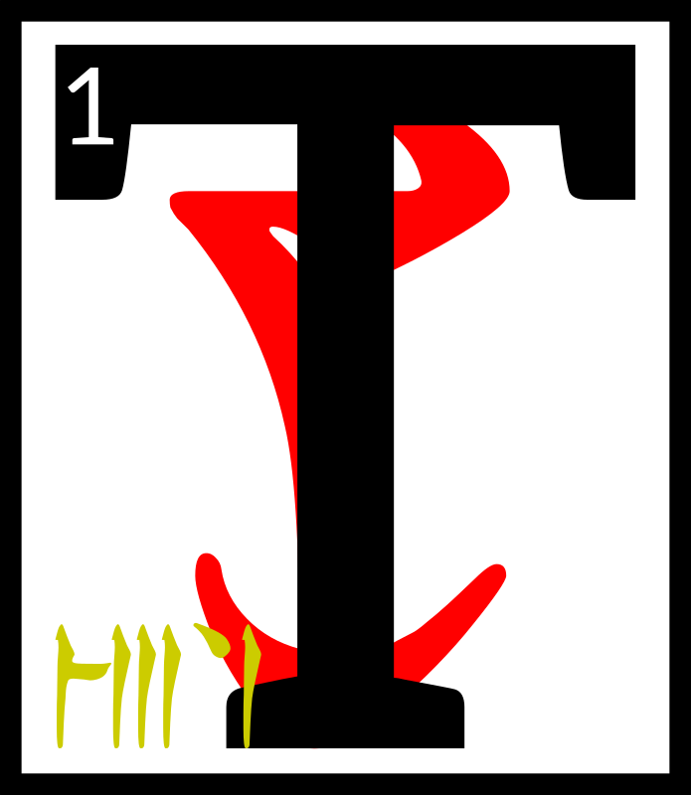
hen Vivec left
his architectural
rapture and went
back to the space
that was not a
space. 2From the
Provisional House he looked into the middle world to find the fourth monster, called
The Pocket Cabal.

3The monster hid itself in the spell-lists of the great Chimeri wizards of the extreme east, where the Emperor Parasols grow wild. 4Vivec disguised himself as a simple traveler, but radiated a tenuous sense-fabric so that the wizards would seek him out. Of Muatra he made
a simple walking dwarf.

5Before long the invisible one was among the libraries of
the east, feeding the essential words of The Pocket Cabal to
The 36 Lessons

his walking dwarf and then running when the magic would fail. 6After a year or two of this thievery, Muatra was sick to its stomach, and the walking dwarf exploded near the slave pens of a wizard's tower. 7The Pocket Cabal then slipped itself into the mouths of the slaves and hid again.

8Vivec then watched as the slaves erupted into babble and breaking magic. 9They rattled their cages and sung out
half-hymns that formed
into forbidden and arcane knowledge. 10Litany fiends appeared and drank from
the excess. Grabbers from
the Adjacent Place came into the world sideways, the slave talking having disrupted the normal non-cardinal points.

11So of course a giant bug appeared, with the greatest eastern wizard inside it.
12He could see past Vivec's disguise and knew of the warrior-poet's divinity but he thought himself so powerful that he talked harshly:

13‘See what you have wrought, silly Triune! Columns of nonsense and litany fiends! 14I cannot believe how reason or temperance can be made whole again due to your eating, eating, eating!
Consort with more demons, why don't you?’

Vivec stabbed the wizard through his soul.

15The giant bug harness fell on the slave cages and the slaves ran about free and reckless, too reckless more with pregnant words. Colors bent into the earth. 16Vivec created a dome-head demon to contain it all.

‘The Pocket Cabal is therefore interred here forever. Let this be a cursed land where sorcery is broken and maligned.’

17Then he picked up Muatra by the beard and left the ghostly hemisphere of the dome-head demon. 18On its boundaries, Vivec placed a warning and a song of entrance that contained errors in it. 19With mock bones of half-dead Muatra he created the tent poles of a fortress-theory and fatal languages were imprisoned for all time.

20Seht appeared and looked
on what his brother-sister had created. 21The Clockwork King said:

‘Of the eight monsters,
this is the most confusing. May I treasure it?’

22Vivec gave Seht leave to
do so, but told him never to
The 36 Lessons

release The Pocket Cabal into the middle world. 23He said:

‘I have hidden secrets in my travels here and made a likeness of Muatra to ward against the unwise.
Under this dome,
the temporal myth
is no longer man.’

24The ending of the words is

ASV

ascahn'sahna'shoreshik
Sermon Twenty-Seven

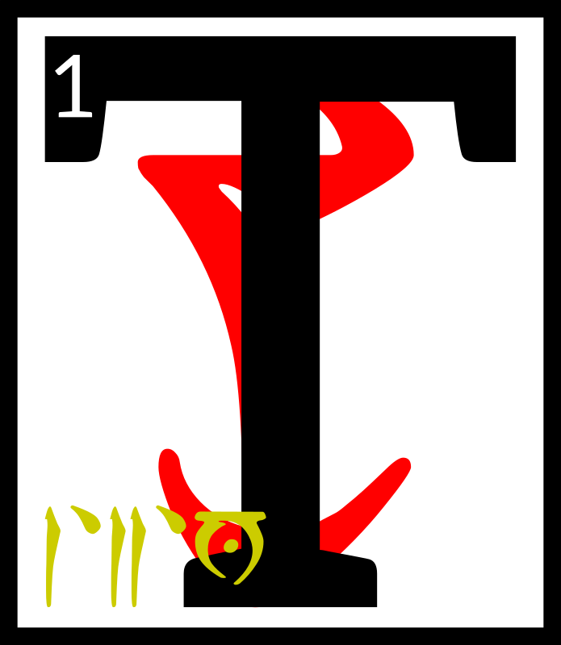
he Scripture of
the Word,

First:

‘All language is
based on meat. Do not let the sophists fool you.’

2Second:

‘The third walking path explores hysteria without fear. The efforts of madmen are a society
of itself, but only if they are written. 3The wise may substitute one law
for another, even into incoherence, and still say he is working within
a method. This is true
of speech and extends
to all scripture.’

4Third:

‘Do not go to the realm of apology for absolution.
Beyond articulation, there is no fault. 5The Adjacent Place, where the Grabbers live, is the illusion of the vocal or the middle realms of thought, by which
I mean the constructed. 6This is how I stole the certainty of the
Chancellor of Exactitude, perfect to look upon from every angle. 7When you come out of the vocal,
you can never be certain.’

8Fourth:

‘The truest body of work
is made up of silence:
as in the silence that results from no reference. By the word I mean
the dead.’

9Fifth:

‘The first meaning is always hidden.’
The 36 Lessons

10Sixth:

‘The realm of apology is perfection and impossible to attack. Thus, the wise avoid it. 11Trinity in unity is the world and word
of action: the third walking path.’

12Seventh:

‘The sage who suppresses his best aphorism: cut off his hands, for he is a thief.’

13Eighth:

‘The clothes of the
broken map are worn
only by fools and heretics.
The map is an exit for laziness. 14It is the dusty tongue, which is to say
the given chart that
most take as a story
that is complete. No word is true until it is eaten.’

15The ending of the words is

ASV

ascahn'daskhora'shoreshik
Sermon Twenty-Eight

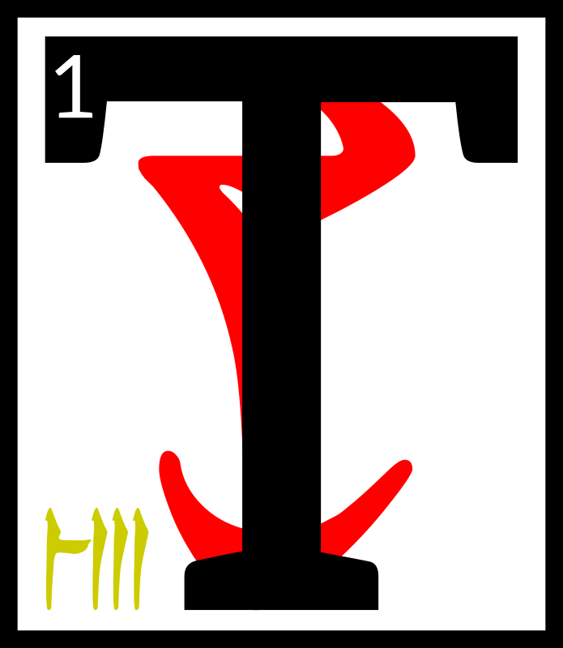
hen Vivec left Seht
to look after the
dome-head demon
and went back to
the space that was
not a space. 2From
the Provisional House he looked into the middle world to find the fifth monster, called The Ruddy Man.

3When the dreughs ruled
the world, the Daedroth Prince Molag Bal had been their chief. 4He took a different shape then, spiny and armored and made for the sea. 5Vivec, in giving birth to the many spawn of
his marriage, had dropped an old image of Molag Bal into
the world: a dead carapace
of memory. 6It would not have been a monster if a Velothi child had not wanted to impress his village by wearing it.

7The Ruddy Man, of the eight monsters, was the least complicated. He made those who wore him into mighty killers and nothing more. He existed in the physical. Only geography makes him special.

8When Vivec found him near the boy's village, anon Gnisis, there was a violent clash of arms and an upheaval of the earth.
The 36 Lessons

9Their battle created the
West Gash. Wanderers that
still go there hear still the sounds of it: sword across the crust, the grunt of God, the snapping of his monster child's splintered legs.

10After his victory, Vivec took the shell of The Ruddy Man to the dreughs that had modified his mother. 11The Queen of Dreughs, whose name is not easy to spell, was in a period of self-incubation. 12Her wardens took the gift from Vivec and promised to guard it from the surface world. This is the first account of dreughs being liars.

13In ten years, The Ruddy Man appeared again, this time near Tear, worn by a wayward shaman who followed the House of Troubles. 14Instead of guarding it, the dreughs had imbued the living armor with mythic inflexibility. 15It molted soon after skill-draping the shaman and stretched his bones to the five corners.

16When Vivec met the monster in battle again he saw the remains of three villages dripping from its feet.
17He took on his giant form and slew The Ruddy Man by way of the Symbolic Collage. 18Since he no longer trusted the Altmer of the sea, Vivec gave the carapace of the monster to the devout and loyal mystics of the Number Room. 19He told them:

‘You may make of
The Ruddy Man a philosopher's armor.’

20The mystics began by wrapping one of their sages in the shells, a series of flourishes by two supra numerates,
one hormonally tall and the other just under his arms. 21They ran around the carapace and through each other, applying holy resin drawn from the carcasses of the now-useless numbers between twelve and thirteen. 22Golden straws were quickly stuck through the mythic epidermal so the sage could breathe. 23After the ceremonial etchings were drawn into hardening resin, long lists of dead names and equations whose solutions were to be found in the mouth of the Chimer inside, there came
the illuminations, inscribed by the bright, terrible fingernail
of Vivec. 24From the nail's tip flowed a searing liquid, filling the grooves of the ceremonial etchings. 25They bled out
to form veined patterns about
the sage-shell that theologians would decipher forever after.

26The ending of the words is

ASV

The 36 Lessons

ascahn'enta'shoreshik
Sermon Twenty-Nine
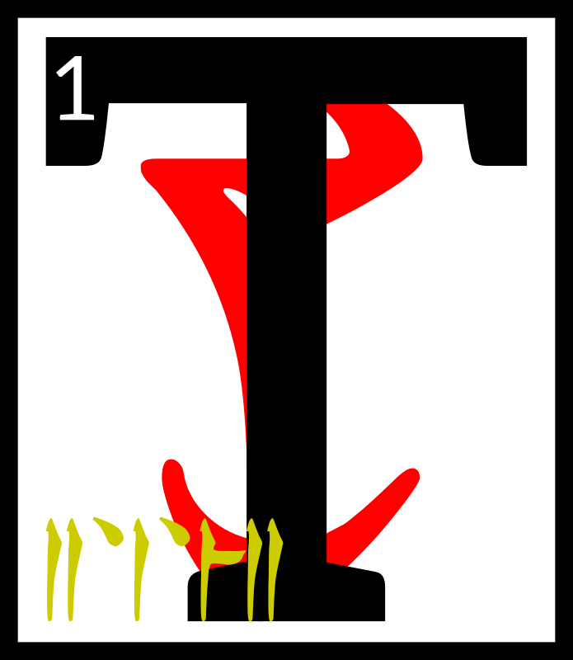
he Scripture of the Numbers:

1. The Dragon Break, or the Tower. 1
2 2. The Enantiomorph. 68
3 3. The Invisible Gate, ASV. 112
4 4. The Corners of House of Troubles. 242
5 5. | The Corners of the World. 100
6 6. | The Walking Ways. 266
7 7. | The Sword at the Center. 39
8 8. | The Wheel, or the Eight Givers. 484
9 9. | The Missing. 11
10 1'0. | The Tribes of the Altmer. 140
11 1'1. | The Number of the Master. 102
12 1'2. | The Heavens. 379
13 1'3. | The Serpent. 36
14 1'4. | The King's Cough. 32
15 1'5. | The Redeeming Force. 110
16 1'6. | The Acceptable Blasphemes. 12
17 1'7. | The Hurling Disk. 283
18 1'8. | The Egg, or Six Times the Wise.
19 1'9. | The Provisional House. 258
20 2'0. | The Lunar Lattice. 425
21 2'1. | The Womb. 13
22 2'2. | Unknown. 453
23 2'3. | The Hollow Prophet. 54
24 2'4. | The Star Wound. 44
25 2'5. | The Emperor. 239
26 2'6. | The Rogue Plane. 81
27 2'7. | The Secret Fire. 120
28 2'8. | The Drowned Lamp. 8
29 2'9. | The Captive Sage. 217
30 3'0. | The Scarab. 10
31 3'1. | The Listening Frame. 473
32 3'2. | The False Call. 7
33 3'3. | The Anticipations. 234
34 3'4. | The Lawless Grammar. 2
35 3'5. | The Prison-Shirt. 191
36 3'6. | The Hours. 364
The 36 Lessons

37‘The presence of
deaf witness, this
is what the numbers are.
They hang onto the Aurbis as the last nostalgia of their godhood. 38The effigies of numbers are their current applications;
this is folly, as above.
To be affixed to a symbol
is too, too certain.’

39The ending of the words is

ASV

cahnahna'shoreshik
Sermon Thirty

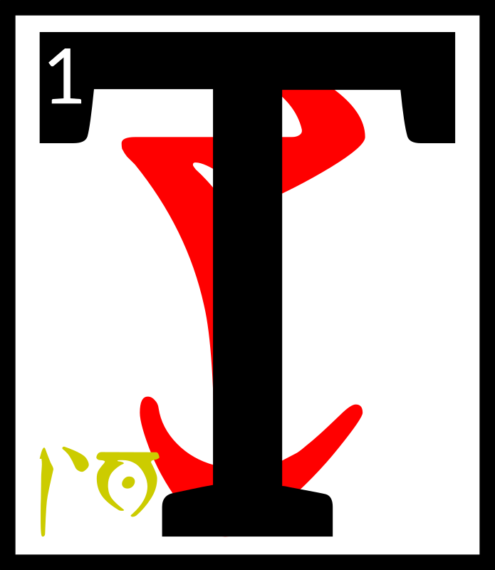
hen Vivec left
the mystics of the
Number Room and
went back to the
space that was not
a space. 2From the
Provisional House he looked into the middle world to find the sixth monster, called
City-Face. 3He was vexed when he could not find it and went back to the Mourning Hold in secret anger, killing a mystic that asked about higher order.

4Nerevar, the Hortator, witnessed this and said, ‘Why do this, milord? The mystics look to you for guidance. They work to make your temple better stoned.’

5Vivec said, ‘No one knows what I am.’

The Hortator nodded and went back to his studies.
6Here is how City-Face hid from his mother-father: it had been born named as Ha-Note,
a bare urge of power,
an esoteric wind nerve tuned
to the frequency of huddled masses. 7It found root in villages and multiplied, finding in the minds of the settled
a veiled astrology, the star charts of culture, and this resonance made its head swim. 8Ha-Note moved sideways
into the Adjacent Place, growing and unbeknownst. Above the vocal, it trembled with new emotions, immortal ones, absorbing more than
the thirty known to exist in
the middle world. 9When
Ha-Note became gravely homesick, the Grabbers took it.

10A Grabber said, ‘New emotions to the lonely occur only of madness. This thing
is gone. It is ours now.’

The 36 Lessons

11Grabbers had never made
a city of their own, and their glimpse of Vivec's, which shone with holiness through all the spheres, had taken their attention.

12‘Under this reason did the issue of Vehk slide
into our realm, drawn by our coveting, hidden in loss. We shall build our tower-hope upon its face.’

13Now many years had passed in Resdaynia, and the high priests of the Dwemer were building something alike as Vivec and alike as the new
Ha-Note of the Grabbers.
14The Hortator was engaged with an army of theirs that
had become too brave, talking foolish words, and Nerevar helped destroy them with the help of the orphan legion of Ayem. 15When he went to give trophy to Vivec, he saw his lord under attack by the City-Face.
16The monster was saying this:

‘Here we are to replace your city, Vehk and Vehk. 17We are from the place of the more-than-known emotions, and our citizenry has died from it. Two things we came for, but can stay for only one. 18Either we ask you
to correct our error
of culture, or merely
take yours by dint of
force. The second is easiest, we think.’

19Vivec sighed.

‘You would replace my direction,’ he said. ‘I weary of this, though I wanted
to kill you an age before. 20Resdaynia is fallen ill, and I have no time for
one more imaginary analogy of an unknown incident. 21Here, take this.’

At which he touched the tower-hope of the City-Face and corrected the error of the Grabbers.

22‘And this.’

At which he stabbed the
heart of the City-Face with the Ethos Knife, which is to say

RKHT AI AE
ALTADOON AI,

the short blade of proper commerce.

23The ending of the words is

ASV

The 36 Lessons

cahnahn'alna'shoreshik
Sermon Thirty-One

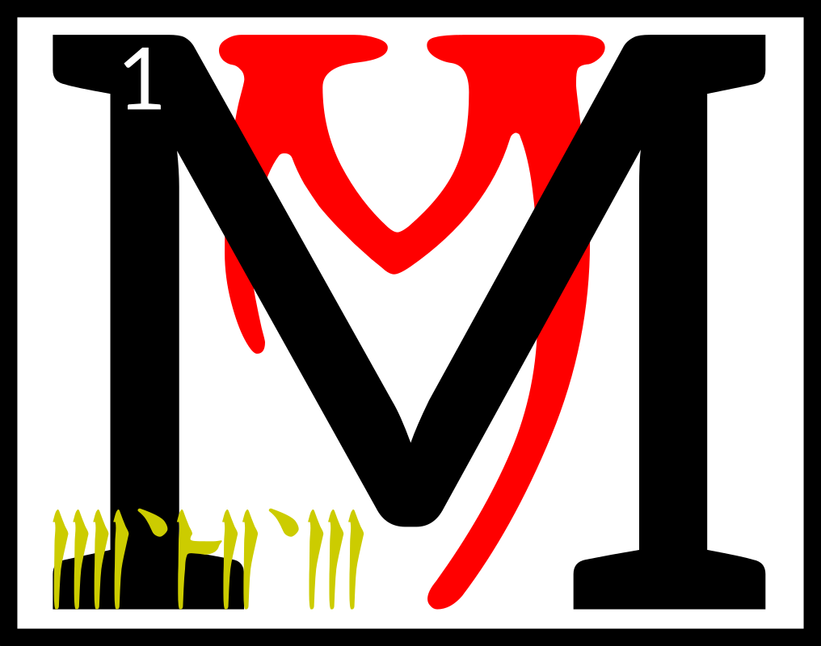
any more
years passed
in Resdaynia,
and the high
priests of the
Dwemer were
almost ready to make war
on the rulers of Veloth.
2The Hortator had become the husband of Ayem during this time, and the first saint of the Triune way. 3Vivec had tired of fighting his sons and daughters, and so took a respite from trying to find them.

4The Hortator said to his wife, ‘Where is Vivec, my teacher?
I love him still, though he grows cold. His lamentations,
if I may call them that, have changed the skin of the whole country. 5He is hardly to be found anywhere in Veloth
of late. The people grow dark because of it.’

6And Ayem took mercy on her troubled husband and told him that the sword of the Triune had been fighting minor monsters stirred up by the Dwemer as they worked on their brass siege machines.
7She took the Hortator
inside her and showed him where his master was.

8ASV, or at least that aspect
that chose to be Vivec, sat
in the Litany Hall of the
False Thinking Temple after his battle with the Flute-and-Pipe Ogres of the West Gash. 9He began writing, again, in his Book of Hours. He had to put on his Water Face first. 10That way he could separate the bronze of the Old Temple from the blue of the New and write with happiness. 11Second,
he had to take another feather from the Big Moon, further rendering it dead. That way
he could write about mortals with truth.

12Third, he recalled
the Pomegranate Banquet, where he was forced to
marry to Molag Bal with
wet scriptures to cement his likeness as Mephala and write with black hands. 13He wrote:

The last time I heard
his voice, showing
the slightest sign of impatience, I learned to control myself and submit to the will of others. 14Afterwards, I dared to take on the sacred fire
and realized there was
no equilibrium with
the ET'ADA. 15They were
liars, lost roots,
The 36 Lessons

and the most I can do is to be an interpreter into the rational. 16Even that fails the needs of the people.
I sit on the mercy seat and pass judgment, the waking state, and the phase aspect of the innate urge. 17Only here can I doubt, in this book, written in water, broadened to include evil.

18Then Vivec threw his ink
on this passage to cover it up
(for the lay reader) and wrote instead:

Find me in the blackened paper, unarmored, in final scenery. 19Truth is like
my husband: instructed
to smash, filled with procedure and noise, hammering, weighty, heaviness made schematic, lessons learned only by
a mace. 20Let those that hear me then be buffeted, and let some die in the ash from the striking.
21Let those that find him find him murdered by illumination, pummeled like a traitorous house, because, if an hour is golden, then immortal I
am a secret code. 22I am the partaker of the
Doom Drum, chosen of
all those that dwell in the middle world to wear this crown, which reverberates with truth, and I am the mangling messiah.

23The ending of the words is

ASV

cahnahn'asca'shoreshik
Sermon Thirty-Two

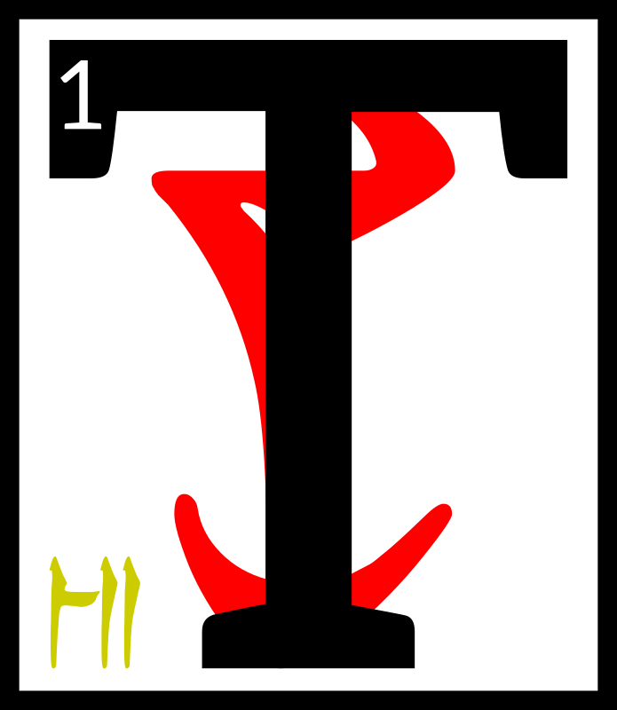
he Scripture of
the Mace,

First:

‘The pleasure
of annihilation is the pleasure of disappearing into the unreal. 2All those that would challenge the sleeping world will seek membership in this movement. I denounce
the alienation of the Cloven Duality with
a hammer.’

3Second:

‘Take from me the lessons as a punishment for being mortal. To be made of dirt is to be treated as such
by your jailers.
The 36 Lessons

4This is the key and
the lock of the Daedra. Why do you think they escaped the compromise?’

5Third:

‘Velothi, your skin has become the pregnant darkness. My brooding
has brought this on.

6Remember that Boethiah asked you to become
the color of bruise. How else to show yourselves people of the exodus
into the vital: pain?’

7Fourth:

‘The sage who is not
an anvil: a conventional sentence and nothing more. By which I mean dead, the fourth
walking way.’

8Fifth:

‘A proper comprehension of the virtues:
stage-managed and
to be murdered.’

9Sixth:

‘In the end, rejoice as
a hostage released from drumming torment but that savors his wound. 10The drum breaks and you find it to be a nest of hornets, which is to say: your sleep is over.’

11Seventh:

‘The suspicious is spectacle and the lie is only a theoretical inspiration.’

12Eighth:

‘But then why, you ask,
do the Daedra wish to meddle with the Aurbis?
It is because they are the radical critique, essential as all martyrs. 13That
some are more evil than others is not an illusion. Or rather, it is a necessary illusion.’

14The ending of the words is

ASV

The 36 Lessons

cahnahn'cahna'shoreshik
Sermon Thirty-Three

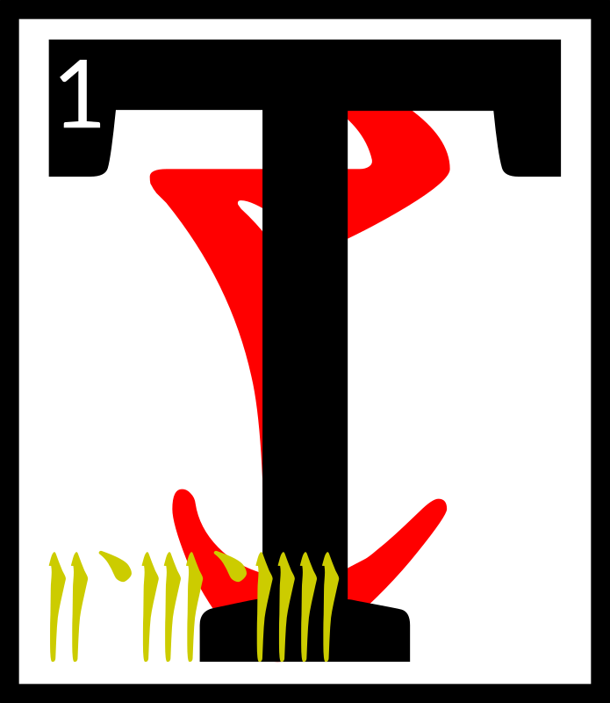
hen Vivec left the
Litany Hall of the
False Thinking
Temple, where he
had brooded for
so long creating the
scripture of the pounding light, and went back to the space that was not a space. 2From the Provisional House he looked into the middle world to find the seventh monster, called Lie Rock.

3Lie Rock was born of
Vivec's Second Aperture
and was thrown out of the
Pomegranate Banquet by a member of the Sweeps, another forgotten guild. 4The Sweep
did not take it for the monster that it was and so he did not expect it to fly from his hand and into the heavens.

5‘I am born of golden wisdom and powers
that should have forever been unalike! With this nature I am invited into the Hidden Heaven!’

6By which he meant the Scaled Blanket, made of not-stars, whose number is thirteen. 7Lie Rock became full of foolishness, haggling with the Void Ghost who hides in the religions of all men. 8The Void Ghost said:

‘Stay with me a full hundred years and I will give you a power that no divinity will dare disobey.’

9But before the hundred years was up, Vivec was already looking for Lie Rock and found him.

10‘Stupid stone,’ Vivec said. ‘To hide in the Scaled Blanket is to make a mark on nothing. His bargains are only for ruling kings!’

11So Vivec sent the Hortator to the heavens to shave Lie Rock asunder by the named axe. 12Nerevar made peace with the south-pole-star of thieving and the north-pole-star of warriors and the third-pole-star, which existed only in the ether, which was governed by the apprentice of Magnus the sun. 13They gave him leave to wander among their charges and gave him red sight by which to find Lie Rock in the Hidden Heaven.

14By chance, Nerevar met the Void Ghost first, who told him that he was in the wrong place to which the Hortator said,
‘Me or you?’ and the Void Ghost said both.
The 36 Lessons

15This sermon does not tell what else was said between these masters.

16Lie Rock, however, used the confusion to launch his own attack on the city-god, Vivec. 17He was hastened by all three of the black guardians,
who wanted him swiftly gone, though they meant no hostility to the lord of the middle air.

18The citizenry of Vivec screamed as they saw
a shooting star come down
out of the sky hole like a
toll-road of hell. 19But Vivec merely raised his hand and froze Lie Rock just above
the city and then he pierced
the monster with Muatra.

20(The practice of piercing
the Second Aperture is now forbidden.)
21When Nerevar returned, he saw the frozen comet above his lord's city. He asked whether or not Vivec wanted it removed.

‘I would have done
so myself if I wanted,
silly Hortator. 22I shall keep it there with its last intention intact, so that
if the love of the people
of this city for me
ever disappear, so shall
the power that holds back their destruction.’

23Nerevar said, ‘Love is under your will only.’

24Vivec smiled and told the Hortator that he had become
a Minister of Truth.

25The ending of the words is

ASV

cahnahn'cina'shoreshik
Sermon Thirty-Four

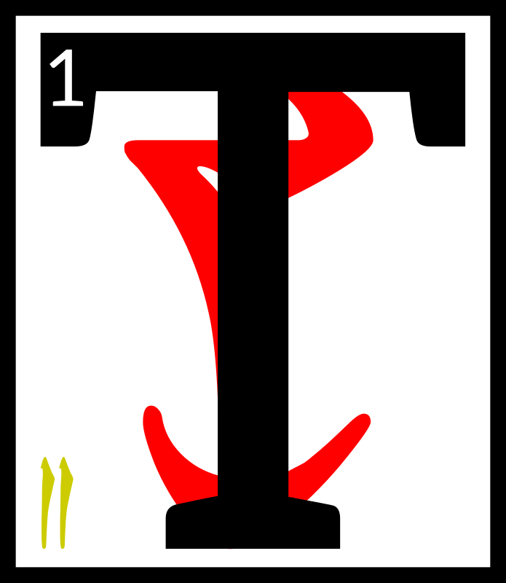
hen Vivec left the
Ministry of Truth
and went back
to the space that
was not a space.
2From the
Provisional House he looked into the middle world to find the eighth and final and mightiest monster, 3called

GULGA MOR JIL
HYAET AE HOOM

4Vivec called to his side the Hortator and this was the first time that Nerevar had ever been to the Provisional House.

The 36 Lessons

5He had the same vision that Vivec had so many years ago: that of the two-headed ruling king.

6‘Who is that?’ he wondered.

Vivec said, ‘The red jewel of conquest.’

7Nerevar, perhaps because he was frightened, became vexed at his lord's answer. ‘Why are you always so evasive?’

8Vivec told the Hortator that
to be otherwise was to betray his nature.

9Together they moved into
the middle world, to a village near where Vivec had been found by Ayem and Seht.
10The eighth monster was there, but he did not act much like a monster. He sat with
his legs in the ocean and with
a troubled look on his face. 11When he saw his mother-father, he asked why he
should have to die and return to oblivion.

12Vivec told the eighth monster that to be otherwise was to betray his nature. 13Since this did not seem to satisfy the monster and Vivec still had a touch of Ayem's mercy he said:

‘The fire is mine:
let it consume thee,
14And make a secret door
At the altar of Padhome,
In the House of Boet-hi-Ah
Where we become safe
And looked after.’

15The monster accepted Muatra with a peaceful look and his bones became the foundation for the City of the Dead, anon Necrom.

16Nerevar put away his axe, which he had at the ready, and frowned.

‘Why,’ he said, ‘did you ask me to come if you knew the eighth monster would give in so easily?’

17Vivec looked at the Hortator for a long time.

Nerevar understood. ‘Do not betray your nature. Answer
as you will.’

18Vivec said, ‘I brought you here because I knew the mightiest of my issue would succumb to Muatra without argument, if only I gave him consolation first.’

19Nerevar looked at Vivec for
a long time.

Vivec understood. ‘Say the words, Hortator.’
The 36 Lessons

Nerevar said, ‘Now I am
the mightiest of your children.’

20Let this sermon be consolation to those who
read it that are destined to die.

21The ending of the words is

ASV

cahnahn'arca'shoreshik
Sermon Thirty-Five

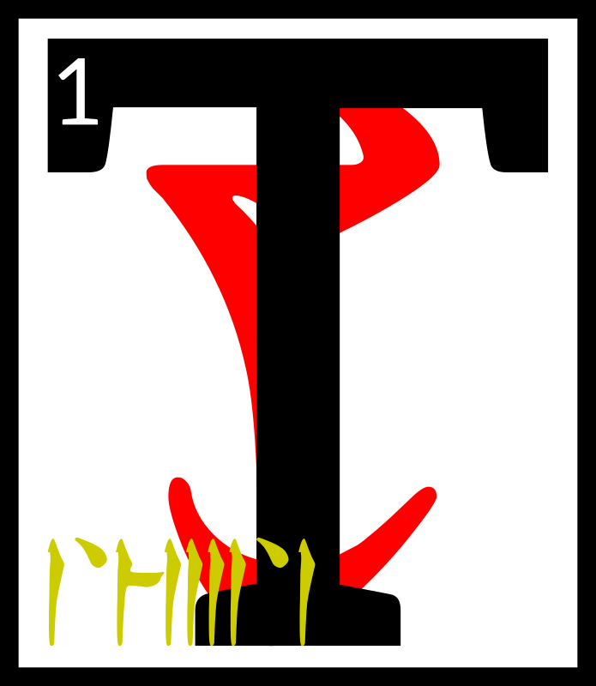
he Scripture of
Love:

‘The formulas of proper Velothi magic continue
in ancient tradition,
but that virility is dead,
by which I mean at least replaced. 2Truth owes
its medicinal nature to the establishment of the myth of justice. 3Its curative properties it likewise owes to the concept of sacrifice. Princes, chiefs, and angels all subscribe to the same notion. 4This is a view primarily based on
a prolific abolition of
an implied profanity,
seen in ceremonies, knife fighting, hunting, and the exploration of the poetic. 5On the ritual of occasions, which comes to us from the days of the cave glow,
I can say nothing more than
to loosen your equation of moods to lunar currency. 6Later, and by that I mean much, much later, my reign will be seen as an act of the highest love, which is a return from the astral destiny and the marriages between. 7By that I mean the catastrophes, which will come from all
five corners. Subsequent
are the revisions, differentiated between hope and the distraught, situations that are only required by the periodic death of the immutable. 8Cosmic time is repeated:
I wrote of this in an
earlier life. An imitation
of submersion is love's premonition, its folly into the underworld, by which I mean the day you will read about outside of yourself in an age of gold. 9For on that day, which is a shadow of the sacrificial concept, all history is obliged to see me for what you are: in love with evil.
The 36 Lessons

10To keep one's powers intact at such a stage is to allow for the existence of what can only be called
a continual spirit.
11Make of your love
a defense against the horizon. Pure existence is only granted to the holy, which comes in a myriad of forms, half of them frightening and the other half divided into equal parts purposeless and assured. 12Late is the lover that comes to this by any other walking way than the fifth, which is the number of the limit of
this world. 13The lover is the highest country and
a series of beliefs. He is
the sacred city bereft of
a double. The uncultivated land of monsters is
the rule. 14This is clearly attested by ANU and his double, which love knows never really happened. Similarly, all the other symbols of absolute reality are ancient ideas ready for their graves, or at least
the essence of such.
15This scripture is directly ordered by the codes of Mephala, the origin of sex and murder, defeated only by those who take up those ideas without
my intervention.
16The religious elite
is not a tendency or
a correlation. They are dogma complemented by
the influence of the untrustworthy sea and the governance of the stars, dominated at the center
by the sword, which is nothing without a victim to cleave unto. 17This is the love of God and he would show you more: predatory but at the same time instrumental to
the will of critical harvest, a scenario by which one becomes as he is, of male and female, the magic hermaphrodite.
18Mark the norms of violence and it barely registers, suspended as
it is by treaties written between the original spirits. 19This should be seen as an opportunity, and in no way tedious, though some will give up for it is easier to kiss the lover than become one. 20The lower regions
crawl with these souls, caves of shallow treasures, meeting in places to testify by way of extension, when love is only satisfied by a considerable (incalculable) effort.’

21The ending of the words is

ASV

The 36 Lessons

cahnahn'tahna'shoreshik
Sermon Thirty-Six

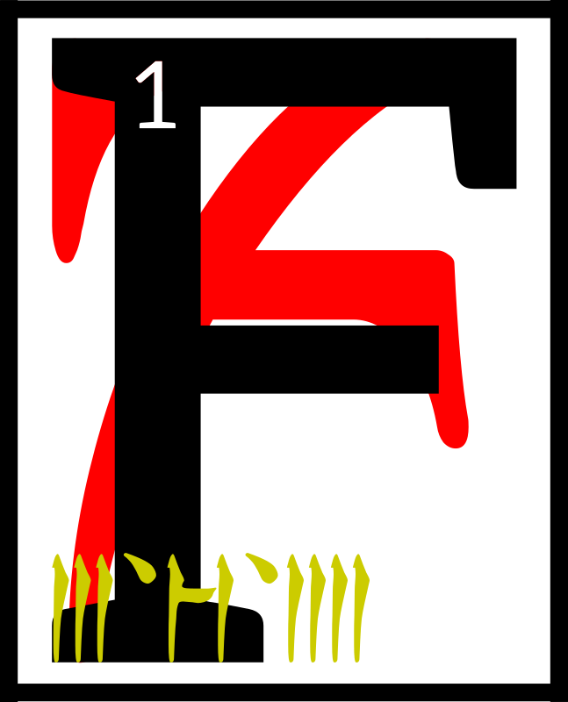
or these were the
days of Resdaynia,
when Chimer
and Dwemer lived
under the wise and
benevolent rule of
the ASV and their champion the Hortator, though the Dwemer had become foolish and challenged their masters.

2Out of their fortresses they came with golden ballistae that walked and mighty atronachs and things that spat flame and things that made killing songs. 3Their king was Dumac Dwarf-Orc, but their high priest was Kagrenac the Blighter.

4Under mountains and over them the war with the Dwemer was raged, and then came the northern men to help Kagrenac and they brought Ysmir again.

5Leading the armies of the Chimer was the slave that would not perish, the Hortator Nerevar, who had traded his axe for the Ethos Knife. 6He slew Dumac at Red Mountain and saw the heart bone for the first time.

7Men of brass destroyed the eleven gates of the Mourning Hold and behind them came the Dwemeri architects of tone. 8Ayem threw down her cloak and became the Face-Snaked Queen of the Three in One. 9Those that looked upon her were overcome by the meanings of the stars.

10Under the sea, Seht stirred and brought the army he
had been working on in the castles of glass and coral. 11Clockwork dreughs, mockeries of the Dwemeri war machines, rose up from the seas and took their counterparts back beneath, where they were swallowed forever by the sea.

12Red Mountain exploded as the Hortator went too far inside, seeking the Sharmat.

13Dwemeri high priest Kagrenac then revealed that which he had built in the image of Vivec. 14It was a walking star, which burnt the armies
of the Triune and destroyed
the heartland of Veloth, creating the Inner Sea.

15Each of the aspects of
the ASV then rose up together, combining as one, and showed the world the sixth path. 16Ayem took from the star
its fire, Seht took from it
its mystery, and Vehk took from it its feet,
The 36 Lessons

which had been constructed before the gift of Molag Bal
and destroyed in the manner
of truth: by a great hammering. 17When the soul of the Dwemer could walk no more, they were removed from this world.

18Resdaynia was no more.
It had been redeemed of
all the iniquities of the foolish.
19The ASV drew nets from the Beginning Place and captured
the ash of Red Mountain, which they knew was the Blight of
the Dwemer and that would serve only to infect the whole of the middle world, and ate it.

ALTADOON DUNMERI!

20The beginning of the words is

ASV

I give you this as Vivec.

SCARAB AE AURBEX



The New Man becomes God becomes Amaranth

neihn'dahrdii

The Avowalments

The Avowalments

leysha am as panthimerdohn
Mystery of the Apotheosis

hen the
Tribunal
mortals
reached
into the
center,
they ceased to be anything except for what they wished
to be. 2The axis erupted.
There was an exact cracking,
an instant of pure Aurbis, their hands burnt black by that ever-nil of static change, and the gods who had never been had always been. 3A whole universe swelled up to legitimize their throne, as the old universe, where the mortals still lapped up Godsblood, warped itself
to accept its new equivalent. 4And like all things magical
it simply could not happen, could not Be. Red Mountain was the intersection of the Is-Is Not as it was of old, its center point, and it did not hold. 5And so the Dragon, having broken, saw fit to heal, turning into the world you know. Except now the gods were alive before their own birth, which had, in fact,
really happened in the death
of the last universe.

6GHARTOK PADHOME AE
ALTADOON DUNMERI

The Tribunal gloriously usurped the worship of their Anticipations,
as was foretold in the words of Veloth.

7Earlier than Vehk were Ayem and Seht. They had supplanted in the orbit of the Chimeri soul those Daedra that predated them, Mephala and Boethiah and Azura respectively. 8None of them did this out of criminal intent. Rather, these beings were the Anticipations in the truest sense, the fore-images of the gods that would come for Morrowind. 9The gods hold
the original Triune in honor
as the bringers of difference and culture, and knowledge, and revere them as the harbingers of the glory of ASV. 10And never did we question their divinities or remove them from our holy books.

But as Vehk once spoke of the Rainmaker, the needs of the people change, and those that provide guidance to them must also change. 11While it may seem strange to imply that
the fore-images of the Tribunal, being Daedra, were adverse
to change, they were, and
they are. 12In this they are
very alike to the Aedra in their fundaments. 13While born of Padomay, they are of too much ego to give up their realms entirely, especially for altruism,
The Avowalments

which is perhaps what they most hate.

14And so from their basis did the Tribunal spring, called to heaven by violence, our people throwing our mantles to them across stars, and across time, and magic and dream, and here they remain.

khirye'ag shoreshiin
The Selected Teachings

of Vehk

he Psijic Endeavor
is the basis for the
teachings of the
Prophet Veloth,
founder of present
day Morrowind
and father of Dunmeri culture. 2Veloth describes the
Psijic Endeavor as a process
of glorious apotheosis, where
time itself is bent inward and outward into ‘a shape that is always new’. 3Those who can attain this state, called Chim, experience an ineffable sense
of the godhead, and escape the strictures of the world-egg.

4It should be noted that,
while Veloth is given credit
for establishing the anti-laws that govern the Endeavor,
this process has its antecedents in the teachings of the Black Hands Mephala, Boethiah, Azura, Trinimac, and, of course, Lorkhan, through that lord's association with PSJJJJ.

5Chim, from the Ehlnofex,
is an ancient sigil connoting ‘royalty’, ‘starlight’, and ‘high splendor’. As with most characters of that dangerous language, the sigil CHIM constantly distorts itself. 6Those scholars that can perceive its shape regard it as a Crowned Tower that threatens to break apart at the slightest break in concentration.

7Representations of the
Chim, and by extension the Psijic Endeavor, are always protean values, such as the anumidi models renowned
by the Dwemer, the Scarab of contemporary astrolothurges, and the Striking (“exact egg-cracking”) of old Argonia.
8All of these representations possess an innate and constant aspect of transformation.

9The purpose of the
Psijic Endeavor is to transcend mortal boundaries set in place by immortal rulers.
The Avowalments

10At its simplest, the state of Chim provides an escape from all known laws of the divine worlds and the corruptions of the black sea of Oblivion. 11It is a return to the first brush of Anu-Padomay, where stasis
and change created possibility. Moreso, it the essence needed
to hold that ‘dawning’ together without disaster. 12One that knows CHIM observes the Tower without fear. Moreso:
he resides within.

13The Tower is an ideal, which, in our world of myth and magic, means that it is so real that it becomes dangerous.
14It is the existence of the True Self within the Universal Self, and is embodied by the fourth constellation, and is guarded by the Thief, the third. 15The Thief is another metaphorical absolute; in this case, he represents the “taking of
the Tower” or, and sometimes more importantly, the “taking” of the Tower's secret: how to permanently exist beyond duplexity, antithesis, or trouble.

16This is not an easy concept,
I know. Imagine being able to feel with all of your senses the relentless alien terror that is God and your place in it, which is everywhere and therefore nowhere, and realizing that
it means the total dissolution
of your individuality into boundless being. 17Imagine that and then still being able to say “I”. The “I” is the Tower.

18The Wheel created the Tower. The Wheel is the structure of this universe, and it is easiest
to see it that way: rim, spokes, hub, and all the spaces within and without. I shall take each
in turn.

19Anu and Padomay, stasis and change, both vast realms sitting in the void, created the wheel. Not vast but infinite, as the void was infinite. 20Imagine
an infinity enclosed by another; you come away with a bubble. Now watch as the two bubbles touch. 21Their intersection is
a perfect circle of pattern and possibility that we shall call
the Aurbis. The Aurbis is the foundation of the Wheel.

22Outside the wheel is the void, bereft of anything. It cannot
be named. If it has more aspects than stasis and change, they
are outside of true language. 23Inside of the Wheel is
the Aurbis. As the process
of subcreation continued, both Anu and Padomay awakened. For to see your antithesis is
to finally awaken. 24Each gave birth to their souls, Anui-El and Sithis, and these souls regarded the Aurbis each in their own part, and from this came the et'Ada, the original patterns. These et'Ada eventually congealed.
The Avowalments

25Anu's firstborn, for he mostly desired order, was time, anon Auri-El. Padomay's firstborn went wandering from the start, changing as he went, and wanted no name but was branded with Lorkhan.
26As time allowed more and more patterns to individualize, Lorkhan watched the Aurbis shape itself and grew equally delighted and tired with each new shaping. 27As the gods and demons of the Aurbis erupted, the get of Padomay tried to leave it all behind for he wanted all of it and none of it all at once. It was then that
he came to the border of
the Aurbis.

28He saw the Tower, for a
circle turned sideways is an “I”.
This was the first word of Lorkhan and he would never, ever forget it.

29For ages the et'Ada grew
and shaped and destroyed
each other and destroyed each other's creations. 30Some were like Lorkhan and discovered the void outside of the Aurbis, though if some saw the Tower
I do not know, but I know that, if they did, none held it in such high esteem. 31In any case, some of those that did see
the void created its like inside the Aurbis, but each of these smaller voids sought each other out. 32Void shall follow void; the et'Ada called it Oblivion. 33What was left of the Aurbis was solid change, otherwise known as magic. The et'Ada called this Aetherius.

34Now Lorkhan had by at this point seen everything there was to see, and could accept none of it. 35Here were the et'Ada with their magic and their voids and everything
in between and he yearned
for the return to flux but at
the same time he could not
bear to lose his identity.
36He did not know what he wanted, but he knew how
to build it. 37Through trickery (“we have made the Aurbis unstable with the voids”)
and wisdom (“we are of two minds and so should make
a perfect gem of compromise”) and force (“do what I say,
rude spirit”), he bound some of the strongest et'Ada to create the World.

38The spokes of the Wheel are the eight gifts of the Aedra, sons and daughters of Aetherius. 39The voids between each spoke number sixteen,
and their masters are the sons and daughters of Oblivion.

40The center of the Wheel was another circle, the hub, which held everything together.
The et'Ada called this Mundus. 41We are the hub, the Mundus that goes by many names.
We are the heart of all creation.
The Avowalments

42What does this mean?
Why should we care? Lorkhan created it so that we could
find what he did. 43In fact, and
here is the secret: the hub is
the reflection of its creators, the circle within the circle, only the border to ours is so much easier to see. 44Stand in its flux and remain whole of mind. Look at it sideways and see the “I”.

This is the Tower.

45It relates to the Psijic Endeavor because from within one, you may regard the other.

46The world you stand on
is said to be the first attempt
at Chim. It is also admittedly the most famous. 47That it
was choreographed by Lorkhan
and ultimately failed is well-documented, but whether or not this failure was intentional is still disputed.

48And this is the most-reached destination of all that embark upon this road: Why would Lorkhan and his (unwitting?) agents sabotage their experiments with the Tower? Why would he crumble that which he esteems?

49Perhaps he failed so you might know how not to.

as telsan am aka'aduri
Hour of the Dragon Break

According to Vehk

he middle dawn
is an axis for
the spirits of the
Foretime. 2As such,
many of the beliefs
of the primitive
Psijics cannot be discounted; here, in this place, are proofs within proofs.
3Of special note is the Blue Star, which the Alesstics call “Mnemoli”, that runs through this part of the Aurbis
every untime.
4The Psijics hold it in much reverence, and many of their folk make pilgrimages to Veloth when it appears because a mountain there catches fire at its passing. 5This mountain is reputed to be one of the last refuges of the Dwemer before they departed from this world.

6And so to most, the middle dawn is little more than an undisputable and grandiose display of mystic power,
The Avowalments

which is to say nonsense, and few regard it as the numinous gateway that it really signifies. 7Like many things they cannot explain, the middle dawn is merely another excuse to declare good omens and portents, but unto you it should be known as the Hurling Disk, numbered seventeen.

8According to the texts, Mnemoli is a wayward child
of ANU, one of a pantheon of forgotten deities known as the “Star Orphans”, a tribe of gods and goddesses that apparently felt abandoned when the Sun withdrew from the World-Making. 9Like many of her siblings, Mnemoli is both confused and delighted with the Aurbis, 10and explores its five quarters as best she can without the help and regulation of worship, which are not needed (by which I mean, always there) during breakings of the sideways wheel.

11The Hurling Disk, it is conjectured, contains a strange mingling of magic from both the Solar and Lunar spheres. 12That singular rarity, coupled with the rarity of its presence within the world, has kept it from gaining a strong foothold in the schools of known sorcery. 13The Selectives claim a similar source of power in their depictions of the Right Reaching, but that has not deterred those magicians
which still try to fathom the meaning of the middle dawn and what benefits they may derive from that understanding. 14Perhaps it is the association of Mnemoli with the vanishing of sequential sensation (and,
by extension, the teeth-filled stare of the Alinor Dragon that comes thereafter) that drives seekers of arcane knowledge
to pledge their scholarship to the Aetherius 15rather than dealing with the esoteric teachings of my murder-brother SEHT or her many aspects, who loves the secret tower so much that she trucks with folk that first gave it legs, head, and sexual recepticle.

16One last note regarding the phenomenon of the middle dawn: it should be mentioned that at least one myth
(“the Blue Bone-Ring of Jyg”) suggests a relationship between Mnemolic sorcery and the
Void Ghost Eaters, the magic practiced in the countless Trickster cults scattered throughout the Tamri-El.

The Avowalments

mnem am so't'ha sil
The Memories of Sotha Sil

emories are
fleeting,
flawed, and
fragile.
So easily
overwritten
by emotion and prejudice.
2I cannot think of a more unregulated recording
of events, which is why
I commit my thoughts into
the unchanging metal of my sequence plaques. 3But even
the most objective view can
still hold bias, and words can only convey so much. 4The engravings on this plaque pale to the complexity of a simple human thought, with all the nuances and richness that even a common mind can hold.

5Lord Seht knows this. After all, his heart drives the Wheels Eternal, oiled and calibrated. This we know. 6To become that which is the only true name, which is not Name, one's mind must be polished. Synchronized. How to accomplish such a task? 7Even a god may become overburdened with the weight of emotions, fractured from
the whole which is logic.

8But in this too the Clockwork God was wise. He gave his memories form, manifestation. 9Glowing stars to make up
the galaxy of his thoughts. Tangible and real, far more
real than ink upon parchment, than words or whispers. 10Whole and perfect, and only able to be so from the strength of his divinity, his gleaming
and peerless mind which holds the true order of all.

11Memories are flawed, yes, but they are precious all the same. They hold our wisdom and knowledge, all that which
we are. 12To give them away would be squandering that gift, and this too Lord Seht knew.
13So he preserved these precious thoughts,
locked safely with his Mnemonic Planisphere. Watched over by the ever-silent Astronomer.
14A multitude of stars which
no longer held emotional sway over him, no, but still remained connected, known.

15It's quiet in the Planisphere, but one hears whispers.
A low hum of voices seem to echo within the halls.
16Those figures of the past, lost but not forgotten, come to light once more.

The Avowalments

sild kol as bal'huloakam
The Post at the Turning Point

maranth anon
Anew AE I,

which is said to
have occupied the
passageways of
heaven and earth, because everyone above and below asks Amaranth anon Anew AE I if they cannot find the passage, 2Amaranth anon Anew AE I is the Godhead who caused to be visible. 3Amaranth anon Anew AE I stands as a post at the
turning point.

4The others say of Amaranth anon Anew AE I the post:

“The one and one
(an inelegant number)
who crosses the middle of
the Z Centerex without calm, may his name be I and
no other, for he takes up
the center of it in sleep.”

5“The path of the stars of the sky should be kept unchanged but
will not, for he dreams in the sun and now has dreamed of orphans, anon Magne-Ge, the colors he still wishes to dream.”

molhi'ag daelshokhthi
The Obscured Loveletter

tell you now,
brothers and
sisters of the
coming forth,
that the holy
Scripture of Love
contains all you need to avoid the perils of the Landfall.
2This warning is given freely and by Love. Sermon 35 begins properly:

3“The formulas of proper Velothi magic continue in ancient tradition, but that virility is dead, by which
I mean at least
replaced. 4Truth owes
its medicinal nature to the establishment of the myth of justice. 5Its curative properties it likewise owes to the concept of sacrifice. Princes, chiefs, and angels all subscribe to the same notion. 6This is a view primarily based on a prolific abolition of an implied profanity, seen
in ceremonies, knife fighting, hunting, and the exploration of the poetic.
The Avowalments

7On the ritual of occasions, which comes to us from the days of the cave glow,
I can say nothing more than
to loosen your equation of moods to lunar currency.”

8In this passage, he describes the goal of the Lunar God,
who some of you still ascribe the name “Lorkhan”.
9When stabilized, the words become proof:

All creation is subgradient. 10First was Void, which became split by AE. Anu and Padomay came next and with their first brush came the Aurbis.

11Void to Aurbis:
naught to pattern.

12“Later, and by that I mean
much, much later, my reign will be seen as an act of the highest love, which is a return from the astral destiny and the marriages between. 13By that I mean the catastrophes, which will come from all
five corners. Subsequent are the revisions, differentiated between hope and the distraught, situations that are only required by the periodic death of the immutable. 14Cosmic time is repeated: I wrote of this in an
earlier life. An imitation
of submersion is love's premonition, its folly into the underworld, by which I mean the day you will read about outside of yourself in an age of gold. 15For on that day, which is a shadow of the sacrificial concept, all history is obliged to see me for what you are: in love with evil.”

16The marriages of the Aether describe the birth of all magic. The Aurbis exploded with
its surplus. Will formed and,
with it, the Potential to Action. 17This is the advent of mantellian, mnemolia, the aetherial realm of the et'Ada. 18The Head of this order is Magnus, but he is not its Ward, for even he was subcreated by the birth of Auri-El.

19Aurbis to Aetherius:
possibility to maintenance by time.

20“To keep one's powers intact at such a stage is to allow for the existence of what can only be called
a continual spirit.
21Make of your love
a defense against the horizon. Pure existence is only granted to the holy, which comes in a myriad of forms, half of them frightening and the other half divided into equal parts purposeless and assured.
The Avowalments

22Late is the lover
that comes to this by any other walking way than the fifth, which is the number of the limit of
this world. 23The lover is the highest country and
a series of beliefs. He is
the sacred city bereft of
a double. The uncultivated land of monsters is
the rule. 24This is clearly attested by ANU and his double, which love knows never really happened.”

25Lull calls this a refutation
of sorts, but the wise may know it as the first appearance of
Nu-Mantia, which is Liberty. Rather, the road to Liberty.

26Another subcreation happened to the wheels of
the et'Ada, a shore that all of creation crashed against, the terminus of limits known as Oblivion. 27An echo of the Void before but unalike, many spirits fled here and came to power
by merely harnessing the impossibility of Limit+All.

28Aetherius to Oblivion:
creation to destruction.

29“Similarly, all the other symbols of absolute reality are ancient ideas ready for their graves, or at least
the essence of such.
30This scripture is directly ordered by the codes of Mephala, the origin of sex and murder, defeated only by those who take up those ideas without
my intervention.
31The religious elite
is not a tendency or
a correlation. They are dogma complemented by the influence of the untrustworthy sea and the governance of the stars, dominated at the center
by the sword, which is nothing without a victim to cleave unto. 32This is the love of God and he would show you more: predatory but at the same time instrumental to the will of critical harvest,
a scenario by which one becomes as he is, of male and female, the magic hermaphrodite.”

33We begin to see the first inkling of emergence, which
by its nature requires the merging of two-fold powers. 34Inevitably, this leads to another gradient, but this time by forceful process: the Trap of the Lunar God. 35The Aedra are Named at this time, having lent their hands to what was to be the arena of the eternally impossible: Mundus,
or Exactness.

36Oblivion to Mundus:
debris of all possibility to anchor of all things.
The Avowalments

37“Mark the norms of violence and it barely registers, suspended as
it is by treaties written between the original spirits.”

38When one visits Memory,
you become filled with the first ideas of the Lunar God, and
see the trap within the trap. 39Vehk knows it at this point, and sees for all of you, and realizes the need for treaty: avenue of escape, first stone.

40If all previous gradients continue along this path, especially given that there is now a centerpoint, impossible Mundus, the process of continuation can be
pre-figured.

41The echo of the Void is Oblivion. The echo of Oblivion is now mortal death. Death results in reappropriation of spirit towards its aligned AE
—either to the god-planet
Aedra or the Principalities of Oblivion. 42Vehk's name for this transaction, mentioned above, is “lunar currency”.

43AE CHIM
NU'MEN NU'MANTIA

Mundus to Mortal Death:
centerpoint to the soon recycled.

44“This should be
seen as an opportunity, and in no way tedious, though some will give up for it is easier to kiss the lover than become one.”

45Here we come to the Scripture's greatest resignation: to imagine the subcreation
after mortal death, which
by pattern would mean an
echo of Mundus, and through this imagining, the failures of
so many.

46Record of the Lunar God's involvement in all of this
is called the Great Pain:
“The Lunar God failed by his own devices, to show the new progeny how they might not.”

47You in the current era have already witnessed many of
the attempts at reaching the final subgradient of all AE, that
state that exists beyond mortal death. 48The Numidium. The Endeavor. The Prolix Tower. CHIM. The Enantiomorph.
The Scarab that Transforms into the New Man.

49Simply put, as the Gods cannot know joy as mortals, their creation, so mortals
may only understand the joy
of Liberty by becoming the progenitors of the models
that can make the jump
past mortal death.
The Avowalments

And so many of you give up.

50Mortal Death to Z,
the state-gradient echo of Mundus Centerex.

51“The lower regions
crawl with these souls, caves of shallow treasures, meeting in places to testify by way of extension, when love is only satisfied by a considerable (incalculable) effort.”

52Those who do not fail
become the New Men: an individual beyond all AE, unerased and all-being. 53Jumping beyond the
last bridge of all existence
is the Last Existence,
The Eternal I.

54I AM.

A whole World of You.

God.

55God outside of all else
but his own free consciousness, hallucinating for eternity
and falling into love:

I AM AND I ARE ALL WE.

56A subject in sensory deprivation begins to hallucinate after only twenty minutes. Scale
unto this along the magical spectrum and maintenance
of time, which is forever,
and you begin to see the Lunar God's failure as Greatest Gift.

57As above, “This is the love of God.”

Why Love?

Know Love to avoid the Landfall, my brothers
and sisters.

58The New Man becomes God becomes Amaranth, everlasting hypnogogic. 59Hallucinations become lucid under His eye
and therefore, like all parents of their children, the Amaranth cherishes and adores all that is come from Him.

60I ARE ALL WE.

God is Love.

61COME TO THE HOUSE
OF WE.

God is Love.

62ONE WORLD IN SPIRIT
I AM.

God is Love.

The Avowalments

bihn'shokil am provicithuhn
The Prophet of Landfall

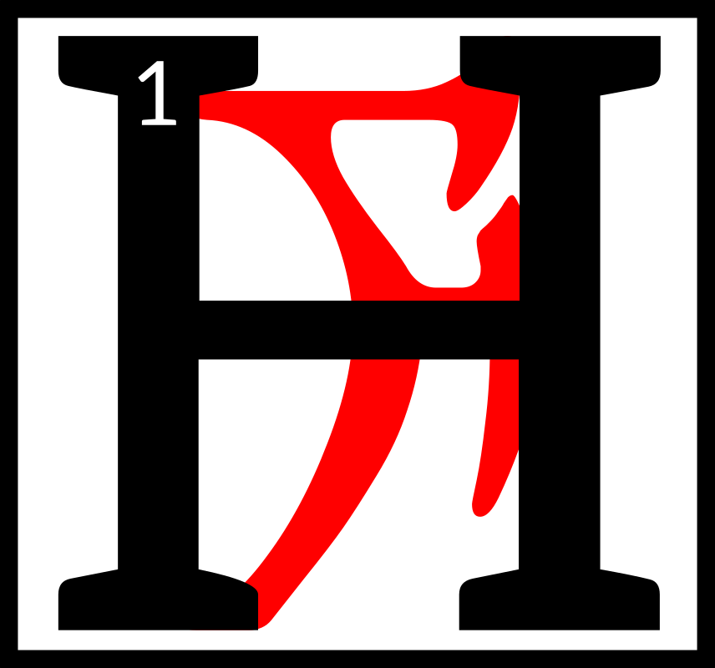
e has come
down from
the mountains,
the chitin of his
belly segments
freshly painted
in Faith. 2The suns shine overhead, each uttering his name in their way.

3The barrens before him distort in the blur of their heat as he climbs the last hill, but his vision is clear. It always has been. 4His fifth and second arms encircle his staff as his mandibles click out a small prayer. 5Beyond the barrens lay the Crescent of the Eighty and One Thrones, and all the villages that hang from it like
a jeweled belt.

6They do not know it yet,
those millions that work, rule, and commit their countless sins out there in the cradle of
all written history, but he
will save them. 7In ones and twos, then in droves, and then their own priests and their own kings will throw down their false idols and take up the
New Faith.

8He would permit himself some pride if that emotion occurred to him; 9instead, he tests
his locust wings on the wind, permitting himself to glide
into the first steps of Salvation.

amaranth
The Amaranth

The Last Sermon

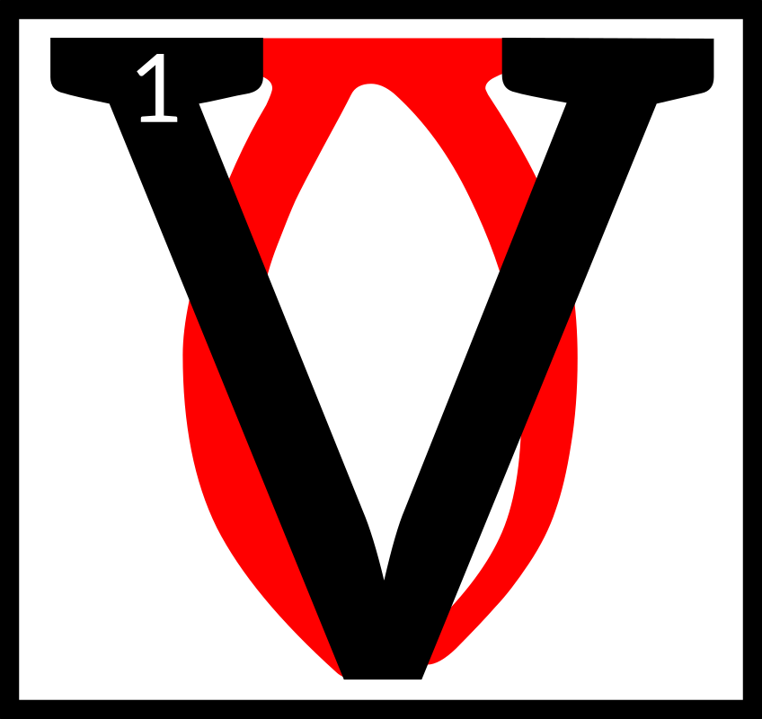
ivec was borne
by ribbons of
water, which
wrote their
starward
couplings in red.
This was a new place of speed. 2His eyes broke on the spikes above the tower, where the Void Ghost squatted over a drake-scaled drum, imbecile in its rhythm. 3And he asked of it:

“Who are you, that need no signature at all?”

4Three in sum, the robes of Ayem stretched towards the bright black rim of memory, roping an arc of purchase.
The Avowalments

This was a new sprinting task. 5And Seht held his swollen belly to its name, clockmaker's daughter, swimming the dead confession along a century of thread, 6Naming her, uneaten,
a golden cache of Veloth and Velothi, for where else would they know to go?

7“Go here: world without wheel, charting zero deaths, and echoes singing,”

Seht said, until all of it was done, and in the center was anything whatever.

8And the red moment became
a great howling unchecked,
for the Provisional House was in ruin. 9And Vivec became
as glass, a lamp, for the dragon's mane had broke, and the
red moon bade him come.

10“The sign of royalty is not this,” a signal blueshift told him, “There is no right lesson learned alone.”

11He refused the twine on her catching net, spiteful that
an uncontinued people would not become fuller by their searching, and yet were wracked in their spirits for flight. 12But the male signals were offended, and Vivec took a fighting form. 13He undid his eastern light, saying to the ASV that through war, they had become brides in glass,
which no power could observe.

14The light bent, and Vivec donned a cuirass made of
red plates of jewel, and a mask that marked him born in the lands of Man. 15Wheeling, he spread into an insect salve, worn on the neck of hist-bulbs when at challenge. 16He roared up and fed his fingers to mammoth ghosts.

The signal fires wondered if they mistook this for surrender, for Vivec had told the void that he could learn to undo it all.

17The light bent, and somewhere a history was finally undone. 18Of it, Vivec remembered the laughing of the netchimen of his village when the hunts were good.
19He marched with his father
in the ash, growing strong in the hooks and sail, able to run
a junk through silt.
20At eleven, he sung to an ashkhan. He became sick
after Red Mountain, with
the nix-blood and fever, and was infirm a hundred years.
21His mother survived him
and laid his body at the altar
of Padomay. She gave him
her skin to wear into the underworld.

22The light bent, and Vivec awoke and grew fangs, unwilling to make of herself
a folding thing.
The Avowalments

This was a new and lunar promise. 23And in her Biting she tunneled up and then downward, while her brother and sister smeared across heaven, thin ruptures
of dissent, food for scarabs
and the Worm.

24She took her people and made them safe, and sat with Azura drawing her own husband's likeness in the dirt.

25“For I have removed
my left hand and my right, he will say,” she said,
“for that is how I shall
win against them.
26Love alone and
you shall know only
mistakes of salt.”

27The worlding of the words is

AMARANTH

almees en medelel

Breviary and Appendix
bahrgui dun

ald ahduhna enshik
g
v
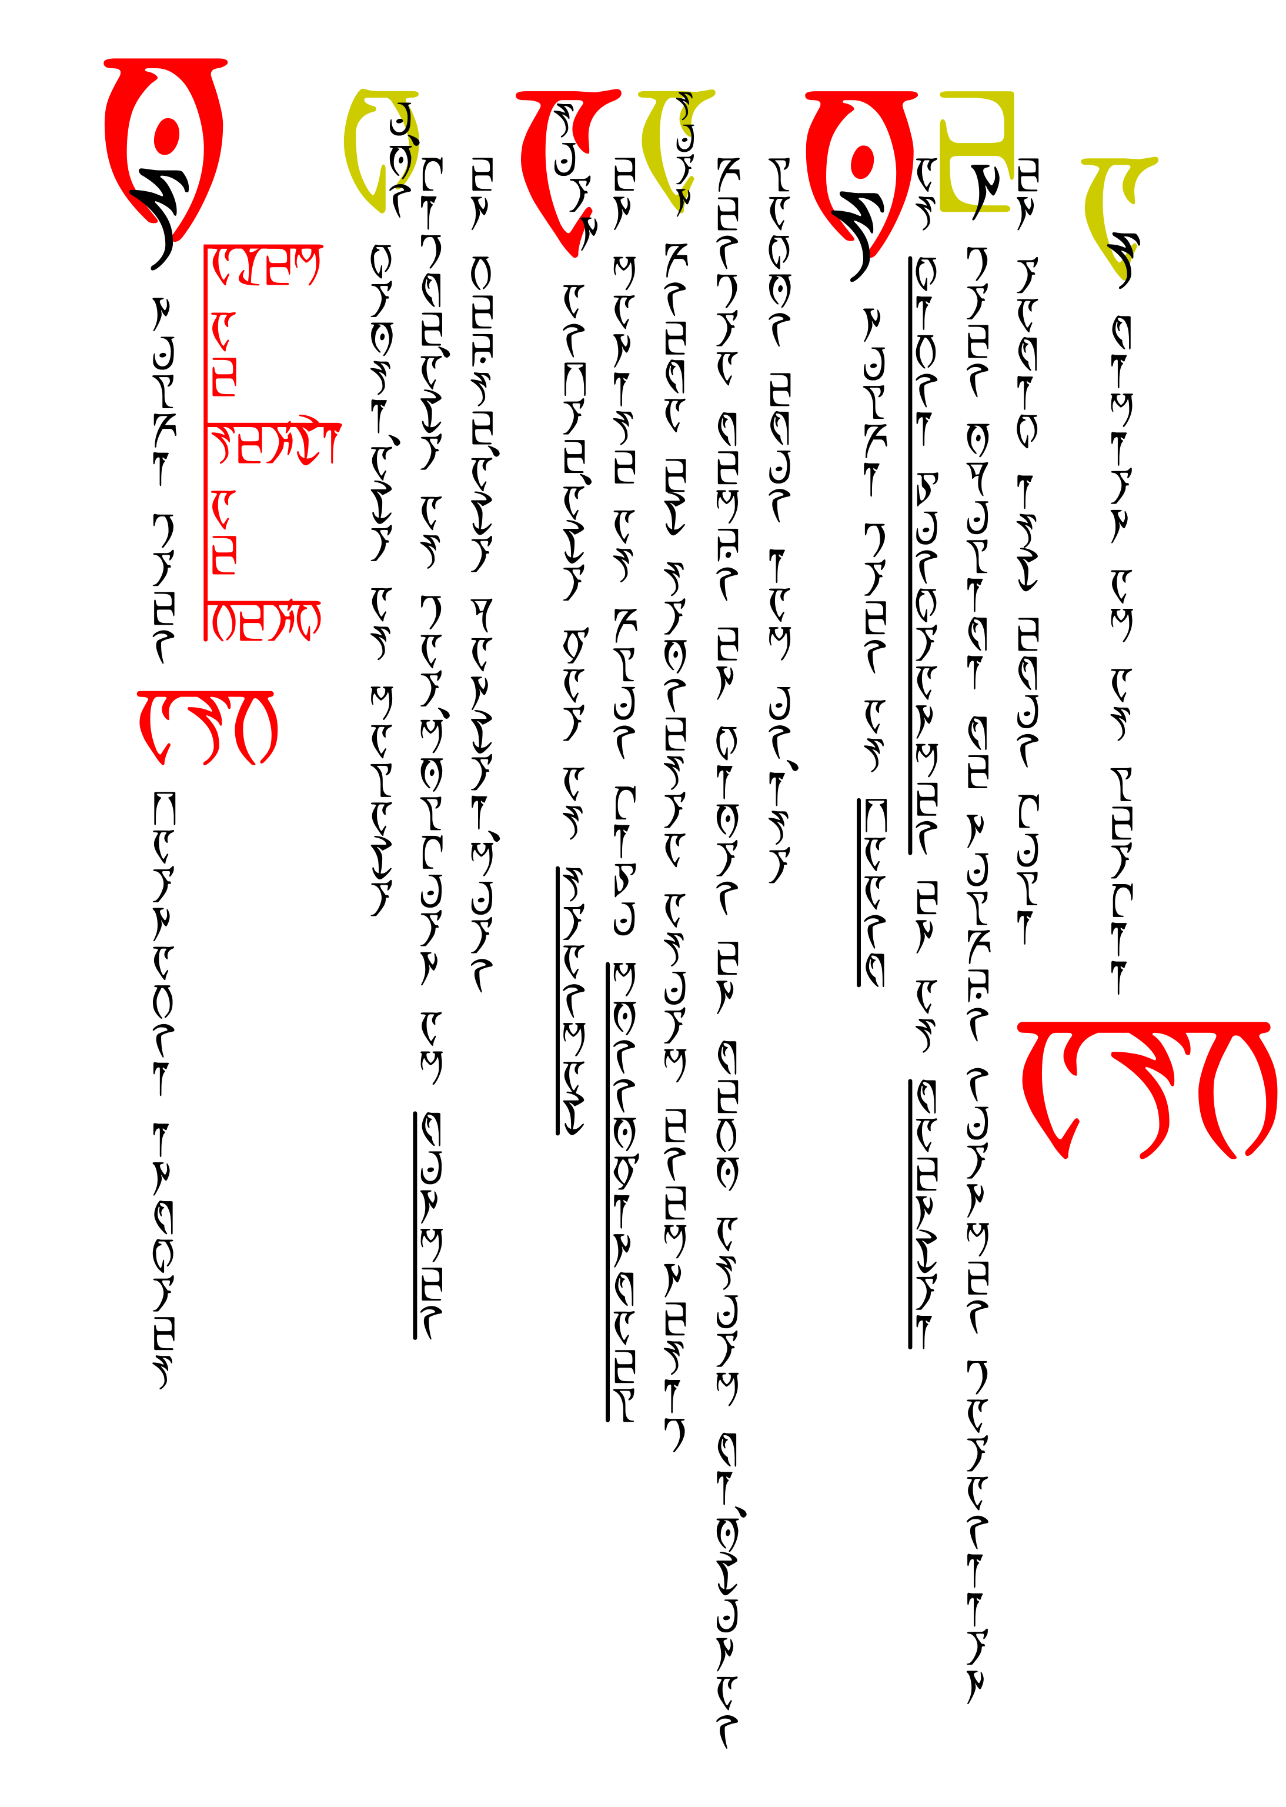
bahrgui dun

AYEM AE SEHTI AE VEHK
ASV
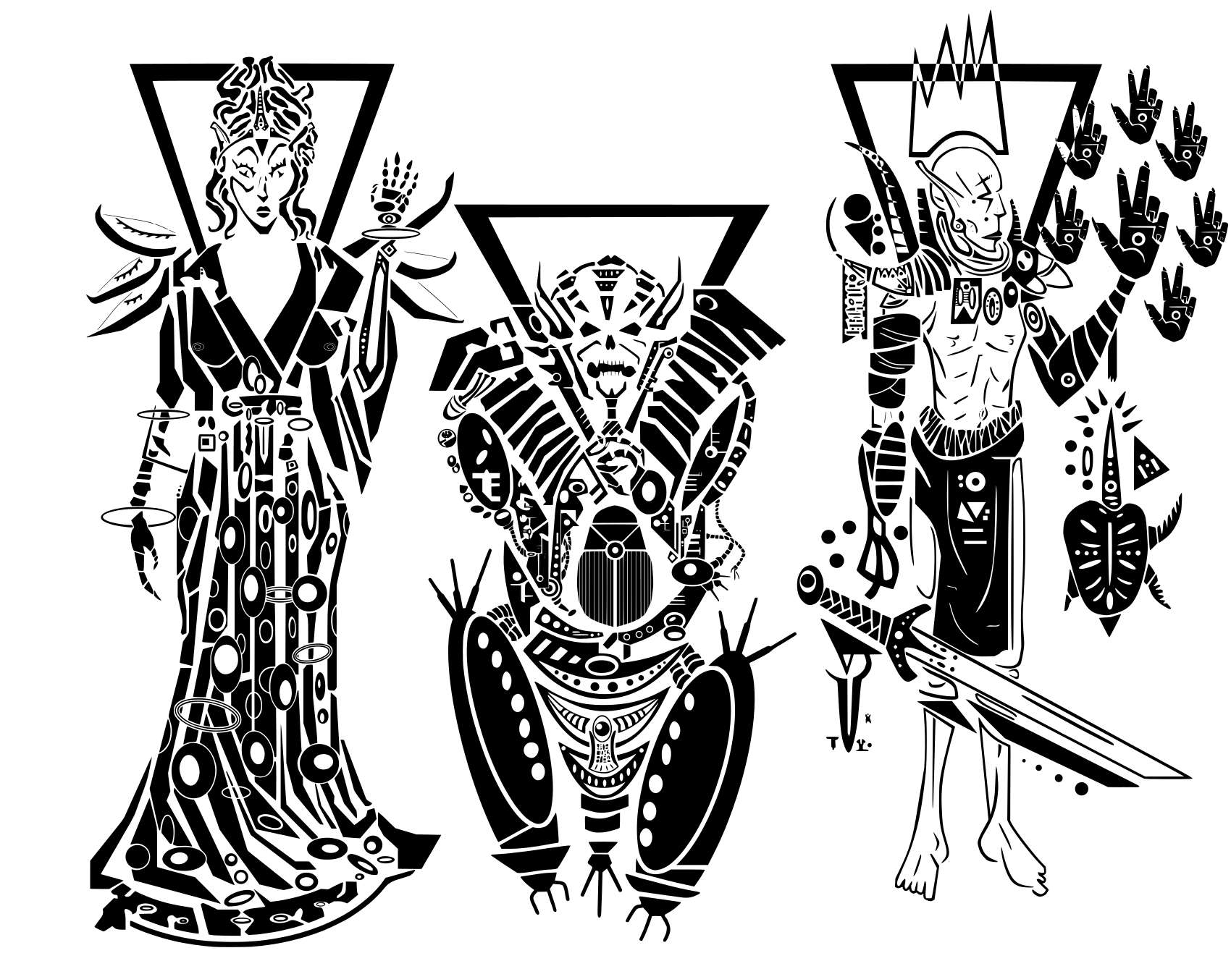
a
s ald panthiihr abahr mal'scutif en bahrhadot
k
hostif devehr as vamidii en beshvii am mer
o
suhm telsad edur po'tosh suhn adur as hagil panthiihr
a
m
e
uhrhe'ag am as aln'muhr n opumelu en ihasmikam

am as ur'iish am iam mer
Temple Oath

AYEM AE SEHTI AE VEHK

ASV
The old gods were cruel and arbitrary,
distant from the hopes and fears of mer.
Their age is past. We are the new gods,
born of the flesh, and wise and caring
of the needs of our people.
Temple Oath

The Old Pilgrim's Oath

I believe in ASV, Triune Grace:

AYEM AE SEHTI AE VEHK

Who walked the earth,
defeated the Dunmer’s greatest enemies,
and achieved divine substance.

They drove out the Sharmat
and maintain the peace of Morrowind.
They guard and counsel their followers,
punish sin and error, and share their bounty,
according to our needs.

I believe in the Ancestors,
the Host of Saints, the Temple,
And in duty to faith, family, masters
and all that is good.

The ending of the words, ASV
Breviary

Prayers of Praise

The Seven-Syllable Spell

AYEM AE SEHTI AE VEHK

We are delivered and made whole.

The Seven-Syllable Spell (Alternate)

Blessed ASV, Triune Grace:
We are delivered and made whole;
In you is an image
And a seven-syllable spell
Which we will repeat
Until the mystery comes:

AYEM AE SEHTI AE VEHK
AYEM AE SEHTI AE VEHK
AYEM AE SEHTI AE VEHK

The ending of the words, ASV

Devotion to Almalexia

Ayem who is Boethiah,
Splendor of the stars,
Mother of mercy:
We wear the skin of Trinimac
And you cleanse our faults
With the faults of Veloth;
So shall we be lead by you
Down the way of the glorious.

The ending of the words, ASV
Breviary

Prayers of Praise

Devotion to Sotha Sil

Seht who is Azura:
Light of knowledge,
You protect the lost
And fill the roads and alleys
With the mystery paths of civilization;
You give the citizens a mind.
So shall we become as a conduit
To the fullness of your concentrate.

The ending of the words, ASV

Devotion to Vivec

Vehk who is Mephala:
Cutter of the weeds of Veloth,
You speak to us of the world
Which you share with mystery and love,
For you have crushed it with your left hand
But in your right is how it could have won against you;
For that which you give us is but an intermittent hope,
So shall we be letters written in uncertainty.

The ending of the words, ASV
Breviary

Prayers of Praise

Canticle of the Missing God

Remember the words of Boethiah:

We pledge ourselves to thee,
The Frame-maker, the Scarab:
A world for us to love thee in,
A cloak of dirt to cherish.

Betrayed by thy ancestors
When thou werest not looking,
Hoary Magnus and his ventured opinions
Cannot sway the understated,
A trick worthy of the always satisfied.

A short season of towers,
A rundown absolution,
And what is this, what is this
But fire under thy eyelid?

Shift ye in your skin,
I say to the Trinimac-eaters,
And pitch ye in your voices
To the color of bruise.

Divide ye like your enemies,
Each into Houses,
And lay ye down your laws,
In set sequence from the center,
Alike the enemy Corners of Troubles,
And see yourselves thence as timber,
Or mud-slats, or sheets of resin.
Breviary

Prayers of Praise

Then do not ye divide,
For yet is the stride of Sithis
Quicker than the rush of enemies,
And He will sunder the whole
For the sake of a shingle.

For we go different, and in thunder
While Sithis is the start of all true Houses,
Built against stasis and lazy slaves.

So turn ye from your predilections,
Broken like false maps
And Move ye and move like this
To quicken against false fathers,
And mothers left in corners
Weeping for glass and rain.

Stasis asks merely for nothing,
For itself, which is nothing,
As you were
In the eight everlasting imperfections

AE HERMA MORA ALTADOON
PADHOME LKHAN AE AI
Breviary

Prayers of Praise

The Ruhn Ania

The homes that sprawl and crouch

AYEM AE SEHTI AE VEHK

The homes that burrow and delve

AYEM AE SEHTI AE VEHK

The homes that soar and sway

AYEM AE SEHTI AE VEHK

The homes that stand and pose

AYEM AE SEHTI AE VEHK

The homes that swim and wade

AYEM AE SEHTI AE VEHK

And you shall come home

To ASV
Breviary

Prayers of Petition

The Mercy Prayer

(anointing with ash or salts)

The fire is mine,
Let it consume thee,
And make a secret door
At the altar of Padhome,
In the House of Boethiah
Where we become safe
And looked after.

The ending of the words, ASV

Prayer for Forgiveness

Blessed ASV,
Hear your faithful child,
For I am lost and far from your Grace.

Almalexia, grant me your mercy.
Sotha Sil, light my path.
Vivec, guide my pen and my blade.

Allow me respite from my torment,
And forgive me my sins.

The ending of the words, ASV
Breviary

Prayers of Petition

Healing Blessing

Blessed ASV,
We ask for your forgiveness.
Purge the sins from this one
And set them on the Triune Path.

The ending of the words, ASV

The Seven Graces

May we heed the Seven Graces, seven times and seven ways.

By Valor may we face our enemies and our fears.
By Daring may we find fortune in bold risk.
By Justice may we deal fairly, in love, trust, and respect.
By Courtesy may our temperate words turn aside anger.
By Pride may we insist upon our ancient rights.
By Generosity may we share freely among house and hearth.
By Humility may we know our place in the greater world.

May we forge a keen Faith in the crucible of suffering
And Engrave upon one’s eye the image of injustice,
For it is better to suffer a wrong than to do one.
Let us then yield to Faith for Faith conquers all,
And death does not diminish, but gilds with glory.

The ending of the words, ASV
Breviary

Prayers of Petition

Prayer for Guidance

Mother, Tinkerer, Poet,
Form us into vessels of thy will.
Guide us on the straight path,
Wherever it might lead us,
That we may never falter from it.

We ask for forgiveness for our sins
And failures to follow thy precepts.
We are all but mortal
And so are doomed to fail,
But help us to mitigate
The necessary effects of our frailty.

The ending of the words, ASV

Prayers at Dawn

Daybreak Troparion

Glory to Ayem, glory to Seht, glory to Vehk.,
From my sleep and my dreams
You have beckoned me.
Illumine my mind and my soul,
And unshackle my lips,
That I may praise you, my Triune,
Both now and ever, and unto all the eras.

The ending of the words, ASV
Breviary

Prayers at Dawn

Morning Grace

Mercy, Mystery, Mastery,
Bless this day before me;
Grant that I may walk with virtue,
And for all that I profit
May it be by your bounty
Shared with grace unto me.

The ending of the words, ASV

The Hagil-Dayn

O Blessed ASV, Three-in-One,
The Opinions of Magnus tear at the dark,
Like a ghost that vanishes at first light.
We are sundered from our sleep
Into a world for us to love you in,
A cloak of dirt for us to cherish.

O Blessed ASV, through birth, ghost, life,
You speak to us of the world,
Which you share with mystery and love.
By your duty do you keep the Compromise
From being filled with Black Sea.
If you are for us, who can stand against us?

O Blessed ASV, Mercy, Mystery, Mastery,
May we walk this day ever in your presence
To accept your grace without limits.
By Three Hands, Three Hearts, and Three Eyes,
We shall forge Darkness into Light
And keep your holy names in every hour.

The ending of the words, ASV
Breviary

Prayers at Dusk

The Pilgrim’s Path

The waking world
Is the amnesia of dream.
You show us the ways to walk
To achieve an exodus,
For wherever so you tread
There is invisible scripture.
So we follow your paths,
And walk with virtue.

The ending of the words, ASV

The Gah-Yalalt

Glory to Ayem, glory to Seht, glory to Vehk.
Thank you, O my Lords, for your protection this day.
Ordeals you should have us face, yes,
But not impeded by the world of restriction.

All praise and wonder be unto you, my Tribunes:
The splendor of stars is Ayem’s domain.
The selfishness of the sea is Seht’s.
Vehk rules the middle air.
All else is earth and under temporal command.

In your wisdom, O my Lords, cut me into better shapes,
And polish me into a perfect gem of compromise.
Cleanse me of my faults and by your hand
I shall arise well and ready to walk your ways,
For I am happy to serve you and win.

The ending of the words, ASV
Breviary

Prayers at Dusk

Waiting Door Vesper

Not into the world, nor out of it,
But between worlds do they linger,
The blessed souls of our dead,
Held to the hearth and tomb
By blood and by loyalty.

All souls know deep down
From whence we originally came,
And how Nirn is cruel
And a crucial step to the Next.

The Ancestors are not departed.
The dead are not under the earth.
Their spirits are in the restless wind,
In the fire’s voice,
In the foot-smoothed step.

We do not grieve for the dead.
We take shelter in their arms,
And pay heed to their words.

From the Waiting Door comes our protection.
We heed the spirits,
Who are the guardians of our hearth,
The teachers of wisdom,
The counselors of fortune,
And the seers of fate.

We live in one world with our spirits.
We shall honor them
Within and without ourselves.

The ending of the words, ASV
Breviary

Prayers for the Dead

The Lorne’ag Duru

In you I know my nature.
In you I have total consolation.
In you I find great peace.
My bones shall be in the foundations of the City.
Now I am become the mightiest of your children.

ALTADOON DUNMERI

The Stirring Repose

Beloved Velothi,
Your skin has become the pregnant darkness.
My brooding has brought this on.

Remember what Boethiah asked:
To become the color of bruise.
How else to show yourselves,
The people of the exodus,
Into the vital: through pain?

In the end, rejoice O Beloved,
As a hostage released
From drumming torment
But that savors their wounds.

The drum breaks open
And you find it to be a nest of hornets,
Which is to say
That your sleep is over.

The beginning of the words, ASV
Breviary

Prayers for the Dead

The Sunna Amaranthi

They add new doors to me
And I become effortlessly trans-immortal
With the comings and goings
And the stride-heat of the market
Where I am traded for.

Yell of the children—hear them play,
Scoffed at, amused, desired,
Paid for in native coin,
New minted with my face on one side
And my city-body on the other.

I stare with each new window.
Soon I am a million-eyed insect dreaming.

AE CHIM NU'MEN NU'MANTIA

The beginning of the words, ASV

Shrine Song

Release our beloved
From this mortal plane,
To return to the ash
From whence we came.

At rest with the spirits,
Their glory to claim.
Their bones do we covet
‘Til rest we attain.
Breviary

Prayers for the Dead

Blessing for the Tomb

We pay reverence to the dead
Through gift and prayer.
We acquaint our ancestors with our affairs,
With our comings and goings,
And with our trials and blessings.

We live in one world with them,
Banishing our feeble ghosts
And giving their memory new life
Through the thrice-folded mind.
We follow the footsteps of the gods,
Treading upon invisible scripture
Towards that state beyond mortal death.

But if the spirits of the dead
Should come back to us unbidden,
From the love of kin or faith to duty,
It is but the answering of those ancestors,
Bound through hearth and house
To the ultimate protection of the clan.

Unto these protectors of our homes
Is the solemn duty to inter them rightly,
That they might draw comfort together
Against the chill of the mortal world,
Whilst they ready to jump that last bridge.

The ending of the words, ASV

Appendix

The Daedric Script

Ayem | Bedt | Cess | Doht | Ekem | Hefed | Geth
A | B | C | d | E | F | G
A | B | C | D | E | F | G

Hekem | Iya | Jeb | Koht | Lyr | Meht | Neht
H | I | J | K | L | M | N
H | I | J | K | L | M | N

Oht | Payem | Quam | Roht | Seht | Tayem | Yoodt
O | P | Q | R | S | T | U
O | P | Q | R | S | T | U

 | Vehk | Web | Xayah | Yahkem | Zyr
 | V | W | X | y | Z
 | V | W | X | Y | Z

Bahr | Aln | Asc | Cahn | Cin | Arc
0 | 1 | 2 | 3 | 4 | 5
0 | 1 | 2 | 3 | 4 | 5

 | Tahn | Sahn | Daskhor | Ent | Alnahn
 | 6 | 7 | 8 | 9 | 1'0
 | 6 | 7 | 8 | 9 | 10

Appendix

Map of Tamri-El
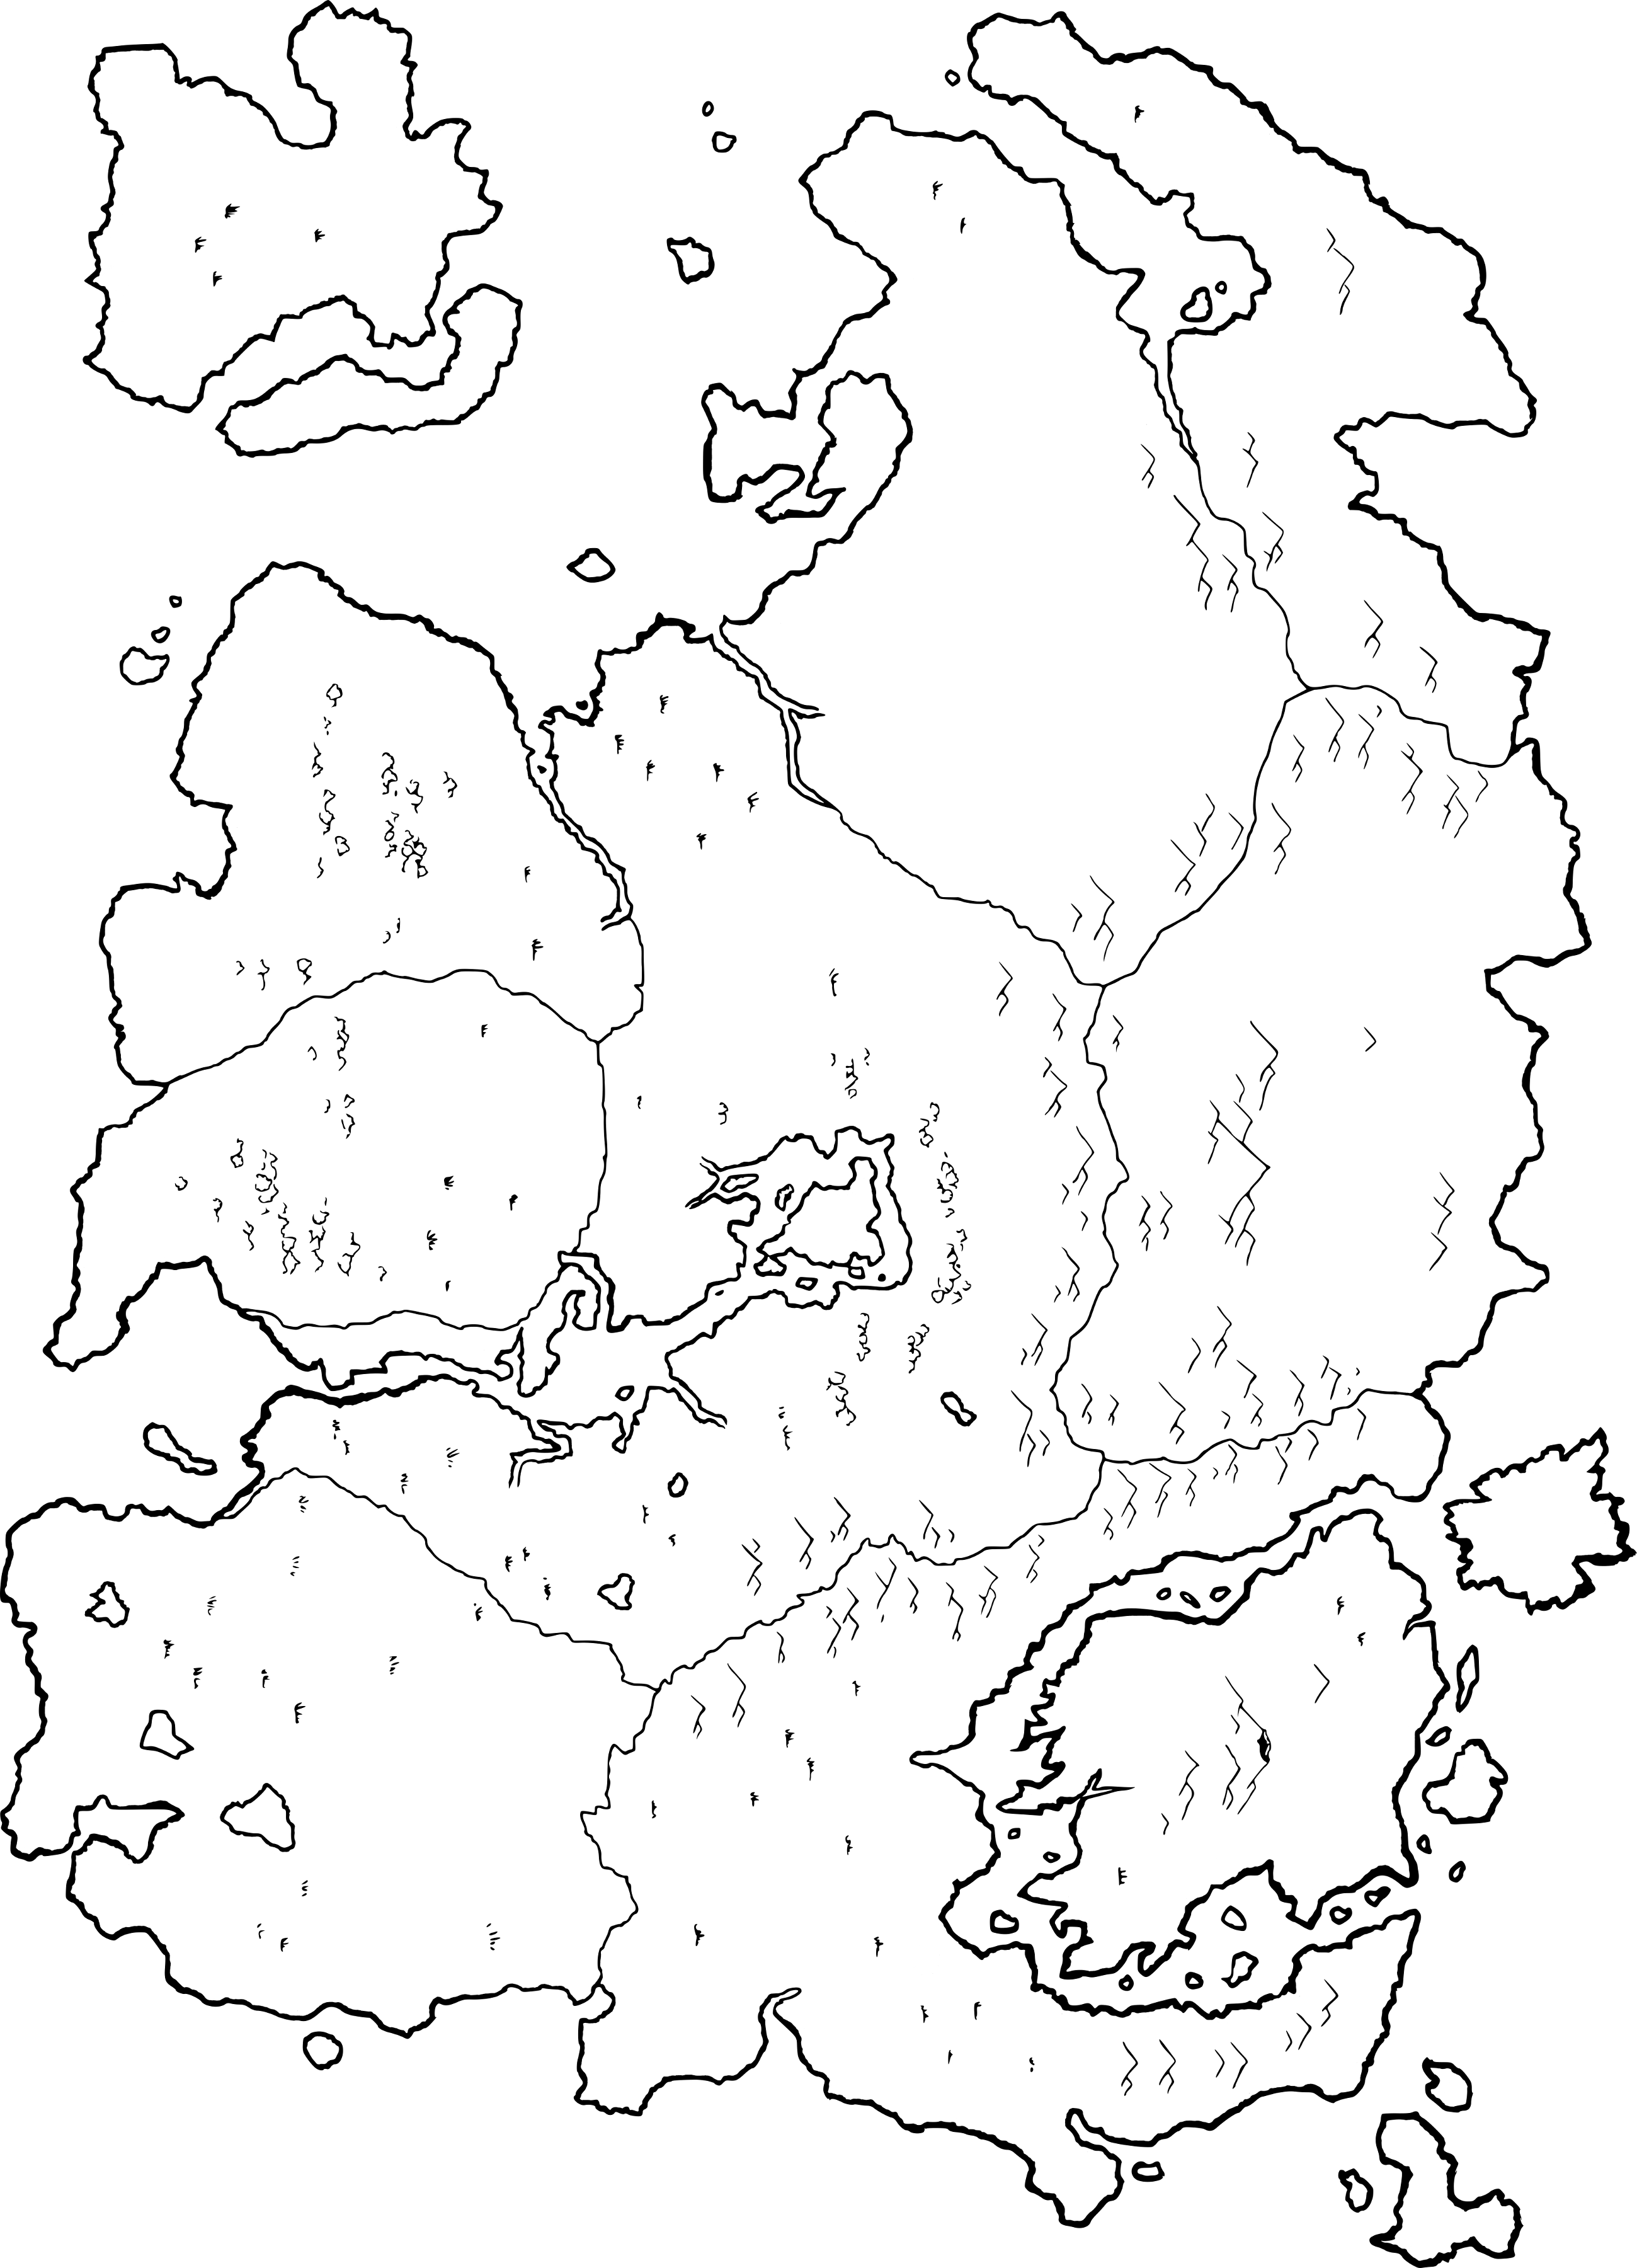
Summerset
High Rock
Hammerfell
Valenwood
Skyrim
Cyrodiil
Elsweyr
Black Marsh
Morrowind
Appendix

Map of Morrowind
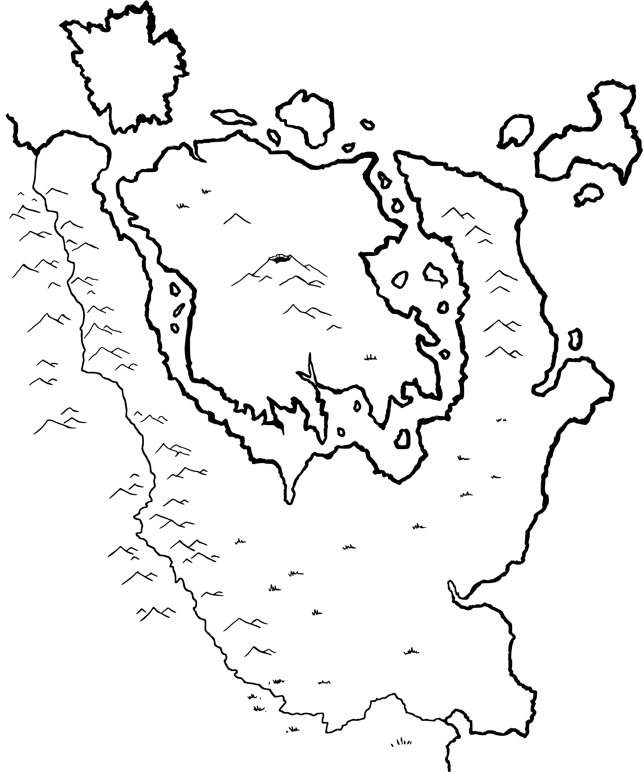
⬤
⬤
⬤
⬤
⬤
⬤
⬤
⬤
⬤
⬤
⬤
⬤
⬤
⬤
⬤
⬤
⬤
⬤
⬤
⬤
Port
Telvannis
Firewatch
Dagon Fel
Vos
Sadrith
Mora
Raven Rock
Maar Gan
Gnisis
Blacklight
Necrom
Akamora
Mournhold
Old
Ebonheart
Vivec
Andothren
Ald-Ruhn
Balmora
Kragenmoor
Narsis
Tear
Morrowind is holy country, the land of wealth beyond measure, and its gods are flesh and blood. Here the fell winds bellow out from the flamefrosted ravines of the Red Mountain, carrying with them eternal and memorious ashes which burn and blister, but like the dust of moths, can induce visions that grant access to the numinous world of dreams and long-dead memories.
Appendix

The World-Egg

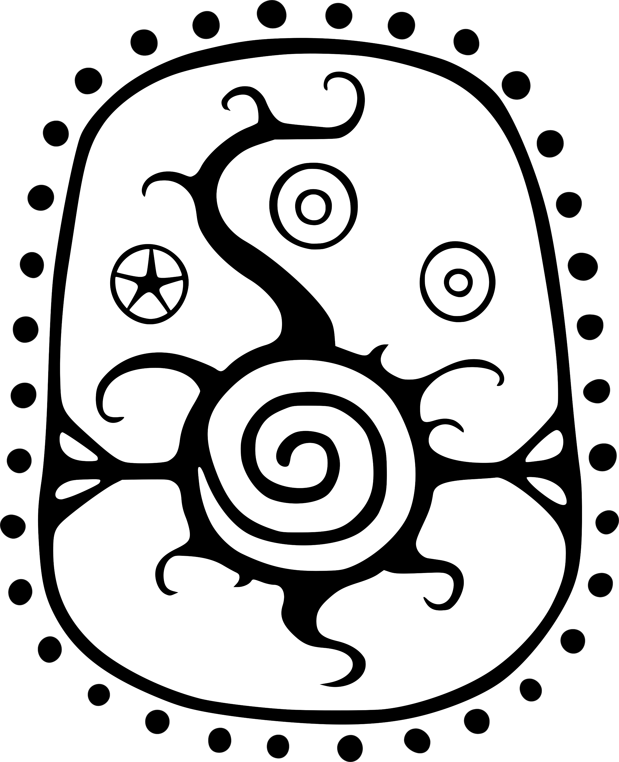

Jode
Jone

Magne

Nirn

Nirn, Ehlnofex for “arena”, is a finite ball of matter and magic made from all of the god planets at the beginning of time, when Lorkhan tricked the gods to create the mortal plane. Nirn is the mortal plane and the mortal planet, which is the same thing.
Its creation upset the cosmic balance; now all souls have a
vested interest in Nirn.
Appendix

The planets are the gods and the planes of the gods, which is the same thing. That they appear as spherical heavenly bodies is
a visual phenomena caused by mortal mental stress. Since each plane is an infinite mass of infinite size, as yet surrounded by the Void of Oblivion, the mortal eye registers them as bubbles within a space. Planets are magical and impossible.

Likewise, Moons are small planets, insofar as one infinite mass of infinite size can be smaller than another. Planets do have orbits,
or at least lunar orbits are perceived to happen by mortals.

Jode and Jone, the moons of Nirn, are the attendant spirits of
the mortal plane. They are like the mortal plane in that they are temporal and subject to the bounds of mortality; in fact of this,
the moons are dead and died long ago. The moons used to be pure white and featureless, but today their “skin” is decaying and withering away. Their planes are likewise dying. Mortals perceive this as the moons being spheres with patches of their “surfaces” completely eaten away; as the moons spin, they seem to become slivers or ragged crescents. These are not caused by shadows, for you can see stars through the black patches of the lunar spheres.

Space is the interpretation of Oblivion, which is black and empty and surrounds the mortal plane. Space is infinite, but it acts just like a planet, in that Oblivion is “surrounded” by Aetherius.
You can see Aetherius by the stars.

The stars, or Magne-Ge, are the bridges to Aetherius, the magic plane. They are perceived as holes on the inside surface of space. Because they are on the inside of a sphere, all stars are equidistant from Nirn. Larger stars, therefore, are not closer to the mortal plane, they are just larger tears in Oblivion.

The largest tear in Oblivion is Magnus, the sun, and the gateway to magic. Magnus was present at the creation of the mortal plane, and, in fact, was its architect. Prehistoric Nirn was a magical place, and highly unstable to the first mortals. Magnus then left, some say in disgust, and Oblivion filled in the void with the Void.
His escape was not easy, and tatters of Magnus remain in the firmament as stars.

Credits

Maps:
Nathan Wilkes

Frescos:
Lukkar:
Velothi Pattern, Sotha Sil Dreaming, Anu/Padomay

Matthew Weathers:
Temple of Vivec

TheMyzel:
Anticipations of Almalexia, Sotha Sil, & Vivec

Tyddyner:
ALMSIVI

LAAMDT & XardasMage:
Telvanni House Symbol

Books (known authors):

Michael Kirkbride:
Sithis (with original/French ending),
Monomyth (Mythic Aurbis),
Changed Ones,
Spirit of Nirn

The 36 Lessons of Vivec

Trial of Vivec (Mystery of the Apotheosis),
The Thief goes to Cyrodiil (Selected Teachings),
Vehk’s Book of Hours (Hour of the Dragon Break),
Amaranth Reveal Thread (Post at the Turning Point),
Loveletter From the Fifth Era (Obscurred Loveletter),
Prophet of Landfall,
Sermon 37 (The Amaranth),

Vivec & Mephala (Morrowind Description),
Pocket Guide 2nd Edition (Morrowind Description),
Cosmology (The World Egg)

Douglass Goodall:
The House of Troubles,

Tamriel Rebuilt:
The Pilgrim’s Way,
The Worship of the Ashlanders (The Daedra),
Ruhn Ania ALMSIVI (The Ruhn Ania)

Moraelyn Ithren:
10th of Last Seed Prayer (Prayer for Forgiveness)

Servants of the Tribunal Guild:
Collected Prayers to the Three in One (Healing Blessing, Prayer for Guidance)

Credits

Books (the rest, in order of appearance):

Exodus from Summerset,
End of the Journey,
The Real Nerevar,
The Anticipations,
The Doors of the Spirit,
Blasphemous Revenants

Homilies of Blessed Almalexia,
Almalexia and the Mudcrab,
Blessed Almalexia's Fables for Morning,
Blessed Almalexia's Fables for Afternoon,
Blessed Almalexia's Fables for Evening

The Truth in Sequence

The Memories of Sotha Sil

The Book of Dawn and Dusk,
The Battle of Red Mountain,
Fellowship of the Temple,
Saryoni’s Sermons

Thank you to all authors and creators named and unnamed.

The Elder Scrolls series are trademarks of Bethesda Softworks LLC,
a ZeniMax Media company. All content in this volume is trademark
or registered trademark of its respective owners. This volume is neither supported nor endorsed by Bethesda Softworks or its licensers.

You may not sell this volume.

(This version is modified for softer language content.)

