**Day 1 - Printing, Commenting, Debugging, String Manipulations, Variables**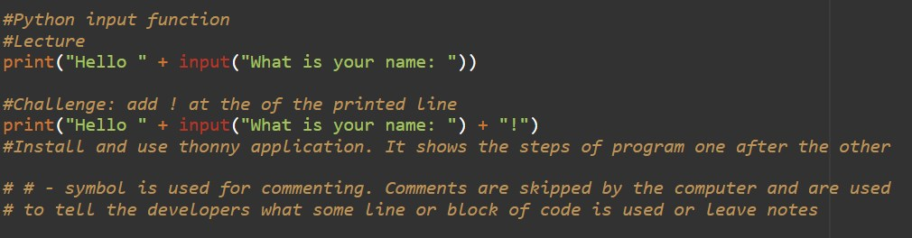

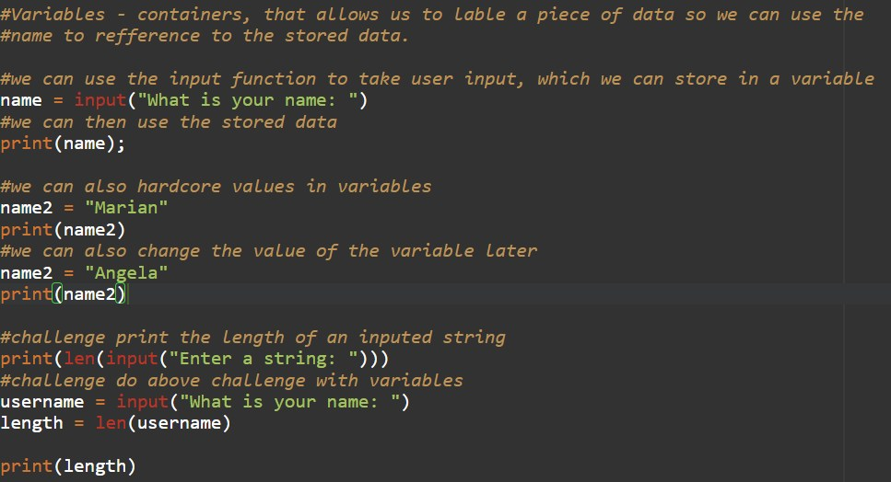

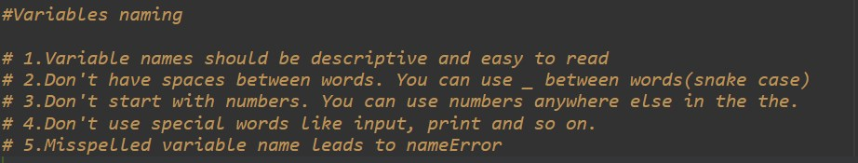

**

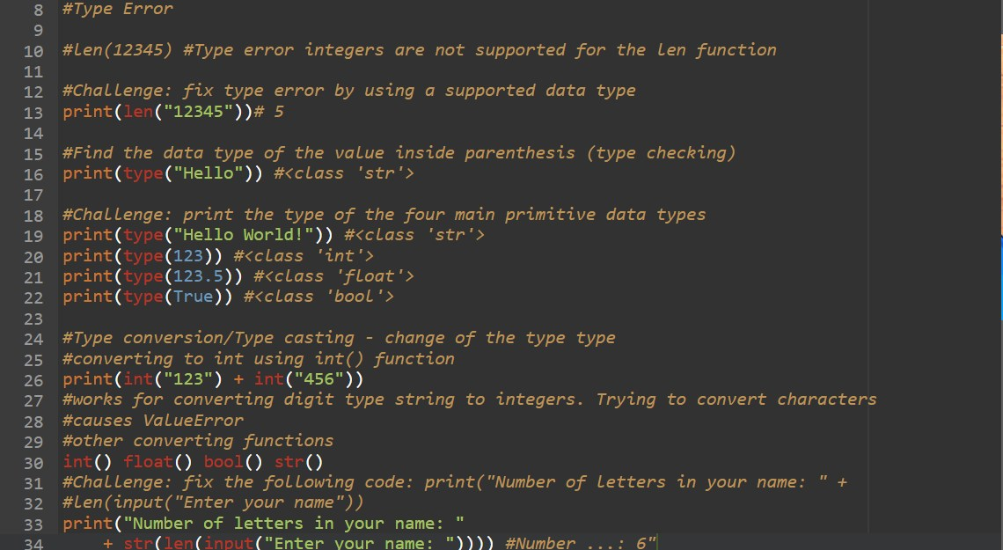

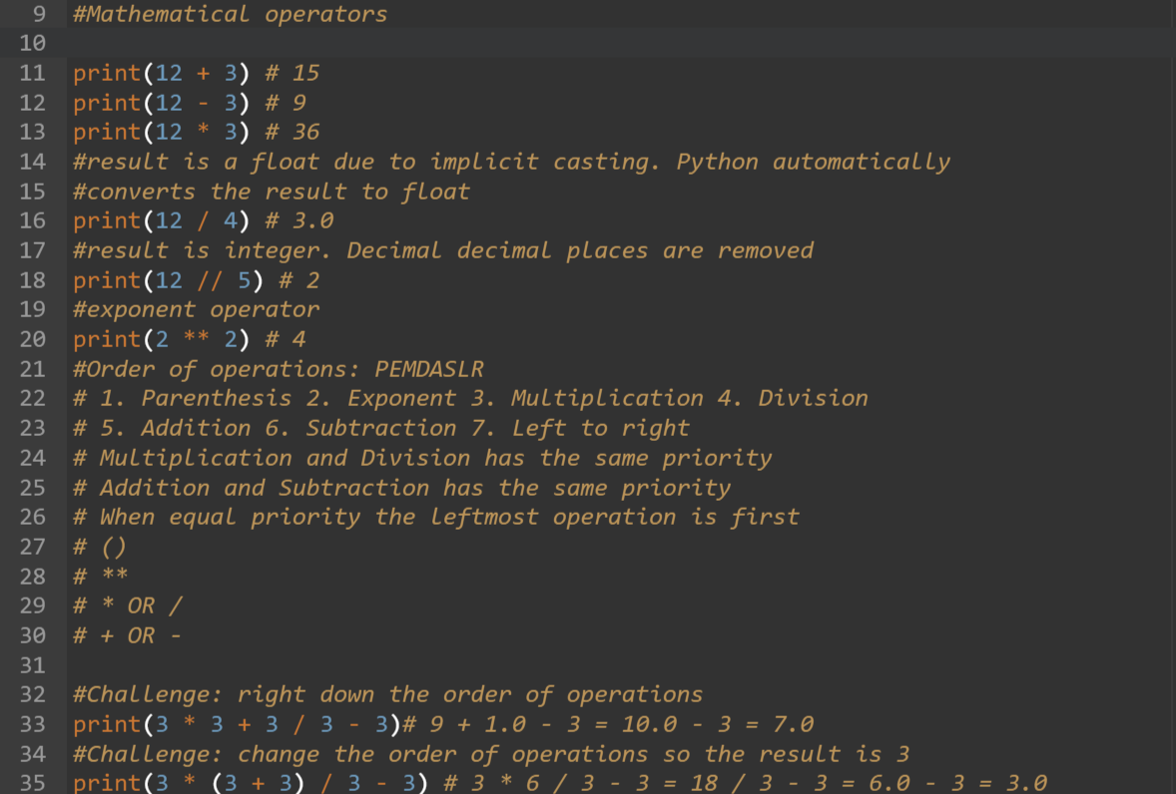

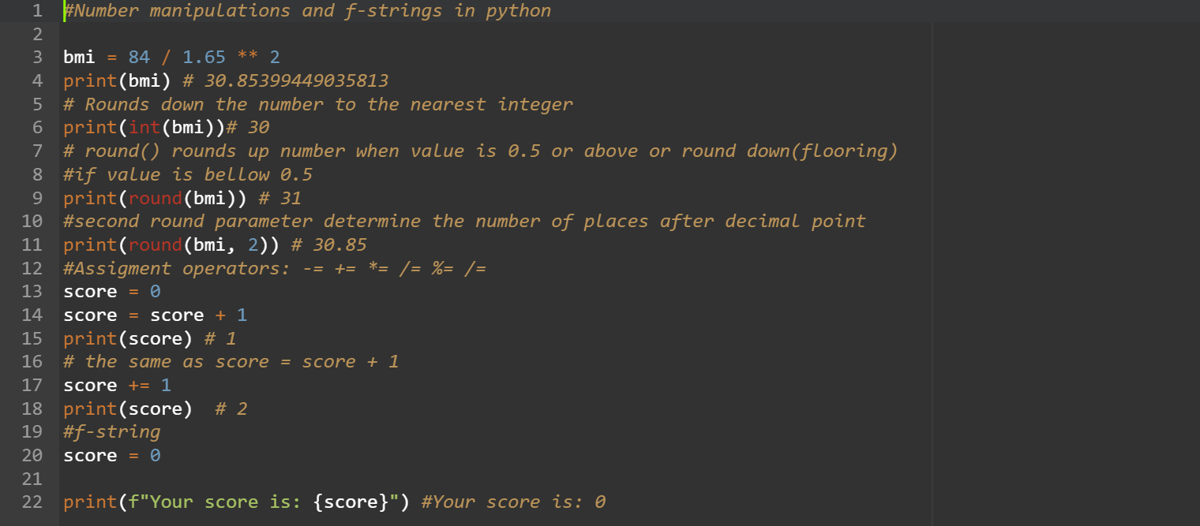

**Day 3 - Conditional statements, Logical operators, Code blocks and Scope**

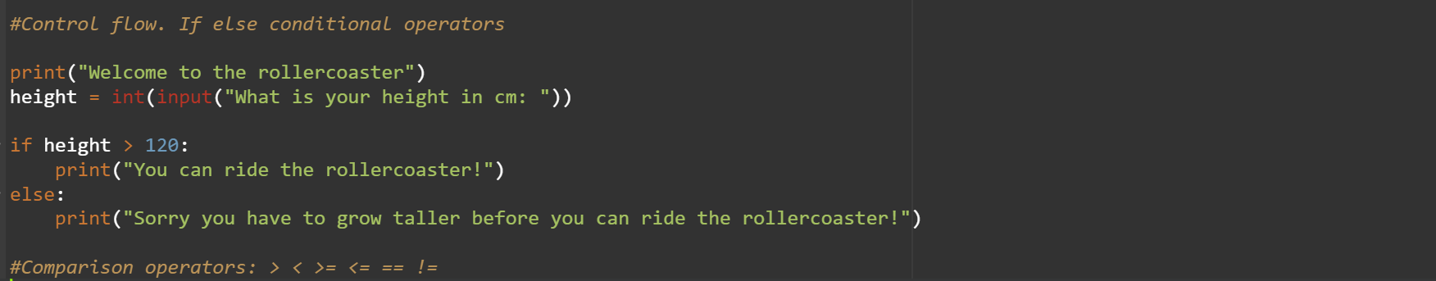

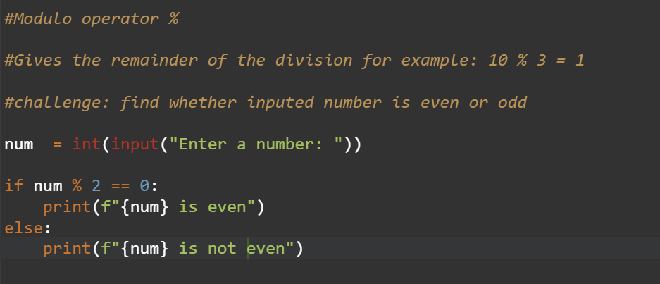

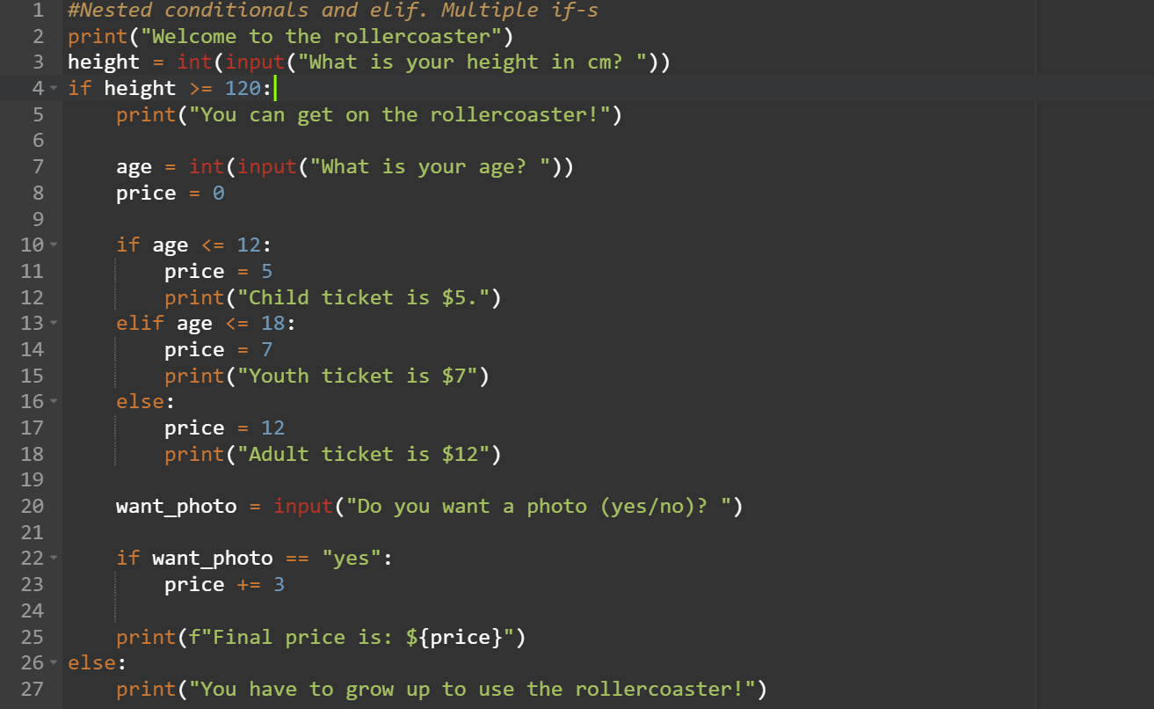

**Day 4 – Randomization and lists**

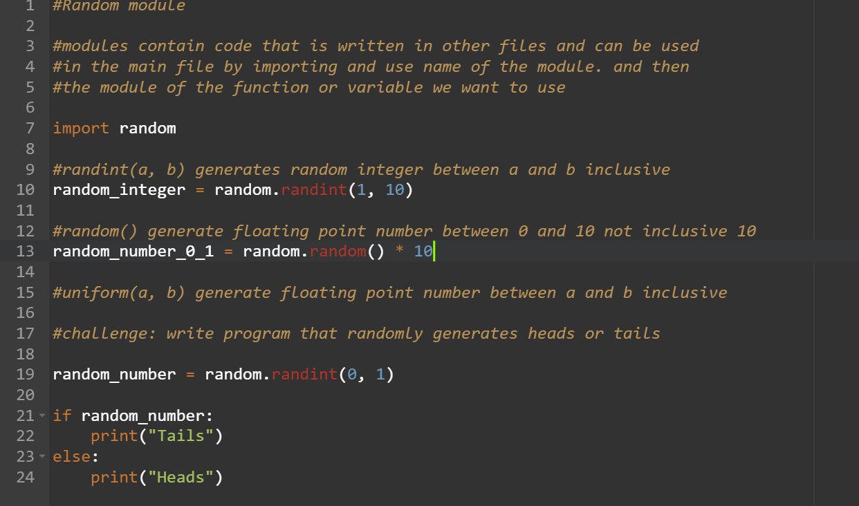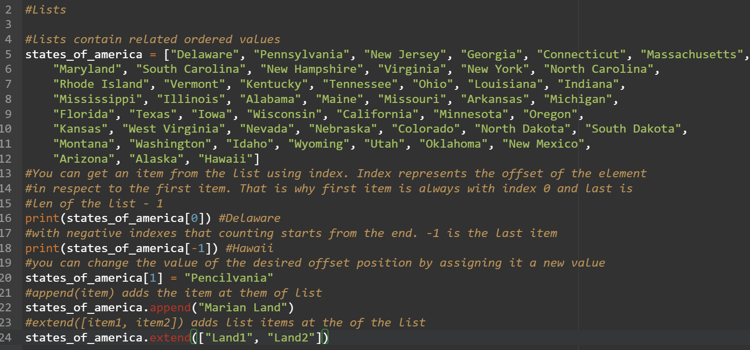**Day 5 - For Loops**

