Практическое задание к лекции по YARN

0. [Исследовательское задание]

Сколько узлов можно потерять в кластере из 10 узлов без потери данных? Из 100 узлов?

**ОТВЕТ:**

В моем понимании, отвечая на вопрос, следует помнить о значении фактора репликации. Условно говоря, если он равен 3 (трем), то один и тот же блок будет представлен оригиналом и его двумя копиями. Все три копии могут физически храниться на двух или трех узлах, т.е. в первом случае какие-то две копии на одном узле, а третья на другом узле. Или же, во втором случае, каждая копия на своем узле – задействовано три узла.

Отсюда вытекает ответ: в первом случае допустимо потерять один узел, а во втором случае допустимо потерять два узла.

1. Опробовать запуски map-reduce задач для кластера используя hadoop-mapreduce-examples.jar.

Для начала зайдем в HUE, чтобы гарантировать автоматическое создание пользовательского каталога

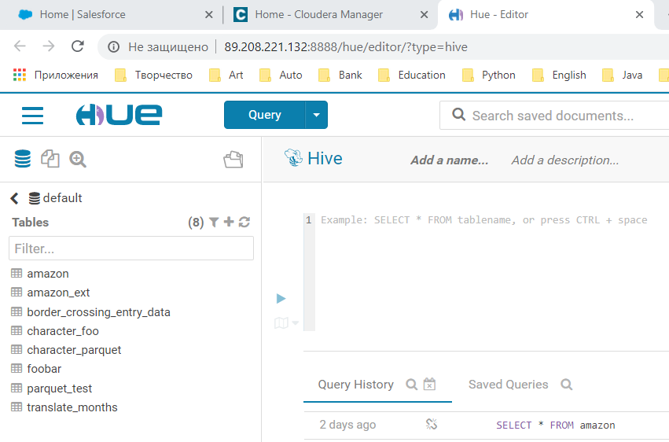

ДАЛЕЕ

Запускаем Putty

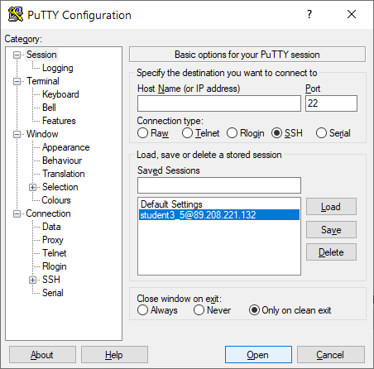

2. Выполнить три любых задачи включенных в этот JAR.

3. Найти свои задачи в интерфейсе Cloudera Manager

4. Опробовать навигацию по интерфейсу YARN

5. Сделать документ со скриншотами того, чтовы видели.

**ВЫПОЛНЕНИЕ**

Переменная

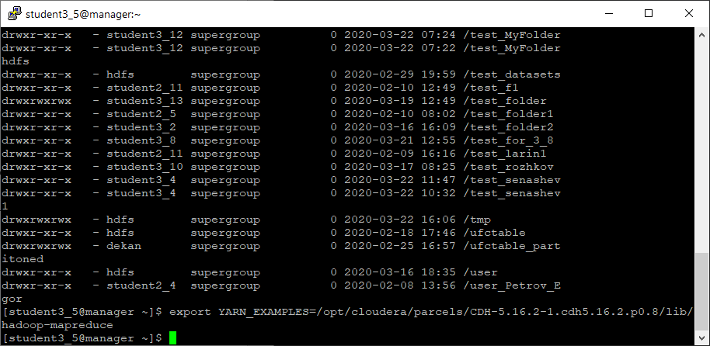

1.

Запускаем первую задачу – число pi методом Monte Carlo

**[student3_5@manager ~]$ yarn jar $YARN_EXAMPLES/hadoop-mapreduce-examples.jar pi 32 20000**

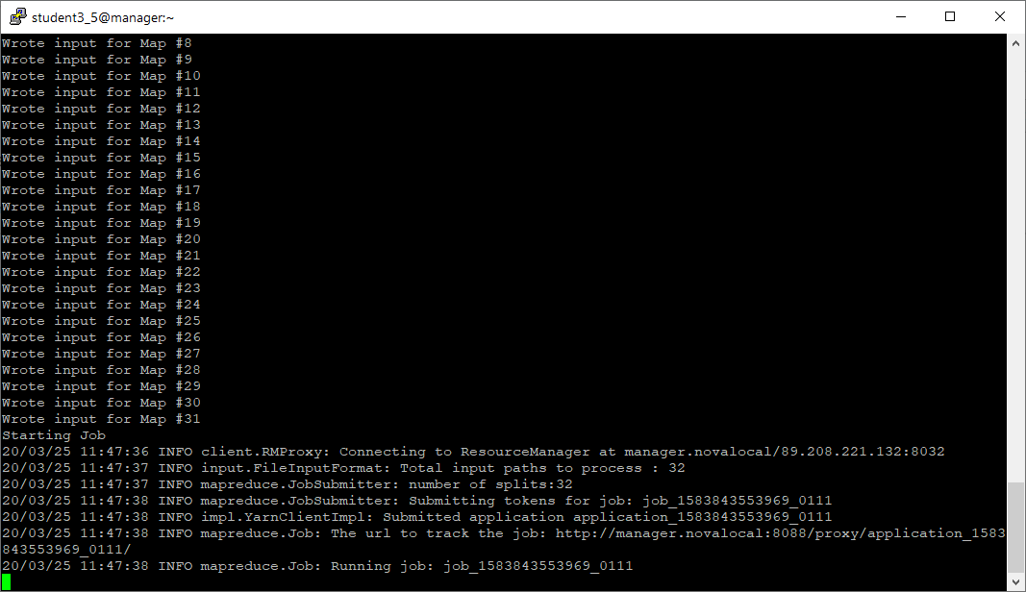

Видим, что задача запущена на Resource Manager **manager.novalocal**

Зайдем в Applications у YARN

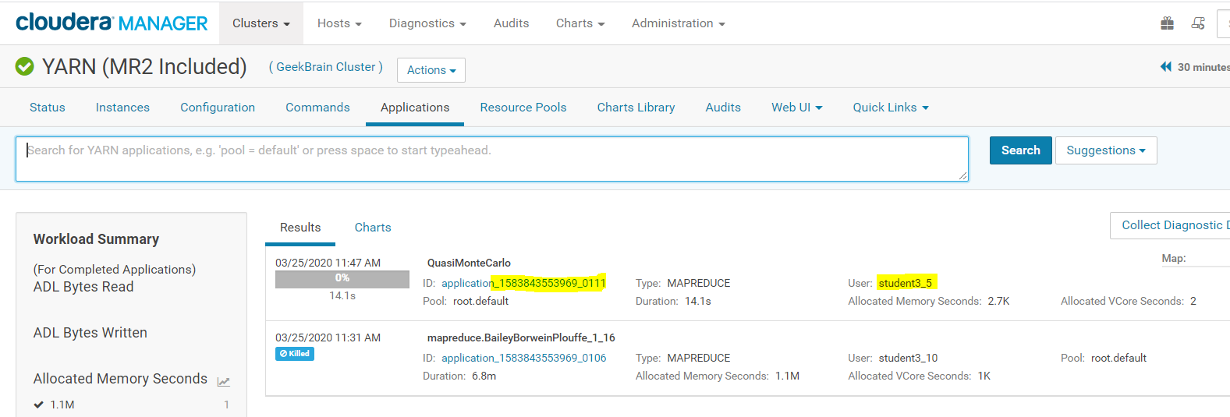

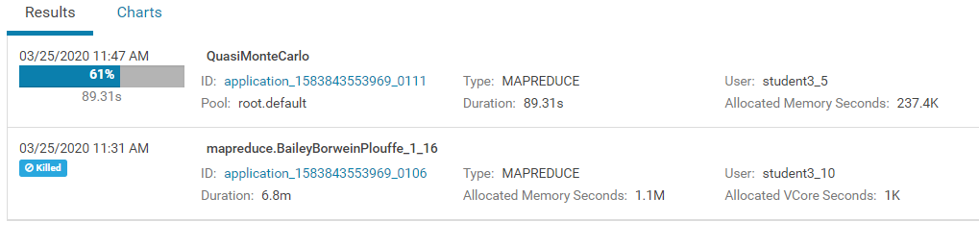

**Задача выполняется успешно, о чем свидетельствует лог ниже:**

20/03/25 11:49:10 INFO mapreduce.Job: Job job_1583843553969_0111 completed successfully

20/03/25 11:49:10 INFO mapreduce.Job: Counters: 49

File System Counters

FILE: Number of bytes read=264

FILE: Number of bytes written=4945312

FILE: Number of read operations=0

FILE: Number of large read operations=0

FILE: Number of write operations=0

HDFS: Number of bytes read=8886

HDFS: Number of bytes written=215

HDFS: Number of read operations=131

HDFS: Number of large read operations=0

HDFS: Number of write operations=3

Job Counters

Launched map tasks=32

Launched reduce tasks=1

Data-local map tasks=32

Total time spent by all maps in occupied slots (ms)=100843

Total time spent by all reduces in occupied slots (ms)=21646

Total time spent by all map tasks (ms)=100843

Total time spent by all reduce tasks (ms)=21646

Total vcore-milliseconds taken by all map tasks=100843

Total vcore-milliseconds taken by all reduce tasks=21646

Total megabyte-milliseconds taken by all map tasks=103263232

Total megabyte-milliseconds taken by all reduce tasks=22165504

Map-Reduce Framework

Map input records=32

Map output records=64

Map output bytes=576

Map output materialized bytes=1120

Input split bytes=5110

Combine input records=0

Combine output records=0

Reduce input groups=2

Reduce shuffle bytes=1120

Reduce input records=64

Reduce output records=0

Spilled Records=128

Shuffled Maps =32

Failed Shuffles=0

Merged Map outputs=32

GC time elapsed (ms)=2294

CPU time spent (ms)=26520

Physical memory (bytes) snapshot=14993186816

Virtual memory (bytes) snapshot=92170371072

Total committed heap usage (bytes)=14864089088

Shuffle Errors

BAD_ID=0

CONNECTION=0

IO_ERROR=0

WRONG_LENGTH=0

WRONG_MAP=0

WRONG_REDUCE=0

File Input Format Counters

Bytes Read=3776

File Output Format Counters

Bytes Written=97

Job Finished in 93.917 seconds

Estimated value of Pi is 3.14153125000000000000

2.

Запускаем задачу подсчета слов

**[student3_5@manager ~]$ yarn jar $YARN_EXAMPLES/hadoop-mapreduce-examples.jar wordcount /test1_mmingalov/resolv.conf /test1_mmingalov/resolv_wordcount**

Для этого первым параметром мы указываем текстовый файл в моей папке. Его содержимое имеет вид

**[student3_5@manager ~]$ hdfs dfs -cat /test1_mmingalov/resolv.conf**

; Created by cloud-init on instance boot automatically, do not edit.

;

# Generated by NetworkManager

nameserver 10.0.2.3

nameserver 8.8.8.8

nameserver 8.8.4.4

search localdomain

**РЕЗУЛЬТАТ**

**[student3_5@manager ~]$ hdfs dfs -cat /test1_mmingalov/resolv_wordcount/\***

# 1

; 2

Generated 1

NetworkManager 1

instance 1

localdomain 1

on 1

8.8.4.4 1

Created 1

edit. 1

nameserver 3

automatically, 1

do 1

not 1

8.8.8.8 1

cloud-init 1

by 2

10.0.2.3 1

boot 1

search 1

3.

GraySort, пример 10 ГБ

В этом примере используются три набора программ MapReduce.

* **TeraGen**: программа MapReduce, которая создает строки с данными для последующей сортировки.
* **TeraSort**: производит выборку входных данных и использует MapReduce для сортировки данных в общем порядке.
* **TeraValidate**: программа MapReduce, которая проверяет глобальную сортировку выходных данных.

В выходном каталоге создается одна функция map для каждого файла, и каждая функция map гарантирует, что каждый ключ будет меньше или равен предыдущему. Функция map создает записи первого и последнего ключей каждого файла. Функция reduce гарантирует, что первый ключ файла i больше последнего ключа файла i-1. Все проблемы указываются в выходных данных этапа редукции вместе с неотсортированными ключами.

3.1. TERAGEN

**[student3_5@manager ~]$ yarn jar $YARN_EXAMPLES/hadoop-mapreduce-examples.jar teragen -Dmapred.map.tasks=50 100000000 /test1_mmingalov/data/10GB-sort-input**

20/03/25 12:59:05 INFO client.RMProxy: Connecting to ResourceManager at manager.novalocal/89.208.221.132:8032

20/03/25 12:59:06 INFO terasort.TeraGen: Generating 100000000 using 50

20/03/25 12:59:06 INFO mapreduce.JobSubmitter: number of splits:50

20/03/25 12:59:06 INFO Configuration.deprecation: mapred.map.tasks is deprecated. Instead, use mapreduce.job.maps

20/03/25 12:59:06 INFO mapreduce.JobSubmitter: Submitting tokens for job: job_1583843553969_0117

20/03/25 12:59:07 INFO impl.YarnClientImpl: Submitted application application_1583843553969_0117

20/03/25 12:59:07 INFO mapreduce.Job: The url to track the job: http://manager.novalocal:8088/proxy/application_1583843553969_0117/

20/03/25 12:59:07 INFO mapreduce.Job: Running job: job_1583843553969_0117

20/03/25 12:59:14 INFO mapreduce.Job: Job job_1583843553969_0117 running in uber mode : false

20/03/25 12:59:14 INFO mapreduce.Job: map 0% reduce 0%

20/03/25 12:59:28 INFO mapreduce.Job: map 2% reduce 0%

…..

20/03/25 13:04:11 INFO mapreduce.Job: map 96% reduce 0%

20/03/25 13:04:14 INFO mapreduce.Job: map 98% reduce 0%

20/03/25 13:04:23 INFO mapreduce.Job: map 100% reduce 0%

20/03/25 13:04:25 INFO mapreduce.Job: Job job_1583843553969_0117 completed successfully

20/03/25 13:04:26 INFO mapreduce.Job: Counters: 31

File System Counters

FILE: Number of bytes read=0

FILE: Number of bytes written=7454940

FILE: Number of read operations=0

FILE: Number of large read operations=0

FILE: Number of write operations=0

HDFS: Number of bytes read=4288

HDFS: Number of bytes written=10000000000

HDFS: Number of read operations=200

HDFS: Number of large read operations=0

HDFS: Number of write operations=100

Job Counters

Launched map tasks=50

Other local map tasks=50

Total time spent by all maps in occupied slots (ms)=545191

Total time spent by all reduces in occupied slots (ms)=0

Total time spent by all map tasks (ms)=545191

Total vcore-milliseconds taken by all map tasks=545191

Total megabyte-milliseconds taken by all map tasks=558275584

Map-Reduce Framework

Map input records=100000000

Map output records=100000000

Input split bytes=4288

Spilled Records=0

Failed Shuffles=0

Merged Map outputs=0

GC time elapsed (ms)=5605

CPU time spent (ms)=237850

Physical memory (bytes) snapshot=15554732032

Virtual memory (bytes) snapshot=139574444032

Total committed heap usage (bytes)=13407092736

org.apache.hadoop.examples.terasort.TeraGen$Counters

CHECKSUM=214760662691937609

File Input Format Counters

Bytes Read=0

File Output Format Counters

Bytes Written=10000000000

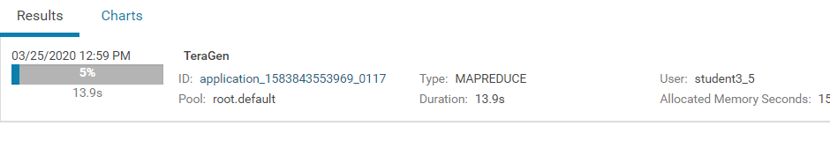

3.2 TERASORT

**[student3_5@manager ~]$ yarn jar $YARN_EXAMPLES/hadoop-mapreduce-examples.jar terasort -Dmapred.map.tasks=50 -Dmapred.reduce.tasks=25 /test1_mmingalov/data/10GB-sort-input /test1_mmingalov/data/10GB-sort-output**

20/03/25 13:17:38 INFO terasort.TeraSort: starting

20/03/25 13:17:39 INFO input.FileInputFormat: Total input paths to process : 50

Spent 258ms computing base-splits.

Spent 4ms computing TeraScheduler splits.

Computing input splits took 263ms

Sampling 10 splits of 100

Making 25 from 100000 sampled records

Computing parititions took 730ms

Spent 996ms computing partitions.

20/03/25 13:17:40 INFO client.RMProxy: Connecting to ResourceManager at manager.novalocal/89.208.221.132:8032

20/03/25 13:17:41 INFO mapreduce.JobSubmitter: number of splits:100

20/03/25 13:17:41 INFO Configuration.deprecation: mapred.reduce.tasks is deprecated. Instead, use mapreduce.job.reduces

20/03/25 13:17:41 INFO Configuration.deprecation: mapred.map.tasks is deprecated. Instead, use mapreduce.job.maps

20/03/25 13:17:41 INFO mapreduce.JobSubmitter: Submitting tokens for job: job_1583843553969_0118

20/03/25 13:17:42 INFO impl.YarnClientImpl: Submitted application application_1583843553969_0118

20/03/25 13:17:42 INFO mapreduce.Job: The url to track the job: http://manager.novalocal:8088/proxy/application_1583843553969_0118/

20/03/25 13:17:42 INFO mapreduce.Job: Running job: job_1583843553969_0118

20/03/25 13:17:52 INFO mapreduce.Job: Job job_1583843553969_0118 running in uber mode : false

20/03/25 13:17:52 INFO mapreduce.Job: map 0% reduce 0%

20/03/25 13:18:07 INFO mapreduce.Job: map 1% reduce 0%

20/03/25 13:18:08 INFO mapreduce.Job: map 2% reduce 0%

20/03/25 13:18:18 INFO mapreduce.Job: map 3% reduce 0%

….

20/03/25 13:28:01 INFO mapreduce.Job: map 97% reduce 0%

20/03/25 13:28:11 INFO mapreduce.Job: map 98% reduce 0%

20/03/25 13:28:25 INFO mapreduce.Job: map 99% reduce 0%

20/03/25 13:28:33 INFO mapreduce.Job: map 100% reduce 0%

20/03/25 13:28:48 INFO mapreduce.Job: map 100% reduce 3%

20/03/25 13:28:51 INFO mapreduce.Job: map 100% reduce 4%

20/03/25 13:29:05 INFO mapreduce.Job: map 100% reduce 8%

……

20/03/25 13:34:19 INFO mapreduce.Job: map 100% reduce 92%

20/03/25 13:34:34 INFO mapreduce.Job: map 100% reduce 96%

20/03/25 13:34:47 INFO mapreduce.Job: map 100% reduce 100%

20/03/25 13:34:48 INFO mapreduce.Job: Job job_1583843553969_0118 completed successfully

20/03/25 13:34:49 INFO mapreduce.Job: Counters: 51

File System Counters

FILE: Number of bytes read=4437647554

FILE: Number of bytes written=8821061379

FILE: Number of read operations=0

FILE: Number of large read operations=0

FILE: Number of write operations=0

HDFS: Number of bytes read=10000014400

HDFS: Number of bytes written=10000000000

HDFS: Number of read operations=375

HDFS: Number of large read operations=0

HDFS: Number of write operations=50

Job Counters

Killed reduce tasks=21

Launched map tasks=100

Launched reduce tasks=46

Data-local map tasks=98

Rack-local map tasks=2

Total time spent by all maps in occupied slots (ms)=1032119

Total time spent by all reduces in occupied slots (ms)=372169

Total time spent by all map tasks (ms)=1032119

Total time spent by all reduce tasks (ms)=372169

Total vcore-milliseconds taken by all map tasks=1032119

Total vcore-milliseconds taken by all reduce tasks=372169

Total megabyte-milliseconds taken by all map tasks=1056889856

Total megabyte-milliseconds taken by all reduce tasks=381101056

Map-Reduce Framework

Map input records=100000000

Map output records=100000000

Map output bytes=10200000000

Map output materialized bytes=4364547145

Input split bytes=14400

Combine input records=0

Combine output records=0

Reduce input groups=100000000

Reduce shuffle bytes=4364547145

Reduce input records=100000000

Reduce output records=100000000

Spilled Records=200000000

Shuffled Maps =2500

Failed Shuffles=0

Merged Map outputs=2500

GC time elapsed (ms)=23656

CPU time spent (ms)=993770

Physical memory (bytes) snapshot=70617931776

Virtual memory (bytes) snapshot=350214242304

Total committed heap usage (bytes)=67904733184

Shuffle Errors

BAD_ID=0

CONNECTION=0

IO_ERROR=0

WRONG_LENGTH=0

WRONG_MAP=0

WRONG_REDUCE=0

File Input Format Counters

Bytes Read=10000000000

File Output Format Counters

Bytes Written=10000000000

20/03/25 13:34:49 INFO terasort.TeraSort: done

3.3. TERAVALIDATE

**[student3_5@manager ~]$ yarn jar $YARN_EXAMPLES/hadoop-mapreduce-examples.jar teravalidate -Dmapred.map.tasks=50 -Dmapred.reduce.tasks=25 /test1_mmingalov/data/10GB-sort-output /test1_mmingalov/data/10GB-sort-validate**

20/03/25 13:39:24 INFO client.RMProxy: Connecting to ResourceManager at manager.novalocal/89.208.221.132:8032

20/03/25 13:39:25 INFO input.FileInputFormat: Total input paths to process : 25

Spent 31ms computing base-splits.

Spent 2ms computing TeraScheduler splits.

20/03/25 13:39:25 INFO mapreduce.JobSubmitter: number of splits:25

20/03/25 13:39:25 INFO Configuration.deprecation: mapred.reduce.tasks is deprecated. Instead, use mapreduce.job.reduces

20/03/25 13:39:25 INFO Configuration.deprecation: mapred.map.tasks is deprecated. Instead, use mapreduce.job.maps

20/03/25 13:39:25 INFO mapreduce.JobSubmitter: Submitting tokens for job: job_1583843553969_0119

20/03/25 13:39:25 INFO impl.YarnClientImpl: Submitted application application_1583843553969_0119

20/03/25 13:39:25 INFO mapreduce.Job: The url to track the job: http://manager.novalocal:8088/proxy/application_1583843553969_0119/

20/03/25 13:39:25 INFO mapreduce.Job: Running job: job_1583843553969_0119

20/03/25 13:39:34 INFO mapreduce.Job: Job job_1583843553969_0119 running in uber mode : false

20/03/25 13:39:34 INFO mapreduce.Job: map 0% reduce 0%

20/03/25 13:39:50 INFO mapreduce.Job: map 1% reduce 0%

20/03/25 13:39:53 INFO mapreduce.Job: map 2% reduce 0%

20/03/25 13:39:56 INFO mapreduce.Job: map 3% reduce 0%

20/03/25 13:39:59 INFO mapreduce.Job: map 4% reduce 0%

20/03/25 13:40:02 INFO mapreduce.Job: map 6% reduce 0%

20/03/25 13:40:09 INFO mapreduce.Job: map 8% reduce 0%

20/03/25 13:40:14 INFO mapreduce.Job: map 12% reduce 0%

…

20/03/25 13:42:42 INFO mapreduce.Job: map 75% reduce 0%

20/03/25 13:42:43 INFO mapreduce.Job: map 76% reduce 0%

20/03/25 13:42:44 INFO mapreduce.Job: map 78% reduce 0%

20/03/25 13:42:52 INFO mapreduce.Job: map 80% reduce 0%

20/03/25 13:42:56 INFO mapreduce.Job: map 84% reduce 0%

20/03/25 13:43:08 INFO mapreduce.Job: map 86% reduce 0%

20/03/25 13:43:12 INFO mapreduce.Job: map 86% reduce 28%

20/03/25 13:43:15 INFO mapreduce.Job: map 88% reduce 28%

20/03/25 13:43:18 INFO mapreduce.Job: map 88% reduce 29%

20/03/25 13:43:30 INFO mapreduce.Job: map 89% reduce 29%

20/03/25 13:43:36 INFO mapreduce.Job: map 90% reduce 29%

20/03/25 13:43:42 INFO mapreduce.Job: map 92% reduce 29%

20/03/25 13:43:48 INFO mapreduce.Job: map 92% reduce 31%

20/03/25 13:43:52 INFO mapreduce.Job: map 96% reduce 31%

20/03/25 13:43:54 INFO mapreduce.Job: map 96% reduce 32%

20/03/25 13:44:05 INFO mapreduce.Job: map 100% reduce 32%

20/03/25 13:44:06 INFO mapreduce.Job: map 100% reduce 100%

20/03/25 13:44:07 INFO mapreduce.Job: Job job_1583843553969_0119 completed successfully

20/03/25 13:44:08 INFO mapreduce.Job: Counters: 50

File System Counters

FILE: Number of bytes read=1290

FILE: Number of bytes written=3892106

FILE: Number of read operations=0

FILE: Number of large read operations=0

FILE: Number of write operations=0

HDFS: Number of bytes read=10000003625

HDFS: Number of bytes written=25

HDFS: Number of read operations=78

HDFS: Number of large read operations=0

HDFS: Number of write operations=2

Job Counters

Launched map tasks=25

Launched reduce tasks=1

Data-local map tasks=15

Rack-local map tasks=10

Total time spent by all maps in occupied slots (ms)=444370

Total time spent by all reduces in occupied slots (ms)=69534

Total time spent by all map tasks (ms)=444370

Total time spent by all reduce tasks (ms)=69534

Total vcore-milliseconds taken by all map tasks=444370

Total vcore-milliseconds taken by all reduce tasks=69534

Total megabyte-milliseconds taken by all map tasks=455034880

Total megabyte-milliseconds taken by all reduce tasks=71202816

Map-Reduce Framework

Map input records=100000000

Map output records=75

Map output bytes=2050

Map output materialized bytes=2400

Input split bytes=3625

Combine input records=0

Combine output records=0

Reduce input groups=51

Reduce shuffle bytes=2400

Reduce input records=75

Reduce output records=1

Spilled Records=150

Shuffled Maps =25

Failed Shuffles=0

Merged Map outputs=25

GC time elapsed (ms)=5752

CPU time spent (ms)=134660

Physical memory (bytes) snapshot=15184551936

Virtual memory (bytes) snapshot=72655646720

Total committed heap usage (bytes)=15941500928

Shuffle Errors

BAD_ID=0

CONNECTION=0

IO_ERROR=0

WRONG_LENGTH=0

WRONG_MAP=0

WRONG_REDUCE=0

File Input Format Counters

Bytes Read=10000000000

File Output Format Counters

Bytes Written=25

6. [Факультативное, для тех кто знает JAVA] Собрать программу для MR на Java и запустить ее. Wordcount будет вполне достаточен.

НЕ ДЕЛАЛ

7. [Задание на 5++] Повторить вот этот пример <https://www.michael-noll.com/tutorials/writing-an-hadoop-mapreduce-program-in-python/>

**ВЫПОЛНЕНИЕ**