**ЗАДАНИЕ:**

Задание в общем повторяет предыдущее:

Создать Flume поток используя Flume сервис соотвествующего номера:

• Тип источника источник – exeс

• Тип канала – memory

• Тип слива – hbase

**РЕШЕНИЕ**

**Подготовим конфигурацию для нашего Flume5**

# Naming the components on the current agent

Flume3_5.sources = Exec

Flume3_5.channels = MemChannel

Flume3_5.sinks = HDFSSink HBaseSink

**# source exec**

Flume3_5.sources.Exec.type = exec

Flume3_5.sources.Exec.channels = MemChannel

Flume3_5.sources.Exec.command = tailf /var/log/cron

# insert timestamp

Flume3_5.sources.Exec.interceptors = tsi

Flume3_5.sources.Exec.interceptors.tsi.type = timestamp

**# channel**

Flume3_5.channels.MemChannel.type = memory

Flume3_5.channels. MemChannel.capacity = 1000

Flume3_5.channels. MemChannel.transactionCapacity = 100

**#HDFS sink**

Flume3_5.sinks.HDFSSink.type = hdfs

Flume3_5.sinks.HDFSSink.channel = MemChannel

Flume3_5.sinks.HDFSSink.hdfs.useLocalTimeStamp = true

Flume3_5.sinks.HDFSSink.hdfs.path = /flume/student3_5/log/%y-%m-%d

Flume3_5.sinks.HDFSSink.hdfs.filePrefix = hdfs-st35-

Flume3_5.sinks.HDFSSink.hdfs.rollSize = 1000

Flume3_5.sinks.HDFSSink.hdfs.rollInterval = 0

Flume3_5.sinks.HDFSSink.hdfs.rollCount = 0

Flume3_5.sinks.HDFSSink.hdfs.fileType = SequenceFile

Flume3_5.sinks.HDFSSink.hdfs.codeC = gzip

**#HBase Sink**

Flume3_5.sinks.HBaseSink.type = hbase

Flume3_5.sinks.HBaseSink.channel = MemChannel

Flume3_5.sinks.HBaseSink.table = student3_5

Flume3_5.sinks.HBaseSink.columnFamily = Message

Flume3_5.sinks.HBaseSink.serializer = org.apache.flume.sink.hbase.SimpleHbaseEventSerializer

ДАЛЕЕ

**PUTTY**

Hbase shell

List

(получили список таблиц)

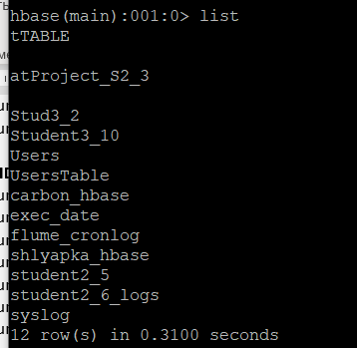

СОЗДАДИМ ТАБЛИЦУ

create 'student3_5', 'Message', 'Items'

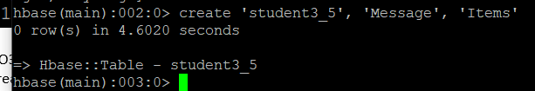

ПОСМОТРЕТЬ СТРУКТУРУ ТАБЛИЦЫ

describe 'student3_5'

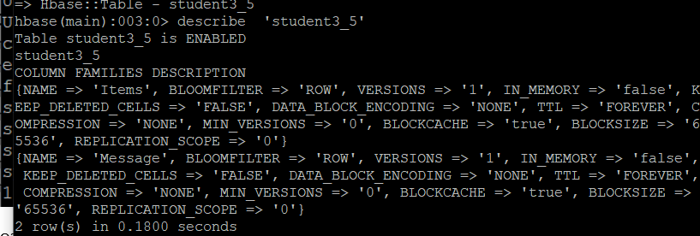

ПРОЧИТАЕМ ДАННЫЕ:

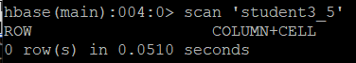

Таблица пуста

**ЗАПУСКАЕМ КОНФИГУРАЦИЮ**

**Проверяем содержимое таблицы**

