**Project Title: Chatbot Deployment with IBM Cloud Watson Assistant**

Phase 4: Development Part 2

The steps to integrate the chatbot with messaging platforms like Facebook and Slack are as follows:

**Integrating with Messaging platforms like Facebook and Slack Integrating with Facebook Messenger:**

# Step 1: Create a Facebook Page

Create a Facebook Page for your chatbot. This will serve as the public face of the bot on Facebook.

# Step 2: Set Up Facebook for Developers

Create a developer account on Facebook for Developers platform.

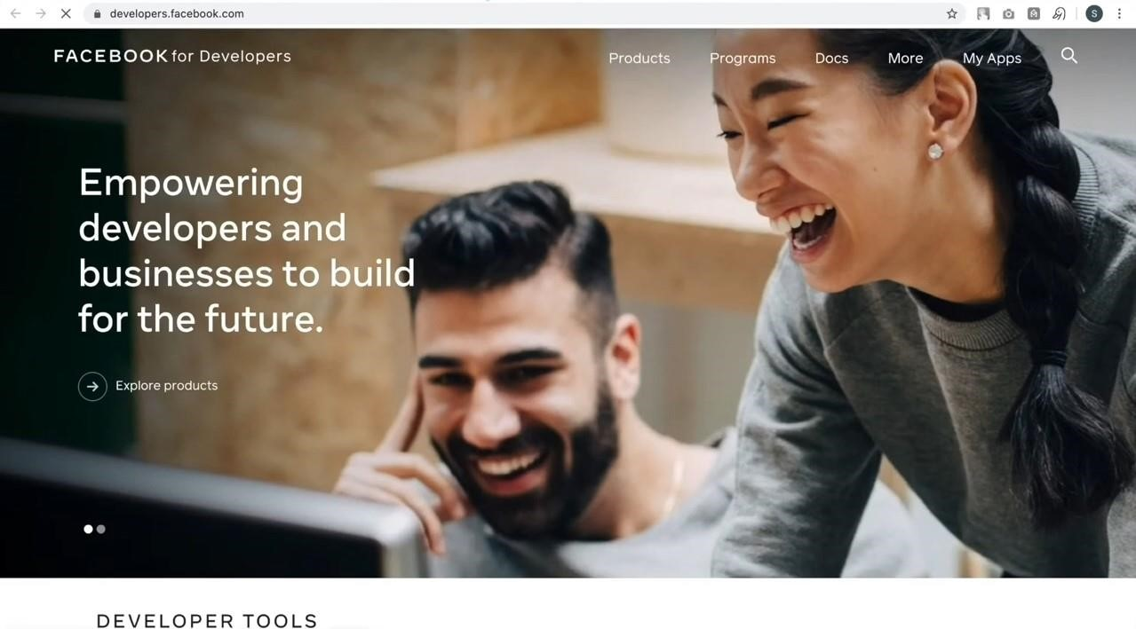

# Step 3: Create a new App

Inside the developer platform, create a new app to represent the chatbot.

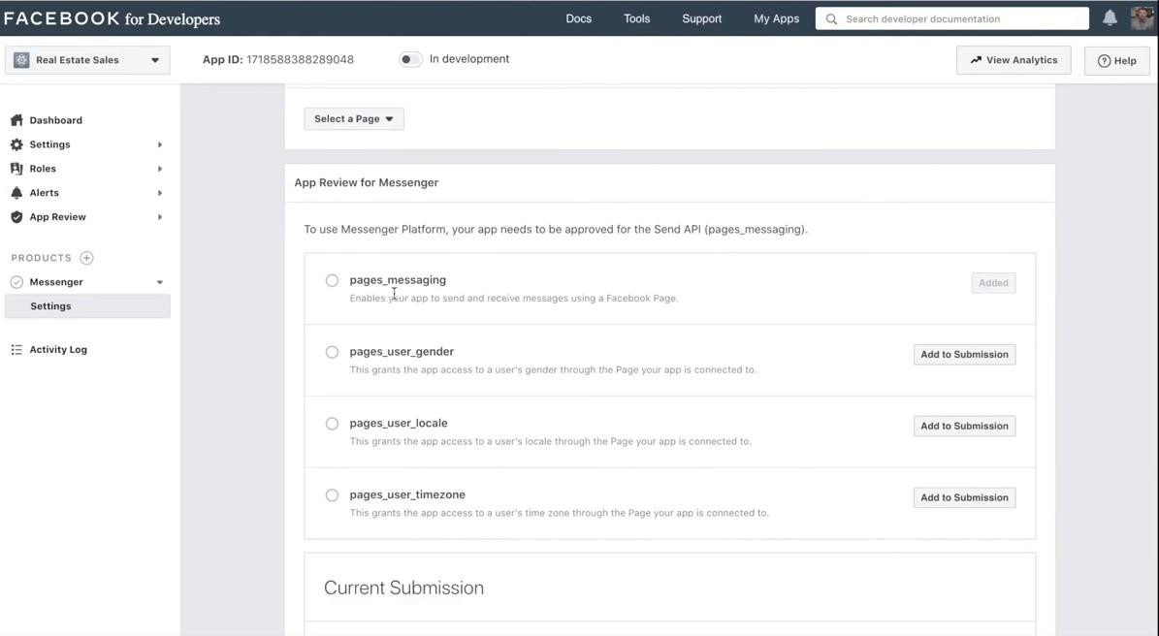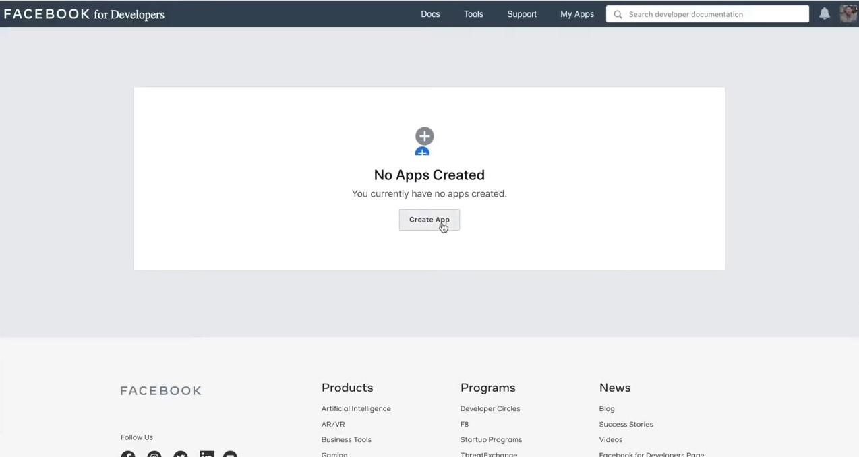

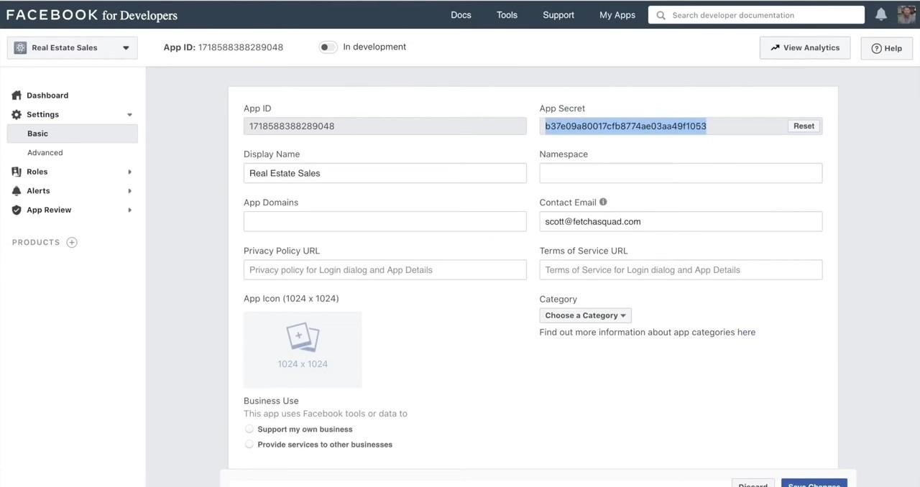

# Step 4: Configure Messenger

* In the app settings, go to the Messenger Platform section.
* Configure the Messenger Platform to handle incoming messages and events from Facebook Messenger.

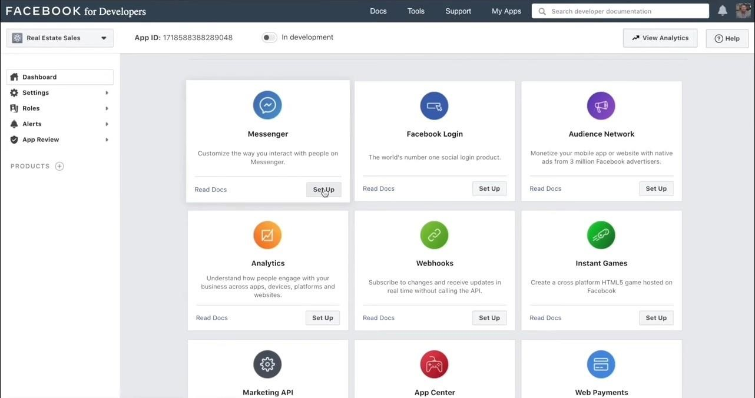

# Step 5: Generate Access Tokens

Obtain access tokens to authenticate the chatbot with Facebook Messenger.

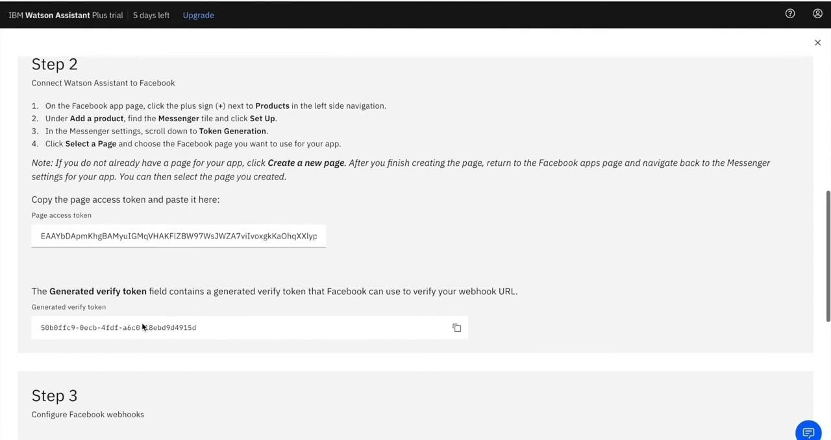

# Step 6: Develop the Webhook

* Create a webhook on the server to handle messages from Facebook Messenger.
* Authenticate webhook using the access token obtained earlier.

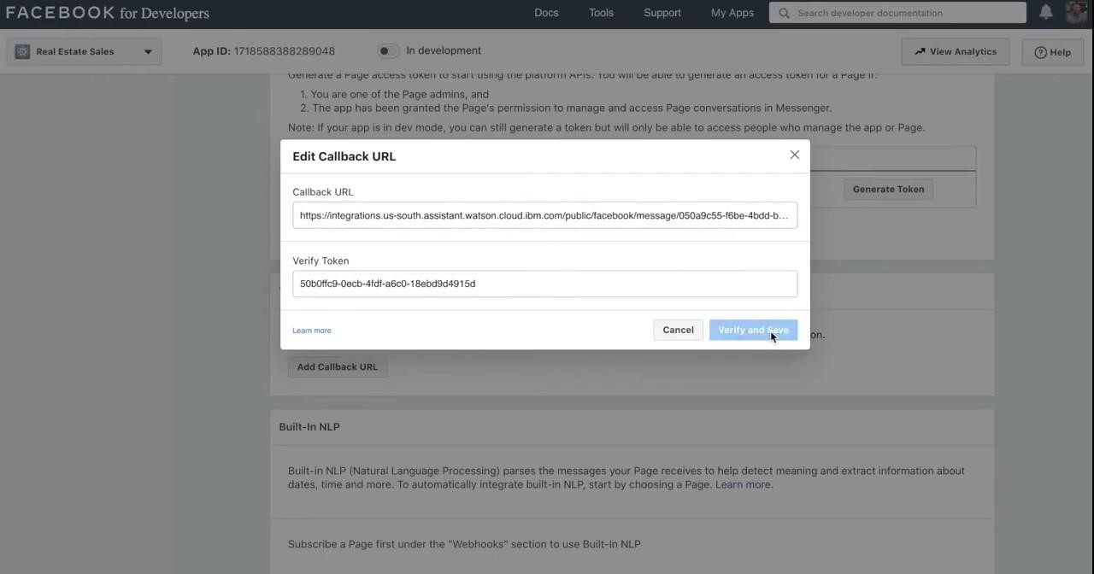

# Step 7: Subscribe the App to a Page

Associate the app with the Facebook Page, enabling it to receive messages sent to the Page.

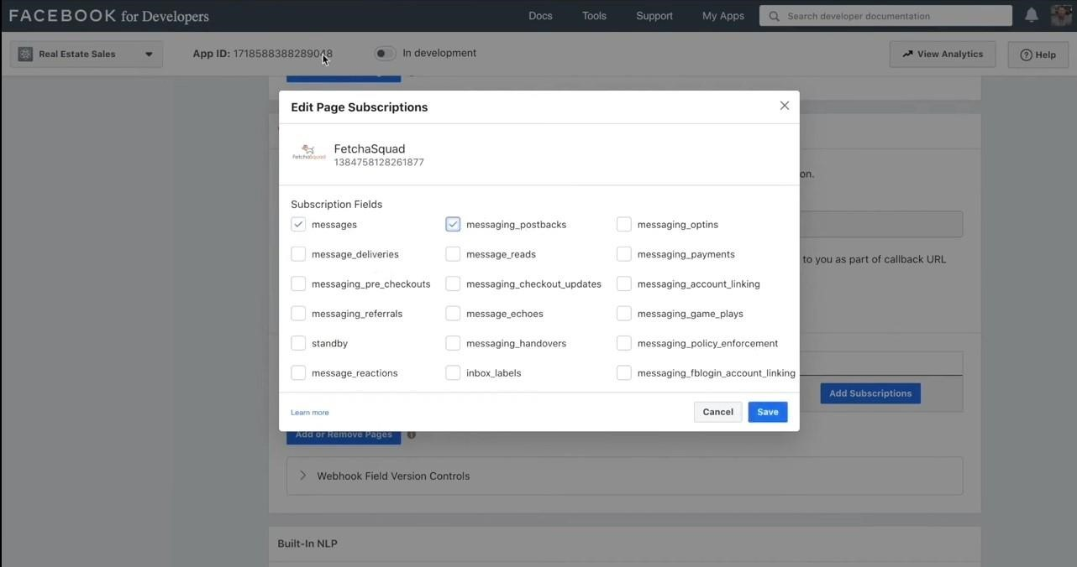

# Step 8: Test and Deploy

* Thoroughly test the chatbot using the Facebook Messenger app.
* Deploy the chatbot to the Page for public use.

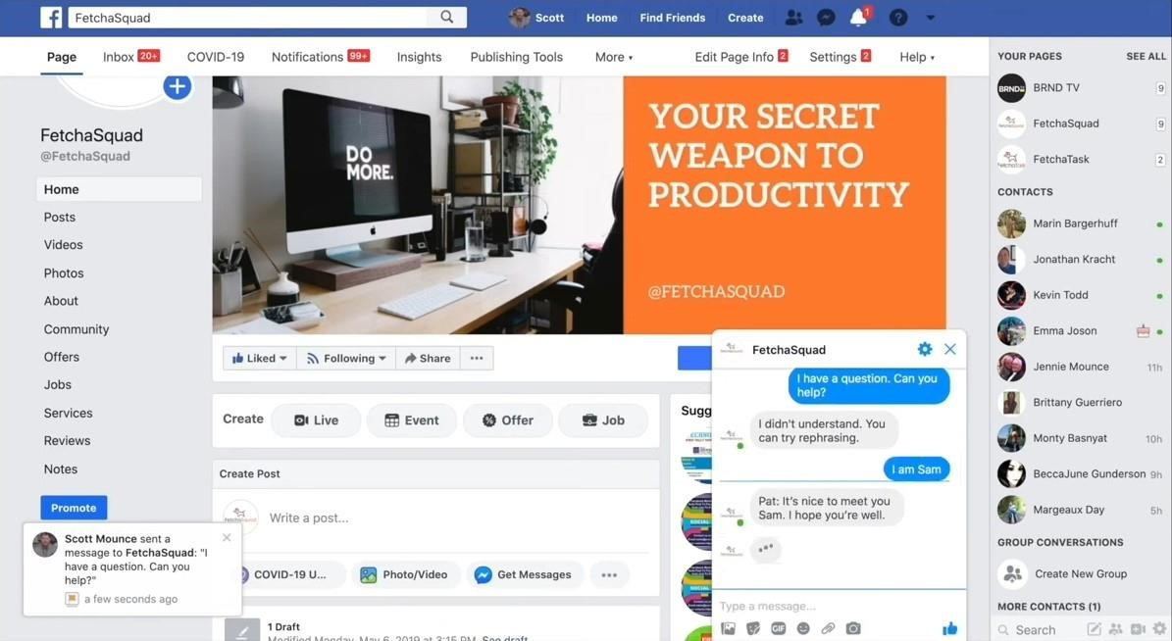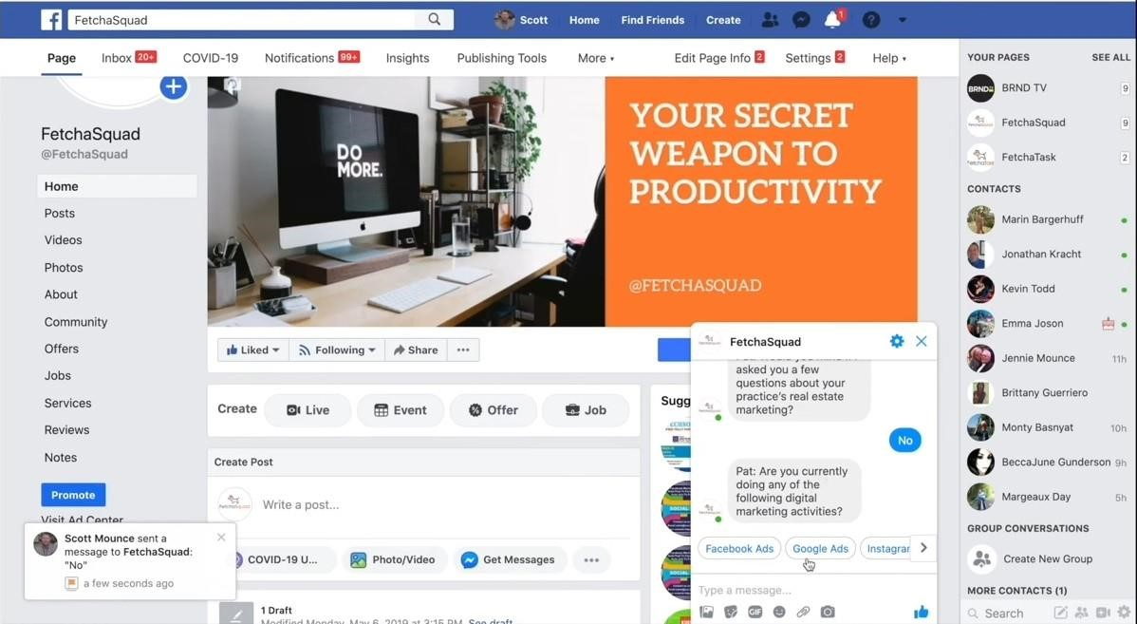

Integrating with Slack:

# Step 1: Create a Slack App

* Go to the Slack API website ([https://api.slack.com/)](https://api.slack.com/).
* Click on "Create New App" and follow the prompts to create Slack app.
* Set the app name and choose the Slack workspace where we want to install the app.

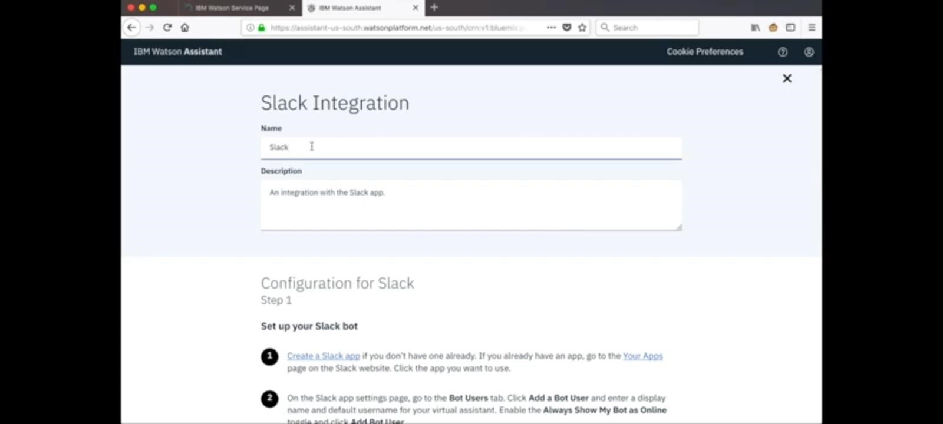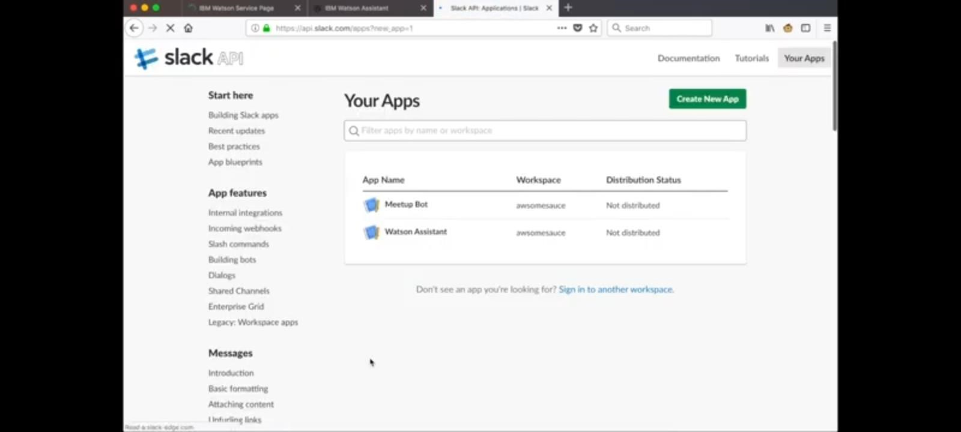

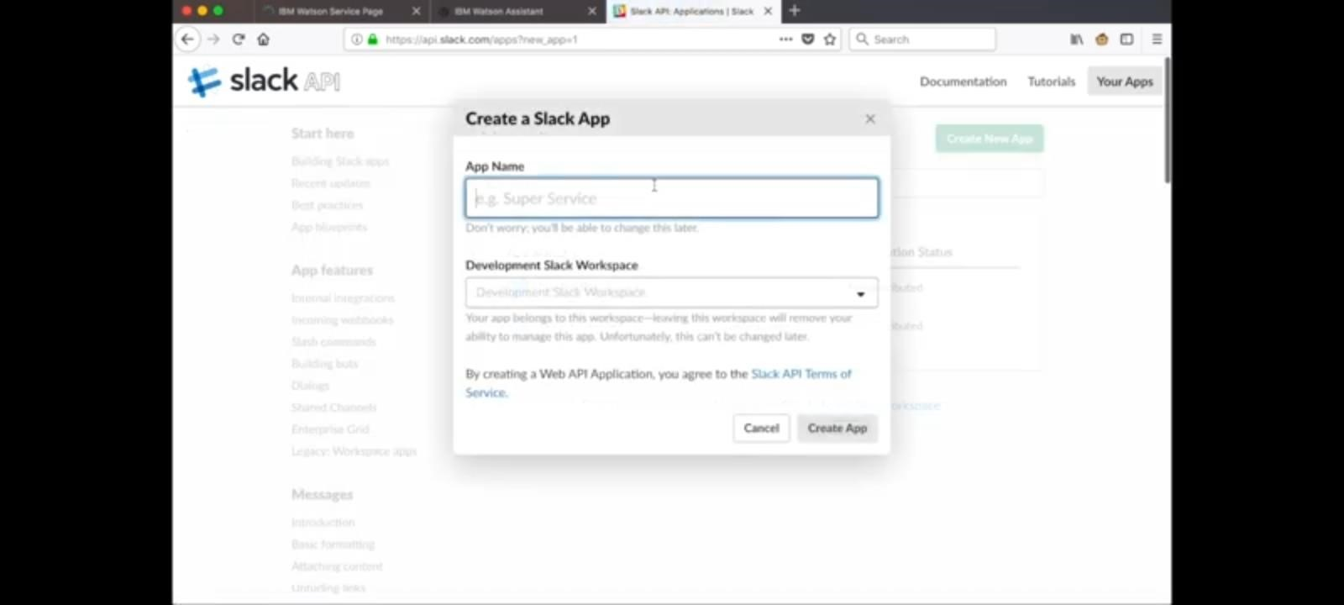

# Step 2: Configure the Slack App

* Configure basic information for the app, including the app name and description.
* Under the "OAuth & Permissions" section, add the necessary scopes for the app. For chatbots, we typically need the ‘**chat:write’** scope.
* After adding scopes, click "**Save Changes**”.

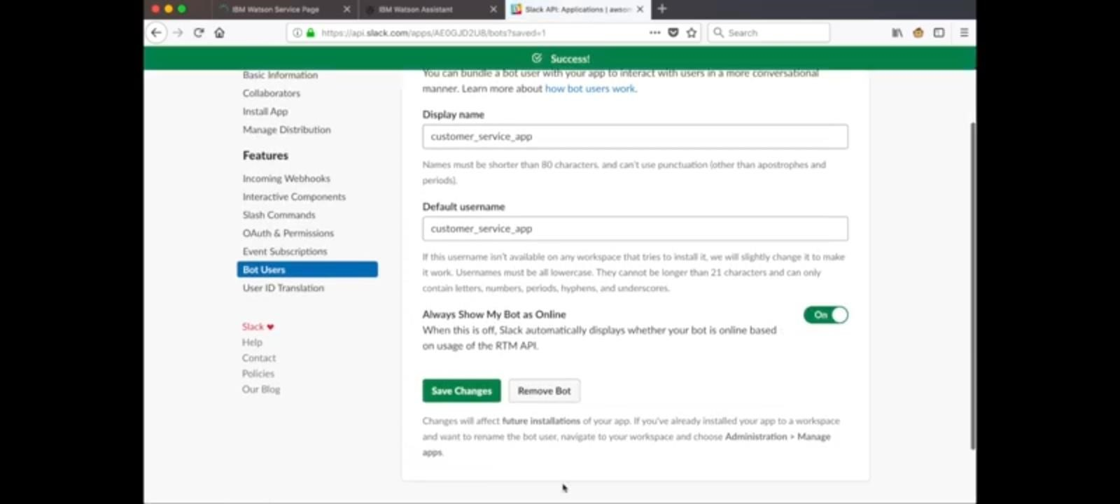

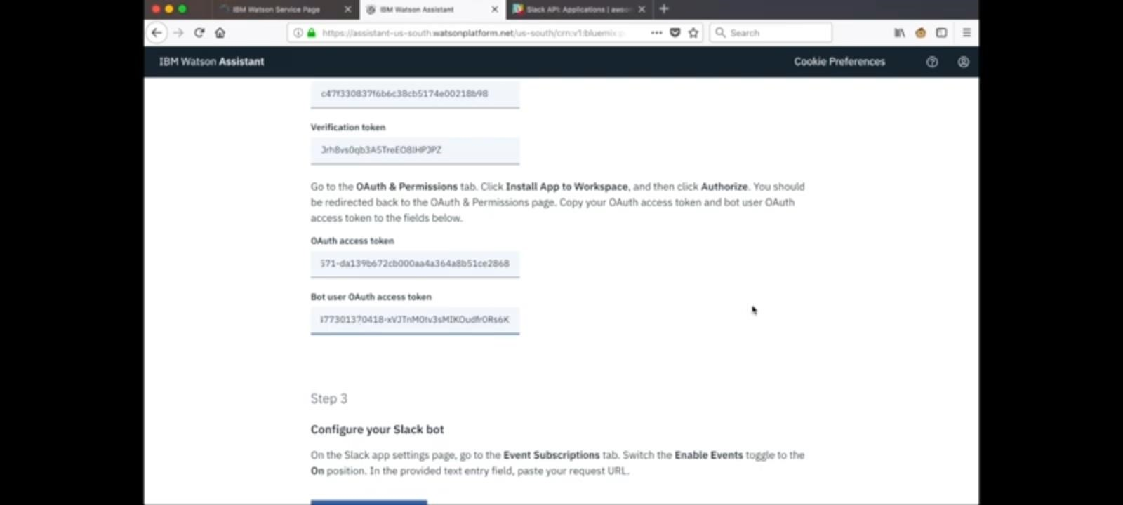

# Step 3: Install App to Workspace

* In the Slack API settings, navigate to the "Install App to Workspace" section.
* Click on the "Install to Workspace" button to install your app in your Slack workspace.

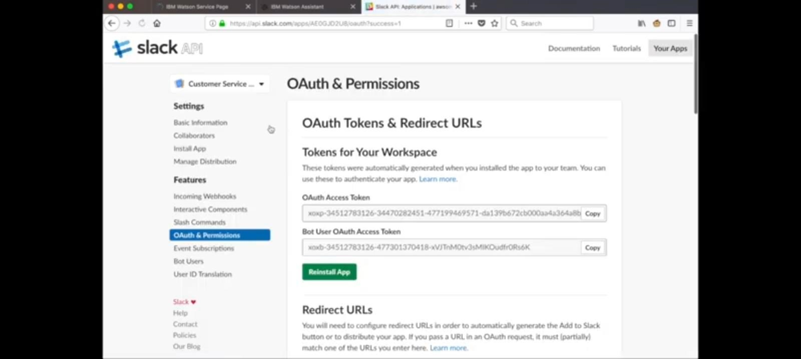

# Step 4: Obtain Slack Credentials

Once installed, we will receive a Bot User OAuth Access Token.

This token is necessary to authenticate the app with Slack.

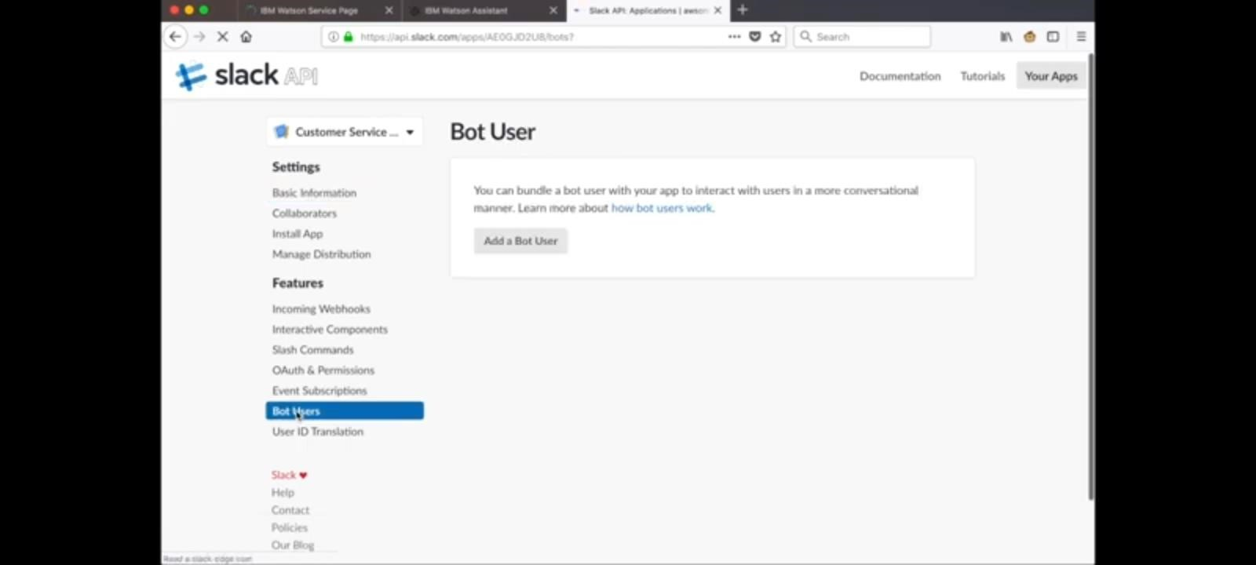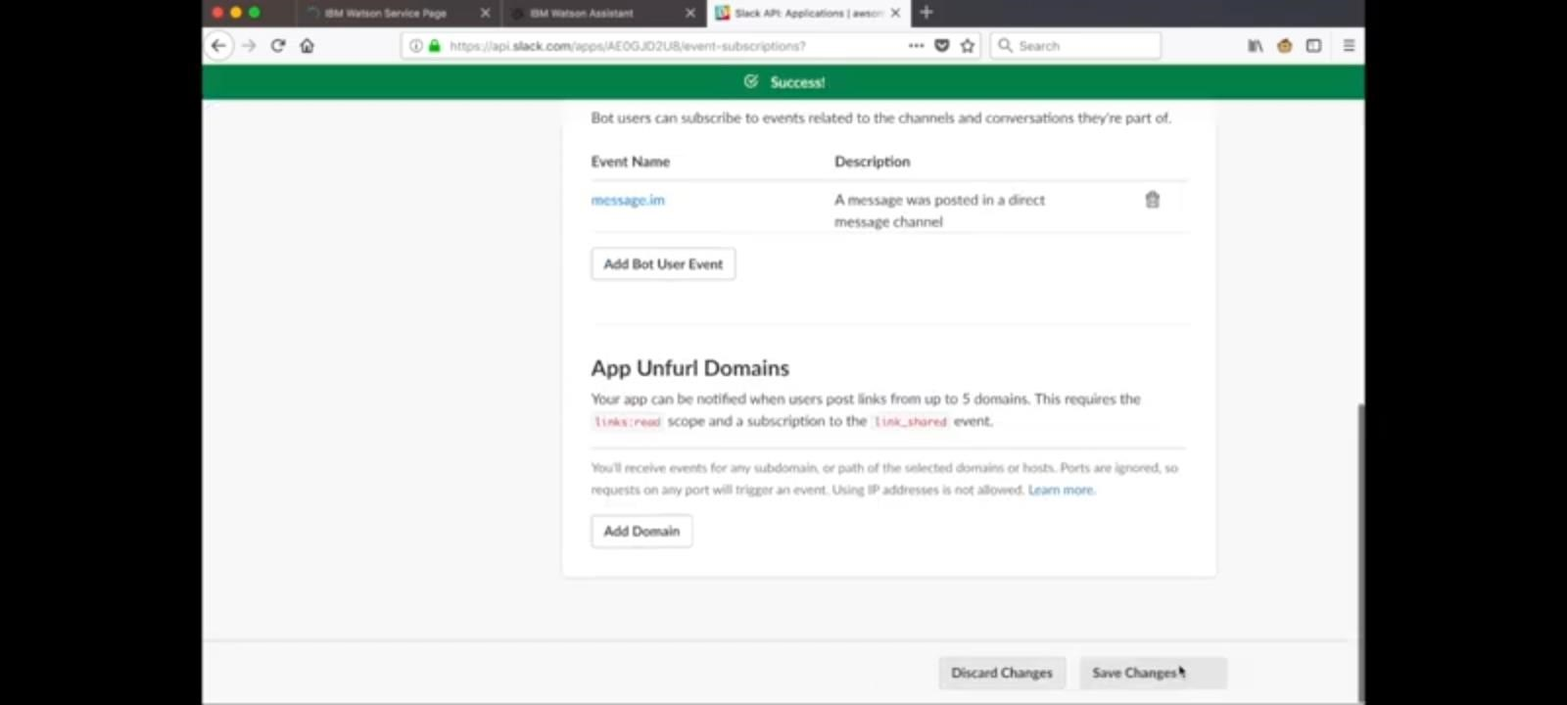

# Step 5: Integrate Watson Assistant with Slack

*1.Configure Watson Assistant:*

* In Watson Assistant instance, go to the "Assistants" section and select the assistant.
* Under the "Options" menu, select "Manage" to configure the assistant.

*2.Add Slack Integration:*

* In the assistant settings, go to the "Integrations" tab.
* Click on "Add Integration" and select "Slack."
* Enter the Bot User OAuth Access Token obtained from Slack.
* Configure other settings as needed, such as the channel or direct message where we want the chatbot to respond.

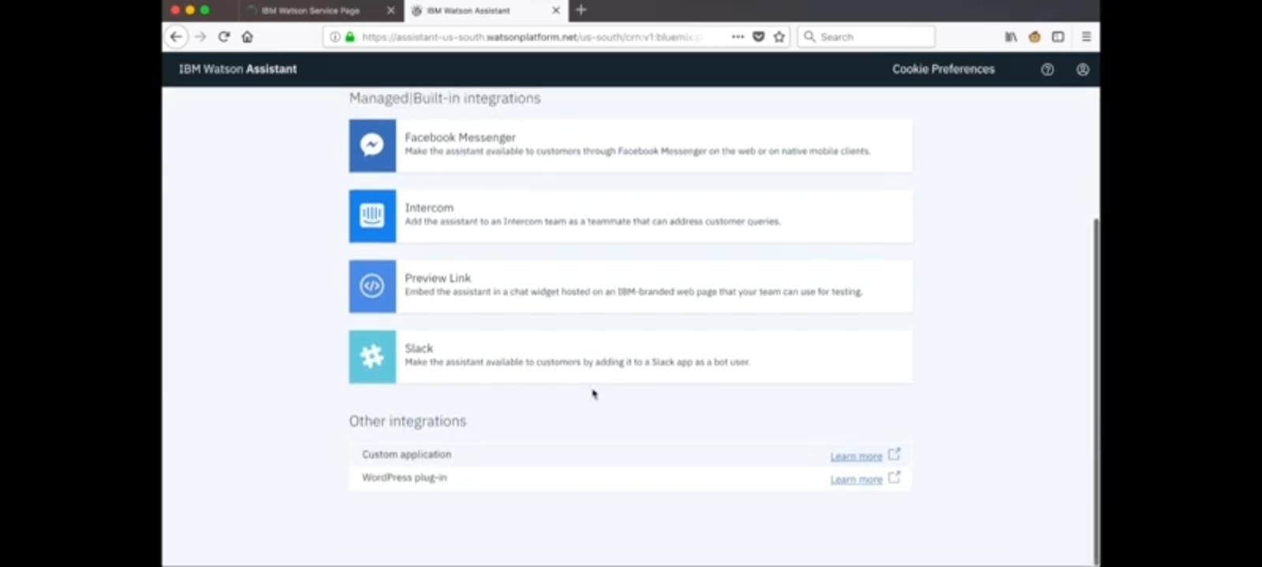

*3.Test Your Integration:*

* Test integration by sending messages to the Slack channel or direct message where the chatbot is configured to respond.
* Ensure that the chatbot replies appropriately and handles user queries as expected.

**Refining Chatbot Responses**:

# *Step 1: Conduct User Testing*

* Invite real users to interact with the chatbot.
* Gather feedback on user experience, clarity of responses, and problem areas.

# *Step 2: Analyse User Interactions*

* Use analytics tools to analyse user interactions.
* Identify common user queries, frequent misunderstandings, and areas where users drop off.

# *Step 3: Iterate on Responses*

* Refine responses based on user feedback and interaction data.
* Rewrite responses to be clearer, more concise, and more userfriendly.

***Step 4: Implement Error Handling:***

* Implement error handling mechanisms for ambiguous queries.
* Ask clarifying questions or offer suggestions when the bot doesn't understand the user's input.

***Step 5: Implement Contextual Understanding*:**

* Use context variables to maintain context across conversations.
* Tailor responses based on user's previous interactions within the same conversation.

# *Step 6: Multilingual Support :*

* If needed we can translate conversation flows and responses into additional languages if user base is multilingual.

***Step 7: Implement A/B Testing:***

* Test different versions of responses to identify which ones users prefer.
* Optimize responses based on the results of A/B testing.

# *Step 8: Human Handoff:*

* If needed we can implement a human handoff feature for scenarios where the chatbot can't assist further.
* Integrate with a live chat system or support ticketing system for seamless escalation to human agents.

