Assignment 3
  - Responsive Web Design · Media Queries + Bootstrap Grid
Name: Miras Zhumazhan | Group: IT-2512
Source repository: https://github.com/mmionya/web-technologies-assignment3

Project and setup
This project is a simple Jamie Paige fan page. It has four sections: an introduction, About the music, albums and frequently asked questions. The page uses local album images, a plain font and standard Bootstrap components.
index.html connects Bootstrap 5.3.8 CSS from its CDN, followed by style.css. The viewport meta tag sets the layout width to the device width. The Bootstrap JavaScript bundle appears before the closing body tag and powers the menu and accordion.

Task 1 · A section with custom media queries
The About the music section (#values) uses only custom classes. Its .values-grid starts with one column. At min-width: 768px it changes to two columns; at min-width: 1200px it changes to three. At 768px, the heading grows from 1.5rem to 1.75rem and the gap grows from 1rem to 1.5rem. This is mobile-first because the phone layout works before either media query applies.
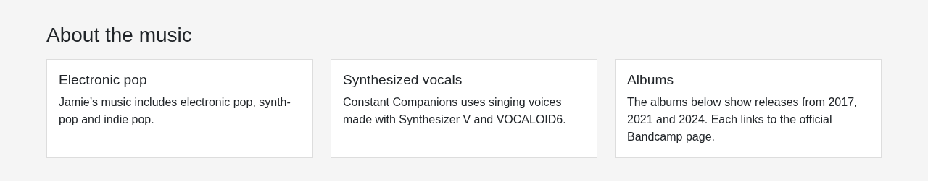
Figure 1. Three custom CSS columns at a 1280 px viewport.
Technical references: https://getbootstrap.com/docs/5.3/getting-started/introduction/ and https://getbootstrap.com/docs/5.3/layout/grid/. Artwork credits and official album sources are recorded in assets/CREDITS.md; README.md includes the component documentation links.

Task 1 · Phone and tablet evidence
The three panels describe electronic pop, synthesized vocals and albums. At 375 px, each panel has its own row. At 768 px, two panels share the first row and the third continues below. CSS Grid shares the available space without fixed panel widths or absolute positioning.
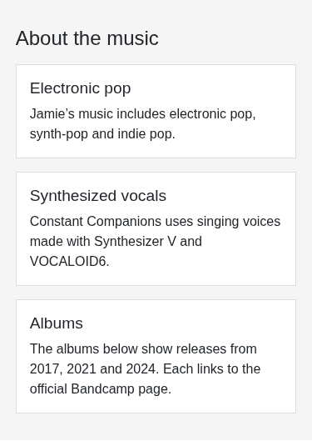  Figure 2. 375 px: one column. | 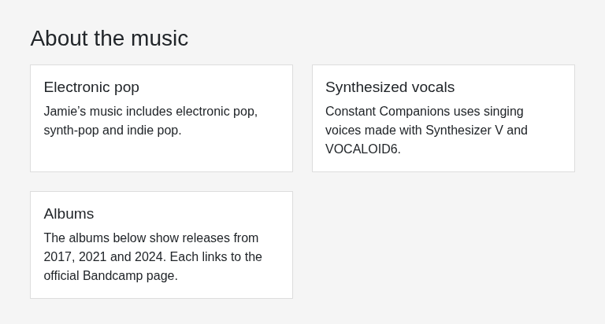  Figure 3. 768 px: two columns.

Task 2 · Bootstrap grid
The album section uses .container, .row and responsive columns: .col-12 .col-md-6 .col-xl-4. Bootstrap's 12-column grid therefore shows one album at 375 px, two at 768 px and three at 1280 px. Bootstrap cards keep the artwork, titles and links together; spacing utilities add consistent gaps.
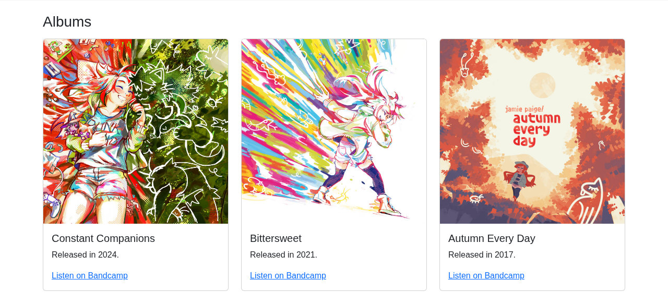
Figure 4. Three Bootstrap album cards at 1280 px.
The introduction uses two Bootstrap columns on wider screens. Responsive order-* classes put the introduction text before the artwork on a phone, so the purpose of the page appears first. On a desktop, the columns sit beside each other.
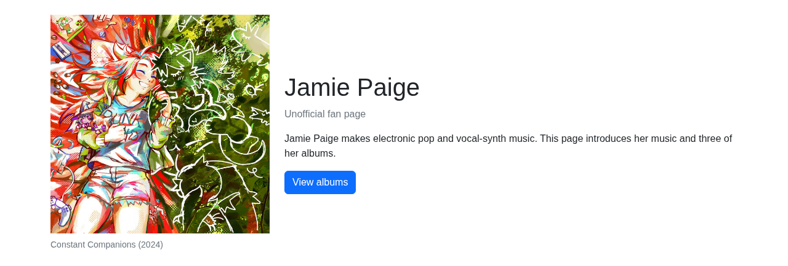
Figure 5. The introduction's two-column desktop layout.

Task 2 · Mobile order and interactive components
The .navbar-expand-lg navigation collapses below 992 px. Its menu button shows links to the page sections. The Unofficial fan page note uses .d-none .d-md-block, so it is hidden below 768 px. The FAQ is a Bootstrap accordion: its buttons show answers using data-bs-* attributes. The page does not need custom JavaScript.
These phone captures show the introduction with text first, the expanded menu, and an open answer. Browser checks also verify all three required viewport widths, both grids, section links, interactive controls and the absence of horizontal scrolling.
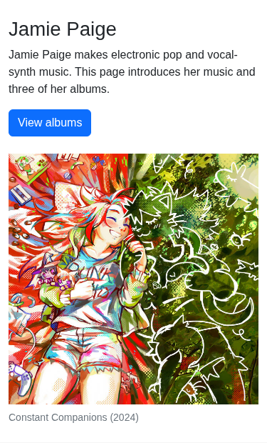  Figure 6. Text comes first at 375 px. | 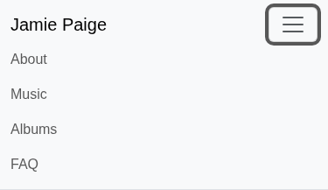  Figure 7. The expanded mobile navigation. | 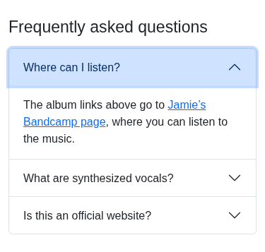  Figure 8. An expanded FAQ answer.

Task 3 · Comparison of the two approaches
Custom CSS at 1280 px (detail: Figure 1). | Bootstrap at 1280 px (detail: Figure 4).
Aspect | Custom CSS: About the music | Bootstrap: albums and introduction
Responsive code | The .values-grid rule defines the base layout; two min-width media queries change its column count. | The album columns use col-12 col-md-6 col-xl-4. Bootstrap already defines the breakpoint rules.
Design control | The heading size and gap change in my own media query in style.css. | Bootstrap supplies column widths, gutters and the standard card appearance. I use its spacing classes.
Changing the layout | To change the desktop count, edit grid-template-columns in the 1200 px media query. | To change the desktop count, edit each album's col-xl-* class; the CSS framework supplies the widths.
Built-in behavior | CSS Grid arranges the three information panels. It does not provide an interactive menu or FAQ. | The Bootstrap bundle handles navbar collapse and accordion state through data attributes.
I would use custom media queries for a small section like About the music, where I want to set the columns and gaps directly. I would use Bootstrap for a whole page that needs common layouts and components, such as the album cards, menu and FAQ. Using both here lets me practise writing responsive CSS and using a framework.

Conclusion
This page shows how a mobile-first layout grows from one column to several columns as more space becomes available. The main difference is where the responsive rules live: in my own media queries or in Bootstrap's predefined classes. Testing at 375, 768 and 1280 px also makes it easier to catch ordering problems, overflow and controls that are difficult to use on a phone.
Validation: tests/check_page.py passed at 320, 375, 768, 1024, 1280 and 1440 px, including both grids, section links, menu and accordion keyboard controls, image loading and no horizontal overflow.

Whole-page screenshot · 375 px
Captured from the implemented page in a real browser. The entire page is included; use the task figures for close-up details.
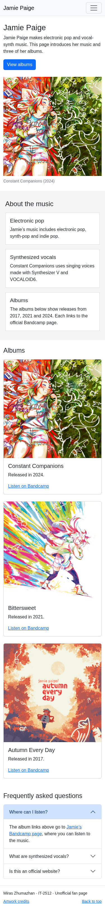
Figure 9. Complete page at a 375 px viewport.

Whole-page screenshot · 768 px
Captured from the implemented page in a real browser. The entire page is included; use the task figures for close-up details.
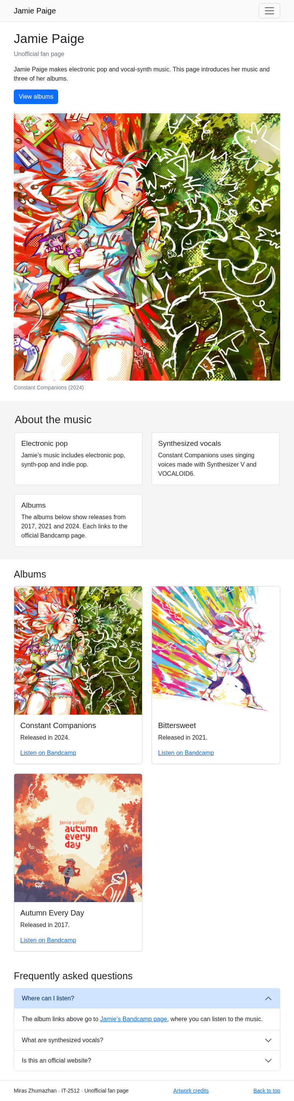
Figure 10. Complete page at a 768 px viewport.

Whole-page screenshot · 1280 px
Captured from the implemented page in a real browser. The entire page is included; use the task figures for close-up details.
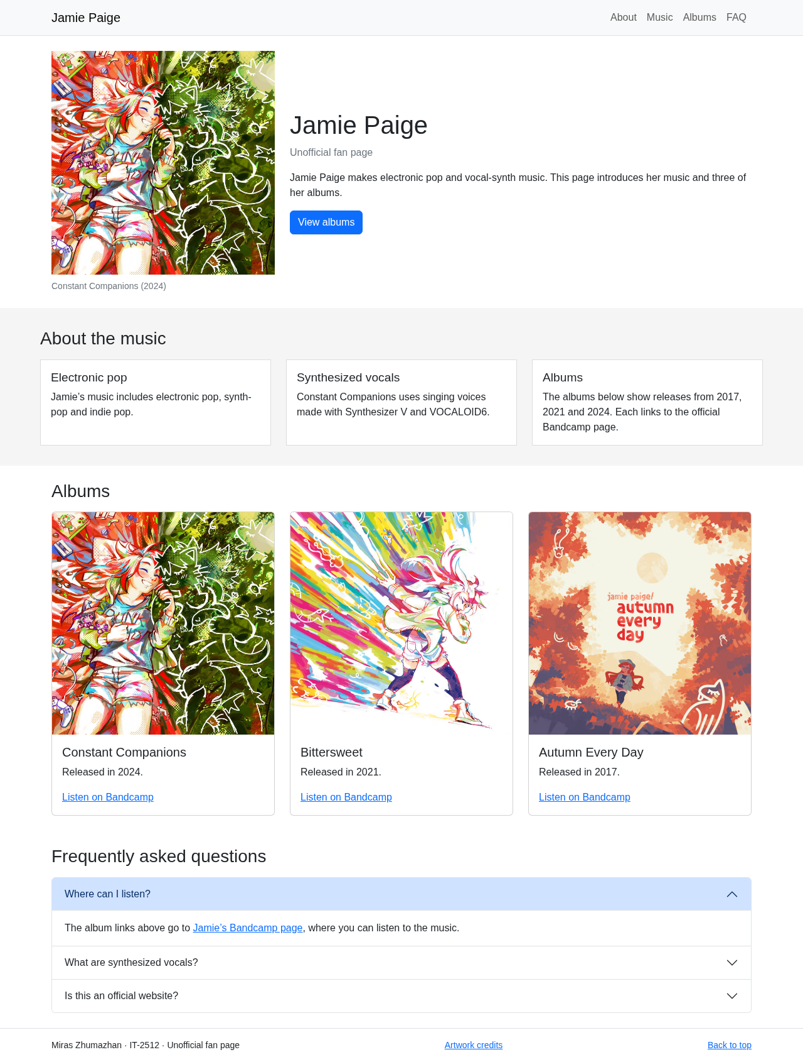
Figure 11. Complete page at a 1280 px viewport.

