**Background**

I work at a large university that has many divisions which are very much decentralized from one another when it comes to things like IT and IT security. Each division has its own IT support groups, its own way of maintaining inventory, its own priorities and objectives when it comes to all things technical. Often, there is even further decentralization within divisions, with departments within them doing their own thing. This has its benefits, but it often makes it difficult for units whose job it is to perform central services.

In my role as a cybersecurity analyst, I'm confronted by this fact daily. Our office is ultimately responsible for the overall security of the university, yet we often lack the visibility into or the authority over its divisions and departments. And while we're asked to report on the overall security posture of the university, it's often somewhat of a guessing game.

One aspect of that security posture is in the realm of endpoint security. Our office contracts with security software vendors to license tools such as malware prevention, firewall services, and vulnerability management. We can't force divisions or departments to use them, but we make them available and we strongly encourage their use.

Recently, we have advocated for a stronger, more active approach to deploying these tools to university endpoints. As with any such effort, leadership is interested in gauging progress, namely how many of the university's endpoints are using the security tools, and how many more do we have to go for a "full" deployment.

The first metric is easy. We have consoles and reports and graphs that we can generate using any given tool. It's the second one, the "denominator" in the equation, that is and has been historically difficult. We don't know how many endpoints each division has, because they don't report those counts centrally. Rather, they maintain them locally, if they maintain them at all. So while we know how many endpoints are secured, we don't know if that represents 50%, 75%, or 100% of the total. (As an aside note, we'll never be able to achieve a "full" deployment. There will always be things like printers, IoT devices, or odd flavours of Linux that don't support installation of the tools on whatever one-off operating system they're running. But we hope to get close, i.e., deploying the tools to as many devices that actually support them.)

I was recently tasked with trying to generate an approximation for how many total endpoints each unit has. That number, along with the counts of tools already deployed, will be included in periodic reports to the head of each division, giving him or her a sense of how "secure" their endpoints are. I put that in quotes because a lot of other factors go into a division's overall security; this is just one of them. But it's an important one, and one that we haven't been able to provide. Now we're able to at least provide an approximation that is based on something more than just a random guess out of thin air.

**Objective**

The goal is to generate approximate endpoint estimates for each division. My approach was to gather data from departments and divisions from which we have known endpoint counts, fit a linear model to that data, and predict endpoint counts based on the coefficients generated by the model.

The data we had with which to create this kind of model was of limited quality. First, we had full-time employee (FTE) counts per department and division (we used March 2022 payroll data). Second, we had mac address counts mapped to IP addresses over a 30-day period during July and August 2022. While the quality of the FTE counts itself was high-fidelity, endpoint counts and FTE counts don't correlate precisely. Likewise, the fidelity of the mac-address data suffers from several problems. First, it is difficult to correlate IP addresses (and, hence, mac addresses) back to a particular division. I created a separate model to do this, but the model is only 81% accurate against validated training data and is likely much less accurate against untested data. Second, the mac address data doesn't account for endpoints that are connected to public or wireless networks, nor does it account for VPN-connected or other remote users.

In addition to FTE and mac address data, a categorical variable (large_unit) was added to account for divisions and departments having atypically high endpoint counts, for example units that host services for other campus units that may require large numbers of servers. We also treated the university's central IT division as a special unit, since it runs many services for campus and will, therefore, have an unusually high endpoint count.

Despite the limitations described above, the model may serve as a rough estimate in the absence of any other means of quantifying endpoint counts. These numbers are only to be used with a heavy disclaimer and not to be used as a checklist against which to measure the true progress of any school, college, or division in deploying security software to their endpoints.

**Data Sources**

For the first data set, we queried mac address counts from a database that tracks mac and IP information for the last 30 days. Example data:

|  |  |
| --- | --- |
| **Subnet** | **Count** |
| 10.1.1.0/24 | 200 |
| 10.1.2.0/24 | 50 |

There were approximately 32,000 subnet records like the above. These counts had to be correlated back to a division code; historically this has always been a challenge, since the network database does not tie a subnet record to a division code. However, each subnet *is* tied back to the staff members who administer it. And from these staff members we can query the university's WhoIs database to glean the division code for each of those staff members. This isn't always reliable, as the staff member isn't necessarily a member of the division the subnet belongs to. But it is right often enough that the information is useful to the model.

To overcome these challenges, I combined the contact-based division predictions with a natural language processing (NLP) model based on document similarity. The subnet names and descriptions were quantitatively compared with terms scraped from websites mapped back to a particular division To calculate the "best" division match, the division with the smallest Jaccard distance was weighted more heavily than those with larger distances. Additional "institutional knowledge" was also used to weight some divisional predictions more heavily than others.

With the aim of correlating endpoint counts directly to FTE counts, we collected the 2022 FTE counts from university HR records. Example data:

|  |  |
| --- | --- |
| **Unit** | **FTE Count** |
| Axx9100 | 177.5 |
| Axy3205 | 22.0 |

We also have a list of 46 departments and divisions that have “full” or “near-full” deployments. For the purposes of estimating total counts, we’ll consider these counts as a “full” deployment upon which to base our model. Along with this list, we identified 13 departments as being potentially “large” units, i.e. ones that have an atypically high endpoint count.

In addition, we have counts of the security tools we’re interested in deploying:

|  |  |  |
| --- | --- | --- |
| **Unit** | **Tool** | **Deployed Count** |
| Axx9100 | Antimalware | 100 |
| Axx9100 | Vulnerability management | 98 |
| Axy3205 | Antimalware | 5 |
| Axy3205 | Vulnerability management | 0 |

What we want to end up with is something like this:

|  |  |  |  |  |  |  |  |
| --- | --- | --- | --- | --- | --- | --- | --- |
| **Unit** | **Full**  **Unit** | **Large**  **Unit** | **Mac Addr**  **Count** | **FTE Count** | **Total**  **Endpoints** | **Antimalware**  **Count** | **Vuln Mgmt**  **Count** |
| Axx9100 | Yes | Yes | 210 | 177.5 | 100 | 100 | 98 |
| Axy3205 | No | No | 50 | 22.0 | ? | 5 | 0 |
| Axz4590 | No | Yes | 400 | 275.0 | ? | 200 | 150 |

And from there we can calculate the percentage deployment of each tool.

**Data Exploration**

First, we’ll look at a sample of the data we have for fully deployed units, which we’ll base the model on.

Here are the endpoint counts vs mac address:

And the endpoint counts vs FTE counts:

Box plots of endpoint count vs large_unit. Note that a unit can be large due to sheer size (as in the case of the outlier shown below) or can be disproportionately large given its relatively smaller FTE count. The latter is what we’re considering a “large unit.”

**Modeling**

To start with, I tried linear models with no transformations, including the following:

'endpoint_ct ~ mac_ct',

'endpoint_ct ~ fte_ct',

'endpoint_ct ~ fte_ct + mac_ct',

'endpoint_ct ~ fte_ct + mac_ct + fte_ct:mac_ct',

'endpoint_ct ~ mac_ct + large_unit',

'endpoint_ct ~ fte_ct + large_unit',

'endpoint_ct ~ large_unit + fte_ct + mac_ct',

'endpoint_ct ~ large_unit + fte_ct + mac_ct + fte_ct:mac_ct',

'endpoint_ct ~ fte_ct + large_unit + fte_ct:large_unit',

'endpoint_ct ~ fte_ct:large_unit',

'endpoint_ct ~ fte_ct + large_unit + central_it',

'endpoint_ct ~ fte_ct + large_unit:fte_ct + central_it:fte_ct',

'endpoint_ct ~ fte_ct + large_unit:fte_ct + central_it',

'endpoint_ct ~ fte_ct + large_unit + central_it:fte_ct',

'endpoint_ct ~ fte_ct + large_unit: central_it’

The first few model results are displayed below:

All results above resulted in residuals that were heteroschedastic and not normally distributed. Therefore, I tried transforming the data using Box-Cox, log, square root, and cubed root transforms. The results were much more favourable:

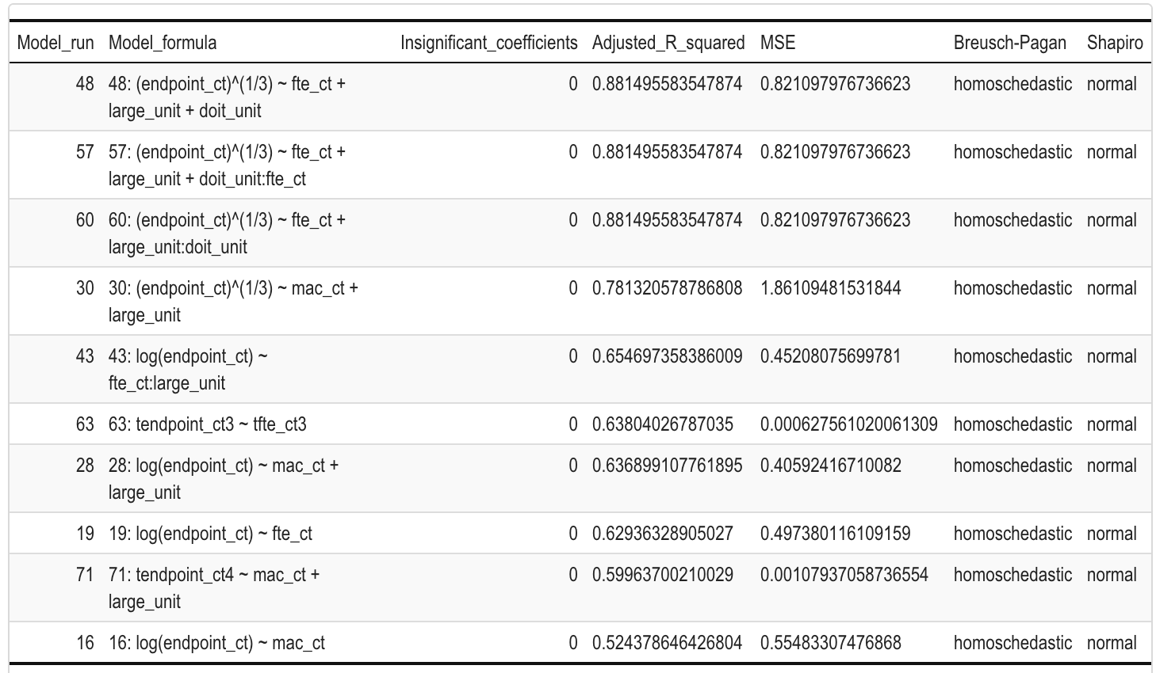

**Model Selection**

Selecting the model with the best adjusted R-squared value, residuals appear both homoschedstic and normally distributed:

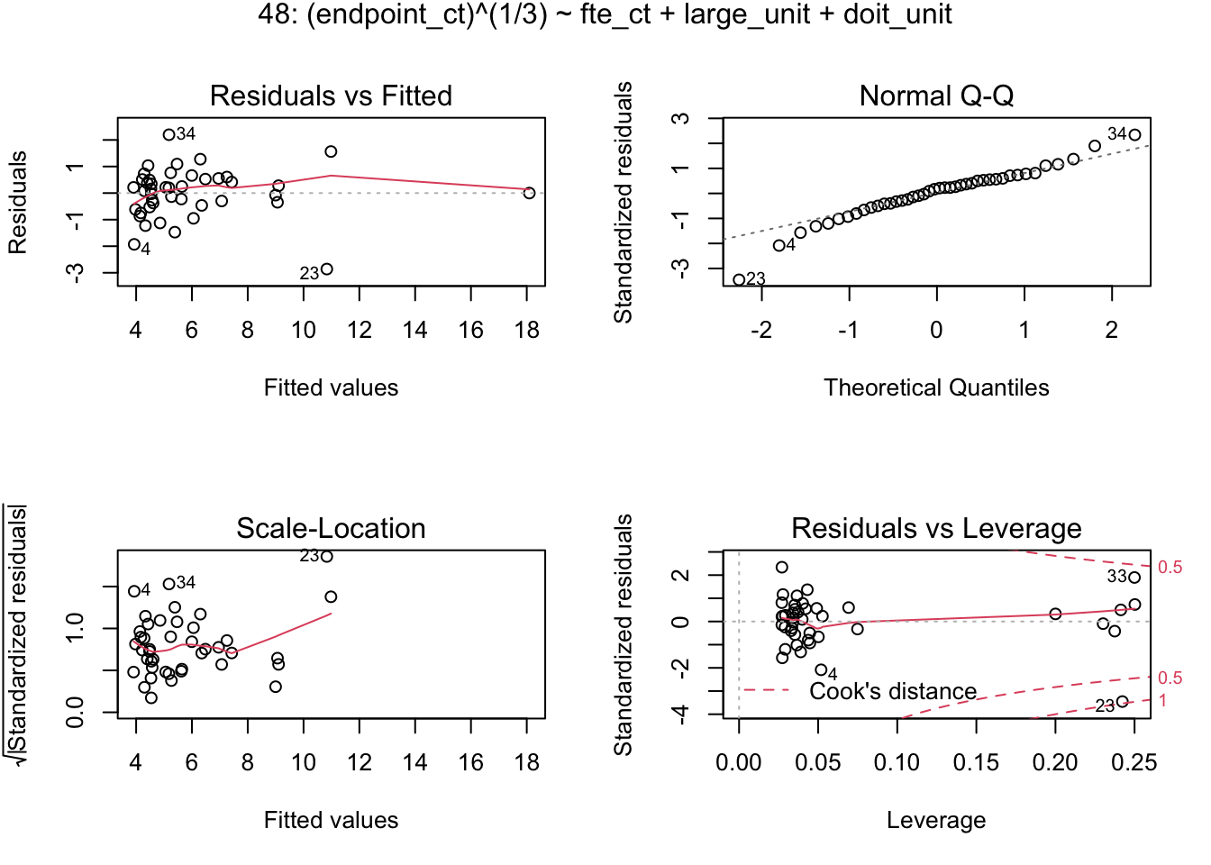

Half-normal plots showing leverage points:

The model summary is as follows:

## [1] "----------------------------------------------------------------------------------------------"

## [1] "48: (endpoint_ct)^(1/3) ~ fte_ct + large_unit + central_it"

##

## Call:

## lm(formula = lmod_form[i], data = dfagg, na.action = na.omit)

##

## Residuals:

## Min 1Q Median 3Q Max

## -2.8602 -0.4185 0.1553 0.5189 2.1964

##

## Coefficients:

## Estimate Std. Error t value Pr(>|t|)

## (Intercept) 3.786386 0.228337 16.582 < 2e-16 ***

## fte_ct 0.016042 0.001832 8.759 9.49e-11 ***

## large_unitTRUE 2.961911 0.465233 6.367 1.60e-07 ***

## central_itTRUE 6.218259 1.225994 5.072 9.98e-06 ***

## ---

## Signif. codes: 0 '***' 0.001 '**' 0.01 '*' 0.05 '.' 0.1 ' ' 1

##

## Residual standard error: 0.9515 on 39 degrees of freedom

## (3 observations deleted due to missingness)

## Multiple R-squared: 0.89, Adjusted R-squared: 0.8815

## F-statistic: 105.1 on 3 and 39 DF, p-value: < 2.2e-16

Model analysis:

[1] "--------------------------------------------------"

## [1] "48: (endpoint_ct)^(1/3) ~ fte_ct + large_unit + central_it"

## lm(formula = lmod_form[i], data = dfagg, na.action = na.omit)

## [1] "Shapiro test for normality: The p-value of 0.264955772266619 is > 0.05, so do not reject the null; i.e., the residuals are normal."

## [1] "Breusch-Pagan test for homoschedasticity: The p-value of 0.110013821492618 is > 0.05 and the test statistic of 6.03303904016363 is < 10, so don't reject the null; i.e., the residuals are homoschedastic."

## [1] "Adjusted R-squared value: 0.881495583547874"

## [1] "Mean squared error: 0.821097976736623"

## [1] "Leverage point cutoff: 0.232558139534884"

## [1] "Variance inflation factor (VIF):"

## fte_ct central_itTRUE large_unitTRUE

## 1.651449 1.621655 1.056396

As shown, there is very strong correlation between FTE count and endpoint count. The Shapiro test confirms normality of residuals, and the Breusch-Pagan test confirms homoschedasticity. In addition, the variance inflation factor (VIF) indicates only slight collinearity among predictors, which isn’t a cause for concern.

The formula and confidence intervals for the selected model:

## [1] "(endpoint_ct)^(1/3) ~ fte_ct + large_unit + central_it"

## [1] "(Intercept): 3.7863864232126 +/- 0.384718839051336 (3.40166758416127, 4.17110526226394)"

## [1] "fte_ct: 0.0160415146800718 +/- 0.00308588481810908 (0.0129556298619628, 0.0191273994981809)"

## [1] "large_unitTRUE: 2.96191104682989 +/- 0.783858809519685 (2.1780522373102, 3.74576985634957)"

## [1] "central_itTRUE: 6.21825878930115 +/- 2.06564624528395 (4.1526125440172, 8.2839050345851)"

The (redacted) predicted endpoint counts:

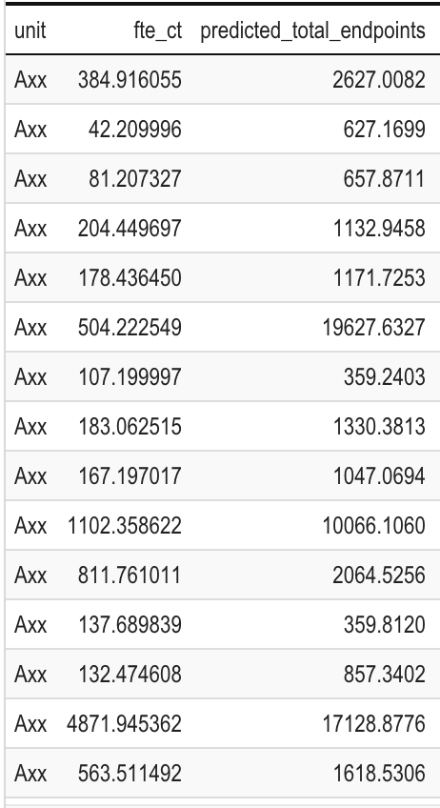

**Conclusion**

In conclusion, there is good statistical evidence to support a very strong linear model correlating endpoint count to FTE count, with additional categorical variables of large_unit and central_it. Commonly used techniques to evaluate the model's residuals indicate that the model is valid. However, the 90% prediction interval includes a wide range of values; while I’m redacting the exact numbers from this post, the difference between the upper and lower bounds was about 120,000, greater than the predicted mean. So while there should be no expectation that this estimate is close to accurate, it may nonetheless serve as a basis for further evaluation.