**CSV Upload Web Interface**

**CSV Upload Web UI:**

After authentication user can access below page to upload csv:

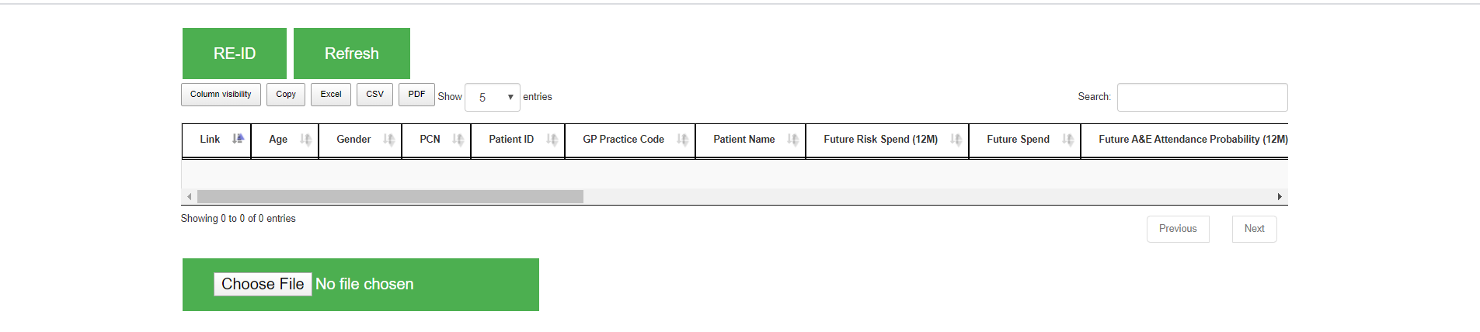

User need to click Choose File to attach a CSV:



It will prompt and select a downloaded file. Once uploaded data will show in Grid:

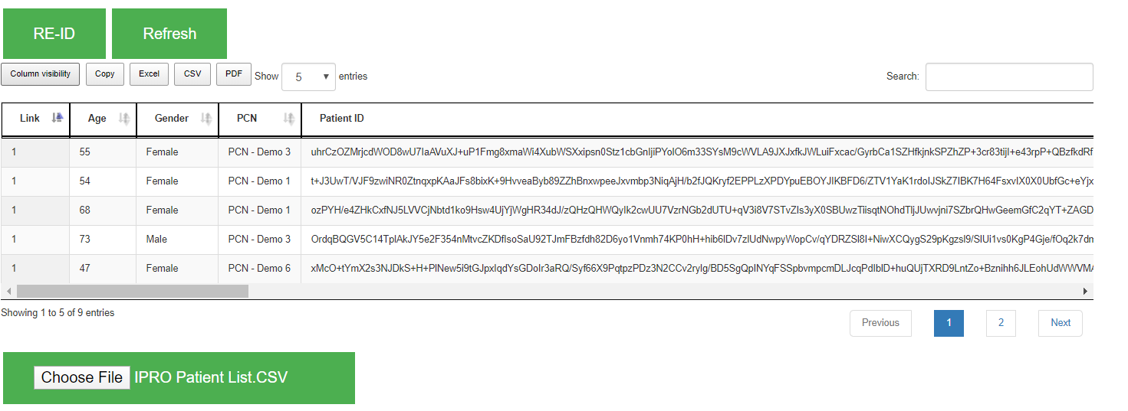

@Note: Data still encrypted as you can see patient Id.

**Re-ID Button:**

To Re-Id the Patient Id. User need to click on Re-Id button and it will start processing to Re-Id the Data.



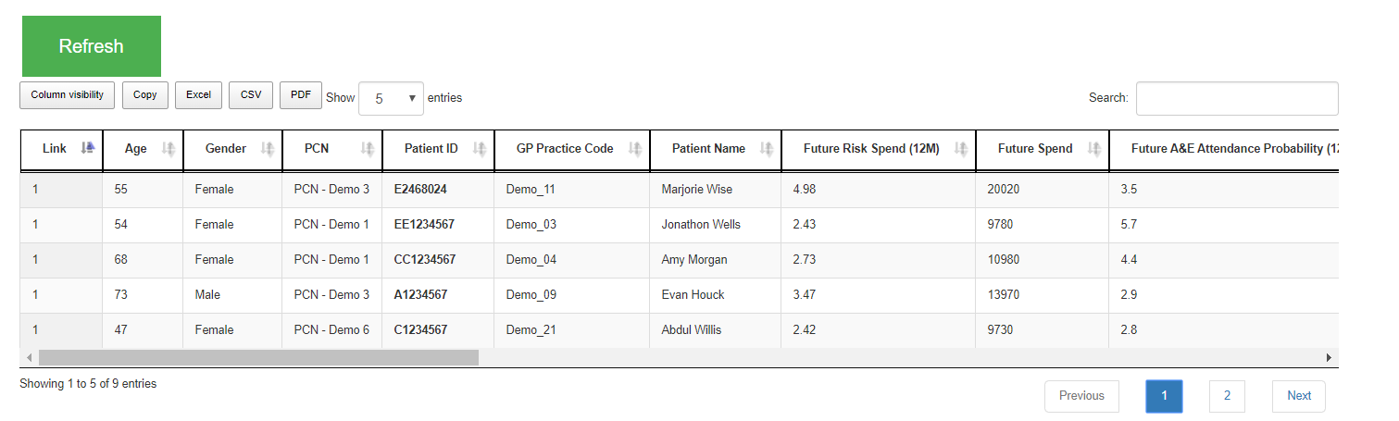

@Note: Patient Id decrypted. Once Re-Id the content. Re-Id button will be hidden and user can work on above data only.

If user want another csv to upload. User need to click Refresh button and it will clean the Grid.



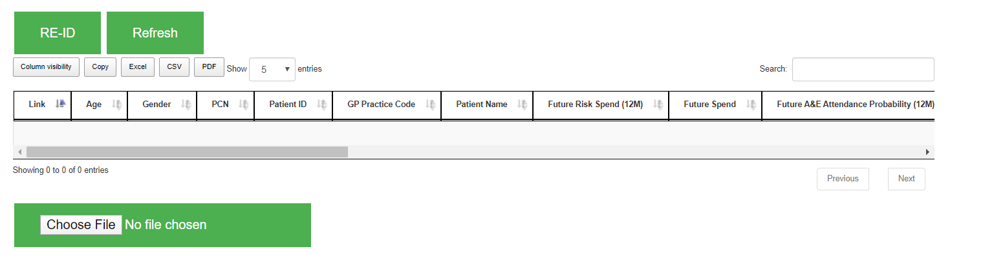

Note: After Refresh. Again Re-Id will appear to Re-Id the new content.

**Grid Features:**

User can customize the columns according to there requirement:

* **Sort by each column**
* **Drag and Drop column**
* **Hide/Unhide Column**
* **Searching**
* **Export Format (CSV, Excel,PDF etc)**
* **Pagination (Dynamic)**

**Sorting:**

**Sorting in Ascending or Descending Order:**

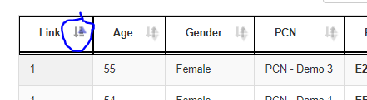

**Searching:**

**Search By content:**

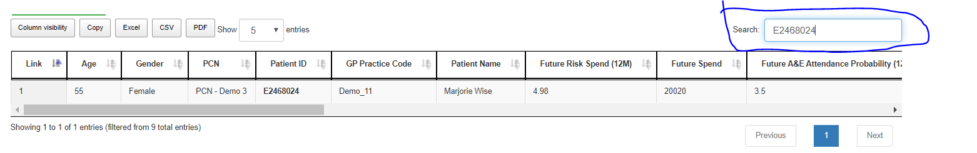

**Hide/Unhide Column:**

**User can hide/unhide column by below button:**

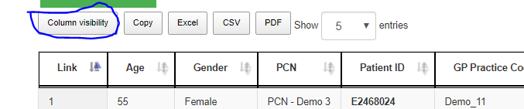

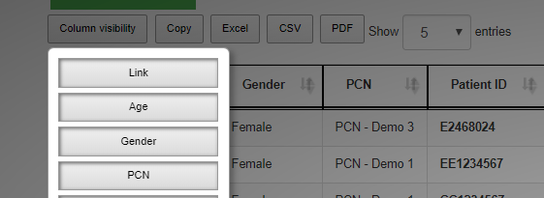

**Drag and Drop Column:**

**Each user can drag and drop the column according to there requirements:**

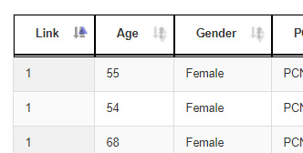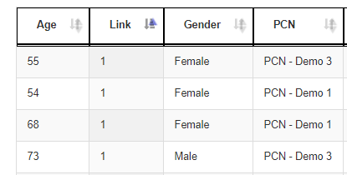

**Export CSV Files:**

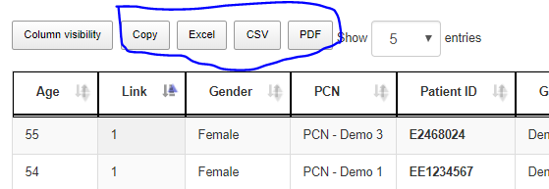

**Pagination:**

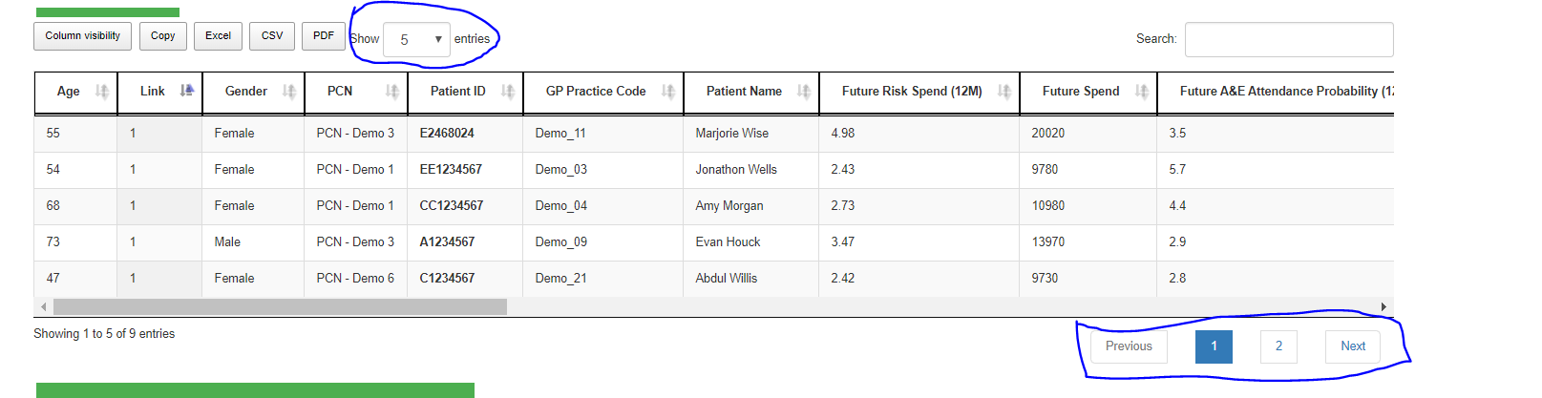

**User Can see the Each records in details way by clicking on row:**

**Grid Format:**

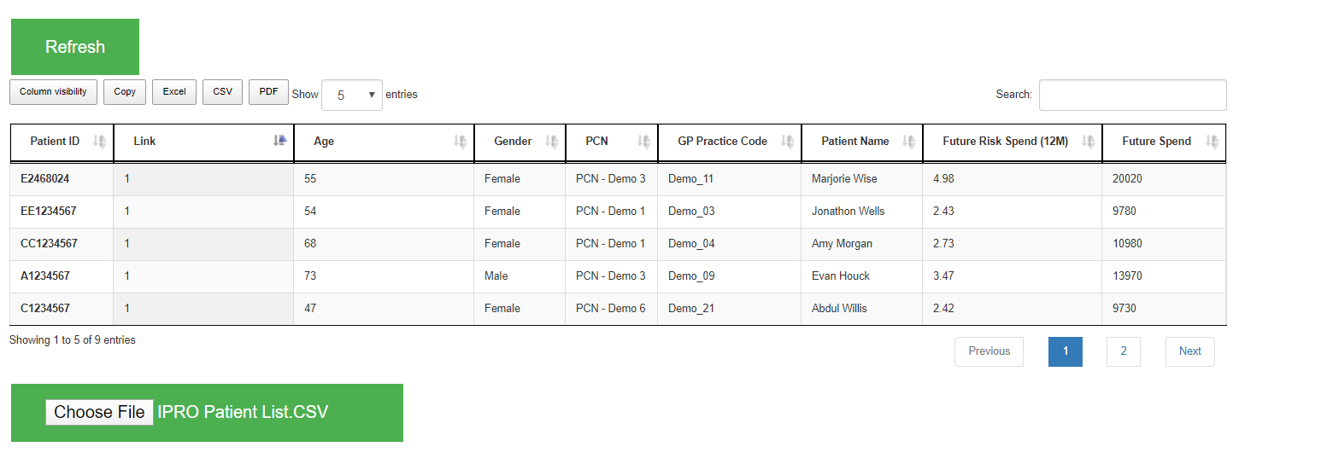

**Details:**

