**LMS**

Import application via github :

<https://github.com/mmishra77790/lms.git>

Start app via eclipse :

Application.java :

Run -> Run as Java Application

Or

java -jar lms.jar

**Once started :**

**Access application via below url :**

<http://localhost:8084/>

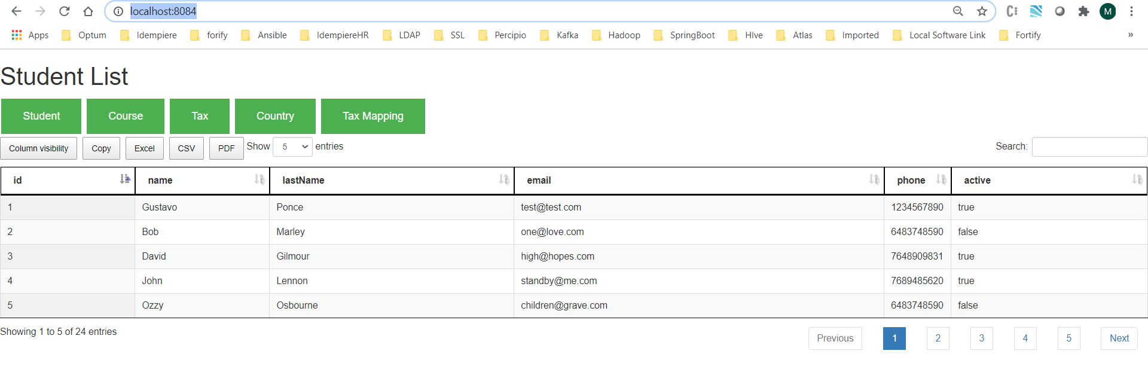

Its load the student list which is dynamic loaded from in-memory h2 database via hibernate.

Added few features like Searching, Sorting, Pagination, Drag and Drop etc

To load more student add a insert query in data.sql file

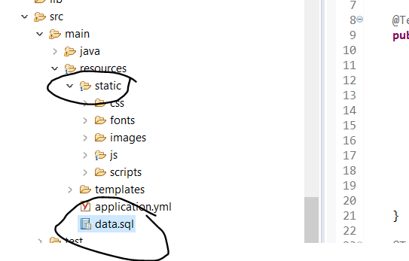

@Note : For Static content too ^^.

For Test cases :

Added two package for testcases util and model :

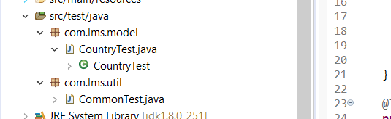

Total 10 testcases added :

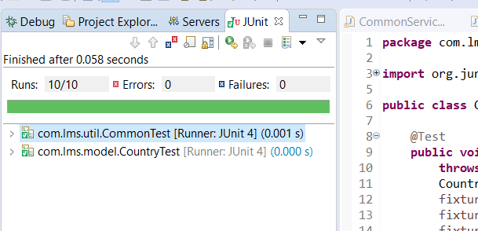

For Swagger configuration:

<http://localhost:8084/swagger-ui.html>

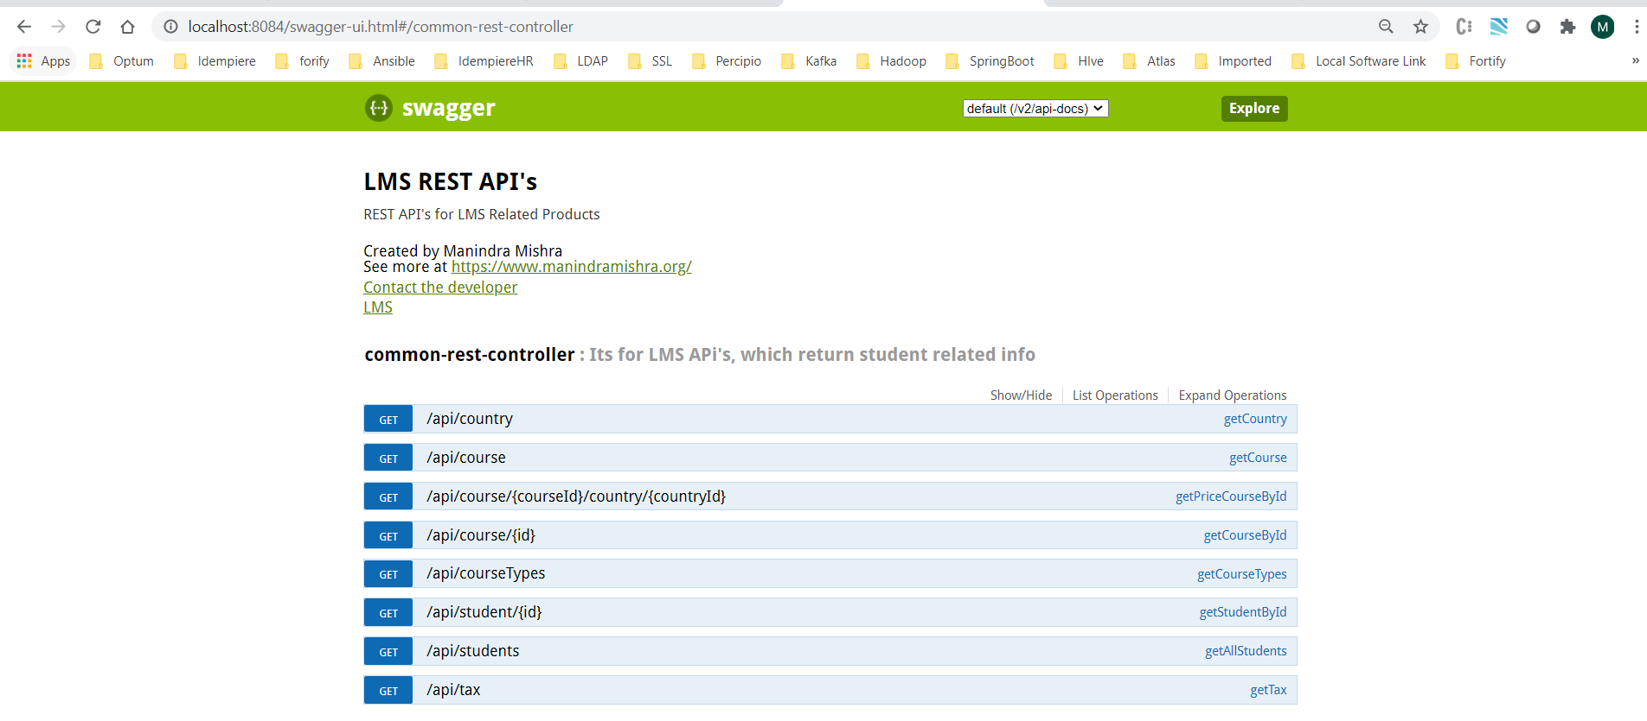

**Call via postman or Swagger itself :**

All logic manage by properties level as of now :

Course Type

Course

Tax

Country

Course Price By Country

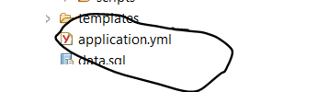

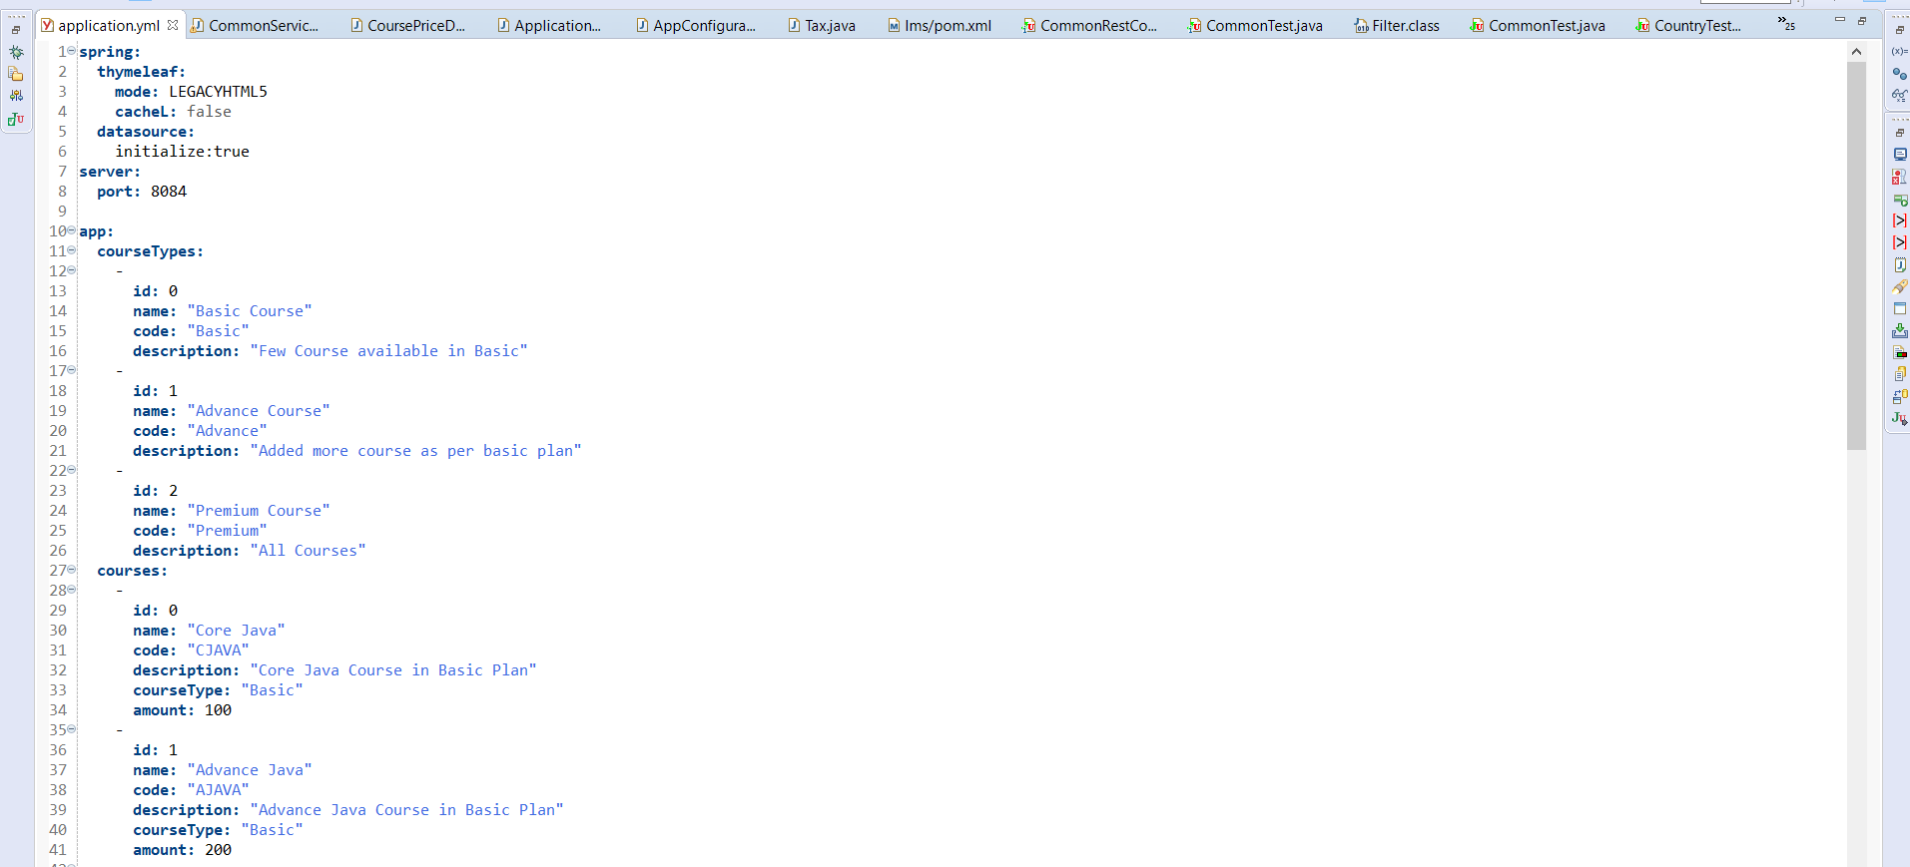

API Call :

Via Swagger :

**For Country:**

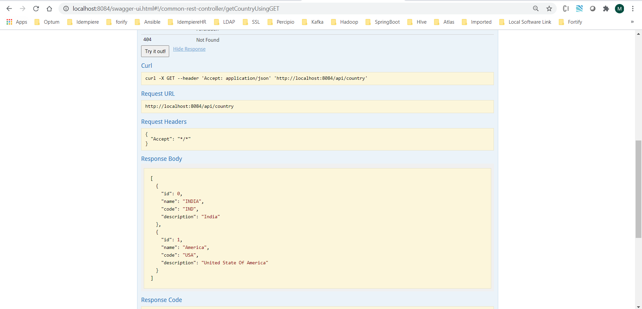

Via Postman :

Course API : http://localhost:8084/api/course

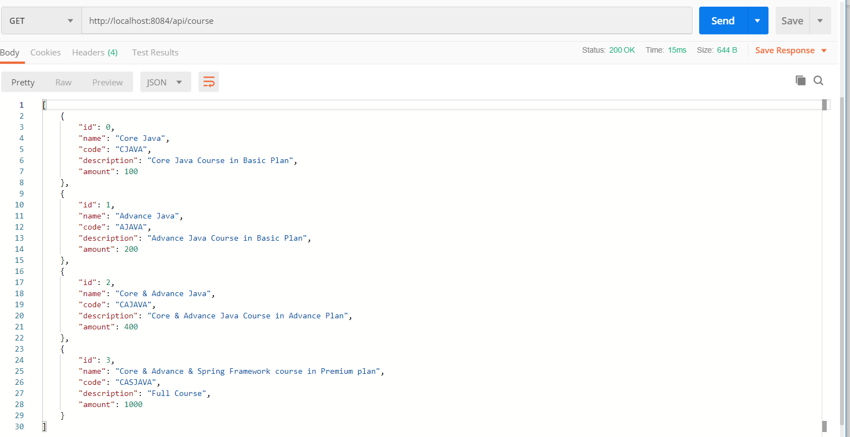

TAX API : http://localhost:8084/api/tax

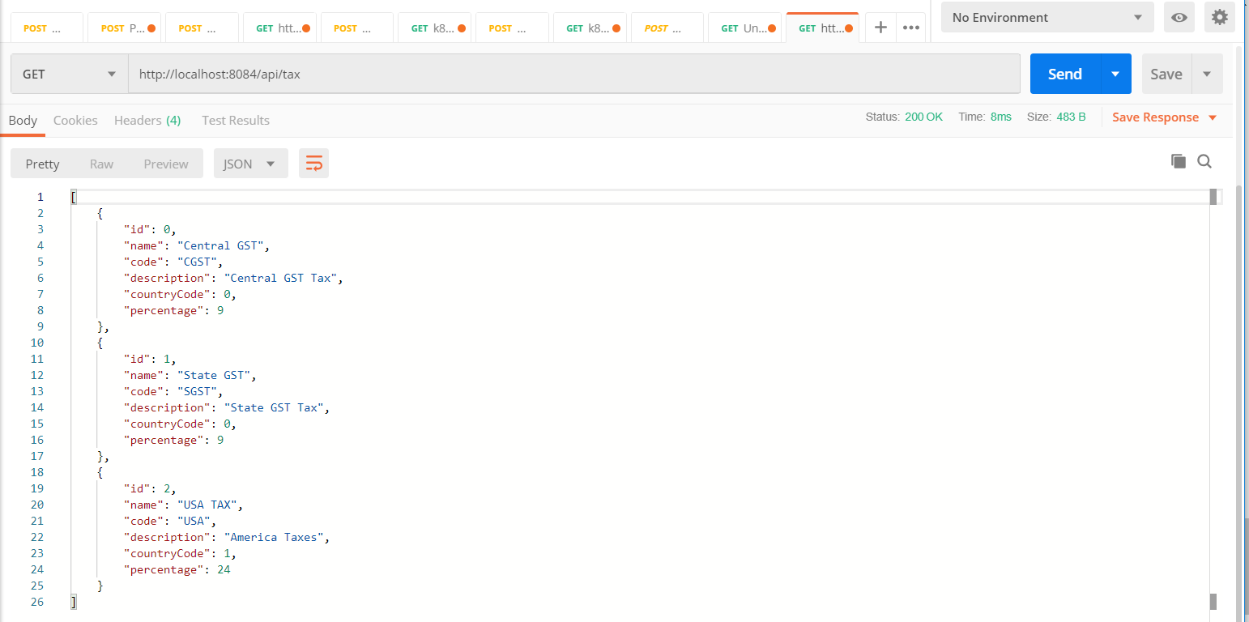

Final API (Priced As per Country) :

Using Above API’s find the course Id and country Id :

As country ID for India is 0 So priced including taxes :

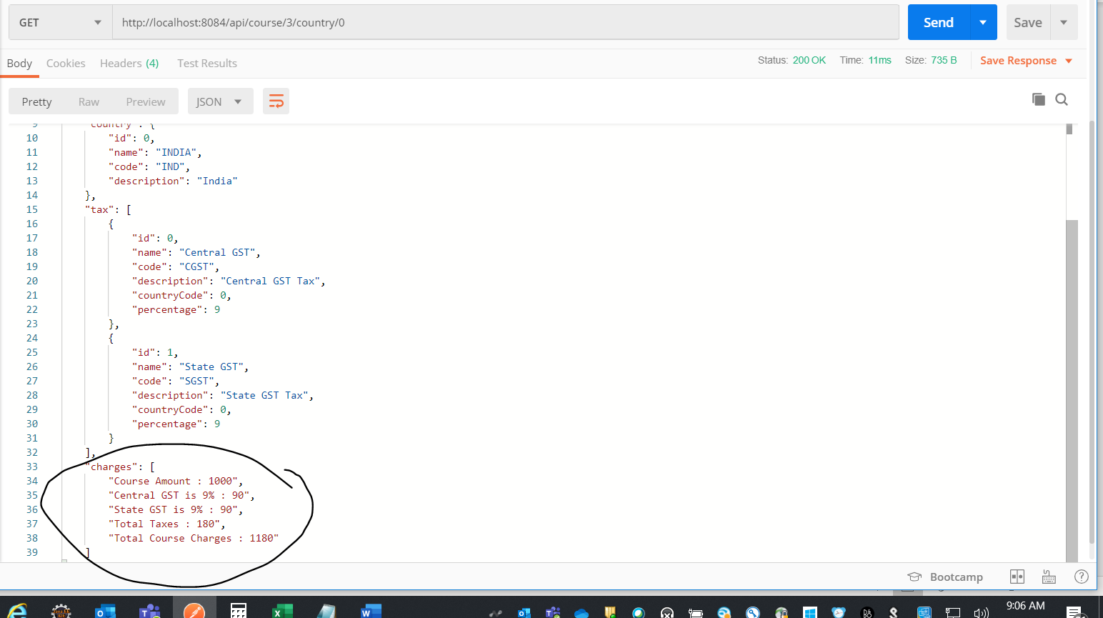

As country ID for USA is 1 So priced including taxes :

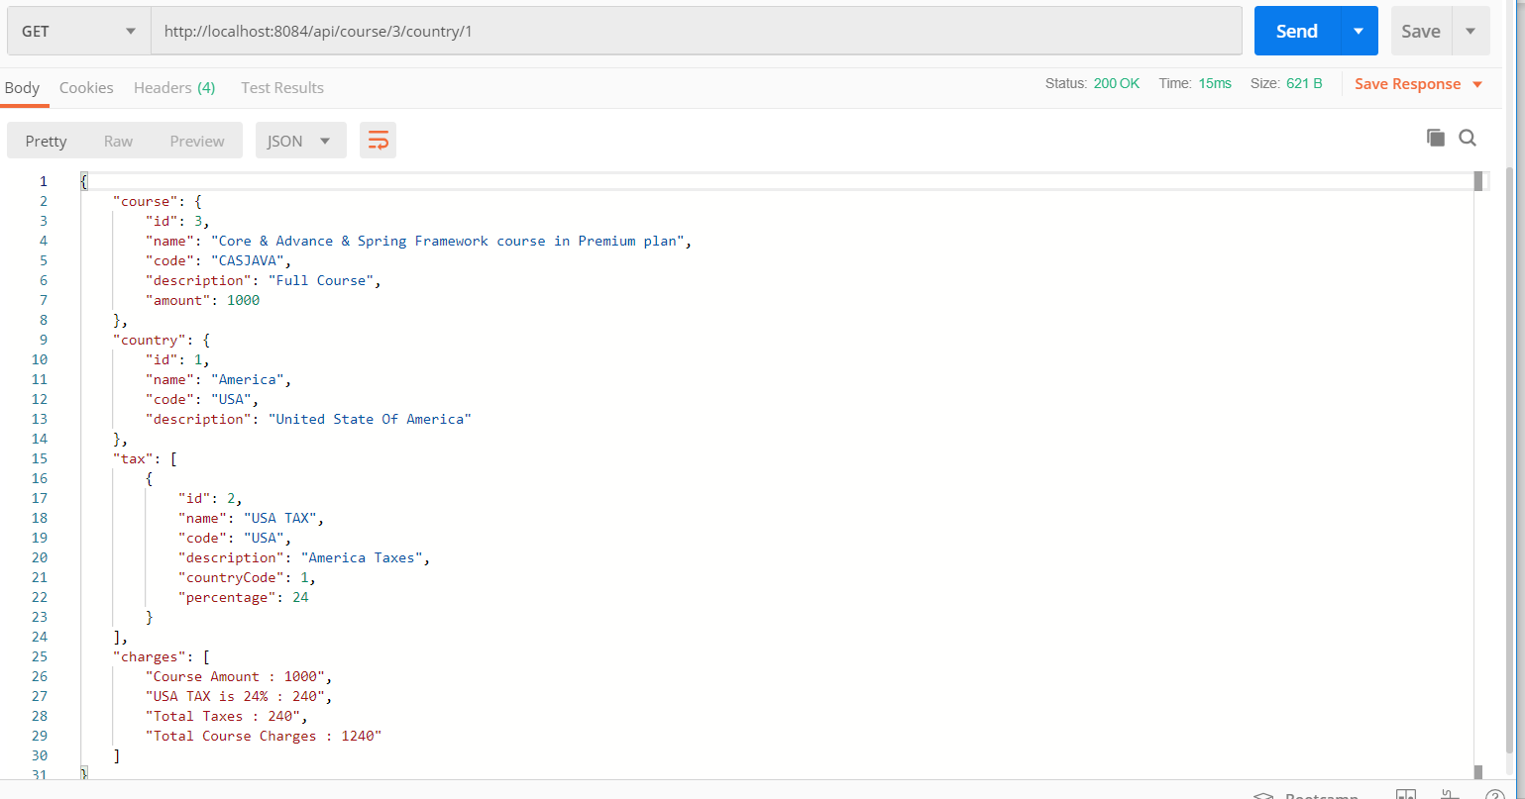

@Note : Taxes, Course, Country is dynamic. Please add a list in properties so you can priced of course via above API’s

Reports :

