# FE

Node.js v18.10.0

Angular CLI 15.2.2

# BE

.net SDK 6

<https://dotnet.microsoft.com/en-us/download/dotnet/thank-you/sdk-6.0.310-windows-x64-installer>

MS SQL server 2019  
<https://www.microsoft.com/en-us/download/details.aspx?id=101064>

Visual Studio 2022  
<https://visualstudio.microsoft.com/vs/community/>

1. In Visual Studio, Solution explorer right click on “Budget” solution and click on “Restore Nugets Packages.”

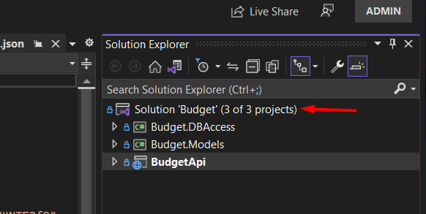

1. After all the packages required by solutions are installed, right click again an select “Build solution”.
2. Again, from solution explorer in Visual studio expand BudgetApi and select appsettings.json file.
3. Setup connection string in BudgetApi/appsetting.json. Use username and password that is set during ms sql server instalation.

1. Make sure that sql server is running.
2. Select Package Manager Console on bottom left or open it from Tool>NuGet Package Manager>
3. Type in update-database command and run.
4. In Solution exlporer select “BudgetApi” project and click on start. Browser should popup with swagger opened.