

**Business Requirements Documents**

Prepared for

[Public Prosecution ]

[23/01/2016]

Version Draft

Prepared by

acer

[]

Contributors

KarthikTageela

Dhivahar

Prasad KT

Revision and Signoff Sheet

Change Record

|  |  |  |  |
| --- | --- | --- | --- |
| Date | Author | Version | Change reference |
| 19 Aug 2015 | ArunRamar,KarthikTageela | 0.1 | First Revision |
| 21 Aug 2015 | KarthikTageela | 0.2 | Second Revision |
| 27 Aug 2015 | KarthikTageela | 0.3 | Third Revision |
| 23 Oct 2015 | KarthikTageela | 1.1 |  |
| 21 Dec 2015 | KarthikTageela | 1.2 |  |
| 12 Jan 2016 | Dhivahar | 1.3 |  |
| 2 Feb 2016 | Dhivahar | 1.4 |  |
| 23 Feb 2016 | KarthikTageela | 1.5 |  |
| 12 March 2016 | KarthikTageela | 1.6 |  |
| 28 March 2016 | Dhivahar | 1.7 |  |

Reviewers

|  |  |  |  |
| --- | --- | --- | --- |
| Name | Version approved | Position | Date |
| Ahmad Sukker |  |  | 25 Aug 2015 |
|  |  |  |  |
|  |  |  |  |

Table of Contents

1 Definitions and Terms 6

2 Project Overview 6

2.1 Back ground and Business Problem 6

2.2 Purpose and Benefits 6

2.2.1 Development Approach 8

2.3 Portal Implementation Scope 8

3 Business Perspective 8

3.1 Target Audiences 8

3.2 Business Value 8

3.3 Business Processes 9

4 GAP Analysis (Current State vs. Future State) 9

4.1 Current State 9

4.2 Future State 11

5 Business Requirements 12

5.1 Functional Requirements 12

5.1.1 User Authentication – Single Sign-on 12

5.1.2 E-Services 12

5.1.3 Administration 13

5.1.4 News 14

5.1.5 Events and Announcement 15

5.1.6 Poll / Survey 15

5.1.7 Weather 16

5.1.8 Search 16

5.1.9 Bilingual support 16

5.1.10 Analytical Services 16

5.1.11 Google Maps API 17

5.1.12 Social Media and Collaboration 17

5.1.13 Gallery 17

5.1.14 Portal home Page components and its functionalities 18

5.1.15 Language 19

5.1.16 Site map 19

5.1.17 Connect with us 20

5.1.18 Links 20

5.2 Non-Functional Requirements 21

5.2.1 Manageability 21

5.2.2 Usability 21

6 User Perspective 21

6.1 User Profiles 22

6.1.1 Actor 1: Public User 22

6.1.2 Actor 2: Authenticated User 22

6.1.3 Portal user Profiles 22

6.1.4 Administrator user Profiles 22

6.2 Use cases and Usage Scenarios 22

6.2.1 User Registration 23

6.2.2 User Authentication 24

6.2.3 Password Reset (Self-Service) 25

6.2.4 New Service: Appeal 25

6.2.5 New Service: Collecting Documents 28

6.2.6 New Service: Correcting Mistake in Judgment Material 30

6.2.7 New Service: Decision of Appeal 33

6.2.8 New Service: Deposit Money in favour of Plaintiff / in Case Custody 36

6.2.9 New Service: Disburse Interpreter Fees 39

6.2.10 New Service: Disburse Expert Fees 42

6.2.11 New Service: Ending a Custody against a Juvenile 44

6.2.12 New Service: Exchange of Bail 47

6.2.13 New Service: Fine Retrieval Request 49

6.2.14 New Service:International Arrest Warrant 52

6.2.15 New Service:Lawyer Profile 56

6.2.16 New Service:Medical Treatment Release 58

6.2.17 New Service:Paying the Fine Imposed by Court 62

6.2.18 New Service:Payment of Lawyers Fee 65

6.2.19 New Service:Provide Financial/Personal Bail 67

6.2.20 New Service:Receiving of Corpse 71

6.2.21 New Service:Referral of Inmate 73

6.2.22 New Service:Review 78

6.2.23 New Service:Prosecution Side Appeal 80

6.2.24 Existing Service:Adjourn a Session or Fix New Date 83

6.2.25 Existing Service:Case Copy 86

6.2.26 Existing Service:Case Information 89

6.2.27 Existing Service:Copy of Judgment 92

6.2.28 Existing Service:Copy of Non-Suit Order 94

6.2.29 Existing Service:Drop Court Imposed Penalty Due to Prescription 97

6.2.30 Existing Service:Exhumation Service 100

6.2.31 Existing Service: Expiration of Penal Case 102

6.2.32 Existing Service: Fine Difference Reimbursement 105

6.2.33 Existing Service: Meeting a Prosecutor/Chief Prosecutor 108

6.2.34 Existing Service: Opening of Memorandums 110

6.2.35 Existing Service: Passport Renewal 112

6.2.36 Existing Service: Payment by Installment the fine imposed by court 115

6.2.37 Existing Service: Photocopy of Case Dropping Decision 118

6.2.38 Existing Service: Postpone the execution of restricted freedom punishment of convicts 120

6.2.39 Existing Service: Receiving of Deposits & Reserve 123

6.2.40 Existing Service: Request for appeal in cassation 126

6.2.41 Existing Service: Receiving of Passport 129

6.2.42 Existing Service: Rehabilitation 132

6.2.43 Existing Service: Return of Bail Amount 134

6.2.44 Existing Service: Stop Searching/Cancellation of Arrest Warrant 136

6.2.45 Existing Service: Objection to Execution of Judgement 139

6.2.46 Existing Service: Subscribing in SMS Service 142

6.2.47 Existing Service: To Whom It May Concern Certificate 145

6.2.48 Existing Service: Visiting a Provisional Detainee 147

6.2.49 Existing Service: Waiver Enclosuer 150

6.2.50 E-Service Payment 152

6.2.51 Configure Database Timeout 153

6.2.52 Configure and Publish News 154

6.2.53 Configure and Publish Events / Announcements 157

6.2.55 Existing Service: 159

6.2.56 Existing Service: Search Lawyers 161

6.2.57 Existing Service: Search Experts 164

6.2.58 Existing Service: Search Translators 166

6.2.59 Existing Service: Contact us 168

6.2.60 Newsletter Subscription(User) 171

6.2.61 Newsletter Subscription(Admin) 172

7 Appendix: Sources of Information 173

7.1 Error Message Guide 173

7.2 Mail Format For E-Service Request 175

7.3 Paid Service Details 175

1. Definitions and Terms

In this section we are going to list all the used abbreviations within this document and the definitions as well

|  |  |
| --- | --- |
| Definition | Details / Definition |
| OAM | Oracle Access Manager |
| ADF | Application Development Framework |
| OHS | Oracle HTTP Server |
| PP | Public Prosecution |
| UAE | United Arab Emirates |
| ADSIC | Abu Dhabi Systems & Information Centre |
| SSO | Single Sign On |
| SEO | Search Engine Optimization |

Table 1: Abbreviation & Definitions

1. Project Overview
   1. Back ground and Business Problem

Public Prosecution Office has a need to revamp their existing web-portal (www.pp.gov.ae) to comply with the requirement specifications for both UAE and ADSIC Government websites.

Public Prosecution would like to take this opportunity to enable the use of latest technology to enhance the functionality of the website to

1. Integrate social media, enabling the users to access the PP through their facebook, twitter and Instagram pages.
2. Include support for users with disability
3. Include ability to publish news and announcements

Current Website uses Java technology to implement the Website and the Online e-services for users to access over internet. This solution is not scalable and hence there is a need to use the latest technologies (Oracle WebCenter and Oracle ADF) to ensure that the Public Prosecution Portal is scalable to handle increase in number of users accessing the Online E-Services.

* 1. Purpose and Benefits

The PP Portal Revamp project will build a new portal to replace www.pp.gov.ae. The new portal will be built using Oracle WebCenter, Oracle ADF and Oracle OAM technology stack.

Benefits:

1. PP Portal implemented in latest portal technology
2. Easy to use and engaging User Interfaces
3. Maintain consitent branding experience
4. Responsive User Interface for easy access from miltuple devices
5. Support Disabled Users through latest in accessibility technology
6. Improve User Engagement by integrating with Social Media tools
7. Single Sign-On for seamless access to secure resources
8. Scalable to meet future growth needs
9. High Availability
10. Improved Monitoring and Analytics
11. Improved Sytem Maintenance features
12. Retain PP's position as a leader in adopting latest technology

What will be accomplished:

1. Install and Configure Oracle WebCenter Portal, Oracle Access Manager and related tools to provide a Scalable and Highly Available infrastructure for the **www.pp.gov.ae** portal
2. Build **www.pp.gov.ae** portal in Oracle WebCenter Portal technology with the following features
   1. Display static pages to internet users
      1. Website with Homepage, Detail pages and Navigation
   2. Login screen to authenticate users accessing the E-Services
   3. Host ADF components as applications/services
3. Build security framework using Oracle Access Manager (OAM) for single sign-on feature for public users who would be accessing the E-Services.
4. Build Document Management feature using Oracle WebCenter Content.
   1. Allow storage, maintenance and access of documents for publi and authenticated users.
5. Develop e-services using Oracle ADF
   1. Deploy E-Services modules to the WebCenter Portal as applications.

Mesurable Benefits:

User Acceptance: Compare Google Analytics statistics prior and after go-live

Portal Implementation ScopeThe project scope includes the following

1. Installation, Configuration and Integration of Oracle WebCenter Portal,Oralce WebCenter Content in a clustered (Two Node) architecture in Production environment and One Non Production environment
2. Installation and Configuration of Oracle Web-Tier (OHS and WebCache) in Production environment and One Non Production environment
3. Development of Page Templates and Skins for the **www.pp.gov.ae**static pages in Oracle WebCenter Portal
   1. Migrate existing webpages from current www.pp.gov.ae to the new Portal
4. Development and display of dynamic content - News and Announcements
5. Development and deployment of 47E-Services using Oracle ADF technology
6. Implementation of Single-Sign on using Oracle Access Manager
7. Facilitate User Acceptance Testing and perform bug fixing
8. Perform Performance Testing and Tuning
   * 1. Development Approach

The Public Prosecution portal project will be developed and delivered in two parallel streams

1. Portal Stream - This stream will deliver the WebCenter Portal
2. E-Services Stream - This stream will deliver the ADF E-Services
   1. Portal Implementation Scope

The project excludes the following.

1. Required Hardware and Storage
2. Installation and configuration of Hosts, Operating System, Network Softwares and other required infrastructure components not limited to Load Balancer(s), Database Server(s), LDAP Server(s), File Systems, Shared File Systems.
3. Software and Support Licenses for all products included in the Architecture
4. The Backend Aplication will remain as-is and not be part of the Public Prosecution Portal revamp project
5. Employee User Authentication Services (for E-Service approvals).
6. Any changes to the existing Oracle Database outside of what is required by Oracle WebCenter Portal and WebCenter Content.
7. Business Perspective

Public Prosecution Office has a need to revamp their existing web-portal to comply with the requirement specifications for both UAE and ADSIC Government websites. Public Prosecution office would like to take the opportunity to implement the new portal with latest technologies to ensure a secure and easy to use environment for users accessing their website. The new portal should provide a immersive experience for users by introducing social media integration and responsive website design.

* 1. Target Audiences

The users accessing the system can be classified under three groups as mentioned below

* + - 1. Internet users (general public accessing the portal over the internet
      2. Portal Admins, content editors and publishers
  1. Business Value

|  |  |
| --- | --- |
| Business Goals | Benefits |
| Retain their position as the technology leader | Benefit from the latest technology and lead the rest in adopting new technologies and innovation. |
| To Revamp the existing web-portal to comply with the requirement specifications for both UAE and ADSIC Government websites. | Compliance to these standards ensure that the solution being EN ISO 9241 |
| Engage users through Social Media  Include support for users with disability  Keep users updated on the latest news and announcements  Provide a secure and easy to use environment for users to access their services | Increase the number of E-Service users using an inclusive approach.  Enhance user engagement via multiple channels (support for various devices).  Reduce the need for manual processes, resulting in cost benefits. |

* 1. Business Processes

This section oulines the processes for Adding New pages, Editing existing pages, Publishing News and Announcements to the WebCenter Portal.

The new process will provide the following benefits

The content publishing is first tested in the UAT environment before the changes are made in the Production environment. This reduces the chances of any issues in the Production environment.

Empower Business Users to publish News/ Announcements in a quick and efficient manner without the need to wait for Portal Administrator. Time to publish News/Announcements is reduced

1. GAP Analysis (Current State vs. Future State)
   1. Current State

|  |  |
| --- | --- |
| Issue |  |
| User Authentication | The user authentication is handled by a custom developed Java application and the user accounts and password are stored in a table in the Oracle database. |
| Single Sign-on (SSO) | Does not support Single-Sign on. This makes it difficult integrating new applications or adding new services without additional effort in migrating user accounts into the new system. Users will have to use different user accounts and passwords for different applications. This also increases the chances of security breach as most of the administrative tasks in the identity lifecycle is manual. |
| UI | User interface needs uplift to portray a consistent brand image |
| Navigation & Ease of Use | Multiple menus make navigation difficult and confusing. The website needs a streamlined Navigation feature to enhance ease of use for end users |
| News | A featured news item is available, but it is only available in Arabic, and is not publishing dynamic content increasing the efforts needed to create and publsh and maintain content. |
| Newsletter | Needs a Newsletter feature.  A newsletter feature for users to sign-up, allows the Public Prosecution office to keep its subscribers informed on the latest developments, news and announcements. It also provides a way for provactively engaging the users of the portal. |
| Social Media Integration | Social Media integration not available |
| Responsive website | Website does not have responsive capabilities |
| Support for standards | Does not support UAE and ADSIC government website standards |
| Scalabilty | The website does not provide scalable solution to cater to increase in user access. Increased user traffic may cause performance issues, which cannot be handled in a seamless, elegant fashion. |
| Bi-lingual support (Support for Arabic and English) | Ability to support both Arabic and English not inbuilt, causing the need to create, publish and maintain two sets of content. This increases the administrative overhead, increased time to create, publish and maintain content. |
| SEO | SEO is lacking in the current portal. This is really a shortcoming, as it reduces the visibility of the portal in the internet world. |
| Support for users with Disability | The portal does not support users with disability. Disability support is a must for Public Prosecution portal as it highlights the Public Prosecution Office’s inclusive policies. |
| Search | Search options to be enhanced to enable searching the Public Prosecution Portal directory. |
| Analytical tools | Lacks analytical tools. Monitoring portal activities is unavailable. This makes it difficult to proactively plan the portal’s performance and traffic. |
| Location (Maps) | Maps. Lacks accurate information presented in an engaging format. |
| Documentation | The existing website solution does not have clear documentation that makes it difficult to configure and extend the infrastructure for future expansion |

* 1. Future State

|  |  |
| --- | --- |
| Feature | Description |
| User Authentication | The user authentication will be handled by Oracle Access Manager. Oracle Access Manager provides |
| Single Sign-on (SSO) | Single Sign-on will be implemented with Oracle Access Manager |
| UI | A new vibrant and responsive website design will be built. |
| Navigation & Ease of Use | Navigation Simplified to ensure ease of use |
| News | Oracle WebCenter Portal provides a way to display the latest new in both Arabic and English based on the user’s preference |
| Newsletter | A newsletter feature for users to sign-up will be built into the Portal.  This will allow the Public Prosecution office to keep its subscribers informed on the latest developments, news and announcements.  It will also provide a way for provactively engaging the users of the portal. |
| Social Media Integration | Social Media Integration will be implemented with Oracle WebCenter Portal technology |
| Responsive website | A Responsive design will be built with Oracle WebCenter Portal technology |
| Support for standards | The new Portal will support UAE and ADSIC government website standards |
| Scalabilty | The new Portal will use ADF technology to ensure that the solution is scalable. |
| Bi-lingual support (Support for Arabic and English) | Support for Arabic and English will be built-in to the Portal. This is made possible with Oracle WebCenter Portal and Oracle WebCenter Content technology. |
| Search Engine optimization | SEO features will be built into the Portal using Oracle WebCenter technology. |
| Support for users with Disability | Disbility support will be included in the new Portal. This feature is made possible with the Oracle WebCenter Portal technology.  Disability support is a must for Public Prosecution portal as it highlights the Public Prosecution Office’s inclusive policies. AA Accessibility Standards will be applied .  Below are just a few examples   * Alternative Text for Images * Keyboard Input * Transcripts for Podcasts |
| Search | Search options to be enhanced to enable searching the Public Prosecution Portal directory. |
| Analytical tools | Lacks analytical tools. Monitoring portal activities is unavailable. This makes it difficult to proactively plan the portal’s performance and traffic. |
| Location (Maps) | Google Map services will be integrated into the new portal, providing accurate and engaging Maps. |
| Documentation | Clear documentation will be provided as part of the new Portal solution implementation. This ensures that future maintenance and upgrades in terms of software and functionality can be done with ease. |

1. Business Requirements
   1. Functional Requirements
      1. User Authentication – Single Sign-on

|  |  |  |  |
| --- | --- | --- | --- |
| ID | Priority | Title | Requirement |
| BR-101 |  | Single Sign-on | User will be able to sign in to the portal and be able to access the static, dynamic pages for information and E-Services. |

* + 1. E-Services

|  |  |  |  |
| --- | --- | --- | --- |
| ID | Priority | Title | Requirement |
| BR-201 |  | E-Services | Users will be able to access E-services. |

* + 1. Administration

|  |  |  |  |
| --- | --- | --- | --- |
| ID | Priority | Title | Requirement |
| BR-301 |  | Oracle WebCenter Portal -Administrative tasks and Content Updates | Roles will be created for the following in the Oracle Webcenter Portal.   |  |  | | --- | --- | | Users | Set of Users who are categorized into Visitors, Administrators, and Employees. | | Admin | Admins are the users responsible for defining users, assigning their roles, providing contents, and approving it for publishing. | | Content  Editors | Editors are admins responsible for providing contents and sending it for approval.The Editors will give the input and those datas can be save in the contents. | | Content  Approver | Approvers are admins responsible for approving the contents sent by editors before publishing.only after getting approval from the content approver the news will be displayed on the page. | | Visitor | Set of Users who are divided into Registered or Non Registered users. | | Registered Users | In addition to normal visitor’s activities, registered users will be able to use portal’s e-services and track previously submitted requests’ Status and History. | | Non Registered Users | Normal visitor who performs activities like navigating, search, etc. |   Business users identified as Content Editorsby Public Prosecution Office will be assigned to Content Editors Profile and be able to add and update Content in the Portal. They will also be able to add/Edit Pages to ensure that they remain relevant with the latest News,Announcements and other information used by the End-users.  The following number of accounts will be assigned to the roles mentioned above  Admin: 2 user accounts  Content Editors: 2 User accounts  Content Approver: 2 User accounts  **Note** : When adding new content or updating the new content by the approvers the email will be sent to the respective persons.  The content approvers also will receive the mail if the content has been approved by the content approvers. |

* + 1. News

|  |  |  |  |
| --- | --- | --- | --- |
| ID | Priority | Title | Requirement |
| BR-401 |  | Feauture News  Latest News  News Listing Page  News Detail Page | The user will be able to see some featured news in this section.The important news will be published here    The latest news will display latest news based on the news published date, the administrator should be able to set the number of news to be displayed in Latest News section - slider, and should have the option to include the news in this section or prevent the news from appearing in this section.    When the user click in one of the news, the website will navigate the user to selected news details page.  New Listing Page is a list of news which shows all the news in a descending order (latest in top).  When the user click in one of the news, the website will navigate the user to selected news details page  News Details Page is the place where the user can see all the information of the news with the complete news description, each news should have one details page.  **Note**: User can change language for the page using language combo-box and remain in the same page (in the pagination) |

* + 1. Events and Announcement

|  |  |  |  |
| --- | --- | --- | --- |
| ID | Priority | Title | Requirement |
| BR-501 |  | Portal Events | The portal administrator will be able to upload the eventsand portal contents and Include ability to publish events  This Upcoming Events will display list of events based on the event date, the administrator should be able to set the number of events to be displayed the list, and should have the option to include the event in this section or prevent the news from appearing in this section. |

* + 1. Poll / Survey

|  |  |  |  |
| --- | --- | --- | --- |
| ID | Priority | Title | Requirement |
| BR-601 |  | Poll/Survey | Users will be able to access the Poll/Survey and portal which includes opinion poll choices will Include ability to submitPoll/Survey |

* + 1. Weather

|  |  |  |  |
| --- | --- | --- | --- |
| ID | Priority | Title | Requirement |
| BR-701 |  | Weather | Users will be able to access the the weather module that will display accurate weather data within UAE |

* + 1. Search

|  |  |  |  |
| --- | --- | --- | --- |
| ID | Priority | Title | Requirement |
| BR-801 |  | **Search** | For easier navigation through the portal for the viewer, a search control shall be implemented to provide a faster way for the viewer to find targeted topic by searching with free text in all the contents. |

* + 1. Bilingual support

|  |  |  |  |
| --- | --- | --- | --- |
| ID | Priority | Title | Requirement |
| BR-901 |  | **Bilingual support** | PP Office’s Portal Website will be available in Arabic and English. The Portal can be viewed by users in Arabic and English. Oracle WebCenter Portal will be configured to display content based on the user's selected language.  Additionally, locale selection applies special formatting considerations applicable to the selected locale. For example, those considerations may include whether information is typically viewed from left to right or right to left, how numbers are depicted (such as monetary information), and so on. |

* + 1. Analytical Services

|  |  |  |  |
| --- | --- | --- | --- |
| ID | Priority | Title | Requirement |
| BR-1001 |  | **Analytical Services** | Analytics allows WebCenter Portal administrators and business users to track and analyse portal usage. Analytics provides the following basic functionality:  • **Usage Tracking Metrics:** Analytics collects and reports metrics for common portal functions, including community, page, portlet, and document visits.  • **Behaviour Tracking:** Users can analyse portal metrics to determine usage patterns, such as portal visit duration and usage over time.  • **User Profile Correlation:** Users can correlate metric information with user profile information. Usage tracking reports can be viewed and filtered by user profile data such as country, company, or state. |

* + 1. Google Maps API

|  |  |  |  |
| --- | --- | --- | --- |
| ID | Priority | Title | Requirement |
| BR-1101 |  | Google Maps API | Google Maps offers an API that allows maps to be embedded on websites offering a locator for urban businesses and other organizations in numerous countries around the world. The API shall be used for easier positioning of locations on map instead of using standard coordinates as input.  The End user will be able to get the location of all the courts accurately with this API implementation |

* + 1. Social Media and Collaboration

|  |  |  |  |
| --- | --- | --- | --- |
| ID | Priority | Title | Requirement |
| BR-701 |  | Social Media and Collaboration | Oracle WebCenter Portal delivers social and collaborative services to help optimize connections between people, information and applications. Social networking services such as Facebook, Twitter, Blog, Youtube and RSS integration will be implemented. Social Media icons will be used to direct the Portal visitors to the PP Office’s Social Media Pages shown below.   * Facebook Profile Page for PP * Twitter Page for PP * YouTube Page for PP * Blogger Page for PP * RSS Page for PP * Instagram Page for PP |

5.1.13 Gallery

|  |  |  |  |
| --- | --- | --- | --- |
| ID | Priority | Title | Requirement |
| BR-1301 |  | **Gallery** | The User can able to view the photos and videos from the home page. The Portal admin only can have the access to upload the photos and video to the gallery.   |  |  | | --- | --- | | Photo  Gallery | The users can also view the photosfrom the image gallery just by clicking Next photo and also in sorting type like top,newest,oldest respectively | | Video  Gallery | The user can also able to view the videos fro the video gallery and they can also have access to use the twitter galleries if ther have respective autorization. | |

5.1.14 Portal home Page components and its functionalities

|  |  |  |  |
| --- | --- | --- | --- |
| ID | Priority | Title | Requirement |
| BR-1401 |  | Home Page-  Oracle WebCenter Portal - | The home page will display with the following contents.   |  |  | | --- | --- | |  |  | |  |  | | Tweets | The user can able to tweets in this section if they have certain authentication.the user tweets will be displayed in the page. | | Instagram | The user can acces the instagramfor  photo-sharing, video-sharing and social networking service that enables its users to take pictures and videos, and share them on a variety of social networking platforms. | | Security  Prosecution | The administrator user will be able to access the security prosecution and upload,Include ability to publish events | | Upcoming Events | The User can able to view the upcoming events that will be held,it will be display on the home page | | Locations | This section will shows the location  to the user |   **ForeignSites**The external links will be provided for some references to the users for Dubai courts, Dubai prosecution etc.   |  |  | | --- | --- | | Complaint  Suggestions | The authenticated user can post their complaints and suggestions as per their wishes. | | Mobile Application | The user can access these site by the mobile application.This Page will redirect to the play store so that the user can access this site via mobiles. | |

# 5.1.15 Language

|  |  |  |  |
| --- | --- | --- | --- |
| **ID** | **Priority** | **Title** | **Requirement** |
| **BR-1501** |  | Language | The language option will be provided so that the user can select the language for their preference. |

# 5.1.16 Site map

|  |  |  |  |
| --- | --- | --- | --- |
| ID | Priority | Title | Requirement |
| **BR-1701** |  | **Site map** | The Sitemap link will be provided for the easy navigation throughout this site and contents by the user.It will be provided in the homepage so that the user can easily navigate accordinf to their preference. |

# 5.1.17 Connect with us

|  |  |  |  |
| --- | --- | --- | --- |
| **ID** | **Priority** | **Title** | **Requirement** |
| **BR-1801** |  | **Connect with us** | The WebCenter Portal will provide the social and services to the users to help optimize connections between people, information and applications. Social networking services such as Facebook, Twitter, Blog and some additional plug-ins |

5.1.18Links

|  |  |  |  |
| --- | --- | --- | --- |
| **ID** | **Priority** | **Title** | **Requirement** |
| BR-1101 |  | Main Link  Quick Links | The user will be able to access the overall main services of this site through this links.  **Home :** The Home link will be redirect to the home page so that the user can access the homepage easily  **About Us :** This link will help the user to show about the prosecution and site details  **Contact Us :** The user can check the contact details by clicking this link  **E-services :** This link will be redirected to the E-service page where the user can access the online services  **Security Prosecution :** In the security prosecution the user can checks the contents and updates in arabic by this link    The user will be able to see about the conditions and site navigation throughout by using quick links.  **Terms and Conditions :**In this link the user can check the conditions and terms about the prosecutions.  **Private Policy :** Here the user can check the policy provided to the users  **Sitemap :**The user can easily search throughout this site according to the preference by clicking on the Sitemap link.  **Disclaimer :**The user can check the law of voluntary person's legal claim to something. |

* 1. Non-Functional Requirements
     1. Manageability

|  |  |  |  |
| --- | --- | --- | --- |
| ID | Priority | Title | Requirement |
| OR-201 |  | Ability to monitor the deployed system status | Administrator should be able to monitor the deployed system status and check their status to solve issues if any |
| OR-202 |  | Availability | The WebCenter Portal should be configured for high availability. |

Table 5: Manageability Requirements

* + 1. Usability

|  |  |  |  |
| --- | --- | --- | --- |
| ID | Priority | Title | Requirement |
| OR-202 |  | Usability | The WebCenter Portal should be configured for ease of use . |

Table 5: Usability Requirements

1. User Perspective

The users accessing the system will be classified under two groups as mentioned below

* + - 1. Internet users (general public accessing the portal over the internet
      2. Portal Admins, content editors and publishers
  1. User Profiles
     1. Actor 1: Public User

|  |
| --- |
| Actor name: Public User |
| Description: Has access to the Public Prosectuion Website to browse and check information |

* + 1. Actor 2: Authenticated User

|  |
| --- |
| Actor name: Authenticated User |
| Description: Has access to the Public Prosecution Portal to submit requests for the e-services |

* + 1. Portal user Profiles

|  |
| --- |
| Actor name: As documented in the section 5.1.3 Administration |
| Description: As documented in the section 5.1.3 Administration |

* + 1. Administrator user Profiles

|  |
| --- |
| Actor name: |
| Description: As documented in the section 5.1.3 Administration |

* 1. Use cases and Usage Scenarios

Note for Use case UC-PS-100, UC-PS-101 and US-PS-102The validation logic used is dependent on the options supported by Oracle Access Management / Oracle WebCenter Portal technology.

**Usecase Diagram**

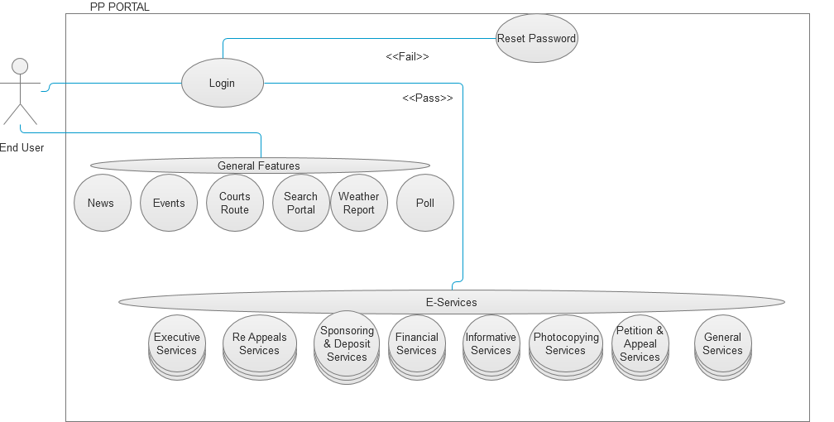

* + 1. User Registration

|  |  |
| --- | --- |
| **Use case:** | User Registration |
| **Use case ID:** | UC-PS-100 |
| **Actor** | End User |
| **Brief Description:** | This service allows the users who access this system over the internet to register themselves with the system |
| **System Trigger:** | Users clicking on “Register New User” link in the login page, complete the fields in the user registration form and click on Submit button. |
| **Preconditions:** | NA |
| **Flow of Events:** | 1. User Clicks on “Login” link in the home page 2. The user is taken to the Login Page 3. The user clicks on “Register New User” link provided in the Login Page 4. A User Registration Form is displayed with the following fields    1. Email    2. Password    3. Confirm Password    4. First Name    5. Last Name    6. Family Name    7. Mobile    8. Date of Birth    9. Nationality    10. Emirates ID    11. ID Expiry Date    12. Preferred Language    13. Option to Accept terms and Conditions    14. Human Verification   (A screen shot of the form is shown below. Only the fields shown will be available in the new form, as the look and feel will different as per what is finalised and approved by the client in a separate document.)   1. User clicks on Submit button 2. The system will validate the following    1. Valid email id is entered in the Username field. (The entry should be of the form [xxx@yyyy.zzz](mailto:xxx@yyyy.zzz). )    2. The password field contains a combination of numeric and alphanumeric characters and is atleast 8 characters in length.(If display an error message highlighting it.    3. The Expiry date is valid (The database views that will be used to check this will be provided by the Public Prosecution team)    4. Check if the user clicked on the Accept check box    5. If any of the above validation fails, appropriate error message will be displayed. 3. Once successfully registered, the user is sent an email. |
| **Postconditions:** | NA |
| **Priority:** | High |
| **Exceptions:** | If the user does not complete all required mandatory fields. If validation fails, error message is displayed |
| **Assumptions:** | The validation logic used is dependent on the options supported in Oracle Access Management / Oracle WebCenter Portal technology |

* + - 1. Edit Profile

|  |  |
| --- | --- |
| **Use case:** | Edit Profile |
| **Actor** | End User |
| **Brief Description:** | This service allows the users who access this system over the internet to edit profile themselves with the system |
| **System Trigger:** | Users clicking on “Edit Profile” link in the E-service page, complete the fields in the edit profile form and click on Submit button. |
| **Preconditions:** | NA |
| **Flow of Events:** | 1. User Clicks on “edit Profile” link in the E-service page 2. The user is taken to the Edit profile Page 3. A Edit Profile Form is displayed with the following fields    1. **First name**    2. **Last name**    3. **Mobile**    4. **Date of Birth**    5. **Education**    6. **Nationality**    7. **Emirates ID**    8. **ID Expiry Date**    9. **Union no**    10. **Occupation** 4. User clicks on Submit button 5. The system will validate the following    1. All Mandatory fields are filled in (only then the Submit button is enabled)    2. Valid email id is entered in the Username field. (The entry should be in the form [xxx@yyyy.zzz](mailto:xxx@yyyy.zzz) )    3. If any of the above validation fails, appropriate error message will be displayed. 6. Once successfully registered, the user will receive an email that the profile has been updated. |
| **Postconditions:** | NA |
| **Priority:** | High |
| **Exceptions:** | If the user does not complete all required mandatory fields, Submit button is not enabled and error message prompted  If validation fails, error message is displayed |
| **Assumptions:** | The validation logic used is dependent on the options supported in Oracle Access Management / Oracle WebCenter Portal technology |

* + 1. User Authentication

|  |  |
| --- | --- |
| **Use case:** | User Authentication |
| **Use case ID:** | UC-PS-101 |
| **Actor** | End User |
| **Brief Description:** | This service allows the user to be authenticated by the system, so that he can access the E-Services |
| **System Trigger:** | User clicks on the “Login” button on the homepage, enters the User ID, password and clicks on the “Submit” Button |
| **Preconditions:** | User must have a valid User id and Password |
| **Flow of Events:** | 1. User clicks on the “Login” link in Home Page 2. User enters the user name and password, clicks on the”Login” button 3. The system will validate the User ID and password 4. If the validation is successful, A second level validation screen appears. This will prompt for the User to enter his data of birth. If the provided information is correct, then a message “Welcome to public prosecution website” will be displayed. 5. The user now will be able to access the E-services |
| **Postconditions:** | NA |
| **Priority:** | High |
| **Exceptions:** | * If the user enters either a wrong password or wrong date of birth, the system will display an error message and prompt him to re-enter his password. |
| **Assumptions:** | The validation logic used is dependent on the options supported in Oracle Access Management / Oracle WebCenter Portal technology |

* + 1. Password Reset (Self-Service)

|  |  |
| --- | --- |
| **Use case:** | Password Reset |
| **Use case ID:** | UC-PS-102 |
| **Actor** | End User |
| **Brief Description:** | This service allows the user to reset his password |
| **System Trigger:** | User clicks on the “Forgot My Password” link in the login page |
| **Preconditions:** | User must have a registered E-mail |
| **Flow of Events:** | 1. User clicks on the “Forgot My Password” link 2. The user is requested to submit the valid e-mail id to reset the password. 3. The system will genenarate only the random password and 4. The Email will be sent to the respected E-mail with the password. 5. The password is successfully reset and the user can login to the E-service page by the received password. |
| **Postconditions:** | The user is able to reset his password |
| **Priority:** | High |
| **Exceptions:** | If the user did not provide the correct response, the error message   |  |  |  |  | | --- | --- | --- | --- | | |  |  | | --- | --- | | |  | | --- | | “User has not been registered | | | “ will be displayed to the user | |
| **Assumptions:** | The validation logic used is dependent on the options supported in Oracle Access Management / Oracle WebCenter Portal technology |

* + 1. New Service: Appeal

|  |  |
| --- | --- |
| **Use case:** | Appeal |
| **Use case ID:** | UC-PS-103 |
| **Actor** | Authenticated User |
| **Brief Description:** | The aim of this service is to allow the user to request for Appeal |
| **System Trigger:** | The end user will click on the submit button in the Service Page |
| **Preconditions:** | User must be logged on to the E-Services system |
| **Flow of Events:** | 1. The end user must fill the following fields  * **Case No [Mandatory]** * **Case Year[Mandatory]** * **Prosecution Name [Mandatory]** * **Relation With Case [Mandatory]** * **Subject [Mandatory]** * **Attachments**  1. When the user moves from one field to another the front end validation is carried out. 2. The User will click submit 3. The system will validate case no. 4. If the request is valid , system will store the request data in the respective database table 5. System will send an email to the user informing that the service request is submitted successfully. |
| **Business Rules** | Please refer to the Associated Table and fields Section for this service given below |
| **Post conditions:** | * Request Submitted successfully and stored in the database * Email sent to the end user conforming the request is raised successfully.[Please Refer Section 7.2 For e-Mail Format ] |
| **Exceptions** | 1. If the case info is not valid the user is prompted with the error ERR_CASE_INVALID 2. If the user entered any invalid values in any mandatory field, the system will highlight the field and show a label that will describe how the correct value should enter. 3. If the user filled all the fields and clicks submit button but no response came from the database within 120 [Default time out period;can be configured manually .Please refer to 6.2.52]secs an error message ERR_TIMEOUT is prompted to the user. |
| **Assumptions:** | NA |

Wire Frame: Service: Appeal

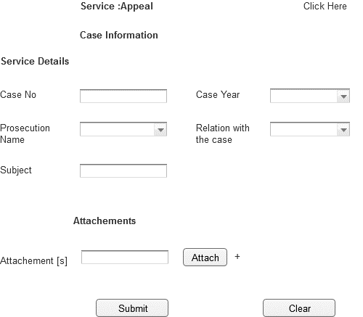

Associated Table and fields

|  |  |  |  |  |  |
| --- | --- | --- | --- | --- | --- |
| **Screen Field** | **Field Type** | **On Screen Validation** | **Mandatory /Optional** | **Auto Populate / User-Input** | **Business Validation For Database Insert** |
| Case No | Text | Number [6digit] | Mandatory | User Input | Case No Entered by User is Validated against the Case Info, User ID To See if the User is a Party to this particular case .This Business condition validated to insert all the screen fields. |
| Case Year | Drop Down | YYYY | Mandatory | User Input |
| Prosecution Name | Drop Down | Character | Mandatory | Populated From Prosecution View |
| Relation With Case | Drop Down | Character | Mandatory | Populated From CaseInfo_View |
| Attachment [s] | Attachment | .pdf ,.gif,.jpeg,.doc,.txt <Need Input> Single File Size 2MB ; Total Of All File Size 10MB | Optional | User Input |
| Subject | Text | Character | Mandatory | User Input |

Associated Screen Fields Error Handling

|  |  |
| --- | --- |
| **Screen Field** | **On Screen Validation Error Code** |
| Case No | ERR_CASE_NO |
| Case Year | ERR_CASE_YEAR |
| Prosecution Name | ERR_PROSEC_NAME |
| Relation With Case | ERR_REL_CASE |
| Attachment [s] | ERR_ATTACH |
| Subject | ERR_SUBJ |

Note:Please refer to the error code section for description of the Error code

* + 1. New Service: Collecting Documents

|  |  |
| --- | --- |
| **Use case:** | Collecting Documents |
| **Use case ID:** | UC-PS-104 |
| **Actor** | Authenticated User |
| **Brief Description:** | The aim of this service is to allow the user to request for Receiving of Documents |
| **Actor:** | End User |
| **System Trigger:** | The end user will click on the submit button in the Service Page |
| **Preconditions:** | User must be logged on to the E-Services system |
| **Flow of Events:** | 1. The end user must fill the following fields  * **Case No [Mandatory]** * **Case Year[Mandatory]** * **Prosecution Name [Mandatory]** * **Relation With Case [Mandatory]** * **Attachments**  1. When the user moves from one field to another the front end validation is carried out. 2. The User will click submit 3. The system will validate case no. 4. If the request is valid , system will store the request data in the respective database table 5. System will send an email to the user informing that the service request is submitted successfully. |
| **Business Rules** | Please refer to the Associated Table and fields Section for this service given below |
| **Post conditions:** | * Request Submitted successfully and stored in the database * Email sent to the end user conforming the request have been submitted successfully. |
| **Alternative flow** | NA |
| **Exceptions:** | 1. If the case info is not valid the user is prompted with the error ERR_CASE_INVALID 2. If the user entered any invalid values in any mandatory field, the system will highlight the field and show a label that will describe how the correct value should enter. 3. If the user filled all the fields and clicks submit button but no response came from the database within 120 [Default time out period;can be configured manually .Please refer to 6.2.52]secs an error message ERR_TIMEOUT is prompted to the user. |
| **Assumptions:** | NA |

Wireframe:Service:Collecting Documents

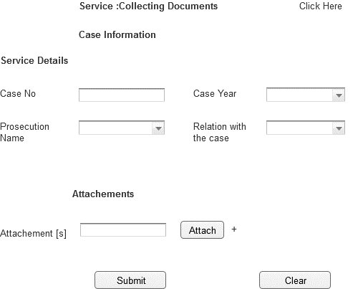

Associated Table and fields

|  |  |  |  |  |  |
| --- | --- | --- | --- | --- | --- |
| **Screen Field** | **Field Type** | **On Screen Validation** | **Mandatory /Optional** | **Auto Populate / User-Input** | **Business Validation For Database Insert** |
| Case No | Text | Number [6digit] | Mandatory | User Input | Case No Entered by User is Validated against the Case Info ,User ID To See if the User is a Party to this particular case .This Business condition validated to insert all the screen fields . |
| Case Year | Drop Down | YYYY | Mandatory | User Input |
| Prosecution Name | Drop Down | Character | Mandatory | Populated From Prosecution View |
| Relation With Case | Drop Down | Character | Mandatory | Populated From CaseInfo_View |
| Attachment [s] | Attachment | .pdf ,.gif,.jpeg,.doc,.txt <Need Input> Single File Size 2MB ; Total Of All File Size 10MB | Optional | User Input |

Associated Screen Fields Error Handling

|  |  |
| --- | --- |
| **Screen Field** | **On Screen Validation Error Code** |
| Case No | ERR_CASE_NO |
| Case Year | ERR_CASE_YEAR |
| Prosecution Name | ERR_PROSEC_NAME |
| Relation With Case | ERR_REL_CASE |
| Attachment [s] | ERR_ATTACH |

Note:Please refer to the error code section for description of the Error code

* + 1. New Service: Correcting Mistake in Judgment Material

|  |  |  |
| --- | --- | --- |
| **Use case:** |  | Correcting Mistake in Judgment Material |
| **Use case ID:** |  | UC-PS-105 |
| **Actor** |  | Authenticated User |
| **Brief Description:** |  | The aim of this service is to allow the user to request for Correcting Mistake in Judgment Material |
| **System Trigger:** |  | The end user will click on the submit button in the Service Page |
| **Preconditions:** |  | User must be logged on to the E-Services system |
| **Flow of Events:** |  | The end user must fill the following fields   * **Case No [Mandatory]** * **Case Year[Mandatory]** * **Prosecution Name [Mandatory]** * **Relation With Case [Mandatory]** * **Error Type[Mandatory]** * **Corrected Phrase[Mandatory]** * **Attachments**  1. Error Type[Mandatory] 2. Corrected Phrase[Mandatory] 3. When the user moves from one field to another the front end validation is carried out. 4. The User will click submit 5. The system will validate case no. 6. If the request is valid , system will store the request data in the respective database table 7. System will send an email to the user informing that the service request is submitted successfully. |
| **Business Rules** |  | Please refer to the Associated Table and fields Section for this service given below |
| **Post conditions:** |  | Request Submitted successfully and stored in the database  Email sent to the end user conforming the request is raised successfully.[Please Refer Section 7.2 For e-Mail Format ] |
| **Alternative flow** |  | NA |
| **Exception** |  | 1. If the case info is not valid the user is prompted with the error ERR_CASE_INVALID 2. If the user entered any invalid values in any mandatory field, the system will highlight the field and show a label that will describe how the correct value should enter. 3. If the user filled all the fields and clicks submit button but no response came from the database within 120 [Default time out period;can be configured manually .Please refer to 6.2.52] secs an error message ERR_TIMEOUT is prompted to the user. |
| **Assumptions:** |  | NA |

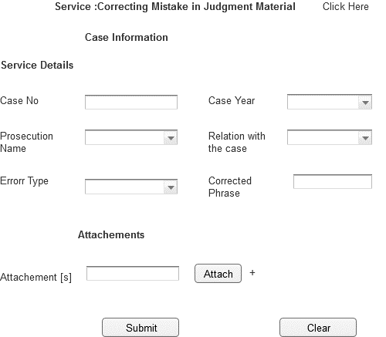

Associated Table and fields

|  |  |  |  |  |  |
| --- | --- | --- | --- | --- | --- |
| **Screen Field** | **Field Type** | **On Screen Validation** | **Mandatory /Optional** | **Auto Populate / User-Input** | **Business Validation For Database Insert** |
| Case No | Text | Number [6digit] | Mandatory | User Input | Case No Entered by User is Validated against the Case Info, User ID To See if the User is a Party to this particular case .This Business condition validated to insert all thescreen fields . |
| Case Year | Drop Down | YYYY | Mandatory | User Input |
| Prosecution Name | Drop Down | Character | Mandatory | Populated From Prosecution View |
| Relation With Case | Drop Down | Character | Mandatory | Populated From CaseInfo_View |
| Attachment [s] | Attachment | .pdf ,.gif,.jpeg,.doc,.txt <Need Input> Single File Size 2MB ; Total Of All File Size 10MB | Optional | User Input |
| Error Type | Text | Character | Mandatory | User Input |
| Corrected Phrase | Text | Character | Mandatory | User Input |

Associated Screen Fields Error Handling

|  |  |
| --- | --- |
| **Screen Field** | **On Screen Validation Error Code** |
| Case No | ERR_CASE_NO |
| Case Year | ERR_CASE_YEAR |
| Prosecution Name | ERR_PROSEC_NAME |
| Relation With Case | ERR_REL_CASE |
| Attachment [s] | ERR_ATTACH |
| Error Type | ERR_ER_TYP |
| Corrected Phrase | ERR_CRT_PHRS |

Note:Please refer to the error code section for description of the Error code

* + 1. New Service: Decision of Appeal

|  |  |
| --- | --- |
| **Use case:** | Decision of Appeal |
| **Use case ID:** | UC-PS-106 |
| **Actor** | Authenticated User |
| **Brief Description:** | The aim of this service is to allow the user to request for Decision of Appeal |
| **System Trigger:** | The end user will click on the submit button in the Service Page |
| **Preconditions:** | User must be logged on to the E-Services system |
| **Flow of Events:** | 1. The end user must fill the following fields  * **Case No [Mandatory]** * **Case Year[Mandatory]** * **Prosecution Name [Mandatory]** * **Relation With Case [Mandatory]** * **Sentence Date[Mandatory]** * **Attachments**  1. When the user moves from one field to another the front end validation is carried out. 2. The User will click submit 3. The system will validate case no. 4. If the request is valid , system will store the request data in the respective database table 5. System will send an email to the user informing that the service request is submitted successfully. |
| **Business Rules** | Please refer to the Associated Table and fields Section for this service given below |
| **Post conditions:** | * Request Submitted successfully and stored in the database * Email sent to the end user conforming the request is raised successfully.[Please Refer Section 7.2 For e-Mail Format ] |
| **Alternative flow** | NA |
| **Exceptions:** | 1. If the case info is not valid the user is prompted with the error ERR_CASE_INVALID 2. If the user entered any invalid values in any mandatory field, the system will highlight the field and show a label that will describe how the correct value should enter. 3. If the user filled all the fields and clicks submit button but no response came from the database within 120 [Default time out period;can be configured manually .Please refer to 6.2.52]secs an error message ERR_TIMEOUT is prompted to the user. |
| **Assumptions:** | NA |

WireFrame:Service:Decision of Appeal

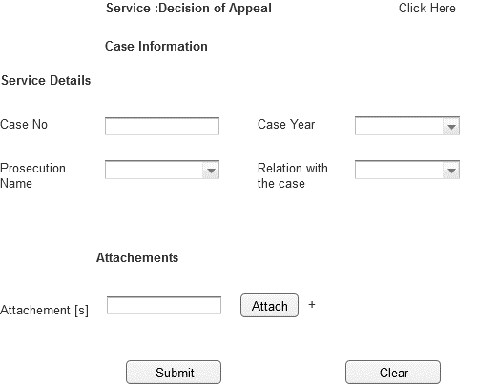

Associated Table and fields

|  |  |  |  |  |  |
| --- | --- | --- | --- | --- | --- |
| **Screen Field** | **Field Type** | **On Screen Validation** | **Mandatory /Optional** | **Auto Populate / User-Input** | **Business Validation For Database Insert** |
| Case No | Text | Number [6digit] | Mandatory | User Input | Case No Entered by User is Validated against the Case Info ,User ID To See if the User is a Party to this particular case .This Business condition validated to insert all the screen fields . |
| Case Year | Drop Down | YYYY | Mandatory | User Input |
| Prosecution Name | Drop Down | Character | Mandatory | Populated From Prosecution View |
| Relation With Case | Drop Down | Character | Mandatory | Populated From CaseInfo_View |
| Sentence Date | Number | Number [DD/MM/YYYY] | Mandatory | User Input |
| Attachment [s] | Attachment | .pdf ,.gif,.jpeg,.doc,.txt <Need Input> Single File Size 2MB ; Total Of All File Size 10MB | Optional | User Input |

Associated Screen Fields Error Handling

|  |  |
| --- | --- |
| **Screen Field** | **On Screen Validation Error Code** |
| Case No | ERR_CASE_NO |
| Case Year | ERR_CASE_YEAR |
| Prosecution Name | ERR_PROSEC_NAME |
| Relation With Case | ERR_REL_CASE |
| Sentence date | ERR_SENT_DATE |
| Attachment [s] | ERR_ATTACH |

Note:Please refer to the error code section for description of the Error code

* + 1. New Service: Deposit Money in favour of Plaintiff / in Case Custody

|  |  |
| --- | --- |
| **Use case:** | Deposit Money in favour of Plaintiff / in Case Custody |
| **Use case ID:** | UC-PS-107 |
| **Actor** | Authenticated User |
| **Brief Description:** | The aim of this service is to allow the user to request for Depositing Money in favour of Plaintiff / in Case Custody |
| **System Trigger:** | The end user will click on the submit button in the Service Page |
| **Preconditions:** | User must be logged on to the E-Services system |
| **Flow of Events:** | 1. The end user must fill the following fields  * **Case No [Mandatory]** * **Case Year[Mandatory]** * **Prosecution Name [Mandatory]** * **Relation With Case [Mandatory]** * **Attachments** * **Deposit Amount [Mandatory]** * **Accused_name[Mandatory]**  1. When the user moves from one field to another the front end validation is carried out. 2. The User will click submit 3. The system will validate case no. 4. If the request is valid , system will store the request data in the respective database table 5. System will send an email to the user informing that the service request is submitted successfully. |
| **Business Rules** | Please refer to the Associated Table and fields Section for this service given below |
| **Post conditions:** | * Request Submitted successfully and stored in the database * Email sent to the end user conforming the request is raised successfully.[Please Refer Section 7.2 For e-Mail Format ] |
| **Alternative flow** | NA |
| **Exception:** | 1. If the case info is not valid the user is prompted with the error ERR_CASE_INVALID 2. If the user entered any invalid values in any mandatory field, the system will highlight the field and show a label that will describe how the correct value should enter. 3. If the user filled all the fields and clicks submit button but no response came from the database within 120 [Default time out period;can be configured manually .Please refer to 6.2.52]secs an error message ERR_TIMEOUT is prompted to the user. |
| **Assumptions:** | NA |

WireFrame:Service:Deposit Money in favour of Plaintiff / in Case Custody

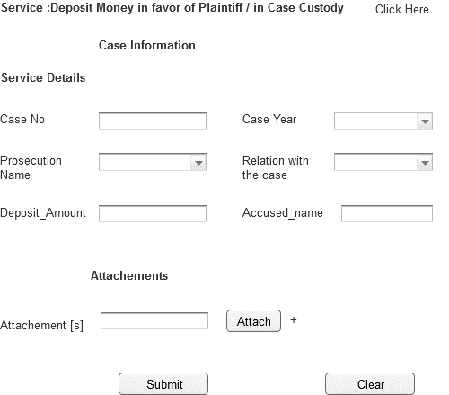

Associated Table and fields

|  |  |  |  |  |  |
| --- | --- | --- | --- | --- | --- |
| **Screen Field** | **Field Type** | **On Screen Validation** | **Mandatory /Optional** | **Auto Populate / User-Input** | **Business Validation For Database Insert** |
| Case No | Text | Number [6digit] | Mandatory | User Input | Case No Entered by User is Validated against the Case Info ,User ID To See if the User is a Party to this particular case .This Business condition validated to insert all the screen fields . |
| Case Year | Drop Down | YYYY | Mandatory | User Input |
| Prosecution Name | Drop Down | Character | Mandatory | Populated From Prosecution View |
| Relation With Case | Drop Down | Character | Mandatory | Populated From CaseInfo_View |
| Attachment [s] | Attachment | .pdf ,.gif,.jpeg,.doc,.txt <Need Input> Single File Size 2MB ; Total Of All File Size 10MB | Optional | User Input |
| Deposit Amount | Text | Number | Mandatory | Populated From Error Type View |
| Accused Name | Text | Character | Mandatory | User Input |

Associated Screen Fields Error Handling

|  |  |
| --- | --- |
| **Screen Field** | **On Screen Validation Error Code** |
| Case No | ERR_CASE_NO |
| Case Year | ERR_CASE_YEAR |
| Prosecution Name | ERR_PROSEC_NAME |
| Relation With Case | ERR_REL_CASE |
| Attachment [s] | ERR_ATTACH |
| Deposit Amount | ERR_DEPST_AMNT |
| Accused Name | ERR_ACC_NME |

Note:Please refer to the error code section for description of the Error code

* + 1. New Service: Disburse Interpreter Fees

|  |  |
| --- | --- |
| **Use case:** | Disburse Interpreter Fees |
| **Use case ID:** | UC-PS-108 |
| **Actor** | Authenticated User |
| **Brief Description:** | The aim of this service is to allow the user to request for Disbursement oftranslation fees for Interpreter/translatorappointed by the public prosecution or the court |
| **System Trigger:** | The end user will click on the submit button in the Service Page |
| **Preconditions:** | User must be logged on to the E-Services system |
| **Flow of Events:** | 1. The end user must fill the following fields  * **Case No [Mandatory]** * **Case Year[Mandatory]** * **Prosecution Name [Mandatory]** * **Relation With Case [Mandatory]** * **Attachments**  1. When the user moves from one field to another the front end validation is carried out. 2. The User will click submit 3. The system will validate case no. 4. If the request is valid , system will store the request data in the respective database table 5. System will send an email to the user informing that the service request is submitted successfully. |
| **Business Rules** | Please refer to the Associated Table and fields Section for this service given below |
| **Post conditions:** | * Request Submitted successfully and stored in the database * Email sent to the end user conforming the request is raised successfully.[Please Refer Section 7.2 For e-Mail Format ] |
| **Alternative flow** | NA |
| **Exceptions:** | 1. If the case info is not valid the user is prompted with the error ERR_CASE_INVALID 2. If the user entered any invalid values in any mandatory field, the system will highlight the field and show a label that will describe how the correct value should enter. 3. If the user filled all the fields and clicks submit button but no response came from the database within 120 [Default time out period;can be configured manually .Please refer to 6.2.52]secs an error message ERR_TIMEOUT is prompted to the user. |
| **Assumptions:** | NA |

WireFrame:Service:Disburse Interpreter Fees

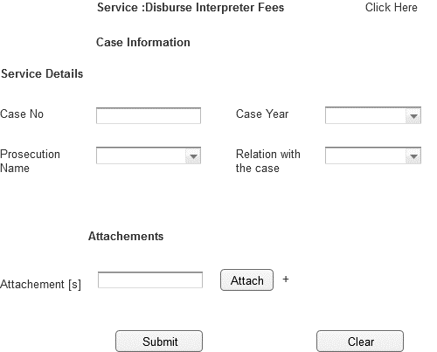

Associated Table and fields

|  |  |  |  |  |  |
| --- | --- | --- | --- | --- | --- |
| **Screen Field** | **Field Type** | **On Screen Validation** | **Mandatory /Optional** | **Auto Populate / User-Input** | **Business Validation For Database Insert** |
| Case No | Text | Number [6digit] | Mandatory | User Input | Case No Entered by User is Validated against the Case Info ,User ID To See if the User is a Party to this particular case .This Business condition validated to insert all the screen fields . |
| Case Year | Drop Down | YYYY | Mandatory | User Input |
| Prosecution Name | Drop Down | Character | Mandatory | Populated From Prosecution View |
| Relation With Case | Drop Down | Character | Mandatory | Populated From CaseInfo_View |
| Attachment [s] | Attachment | .pdf ,.gif,.jpeg,.doc,.txt <Need Input> Single File Size 2MB ; Total Of All File Size 10MB | Optional | User Input |

Associated Screen Fields Error Handling

|  |  |
| --- | --- |
| **Screen Field** | **On Screen Validation Error Code** |
| Case No | ERR_CASE_NO |
| Case Year | ERR_CASE_YEAR |
| Prosecution Name | ERR_PROSEC_NAME |
| Relation With Case | ERR_REL_CASE |
| Attachment [s] | ERR_ATTACH |

Note:Please refer to the error code section for description of the Error code

* + 1. New Service: Disbursement Expert Fees

|  |  |
| --- | --- |
| **Use case:** | Disburse Expert Fees |
| **Use case ID:** | UC-PS-109 |
| **Actor** | Authenticated User |
| **Brief Description:** | The aim of this service is to allow the user to request for Disbursement of Expert Fees |
| **System Trigger:** | The end user will click on the submit button in the Service Page |
| **Preconditions:** | User must be logged on to the E-Services system |
| **Flow of Events:** | 1. The end user must fill the following fields  * **Case No [Mandatory]** * **Case Year[Mandatory]** * **Prosecution Name [Mandatory]** * **Relation With Case [Mandatory]** * **Attachments** * **Iban_Number [Mandatory]**  1. When the user moves from one field to another the front end validation is carried out. 2. The User will click submit 3. The system will validate case no. 4. If the request is valid , system will store the request data in the respective database table 5. System will send an email to the user informing that the service request is submitted successfully. |
| **Business Rules** | Please refer to the Associated Table and fields Section for this service given below |
| **Post conditions:** | * Request Submitted successfully and stored in the database * Email sent to the end user conforming the request is raised successfully.[Please Refer Section 7.2 For e-Mail Format ] |
| **Alternative flow** | NA |
| **Exceptions:** | 1. If the case info is not valid the user is prompted with the error ERR_CASE_INVALID 2. If the user entered any invalid values in any mandatory field, the system will highlight the field and show a label that will describe how the correct value should enter. 3. If the user filled all the fields and clicks submit button but no response came from the database within 120 [Default time out period;can be configured manually .Please refer to 6.2.52]secs an error message ERR_TIMEOUT is prompted to the user. |
| **Assumptions:** | NA |

WireFrame:Service:Disbursement of Expert Fee

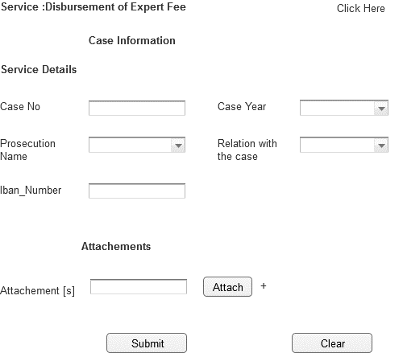

Associated Table and fields

|  |  |  |  |  |  |
| --- | --- | --- | --- | --- | --- |
|  | **Field Type** | **On Screen Validation** | **Mandatory /Optional** | **Auto Populate / User-Input** | **Business Validation For Database Insert** |
| Case No | Text | Number [6 Digit] | Mandatory | User Input | Case No Entered by User is Validated against the Case Info, User ID To See if the User is a Party to this particular case .This Business condition validated to insert all the screen fields. |
| Case Year | Drop Down | YYYY | Mandatory | User Input |
| Prosecution Name | Drop Down | Character[50] | Mandatory | Populated From Prosecution View |
| Relation With Case | Drop Down | Character[50] | Mandatory | Populated From CaseInfo_View |
| Attachment [s] | Attachment | .pdf ,.gif,.jpeg,.doc,.txt <Need Input> Single File Size 2MB ; Total Of All File Size 10MB | Optional | User Input |
| Iban Number | Text |  | Mandatory | User Input |

Associated Screen Fields Error Handling

|  |  |
| --- | --- |
| **Screen Field** | **On Screen Validation Error Code** |
| Case No | ERR_CASE_NO |
| Case Year | ERR_CASE_YEAR |
| Prosecution Name | ERR_PROSEC_NAME |
| Relation With Case | ERR_REL_CASE |
| Attachment [s] | ERR_ATTACH |
| Iban Number | ERR_IB_NUM |

Note:Please refer to the error code section for description of the Error code

* + 1. New Service: Ending a Custody against a Juvenile

|  |  |
| --- | --- |
| **Use case:** | Ending a Custody against a Juvenile |
| **Use case ID:** | UC-PS-110 |
| **Actor** | Authenticated User |
| **Brief Description:** | The aim of this service is to allow the user, his legal representative or guardian to request for Ending a Custody Against a Juvenile |
| **System Trigger:** | The end user will click on the submit button in the Service Page |
| **Preconditions:** | User must be logged on to the E-Services system |
| **Flow of Events:** | 1. The end user must fill the following fields  * **Case No [Mandatory]** * **Case Year[Mandatory]** * **Prosecution Name [Mandatory]** * **Relation With Case [Mandatory]** * **Attachments**  1. When the user moves from one field to another the front end validation is carried out. 2. The User will click submit 3. The system will validate case no. 4. If the request is valid , system will store the request data in the respective database table 5. System will send an email to the user informing that the service request is submitted successfully. |
| **Business Rules** | Please refer to the Associated Table and fields Section for this service given below |
| **Post conditions:** | * Request Submitted successfully and stored in the database * Email sent to the end user conforming the request is raised successfully.[Please Refer Section 7.2 For e-Mail Format ] |
| **Alternative flow** | NA |
| **Exceptions:** | 1. If the case info is not valid the user is prompted with the error ERR_CASE_INVALID 2. If the user entered any invalid values in any mandatory field, the system will highlight the field and show a label that will describe how the correct value should enter. 3. If the user filled all the fields and clicks submit button but no response came from the database within 120 [Default time out period;can be configured manually .Please refer to 6.2.52]secs an error message ERR_TIMEOUT is prompted to the user. |
| **Assumptions:** | NA |
| **Issues:** | None |
|  |  |

WireFrame:Service:Ending a Custody Against a Juvenile

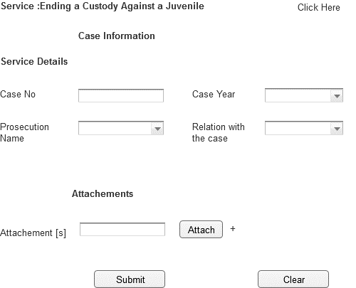

Associated Table and fields

|  |  |  |  |  |  |
| --- | --- | --- | --- | --- | --- |
| **Screen Field** | **Field Type** | **On Screen Validation** | **Mandatory /Optional** | **Auto Populate / User-Input** | **Business Validation For Database Insert** |
| Case No | Text | Number [6digit] | Mandatory | User Input | Case No Entered by User is Validated against the Case Info, User ID To See if the User is a Party to this particular case .This Business condition validated to insert all the screen fields. |
| Case Year | Drop Down | YYYY | Mandatory | User Input |
| Prosecution Name | Drop Down | Character | Mandatory | Populated From Prosecution View |
| Relation With Case | Drop Down | Character | Mandatory | Populated From CaseInfo_View |
| Attachment [s] | Attachment | .pdf ,.gif,.jpeg,.doc,.txt <Need Input> Single File Size 2MB ; Total Of All File Size 10MB | Optional | User Input |

Associated Screen Fields Error Handling

|  |  |
| --- | --- |
| **Screen Field** | **On Screen Validation Error Code** |
| Case No | ERR_CASE_NO |
| Case Year | ERR_CASE_YEAR |
| Prosecution Name | ERR_PROSEC_NAME |
| Relation With Case | ERR_REL_CASE |
| Attachment [s] | ERR_ATTACH |

Note:Please refer to the error code section for description of the Error code

* + 1. New Service: Exchange of Bail

|  |  |
| --- | --- |
| **Use case:** | Exchange of Bail |
| **Use case ID:** | UC-PS-111 |
| **Actor** | Authenticated User |
| **Brief Description:** | The aim of this service is to allow the user to request for Exchange of Bail by submitting another passport or a sum of money |
| **System Trigger:** | The end user will click on the submit button in the Service Page |
| **Preconditions:** | User must be logged on to the E-Services system |
| **Flow of Events:** | 1. The end user must fill the following fields  * **Case No [Mandatory]** * **Case Year[Mandatory]** * **Prosecution Name [Mandatory]** * **Relation With Case [Mandatory]** * **Attachments** * **Accused name [Mandatory]**  1. When the user moves from one field to another the front end validation is carried out. 2. The User will click submit 3. The system will validate case no. 4. If the request is valid , system will store the request data in the respective database table 5. System will send an email to the user informing that the service request is submitted successfully. |
| **Business Rules** | Please refer to the Associated Table and fields Section for this service given below |
| **Post conditions:** | * Request Submitted successfully and stored in the database * Email sent to the end user conforming the request is raised successfully.[Please Refer Section 7.2 For e-Mail Format ] |
| **Alternative flow** | NA |
| **Exceptions:** | 1. If the case info is not valid the user is prompted with the error ERR_CASE_INVALID 2. If the user entered any invalid values in any mandatory field, the system will highlight the field and show a label that will describe how the correct value should enter. 3. If the user filled all the fields and clicks submit button but no response came from the database within 120 [Default time out period;can be configured manually .Please refer to 6.2.52]secs an error message ERR_TIMEOUT is prompted to the user. |
| **Assumptions:** | NA |

Wireframe:Service:Exchange of Bail

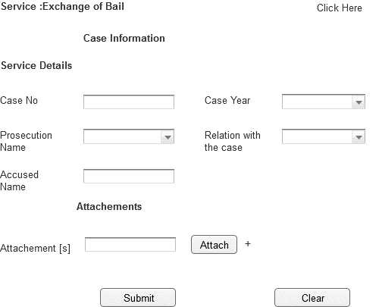

Associated Table and fields

|  |  |  |  |  |  |
| --- | --- | --- | --- | --- | --- |
| **Screen Field** | **Field Type** | **On Screen Validation** | **Mandatory /Optional** | **Auto Populate / User-Input** | **Business Validation For Database Insert** |
| Case No | Text | Number [6 Digit] | Mandatory | User Input | Case No Entered by User is Validated against the Case Info ,User ID To See if the User is a Party to this particular case .This Business condition validated to insert all the screen fields . |
| Case Year | Drop Down | YYYY | Mandatory | User Input |
| Prosecution Name | Drop Down | Character[50] | Mandatory | Populated From Prosecution View |
| Relation With Case | Drop Down | Character[50] | Mandatory | Populated From CaseInfo_View |
| Attachment [s] | Attachment | .pdf ,.gif,.jpeg,.doc,.txt <Need Input> Single File Size 2MB ; Total Of All File Size 10MB | Optional | User Input |
| Accused Name | Text | Character | Mandatory | User Input |

Associated Screen Fields Error Handling

|  |  |
| --- | --- |
| **Screen Field** | **On Screen Validation Error Code** |
| Case No | ERR_CASE_NO |
| Case Year | ERR_CASE_YEAR |
| Prosecution Name | ERR_PROSEC_NAME |
| Relation With Case | ERR_REL_CASE |
| Attachment [s] | ERR_ATTACH |
| Accused Name | ERR_ACC_NME |

Note:Please refer to the error code section for description of the Error code

* + 1. New Service: Fine Retrieval Request

|  |  |
| --- | --- |
| **Use case:** | Fine Retrieval Request |
| **Use case ID:** | UC-PS-112 |
| **Actor** | Authenticated User |
| **Brief Description:** | The aim of this service is to allow the user to request for Fine Retrieval Request |
| **System Trigger:** | The end user will click on the submit button in the Service Page |
| **Preconditions:** | User must be logged on to the E-Services system |
| **Flow of Events:** | 1. The end user must fill the following fields  * **Case No [Mandatory]** * **Case Year[Mandatory]** * **Prosecution Name [Mandatory]** * **Relation With Case [Mandatory]** * **Attachments**  1. When the user moves from one field to another the front end validation is carried out. 2. The User will click submit 3. The system will validate case no. 4. If the request is valid , system will store the request data in the respective database table 5. System will send an email to the user informing that the service request is submitted successfully. |
| **Business Rules** | Please refer to the Associated Table and fields Section for this service given below |
| **Post conditions:** | * Request Submitted successfully and stored in the database * Email sent to the end user conforming the request is raised successfully.[Please Refer Section 7.2 For e-Mail Format ] |
| **Alternative flow** | NA |
| **Exceptions:** | 1. If the case info is not valid the user is prompted with the error ERR_CASE_INVALID 2. If the user entered any invalid values in any mandatory field, the system will highlight the field and show a label that will describe how the correct value should enter. 3. If the user filled all the fields and clicks submit button but no response came from the database within 120 [Default time out period;can be configured manually .Please refer to 6.2.52]secs an error message ERR_TIMEOUT is prompted to the user. |
| **Assumptions:** | NA |

WireFrame:Service:FineRetrival Request

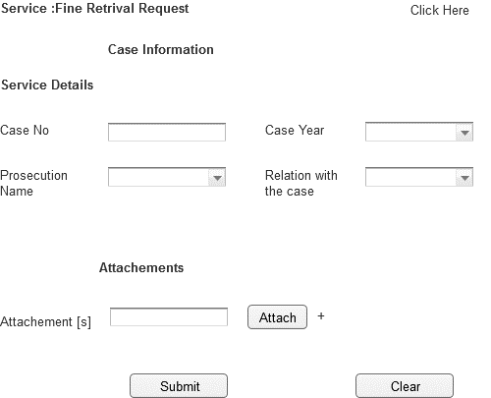

Associated Table and fields

|  |  |  |  |  |  |
| --- | --- | --- | --- | --- | --- |
| **Screen Field** | **Field Type** | **On Screen Validation** | **Mandatory /Optional** | **Auto Populate / User-Input** | **Business Validation For Database Insert** |
| Case No | Text | Number | Mandatory | User Input | Case No Entered by User is Validated against the Case Info ,User ID To See if the User is a Party to this particular case .This Business condition validated to insert all the screen fields . |
| Case Year | Drop Down | YYYY | Mandatory | User Input |
| Prosecution Name | Drop Down | Character | Mandatory | Populated From Prosecution View |
| Relation With Case | Drop Down | Character | Mandatory | Populated From CaseInfo_View |
| Attachment [s] | Attachment | .pdf ,.gif,.jpeg,.doc,.txt <Need Input> Single File Size 2MB ; Total Of All File Size 10MB | Optional | User Input |

Associated Screen Fields Error Handling

|  |  |
| --- | --- |
| **Screen Field** | **On Screen Validation Error Code** |
| Case No | ERR_CASE_NO |
| Case Year | ERR_CASE_YEAR |
| Prosecution Name | ERR_PROSEC_NAME |
| Relation With Case | ERR_REL_CASE |
| Attachment [s] | ERR_ATTACH |

Note:Please refer to the error code section for description of the Error code

* + 1. New Service:International Arrest Warrant

|  |  |
| --- | --- |
| **Use case:** | International Arrest Warrant |
| **Use case ID:** | UC-PS-113 |
| **Actor** | Authenticated User |
| **Brief Description:** | The aim of this service is to allow the user to request for International Arrest Warrant |
| **System Trigger:** | The end user will click on the submit button in the Service Page |
| **Preconditions:** | User must be logged on to the E-Services system |
| **Flow of Events:** | 1. The end user must fill the following fields  * **Case No [Mandatory]** * **Case Year[Mandatory]** * **Prosecution Name [Mandatory]** * **Relation With Case [Mandatory]** * **Attachments** * **person_capture_name[Mandatory]** * **person_capture_data[Mandatory]** * **person_capture_photo[Mandatory]**  1. When the user moves from one field to another the front end validation is carried out. 2. The User will click submit 3. The system will validate case no. 4. If the request is valid , system will store the request data in the respective database table 5. System will send an email to the user informing that the service request is submitted successfully. |
| **Business Rules** | Please refer to the Associated Table and fields Section for this service given below |
| **Post conditions:** | * Request Submitted successfully and stored in the database * Email sent to the end user conforming the request is raised successfully.[Please Refer Section 7.2 For e-Mail Format ] |
| **Alternative flow** | NA |
| **Exceptions:** | 1. If the case info is not valid the user is prompted with the error ERR_CASE_INVALID 2. If the user entered any invalid values in any mandatory field, the system will highlight the field and show a label that will describe how the correct value should enter. 3. If the user filled all the fields and clicks submit button but no response came from the database within 120 [Default time out period;can be configured manually .Please refer to 6.2.52]secs an error message ERR_TIMEOUT is prompted to the user. |
| **Assumptions:** | NA |

WireFrame:Service:International Arrest Warrant

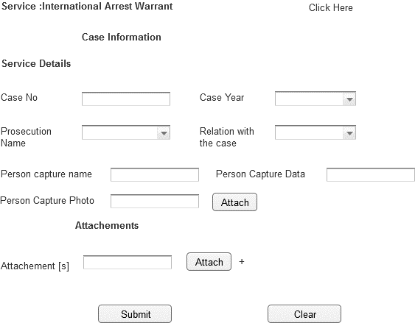

Associated Table and fields

|  |  |  |  |  |  |
| --- | --- | --- | --- | --- | --- |
| **Screen Field** | **Field Type** | **On Screen Validation** | **Mandatory /Optional** | **Auto Populate / User-Input** | **Business Validation For Database Insert** |
| Case No | Text | Number [6digit] | Mandatory | User Input | Case No Entered by User is Validated against the Case Info ,User ID To See if the User is a Party to this particular case .This Business condition validated to insert all the screen fields . |
| Case Year | Drop Down | YYYY | Mandatory | User Input |
| Prosecution Name | Drop Down | Character | Mandatory | Populated From Prosecution View |
| Relation With Case | Drop Down | Character | Mandatory | Populated From CaseInfo_View |
| Attachment [s] | Attachment | .pdf ,.gif,.jpeg,.doc,.txt <Need Input> Single File Size 2MB ; Total Of All File Size 10MB | Optional | User Input |
| Person_capture_name | Text | Number | Mandatory | Populated From Error Type View |
| Person_capture_data | Text | Character | Mandatory | User Input |
| Person_capture_photo | Attachment | gif,.jpeg,.bmp; Size 2MB | Mandatory | User Input |

Associated Screen Fields Error Handling

|  |  |
| --- | --- |
| **Screen Field** | **On Screen Validation Error Code** |
| Case No | ERR_CASE_NO |
| Case Year | ERR_CASE_YEAR |
| Prosecution Name | ERR_PROSEC_NAME |
| Relation With Case | ERR_REL_CASE |
| Attachment [s] | ERR_ATTACH |
| Person capture name | ERR_CPTR_NAME |
| Person capture Data | ERR_CPTR_DATA |
| Person capture photo | ERR_CPTR_PHOTO |

Note:Please refer to the error code section for description of the Error code

* + 1. New Service:Lawyer Profile

|  |  |
| --- | --- |
| **Use case:** | Lawyer Profile request |
| **Use case ID:** | UC-PS-114 |
| **Actor** | Authenticated User |
| **Brief Description:** | The aim of this service is to allow the user to request for Lawyer Profile |
| **System Trigger:** | The end user will click on the submit button in the Service Page |
| **Preconditions:** | User must be logged on to the E-Services system |
| **Flow of Events:** | 1. The end user must fill the following fields  * **Case No [Mandatory]** * **Case Year[Mandatory]** * **Prosecution Name [Mandatory]** * **Relation With Case [Mandatory]** * **Attachments** * **Contract Number[Mandatory]** * **Defendant Name [Mandatory]** * When the user moves from one field to another the front end validation is carried out.  1. The User will click submit 2. The system will validate case no. 3. If the request is valid , system will store the request data in the respective database table 4. System will send an email to the user informing that the service request is submitted successfully. |
| **Business Rules** | Please refer to the Associated Table and fields Section for this service given below |
| **Post conditions:** | * Request Submitted successfully and stored in the database * Email sent to the end user conforming the request is raised successfully.[Please Refer Section 7.2 For e-Mail Format ] |
| **Alternative flow** | NA |
| **Exceptions:** | 1. If the case info is not valid the user is prompted with the error ERR_CASE_INVALID 2. If the user entered any invalid values in any mandatory field, the system will highlight the field and show a label that will describe how the correct value should enter. 3. If the user filled all the fields and clicks submit button but no response came from the database within 120 [Default time out period;can be configured manually .Please refer to 6.2.52]secs an error message ERR_TIMEOUT is prompted to the user. |
| **Assumptions:** | NA |

WireFrame:Service:Lawyer Profile request

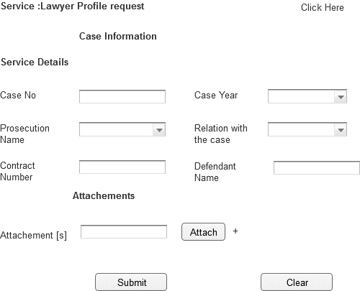

Associated Table and fields

|  |  |  |  |  |  |
| --- | --- | --- | --- | --- | --- |
| **Screen Field** | **Field Type** | **On Screen Validation** | **Mandatory /Optional** | **Auto Populate / User-Input** | **Business Validation For Database Insert** |
| Case No | Text | Number [6digit] | Mandatory | User Input | Case No Entered by User is Validated against the Case Info ,User ID To See if the User is a Party to this particular case .This Business condition validated to insert all the screen fields . |
| Case Year | Drop Down | YYYY | Mandatory | User Input |
| Prosecution Name | Drop Down | Character | Mandatory | Populated From Prosecution View |
| Relation With Case | Drop Down | Character | Mandatory | Populated From CaseInfo_View |
| Attachment [s] | Attachment | .pdf ,.gif,.jpeg,.doc,.txt <Need Input> Single File Size 2MB ; Total Of All File Size 10MB | Optional | User Input |
| Contract Number | Number | Number | Mandatory | User Input |
| Defendant Name | Text | Character | Mandatory | User Input |

Associated Screen Fields Error Handling

|  |  |
| --- | --- |
| **Screen Field** | **On Screen Validation Error Code** |
| Case No | ERR_CASE_NO |
| Case Year | ERR_CASE_YEAR |
| Prosecution Name | ERR_PROSEC_NAME |
| Relation With Case | ERR_REL_CASE |
| Attachment [s] | ERR_ATTACH |
| Contract Number | ERR_CNTCT_NUM |
| Defendant Name | ERR_DFNDT_NAME |

Note:Please refer to the error code section for description of the Error code

* + 1. New Service:Medical Treatment Release

|  |  |
| --- | --- |
| **Use case:** | Medical Treatment Release |
| **Use case ID:** | UC-PS-115 |
| **Actor** | Authenticated User |
| **Brief Description:** | The aim of this service is to allow the imprisoned user, his family or his legal representative to request for Medical Treatment Release |
| **System Trigger:** | The end user will click on the submit button in the Service Page |
| **Preconditions:** | User must be logged on to the E-Services system |
| **Flow of Events:** | 1. The end user must fill the following fields  * **Case No [Mandatory]** * **Case Year[Mandatory]** * **Prosecution Name [Mandatory]** * **Relation With Case [Mandatory]** * **Attachments** * **Inmate [Mandatory]** * **Diseases Type [Mandatory]** * **Medical Report[Mandatory]**  1. When the user moves from one field to another the front end validation is carried out. 2. The User will click submit 3. The system will validate case no. 4. If the request is valid , system will store the request data in the respective database table 5. System will send an email to the user informing that the service request is submitted successfully. |
| **Business Rules** | Please refer to the Associated Table and fields Section for this service given below |
| **Post conditions:** | * Request Submitted successfully and stored in the database * Email sent to the end user conforming the request is raised successfully.[Please Refer Section 7.2 For e-Mail Format ] |
| **Alternative flow** | NA |
| **Exceptions:** | 1. If the case info is not valid the user is prompted with the error ERR_CASE_INVALID 2. If the user entered any invalid values in any mandatory field, the system will highlight the field and show a label that will describe how the correct value should enter. 3. If the user filled all the fields and clicks submit button but no response came from the database within 120 [Default time out period;can be configured manually .Please refer to 6.2.52]secs an error message ERR_TIMEOUT is prompted to the user. |
| **Assumptions:** | NA |

WireFrame:Service:Medical Treatment Realse

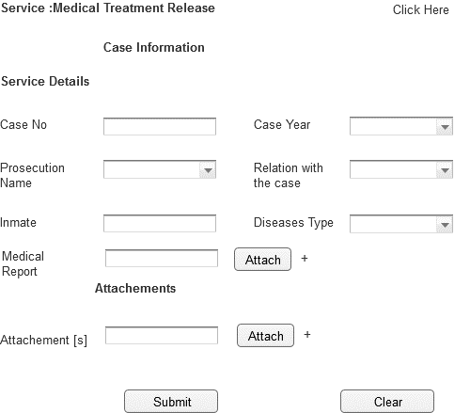

Associated Table and fields

|  |  |  |  |  |  |
| --- | --- | --- | --- | --- | --- |
| **Screen Field** | **Field Type** | **On Screen Validation** | **Mandatory /Optional** | **Auto Populate / User-Input** | **Business Validation For Database Insert** |
| Case No | Text | Number [6digit] | Mandatory | User Input | Case No Entered by User is Validated against the Case Info ,User ID To See if the User is a Party to this particular case .This Business condition validated to insert all the screen fields . |
| Case Year | Drop Down | YYYY | Mandatory | User Input |
| Prosecution Name | Drop Down | Character | Mandatory | Populated From Prosecution View |
| Relation With Case | Drop Down | Character | Mandatory | Populated From CaseInfo_View |
| Attachment [s] | Attachment | .pdf ,.gif,.jpeg,.doc,.txt <Need Input> Single File Size 2MB ; Total Of All File Size 10MB | Optional | User Input |
| Inmate | Text | Character | Mandatory | User Input |
| Diseases Type | Text | Character | Mandatory | User Input |
| Medical Report | Character | Character | Mandatory | User Input |

Associated Screen Fields Error Handling

|  |  |
| --- | --- |
| **Screen Field** | **On Screen Validation Error Code** |
| Case No | ERR_CASE_NO |
| Case Year | ERR_CASE_YEAR |
| Prosecution Name | ERR_PROSEC_NAME |
| Relation With Case | ERR_REL_CASE |
| Attachment [s] | ERR_ATTACH |
| Inmate | ERR_IMTE |
| Diseases Type | ERR_DISES_TYP |
| Medical Report | ERR_MDCL_RPT |

Note:Please refer to the error code section for description of the Error code

* + 1. New Service:Paying the Fine Imposed by Court

|  |  |
| --- | --- |
| **Use case:** | Paying Fine Imposed by Court |
| **Use case ID:** | UC-PS-116 |
| **Actor** | Authenticated User |
| **Brief Description:** | The aim of this service is to allow the user to submit a request for Paying the Fine Imposed by Court |
| **System Trigger:** | The end user will click on the submit button in the Service Page |
| **Preconditions:** | User must be logged on to the E-Services system |
| **Flow of Events:** | 1. The end user must fill the following fields  * **Case No [Mandatory]** * **Case Year[Mandatory]** * **Prosecution Name [Mandatory]** * **Relation With Case [Mandatory]** * **Attachments** * When the user moves from one field to another the front end validation is carried out.  1. The User will click submit 2. The system will validate case no. 3. If the request is valid , system will store the request data in the respective database table 4. System will send an email to the user informing that the service request is submitted successfully. |
| **Business Rules** | Please refer to the Associated Table and fields Section for this service given below |
| **Post conditions:** | * Request Submitted successfully and stored in the database * Email sent to the end user conforming the request is raised successfully.[Please Refer Section 7.2 For e-Mail Format ] |
| **Alternative flow** | NA |
| **Exceptions:** | 1. If the case info is not valid the user is prompted with the error ERR_CASE_INVALID 2. If the user entered any invalid values in any mandatory field, the system will highlight the field and show a label that will describe how the correct value should enter. 3. If the user filled all the fields and clicks submit button but no response came from the database within 120 [Default time out period;can be configured manually .Please refer to 6.2.52]secs an error message ERR_TIMEOUT is prompted to the user. |
| **Assumptions:** | NA |

WireFrame:Service:Paying Fine Imposed by Court

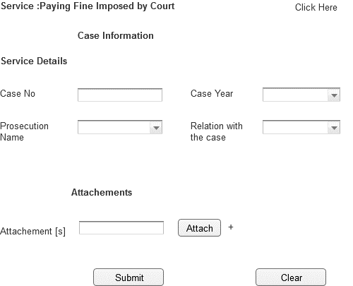

Associated Table and fields

|  |  |  |  |  |  |
| --- | --- | --- | --- | --- | --- |
| **Screen Field** | **Field Type** | **On Screen Validation** | **Mandatory /Optional** | **Auto Populate / User-Input** | **Business Validation For Database Insert** |
| Case No | Text | Number [6digit] | Mandatory | User Input | Case No Entered by User is Validated against the Case Info ,User ID To See if the User is a Party to this particular case .This Business condition validated to insert all the screen fields . |
| Case Year | Drop Down | YYYY | Mandatory | User Input |
| Prosecution Name | Drop Down | Character | Mandatory | Populated From Prosecution View |
| Relation With Case | Drop Down | Character | Mandatory | Populated From CaseInfo_View |
| Attachment [s] | Attachment | .pdf ,.gif,.jpeg,.doc,.txt <Need Input> Single File Size 2MB ; Total Of All File Size 10MB | Optional | User Input |

Associated Screen Fields Error Handling

|  |  |
| --- | --- |
| **Screen Field** | **On Screen Validation Error Code** |
| Case No | ERR_CASE_NO |
| Case Year | ERR_CASE_YEAR |
| Prosecution Name | ERR_PROSEC_NAME |
| Relation With Case | ERR_REL_CASE |
| Attachment [s] | ERR_ATTACH |

Note:Please refer to the error code section for description of the Error code

* + 1. New Service:Payment of Lawyers Fee

|  |  |
| --- | --- |
| **Use case:** | Payment of Lawyers Fee |
| **Use case ID:** | UC-PS-117 |
| **Actor** | Authenticated User |
| **Brief Description:** | The aim of this service is to allow the user to request for Payment of Lawyers Fee |
| **System Trigger:** | The end user will click on the submit button in the Service Page |
| **Preconditions:** | User must be logged on to the E-Services system |
| **Flow of Events:** | 1. The end user must fill the following fields  * **Case No [Mandatory]** * **Case Year[Mandatory]** * **Prosecution Name [Mandatory]** * **Relation With Case [Mandatory]** * **Attachments** * **Iban Number [Mandatory]** * When the user moves from one field to another the front end validation is carried out.  1. The User will click submit 2. The system will validate case no. 3. If the request is valid , system will store the request data in the respective database table 4. System will send an email to the user informing that the service request is submitted successfully. |
| **Business Rules** | Please refer to the Associated Table and fields Section for this service given below |
| **Post conditions:** | * Request Submitted successfully and stored in the database * Email sent to the end user conforming the request is raised successfully.[Please Refer Section 7.2 For e-Mail Format ] |
| **Alternative flow** | NA |
| **Exceptions:** | 1. If the case info is not valid the user is prompted with the error ERR_CASE_INVALID 2. If the user entered any invalid values in any mandatory field, the system will highlight the field and show a label that will describe how the correct value should enter. 3. If the user filled all the fields and clicks submit button but no response came from the database within 120 [Default time out period;can be configured manually .Please refer to 6.2.52]secs an error message ERR_TIMEOUT is prompted to the user. |
| **Assumptions:** | NA |

WireFrame:Service:Payment of Lawyers Fee

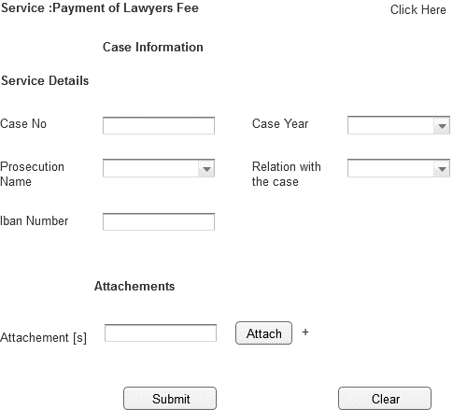

Associated Table and fields

|  |  |  |  |  |  |
| --- | --- | --- | --- | --- | --- |
| **Screen Field** | **Field Type** | **On Screen Validation** | **Mandatory /Optional** | **Auto Populate / User-Input** | **Business Validation For Database Insert** |
| Case No | Text | Number [6 Digit] | Mandatory | User Input | Case No Entered by User is Validated against the Case Info ,User ID To See if the User is a Party to this particular case .This Business condition validated to insert all the screen fields . |
| Case Year | Drop Down | YYYY | Mandatory | User Input |
| Prosecution Name | Drop Down | Character[50] | Mandatory | Populated From Prosecution View |
| Relation With Case | Drop Down | Character[50] | Mandatory | Populated From CaseInfo_View |
| Attachment [s] | Attachment | .pdf ,.gif,.jpeg,.doc,.txt <Need Input> Single File Size 2MB ; Total Of All File Size 10MB | Optional | User Input |
| Iban Number | Text |  | Mandatory | User Input |

Associated Screen Fields Error Handling

|  |  |
| --- | --- |
| **Screen Field** | **On Screen Validation Error Code** |
| Case No | ERR_CASE_NO |
| Case Year | ERR_CASE_YEAR |
| Prosecution Name | ERR_PROSEC_NAME |
| Relation With Case | ERR_REL_CASE |
| Attachment [s] | ERR_ATTACH |
| Iban Number | ERR_IB_NUM |

Note:Please refer to the error code section for description of the Error code

* + 1. New Service:Provide Financial/Personal Bail

|  |  |
| --- | --- |
| **Use case:** | Provide Financial/Personal Bail |
| **Use case ID:** | UC-PS-118 |
| **Actor** | Authenticated User |
| **Brief Description:** | The aim of this service is to allow the user to request for Provide Financial/Personal Bail |
| **System Trigger:** | The end user will click on the submit button in the Service Page |
| **Preconditions:** | User must be logged on to the E-Services system |
| **Flow of Events:** | 1. The end user must fill the following fields  * **Case No [Mandatory]** * **Case Year[Mandatory]** * **Prosecution Name [Mandatory]** * **Relation With Case [Mandatory]** * **Attachments** * **Accused Name [Mandatory]** * When the user moves from one field to another the front end validation is carried out.  1. The User will click submit 2. The system will validate case no. 3. If the request is valid , system will store the request data in the respective database table 4. System will send an email to the user informing that the service request is submitted successfully. |
| **Business Rules** | Please refer to the Associated Table and fields Section for this service given below |
| **Post conditions:** | * Request Submitted successfully and stored in the database * Email sent to the end user conforming the request is raised successfully.[Please Refer Section 7.2 For e-Mail Format ] |
| **Alternative flow** | NA |
| **Exceptions:** | 1. If the case info is not valid the user is prompted with the error ERR_CASE_INVALID 2. If the user entered any invalid values in any mandatory field, the system will highlight the field and show a label that will describe how the correct value should enter. 3. If the user filled all the fields and clicks submit button but no response came from the database within 120 [Default time out period;can be configured manually .Please refer to 6.2.52]secs an error message ERR_TIMEOUT is prompted to the user. |
| **Assumptions:** | NA |

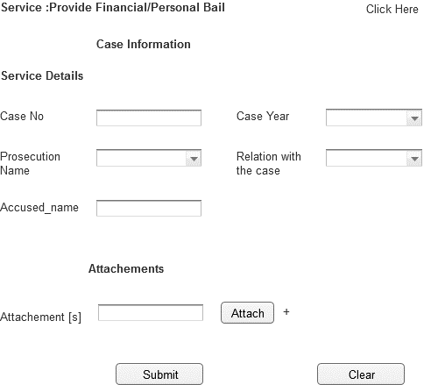

Associated Table and fields

|  |  |  |  |  |  |
| --- | --- | --- | --- | --- | --- |
| **Screen Field** | **Field Type** | **On Screen Validation** | **Mandatory /Optional** | **Auto Populate / User-Input** | **Business Validation For Database Insert** |
| Case No | Text | Number [6 Digit] | Mandatory | User Input | Case No Entered by User is Validated against the Case Info ,User ID To See if the User is a Party to this particular case .This Business condition validated to insert all the screen fields . |
| Case Year | Drop Down | YYYY | Mandatory | User Input |
| Prosecution Name | Drop Down | Character[50] | Mandatory | Populated From Prosecution View |
| Relation With Case | Drop Down | Character[50] | Mandatory | Populated From CaseInfo_View |
| Attachment [s] | Attachment | .pdf ,.gif,.jpeg,.doc,.txt <Need Input> Single File Size 2MB ; Total Of All File Size 10MB | Optional | User Input |
| Accused Name | Text | Characted | Mandatory | User Input |

Associated Screen Fields Error Handling

|  |  |
| --- | --- |
| **Screen Field** | **On Screen Validation Error Code** |
| Case No | ERR_CASE_NO |
| Case Year | ERR_CASE_YEAR |
| Prosecution Name | ERR_PROSEC_NAME |
| Relation With Case | ERR_REL_CASE |
| Attachment [s] | ERR_ATTACH |
| Accused Name | ERR_ACCUSD_NM |

* + 1. New Service:Receiving of Corpse

|  |  |
| --- | --- |
| **Use case:** | Receiving of Corpse |
| **Use case ID:** | UC-PS-119 |
| **Actor** | Authenticated User |
| **Brief Description:** | The aim of this service is to allow the user to request for Receiving of Corpse |
| **System Trigger:** | The end user will click on the submit button in the Service Page |
| **Preconditions:** | User must be logged on to the E-Services system |
| **Flow of Events:** | 1. The end user must fill the following fields  * **Case No [Mandatory]** * **Case Year[Mandatory]** * **Prosecution Name [Mandatory]** * **Relation With Case [Mandatory]** * **Attachments** * When the user moves from one field to another the front end validation is carried out.  1. The User will click submit 2. The system will validate case no. 3. If the request is valid , system will store the request data in the respective database table 4. System will send an email to the user informing that the service request is submitted successfully. |
| **Business Rules** | Please refer to the Associated Table and fields Section for this service given below |
| **Post conditions:** | * Request Submitted successfully and stored in the database * Email sent to the end user conforming the request is raised successfully.[Please Refer Section 7.2 For e-Mail Format ] |
| **Alternative Flow** | NA |
| **Exceptions:** | 1. If the case info is not valid the user is prompted with the error ERR_CASE_INVALID 2. If the user entered any invalid values in any mandatory field, the system will highlight the field and show a label that will describe how the correct value should enter. 3. If the user filled all the fields and clicks submit button but no response came from the database within 120 [Default time out period;can be configured manually .Please refer to 6.2.52]secs an error message ERR_TIMEOUT is prompted to the user. |
| **Assumptions:** | NA |

WireFrame:Service:Receiving if Corpase

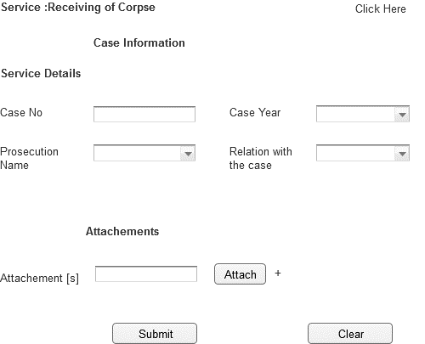

Associated Table and fields

|  |  |  |  |  |  |
| --- | --- | --- | --- | --- | --- |
| **Screen Field** | **Field Type** | **On Screen Validation** | **Mandatory /Optional** | **Auto Populate / User-Input** | **Business Validation For Database Insert** |
| Case No | Text | Number | Mandatory | User Input | Case No Entered by User is Validated against the Case Info ,User ID To See if the User is a Party to this particular case .This Business condition validated to insert all the screen fields . |
| Case Year | Drop Down | YYYY | Mandatory | User Input |
| Prosecution Name | Drop Down | Character | Mandatory | Populated From Prosecution View |
| Relation With Case | Drop Down | Character | Mandatory | Populated From CaseInfo_View |
| Attachment [s] | Attachment | .pdf ,.gif,.jpeg,.doc,.txt <Need Input> Single File Size 2MB ; Total Of All File Size 10MB | Optional | User Input |

Associated Screen Fields Error Handling

|  |  |
| --- | --- |
| **Screen Field** | **On Screen Validation Error Code** |
| Case No | ERR_CASE_NO |
| Case Year | ERR_CASE_YEAR |
| Prosecution Name | ERR_PROSEC_NAME |
| Relation With Case | ERR_REL_CASE |
| Attachment [s] | ERR_ATTACH |

* + 1. New Service:Referral of Inmate

|  |  |
| --- | --- |
| **Use case:** | Referral of Inmate |
| **Use case ID:** | UC-PS-120 |
| **Actor** | Authenticated User |
| **Brief Description:** | The aim of this service is to allow the user to request for transfer to a certain place |
| **System Trigger:** | The end user will click on the submit button in the Service Page |
| **Preconditions:** | User must be logged on to the E-Services system |
| **Flow of Events:** | 1. The end user must fill the following fields  * **Case No [Mandatory]** * **Case Year[Mandatory]** * **Prosecution Name [Mandatory]** * **Relation With Case [Mandatory]** * **Attachments** * **Prisoner name [Mandatory]** * **Request reason [Mandatory]**  1. When the user moves from one field to another the front end validation is carried out. 2. The User will click submit 3. The system will validate case no. 4. If the request is valid , system will store the request data in the respective database table 5. System will send an email to the user informing that the service request is submitted successfully. |
| **Business Rules** | Please refer to the Associated Table and fields Section for this service given below |
| **Post conditions:** | * Request Submitted successfully and stored in the database * Email sent to the end user conforming the request is raised successfully.[Please Refer Section 7.2 For e-Mail Format ] |
| **Alternative Flow** | NA |
| **Exceptions:** | 1. If the case info is not valid the user is prompted with the error ERR_CASE_INVALID 2. If the user entered any invalid values in any mandatory field, the system will highlight the field and show a label that will describe how the correct value should enter. 3. If the user filled all the fields and clicks submit button but no response came from the database within 120 [Default time out period;can be configured manually .Please refer to 6.2.52]secs an error message ERR_TIMEOUT is prompted to the user. |
| **Assumptions:** | NA |

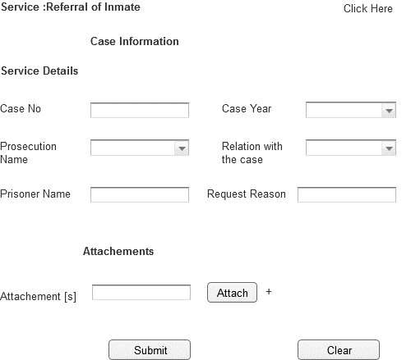

Associated Table and fields

|  |  |  |  |  |  |
| --- | --- | --- | --- | --- | --- |
| **Screen Field** | **Field Type** | **On Screen Validation** | **Mandatory /Optional** | **Auto Populate / User-Input** | **Business Validation For Database Insert** |
| Case No | Text | Number [6digit] | Mandatory | User Input | Case No Entered by User is Validated against the Case Info ,User ID To See if the User is a Party to this particular case .This Business condition validated to insert all the screen fields . |
| Case Year | Drop Down | YYYY | Mandatory | User Input |
| Prosecution Name | Drop Down | Character | Mandatory | Populated From Prosecution View |
| Relation With Case | Drop Down | Character | Mandatory | Populated From CaseInfo_View |
| Attachment [s] | Attachment | .pdf ,.gif,.jpeg,.doc,.txt <Need Input> Single File Size 2MB ; Total Of All File Size 10MB | Optional | User Input |
| Prisoner Name | Text | Character | Mandatory | User Input |
| Reason Request | Text | Character | Mandatory | User Input |

Associated Screen Fields Error Handling

|  |  |
| --- | --- |
| **Screen Field** | **On Screen Validation Error Code** |
| Case No | ERR_CASE_NO |
| Case Year | ERR_CASE_YEAR |
| Prosecution Name | ERR_PROSEC_NAME |
| Relation With Case | ERR_REL_CASE |
| Attachment [s] | ERR_ATTACH |
| Prisoner Name | ERR_PRSN_NM |
| Reason Request | ERR_RES_REQ |

New Service: Receiving of Seizures

|  |  |
| --- | --- |
| **Use case:** | Receiving of Seizures |
| **Use case ID:** | UC-PS-121 |
| **Actor** | Authenticated User |
| **Brief Description:** | The aim of this service is to allow the user to Receiving of Seizures |
| **System Trigger:** | The end user will click on the submit button in the Service Page |
| **Preconditions:** | User must be logged on to the E-Services system |
| **Flow of Events:** | 1. The end user must fill the following fields  * **Case No [Mandatory]** * **Case Year[Mandatory]** * **Prosecution Name [Mandatory]** * **Relation With Case [Mandatory]** * **Attachments** * **Appeal [Mandatory]**   When the user moves from one field to another the front end validation is carried out.   1. The User will click submit 2. The system will validate case no. 3. If the request is valid , system will store the request data in the respective database table 4. System will send an email to the user informing that the service request is submitted successfully. |
| **Business Rules** | Please refer to the Associated Table and fields Section for this service given below |
| **Post conditions:** | * Request Submitted successfully and stored in the database * Email sent to the end user conforming the request is raised successfully.[Please Refer Section 7.2 For e-Mail Format ] |
| **Alternative Flow** | NA |
| **Exceptions:** | 1. If the case info is not valid the user is prompted with the error ERR_CASE_INVALID 2. If the user entered any invalid values in any mandatory field, the system will highlight the field and show a label that will describe how the correct value should enter. 3. If the user filled all the fields and clicks submit button but no response came from the database within 120 [Default time out period;can be configured manually .Please refer to 6.2.52]secs an error message ERR_TIMEOUT is prompted to the user. |
| **Assumptions:** | NA |

|  |  |  |  |  |  |
| --- | --- | --- | --- | --- | --- |
| **Screen Field** | **Field Type** | **On Screen Validation** | **Mandatory /Optional** | **Auto Populate / User-Input** | **Business Validation For Database Insert** |
| Case No | Text | Number [6digit] | Mandatory | User Input | Case No Entered by User is Validated against the Case Info ,User ID To See if the User is a Party to this particular case .This Business condition validated to insert all the screen fields . |
| Case Year | Drop Down | YYYY | Mandatory | User Input |
| Prosecution Name | Drop Down | Character | Mandatory | Populated From Prosecution View |
| Relation With Case | Drop Down | Character | Mandatory | Populated From CaseInfo_View |
| Attachment [s] | Attachment | .pdf ,.gif,.jpeg,.doc,.txt <Need Input> Single File Size 2MB ; Total Of All File Size 10MB | Optional | User Input |
| Appeal | Text | Character | Mandatory | User Input |

Associated Screen Fields Error Handling

|  |  |
| --- | --- |
| **Screen Field** | **On Screen Validation Error Code** |
| Case No | ERR_CASE_NO |
| Case Year | ERR_CASE_YEAR |
| Prosecution Name | ERR_PROSEC_NAME |
| Relation With Case | ERR_REL_CASE |
| =Attachment [s] | ERR_ATTACH |
| APPEAL | ERR_APPEAL |

* + 1. New Service:Review

|  |  |
| --- | --- |
| **Use case:** | Review |
| **Use case ID:** | UC-PS-122 |
| **Actor** | Authenticated User |
| **Brief Description:** | The aim of this service is to allow the user to submit a request to Review against final judgment imposing penalty or measure asper code of penal procedures. |
| **System Trigger:** | The end user will click on the submit button in the Service Page |
| **Preconditions:** | User must be logged on to the E-Services system |
| **Flow of Events:** | 1. The end user must fill the following fields  * **Case No [Mandatory]** * **Case Year[Mandatory]** * **Prosecution Name [Mandatory]** * **Relation With Case [Mandatory]** * **Attachments** * **Request Reason [Mandatory]** * When the user moves from one field to another the front end validation is carried out.  1. The User will click submit 2. The system will validate case no. 3. If the request is valid , system will store the request data in the respective database table 4. System will send an email to the user informing that the service request is submitted successfully. |
| **Business Rules** | Please refer to the Associated Table and fields Section for this service given below |
| **Post conditions:** | * Request Submitted successfully and stored in the database * Email sent to the end user conforming the request is raised successfully.[Please Refer Section 7.2 For e-Mail Format ] |
| **Alternative Flow** | NA |
| **Exceptions:** | 1. If the case info is not valid the user is prompted with the error ERR_CASE_INVALID 2. If the user entered any invalid values in any mandatory field, the system will highlight the field and show a label that will describe how the correct value should enter. 3. If the user filled all the fields and clicks submit button but no response came from the database within 120 [Default time out period;can be configured manually .Please refer to 6.2.52]secs an error message ERR_TIMEOUT is prompted to the user. |
| **Assumptions:** | NA |

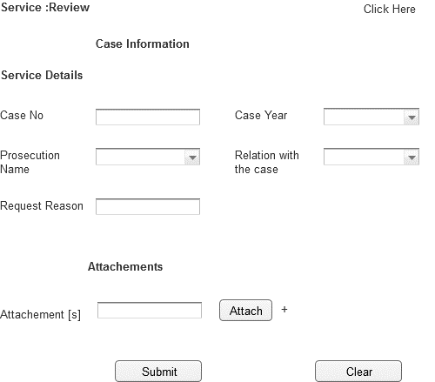

Associated Table and fields

|  |  |  |  |  |  |
| --- | --- | --- | --- | --- | --- |
| **Screen Field** | **Field Type** | **On Screen Validation** | **Mandatory /Optional** | **Auto Populate / User-Input** | **Business Validation For Database Insert** |
| Case No | Text | Number [6digit] | Mandatory | User Input | Case No Entered by User is Validated against the Case Info, User ID To See if the User is a Party to this particular case .This Business condition validated to insert all the screen fields . |
| Case Year | Drop Down | YYYY | Mandatory | User Input |
| Prosecution Name | Drop Down | Character | Mandatory | Populated From Prosecution View |
| Relation With Case | Drop Down | Character | Mandatory | Populated From CaseInfo_View |
| Attachment [s] | Attachment | .pdf ,.gif,.jpeg,.doc,.txt <Need Input> Single File Size 2MB ; Total Of All File Size 10MB | Optional | User Input |
| Request Reason | Text | Character | Mandatory | User Input |

Associated Screen Fields Error Handling

|  |  |
| --- | --- |
| **Screen Field** | **On Screen Validation Error Code** |
| Case No | ERR_CASE_NO |
| Case Year | ERR_CASE_YEAR |
| Prosecution Name | ERR_PROSEC_NAME |
| Relation With Case | ERR_REL_CASE |
| Attachment [s] | ERR_ATTACH |
| Reason Request | ERR_RES_REQ |

* + 1. New Service: Prosecution Side Appeal

|  |  |
| --- | --- |
| **Use case:** | Prosecution Appeal |
| **Use case ID:** | UC-PS-123 |
| **Actor** | Authenticated User |
| **Brief Description:** | The aim of this service is to allow the user to request for prosecution side Appeal |
| **System Trigger:** | The end user will click on the submit button in the Service Page |
| **Preconditions:** | User must be logged on to the E-Services system |
| **Flow of Events:** | 1. The end user must fill the following fields  * **Case No [Mandatory]** * **Case Year[Mandatory]** * **Prosecution Name [Mandatory]** * **Relation With Case [Mandatory]** * **Attachments** * When the user moves from one field to another the front end validation is carried out.  1. The User will click submit 2. The system will validate case no. 3. If the request is valid , system will store the request data in the respective database table 4. System will send an email to the user informing that the service request is submitted successfully. |
| **Business Rules** | Please refer to the Associated Table and fields Section for this service given below |
| **Post conditions:** | * Request Submitted successfully and stored in the database * Email sent to the end user conforming the request is raised successfully.[Please Refer Section 7.2 For e-Mail Format ] |
| **Alternative Flow** | NA |
| **Exceptions:** | 1. If the case info is not valid the user is prompted with the error ERR_CASE_INVALID 2. If the user entered any invalid values in any mandatory field, the system will highlight the field and show a label that will describe how the correct value should enter. 3. If the user filled all the fields and clicks submit button but no response came from the database within 120 [Default time out period;can be configured manually .Please refer to 6.2.52]secs an error message ERR_TIMEOUT is prompted to the user. |
| **Assumptions:** | NA |

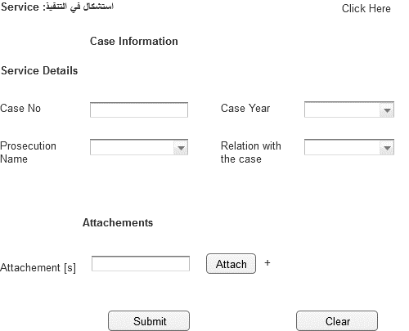

Associated Table and fields

|  |  |  |  |  |  |
| --- | --- | --- | --- | --- | --- |
| **Screen Field** | **Field Type** | **On Screen Validation** | **Mandatory /Optional** | **Auto Populate / User-Input** | **Business Validation For Database Insert** |
| Case No | Text | Number | Mandatory | User Input | Case No Entered by User is Validated against the Case Info ,User ID To See if the User is a Party to this particular case .This Business condition validated to insert all the screen fields . |
| Case Year | Drop Down | YYYY | Mandatory | User Input |
| Prosecution Name | Drop Down | Character | Mandatory | Populated From Prosecution View |
| Relation With Case | Drop Down | Character | Mandatory | Populated From CaseInfo_View |
| Attachment [s] | Attachment | .pdf ,.gif,.jpeg,.doc,.txt <Need Input> Single File Size 2MB ; Total Of All File Size 10MB | Optional | User Input |

|  |  |
| --- | --- |
| Associated Screen Fields Error Handling | |
| **Screen Field** | **On Screen Validation Error Code** |
| Case No | ERR_CASE_NO |
| Case Year | ERR_CASE_YEAR |
| Prosecution Name | ERR_PROSEC_NAME |
| Relation With Case | ERR_REL_CASE |
| Attachment [s] | ERR_ATTACH |

* + 1. Existing Service:Adjourn a Session or Fix New Date

|  |  |
| --- | --- |
| **Use case:** | Adjourn a Session or Fix New Date |
| **Use case ID:** | UC-PS-124 |
| **Actor** | Authenticated User |
| **Brief Description:** | The aim of this service is to allow the user to request for Adjourn a Session or Fix New Date |
| **System Trigger:** | The end user will click on the submit button in the Service Page |
| **Preconditions:** | User must be logged on to the E-Services system |
| **Flow of Events:** | 1. The end user must fill the following fields  * **Case No [Mandatory]** * **Case Year[Mandatory]** * **Prosecution Name [Mandatory]** * **Relation With Case [Mandatory]** * **Attachments** * **Postpone_Reason[Mandatory]** * **Session_Date[Mandatory]** * When the user moves from one field to another the front end validation is carried out.   [Specify the field level validations]   1. The User will click submit 2. The system will validate case no. 3. If the request is valid , system will store the request data in the respective database table 4. System will send an email to the user informing that the service request is submitted successfully. |
| **Business Rules** | Please refer to the Associated Table and fields Section for this service given below |
| **Post conditions:** | * Request Submitted successfully and stored in the database * Email sent to the end user conforming the request is raised successfully.[Please Refer Section 7.2 For e-Mail Format ] |
| **Alternative Flow** | NA |
| **Exceptions:** | 1. If the case info is not valid the user is prompted with the error ERR_CASE_INVALID 2. If the user entered any invalid values in any mandatory field, the system will highlight the field and show a label that will describe how the correct value should enter. 3. If the user filled all the fields and clicks submit button but no response came from the database within 120 [Default time out period;can be configured manually .Please refer to 6.2.52]secs an error message ERR_TIMEOUT is prompted to the user. |
| **Assumptions:** | NA |

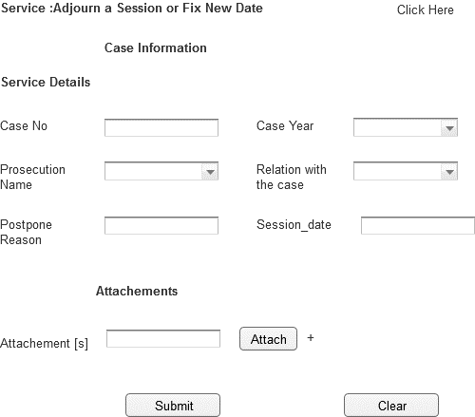

Associated Table and fields

|  |  |  |  |  |  |
| --- | --- | --- | --- | --- | --- |
| **Screen Field** | **Field Type** | **On Screen Validation** | **Mandatory /Optional** | **Auto Populate / User-Input** | **Business Validation For Database Insert** |
| Case No | Text | Number [6digit] | Mandatory | User Input | Case No Entered by User is Validated against the Case Info ,User ID To See if the User is a Party to this particular case .ThisBusiness condition validated to to insert all the screen fields . |
| Case Year | Drop Down | YYYY | Mandatory | User Input |
| Prosecution Name | Drop Down | Character | Mandatory | Populated From Prosecution_View |
| Relation With Case | Drop Down | Character | Mandatory | Populated From CaseInfo_View |
| Attachment [s] | Attachment | .pdf ,.gif,.jpeg,.doc,.txt <Need Input> Single File Size 2MB ; Total Of All File Size 10MB | Optional | User Input |
| Postpone_Reason | Text | Character | Mandatory | User Input |
| Session_date | Drop Down | DD-MM-YYY | Mandatory | User Input |

|  |  |
| --- | --- |
| Associated Screen Fields Error Handling | |
| **Screen Field** | **On Screen Validation Error Code** |
| Case No | ERR_CASE_NO |
| Case Year | ERR_CASE_YEAR |
| Prosecution Name | ERR_PROSEC_NAME |
| Relation With Case | ERR_REL_CASE |
| Attachment [s] | ERR_ATTACH |
| Postpone_Reason | ERR_POS_RES |
| Session_date | ERR_SES_DAT |

* + 1. Existing Service:Case Copy

|  |  |
| --- | --- |
| **Use case:** | Case Copy |
| **Use case ID:** | UC-PS-125 |
| **Actor** | Authenticated User |
| **Brief Description:** | The aim of this service is to allow the user to request for Case Copy |
| **System Trigger:** | The end user will click on the submit button in the Service Page |
| **Preconditions:** | User must be logged on to the E-Services system |
| **Flow of Events:** | 1. The end user must fill the following fields  * **Case No [Mandatory]** * **Case Year[Mandatory]** * **Prosecution Name [Mandatory]** * **Relation With Case [Mandatory]** * **Attachments** * When the user moves from one field to another the front end validation is carried out.   [Specify the field level validations]   1. The User will click submit 2. The system will validate case no. 3. If the request is valid , system will store the request data in the respective database table 4. System will send an email to the user informing that the service request is submitted successfully. |
| **Business Rules** | Please refer to the Associated Table and fields Section for this service given below |
| **Post conditions:** | * Request Submitted successfully and stored in the database * Email sent to the end user conforming the request is raised successfully.[Please Refer Section 7.2 For e-Mail Format ] |
| **Alternative Flow** | NA |
| **Exceptions:** | 1. If the case info is not valid the user is prompted with the error ERR_CASE_INVALID 2. If the user entered any invalid values in any mandatory field, the system will highlight the field and show a label that will describe how the correct value should enter. 3. If the user filled all the fields and clicks submit button but no response came from the database within 120 [Default time out period;can be configured manually .Please refer to 6.2.52]secs an error message ERR_TIMEOUT is prompted to the user. |
| **Assumptions:** | NA |

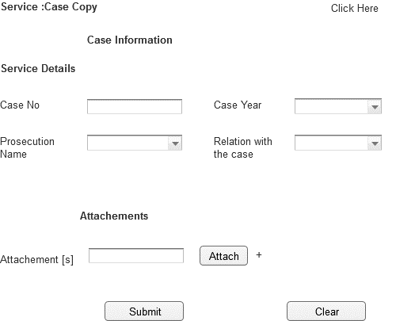

Associated Table and fields

|  |  |  |  |  |  |
| --- | --- | --- | --- | --- | --- |
| **Screen Field** | **Field Type** | **On Screen Validation** | **Mandatory /Optional** | **Auto Populate / User-Input** | **Business Validation For Database Insert** |
| Case No | Text | Number | Mandatory | User Input | Case No Entered by User is Validated against the Case Info ,User ID To See if the User is a Party to this particular case .ThisBusiness condition validated to to insert all the screen fields . |
| Case Year | Drop Down | YYYY | Mandatory | User Input |
| Prosecution Name | Drop Down | Character | Mandatory | Populated From Prosecution_View |
| Relation With Case | Drop Down | Character | Mandatory | Populated From CaseInfo_View |
| Attachment [s] | Attachment | .pdf ,.gif,.jpeg,.doc,.txt <Need Input> Single File Size 2MB ; Total Of All File Size 10MB | Optional | User Input |

|  |  |
| --- | --- |
| Associated Screen Fields Error Handling | |
| **Screen Field** | **On Screen Validation Error Code** |
| Case No | ERR_CASE_NO |
| Case Year | ERR_CASE_YEAR |
| Prosecution Name | ERR_PROSEC_NAME |
| Relation With Case | ERR_REL_CASE |
| Attachment [s] | ERR_ATTACH |

* + 1. Existing Service:Case Information

|  |  |
| --- | --- |
| **Use case:** | Case Information |
| **Use case ID:** | UC-PS-126 |
| **Actor** | Authenticated User |
| **Brief Description:** | The aim of this service is to allow the user to request for Case Information |
| **System Trigger:** | The end user will click on the submit button in the Service Page |
| **Preconditions:** | User must be logged on to the E-Services system |
| **Flow of Events:** | 1. The end user must fill the following fields  * **Case No [Mandatory]** * **Case Year[Mandatory]** * **Prosecution Name [Mandatory]** * **Relation With Case [Mandatory]** * **Attachments** * When the user moves from one field to another the front end validation is carried out.   [Specify the field level validations]   1. The User will click submit 2. The system will validate case no. 3. If the request is valid , system will store the request data in the respective database table 4. System will send an email to the user informing that the service request is submitted successfully. |
| **Business Rules** | Please refer to the Associated Table and fields Section for this service given below |
| **Post conditions:** | * Request Submitted successfully and stored in the database * Email sent to the end user conforming the request is raised successfully.[Please Refer Section 7.2 For e-Mail Format ] |
| **Alternative Flow** | NA |
| **Exceptions:** | 1. If the case info is not valid the user is prompted with the error ERR_CASE_INVALID 2. If the user entered any invalid values in any mandatory field, the system will highlight the field and show a label that will describe how the correct value should enter. 3. If the user filled all the fields and clicks submit button but no response came from the database within 120 [Default time out period;can be configured manually .Please refer to 6.2.52]secs an error message ERR_TIMEOUT is prompted to the user. |
| **Assumptions:** | NA |
| **Issues:** | NA |

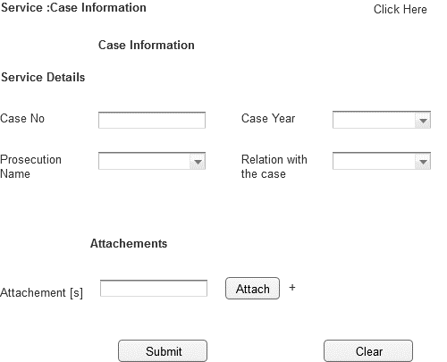

Associated Table and fields

|  |  |  |  |  |  |
| --- | --- | --- | --- | --- | --- |
| **Screen Field** | **Field Type** | **On Screen Validation** | **Mandatory /Optional** | **Auto Populate / User-Input** | **Business Validation For Database Insert** |
| Case No | Text | Number | Mandatory | User Input | Case No Entered by User is Validated against the Case Info ,User ID To See if the User is a Party to this particular case .ThisBusiness condition validated to to insert all the screen fields . |
| Case Year | Drop Down | YYYY | Mandatory | User Input |
| Prosecution Name | Drop Down | Character | Mandatory | Populated From Prosecution_View |
| Relation With Case | Drop Down | Character | Mandatory | Populated From CaseInfo_View |
| Attachment [s] | Attachment | .pdf ,.gif,.jpeg,.doc,.txt <Need Input> Single File Size 2MB ; Total Of All File Size 10MB | Optional | User Input |

|  |  |
| --- | --- |
| Associated Screen Fields Error Handling | |
| **Screen Field** | **On Screen Validation Error Code** |
| Case No | ERR_CASE_NO |
| Case Year | ERR_CASE_YEAR |
| Prosecution Name | ERR_PROSEC_NAME |
| Relation With Case | ERR_REL_CASE |
| Attachment [s] | ERR_ATTACH |

* + 1. Existing Service:Copy of Judgment

|  |  |
| --- | --- |
| **Use case:** | Copy of Judgment |
| **Use case ID:** | UC-PS-127 |
| **Actor** | Authenticated User |
| **Brief Description:** | The aim of this service is to allow the user to request for Copy of Judgment |
| **System Trigger:** | The end user will click on the submit button in the Service Page |
| **Preconditions:** | User must be logged on to the E-Services system |
| **Flow of Events:** | 1. The end user must fill the following fields  * **Case No [Mandatory]** * **Case Year[Mandatory]** * **Prosecution Name [Mandatory]** * **Relation With Case [Mandatory]** * **Attachments** * When the user moves from one field to another the front end validation is carried out.   [Specify the field level validations]   1. The User will click submit 2. The system will validate case no. 3. If the request is valid , system will store the request data in the respective database table 4. System will send an email to the user informing that the service request is submitted successfully. |
| **Business Rules** | Please refer to the Associated Table and fields Section for this service given below |
| **Post conditions:** | * Request Submitted successfully and stored in the database * Email sent to the end user conforming the request is raised successfully.[Please Refer Section 7.2 For e-Mail Format ] |
| **Alternative Flow** | NA |
| **Exceptions:** | 1. If the case info is not valid the user is prompted with the error ERR_CASE_INVALID 2. If the user entered any invalid values in any mandatory field, the system will highlight the field and show a label that will describe how the correct value should enter. 3. If the user filled all the fields and clicks submit button but no response came from the database within 120 [Default time out period;can be configured manually .Please refer to 6.2.52]secs an error message ERR_TIMEOUT is prompted to the user. |
| **Assumptions:** | NA |

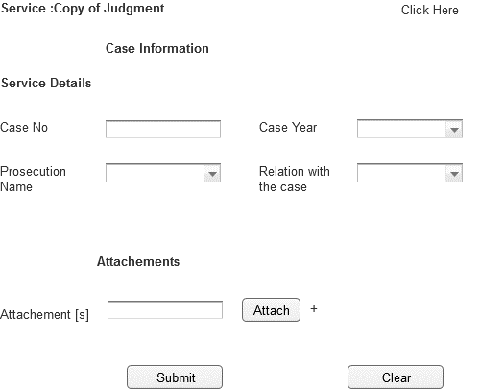

Associated Table and fields

|  |  |  |  |  |  |
| --- | --- | --- | --- | --- | --- |
| **Screen Field** | **Field Type** | **On Screen Validation** | **Mandatory /Optional** | **Auto Populate / User-Input** | **Business Validation For Database Insert** |
| Case No | Text | Number | Mandatory | User Input | Case No Entered by User is Validated against the Case Info ,User ID To See if the User is a Party to this particular case .ThisBusiness condition validated to to insert all the screen fields . |
| Case Year | Drop Down | YYYY | Mandatory | User Input |
| Prosecution Name | Drop Down | Character | Mandatory | Populated From Prosecution_View |
| Relation With Case | Drop Down | Character | Mandatory | Populated From CaseInfo_View |
| Attachment [s] | Attachment | .pdf ,.gif,.jpeg,.doc,.txt <Need Input> Single File Size 2MB ; Total Of All File Size 10MB | Optional | User Input |

|  |  |
| --- | --- |
| Associated Screen Fields Error Handling | |
| **Screen Field** | **On Screen Validation Error Code** |
| Case No | ERR_CASE_NO |
| Case Year | ERR_CASE_YEAR |
| Prosecution Name | ERR_PROSEC_NAME |
| Relation With Case | ERR_REL_CASE |
| Attachment [s] | ERR_ATTACH |

* + 1. Copy of Non-Suit Order

|  |  |
| --- | --- |
| **Use case:** | Copy of Non-Suit Order |
| **Use case ID:** | UC-PS-128 |
| **Actor** | Authenticated User |
| **Brief Description:** | The aim of this service is to allow the user to request for Copy of Non-Suit Order |
| **System Trigger:** | The end user will click on the submit button in the Service Page |
| **Preconditions:** | User must be logged on to the E-Services system |
| **Flow of Events:** | 1. The end user must fill the following fields  * **Case No [Mandatory]** * **Case Year[Mandatory]** * **Prosecution Name [Mandatory]** * **Relation With Case [Mandatory]** * **Attachments** * When the user moves from one field to another the front end validation is carried out.   [Specify the field level validations]   1. The User will click submit 2. The system will validate case no. 3. If the request is valid , system will store the request data in the respective database table 4. System will send an email to the user informing that the service request is submitted successfully. |
| **Business Rules** | Please refer to the Associated Table and fields Section for this service given below |
| **Post conditions:** | * Request Submitted successfully and stored in the database * Email sent to the end user conforming the request is raised successfully.[Please Refer Section 7.2 For e-Mail Format ] |
| **Alternative Flow** | NA |
| **Exceptions:** | 1. If the case info is not valid the user is prompted with the error ERR_CASE_INVALID 2. If the user entered any invalid values in any mandatory field, the system will highlight the field and show a label that will describe how the correct value should enter. 3. If the user filled all the fields and clicks submit button but no response came from the database within 120 [Default time out period;can be configured manually .Please refer to 6.2.52]secs an error message ERR_TIMEOUT is prompted to the user. |
| **Assumptions:** | NA |
| **Issues:** | NA |

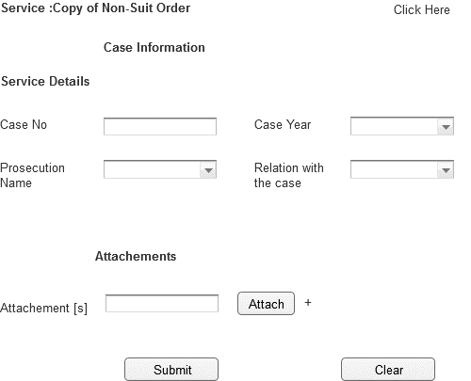

Associated Table and fields

|  |  |  |  |  |  |
| --- | --- | --- | --- | --- | --- |
| **Screen Field** | **Field Type** | **On Screen Validation** | **Mandatory /Optional** | **Auto Populate / User-Input** | **Business Validation For Database Insert** |
| Case No | Text | Number | Mandatory | User Input | Case No Entered by User is Validated against the Case Info ,User ID To See if the User is a Party to this particular case .ThisBusiness condition validated to to insert all the screen fields . |
| Case Year | Drop Down | YYYY | Mandatory | User Input |
| Prosecution Name | Drop Down | Character | Mandatory | Populated From Prosecution_View |
| Relation With Case | Drop Down | Character | Mandatory | Populated From CaseInfo_View |
| Attachment [s] | Attachment | .pdf ,.gif,.jpeg,.doc,.txt <Need Input> Single File Size 2MB ; Total Of All File Size 10MB | Optional | User Input |

|  |  |
| --- | --- |
| Associated Screen Fields Error Handling | |
| **Screen Field** | **On Screen Validation Error Code** |
| Case No | ERR_CASE_NO |
| Case Year | ERR_CASE_YEAR |
| Prosecution Name | ERR_PROSEC_NAME |
| Relation With Case | ERR_REL_CASE |
| Attachment [s] | ERR_ATTACH |

* + 1. Existing Service:Drop Court Imposed Penalty Due to Prescription

|  |  |
| --- | --- |
| **Use case:** | Drop Court Imposed Penalty Due to Prescription |
| **Use case ID:** | UC-PS-129 |
| **Actor** | Authenticated User |
| **Brief Description:** | The aim of this service is to allow the user to request for Drop Court Imposed Penalty Due to Prescription |
| **System Trigger:** | The end user will click on the submit button in the Service Page |
| **Preconditions:** | User must be logged on to the E-Services system |
| **Flow of Events:** | 1. The end user must fill the following fields  * **Case No [Mandatory]** * **Case Year[Mandatory]** * **Prosecution Name [Mandatory]** * **Relation With Case [Mandatory]** * **Judgement date[Mandatory]** * **Attachments** * When the user moves from one field to another the front end validation is carried out.   [Specify the field level validations]   1. The User will click submit 2. The system will validate case no. 3. If the request is valid , system will store the request data in the respective database table 4. System will send an email to the user informing that the service request is submitted successfully. |
| **Business Rules** | Please refer to the Associated Table and fields Section for this service given below |
| **Post conditions:** | * Request Submitted successfully and stored in the database * Email sent to the end user conforming the request is raised successfully.[Please Refer Section 7.2 For e-Mail Format ] |
| **Alternative Flow** | NA |
| **Exceptions:** | 1. If the case info is not valid the user is prompted with the error ERR_CASE_INVALID 2. If the user entered any invalid values in any mandatory field, the system will highlight the field and show a label that will describe how the correct value should enter. 3. If the user filled all the fields and clicks submit button but no response came from the database within 120 [Default time out period;can be configured manually .Please refer to 6.2.52]secs an error message ERR_TIMEOUT is prompted to the user. |
| **Assumptions:** | NA |
| **Issues:** | NA |

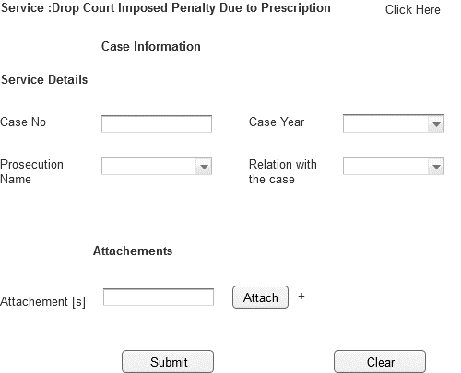

Associated Table and fields

|  |  |  |  |  |  |
| --- | --- | --- | --- | --- | --- |
| **Screen Field** | **Field Type** | **On Screen Validation** | **Mandatory /Optional** | **Auto Populate / User-Input** | **Business Validation For Database Insert** |
| Case No | Text | Number | Mandatory | User Input | Case No Entered by User is Validated against the Case Info ,User ID To See if the User is a Party to this particular case .ThisBusiness condition validated to to insert all the screen fields . |
| Case Year | Drop Down | YYYY | Mandatory | User Input |
| Prosecution Name | Drop Down | Character | Mandatory | Populated From Prosecution_View |
| Relation With Case | Drop Down | Character | Mandatory | Populated From CaseInfo_View |
| Judgement date | Number | Number[DD-MM-YYYY] | Mandatory | User Input |
| Attachment [s] | Attachment | .pdf ,.gif,.jpeg,.doc,.txt <Need Input> Single File Size 2MB ; Total Of All File Size 10MB | Optional | User Input |

|  |  |
| --- | --- |
| Associated Screen Fields Error Handling | |
| **Screen Field** | **On Screen Validation Error Code** |
| Case No | ERR_CASE_NO |
| Case Year | ERR_CASE_YEAR |
| Prosecution Name | ERR_PROSEC_NAME |
| Relation With Case | ERR_REL_CASE |
| Judgement date | ERR_JUDGE_DATE |
| Attachment [s] | ERR_ATTACH |

* + 1. Existing Service:Exhumation Service

|  |  |
| --- | --- |
| **Use case:** | Exhumation Service |
| **Use case ID:** | UC-PS-130 |
| **Actor** | Authenticated User |
| **Brief Description:** | The aim of this service is to allow the user to request for Exhumation Service |
| **System Trigger:** | The end user will click on the submit button in the Service Page |
| **Preconditions:** | User must be logged on to the E-Services system |
| **Flow of Events:** | 1. The end user must fill the following fields  * **Case No [Mandatory]** * **Case Year[Mandatory]** * **Prosecution Name [Mandatory]** * **Relation With Case [Mandatory]** * **Attachments** * When the user moves from one field to another the front end validation is carried out.   [Specify the field level validations]   1. The User will click submit 2. The system will validate case no. 3. If the request is valid , system will store the request data in the respective database table 4. System will send an email to the user informing that the service request is submitted successfully. |
| **Business Rules** | Please refer to the Associated Table and fields Section for this service given below |
| **Post conditions:** | * Request Submitted successfully and stored in the database * Email sent to the end user conforming the request is raised successfully.[Please Refer Section 7.2 For e-Mail Format ] |
| **Alternative Flow** | NA |
| **Exceptions:** | 1. If the case info is not valid the user is prompted with the error ERR_CASE_INVALID 2. If the user entered any invalid values in any mandatory field, the system will highlight the field and show a label that will describe how the correct value should enter. 3. If the user filled all the fields and clicks submit button but no response came from the database within 120 [Default time out period;can be configured manually .Please refer to 6.2.52]secs an error message ERR_TIMEOUT is prompted to the user. |
| **Assumptions:** | NA |
| **Issues:** | NA |

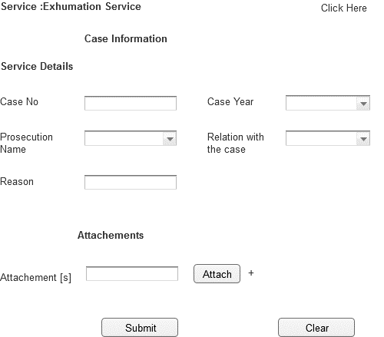

Associated Table and fields

|  |  |  |  |  |  |
| --- | --- | --- | --- | --- | --- |
| **Screen Field** | **Field Type** | **On Screen Validation** | **Mandatory /Optional** | **Auto Populate / User-Input** | **Business Validation For Database Insert** |
| Case No | Text | Number [6 Digit] | Mandatory | User Input | Case No Entered by User is Validated against the Case Info ,User ID To See if the User is a Party to this particular case .ThisBusiness condition validated to to insert all the screen fields . |
| Case Year | Drop Down | YYYY | Mandatory | User Input |
| Prosecution Name | Drop Down | Character | Mandatory | Populated From Prosecution_View |
| Relation With Case | Drop Down | Character | Mandatory | Populated From CaseInfo_View |
| Attachment [s] | Attachment | .pdf ,.gif,.jpeg,.doc,.txt <Need Input> Single File Size 2MB ; Total Of All File Size 10MB | Optional | User Input |
| Reason | Text | Character[200] | Mandatory | User Input |

|  |  |
| --- | --- |
| Associated Screen Fields Error Handling | |
| **Screen Field** | **On Screen Validation Error Code** |
| Case No | ERR_CASE_NO |
| Case Year | ERR_CASE_YEAR |
| Prosecution Name | ERR_PROSEC_NAME |
| Relation With Case | ERR_REL_CASE |
| Attachment [s] | ERR_ATTACH |
| REASON | ERR_RES |

* + 1. Existing Service:Expiration of Penal Case

|  |  |
| --- | --- |
| **Use case:** | Expiration of Penal Case |
| **Use case ID:** | UC-PS-131 |
| **Actor** | Authenticated User |
| **Brief Description:** | The aim of this service is to allow the user to request for piration of Penal Case |
| **System Trigger:** | The end user will click on the submit button in the Service Page |
| **Preconditions:** | User must be logged on to the E-Services system |
| **Flow of Events:** | 1. The end user must fill the following fields  * **Case No [Mandatory]** * **Case Year[Mandatory]** * **Prosecution Name [Mandatory]** * **Relation With Case [Mandatory]** * **Crime date[Mandatory]** * **Stop reason[Mandatory]** * **Attachments** * When the user moves from one field to another the front end validation is carried out.   [Specify the field level validations]   1. The User will click submit 2. The system will validate case no. 3. If the request is valid , system will store the request data in the respective database table 4. System will send an email to the user informing that the service request is submitted successfully. |
| **Business Rules** | Please refer to the Associated Table and fields Section for this service given below |
| **Post conditions:** | * Request Submitted successfully and stored in the database * Email sent to the end user conforming the request is raised successfully.[Please Refer Section 7.2 For e-Mail Format ] |
| **Alternative Flow** | NA |
| **Exceptions:** | 1. If the case info is not valid the user is prompted with the error ERR_CASE_INVALID 2. If the user entered any invalid values in any mandatory field, the system will highlight the field and show a label that will describe how the correct value should enter. 3. If the user filled all the fields and clicks submit button but no response came from the database within 120 [Default time out period;can be configured manually .Please refer to 6.2.52]secs an error message ERR_TIMEOUT is prompted to the user. |
| **Assumptions:** | NA |

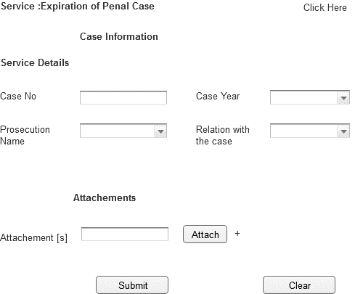

Associated Table and fields

|  |  |  |  |  |  |
| --- | --- | --- | --- | --- | --- |
| **Screen Field** | **Field Type** | **On Screen Validation** | **Mandatory /Optional** | **Auto Populate / User-Input** | **Business Validation For Database Insert** |
| Case No | Text | Number | Mandatory | User Input | Case No Entered by User is Validated against the Case Info ,User ID To See if the User is a Party to this particular case .ThisBusiness condition validated to to insert all the screen fields . |
| Case Year | Drop Down | YYYY | Mandatory | User Input |
| Prosecution Name | Drop Down | Character | Mandatory | Populated From Prosecution_View |
| Relation With Case | Drop Down | Character | Mandatory | Populated From CaseInfo_View |
| Crime date | Text | Number  [DD/MM/YYYY] | Mandatory | User Input |
| Stop reason | Text | Character | Mandatory | User Input |
| Attachment [s] | Attachment | .pdf ,.gif,.jpeg,.doc,.txt <Need Input> Single File Size 2MB ; Total Of All File Size 10MB | Optional | User Input |

|  |  |
| --- | --- |
| Associated Screen Fields Error Handling | |
| **Screen Field** | **On Screen Validation Error Code** |
| Case No | ERR_CASE_NO |
| Case Year | ERR_CASE_YEAR |
| Prosecution Name | ERR_PROSEC_NAME |
| Relation With Case | ERR_REL_CASE |
| Attachment [s] | ERR_ATTACH |

* + 1. Existing Service: Fine Difference Reimbursement

|  |  |
| --- | --- |
| **Use case:** | Fine Difference Reimbursement |
| **Use case ID:** | UC-PS-132 |
| **Actor** | Authenticated User |
| **Brief Description:** | The aim of this service is to allow the user to request for Fine Difference Reimbursement |
| **System Trigger:** | The end user will click on the submit button in the Service Page |
| **Preconditions:** | User must be logged on to the E-Services system |
| **Flow of Events:** | 1. The end user must fill the following fields  * **Case No [Mandatory]** * **Case Year[Mandatory]** * **Prosecution Name [Mandatory]** * **Relation With Case [Mandatory]** * **Attachments** * When the user moves from one field to another the front end validation is carried out.   [Specify the field level validations]   1. The User will click submit 2. The system will validate case no. 3. If the request is valid , system will store the request data in the respective database table 4. System will send an email to the user informing that the service request is submitted successfully. |
| **Business Rules** | Please refer to the Associated Table and fields Section for this service given below |
| **Post conditions:** | * Request Submitted successfully and stored in the database * Email sent to the end user conforming the request is raised successfully.[Please Refer Section 7.2 For e-Mail Format ] |
| **Alternative Flow** | NA |
| **Exceptions:** | 1. If the case info is not valid the user is prompted with the error ERR_CASE_INVALID 2. If the user entered any invalid values in any mandatory field, the system will highlight the field and show a label that will describe how the correct value should enter. 3. If the user filled all the fields and clicks submit button but no response came from the database within 120 [Default time out period;can be configured manually .Please refer to 6.2.52]secs an error message ERR_TIMEOUT is prompted to the user. |
| **Assumptions:** | NA |
| **Issues:** | None |

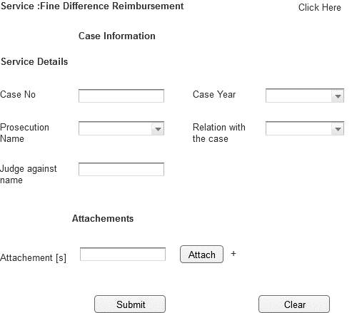

Associated Table and fields

|  |  |  |  |  |  |
| --- | --- | --- | --- | --- | --- |
| **Screen Field** | **Field Type** | **On Screen Validation** | **Mandatory /Optional** | **Auto Populate / User-Input** | **Business Validation For Database Insert** |
| Case No | Text | Number [6 Digit] | Mandatory | User Input | Case No Entered by User is Validated against the Case Info ,User ID To See if the User is a Party to this particular case .ThisBusiness condition validated to to insert all the screen fields . |
| Case Year | Drop Down | YYYY | Mandatory | User Input |
| Prosecution Name | Drop Down | Character | Mandatory | Populated From Prosecution_View |
| Relation With Case | Drop Down | Character | Mandatory | Populated From CaseInfo_View |
| Attachment [s] | Attachment | .pdf ,.gif,.jpeg,.doc,.txt <Need Input> Single File Size 2MB ; Total Of All File Size 10MB | Optional | User Input |

|  |  |
| --- | --- |
| Associated Screen Fields Error Handling | |
| **Screen Field** | **On Screen Validation Error Code** |
| Case No | ERR_CASE_NO |
| Case Year | ERR_CASE_YEAR |
| Prosecution Name | ERR_PROSEC_NAME |
| Relation With Case | ERR_REL_CASE |
| Attachment [s] | ERR_ATTACH |

* + 1. Existing Service: Meeting a Prosecutor/Chief Prosecutor

|  |  |
| --- | --- |
| **Use case:** | Meeting a Prosecutor/Chief Prosecutor |
| **Use case ID:** | UC-PS-133 |
| **Actor** | Authenticated User |
| **Brief Description:** | The aim of this service is to allow the user to request for Meeting a Prosecutor/Chief Prosecutor |
| **System Trigger:** | The end user will click on the submit button in the Service Page |
| **Preconditions:** | User must be logged on to the E-Services system |
| **Flow of Events:** | 1. The end user must fill the following fields  * **Case No [Mandatory]** * **Case Year[Mandatory]** * **Prosecution Name [Mandatory]** * **Relation With Case [Mandatory]** * **Interview time[Mandatory]** * **Interview Date[Mandatory]** * **Attachments** * **Request_subject[Mandatory]** * When the user moves from one field to another the front end validation is carried out.   [Specify the field level validations]   1. The User will click submit 2. The system will validate case no. 3. If the request is valid , system will store the request data in the respective database table 4. System will send an email to the user informing that the service request is submitted successfully. |
| **Business Rules** | Please refer to the Associated Table and fields Section for this service given below |
| **Post conditions:** | * Request Submitted successfully and stored in the database * Email sent to the end user conforming the request is raised successfully.[Please Refer Section 7.2 For e-Mail Format ] |
| **Alternative Flow** | NA |
| **Exceptions:** | 1. If the case info is not valid the user is prompted with the error ERR_CASE_INVALID 2. If the user entered any invalid values in any mandatory field, the system will highlight the field and show a label that will describe how the correct value should enter. 3. If the user filled all the fields and clicks submit button but no response came from the database within 120 [Default time out period;can be configured manually .Please refer to 6.2.52]secs an error message ERR_TIMEOUT is prompted to the user. |
| **Assumptions:** | NA |
| **Issues:** | NA |

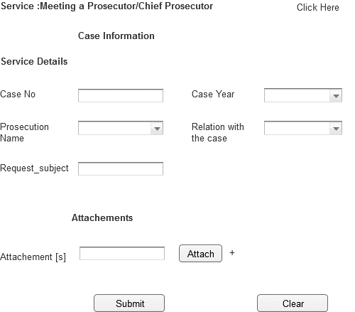

Associated Table and fields

|  |  |  |  |  |  |
| --- | --- | --- | --- | --- | --- |
| **Screen Field** | **Field Type** | **On Screen Validation** | **Mandatory /Optional** | **Auto Populate / User-Input** | **Business Validation For Database Insert** |
| Case No | Text | Number [6 Digit] | Mandatory | User Input | Case No Entered by User is Validated against the Case Info ,User ID To See if the User is a Party to this particular case .ThisBusiness condition validated to to insert all the screen fields . |
| Case Year | Drop Down | YYYY | Mandatory | User Input |
| Prosecution Name | Drop Down | Character | Mandatory | Populated From Prosecution_View |
| Relation With Case | Drop Down | Character | Mandatory | Populated From CaseInfo_View |
| Attachment [s] | Attachment | .pdf ,.gif,.jpeg,.doc,.txt <Need Input> Single File Size 2MB ; Total Of All File Size 10MB | Optional | User Input |
| Interview Date | Number | Number [DD/MM/YYYY] | Mandatory | User Input |
| Interview Time | Number | Number [DD/MM/YYYY] | Mandatory | User Input |
| Request_subject | Text | Character | Mandatory | User Input |

|  |  |
| --- | --- |
| Associated Screen Fields Error Handling | |
| **Screen Field** | **On Screen Validation Error Code** |
| Case No | ERR_CASE_NO |
| Case Year | ERR_CASE_YEAR |
| Prosecution Name | ERR_PROSEC_NAME |
| Relation With Case | ERR_REL_CASE |
| Interview Date | ERR_INT_DATE |
| Interview Time | ERR_INT_TIME |
| Attachment [s] | ERR_ATTACH |
| Reequest Subject | ERR_REQ_SUBJ |

* + 1. Existing Service: Opening of Memorandums

|  |  |
| --- | --- |
| **Use case:** | Opening of Memorandums |
| **Use case ID:** | UC-PS-134 |
| **Actor** | Authenticated User |
| **Brief Description:** | The aim of this service is to allow the user to request for Opening of Memorandums |
| **System Trigger:** | The end user will click on the submit button in the Service Page |
| **Preconditions:** | User must be logged on to the E-Services system |
| **Flow of Events:** | 1. The end user must fill the following fields  * **Case No [Mandatory]** * **Case Year[Mandatory]** * **Prosecution Name [Mandatory]** * **Relation With Case [Mandatory]** * **Attachments** * **Witness_name[Mandatory]** * **Nationality[Mandatory]** * **Address[Mandatory]** * **Subject[Mandatory]** * **Mobile[Mandatory]** * When the user moves from one field to another the front end validation is carried out.   [Specify the field level validations]   1. The User will click submit 2. The system will validate case no. 3. If the request is valid , system will store the request data in the respective database table 4. System will send an email to the user informing that the service request is submitted successfully. |
| **Business Rules** | Please refer to the Associated Table and fields Section for this service given below |
| **Post conditions:** | * Request Submitted successfully and stored in the database * Email sent to the end user conforming the request is raised successfully.[Please Refer Section 7.2 For e-Mail Format ] |
| **Alternative Flow** | NA |
| **Exceptions:** | 1. If the case info is not valid the user is prompted with the error ERR_CASE_INVALID 2. If the user entered any invalid values in any mandatory field, the system will highlight the field and show a label that will describe how the correct value should enter. 3. If the user filled all the fields and clicks submit button but no response came from the database within 120 [Default time out period;can be configured manually .Please refer to 6.2.52]secs an error message ERR_TIMEOUT is prompted to the user. |
| **Assumptions:** | NA |
| **Issues:** | NA |

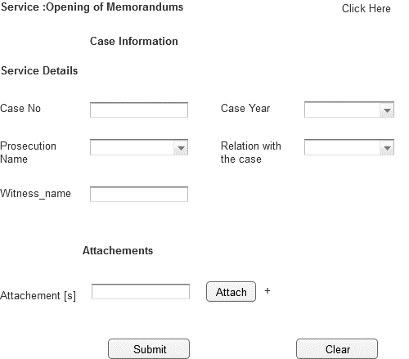

Associated Table and fields

|  |  |  |  |  |  |
| --- | --- | --- | --- | --- | --- |
| **Screen Field** | **Field Type** | **On Screen Validation** | **Mandatory /Optional** | **Auto Populate / User-Input** | **Business Validation For Database Insert** |
| Case No | Text | Number [6 Digit] | Mandatory | User Input | Case No Entered by User is Validated against the Case Info ,User ID To See if the User is a Party to this particular case .ThisBusiness condition validated to to insert all the screen fields . |
| Case Year | Drop Down | YYYY | Mandatory | User Input |
| Prosecution Name | Drop Down | Character | Mandatory | Populated From Prosecution_View |
| Relation With Case | Drop Down | Character | Mandatory | Populated From CaseInfo_View |
| Attachment [s] | Attachment | .pdf ,.gif,.jpeg,.doc,.txt <Need Input> Single File Size 2MB ; Total Of All File Size 10MB | Optional | User Input |
| Nationality | Text | Character | Mandatory | User Input |
| Address | Text | Character | Mandatory | User Input |
| Subject | Text | Character | Mandatory | User Input |
| Mobile | Number | Number [10 Digit] | Mandatory | User Input |
| Witness_name | Text | Character | Mandatory | User Input |
|  |  |  |  |  |  |

|  |  |
| --- | --- |
| **Screen Field** | **On Screen Validation Error Code** |
| Case No | ERR_CASE_NO |
| Case Year | ERR_CASE_YEAR |
| Prosecution Name | ERR_PROSEC_NAME |
| Relation With Case | ERR_REL_CASE |
| Attachment [s] | ERR_ATTACH |
| Witness Name | ERR_WIT_NM |

* + 1. Existing Service: Passport Renewal

|  |  |
| --- | --- |
| **Use case:** | Passport Renewal |
| **Use case ID:** | UC-PS-135 |
| **Actor** | Authenticated User |
| **Brief Description:** | The aim of this service is to allow the user to request for Passport Renewal |
| **System Trigger:** | The end user will click on the submit button in the Service Page |
| **Preconditions:** | User must be logged on to the E-Services system |
| **Flow of Events:** | 1. The end user must fill the following fields  * **Case No [Mandatory]** * **Case Year[Mandatory]** * **Prosecution Name [Mandatory]** * **Relation With Case [Mandatory]** * **Passport number[Mandatory]** * **Expiry date[Mandatory]** * **Issue date[Mandatory]** * **Attachments**   When the user moves from one field to another the front end validation is carried out.  [Specify the field level validations]   1. The User will click submit 2. The system will validate case no. 3. If the request is valid , system will store the request data in the respective database table 4. System will send an email to the user informing that the service request is submitted successfully. |
| **Business Rules** | Please refer to the Associated Table and fields Section for this service given below |
| **Post conditions:** | * Request Submitted successfully and stored in the database * Email sent to the end user conforming the request is raised successfully.[Please Refer Section 7.2 For e-Mail Format ] |
| **Alternative Flow** | NA |
| **Exceptions:** | 1. If the case info is not valid the user is prompted with the error ERR_CASE_INVALID 2. If the user entered any invalid values in any mandatory field, the system will highlight the field and show a label that will describe how the correct value should enter. 3. If the user filled all the fields and clicks submit button but no response came from the database within 120 [Default time out period;can be configured manually .Please refer to 6.2.52]secs an error message ERR_TIMEOUT is prompted to the user. |
| **Assumptions:** | NA |
| **Issues:** | None |

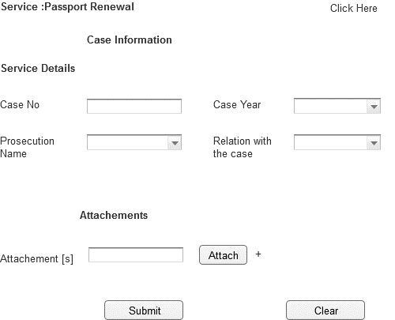

Associated Table and fields

|  |  |  |  |  |  |
| --- | --- | --- | --- | --- | --- |
| **Screen Field** | **Field Type** | **On Screen Validation** | **Mandatory /Optional** | **Auto Populate / User-Input** | **Business Validation For Database Insert** |
| Case No | Text | Number | Mandatory | User Input | Case No Entered by User is Validated against the Case Info ,User ID To See if the User is a Party to this particular case .ThisBusiness condition validated to to insert all the screen fields . |
| Case Year | Drop Down | YYYY | Mandatory | User Input |
| Prosecution Name | Drop Down | Character | Mandatory | Populated From Prosecution_View |
| Relation With Case | Drop Down | Character | Mandatory | Populated From CaseInfo_View |
| Passport number | Text | Number | Mandatory | User Input |
| Expiry date | Number | Number [DD/MM/YYYY] | Mandatory | User Input |
| Issue date | Number | Number [DD/MM/YYYY] | Mandatory | User Input |
| Attachment [s] | Attachment | .pdf ,.gif,.jpeg,.doc,.txt <Need Input> Single File Size 2MB ; Total Of All File Size 10MB | Optional | User Input |

|  |  |
| --- | --- |
| Associated Screen Fields Error Handling | |
| **Screen Field** | **On Screen Validation Error Code** |
| Case No | ERR_CASE_NO |
| Case Year | ERR_CASE_YEAR |
| Prosecution Name | ERR_PROSEC_NAME |
| Relation With Case | ERR_REL_CASE |
| Passport number | ERR_PASS_NUM |
| Expiry date | ERR_EXP_DATE |
| Issue date | ERR_ISSUE_DATE |
| Attachment [s] | ERR_ATTACH |

* + 1. Existing Service: Payment by installment the fine imposed by the court

|  |  |
| --- | --- |
| **Use case:** | Payment by installment the fine imposed by the court |
| **Use case ID:** | UC-PC 136 |
| **Actor** | Authenticated User |
| **Brief Description:** | The aim of this service is to allow the user to request for Reimbursing Imposed Fine |
| **System Trigger:** | The end user will click on the submit button in the Service Page |
| **Preconditions:** | User must be logged on to the E-Services system |
| **Flow of Events:** | 1. The end user must fill the following fields  * **Case No [Mandatory]** * **Case Year[Mandatory]** * **Prosecution Name [Mandatory]** * **Relation With Case [Mandatory]** * **Attachments** * **Fine_Amount[Mandatory]** * **Installment Amount[Mandatory]** * When the user moves from one field to another the front end validation is carried out.   [Specify the field level validations]   1. The User will click submit 2. The system will validate case no. 3. If the request is valid , system will store the request data in the respective database table 4. System will send an email to the user informing that the service request is submitted successfully. |
| **Business Rules** | Please refer to the Associated Table and fields Section for this service given below |
| **Post conditions:** | * Request Submitted successfully and stored in the database * Email sent to the end user conforming the request is raised successfully.[Please Refer Section 7.2 For e-Mail Format ] |
| **Alternative Flow** | NA |
| **Exceptions:** | 1. If the case info is not valid the user is prompted with the error ERR_CASE_INVALID 2. If the user entered any invalid values in any mandatory field, the system will highlight the field and show a label that will describe how the correct value should enter. 3. If the user filled all the fields and clicks submit button but no response came from the database within 120 [Default time out period;can be configured manually .Please refer to 6.2.52]secs an error message ERR_TIMEOUT is prompted to the user. |
| **Assumptions:** | NA |
| **Issues:** | None |

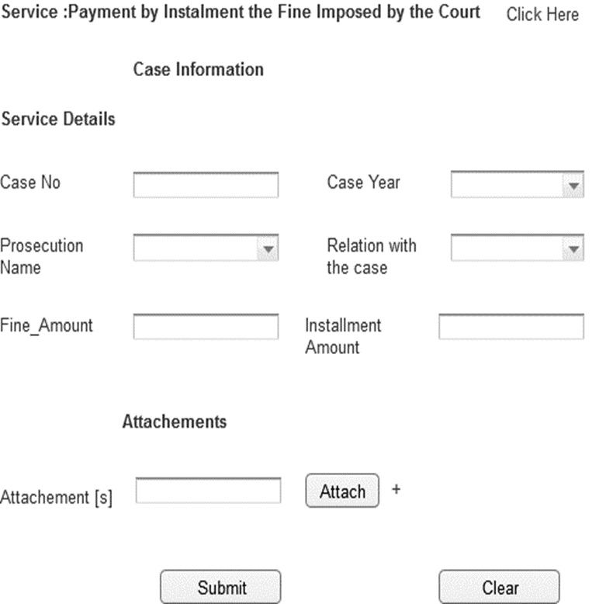

|  |  |  |  |  |  |
| --- | --- | --- | --- | --- | --- |
| **Screen Field** | **Field Type** | **On Screen Validation** | **Mandatory /Optional** | **Auto Populate / User-Input** | **Business Validation For Database Insert** |
| Case No | Text | Number | Mandatory | User Input | Case No Entered by User is Validated against the Case Info ,User ID To See if the User is a Party to this particular case .ThisBusiness condition validated to to insert all the screen fields . |
| Case Year | Drop Down | YYYY | Mandatory | User Input |
| Prosecution Name | Drop Down | Character | Mandatory | Populated From Prosecution_View |
| Relation With Case | Drop Down | Character | Mandatory | Populated From CaseInfo_View |
| Attachment [s] | Attachment | .pdf ,.gif,.jpeg,.doc,.txt <Need Input> Single File Size 2MB ; Total Of All File Size 10MB | Optional | User Input |
| Fine_Amount | Text | Number | Mandatory | User Input |
| Installment Amount | Text | Number | Mandatory | User Input |

|  |  |
| --- | --- |
| Associated Screen Fields Error Handling | |
| **Screen Field** | **On Screen Validation Error Code** |
| Case No | ERR_CASE_NO |
| Case Year | ERR_CASE_YEAR |
| Prosecution Name | ERR_PROSEC_NAME |
| Relation With Case | ERR_REL_CASE |
| Attachment [s] | ERR_ATTACH |
| Fine Amount | ERR_FINE_amT |
| Installement Amount | ERR_INST_AMT |

* + 1. Existing Service: Photocopy of Case Dropping Decision

|  |  |
| --- | --- |
| **Use case:** | Photocopy of Case Dropping Decision |
| **Use case ID:** | UC-PS-137 |
| **Actor** | Authenticated User |
| **Brief Description:** | The aim of this service is to allow the user to request for Photocopy of Case Dropping Decision |
| **System Trigger:** | The end user will click on the submit button in the Service Page |
| **Preconditions:** | User must be logged on to the E-Services system |
| **Flow of Events:** | 1. The end user must fill the following fields  * **Case No [Mandatory]** * **Case Year[Mandatory]** * **Prosecution Name [Mandatory]** * **Relation With Case [Mandatory]** * **Attachments** * When the user moves from one field to another the front end validation is carried out.   [Specify the field level validations]   1. The User will click submit 2. The system will validate case no. 3. If the request is valid , system will store the request data in the respective database table 4. System will send an email to the user informing that the service request is submitted successfully. |
| **Business Rules** | Please refer to the Associated Table and fields Section for this service given below |
| **Post conditions:** | * Request Submitted successfully and stored in the database * Email sent to the end user conforming the request is raised successfully.[Please Refer Section 7.2 For e-Mail Format ] |
| **Alternative Flow** | NA |
| **Exceptions:** | 1. If the case info is not valid the user is prompted with the error ERR_CASE_INVALID 2. If the user entered any invalid values in any mandatory field, the system will highlight the field and show a label that will describe how the correct value should enter. 3. If the user filled all the fields and clicks submit button but no response came from the database within 120 [Default time out period;can be configured manually .Please refer to 6.2.52]secs an error message ERR_TIMEOUT is prompted to the user. |
| **Assumptions:** | NA |
| **Issues:** | None |

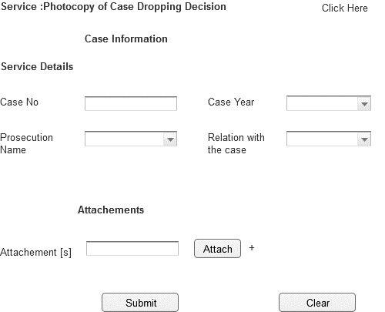

Associated Table and fields

|  |  |  |  |  |  |
| --- | --- | --- | --- | --- | --- |
| **Screen Field** | **Field Type** | **On Screen Validation** | **Mandatory /Optional** | **Auto Populate / User-Input** | **Business Validation For Database Insert** |
| Case No | Text | Number | Mandatory | User Input | Case No Entered by User is Validated against the Case Info ,User ID To See if the User is a Party to this particular case .ThisBusiness condition validated to to insert all the screen fields . |
| Case Year | Drop Down | YYYY | Mandatory | User Input |
| Prosecution Name | Drop Down | Character | Mandatory | Populated From Prosecution_View |
| Relation With Case | Drop Down | Character | Mandatory | Populated From CaseInfo_View |
| Attachment [s] | Attachment | .pdf ,.gif,.jpeg,.doc,.txt <Need Input> Single File Size 2MB ; Total Of All File Size 10MB | Optional | User Input |

|  |  |
| --- | --- |
| Associated Screen Fields Error Handling | |
| **Screen Field** | **On Screen Validation Error Code** |
| Case No | ERR_CASE_NO |
| Case Year | ERR_CASE_YEAR |
| Prosecution Name | ERR_PROSEC_NAME |
| Relation With Case | ERR_REL_CASE |
| Attachment [s] | ERR_ATTACH |

* + 1. Existing Service: Postpone the execution of restricted freedom punishment of convicts

|  |  |
| --- | --- |
| **Use case:** | Postpone the execution of restricted freedom punishment of convicts |
| **Use case ID:** | UC-PS-138 |
| **Actor** | Authenticated User |
| **Brief Description:** | The aim of this service is to allow the user to request for Postpone the execution of restricted freedom punishment of convicts |
| **System Trigger:** | The end user will click on the submit button in the Service Page |
| **Preconditions:** | User must be logged on to the E-Services system |
| **Flow of Events:** | 1. The end user must fill the following fields  * **Case No [Mandatory]** * **Case Year[Mandatory]** * **Prosecution Name [Mandatory]** * **Relation With Case [Mandatory]** * **Delay Reason[Mandatory]** * **Attachments** * When the user moves from one field to another the front end validation is carried out.   [Specify the field level validations]   1. The User will click submit 2. The system will validate case no. 3. If the request is valid , system will store the request data in the respective database table 4. System will send an email to the user informing that the service request is submitted successfully. |
| **Business Rules** | Please refer to the Associated Table and fields Section for this service given below |
| **Post conditions:** | * Request Submitted successfully and stored in the database * Email sent to the end user conforming the request is raised successfully.[Please Refer Section 7.2 For e-Mail Format ] |
| **Alternative Flow** | NA |
| **Exceptions:** | 1. If the case info is not valid the user is prompted with the error ERR_CASE_INVALID 2. If the user entered any invalid values in any mandatory field, the system will highlight the field and show a label that will describe how the correct value should enter. 3. If the user filled all the fields and clicks submit button but no response came from the database within 120 [Default time out period;can be configured manually .Please refer to 6.2.52]secs an error message ERR_TIMEOUT is prompted to the user. |
| **Assumptions:** | NA |
| **Issues:** | NA |

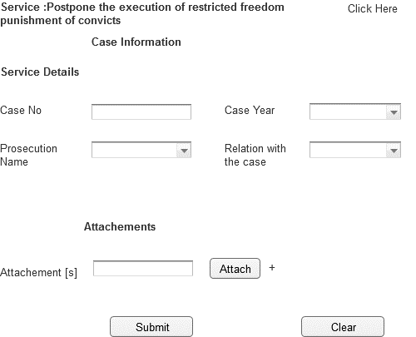

Associated Table and fields

|  |  |  |  |  |  |
| --- | --- | --- | --- | --- | --- |
| **Screen Field** | **Field Type** | **On Screen Validation** | **Mandatory /Optional** | **Auto Populate / User-Input** | **Business Validation For Database Insert** |
| Case No | Text | Number | Mandatory | User Input | Case No Entered by User is Validated against the Case Info ,User ID To See if the User is a Party to this particular case .ThisBusiness condition validated to to insert all the screen fields . |
| Case Year | Drop Down | YYYY | Mandatory | User Input |
| Prosecution Name | Drop Down | Character | Mandatory | Populated From Prosecution_View |
| Relation With Case | Drop Down | Character | Mandatory | Populated From CaseInfo_View |
| Delay reason | Text | Character | Mandatory | User Input |
| Attachment [s] | Attachment | .pdf ,.gif,.jpeg,.doc,.txt <Need Input> Single File Size 2MB ; Total Of All File Size 10MB | Optional | User Input |

|  |  |
| --- | --- |
| Associated Screen Fields Error Handling | |
| **Screen Field** | **On Screen Validation Error Code** |
| Case No | ERR_CASE_NO |
| Case Year | ERR_CASE_YEAR |
| Prosecution Name | ERR_PROSEC_NAME |
| Relation With Case | ERR_REL_CASE |
| Delay reason | ERR_DELAY_REASON |
| Attachment [s] | ERR_ATTACH |

* + 1. Existing Service: Receiving of Deposits & Reserve

|  |  |
| --- | --- |
| **Use case:** | Receiving of Deposits & Reserve |
| **Use case ID:** | US-PS-139 |
| **Actor** | Authenticated User |
| **Brief Description:** | The aim of this service is to allow the user to request for Receiving of Deposits & Reserve |
| **System Trigger:** | The end user will click on the submit button in the Service Page |
| **Preconditions:** | User must be logged on to the E-Services system |
| **Flow of Events:** | 1. The end user must fill the following fields  * **Case No [Mandatory]** * **Case Year[Mandatory]** * **Prosecution Name [Mandatory]** * **Relation With Case [Mandatory]** * **Attachments** * **Restraint_type[Mandatory]** * When the user moves from one field to another the front end validation is carried out.   [Specify the field level validations]   1. The User will click submit 2. The system will validate case no. 3. If the request is valid , system will store the request data in the respective database table 4. System will send an email to the user informing that the service request is submitted successfully. |
| **Business Rules** | Please refer to the Associated Table and fields Section for this service given below |
| **Post conditions:** | * Request Submitted successfully and stored in the database * Email sent to the end user conforming the request is raised successfully.[Please Refer Section 7.2 For e-Mail Format ] |
| **Alternative Flow** | NA |
| **Exceptions:** | 1. If the case info is not valid the user is prompted with the error ERR_CASE_INVALID 2. If the user entered any invalid values in any mandatory field, the system will highlight the field and show a label that will describe how the correct value should enter. 3. If the user filled all the fields and clicks submit button but no response came from the database within 120 [Default time out period;can be configured manually .Please refer to 6.2.52]secs an error message ERR_TIMEOUT is prompted to the user. |
| **Assumptions:** | NA |
| **Issues:** | NA |

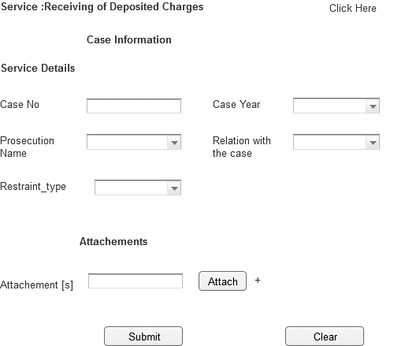

Associated Table and fields

|  |  |  |  |  |  |
| --- | --- | --- | --- | --- | --- |
| **Screen Field** | **Field Type** | **On Screen Validation** | **Mandatory /Optional** | **Auto Populate / User-Input** | **Business Validation For Database Insert** |
| Case No | Text | Number [6 Digit] | Mandatory | User Input | Case No Entered by User is Validated against the Case Info ,User ID To See if the User is a Party to this particular case .ThisBusiness condition validated to to insert all the screen fields . |
| Case Year | Drop Down | YYYY | Mandatory | User Input |
| Prosecution Name | Drop Down | Character | Mandatory | Populated From Prosecution_View |
| Relation With Case | Drop Down | Character | Mandatory | Populated From CaseInfo_View |
| Attachment [s] | Attachment | .pdf ,.gif,.jpeg,.doc,.txt <Need Input> Single File Size 2MB ; Total Of All File Size 10MB | Optional | User Input |
| Restraint_type | Drop Down | Character | Mandatory | Populated From Restraint_type_View |

|  |  |
| --- | --- |
| Associated Screen Fields Error Handling | |
| **Screen Field** | **On Screen Validation Error Code** |
| Case No | ERR_CASE_NO |
| Case Year | ERR_CASE_YEAR |
| Prosecution Name | ERR_PROSEC_NAME |
| Relation With Case | ERR_REL_CASE |
| Attachment [s] | ERR_ATTACH |
| Restraint_type | ERR_REST_TYP |

* + 1. Existing Service: Request for appeal in cassation

|  |  |
| --- | --- |
| **Use case:** | Request for appeal in cassation. |
| **Use case ID:** | UC-PS-140 |
| **Actor** | Authenticated User |
| **Brief Description:** | The aim of this service is to allow the user to request for Request for appeal in cassation |
| **System Trigger:** | The end user will click on the submit button in the Service Page |
| **Preconditions:** | User must be logged on to the E-Services system |
| **Flow of Events:** | 1. The end user must fill the following fields  * **Case No [Mandatory]** * **Case Year[Mandatory]** * **Prosecution Name [Mandatory]** * **Relation With Case [Mandatory]** * **Attachments** * **APPEAL_SUBJECT[Mandatory]** * When the user moves from one field to another the front end validation is carried out.   [Specify the field level validations]   1. The User will click submit 2. The system will validate case no. 3. If the request is valid , system will store the request data in the respective database table 4. System will send an email to the user informing that the service request is submitted successfully. |
| **Business Rules** | Please refer to the Associated Table and fields Section for this service given below |
| **Post conditions:** | * Request Submitted successfully and stored in the database * Email sent to the end user conforming the request is raised successfully.[Please Refer Section 7.2 For e-Mail Format ] |
| **Alternative Flow** | NA |
| **Exceptions:** | 1. If the case info is not valid the user is prompted with the error ERR_CASE_INVALID 2. If the user entered any invalid values in any mandatory field, the system will highlight the field and show a label that will describe how the correct value should enter. 3. If the user filled all the fields and clicks submit button but no response came from the database within 120 [Default time out period;can be configured manually .Please refer to 6.2.52]secs an error message ERR_TIMEOUT is prompted to the user. |
| **Assumptions:** | NA |
| **Issues:** | NA |

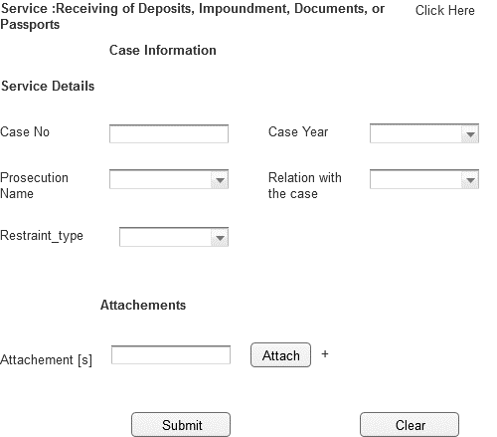

Associated Table and fields

|  |  |  |  |  |  |
| --- | --- | --- | --- | --- | --- |
| **Screen Field** | **Field Type** | **On Screen Validation** | **Mandatory /Optional** | **Auto Populate / User-Input** | **Business Validation For Database Insert** |
| Case No | Text | Number [6 Digit] | Mandatory | User Input | Case No Entered by User is Validated against the Case Info ,User ID To See if the User is a Party to this particular case .ThisBusiness condition validated to to insert all the screen fields . |
| Case Year | Drop Down | YYYY | Mandatory | User Input |
| Prosecution Name | Drop Down | Character | Mandatory | Populated From Prosecution_View |
| Relation With Case | Drop Down | Character | Mandatory | Populated From CaseInfo_View |
| Attachment [s] | Attachment | .pdf ,.gif,.jpeg,.doc,.txt <Need Input> Single File Size 2MB ; Total Of All File Size 10MB | Optional | User Input |
| APPEAL_SUBJECT | Drop Down | Character | Mandatory | Populated From Restraint_type_View |

|  |  |
| --- | --- |
| Associated Screen Fields Error Handling | |
| **Screen Field** | **On Screen Validation Error Code** |
| Case No | ERR_CASE_NO |
| Case Year | ERR_CASE_YEAR |
| Prosecution Name | ERR_PROSEC_NAME |
| Relation With Case | ERR_REL_CASE |
| Attachment [s] | ERR_ATTACH |
| Restraint_type | ERR_REST_TYP |

* + 1. Existing Service: Receiving of Passport

|  |  |
| --- | --- |
| **Use case:** | Receiving of Passport |
| **Use case ID:** | UC-PS-141 |
| **Actor** | Authenticated User |
| **Brief Description:** | The aim of this service is to allow the user to request for Receiving of Passport |
| **System Trigger:** | The end user will click on the submit button in the Service Page |
| **Preconditions:** | User must be logged on to the E-Services system |
| **Flow of Events:** | 1. The end user must fill the following fields  * **Case No [Mandatory]** * **Case Year[Mandatory]** * **Prosecution Name [Mandatory]** * **Relation With Case [Mandatory]** * **Reserved place[Mandatory]** * **Attachments** * When the user moves from one field to another the front end validation is carried out.   [Specify the field level validations]   1. The User will click submit 2. The system will validate case no. 3. If the request is valid , system will store the request data in the respective database table 4. System will send an email to the user informing that the service request is submitted successfully. |
| **Business Rules** | Please refer to the Associated Table and fields Section for this service given below |
| **Post conditions:** | * Request Submitted successfully and stored in the database * Email sent to the end user conforming the request is raised successfully.[Please Refer Section 7.2 For e-Mail Format ] |
| **Alternative Flow** | NA |
| **Exceptions:** | 1. If the case info is not valid the user is prompted with the error ERR_CASE_INVALID 2. If the user entered any invalid values in any mandatory field, the system will highlight the field and show a label that will describe how the correct value should enter. 3. If the user filled all the fields and clicks submit button but no response came from the database within 120 [Default time out period;can be configured manually .Please refer to 6.2.52]secs an error message ERR_TIMEOUT is prompted to the user. |
| **Assumptions:** | NA |
| **Issues:** | NA |

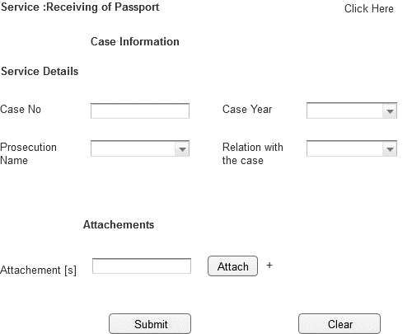

Associated Table and fields

|  |  |  |  |  |  |
| --- | --- | --- | --- | --- | --- |
| **Screen Field** | **Field Type** | **On Screen Validation** | **Mandatory /Optional** | **Auto Populate / User-Input** | **Business Validation For Database Insert** |
| Case No | Text | Number | Mandatory | User Input | Case No Entered by User is Validated against the Case Info ,User ID To See if the User is a Party to this particular case .ThisBusiness condition validated to to insert all the screen fields . |
| Case Year | Drop Down | YYYY | Mandatory | User Input |
| Prosecution Name | Drop Down | Character | Mandatory | Populated From Prosecution_View |
| Relation With Case | Drop Down | Character | Mandatory | Populated From CaseInfo_View |
| Reserved place | Text | Character | Mandatory | User Input |
| Attachment [s] | Attachment | .pdf ,.gif,.jpeg,.doc,.txt <Need Input> Single File Size 2MB ; Total Of All File Size 10MB | Optional | User Input |

|  |  |
| --- | --- |
| Associated Screen Fields Error Handling | |
| **Screen Field** | **On Screen Validation Error Code** |
| Case No | ERR_CASE_NO |
| Case Year | ERR_CASE_YEAR |
| Prosecution Name | ERR_PROSEC_NAME |
| Relation With Case | ERR_REL_CASE |
| Reserved place | ERR_RES_PLACE |
| Attachment [s] | ERR_ATTACH |

* + 1. Existing Service: Rehabilitation

|  |  |
| --- | --- |
| **Use case:** | Rehabilitation |
| **Use case ID:** | UC-PS-142 |
| **Actor** | Authenticated User |
| **Brief Description:** | The aim of this service is to allow the user to request for Rehabilitation |
| **System Trigger:** | The end user will click on the submit button in the Service Page |
| **Preconditions:** | User must be logged on to the E-Services system |
| **Flow of Events:** | 1. The end user must fill the following fields  * **Case No [Mandatory]** * **Case Year[Mandatory]** * **Prosecution Name [Mandatory]** * **Relation With Case [Mandatory]** * **Attachments** * When the user moves from one field to another the front end validation is carried out.   [Specify the field level validations]   1. The User will click submit 2. The system will validate case no. 3. If the request is valid , system will store the request data in the respective database table 4. System will send an email to the user informing that the service request is submitted successfully. |
| **Business Rules** | Please refer to the Associated Table and fields Section for this service given below |
| **Post conditions:** | * Request Submitted successfully and stored in the database * Email sent to the end user conforming the request is raised successfully.[Please Refer Section 7.2 For e-Mail Format ] |
| **Alternative Flow** | NA |
| **Exceptions:** | 1. If the case info is not valid the user is prompted with the error ERR_CASE_INVALID 2. If the user entered any invalid values in any mandatory field, the system will highlight the field and show a label that will describe how the correct value should enter. 3. If the user filled all the fields and clicks submit button but no response came from the database within 120 [Default time out period;can be configured manually .Please refer to 6.2.52]secs an error message ERR_TIMEOUT is prompted to the user. |
| **Assumptions:** | NA |
| **Issues:** | NA |

Associated Table and fields

|  |  |  |  |  |  |
| --- | --- | --- | --- | --- | --- |
| **Screen Field** | **Field Type** | **On Screen Validation** | **Mandatory /Optional** | **Auto Populate / User-Input** | **Business Validation For Database Insert** |
| Case No | Text | Number | Mandatory | User Input | Case No Entered by User is Validated against the Case Info ,User ID To See if the User is a Party to this particular case .ThisBusiness condition validated to to insert all the screen fields . |
| Case Year | Drop Down | YYYY | Mandatory | User Input |
| Prosecution Name | Drop Down | Character | Mandatory | Populated From Prosecution_View |
| Relation With Case | Drop Down | Character | Mandatory | Populated From CaseInfo_View |
| Attachment [s] | Attachment | .pdf ,.gif,.jpeg,.doc,.txt <Need Input> Single File Size 2MB ; Total Of All File Size 10MB | Optional | User Input |

|  |  |
| --- | --- |
| Associated Screen Fields Error Handling | |
| **Screen Field** | **On Screen Validation Error Code** |
| Case No | ERR_CASE_NO |
| Case Year | ERR_CASE_YEAR |
| Prosecution Name | ERR_PROSEC_NAME |
| Relation With Case | ERR_REL_CASE |
| Attachment [s] | ERR_ATTACH |

* + 1. Existing Service:Return of Bail Amount

|  |  |
| --- | --- |
| **Use case:** | Return of Bail Amount |
| **Use case ID:** | UC-PS-143 |
| **Actor** | Authenticated User |
| **Brief Description:** | The aim of this service is to allow the user to request for Return of Bail Amount |
| **System Trigger:** | The end user will click on the submit button in the Service Page |
| **Preconditions:** | User must be logged on to the E-Services system |
| **Flow of Events:** | 1. The end user must fill the following fields  * **Case No [Mandatory]** * **Case Year[Mandatory]** * **Prosecution Name [Mandatory]** * **Relation With Case [Mandatory]** * **Attachments** * When the user moves from one field to another the front end validation is carried out.   [Specify the field level validations]   1. The User will click submit 2. The system will validate case no. 3. If the request is valid , system will store the request data in the respective database table 4. System will send an email to the user informing that the service request is submitted successfully. |
| **Business Rules** | Please refer to the Associated Table and fields Section for this service given below |
| **Post conditions:** | * Request Submitted successfully and stored in the database * Email sent to the end user conforming the request is raised successfully.[Please Refer Section 7.2 For e-Mail Format ] |
| **Alternative Flow** | NA |
| **Exceptions:** | 1. If the case info is not valid the user is prompted with the error ERR_CASE_INVALID 2. If the user entered any invalid values in any mandatory field, the system will highlight the field and show a label that will describe how the correct value should enter. 3. If the user filled all the fields and clicks submit button but no response came from the database within 120 [Default time out period;can be configured manually .Please refer to 6.2.52]secs an error message ERR_TIMEOUT is prompted to the user. |
| **Assumptions:** | NA |
| **Issues:** | NA |

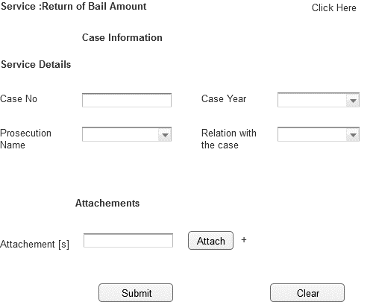

Associated Table and fields

|  |  |  |  |  |  |
| --- | --- | --- | --- | --- | --- |
| **Screen Field** | **Field Type** | **On Screen Validation** | **Mandatory /Optional** | **Auto Populate / User-Input** | **Business Validation For Database Insert** |
| Case No | Text | Number | Mandatory | User Input | Case No Entered by User is Validated against the Case Info ,User ID To See if the User is a Party to this particular case .ThisBusiness condition validated to to insert all the screen fields . |
| Case Year | Drop Down | YYYY | Mandatory | User Input |
| Prosecution Name | Drop Down | Character | Mandatory | Populated From Prosecution_View |
| Relation With Case | Drop Down | Character | Mandatory | Populated From CaseInfo_View |
| Attachment [s] | Attachment | .pdf ,.gif,.jpeg,.doc,.txt <Need Input> Single File Size 2MB ; Total Of All File Size 10MB | Optional | User Input |

|  |  |
| --- | --- |
| Associated Screen Fields Error Handling | |
| **Screen Field** | **On Screen Validation Error Code** |
| Case No | ERR_CASE_NO |
| Case Year | ERR_CASE_YEAR |
| Prosecution Name | ERR_PROSEC_NAME |
| Relation With Case | ERR_REL_CASE |
| Attachment [s] | ERR_ATTACH |

* + 1. xchangExisting Service:Stop Searching/Cancellation of Arrest Warrant

|  |  |
| --- | --- |
| **Use case:** | Stop Searching/Cancellation of Arrest Warrant |
| **Use case ID:** | UC-PS-144 |
| **Actor** | Authenticated User |
| **Brief Description:** | The aim of this service is to allow the user to request for Stop Searching/Cancellation of Arrest Warrant |
| **System Trigger:** | The end user will click on the submit button in the Service Page |
| **Preconditions:** | User must be logged on to the E-Services system |
| **Alternative Flow** | NA |
| **Flow of Events:** | 1. The end user must fill the following fields  * **Case No [Mandatory]** * **Case Year[Mandatory]** * **Prosecution Name [Mandatory]** * **Relation With Case [Mandatory]** * **Attachments** * When the user moves from one field to another the front end validation is carried out.   [Specify the field level validations]   1. The User will click submit 2. The system will validate case no. 3. If the request is valid , system will store the request data in the respective database table 4. System will send an email to the user informing that the service request is submitted successfully. |
| **Business Rules** | Please refer to the Associated Table and fields Section for this service given below |
| **Post conditions:** | * Request Submitted successfully and stored in the database * Email sent to the end user conforming the request is raised successfully.[Please Refer Section 7.2 For e-Mail Format ] |
| **Alternative Flow** | NA |
| **Exceptions:** | 1. If the case info is not valid the user is prompted with the error ERR_CASE_INVALID 2. If the user entered any invalid values in any mandatory field, the system will highlight the field and show a label that will describe how the correct value should enter. 3. If the user filled all the fields and clicks submit button but no response came from the database within 120 [Default time out period;can be configured manually .Please refer to 6.2.52]secs an error message ERR_TIMEOUT is prompted to the user. |
| **Assumptions:** | NA |
| **Issues:** | NA |



Associated Table and fields

|  |  |  |  |  |  |
| --- | --- | --- | --- | --- | --- |
| **Screen Field** | **Field Type** | **On Screen Validation** | **Mandatory /Optional** | **Auto Populate / User-Input** | **Business Validation For Database Insert** |
| Case No | Text | Number | Mandatory | User Input | Case No Entered by User is Validated against the Case Info ,User ID To See if the User is a Party to this particular case .ThisBusiness condition validated to to insert all the screen fields . |
| Case Year | Drop Down | YYYY | Mandatory | User Input |
| Prosecution Name | Drop Down | Character | Mandatory | Populated From Prosecution_View |
| Relation With Case | Drop Down | Character | Mandatory | Populated From CaseInfo_View |
| Attachment [s] | Attachment | .pdf ,.gif,.jpeg,.doc,.txt <Need Input> Single File Size 2MB ; Total Of All File Size 10MB | Optional | User Input |

|  |  |
| --- | --- |
| Associated Screen Fields Error Handling | |
| **Screen Field** | **On Screen Validation Error Code** |
| Case No | ERR_CASE_NO |
| Case Year | ERR_CASE_YEAR |
| Prosecution Name | ERR_PROSEC_NAME |
| Relation With Case | ERR_REL_CASE |
| Attachment [s] | ERR_ATTACH |

* + 1. Existing Service:Objection to Execution of Judgement

|  |  |
| --- | --- |
| **Use case:** | Objection to Execution of Judgement |
| **Use case ID:** | UC-PS-145 |
| **Actor** | Authenticated User |
| **Brief Description:** | The aim of this service is to allow the user to request for Objection to Execution of Judgement |
| **System Trigger:** | The end user will click on the submit button in the Service Page |
| **Preconditions:** | User must be logged on to the E-Services system |
| **Flow of Events:** | 1. The end user must fill the following fields  * **Case No [Mandatory]** * **Case Year[Mandatory]** * **Prosecution Name [Mandatory]** * **Relation With Case [Mandatory]** * **Attachments**   1. When the user moves from one field to another the front end validation is carried out.  [Specify the field level validations]   1. The User will click submit 2. The system will validate case no. 3. If the request is valid , system will store the request data in the respective database table 4. System will send an email to the user informing that the service request is submitted successfully. |
| **Business Rules** | Please refer to the Associated Table and fields Section for this service given below |
| **Post conditions:** | * Request Submitted successfully and stored in the database * Email sent to the end user conforming the request is raised successfully.[Please Refer Section 7.2 For e-Mail Format ] |
| **Alternative Flow** | NA |
| **Exceptions:** | 1. If the case info is not valid the user is prompted with the error ERR_CASE_INVALID 2. If the user entered any invalid values in any mandatory field, the system will highlight the field and show a label that will describe how the correct value should enter. 3. If the user filled all the fields and clicks submit button but no response came from the database within 120 [Default time out period;can be configured manually .Please refer to 6.2.52]secs an error message ERR_TIMEOUT is prompted to the user. |
| **Assumptions:** | NA |
| **Issues:** | NA |

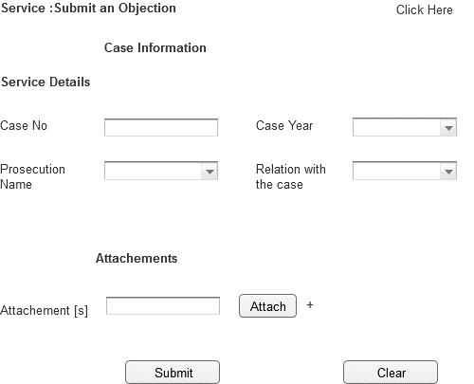

Associated Table and fields

|  |  |  |  |  |  |
| --- | --- | --- | --- | --- | --- |
| **Screen Field** | **Field Type** | **On Screen Validation** | **Mandatory /Optional** | **Auto Populate / User-Input** | **Business Validation For Database Insert** |
| Case No | Text | Number | Mandatory | User Input | Case No Entered by User is Validated against the Case Info ,User ID To See if the User is a Party to this particular case .ThisBusiness condition validated to to insert all the screen fields . |
| Case Year | Drop Down | YYYY | Mandatory | User Input |
| Prosecution Name | Drop Down | Character | Mandatory | Populated From Prosecution_View |
| Relation With Case | Drop Down | Character | Mandatory | Populated From CaseInfo_View |
| Attachment [s] | Attachment | .pdf ,.gif,.jpeg,.doc,.txt <Need Input> Single File Size 2MB ; Total Of All File Size 10MB | Optional | User Input |

|  |  |
| --- | --- |
| Associated Screen Fields Error Handling | |
| **Screen Field** | **On Screen Validation Error Code** |
| Case No | ERR_CASE_NO |
| Case Year | ERR_CASE_YEAR |
| Prosecution Name | ERR_PROSEC_NAME |
| Relation With Case | ERR_REL_CASE |
| Attachment [s] | ERR_ATTACH |

* + 1. Existing Service:Subscribing in SMS Service

|  |  |
| --- | --- |
| **Use case:** | Subscribing in SMS Service |
| **Use case ID:** | UC-PS-146 |
| **Actor** | Authenticated User |
| **Brief Description:** | The aim of this service is to allow the user to request for Subscribing in SMS Service |
| **System Trigger:** | The end user will click on the submit button in the Service Page |
| **Preconditions:** | User must be logged on to the E-Services system |
| **Flow of Events:** | 1. The end user must fill the following fields  * **Case No [Mandatory]** * **Case Year[Mandatory]** * **Prosecution Name [Mandatory]** * **Relation With Case [Mandatory]** * **Attachments** * **E-mail[Mandatory]** * **SMS[Mandatory]** * When the user moves from one field to another the front end validation is carried out.   [Specify the field level validations]   1. The User will click submit 2. The system will validate case no. 3. If the request is valid , system will store the request data in the respective database table 4. System will send an email to the user informing that the service request is submitted successfully. |
| **Business Rules** | Please refer to the Associated Table and fields Section for this service given below |
| **Post conditions:** | * Request Submitted successfully and stored in the database * Email sent to the end user conforming the request is raised successfully.[Please Refer Section 7.2 For e-Mail Format ] |
| **Alternative Flow** | NA |
| **Exceptions:** | 1. If the case info is not valid the user is prompted with the error ERR_CASE_INVALID 2. If the user entered any invalid values in any mandatory field, the system will highlight the field and show a label that will describe how the correct value should enter. 3. If the user filled all the fields and clicks submit button but no response came from the database within 120 [Default time out period;can be configured manually .Please refer to 6.2.52]secs an error message ERR_TIMEOUT is prompted to the user. |
| **Assumptions:** | NA |
| **Issues:** | NA |

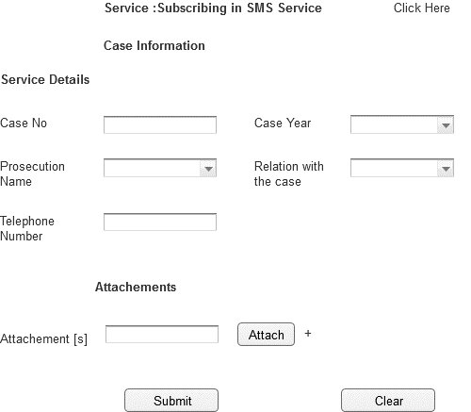

Associated Table and fields

|  |  |  |  |  |  |  |  |
| --- | --- | --- | --- | --- | --- | --- | --- |
| **Screen Field** | | **Field Type** | **On Screen Validation** | | **Mandatory /Optional** | **Auto Populate / User-Input** | **Business Validation For Database Insert** |
| Case No | | Text | Number [6 Digit] | | Mandatory | User Input | Case No Entered by User is Validated against the Case Info ,User ID To See if the User is a Party to this particular case .ThisBusiness condition validated to to insert all the screen fields . |
| Case Year | | Drop Down | YYYY | | Mandatory | User Input |
| Prosecution Name | | Drop Down | Character | | Mandatory | Populated From Prosecution_View |
| Relation With Case | | Drop Down | Character | | Mandatory | Populated From CaseInfo_View |
| Attachment [s] | | Attachment | .pdf ,.gif,.jpeg,.doc,.txt <Need Input> Single File Size 2MB ; Total Of All File Size 10MB | | Optional | User Input |
| E-mail | | Check box | Character | | Mandatory | User Input |
| SMS | | Check box | Character | | Mandatory | User Input |  |
| Associated Screen Fields Error Handling | | |
| **Screen Field** | | **On Screen Validation Error Code** |
| Case No | | ERR_CASE_NO |
| Case Year | | ERR_CASE_YEAR |
| Prosecution Name | | ERR_PROSEC_NAME |
| Relation With Case | | ERR_REL_CASE |
| Attachment [s] | | ERR_ATTACH |
| Telephone Number | | ERR_TEL_NUM |

* + 1. Existing Service:To Whom It May Concern Certificate

|  |  |
| --- | --- |
| **Use case:** | To Whom It May Concern Certificate |
| **Use case ID:** | UC-PS-147 |
| **Actor** | Authenticated User |
| **Brief Description:** | The aim of this service is to allow the user to request for To Whom It May Concern Certificate |
| **System Trigger:** | The end user will click on the submit button in the Service Page |
| **Preconditions:** | User must be logged on to the E-Services system |
| **Flow of Events:** | 1. The end user must fill the following fields  * **Case No [Mandatory]** * **Case Year[Mandatory]** * **Prosecution Name [Mandatory]** * **Relation With Case [Mandatory]** * **Attachments** * **Concerned party[Mandatory]** * **Certificate_Type[Mandatory]** * When the user moves from one field to another the front end validation is carried out.   [Specify the field level validations]   1. The User will click submit 2. The system will validate case no. 3. If the request is valid , system will store the request data in the respective database table 4. System will send an email to the user informing that the service request is submitted successfully. |
| **Business Rules** | Please refer to the Associated Table and fields Section for this service given below |
| **Post conditions:** | * Request Submitted successfully and stored in the database * Email sent to the end user conforming the request is raised successfully.[Please Refer Section 7.2 For e-Mail Format ] |
| **Alternative Flow** | NA |
| **Exceptions:** | 1. If the case info is not valid the user is prompted with the error ERR_CASE_INVALID 2. If the user entered any invalid values in any mandatory field, the system will highlight the field and show a label that will describe how the correct value should enter. 3. If the user filled all the fields and clicks submit button but no response came from the database within 120 [Default time out period;can be configured manually .Please refer to 6.2.52]secs an error message ERR_TIMEOUT is prompted to the user. |
| **Assumptions:** | NA |
| **Issues:** | NA |

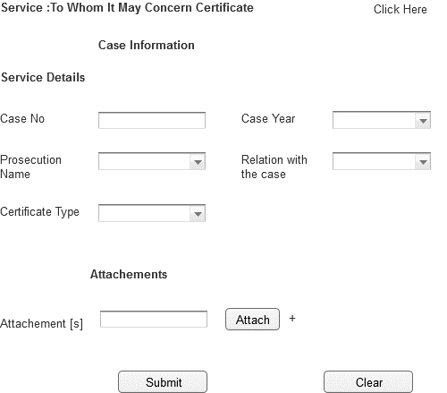

Associated Table and fields

|  |  |  |  |  |  |
| --- | --- | --- | --- | --- | --- |
| **Screen Field** | **Field Type** | **On Screen Validation** | **Mandatory /Optional** | **Auto Populate / User-Input** | **Business Validation For Database Insert** |
| Case No | Text | Number [6 Digit] | Mandatory | User Input | Case No Entered by User is Validated against the Case Info ,User ID To See if the User is a Party to this particular case .ThisBusiness condition validated to to insert all the screen fields . |
| Case Year | Drop Down | YYYY | Mandatory | User Input |
| Prosecution Name | Drop Down | Character | Mandatory | Populated From Prosecution_View |
| Relation With Case | Drop Down | Character | Mandatory | Populated From CaseInfo_View |
| Attachment [s] | Attachment | .pdf ,.gif,.jpeg,.doc,.txt <Need Input> Single File Size 2MB ; Total Of All File Size 10MB | Optional | User Input |
| Concerned party | Text | Character | Mandatory | User Input |
| Certificate_Type | Drop Down | Character | Mandatory | Populated From Certificate_TypeView |

|  |  |
| --- | --- |
| Associated Screen Fields Error Handling | |
| **Screen Field** | **On Screen Validation Error Code** |
| Case No | ERR_CASE_NO |
| Case Year | ERR_CASE_YEAR |
| Prosecution Name | ERR_PROSEC_NAME |
| Relation With Case | ERR_REL_CASE |
| Concerned party | ERR_CON_PARY |
| Attachment [s] | ERR_ATTACH |
| Certificate Type | ERR_CERT_TYP |

* + 1. Existing Service:Visiting a Provisional Detainee

|  |  |
| --- | --- |
| **Use case:** | Visiting a Provisional Detainee |
| **Use case ID:** | UC-PS-148 |
| **Actor** | Authenticated User |
| **Brief Description:** | The aim of this service is to allow the user to request for Visiting a Provisional Detainee |
| **System Trigger:** | The end user will click on the submit button in the Service Page |
| **Preconditions:** | User must be logged on to the E-Services system |
| **Flow of Events:** | 1. The end user should fill the following fields  * **Case No [Mandatory]** * **Case Year[Mandatory]** * **Prosecution Name [Mandatory]** * **Relation With Case [Mandatory]** * **Visit Date [Mandatory]** * **Prison name[Mandatory]** * **Visit purpose[Mandatory]** * **Nationality[Mandatory]** * **Prison[Mandatory]** * **Attachments**   Add another Visitor   * **Name** * **Email** * **Phone** * **Relation**  1. When the user moves from one field to another the front end validation is carried out.   [Specify the field level validations]   1. The User will click submit 2. The system will validate case no. 3. If the request is valid , system will store the request data in the respective database table 4. The user can add another visitor by clicking the ‘Add another visitor’ if necessary or else they can ignore using the delete button. 5. System will send an email to the user informing that the service request is submitted successfully. |
| **Business Rules** | Please refer to the Associated Table and fields Section for this service given below |
| **Post conditions:** | * Request Submitted successfully and stored in the database * Email sent to the end user conforming the request is raised successfully.[Please Refer Section 7.2 For e-Mail Format ] |
| **Alternative Flow** | NA |
| **Exceptions:** | 1. If the case info is not valid the user is prompted with the error ERR_CASE_INVALID 2. If the user entered any invalid values in any mandatory field, the system will highlight the field and show a label that will describe how the correct value should enter. 3. If the user filled all the fields and clicks submit button but no response came from the database within 120 [Default time out period;can be configured manually .Please refer to 6.2.52]secs an error message ERR_TIMEOUT is prompted to the user. |
| **Assumptions:** | NA |
| **Issues:** | NA |

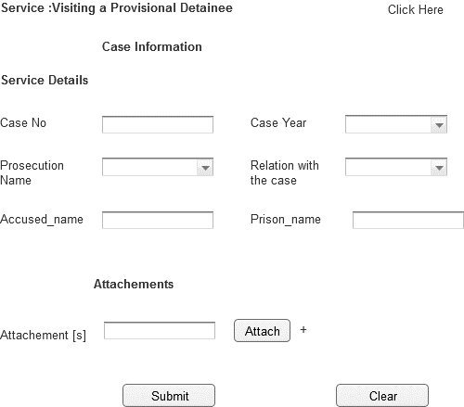

Associated Table and fields

|  |  |  |  |  |  |
| --- | --- | --- | --- | --- | --- |
| **Screen Field** | **Field Type** | **On Screen Validation** | **Mandatory /Optional** | **Auto Populate / User-Input** | **Business Validation For Database Insert** |
| Case No | Text | Number [6digit] | Mandatory | User Input | Case No Entered by User is Validated against the Case Info ,User ID To See if the User is a Party to this particular case .ThisBusiness condition validated to to insert all the screen fields . |
| Case Year | Drop Down | YYYY | Mandatory | User Input |
| Prosecution Name | Drop Down | Character | Mandatory | Populated From Prosecution_View |
| Relation With Case | Drop Down | Character | Mandatory | Populated From CaseInfo_View |
| Attachment [s] | Attachment | .pdf ,.gif,.jpeg,.doc,.txt <Need Input> Single File Size 2MB ; Total Of All File Size 10MB | Optional | User Input |
| Prison_name | Text | Character | Mandatory | User Input |
| Visit Date | Date | DD-MM-YYY | Mandatory | User Input |
| Visit purpose | Text | Character | Mandatory | User Input |
| Nationality | Text | Character | Mandatory | User Input |

|  |  |
| --- | --- |
| **Screen Field** | **On Screen Validation Error Code** |
| Case No | ERR_CASE_NO |
| Case Year | ERR_CASE_YEAR |
| Prosecution Name | ERR_PROSEC_NAME |
| Relation With Case | ERR_REL_CASE |
| Attachment [s] | ERR_ATTACH |
| Accused Name | ERR_ACC_NM |
| Prisoner Name | ERR_PRSN_NM |

* + 1. Existing Service:Waiver Enclosuer

|  |  |
| --- | --- |
| **Use case:** | Waiver Enclosuer |
| **Use case ID:** | UC-PS-149 |
| **Actor** | Authenticated User |
| **Brief Description:** | The aim of this service is to allow the user to request for Waiver Enclosuer |
| **System Trigger:** | The end user will click on the submit button in the Service Page |
| **Preconditions:** | User must be logged on to the E-Services system |
| **Flow of Events:** | 1. The end user must fill the following fields  * **Case No [Mandatory]** * **Case Year[Mandatory]** * **Prosecution Name [Mandatory]** * **Relation With Case [Mandatory]** * **Attachments** * **Accused name [Mandatory]**   When the user moves from one field to another the front end validation is carried out.  [Specify the field level validations]   1. The User will click submit 2. The system will validate case no. 3. If the request is valid , system will store the request data in the respective database table 4. System will send an email to the user informing that the service request is submitted successfully. |
| **Business Rules** | Please refer to the Associated Table and fields Section for this service given below |
| **Post conditions:** | * Request Submitted successfully and stored in the database * Email sent to the end user conforming the request is raised successfully.[Please Refer Section 7.2 For e-Mail Format ] |
| **Alternative Flow** | NA |
| **Exceptions:** | 1. If the case info is not valid the user is prompted with the error ERR_CASE_INVALID 2. If the user entered any invalid values in any mandatory field, the system will highlight the field and show a label that will describe how the correct value should enter. 3. If the user filled all the fields and clicks submit button but no response came from the database within 120 [Default time out period;can be configured manually .Please refer to 6.2.52]secs an error message ERR_TIMEOUT is prompted to the user. |
| **Assumptions:** | NA |
| **Issues:** | None |

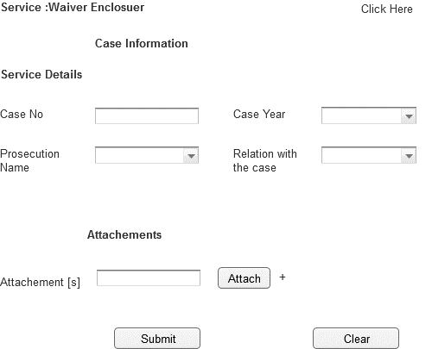

Associated Table and fields

|  |  |  |  |  |  |
| --- | --- | --- | --- | --- | --- |
| **Screen Field** | **Field Type** | **On Screen Validation** | **Mandatory /Optional** | **Auto Populate / User-Input** | **Business Validation For Database Insert** |
| Case No | Text | Number[6digit] | Mandatory | User Input | Case No Entered by User is Validated against the Case Info ,User ID To See if the User is a Party to this particular case .ThisBusiness condition validated to to insert all the screen fields . |
| Case Year | Drop Down | YYYY | Mandatory | User Input |
| Prosecution Name | Drop Down | Character | Mandatory | Populated From Prosecution_View |
| Relation With Case | Drop Down | Character | Mandatory | Populated From CaseInfo_View |
| Accused name | Text | Character | Mandatory | User Input |
| Attachment [s] | Attachment | .pdf ,.gif,.jpeg,.doc,.txt <Need Input> Single File Size 2MB ; Total Of All File Size 10MB | Optional | User Input |

|  |  |
| --- | --- |
| Associated Screen Fields Error Handling | |
| **Screen Field** | **On Screen Validation Error Code** |
| Case No | ERR_CASE_NO |
| Case Year | ERR_CASE_YEAR |
| Prosecution Name | ERR_PROSEC_NAME |
| Relation With Case | ERR_REL_CASE |
| Attachment [s] | ERR_ATTACH |

* + 1. E-Service Payment

|  |  |
| --- | --- |
| **Use case:** | E-Service Payment |
| **Use case ID:** | UC-PS-150 |
| **Actor** | Authenticated User |
| **Brief Description:** | The aim of this service is to allow the user to to make a online payment for the requested e-service |
| **System Trigger:** | The end user will click on the payment link in the Service status Page |
| **Preconditions:** | User must be logged on to the E-Services system with a successfully submitted e-service request |
| **Flow of Events:** | 1. The user receives a payment link in the e-service status page 2. The user clicks on the payment link 3. The user accepts the service fee 4. The user is re-directed to the E-Dhiram integration screen 5. The user makes the transaction 6. The user is re-directed to the e-services page to show the status of the transaction   E-mail and SMS is sent to the user |
| **Post conditions:** | * Transaction details successfully stored in the database |
| **Exceptions:** | 1. If there is no response from the e-Dhiram payment system the transaction is set to pending 2. The sync with E-Dhiram System is carried out for all the pending transaction within 48hrs is prompted to the user. |
| **Alternmative Flow** | NA |
| **Assumptions:** | 1. Only the below Mentioned E-services have a fee associated with them  * Case Copy * Copy of Judgment * Copy of Non-Suit Order * Photocopy of Case Dropping Decision * To It May Concern Certificate   The appropriate payment for the user service is determined by the back end Oracle Authentication System  **Note** : Please refer the below given Appendix 7.3 Paid Service Details for fee Information |
| **Issues:** | NA |

* + 1. Configure Database Timeout

|  |  |
| --- | --- |
| **Use case:** | Configure Database Timeout |
| **Use case ID:** | UC-PS-151 |
| **Actor** | Admin User |
| **Brief Description:** | The aim of this service is to allow the admin user to configure the database time out period |
| **System Trigger:** | NA |
| **Preconditions:** |  |
| **Flow of Events:** | 1. The admin user will login to the portal admin console 2. The admin user can set the data base time out period 3. The revised timeout period is stored in the database successfully |
| **Post conditions:** | * The database timeout period is revised successfully for all end users |
| **Exceptions:** | NA |
| **Alternmative Flow** | NA |
| **Assumptions:** | The database timeout period is set to 120 secs by default |
| **Issues:** | NA |

* + 1. Configure and Publish News

|  |  |
| --- | --- |
| **Use case:** | Configure and Publish News |
| **Use case ID:** | UC-PS-152 |
| **Actor** | The Content Editor, Content Publisher |
| **Brief Description:** | The aim of this service is to allow the admin user to configure and publish the news to be displayed into the Portal |
| **System Trigger:** | NA |
| **Preconditions:** | User must be logged on to the webcenter portal   * **Latest news**: Latest News section will show (News teaser Title, Teaser Description, News Date, and Teaser Image) * Latest News will be sorted by News Date descending (latest in top) * When the user click in one of the news, the website will navigate the user to selected news details page. * **Featured News** will show ( News Teaser Title, News Date) * Featured News will be sorted by News Date descending (latest in top) * Link should be available (Read All News) to redirect the user to the news listing page. * When the user click in one of the news, the website will navigate the user to selected news details page * **News Listing**: News List section will show (News Teaser Title, Teaser Description, News Date, and Teaser Image) * When the user click in one of the news, the website will navigate the user to selected news details page * Pagination should be available in the news listing. * User should be able to search for specific news * User should be able to filter news by news Date (From, To) * User can change language for the page using language combo-box and remain in the same page (in the pagination) |
| **Flow of Events:** | 1. The admin user will login to the portal admin console 2. The admin user must have to fill the following fields    1. **Title[Mandatory]**    2. **Description[Mandatory]**    3. **Image**    4. **Thumbnail**    5. **Status[Mandatory]**    6. **Create Date[Mandatory]**    7. **News Date[Mandatory]**    8. **Publish Date[Mandatory]**    9. **Last Modified[Mandatory]**    10. **Is Featured News**    11. **Show in homepage**   3**.** The **Content Editor** should be able to (Add, Edit, and Delete) news  **Adding News**: After Content Editor create new News and Save; the following should happen:   * + News status will be **New**   + News Create Date will be the date news saved   + Email will be sent to the Publisher to Review the created news.   4. **Update News**: After Content Editor update existing News and Save; the following should happen:   * + News status will be changed to **modified**   + News last modified time will be updated to current time.   + Email will be sent to the Publisher to Review the updates in the news   5. The **ContentPublisher** should be able to (Approve “Publish, Reject News, Deactivate, Activate, and Delete)   * **News Approval** if the Publisher approved the news the news will be visible to the Public User   + News Status should be changed to **Published**.   + Publishing date should be updated. * **Reject News**:if the news was rejected and email should be sent back to the Content Editor informing the rejection of the news.   + News Status should be changed to **Rejected**. * **Activate News**: News Status will be changed to **Active** and will be visible to End User. * **Deactivate News**: News Status will be changed to **Inactive** and will be hidden from End User |
| **Post conditions:** | * Updated news:The email should highlight the changes (adding new news), the email also should contain a link to redirect the publisher to the updated news. * The email should highlight the changes (Update Existing news), the email also should contain a link to redirect the publisher to the updated news. |
| **Exceptions:** | * If the user entered any invalid values in any field, the system will highlight the field |
| **Alternmative Flow** | NA |
| **Assumptions:** | NA |
| **Issues:** | NA |

Associated Table and fields

|  |  |  |  |  |  |
| --- | --- | --- | --- | --- | --- |
| **Screen Field** | **Field Type** | **On Screen Validation** | **Mandatory /Optional** | **Auto Populate / User-Input** | **Business Validation For Insert** |
| Title | Text | Character[500] | Mandatory | User Input | If the Images was not inserted in the news, or any section in the website, the website will show Public Prosecution logo automatically |
| Description | Text | Character[Max] | Mandatory | User Input |
|  |  |  |  |  |
| Image | BLOB | Image | Optional | User Input |
|  |  |  |  |  |
| Thumbnail | BLOB | Image | Optional | User Input |
| Status | Drop Down | Lookup (New, Modified, Published, Rejected, Active, Inactive) | Mandatory | Auto Populate |
| Created Date | Date | Date Time | Mandatory | User Input |
| News Date | Date | Date Time | Mandatory | User Input |
| Publish Date | Date | Date Time | Mandatory | User Input |
| Last Modified | Date | Date Time | Mandatory | User Input |
| Is Featured News | Drop Down | Binary (True: is featured) | False by default | Auto Populate |
| Show in homepage | Drop Down | Binary (True: is featured) | True by default | Auto Populate |

* + 1. Configure and Publish Events / Announcements

|  |  |
| --- | --- |
| **Use case:** | Configure and Publish Events / Announcements |
| **Use case ID:** | UC-PS-153 |
| **Actor** | The Content Editor, Content Publisher |
| **Brief Description:** | The aim of this service is to allow the admin user to add and publish the Events / Announcements to be displayed into the Portal |
| **System Trigger:** | NA |
| **Preconditions:** | * User must be logged on to the webcenter portal * Upcoming events section will show (Event Date, Event Title) * Upcoming events will be sorted by News Date descending (latest in top) * When the user click in one of the events, the website will navigate the user to selected event details page. |
| **Flow of Events:** | 1. The content editor will login to the portal admin console  2. The content editor user must fill the following fields   1. **Title[Mandatory]** 2. **Description[Mandatory]** 3. **Image** 4. **Thumbnail** 5. **Status[Mandatory]** 6. **Create Date[Mandatory]** 7. **Event Date from[Mandatory]** 8. **Event Date to[Mandatory]** 9. **Event Attendance Time From[Mandatory]** 10. **Event Attendance Time To[Mandatory]** 11. **Location** 12. **Organizer** 13. **Event Type[Mandatory]** 14. **Publish Date[Mandatory]** 15. **Last Modified[Mandatory]**   3**.** The**Content Editor** should be able to (Add, Edit, and Delete “non-published”) events.   * **Adding Events**: After Content Editor create new Event and Save; the following will be happen:   + Event status will be **New**   + Event Create Date will be the date when the event was saved.   + Email will be sent to the Publisher to Review the created event. * **Update Event**: After Content Editor update existing Event and Save; the following will be happen:   + Event status will be changed to **modified**   + Event last modified time will be updated to current time.   + Email will be sent to the Publisher to Review the updates in the Event. .   4. The **Content Publisher** should be able to (Approve “Publish, Reject Events, Deactivate, Activate, and Delete),   * **Events Approval**: if the Publisher approved the Event; the Event will be visible to the Public User   + Event Status should be changed to **Published**.   + Publishing date should be updated. * **Reject Events**: if the Event was rejected an email should be sent back to the Content Editor informing the rejection of the Event.   + News Status should be changed to **Rejected**. * **Activate Events**: Event Status will be changed to **Active** and will be visible to End User. * **Deactivate Events**: Events Status will be changed to **Inactive** and will be hidden from End User. |
| **Post conditions:** | * Created Event: The email should highlight the changes (adding new events), the email also should contain a link to redirect the publisher to the created event. * Updated Event: The email should highlight the changes (Update Existing Event), the email also should contain a link to redirect the publisher to the updated Event. |
| **Alternmative Flow** | NA |
| **Assumptions:** | NA |
| **Issues:** | NA |

Associated Table and fields

|  |  |  |  |  |  |
| --- | --- | --- | --- | --- | --- |
| **Screen Field** | **Field Type** | **On Screen Validation** | **Mandatory /Optional** | **Auto Populate / User-Input** | **Business Validation For Insert** |
| Title | Text | Character[500] | Mandatory | User Input | If the Images was not inserted in the event, or any section in the website, the website will show Public Prosecution logo automatically. |
| Description | Text | Character[Max] | Mandatory | User Input |
|  |  |  |  |  |
| Image | Attachment | Image(BLOB) | Optional | User Input |
|  |  |  |  |  |
| Thumbnail | Attachment | Image(BLOB) | Optional | User Input |
| Status | Text | Lookup (New, Modified, Published, Rejected, Active, Inactive) | Mandatory  (Automatic) | User Input |
| Created Date | Drop Down | Date Time | Mandatory  (Automatic) | User Input |
| Event Date from | Drop Down | Date Time | Mandatory | User Input |
| Event Date to | Drop Down | Date Time | Mandatory  (equal Event Date from by default) | User Input |
| Event Attendance Time From | Drop Down | Time | Mandatory  (8:00am by default) | User Input |
| Event Attendance Time To | Drop Down | Time | Mandatory  (6:00pm by default) | User Input |
| Location | Drop Down | Varchar2(500) | Optional | User Input |
| Organizer | Drop Down | Varchar2(500) | Optional | User Input |
| Event Type | Drop Down | Varchar2(200) | Mandatory | User Input |
| Publish Date | Drop Down | Date Time | Mandatory | User Input |
| Last Modified | Drop Down | Date Time | Mandatory | User Input |

6.2.55 Existing Service: Search Case

|  |  |
| --- | --- |
| **Use case:** | Search Case |
| **Use case ID:** | UC-PS-154 |
| **Actor** | Authenticated User |
| **Brief Description:** | The aim of this service is to allow the user to search for the cases |
| **Actor:** | End User |
| **System Trigger:** | The end user will click on the search button in the Service Page |
| **Preconditions:** | User must be logged on to the Public Services system |
| **Flow of Events:** | 1. The end user must fill the following fields  * **Case No [Mandatory]** * **Case Year[Mandatory]** * **Location of Case [Mandatory]**  1. When the user moves from one field to another the front end validation is carried out. 2. The User will click search 3. The system will validate case no. 4. If the request is valid , system will store the request data in the respective database table |
| **Business Rules** | Please refer to the Associated Table and fields Section for this service given below |
| **Post conditions:** | NA |
| **Alternative flow** | NA |
| **Exceptions:** | If the case info is not valid the user is prompted with the error ERR_CASE_INVALID |
| **Assumptions:** | NA |

Service:Search Case

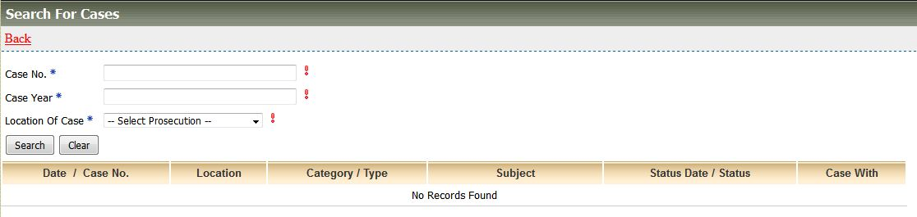

Associated Table and fields

|  |  |  |  |  |  |
| --- | --- | --- | --- | --- | --- |
| **Screen Field** | **Field Type** | **On Screen Validation** | **Mandatory /Optional** | **Auto Populate / User-Input** | **Business Validation For Database Insert** |
| Case No | Text | Number [6digit] | Mandatory | User Input | Case No Entered by User is Validated against the Case Info ,User ID To See if the User is a Party to this particular case .This Business condition validated to insert all the screen fields . |
| Case Year | Drop Down | YYYY | Mandatory | User Input |
| Location of Case | Drop Down | Character | Mandatory | Populated From CaseInfo_View |

Associated Screen Fields Error Handling

|  |  |
| --- | --- |
| **Screen Field** | **On Screen Validation Error Code** |
| Case No | ERR_CASE_NO |
| Case Year | ERR_CASE_YEAR |
| Location of Case | ERR_LOC_CASE |

Note:Please refer to the error code section for description of the Error code

6.2.56 Existing Service: Lawyer Record

|  |  |
| --- | --- |
| **Use case:** | Search Lawyers |
| **Use case ID:** | UC-PS-155 |
| **Actor** | Authenticated User |
| **Brief Description:** | The aim of this service is to allow the user to search for the lawyers record |
| **Actor:** | End User |
| **System Trigger:** | The end user will click on the search button in the Service Page |
| **Preconditions:** | User must be logged on to the Public Services system |
| **Flow of Events:** | 1.The end user must fill the following fields   * **Name [Mandatory]** * **Address[Mandatory]** * **City [Mandatory]**   2. When the user moves from one field to another the front end validation is carried out.  3. The User will click search  4. The system will validate the name.  5. If the request is valid , system will store the request data in the respective database table |
| **Business Rules** | Please refer to the Associated Table and fields Section for this service given below |
| **Post conditions:** | NA |
| **Alternative flow** | NA |
| **Exceptions:** | If the case info is not valid the user is prompted with the error ERR_CASE_INVALID |
| **Assumptions:** | NA |

Service:Search Lawyers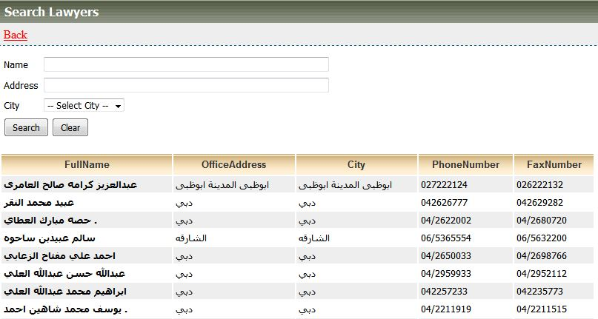

Associated Table and fields

|  |  |  |  |  |  |
| --- | --- | --- | --- | --- | --- |
| **Screen Field** | **Field Type** | **On Screen Validation** | **Mandatory /Optional** | **Auto Populate / User-Input** | **Business Validation For Database Insert** |
| Name | Text | Character | Mandatory | User Input | Case No Entered by User is Validated against the Case Info ,User ID To See if the User is a Party to this particular case .This Business condition validated to insert all the screen fields . |
| Address | Text | Character[150] | Mandatory | User Input |
|  |  |  |  |  |
| City | Drop Down | Character | Mandatory | Populated From CaseInfo_View |

Associated Screen Fields Error Handling

|  |  |
| --- | --- |
| **Screen Field** | **On Screen Validation Error Code** |
| Name | ERR_PROSEC_NAME |
| Address | ERR_ADDRESS |
| City | ERR_CITY |

Note:Please refer to the error code section for description of the Error code

6.2.57 Existing Service: Search Experts

|  |  |
| --- | --- |
| **Use case:** | Search Experts |
| **Use case ID:** | UC-PS-156 |
| **Actor** | Authenticated User |
| **Brief Description:** | The aim of this service is to allow the user to search for Experts |
| **Actor:** | End User |
| **System Trigger:** | The end user will click on the search button in the Service Page |
| **Preconditions:** | User must be logged on to the Public Services system |
| **Flow of Events:** | 1. The end user must fill the following fields  * **Name [Mandatory]** * **Address[Mandatory]** * **City [Mandatory]**  1. When the user moves from one field to another the front end validation is carried out. 2. The User will click search 3. The system will validate the name. 4. If the request is valid , system will store the request data in the respective database table |
| **Business Rules** | Please refer to the Associated Table and fields Section for this service given below |
| **Post conditions:** | NA |
| **Alternative flow** | NA |
| **Exceptions:** | If the case info is not valid the user is prompted with the error ERR_NAME_INVALID |
| **Assumptions:** | NA |

Service:Search Experts

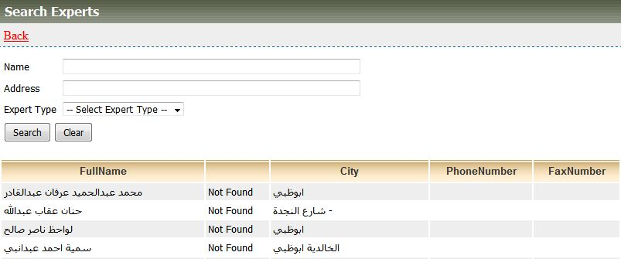

Associated Table and fields

|  |  |  |  |  |  |
| --- | --- | --- | --- | --- | --- |
| **Screen Field** | **Field Type** | **On Screen Validation** | **Mandatory /Optional** | **Auto Populate / User-Input** | **Business Validation For Database Insert** |
| Name | Text | Character[15] | Mandatory | User Input | Case No Entered by User is Validated against the Case Info ,User ID To See if the User is a Party to this particular case .This Business condition validated to insert all the screen fields . |
| Address | Text | Character[150] | Mandatory | User Input |
| City | Text | Character | Mandatory | User Input |

Associated Screen Fields Error Handling

|  |  |
| --- | --- |
| **Screen Field** | **On Screen Validation Error Code** |
| Name | ERR_PROSEC_NAME |
| Address | ERR_ADDRESS |
| City | ERR_CITY_TYPE |

Note:Please refer to the error code section for description of the Error code

6.2.58 Existing Service: Search Translators

|  |  |
| --- | --- |
| **Use case:** | Search Translators |
| **Use case ID:** | UC-PS-157 |
| **Actor** | Authenticated User |
| **Brief Description:** | The aim of this service is to allow the user to search for translators |
| **Actor:** | End User |
| **System Trigger:** | The end user will click on the search button in the Service Page |
| **Preconditions:** | User must be logged on to the Public Services system |
| **Flow of Events:** | 1. The end user must fill the following fields  * Name**[Mandatory]** * **Address[Mandatory]**  1. When the user moves from one field to another the front end validation is carried out. 2. The User will click search 3. The system will validate case no. 4. If the request is valid , system will store the request data in the respective database table |
| **Business Rules** | Please refer to the Associated Table and fields Section for this service given below |
| **Post conditions:** | NA |
| **Alternative flow** | NA |
| **Exceptions:** | If the case info is not valid the user is prompted with the error ERR_NAME_INVALID |
| **Assumptions:** | NA |

Service:Search Translators

Associated Table and fields

|  |  |  |  |  |  |
| --- | --- | --- | --- | --- | --- |
| **Screen Field** | **Field Type** | **On Screen Validation** | **Mandatory /Optional** | **Auto Populate / User-Input** | **Business Validation For Database Insert** |
| Name | Text | Character[15] | Mandatory | User Input | The Name Entered by User is Validated against the Case Info ,User ID To See if the User is a Party to this particular case .This Business condition validated to insert all the screen fields . |
| Address | Text | Character[150] | Mandatory | User Input |

Associated Screen Fields Error Handling

|  |  |
| --- | --- |
| **Screen Field** | **On Screen Validation Error Code** |
| Name | ERR_PROSEC_NAME |
| Address | ERR_ADDRESS_YEAR |

Note:Please refer to the error code section for description of the Error code

6.2.59 Existing Service: Contact us

|  |  |
| --- | --- |
| **Use case:** | Contact us |
| **Use case ID:** | UC-PS-158 |
| **Actor** | Authenticated User |
| **Brief Description:** | The aim of this service is to allow the user to contact |
| **Actor:** | End User |
| **System Trigger:** | The end user will click on the submit button in the Service Page |
| **Preconditions:** | User must be logged on to the Public Services system |
| **Flow of Events:** | 1. The end user must fill the following fields  * **Name [Mandatory]** * **E-Mail [Mandatory]** * **Address** * **Phone no** * **Subject[Mandatory]** * **Description[Mandatory]**  1. When the user moves from one field to another the front end validation is carried out. 2. The User will click submit 3. The system will validate case name. 4. If the request is valid , system will store the request data in the respective database table 5. System will send an email to the user informing that the service request is submitted successfully. |
| **Business Rules** | Please refer to the Associated Table and fields Section for this service given below |
| **Post conditions:** | * Request Submitted successfully and stored in the database * Email sent to the end user conforming the request have been submitted successfully. |
| **Alternative flow** | NA |
| **Exceptions:** | 1. If the case info is not valid the user is prompted with the error ERR_NAME_INVALID 2. If the user entered any invalid values in any mandatory field, the system will highlight the field and show a label that will describe how the correct value should enter. 3. If the user filled all the fields and clicks submit button but no response came from the database within 120 [Default time out period can be configured manually. |
| **Assumptions:** | NA |

Service:Contact Us

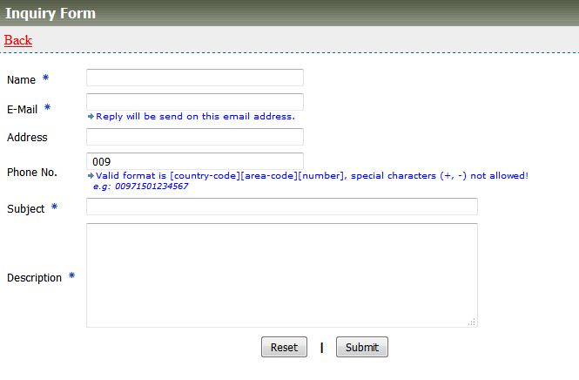

Associated Table and fields

|  |  |  |  |  |  |
| --- | --- | --- | --- | --- | --- |
| **Screen Field** | **Field Type** | **On Screen Validation** | **Mandatory /Optional** | **Auto Populate / User-Input** | **Business Validation For Database Insert** |
| Name | Text | Character[15] | Mandatory | User Input | Name Entered by User is Validated against the Case Info ,User ID To See if the User is a Party to this particular case .This Business condition validated to insert all the screen fields . |
| E-mail | Text | Character[20] | Mandatory | User Input |
| Address | Text | Character[150] | optional | User Input |
| Phone no | Number | Number [10digit] | Optional | User Input |
| Subject | Text | Character[150] | Mandatory | User Input |
| Description | Text | Character[150] | Mandatory | User Input |

Associated Screen Fields Error Handling

|  |  |
| --- | --- |
| **Screen Field** | **On Screen Validation Error Code** |
| Name | ERR_PROSEC_NAME |
| E-mail | ERR_EMAIL |
| Address | ERR_ADDRESS |
| Phone no | ERR_PHONE_NO |
| Subject | ERR_SUBJECT |
| Description | ERR_DESC |

Note:Please refer to the error code section for description of the Error code

### 6.2.60 Newsletter Subscription(User)

|  |  |
| --- | --- |
| **Use case:** | Newsletter Subscription User |
| **Use case ID:** | UC-PS-159 |
| **Actor** | The Authenticated User |
| **Brief Description:** | The aim of this service is to allow the user to subscribe the newsletter |
| **System Trigger:** | The end user will click on the subscribe button in the Service Page |
| **Preconditions:** | * User must be logged on to the Public Services system |
| **Flow of Events:** | 1. The user must fill the following fields   1. **Name** 2. **Email** 3. **Select categories** 4. **subscribe button** 5. The User can able to enters the above details and when clicks on the Subscribe button. 6. The details will be save in the NEWSLETTER_SUBSCRIPTION table. |
| **Business Rules** | Please refer to the Associated Table and fields Section for this service given below |
| **Post conditions:** | * Request Submitted successfully and stored in the database |

Associated Table and fields

|  |  |  |  |
| --- | --- | --- | --- |
| **Screen Field** | **Field Type** | **On Screen Validation** | **Mandatory /Optional** |
| Ns_Id | number | Character | Mandatory |
| Ns_Name | Character(20) | Character(20) | Mandatory |
| Ns_Email | Character(20) | Character(20) | Mandatory |
|  |  |  |  |
| Ns_Categories | Character | Character | Mandatory |

### 6.2.61 Newsletter Subscription(Admin)

|  |  |
| --- | --- |
| **Use case:** | Newsletter Subscription Admin |
| **Use case ID:** | UC-PS-160 |
| **Actor** | The Admin User |
| **Brief Description:** | The aim of this service is to allow the admin user to send the newsletter |
| **System Trigger:** | The admin user will click on the send button in the Service Page |
| **Preconditions:** | * User must be logged on to the Public Services system |
| **Flow of Events:** | 1. The user must fill the following fields             a.  Categories tab  **i.**  **Table to add categories**             b. Send Newsletter tab  **i.     Select categories ( one or more)**  **ii.    Email subject**  **iii.   Enter the email body (Plain text)**  **iv.  Add attachment**  **v.   Send button**   1. The admin can able to select the category from (check boxes) and 2. The email subject, email body and the Add attachment should enter. 3. When the admin clicks on the SEND button the Newsletter will be send to registered Emails from the NEWSLETTER_SUBSCRIPTION tablewithout duplicates in emails. |
| **Post conditions:** | * Request Submitted successfully and stored in the database |

1. Appendix: Sources of Information

* 1-PP_MOM_2-8-2015
* 2-PP_MOM_3-8-2015
* 3-PP_MOM_10-8-2015
* 4-PP_MOM_11-8-2015
* 5-PP_MOM_18-8-2015
* 6-PP_MOM_19-8-2015
* 20 PP Services – Business Details & Requirements
* Business Details for the PP Services
* WEB_SERVICES_DESCRIPTION
* MOJ Schema
* XML Mapping File
* Views

< I am expecting TACME to provide a Document repository and we need to provide only with the links here >

* 1. Error Message Guide

|  |  |  |
| --- | --- | --- |
| **Screen Field** | **On Screen Validation Error Code** | **Error Message** |
| Case No | ERR_CASE_NO | Enter a Valid Case Number with 6 digit Number Format |
| Case Year | ERR_CASE_YEAR | Please Select the Case year |
| Prosecution Name | ERR_PROSEC_NAME | Enter Characters only |
| Relation With Case | ERR_REL_CASE | Enter Characters only |
| Attachment [s] | ERR_ATTACH | .pdf ,.gif,.jpeg,.doc,.txt <Need Input> Single File Size 2MB ; Total Of All File Size 10MB |
| Accused Name | ERR_ACC_NM | Enter Characters only |
| Prisoner Name | ERR_PRSN_NM | Enter Characters only |
| Subject | ERR_SUBJ | Enter Characters only |
| Submit | ERR_TIMEOUT | Database timeout occurred Please enter details again. If issue persists please notify administrator |
| Errorr Type | ERR_TYP | Enter Characters only |
| Corrected Phrase | ERR_CRR_PHR | Enter Characters only |
| Deposit_Amount | ERR_DEP_AMT | Enter Number Only |
| Accused_name | ERR_ACC_NM | Enter Characters only |
| Iban_Number | ERR_IBAN_NM | Enter in Valid IBAN format |
| person_capture_name | ERR_PER_CAP_NM | Enter Characters only |
| person_capture_data | ERR_PER_CAP_DAT | Enter Characters only |
| person_capture_photo | ERR_PER_CAP_PHO | .bmp,.gif,.jpeg, Single File Size 2MB |
| Contract Number | ERR_CNT_NM | Enter Number Only |
| Defendant Name | ERR_DEF_NAM | Enter Characters only |
| Inmate | ERR_INM | Enter Characters only |
| Diseases Type | ERR_DIS_TYP | Choose any Value from the Drop Down |
| Medical Report | ERR_MED_REP | .pdf ,doc,.txt Single File Size 2MB |
| Request_reason | ERR_REQ_RES | Enter Characters only |
| Appeal | ERR_APPEAL | Enter Characters only |
| Restraint_type | ERR_RES_TYP | Choose any Value from the Drop Down |
| Certificate_Type | ERR_CER_TYP | Choose any Value from the Drop Down |
| Telephone_Number | ERR_TEL_NM | Enter Valid Number |
| Postpone_Reason | ERR_POS_RES | Enter Characters only |
| Session_date | ERR_SES_DAT | Select a Date |
| Session_date | ERR_SES_DAT | Select a Date |
| Judge_against_name | ERR_JDG_AGN | Enter Characters only |
| Request_subject | ERR_REQ_SUBJ | Enter Characters only |
| Witness_name | ERR_WIT_NAM | Enter Characters only |
| Fine_Amount | ERR_FIN_AMT | Enter Number Only |
| Istallment Amount | ERR_INST_AMT | Enter Number Only |
| Restraint_type | ERR_RES_TYP | Choose any Value from the Drop Down |
| Case No | ERR_CASE_INVALID | You are not Party to the Case |

* 1. Mail Format For E-Service Request

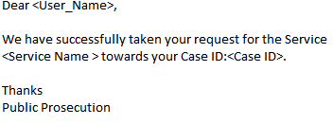

* 1. Paid Service Details

|  |  |  |
| --- | --- | --- |
| **SERVICE_NAME** | **FEES** | **SPECIFIC CONDITIONS** |
| Copy of Judgment | 10 AED for the first copy / 100 AED for the next copy | 1. 10 AED- photocopy of any of the above mentioned if the parties apply for the first time.  2. 100 AED- photocopy of any of the above mentioned of the parties apply for the second time.  3. 100 AED- photocopy of any of the above mentioned of the request comes from non-parties. |
| To It May Concern Certificate | 10 Dirhams | NA |
| Case Copy | 5 Dirhams / Maximum 300 Dirhams | 5 AED per paper, up to 300 AED maximum |
| Photocopy of Case Dropping Decision | 10 Dirhams | NA |
| Copy of Non-Suit Order | 10 Dirhams | NA |