


Multi Modal Intelligent Traffic Signal System
Simulation Deployment – User Manual

Revision 0.2
September 13, 2020
Table of Contents
1. Purpose of Document 3
2. Requirements: 3
3. Simulation Model 3
3.1. Configuring Connected Vehicle 4
3.2. Signal Controller 5
3.2.1. Configuring Econolite ASC/3 Signal Controller 5
3.2.2. Configuring MaxTime Signal Controller 6
4. VISSIM Driver Model DLL 7
5. Simulation-Tools 8
5.1. Message-Distributor 9
5.2. Priority-Request-Generator-Server 11
6. Deployment – Docker Containers 12
List of Figures:
Figure 1: VISSIM Simulation model of Two intersections 4
Figure 2: Defining Connected Vehicle Type 4
Figure 3: Prepare to setup the parameters 5
Figure 4: Define the parameters 6
Figure 5: Starting MaxTime signal Controller 6
Figure 6: Defining the IP address in MaxTime Signal Controller 7
Figure 7: Flow diagram of Priority-Request-Generator-Server 11
Figure 8: Snapshot of supervisord.conf files for (a) intersection container
(b) simulation-tools container 15
Revision History
Revision No. (Date) | Description
0.2  (09/13/2020) | - Updated the name of driver model  - Updated the system requirements

Purpose of Document
This document is an instruction guide for deploying Multi-Modal Intelligent Traffic Signal System (MMITSS) applications in the simulation platform. The document contains the detailed configuration and usage instructions for deploying the MMITSS software components in the docker container.

Requirements:
The following devices, software and libraries are required to be installed to deploy MMITSS applications in the simulation environment.
- VISSIM 10 or VISSIM 2020 installed on a MS Windows (version 10) computer
- A Linux box (preferably Ubuntu 18.04) installed with docker, docker-compose, supervisor and clone mmitss repository.
- Update the ubuntu repositories by entering following command:
sudo apt-get update
- Once updating of repositories is complete, run the following command to install required packages
sudo apt-get install -y chrony build-essential tcpdump libssl-dev zlib1g-dev python3-pip
- Install the required python packages
sudo pip3 install pyinstaller
sudo pip3 install apscheduler
sudo pip3 install sh psutil
sudo pip3 install haversine
- If MMITSS path is not set already, set the MMITSS path in the .bashrc file by executing the following command:
export MMITSS_ROOT=<mmitss directory>
For example if mmitss is cloned on home/user directory then the command will be:
export MMITSS_ROOT=/home/user

Simulation Model
PTV VISSIM (a microscopic simulation software) is used to simulate all modes of traffic and analyses the performance of MMITSS. VISSIM can be utilized to create realistic and accurate models to test different traffic scenarios, including a variety of connected vehicle penetration rates. A sample VISSIM model of DaisyMountain & GavilanPeak and DaisyMountain & DedicationTrail intersections at Anthem, Arizona is shown in Figure 1.
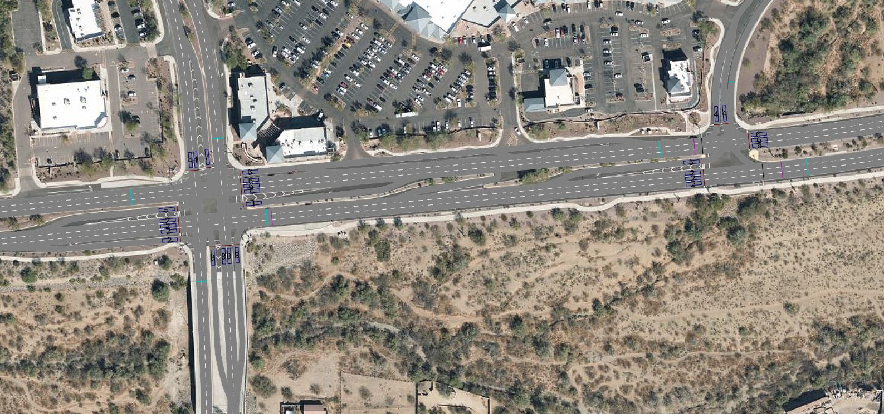
Figure 1: VISSIM Simulation model of Two intersections

3.1. Configuring Connected Vehicle:
A new vehicle type (Connected vehicle) can be created using an external driver model dll. In Section 4, the method for setting up driver model dll is discussed.
- To create a connected vehicle say Transit, a new vehicle type must be defined (Figure 2).
- The directory of the diver model dll file has to be indicated under the External Driver Model as shown in the Figure 2.
- The new vehicle type is required to be assigned under the “Vehicle Classes”. Go to Data->Vehicle Classes option and add the vehicle type.
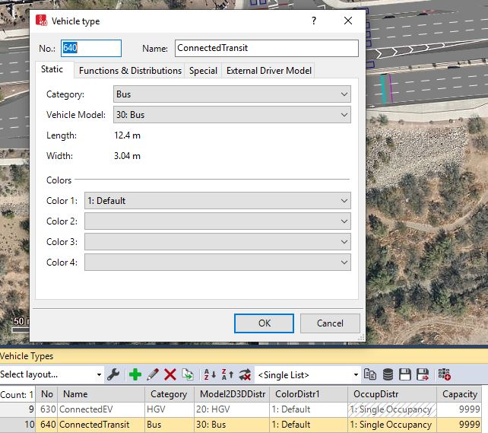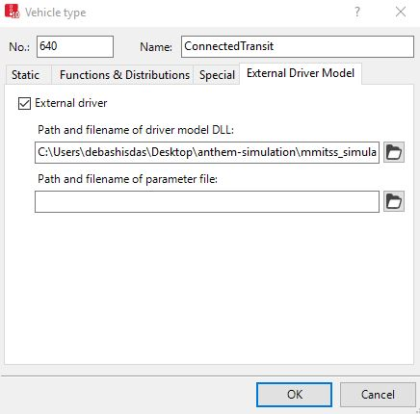
Figure 2: Defining Connected Vehicle Type
3.2. Signal Controller:
To establish communication between the MMITSS software components and a simulated software-in-the-loop (SIL) signal controller, the signal controller must be properly configured. Different agencies use different type of signal controllers. Two SIL controllers have been used with MMITSS: Econolite ASC/3 and Intelight MaxTime. The Econolite and Intelight SIL software must be obtained by the user from PTV and/or the controller vendors separately from MMITSS.
3.2.1. Configuring Econolite ASC/3 signal controller:
The following steps are required to configure Econolite ASC/3 signal controller:
(a) Determine the IP address of the MS Windows computer where VISSIM is installed. The Linux computer where the MMITSS Roadside Processor (MRP) container will be and the VISSIM computer must be in the same subnet. For example, if the MRP container host IP address is: 10.254.56.xx then the VISSIM computer IP address must be 10.254.56.yy, where xx and yy are determined by the user.
(b) Next define the controller IP, subnet mask, default gateway IP, server IP, NTCIP backup time and NTCIP UDP Port in the VISSIM ASC/3 controller. From the VISSIM open each signal controller and select “Parameters” option (Figure 3). Go to the Comm-Pg1 option (MM 1-4) under configuration and define the parameters (Figure 4).
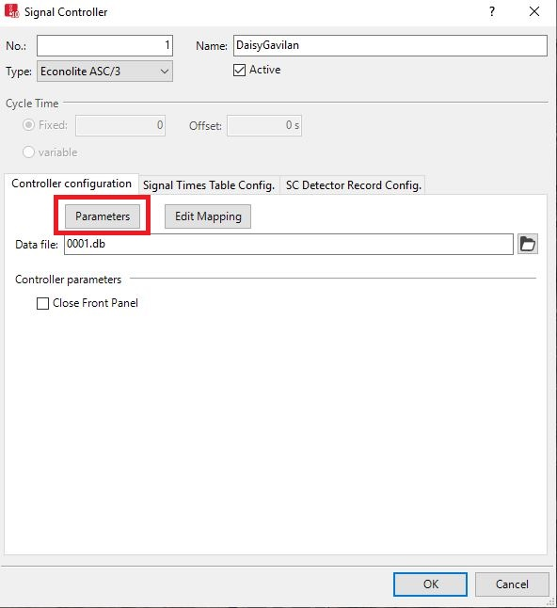
Figure 3: Prepare to setup the parameters
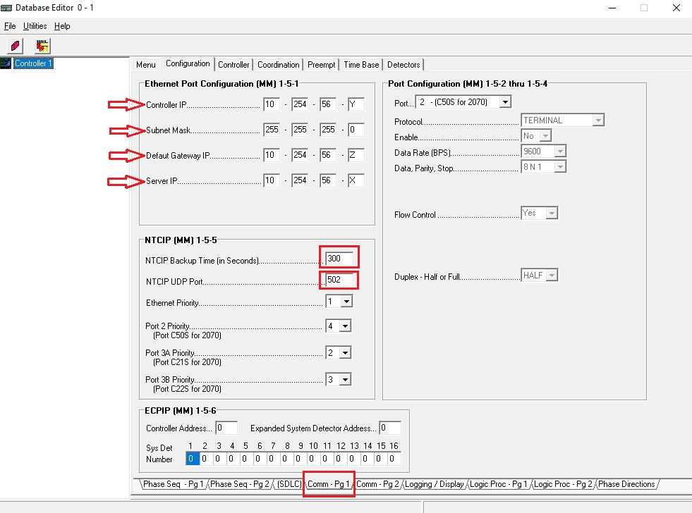
Figure 4: Define the parameters
3.2.2. Configuring MaxTime signal controller:
Following steps are required to configure MaxTime Signal controller:
(a) Start MaxTime by defining unique Web Port, PTV VISSIM TCP port, PTV VISSIM ID for each intersection (Figure 5). The PTV VISSIM TCP port must match the port number of the standard signal control parameters.
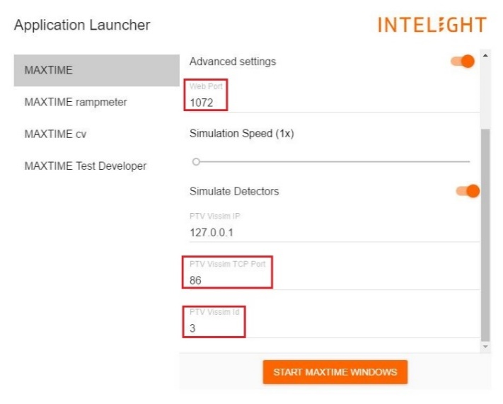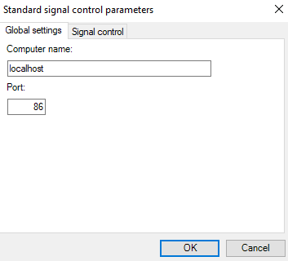
Figure 5: Starting MaxTime signal Controller
(b) The controller IP address has to define from peer configuration (Figure 6).
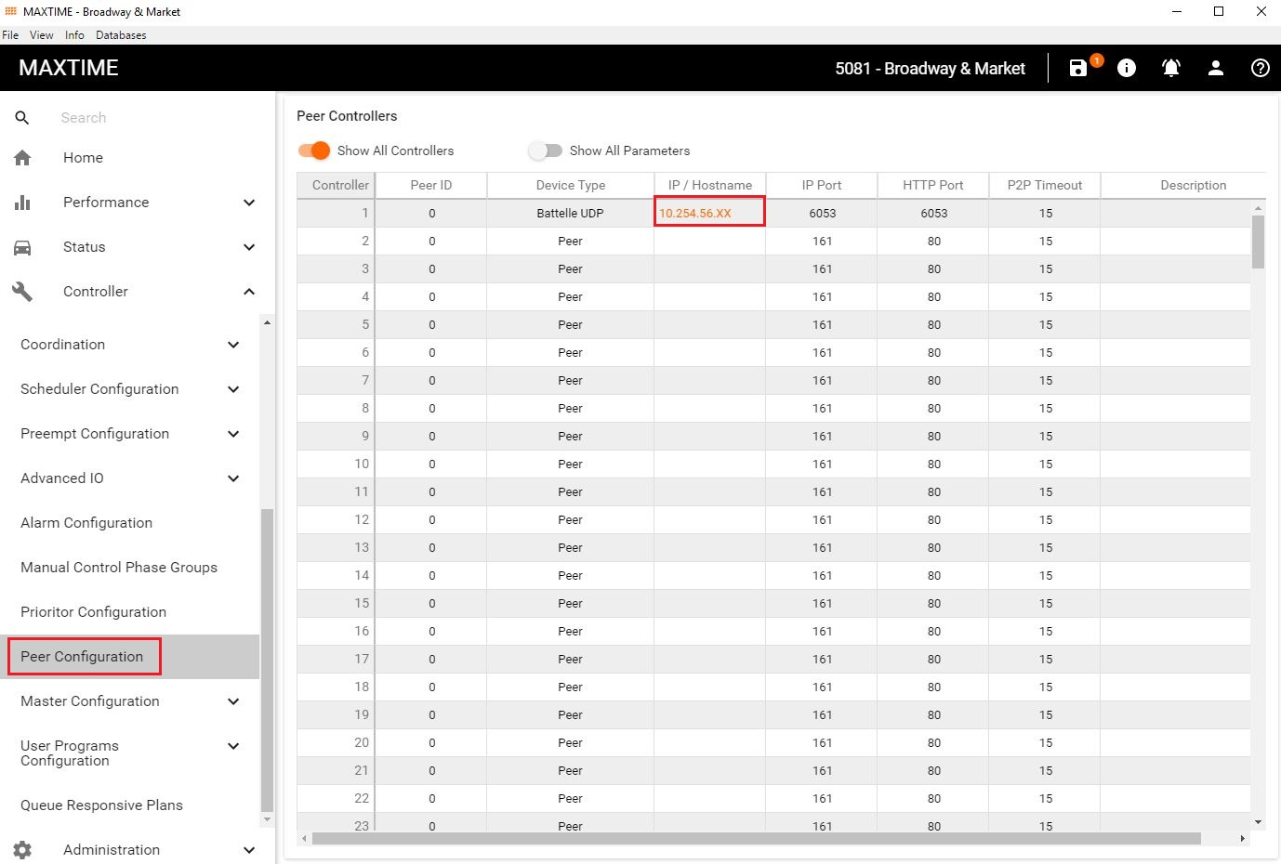
Figure 6: Defining the IP address in MaxTime Signal Controller

VISSIM Driver Model DLL
A custom driver model has been built using the original sample driver-model provided with VISSIM distribution. Then new driver-model simulates connected vehicles that interact with MMITSS applications. Four variants of this driver-model have been built. They are as follows:
- Mmitss_DriverModelPassenger.dll (type = “passenger”)
- Mmitss_DriverModelEmergency.dll (type = “emergency”)
- Mmitss_DriverModelTransit.dll (type = “transit”)
- Mmitss_DriverModelTruck.dll (type = “truck”)
At every time instant in the VISSIM simulation, vehicles using any of above driver-models send a UDP packet containing a Basic Safety Message (BSM) in a blob formatted message. The blob contains the vehicle’s identification, type, size, current location and motion to a network node defined in the configuration file.
Functionally all four driver models are identical except that the value in the “type” field in the BSM blob is different for each driver-model. These driver-models have been tested in VISSIM VISSIM 2021.
To use the driver-models, a directory named “mmitss_simulation” needs to be placed in the same directory where the “*.inpx” file where the simulation exists. This directory is provided in the MMITSS simulation distribution package. The “mmitss_simulation” directory contains a configuration file named “mmitss_driver_model_config.json” and a subdirectory named “driver_models” where all four prebuilt driver-models are stored. All four driver-models use the same configuration file and the relative location of the “*.inpx” configuration file cannot be altered. The configuration file establishes the network node (called “msg_distributor”) where the UDP packets are to be sent. In addition, the GPS coordinates of the VISSIM model origin (0,0) is set in the configuration file. This information is required to correctly transform the vehicle’s current location from the VISSIM’s local coordinate system to the GPS coordinate system (WGS-84). An example of the content of the “mmitss_driver_model_config.json” is as follows:
{
""client_ip": "127.0.0.1",
"client_port": 10005,
"VISSIM_origin_position": {
"elevation_Meter": 540.11,
"latitude" : {
"Degree" : 33.0,
"Minute" : 50.0,
"Second" : 35.4
},
"longitude" : {
"Degree" : -112.0,
"Minute" : -8.0,
"Second" : -6.1
}
}
}
The IP address and UDP port of the receiver network node are specified in the “msg-distributor-ip" and “msg-distributor-port" fields respectively. The message-distributor component of MMITSS simulation-tools is used to send vehicle data to the geo-located MMITSS intersections components (e.g. the MRP components).

Simulation-Tools
To interface the simulation models with other MMITSS core components, thre additional components are provided: simulated-bsm-blob-processor, message-distributor and priority-request-generator-server. The simulated-bsm-blob-processor is responsible for receiving and forwrading the decoded the BSM blob to the message distributor. The message-distributor component is responsible for receiving and distributing the messages from the simulated-bsm-blob-processor and other MMITSS components to the priority-request-generator-server component or to the appropriate intersection containers. The priority-request-generator-server component is responsible for formulating the Signal Request Messages (SRMs) based on the vehicle information received from the message-distributor component.

5.1. Simulated-BSM-Blob-Processor
The simulated-bsm-blob-processor receives the BSM blob from the VISSIM simulation model over the socket. It decodes the BSM blob to a BSM JSON string and forwards to the message-distributor. An example of decoded BSM JSON string is as follows:
{
"MsgType": BSM,
"BasicVehicle": {
"heading_Degree": 359.1,
"position": {
"elevation_Meter": 587,
"latitude_DecimalDegree": 33.843455,
"longitude_DecimalDegree": -112.135159
},
"secMark_Second": 2600,
"size": {
"length_cm": 400,
"width_cm": 300
},
"speed_MeterPerSecond": 12.5,
"temporaryID": 5822735,
"type": "transit"
},
}

5.2. Message-Distributor
As the name suggests, the message-distributor component is responsible for receiving messages from the simulated-bsm-blob-processor or other MMITSS components and distributing them to applicable configured clients. The message-distributor also allows the simulation to be configured for the wireless range (in Meter) of each roadside unit deployed in the corridor along with a probability of dropping message packets. These parameters are set as part of the model calibration process. The clients (IP address and UDP port) for supported messages can be configured in the configuration file of the message-distributor. An example of the configuration file (mmitss-message-distributor-config.json) is as follows:
{
"package_drop_probability": 0,
"raw_bsm_logging": true,
"intersections": [
{
"name": "DaisyMountain_GavilanPeak",
"ip_address": "xxx.xxx.xxx.xxx",
"bsm_client_port": 5001,
"srm_client_port": 20002,
"dsrc_range_Meter": 500,
"position": {
"latitude_DecimalDegree": 33.842932,
"longitude_DecimalDegree": -112.135186,
"elevation_Meter": 539
}
},
{
"name": "DaisyMountain_DedicationTrail",
"ip_address": "xxx.xxx.xxx.yyy",
"bsm_client_port": 5001,
"srm_client_port": 20002,
"dsrc_range_Meter": 500,
"position": {
"latitude_DecimalDegree": 33.843239,
"longitude_DecimalDegree": -112.131541,
"elevation_Meter": 539
}
},
],
"bsm_clients":
{
"transit":[
{
"ip_address": "xxx.xxx.xxx.zzz",
"port":20022
}
],
"truck":[
{
"ip_address": "xxx.xxx.xxx.zzz",
"port":20022
}
],
"emergency":[
{
"ip_address": "xxx.xxx.xxx.zzz",
"port":20022
}
],
"passenger":[
]
},
"map_clients":
[
{
"ip_address": "xxx.xxx.xxx.zzz",
"port":20022
}
],
"ssm_clients":
[
{
"ip_address": "xxx.xxx.xxx.zzz",
"port":20022
}
]
}
The message-distributor receives and distributes following messages:
- BSM-like information from VISSIM simulation model:
If the vehicle type in the received message is either “emergency”, “transit”, or “truck”, the message is forwarded to the priority-request-generator-server component (or more clients if required). In the configuration file, the IP address xxx.xxx.xxx.zzz corresponds to the docker container (or physical machine) that hosts the priority-request-generator-server. In addition, regardless of the vehicle type, if the location described in the received message is within the wireless range (meters) of any of the configured intersections, the message is distributed to that intersection’s BSM receiving client (defined by intersection_ip and bsm_client_port).
- SRMs from priority-request-generator-server
The priority-request-generator-server sends JSON strings of formulated SRMs to the message-distributor. If the location of vehicle (as per the received message) is within the wireless range of any (meters) of any of configured intersections, the message is distributed to that intersection’s SRM receiving client (defined by intersection_ip and srm_client_port). For MMITSS priority applications, the SRM receiving client is the priority-request-server.
- SSMs from priority-request-server of each intersection
The priority-request-server component for each intersection generates and broadcasts a signal status message (SSM) as an acknowledgement of the receipt of SRM if it is eligible for the priority service. The priority-request-server for each intersection also forwards SSMs to the message-distributor, which then forwards these SSMs to the SSM receiving clients. For MMITSS priority applications, one SSM receiving client is the priority-request-generator-server component.
- MAPs from map-spat-broadcasters of each intersection
The map-spat-broadcaster component for each intersection broadcasts MAP message at a frequency of 1 Hz. It also forwards the MAP messages to the message-distributor, which then forwards these MAPs to configured MAP receiving clients. For MMITSS priority applications, the MAP receiving client is the priority-request-generator-server component.
5.3. Priority-Request-Generator-Server
The priority-request-generator-server is responsible for simulating the priority-request-generator for each priority eligible vehicle. In a field deployment, each vehicle-side processor would have a priority-request-generator, but in simulation each priority-request-generator is an instance in the priority-request-generator-server. The priority-request-generator-server receives BSMs from the message-distributor. If the vehicle ID is not available in the list of active vehicles, it creates an instance of priority-request-generator for that vehicle ID. If the vehicle ID is already listed, it updates the vehicle information. The priority-request-generator-server also receives MAP messages from the message-distributor. It calculates the haversine distance between the map reference point and all vehicles based on their current gps coordinates. If the distance is within wireless range, it forwards the MAP messages to the instance of priority-request-generator. Each instance of priority-request-generator will generate SRM JSON string, based on the MAP and gps coordinates. The priority-request-generator-server sends those SRMs JSON strings to the message-distributor. It can also receive SSM JSON strings form the message-distributor and forwards it to the vehicles priority-request-generator instances to maintain the Active Request Table (ART).
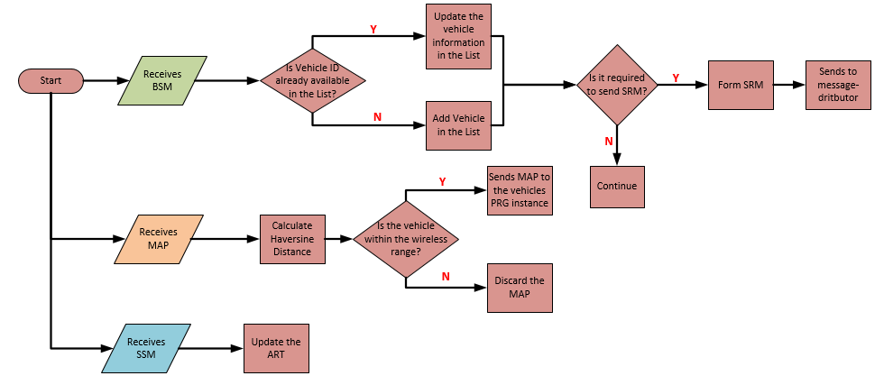
Figure 7: Flow diagram of Priority-Request-Generator-Server

Deployment – Docker Containers
To deploy MMITSS in the simulation environment, following steps can be followed:
Step1: Create configuration file
Two configurations files are required: mmitss-phase3-master-config.json, and mmitss-data-external-clients.json, for each intersection as well as mmitss-phase3-master-config.json, mmitss-message-distributor-config.json configuration files for the simulation tools (message-distributor, priority-request-generator-server). The configuration files contain the IP addresses, UDP ports, and other configuration data which is required to establish communication between the MMITSS software components. Configuration files for each intersection need to be placed in the <intersectionName>/nojournal/bin directory. The simulation tools configuration files are required to be placed in simulation-tools/nojournal/bin directory. An example of mmitss-phase3-master-config.json is follows:
{
"HostIp": "10.12.6.103",
"SourceDsrcDeviceIp": "10.12.6.105",
"IntersectionName": "intersection-1",
"MapPayload": "001283fe38083020315abe2149d0eec5287358f623c402dc051870d16049a00000048000bb5ef1800a0a181a820000020000171c4d4781414c735fcbd028280",
"IntersectionID": 44383,
"RegionalID": 0,
"DataCollectorIP": "172.3.1.91",
"HMIControllerIP": "10.12.7.3",
"MessageDistributorIP": "10.12.6.20",
"PriorityRequestGeneratorServerIP": "10.12.6.20",
"VehicleType": "Transit",
"Logging": true,
"ConsoleOutput": true,
"SRMTimedOutTime": 10.0,
"ScheduleExecutionBuffer": 1.0,
"SystemPerformanceTimeInterval": 300.0,
"ApplicationPlatform": "roadside",
"PortNumber": {
"MessageTransceiver": {
"MessageSender": 10003,
"MessageReceiver": 10002,
"MessageEncoder": 10003,
"MessageDecoder": 10002
},
"MessageDistributor": 5000,
"RsmDecoder": 10006,
"OBUBSMReceiver": 10005,
"HostBsmDecoder": 10005,
"TrajectoryAware": 20001,
"PriorityRequestServer": 20002,
"PrioritySolver": 20003,
"PriorityRequestGenerator": 20004,
"TrafficControllerInterface": 20005,
"TrafficControllerCurrPhaseListener": 20006,
"TrafficControllerTimingPlanSender": 20007,
"PerformanceObserver": 20008,
"HMIController": 20009,
"PrioritySolverToTCIInterface": 20010,
"SignalCoordination": 20011,
"MapSPaTBroadcaster": 6053,
"DsrcImmediateForwarder": 1516,
"PriorityRequestServer_SendSSM": 50003,
"DataCollector": 30001,
"SnmpEngine": 20020,
"SnmpEngineInterface": 20021,
"PriorityRequestGeneratorServer": 20022,
"TrajectoryAware_MapEngineInterface": 20023,
"MapEngine": 20024,
"LightSirenStatusManager": 20025,
"PeerToPeerPriority": 20026,
"SystemPerformanceDataCollector": 20027
},
"psid": {
"map": "8002",
"spat": "8002",
"rsm": "8002",
"srm": "8002",
"ssm": "8002",
"bsm": "20"
},
"msgId": {
"map": "0012",
"spat": "0013",
"rsm": "0021",
"srm_lower": "001d",
"srm_upper": "001D",
"ssm_lower": "001e",
"ssm_upper": "001E",
"bsm": "0014"
},
"TxChannel": {
"map": 172,
"spat": 172,
"rsm": 172,
"srm": 182,
"ssm": 182,
"bsm": 172
},
"TxMode": {
"map": "CONT",
"spat": "CONT",
"rsm": "CONT",
"srm": "ALT",
"ssm": "ALT",
"bsm": "CONT"
},
"SignalController": {
"IpAddress": "10.12.6.104",
"NtcipPort": 501,
"TimingPlanUpdateInterval_sec": 600,
"NtcipBackupTime_sec": 300,
"Vendor": "Econolite",
"TimingPlanMib": "/nojournal/bin/EconoliteMib.py",
"InactiveVehPhases": [],
"InactivePedPhases": [],
"SplitPhases": {
"1": 6,
"3": 8,
"5": 2,
"7": 4
},
"PermissiveEnabled": {
"1": true,
"3": true,
"5": true,
"7": true
}
},
"DataTransfer":
{
"server":
{
"data_directory": "/home/ubuntu/mmitss",
"ip_address": "127.0.0.1",
"username": "username",
"password": "password"
},
"intersection":
[
{
"name": "intersection-1",
"v2x-data_location": "/home/ubuntu/mmitss"
}
],
"StartTime_PushToServer":
{
"hour": 0,
"minute": 0
}

},
"PriorityParameter": {
"EmergencyVehicleWeight": 1.0,
"EmergencyVehicleSplitPhaseWeight": 0.1,
"TransitWeight": 1.0,
"TruckWeight": 1.0,
"DilemmaZoneRequestWeight": 20.0,
"CoordinationWeight": 0.1
}
}

- For each intersection, “HostIp”, “IntersectionName”, “MapPayload”, “IntersectionID”, signal controller “IpAddress”, “NtcipPort”, and “NtcipBackupTime_sec”, “Vendor”, “TimingPlanMib” are required to be specified in the mmitss-phase3-master-config.json file. The map payload can be obtained by creating an intersection map using USDOT map tool (https://webapp.connectedvcs.com/isd/).
- For simulation tools, “MessageDistributorIP”, “PriorityRequestGeneratorServerIP” are required to be specified in the mmitss-phase3-master-config.jsonfile.
- Create a log folder in the nojournal/bin directory for each intersection and simulation tools. To log the data, specify “Logging”: “True” in the mmitss-phase3-master-config.json file.
- The structure of mmitss-message-distributor-config.json is discussed in the section 5.1.
Step2: Define the docker files
Two dockerfiles are required: 1. For MMITSS roadside software component- “Dockerfiles” and 2. For simulation tools- “Dockerfile_simulation-tools”. The dockerfiles are required to be placed in the mmitss/bin directory. It is required to specify the docker image name (”mmitssuarizona/mmitss-base-x86:1.3”) in the dockerfile.
An example of the Dockerfile is as follows:
#---------------------------------------------------------------------------#
# Dockerfile to build an x86 platform image for an intersection #
#---------------------------------------------------------------------------#
FROM mmitssuarizona/mmitss-base-x86:1.3
COPY TrafficControllerInterface/x86/M_TrafficControllerInterface /mmitss
COPY SnmpEngine/x86/M_SnmpEngine /mmitss
COPY PriorityRequestSolver/x86/M_PriorityRequestSolver /mmitss
COPY PriorityRequestServer/x86/M_PriorityRequestServer /mmitss
COPY MapSpatBroadcaster/x86/M_MapSpatBroadcaster /mmitss
COPY supervisord.conf /mmitss
CMD ["/usr/bin/supervisord"]
An example of the Dockerfile_simulation-tools is as follows:
#---------------------------------------------------------------------------#
# Dockerfile to build an x86 platform image for an intersection #
#---------------------------------------------------------------------------#
FROM mmitssuarizona/mmitss-base-x86:1.3
COPY PriorityRequestGeneratorServer/x86/M_PriorityRequestGeneratorServer /mmitss
COPY MessageDistributor/x86/M_MessageDistributor /mmitss
RUN mkdir -p /mmitss/map
COPY supervisord_simulation-tools.conf /mmitss/supervisord.conf
CMD ["/usr/bin/supervisord"]

Step 3: Define supervisrod.conf and supervisor_simulation-tool.conf file
To monitor the applications in the container, it is required to define two supervisord.conf files. For MMITSS roadside software components the file is named supervisrod.conf and for the simulation tools the file is named supervisrod-simulation-tools.conf. They must be placed in the same directory structure as the Dockerfile (mmitss/bin).
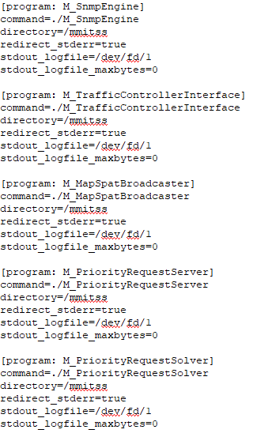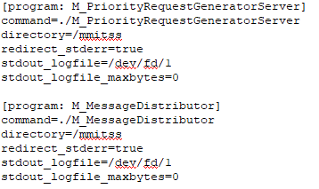
(a) (b)
Figure 8: Snapshot of supervisord.conf files for (a) intersection container (b) simulation-tools container
Step 4: Define docker-compose.yml file
To run all the software components in the docker container, docker-compose.yml file is required. The yml file must be placed in the same directory structure as Dockerfile (mmitss/bin).
- For each MMITSS controlled intersection, “intersection”, “container name”, “source”, and “ipv4_address” are required to be specified. Container name can be the same as the intersection name. The “source” must be the directory where the configuration files are located and the “ipv4 address” has to match the Host IP address which is defined in the mmitss-phase3-master-config.json file for each intersection.
- For simulations tools, the “dockerfile” name has to be defined along with the “container name”, “source”, “ipv4_address”. The “container_name” can be “simulation-tools”, and the “source” must be the directory of configuration files and the “ipv4_address” has to match the message-distributor IP address which is defined in the mmitss-phase3-master-config.json file.
- The ethernet interface of the computer and subnet has to be defined under the network. The name of the ethernet interface which will be used to communicate with the containers can be obtained by executing following command in a terminal on the computer:
ifconfig
An example of the docker-compose.yml file for two intersections and simulation tools is as follows:
version: "3.8"
x-var: &IMAGE_MRP_SIMULATION
mmitssuarizona/mmitss-mrp-$PROCESSOR:2.1

x-var: &IMAGE_SERVER_TOOLS
mmitssuarizona/mmitss-simulation_server-tools-$PROCESSOR:2.1

services:

speedway-campbell:
container_name: speedway-campbell
volumes:
- type: bind
source: $MMITSS_ROOT/mmitss/config/speedway-sample/simulation/speedway-campbell/nojournal
target: /nojournal
networks:
mmitss_vlan:
ipv4_address: 10.12.6.3
image: *IMAGE_MRP_SIMULATION
environment:
- TZ=America/Phoenix

speedway-mountain:
container_name: speedway-mountain
volumes:
- type: bind
source: $MMITSS_ROOT/mmitss/config/speedway-sample/simulation/speedway-mountain/nojournal
target: /nojournal
networks:
mmitss_vlan:
ipv4_address: 10.12.6.9
image: *IMAGE_MRP_SIMULATION
environment:
- TZ=America/Phoenix

simulation_server-tools:
container_name: simulation_server-tools
volumes:
- type: bind
source: $MMITSS_ROOT/mmitss-az/config/simulation_server-tools/nojournal
target: /nojournal

networks:
mmitss_vlan:
driver: macvlan
driver_opts:
parent: $MMITSS_NETWORK_ADAPTER
ipam:
config:
- subnet: 10.12.6.0/24

Step 5: Build and run the docker container
- Open a terminal in Linux box and change to directory where all configuration files are stored.
- To run the docker containers ake sure the VISSIM simulation model has started and execute the following command:
docker-compose -f <docker-compose.yml file directory> up
For example, to run the docker container from mmitss-az repository (if mmitss-az is cloned into home/ubuntu directory) execute the following command:
docker-compose -f home/ubuntu/mmitss-az/build/docker-compose/simulation/speedway-sample/docker-compose.yml up
- To monitor the containers execute the following command:
docker-compose exec <container_name> /bin/bash
or,
docker container exec -it <container_name> /bin/bash
This command will direct the console commands to the inside of the container. The following command can be executed to monitor the applications using supervisor.
supervisorctl
- To stop all the containers, execute the following command:
docker-compose stop
To stop a specific container, execute the following command
docker-compose stop <container_name>
- To start all the containers the execute the following command:
docker-compose start
To start a specific container, execute the following command
docker-compose start <container_name>
- To take down the whole macvlan network of docker containers, execute the following command
docker-compose down
- To bring up the whole macvlan network of docker containers, execute the following command
docker-compose up

