ECG-leads positioning
Documentation

Source: http://speech.rutgers.edu/VoiceInter/ECGwaves.html

The ECG leads
As mentioned earlier, the ECG signals can be measured between pairs of electrodes placed on the human body. However, the ECG waves from these signals have different shapes and amplitudes, depending on the position on the human body where they are placed. In electrocardiography, a pair of electrodes forms a so called ECGlead. Over the years, a standard has been established in electrocardiography and this standard specifies 12 separate leads and the corresponding positions of the electrodes on the human body. Also, this standard provides a means of obtaining the 12 standard ECG leads by combining the signals from different electrodes. The reason for recording and analyzing more than a single ECG lead is that different parts of the heart can be "seen" better from different angles (provided by different leads). Each ECG lead provides a different view of the same cardiac activity. The 12 standard ECG leads are divided in limb leads, called --- I, II, III, AVR, AVL and AVF --- and chest leads called ---V1, V2, V3, V4, V5, V6. The limb leads provide views of the cardiac activity in the frontal plane and the chest leads provide views in the horizontal plane of the heart.
The description of the 12 ECG leads and the corresponding electrode positions is provided in the following:
I: is a leadobtained between a negative electrode placed on the right arm and a positive electrode placed on the left arm
- II: is a lead obtained between a negative electrode placed on the right arm and a positive electrode placed on the left foot
- III: is a lead obtained between a negative electrode placed on the left arm and a positive electrode placed on the left foot
- AVR: is a lead obtained between the average signal obtained from three negative electrodes (left arm, left leg and right foot) and the signal obtained from a positive electrode placed on the right arm
- AVL: is a lead obtained between the average signal obtained from three negative electrodes (right arm, left foot and right foot) and the signal obtained from a positive electrode placed on the left arm
- AVF: is a lead obtained between the average signal obtained from three negative electrodes (left arm, right arm and and right foot) and the signal obtained from a positive electrode placed on the left foot
- V1: is a lead obtained between the reference negative electrode and a positive electrode placed on the chest in the V1 position (see next figure)
- V2: is a lead obtained between the reference negative electrode and a positive electrode placed on the chest in the V2 position (see next figure)
- V3: is a lead obtained between the reference negative electrode and a positive electrode placed on the chest in the V3 position (see next figure)
- V4: is a lead obtained between the reference negative electrode and a positive electrode placed on the chest in the V4 position (see next figure)
- V5: is a lead obtained between the reference negative electrode and a positive electrode placed on the chest in the V5 position (see next figure)
- V6: is a lead obtained between the reference negative electrode and a positive electrode placed on the chest in the V6 position (see next figure)

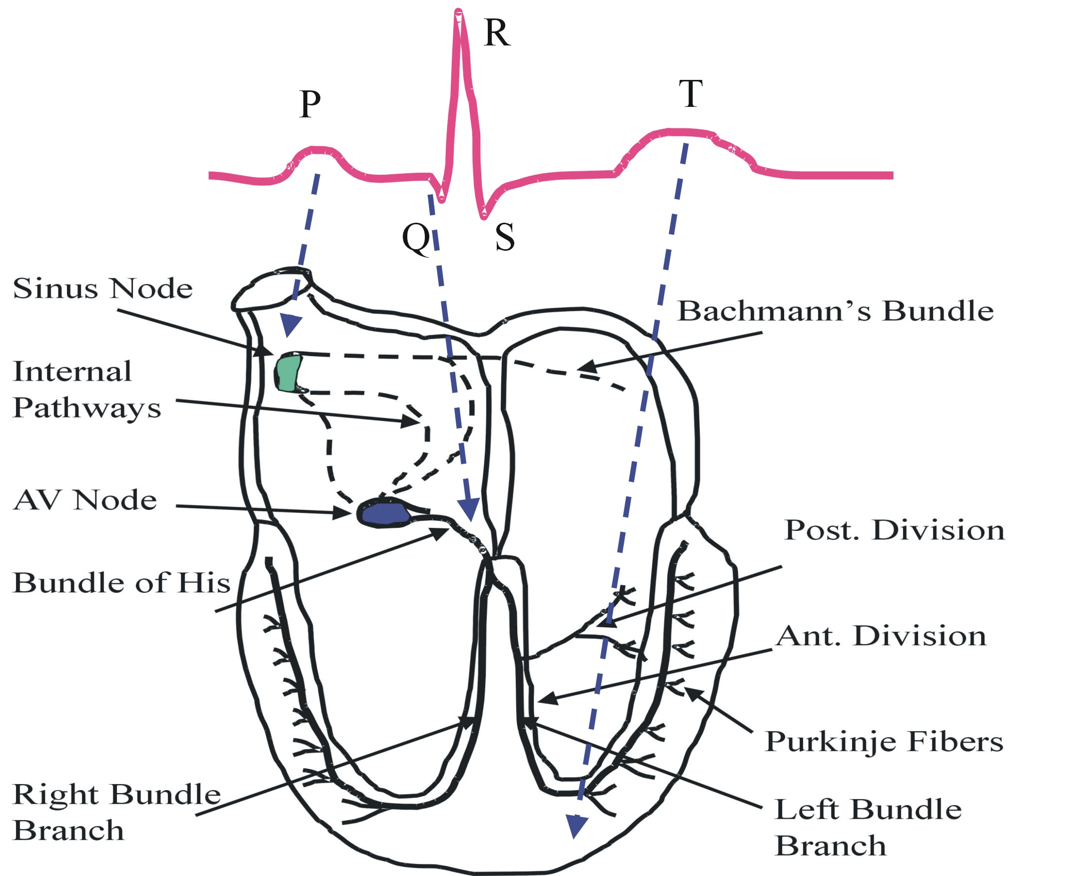

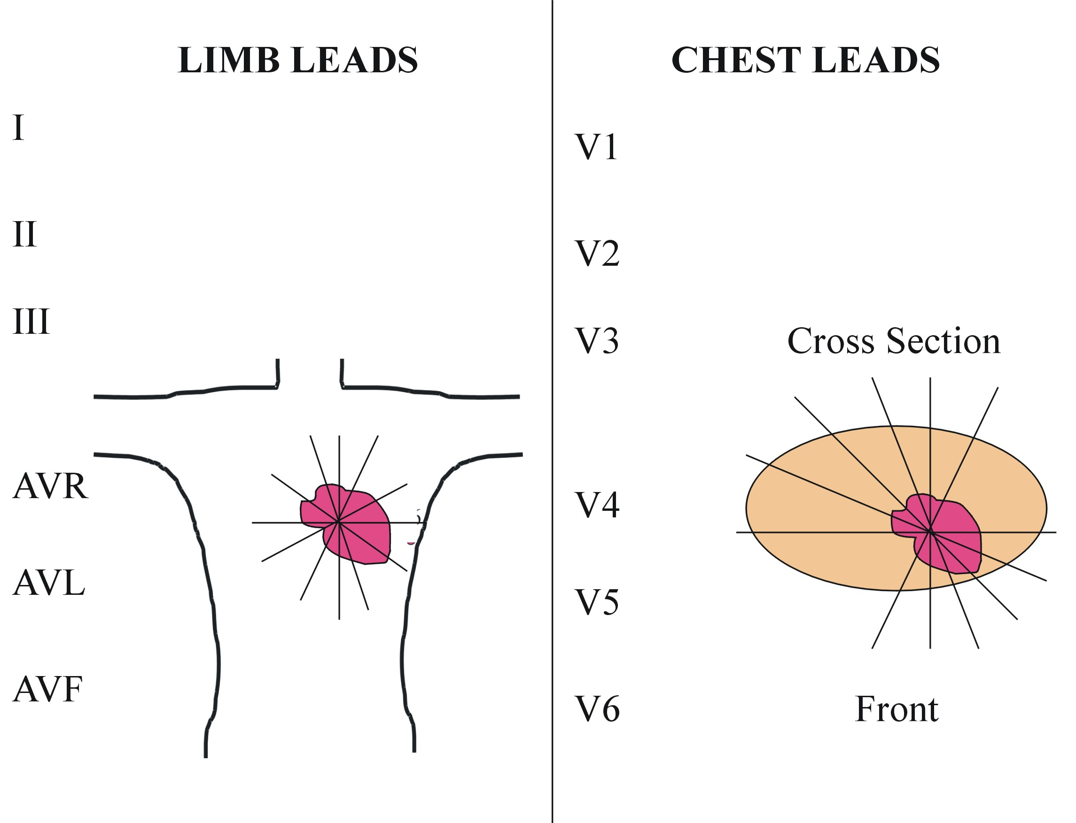

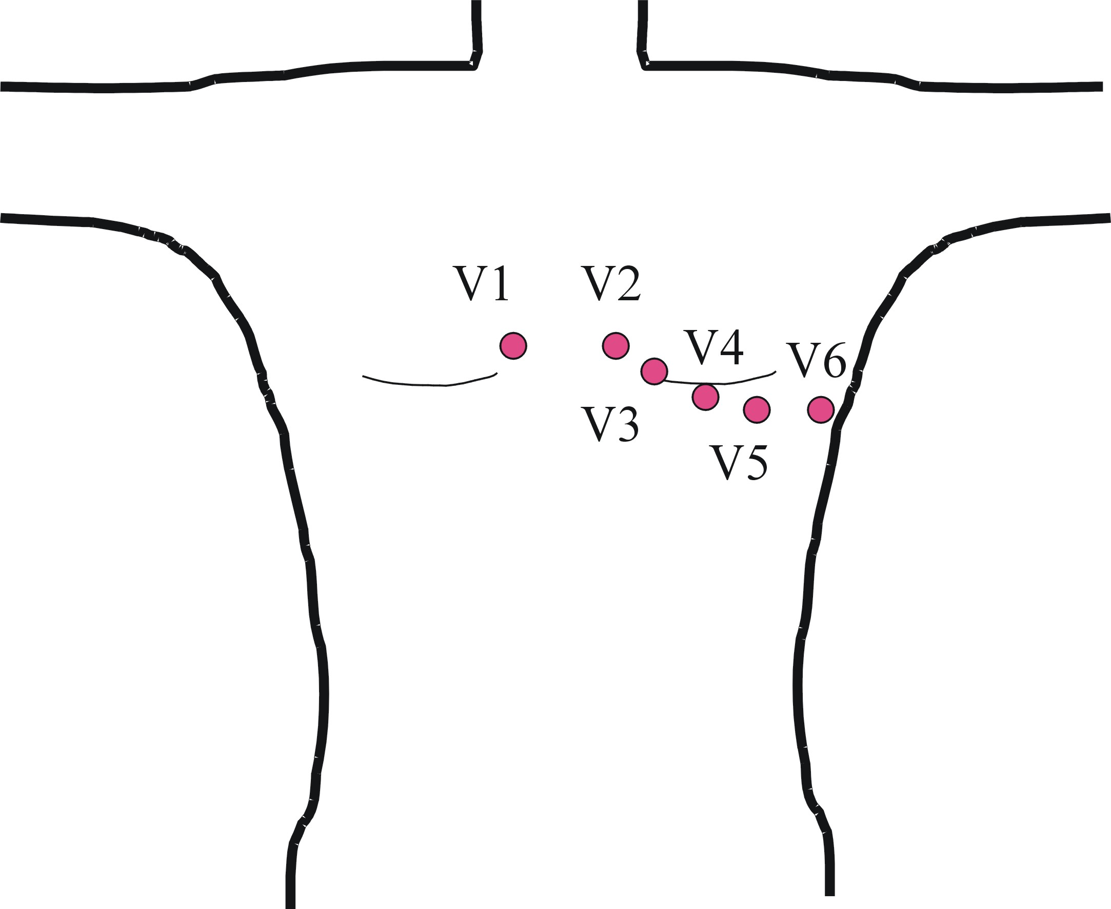
Ref
Bias

Note: the position of the reference will influence the form of the ECG signals, and might dependent on the particular application requiring ECG monitoring. The scheme gives one possibility.

