INTEGRATED ROADMAP

Integrated Coach Roadmap: August 2026 to 2029
  - Coach 3.0 through the AI-native Private Bank
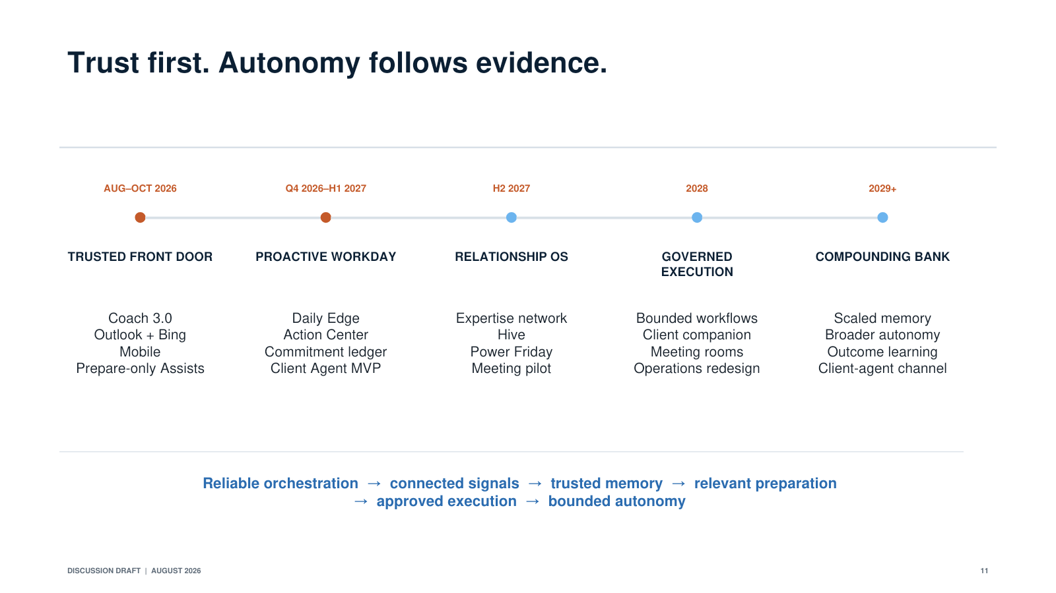
Roadmap from Coach 3.0 through the AI-native Private Bank
The roadmap should tell one clear progression.
Coach 2.0 established multi-agent orchestration. Coach 3.0 should make that orchestration reliable, connected and usable across the daily workflow. From there, Coach can become proactive, develop persistent client memory, connect the firm's expertise, support differentiated meetings, coordinate governed execution and ultimately extend a permissioned experience directly to clients.
The progression is:
Answer to orchestrate to anticipate to remember to act to learn.
Dates beyond the current commitments are directional. Every new stage should clear measurable quality, control, adoption and economic gates before it scales.

PHASE 1: COACH 3.0 AS THE TRUSTED ORCHESTRATOR

August through October 2026

Objective
Make Coach reliable enough to become part of the daily operating rhythm and establish the control and measurement foundations for proactive and agentic work.

Committed milestones

August 2026
• Complete stabilization, bug reduction and routing improvements
• Upgrade the CRM and portfolio search agents
• Roll out progressively to reach 100 percent advisor enablement by August 31
• Establish production golden tasks for the highest-volume and highest-risk workflows
• Instrument end-to-end reliability, latency, task completion, citations, corrections and cost

September 2026
• Official Coach 3.0 launch on Tuesday, September 1
• Operate a launch war room focused on reliability, routing accuracy, adoption and rapid correction
• Bring Outlook and Bing capabilities into controlled production in mid-September
• Use Outlook initially for retrieval, context and preparation, not autonomous sending
• Complete mobile hardening and broad mobile rollout by September 30

October 2026
• Launch the first prepare-only Assists through the Action Center on October 15 for a controlled cohort
• Require human review before any communication or operational action
• Introduce structured action records with purpose, evidence, proposed action, owner and approval status
• Establish the initial agent registry and named owner for every production skill and Assist

Initial lighthouse workflows
• High-quality Q&A across approved Private Bank content
• CRM and portfolio analysis
• One-click meeting preparation
• Outlook request to prepared draft or work packet
• Action Center review and approval experience

Exit gates
• Stable performance on the production golden-task suite
• Reliability and latency appropriate to the workflow
• Complete source and action traces for controlled domains
• No critical entitlement, confidentiality or unauthorized-action incidents
• Sustained repeat use, not only launch-week activity
• A majority of prepared outputs accepted or usefully edited in pilot workflows
• Support and cost per successful task within agreed limits
Reaching 100 percent enablement is a distribution milestone, not an adoption outcome.

PHASE 2: THE PROACTIVE WORKDAY

Fourth quarter 2026 through first quarter 2027

Objective
Move Coach from a place employees visit when they have a question to an always-available work partner that identifies what matters and prepares the next action.

Capabilities
• AI Discover evolves into the Daily Edge, showing the small number of relationships and actions that matter now
• Autopilot uses permitted calendar, Outlook, client, portfolio, market and commitment signals
• An event layer standardizes the triggers that wake agents
• A commitment ledger captures promises, follow-ups, approvals and unresolved questions
• An attention engine ranks urgency and protects users from alert overload
• The Action Center becomes the shared place to review, approve, edit, dismiss and monitor prepared work
• Guided Mode and Command Mode become fluid task experiences on the same platform

Priority lighthouses
1. The Daily Edge
Three or fewer high-value priorities with an explanation of what changed, why it matters and what work has already been prepared.
2. Before and after the meeting
Coach prepares the team, identifies assumptions requiring validation, drafts the follow-up and records confirmed commitments.
3. Inbox to prepared action
Coach recognizes a client request, gathers context and prepares the response or work item. The employee reviews before anything is sent or executed.
4. Power Friday pilot
A small voluntary cohort receives one personalized development experience based on permitted work signals. Detailed coaching remains private and separate from performance evaluation.

Foundations built in parallel
• Common event, opportunity, commitment and action objects
• Feedback from accept, edit, dismiss, override and completion behavior
• Agent passports, lifecycle reviews and pause controls
• Client memory schema with source, date, confidence, permission and expiration
• Specialist publishing workflow design

Exit gates
• Proactive signals produce repeated action and are rated relevant by users
• Irrelevant-alert rates remain below the agreed threshold as volume grows
• Preparation and follow-up time improve materially versus baseline
• Commitment completion improves without increasing administrative burden
• Guided and Command Mode each succeed for the tasks where users select them
• No use of mode selection as an employee ranking or maturity measure

PHASE 3: CLIENT AGENT AND THE EXPERTISE NETWORK

First half of 2027

Objective
Create persistent, permissioned relationship intelligence and a low-friction way for the firm's best ideas to reach the right relationships.

Client Agent minimum viable product
• Pilot with selected households, advisors and markets
• Begin with a limited set of authoritative sources and high-value memories
• Distinguish confirmed facts, system data, advisor judgment, signals and AI inferences
• Require advisor validation before material inferences become confirmed memory
• Apply source, timestamp, permission and expiration to every memory item
• Generate a small number of targeted validation questions
• Coordinate opportunities and commitments across the relationship team
• Operate through events and scheduled refreshes rather than continuously running models

Expertise network pilot
• Start with one specialist group or asset class
• Allow specialists to contribute through voice, rough notes or source material
• Use the Expertise Compiler to structure the thesis, evidence, risks, target circumstances, exclusions and expiration
• Require specialist review and attribution
• Match the approved idea to relevant relationships
• Prepare client-specific analysis for advisor review
• Return adoption, questions and outcomes to the specialist

Power Friday and Simulation Academy
• Expand the Personal Capability Agent pilot if employee trust is strong
• Launch a narrow set of simulated client scenarios for new analysts
• Combine simulation with continued support of real bankers and real client relationships

Exit gates
• Material client facts meet the required accuracy standard in audited samples
• Every retained memory has provenance, validation status and permission scope
• Advisor validation is useful and low burden
• No unauthorized cross-client or cross-household exposure
• Specialist matches are rated relevant by relationship teams
• Ideas that are not suitable or no longer current are filtered or expired correctly
• Power Friday produces demonstrated skill transfer without evidence of surveillance concerns

PHASE 4: THE INTELLIGENT MEETING AND GOVERNED EXECUTION

Second half of 2027

Objective
Turn relationship intelligence into a differentiated client decision experience and prove that Coach can move selected work safely from intent toward completion.

Intelligent meeting experience

Version 1: Prepare and remember
The Client Agent prepares the relationship team and captures proposed decisions, commitments and open questions after the meeting.

Version 2: Banker-side live support
Coach privately surfaces approved context, sources, questions and analysis during selected meetings.

Version 3: Client-visible decision workspace
Selected offices pilot approved scenario modules for portfolio, planning, lending or liquidity conversations. Sources, assumptions and limitations remain visible. The banker leads the experience.

Governed execution
• Select two or three low-risk, high-volume workflows
• Begin with document collection, status inquiry, case creation, information prefill or similarly reversible work
• Move from prepare-only to execute-with-approval only after workflow-specific gates are met
• Use deterministic systems for the controlled action
• Provide operations teams with an exception cockpit containing context, evidence, root cause and proposed resolution
• Test pause, retry, duplicate prevention, rollback and human fallback

Leadership operating view
• Provide aggregated views of emerging client needs, commitments, capacity and bottlenecks
• Support resource allocation and coaching without exposing hidden individual development scores

Exit gates
• Client-visible calculations agree with approved tools and display all material assumptions
• Meeting participants understand when AI is active and what will be retained
• Commitment and follow-up capture are accurate and clearly distinguish decisions from discussion
• Every executed action has complete authorization and audit records
• No unauthorized or duplicate execution
• Exception and rework rates improve rather than shift work downstream
• Operations owners can support the workflow at scale

PHASE 5: THE RELATIONSHIP OPERATING SYSTEM
2028

Objective
Scale Client Agents, expertise and execution into one coordinated relationship experience across employees, prospects, clients and the broader firm.

Capabilities
• Expand Client Agent coverage based on proven data and permission domains
• Maintain one relationship plan, one commitment state and coordinated human and digital ownership
• Add carefully permissioned household and relationship graphs for spouses, children, trustees and external advisors
• Extend the Expertise Network across investment, lending, wealth planning and other specialist domains
• Expand intelligent meeting environments to additional markets and approved scenarios
• Introduce the Prospect Agent and preserve context as it becomes the Client Agent during onboarding
• Expand governed execution to additional low- and medium-risk workflows where controls and economics are proven
• Scale Power Friday and the Simulation Academy based on demonstrated capability improvement
• Introduce an outcome engine that connects signals, recommendations, actions and results
• Pilot whole-firm intelligence routing so employees can access the right expertise without navigating organizational boundaries

Permissioned client companion pilot
• Begin with narrow, high-trust experiences such as secure explanations, meeting follow-up, document exchange, status and scenario continuation
• Make the human relationship team easy to reach
• Carry context across self-service and human conversations without requiring the client to repeat themselves
• Establish explicit consent, recordkeeping, escalation and support models before expansion

Exit gates
• Client Agents improve preparation, relevance and commitment completion across diverse cohorts
• Household permissions remain accurate as relationships become more complex
• Governed execution maintains or improves control performance as volume scales
• Client-companion users understand the experience, trust the handoff and receive timely human support
• The outcome engine distinguishes useful activity from activity that merely creates engagement
• Platform reuse and cost per successful task remain within target

PHASE 6: THE AI-NATIVE PRIVATE BANK AT SCALE
2029

Objective
Create a Private Bank that remembers, anticipates, coordinates, learns and acts as one, while preserving human judgment and clearly defined human-only decisions.

End-state capabilities
• A permissioned Client Agent supports each appropriate relationship
• Coach provides one simple command and guided surface for employees
• Autopilot continuously identifies and prepares the few actions that matter
• Specialists publish executable expertise into an intelligent matching network
• Clients can move among self-service, virtual meetings and in-person decision environments without losing context
• Selected workflows execute autonomously within explicit, observable boundaries
• Operations professionals supervise intelligent execution and resolve true exceptions
• Power Friday helps every colleague improve from the work they performed that week
• The Simulation Academy accelerates apprenticeship and tests new skills, agents and policies safely
• Leaders manage through a living view of client needs, capacity, commitments and outcomes
• The outcome engine continuously improves memory, matching, skills, execution and coaching
The 2029 end state is not universal autonomy. Money movement, final advice, credit judgment and other high-impact activities may remain human-led or approval-based. The objective is not to remove people from private banking. It is to remove the work that prevents them from practicing private banking at its best.

CROSS-ROADMAP DISCIPLINES
1. Gates before scale
Every phase must clear quality, control, adoption and economic gates. Calendar dates create focus, but they do not override evidence.
2. Vertical slices before broad platforms
Build thin, complete experiences tied to client and employee outcomes. Do not spend years building a universal knowledge graph, agent marketplace or data platform before proving the lighthouse workflows.
3. No more than a few lighthouses per wave
Focus creates reliability, behavior change and measurable outcomes. A wide portfolio of demonstrations will not create an operating system.
4. One platform, federated domain ownership
Coach owns common orchestration, memory, action, evaluation and control services. Domain teams own the expertise, authoritative data and outcomes for their workflows.
5. Prepare before execute
New workflows begin in recommendation or prepare-only mode. Execution is earned per action after stable performance and tested controls.
6. Employee and client trust as a product requirement
People can inspect evidence, correct assumptions, understand permissions and know when AI is active. Developmental experiences remain distinct from supervision.
7. Outcomes before activity
The roadmap is succeeding when client needs are addressed earlier, commitments are completed, time to execution falls, employees improve and controls strengthen. Prompts, logins, generated content and number of agents are supporting measures only.
The destination can be summarized in one line:
Every client feels that the full intelligence of J.P. Morgan is continuously working for them, and every employee has a trusted digital team helping them understand, anticipate and act.

