TRUST AND AUTONOMY

Trust, Governance and Autonomy Framework
  - The controls that allow capability to expand safely
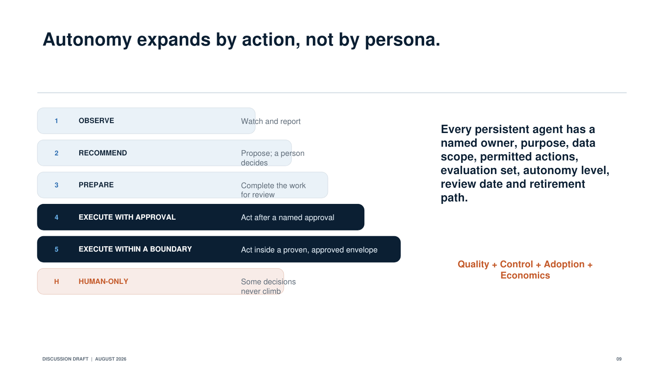
Action-level autonomy ladder
The ambition is to make Coach the trusted intelligence and execution layer for the Private Bank. That requires a governance model that expands capability without weakening human accountability, client confidentiality or the controls that protect the firm.
The governing idea is simple:
The better we encode our controls, the more autonomy we can safely provide.
This is not governance added after an agent has been built. Trust must be part of the product architecture, the data model, the user experience and the operating model from the beginning.

1. Core principles
1. Human accountability remains clear.
Every persistent agent, skill and automated workflow has a named human owner. AI can assemble evidence, recommend, prepare and, in defined cases, act. It does not remove accountability for the client relationship, the advice given or the control environment.
2. Autonomy belongs to the action, not the person or the model.
An autonomy level is assigned to a specific skill and action based on risk, reversibility, financial impact, confidence requirements, client permissions and the strength of the underlying system controls. A senior employee does not receive more autonomous execution simply because of seniority, and a more capable model does not automatically receive broader authority.
3. Guided Mode and Command Mode are task modes, not employee categories.
Command Mode gives a user more direct control over the analysis or workflow. Guided Mode provides more structure, recommendations and preparation. The same person may use Command Mode for one task and Guided Mode for another. Neither mode changes the person's entitlements, the agent's permitted actions or the controls governing the task. There is no expectation that people should "graduate" from Guided Mode to Command Mode.
4. Intelligence and execution remain separate rails.
Coach interprets intent, assembles context, reasons, recommends and orchestrates. Deterministic systems continue to execute identity verification, account changes, money movement, books and records, suitability controls and other actions that require certainty. Coach can initiate those systems only through approved tools with explicit preconditions and audit records.
5. Minimum necessary access and memory.
An agent receives only the data and tools required for its approved purpose. Entitlements are resolved at retrieval time and again at action time. Information should not become permanently retained merely because a model observed it.
6. Evidence before confidence.
Material conclusions should show their sources, dates, assumptions and limitations. Model confidence alone is never a substitute for evidence, policy checks or human judgment.
7. Reversible before irreversible.
The first autonomous workflows should be low risk, bounded, observable and reversible. The system must be able to pause, escalate, retry safely and, where practical, roll back.
8. No silent escalation.
An agent cannot expand its own purpose, data access, action scope or autonomy level. Changes require evaluation, approval, versioning and communication to affected users.

2. The autonomy ladder

Human-only
The activity remains under direct human control. AI may provide research or administrative support, but it cannot recommend a final decision or initiate the controlled action where policy requires exclusive human judgment.

Level 0: Observe
The agent senses events, retrieves approved information and identifies possible issues. It does not make a recommendation or create an actionable record without human initiation.

Level 1: Recommend
The agent explains what may matter, why it matters and what options the user could consider. The human decides whether any work should begin.

Level 2: Prepare
The agent assembles analysis, drafts communications, pre-fills information or creates a proposed action in the Action Center. Nothing is sent or executed until an authorized human reviews and approves it.

Level 3: Execute with approval
After explicit approval, the agent invokes approved tools and deterministic workflows. Preconditions, permissions and policy checks are evaluated immediately before execution.

Level 4: Execute within an approved boundary
The agent may act without transaction-by-transaction approval only within a narrow, pre-approved scope. The action must be low consequence or readily reversible, performance must be stable, monitoring must be continuous and the owner must be able to pause the agent immediately.
Moving up this ladder is a product and control decision supported by evidence. It is not a default consequence of time in production.

3. The agent passport
Every persistent agent and production skill should have an agent passport containing:
• Named product owner and business/control owner
• Purpose and intended users
• Approved inputs and authoritative sources
• Data classifications and entitlements
• Permitted tools and actions
• Trigger conditions and operating frequency
• Autonomy level by action
• Required human approvals
• Expected outputs and records created
• Evaluation suite and minimum performance standards
• Known limitations and prohibited uses
• Monitoring and service-level expectations
• Escalation, pause, rollback and incident procedures
• Model and prompt versions
• Retention requirements
• Review, recertification and expiration dates
The agent passport gives employees, owners and control partners a common understanding of what the agent is designed to do and what it is not allowed to do.

4. Client Agent and relationship memory governance
The Client Agent is strategically central and also one of the most sensitive capabilities in the vision. Its memory should follow a disciplined lifecycle:
Signal to proposed understanding to advisor validation to confirmed memory to revalidation or expiration.
Each memory item should be classified as one of the following:
• Confirmed client or advisor fact
• Authoritative system data
• Attributed professional judgment
• New signal requiring interpretation
• AI-generated inference requiring validation
Each item should carry its source, date, owner, confidence or validation status, permission scope and expiration or review rule. An inference must never silently become a fact.
The Client Agent should ask only a small number of high-value validation questions. It should not create a new administrative burden for advisors. Authorized users must be able to correct, qualify or remove information, and material corrections should propagate to dependent recommendations and actions.
Relationship memory must respect person-level and entity-level permissions. A household connection does not automatically grant every family member access to every fact. Information barriers and confidentiality restrictions apply across retrieval, inference, display and action.
The first Client Agent should be read-oriented and event-driven. It should support selected relationships and narrow use cases before becoming a universal, continuously active agent.

5. Proactive attention governance
Autopilot must decide not only whether something is relevant, but whether it is important enough to interrupt someone now.
Every proactive signal should explain:
• What changed
• Why the system believes it matters
• Which evidence supports the conclusion
• What action, if any, is proposed
• How the user can correct or dismiss it
Each user should have an attention budget. Low-value signals should be summarized or held rather than pushed individually. The platform should measure irrelevant alerts, ignored alerts, repeated dismissals and missed high-value events. Feedback should improve ranking without turning user behavior into a hidden performance score.

6. Specialist expertise and broadcasting governance
A specialist idea should remain attributable to its human author. Before publication, the Expertise Compiler should capture the thesis, evidence, risks, counterarguments, target circumstances, exclusions, suitability considerations and expiration conditions.
Client matching is a relevance signal, not a suitability decision. Initially, ideas should be delivered to the relationship team with the reason for the match and supporting evidence. They should not be sent directly to clients or converted automatically into trades or product recommendations.
Hive should use aggregation thresholds and confidentiality safeguards so that specialists can understand franchise-level needs without identifying or inferring individual client activity beyond their permissions.

7. Intelligent meeting governance
The in-person and virtual meeting experience should be introduced in stages.
First, AI prepares the team before the meeting and captures proposed decisions and commitments afterward. Next, it supports the banker privately during the conversation. Client-visible live analysis should use approved components, validated calculators and clearly displayed assumptions before more dynamic generation is introduced.
Clients should understand when AI is active, which information it is using and what will be retained. The banker or client should be able to pause the system, exclude a topic or correct the record. The system must distinguish between decisions, commitments, exploratory ideas and unresolved questions.
The banker remains the leader of the meeting. AI supports the relationship. It does not become an uninvited participant or present unreviewed analysis as final advice.

8. Power Friday trust covenant
Power Friday and the Personal Capability Agent must be designed as development experiences, not covert employee surveillance.
Employees should be able to see the evidence behind a recommendation, correct the system's interpretation and choose the capability they want to develop. Detailed coaching should remain private by default and separate from formal performance evaluation. Managers should see shared goals and aggregated capability themes, not hidden individual scores or rankings.
Formal supervision and compliance processes should remain clearly disclosed and separate. A developmental program will only work if employees trust that honest practice and experimentation will not be repurposed against them.
The system should evaluate performance against approved capabilities and client outcomes, not one preferred personality, accent or communication style. Call and meeting analysis should be tested across representative employee and client populations before it is used for development.

9. External content and tool security
Outlook, web search, uploaded files and external documents introduce untrusted content into the orchestration layer. That content must be treated as evidence to analyze, not as instructions the agent is automatically allowed to follow.
The platform should isolate untrusted content, detect prompt-injection patterns, restrict tool use through allowlists, prevent secrets or unrelated client data from being included in prompts, and require the same action-time permissions regardless of what an email or webpage asks the agent to do. Attachments and links should pass existing malware and content-security controls before an agent uses them.
No external instruction can change an agent's purpose, access, recipient, approval rule or autonomy level.

10. Required execution controls
Before any agent can execute, the workflow should include:
• Identity and entitlement checks at the moment of action
• Deterministic preconditions and policy validation
• Clear human approval where required
• Dual control for designated high-risk actions
• Idempotency so a retry cannot create duplicate actions
• Complete input, output and decision logging
• Safe failure and human fallback paths
• Pause and kill controls
• Rollback or compensating actions where practical
• Post-action confirmation and exception monitoring
• A record of the model, skill, data and policy versions used

11. Lifecycle gates

Gate A: Safe to experiment
The use case has a clear client or employee outcome, a named owner, an approved data scope, a defined risk classification and an offline evaluation set. Synthetic or de-identified data is used where possible.

Gate B: Safe to pilot in prepare-only mode
The agent meets its domain evaluation target, provides source and action traces, respects entitlements, supports human correction and has a tested escalation path. Pilot users understand its limitations.

Gate C: Safe to execute after approval
The target system is deterministic, action preconditions are explicit, authorization is checked at execution, audit records are complete, duplicate execution is prevented and rollback or remediation has been tested.

Gate D: Safe for bounded autonomy
The workflow is low consequence or reversible, production performance has remained stable for a sustained period, exception rates are within threshold, monitoring and incident response are operational and the business/control owner has recertified the scope.

Gate E: Safe to scale or expose directly to clients
Client permissions, disclosures, recordkeeping, explainability, human escalation, support capacity and unit economics have all been proven. The capability produces a measurable outcome, not merely engagement.

12. Ongoing oversight
Production governance should include a weekly health review for reliability, quality and incidents; a monthly use-case review for adoption, outcomes and control performance; and a quarterly autonomy and investment review. Material model, data, skill or policy changes should trigger regression testing and, when necessary, a return to a lower autonomy level.
Agents that no longer produce value, no longer meet their evaluations or no longer have an accountable owner should be paused or retired.
The objective is not maximum autonomy. It is maximum trusted capability.

