AI product compensation at J.P. Morgan Private Bank
The consolidated case: market evidence, proposed targets, cost and implementation
Research date 9 November 2026 | Annual USD | New York reference market | Public data only
About this version
This document consolidates two research passes run on 9 November 2026: the first memo and benchmark workbook, and a second pass that widened the employer set and tested JPMorgan's own pay bands.
Section 17 shows where the two differed and what was used. The companion workbook holds every data point and a costing model. The companion deck is the leadership summary.
Contents
1. The decision
2. Why these roles are priced in a different market
3. The Private Bank AI product owner mandate
4. What JPMorgan pays these roles today
5. Who can take them
6. The gap, level by level
7. Frontier AI labs
8. Big Tech
9. Wealth AI startups and fintech
10. Banks, wealth firms and asset managers
11. Measuring compensation consistently
12. The proposed compensation policy
13. How to get there in two steps
14. Economics
15. Management request and implementation
16. Likely objections
17. How the two research passes were reconciled
18. Method, caveats and sources
Appendix A. Posted roles ledger
Appendix B. Reported pay ledger
Appendix C. Other sources

1. The decision
We should establish differentiated compensation targets for AI product owners who combine independent product ownership, technical AI judgment and hands-on building. These roles compete with wealth technology firms, fintech companies, large technology employers and, for the strongest specialists, frontier AI labs. A banking-only comparator set understates that market.
The proposal is $300K–$450K in recurring annual compensation for VPs who independently own a production AI product, and $450K–$650K for EDs leading a substantial AI platform or portfolio. These are recommended recruiting and retention targets informed by public evidence. They are not existing JPMorgan bands, measured market percentiles or a conclusion about any individual's pay.
JPMorgan level and qualifying scope | Proposed base | Proposed annual total | Planning midpoint
Associate with growing independent ownership of AI features or a bounded product | $145K–$185K | $180K–$260K | $220K
VP independently owning a production AI product | $200K–$250K | $300K–$450K | $375K
ED leading a substantial AI platform, product portfolio or several product teams | $250K–$320K | $450K–$650K | $550K

Annual total means base salary plus the annual incentive award, counting its cash and deferred portions once, plus any genuinely additional recurring long-term award. It excludes one-time sign-on or retention awards.

Four findings carry the case
- The market for this skill is wider than banks. At matched levels, Google, Meta, Stripe and Robinhood pay 1.3 to 2.0 times JPMorgan's reported total. Bank and wealth peers pay 0.6 to 1.1 times. Thirteen of the seventeen other employers charted report higher product manager pay than JPMorgan. (Sections 5 and 6)
- Regulated peers already price AI product above general product. Goldman Sachs posts its Private Wealth AI product VP role at $160,000–$270,000. Schwab and Morgan Stanley post AI product roles that start above JPMorgan's VP ceiling of $215,000. (Section 10)
- JPMorgan already has the band. Applied AI/ML roles are posted 14% to 29% above product roles at the same level. Every proposed base range fits inside that existing band. (Section 4)
- The proposed ranges are measured, not maximal. For VPs and EDs they start near 75% of Google and Meta pay in New York and centre at about 94%. They do not match OpenAI or Anthropic. (Section 12)

What it costs
Against public pay data, moving a VP to the floor of the range costs about $89,000 a year and to the midpoint about $164,000. For an ED the figures are about $105,000 and $205,000. An illustrative team of 12 costs $0.92M a year at the floor and $1.73M at the midpoint. Actual cost depends on current pay, which the workbook is built to take. (Section 14)

What leadership is asked to approve
- A defined AI product specialist profile, with the evidence required to qualify.
- The target ranges above for people who meet it.
- Re-mapping those roles to the Applied AI/ML base band, with a stock component, as the first step.
- A person-by-person review against matched external roles, funded from the actual gaps.
- A review of results after the next compensation and recruiting cycle.

2. Why these roles are priced in a different market
The argument is strongest when it names the additional work these people do. A differentiated AI product role combines five capabilities.
Capability | What counts as evidence
Independent product leadership | Identifies a valuable problem, makes prioritization decisions, owns the roadmap and delivers adoption and business outcomes.
Technical AI judgment | Makes informed decisions about models, retrieval, agents, evaluation, reliability, cost and production limits.
Hands-on building | Produces working prototypes, evaluates outputs, uses APIs and data, and resolves meaningful technical questions without delegating every step.
Financial-services expertise | Understands advisor and client workflows, financial data, operational controls and the consequences of errors.
Production accountability | Owns the move from demonstration to a reliable product that people use repeatedly.

These requirements are visible in employers' hiring criteria. JPMorgan's own Service Assist AI Builder VP posting calls for hands-on agent building, prototyping, evaluation and technical skills including Python, SQL, Git and APIs. Its Private Bank Applied AI and Data Products VP posting seeks experience shipping LLM, retrieval and agent-based products. [BANK04] [BANK03]
The outside market recruits for the same combination. OpenAI's Product Manager, Financial Services role explicitly includes wealth management. It combines financial-domain knowledge with product building, evaluations and deployment into financial workflows. [FB01]

Evidence of a pay premium
- Pave reports a 25.6% base-salary premium for AI product manager titles, the highest of any function it studied, across 6,200 employees with AI in their title. It cautions that title inflation may contribute. [P01] [P02]
- PwC's 2026 Global AI Jobs Barometer puts the average wage premium for AI skills at 62%, up from 57% a year earlier. [C01]
- Evident's 2026 AI Index found that AI enablement roles grew 21% in a year across 50 banks, faster than any other AI job category. [C02]
None of these is a controlled estimate for New York financial-services product managers. They support differentiation. They do not support a blanket percentage increase.

The work carries revenue
JPMorgan has reported a 20% lift in private banking gross sales from its AI tools and expects bankers to cover up to 50% more clients, InvestmentNews reported in June 2026. The firm's 2026 technology budget is $19.8 billion. [C03] [C04]

The practical test
The test should be demonstrated responsibility. An employee who independently builds, evaluates and ships a financially consequential AI product warrants a different market assessment from someone whose involvement in AI is narrower. Neither tenure nor an AI label is sufficient on its own.

3. The Private Bank AI product owner mandate
This section records the team's remit as described by its leadership on 9 November 2026. It is context for assessing scope, not independent market research. The client-meeting figure is the team's own count.
Our AI product owners help determine what the Private Bank should build next. They identify opportunities, introduce new thinking, explore emerging capabilities and turn ideas into working products. Their mandate extends from creating the vision to bringing it into use, building support across the business and representing our AI capabilities to clients.
The team brings together former advisors with deep knowledge of clients and front-office workflows and specialists with advanced technical expertise. Its strength comes from connecting these perspectives: understanding which problems matter, what technology can solve and how to make a new capability useful. Individual roles combine these strengths in different proportions.

Create the vision and explore the frontier
These colleagues continuously explore new models, tools and ways of working. They originate product ideas, challenge assumptions, design experiments and build prototypes. They use what they learn to decide which opportunities deserve investment and then carry promising ideas through execution.
The value includes the judgment to choose what to pursue, adapt or stop, as well as the ability to deliver. Their contribution starts before a roadmap exists, when the opportunity is still uncertain and someone needs to imagine what could be possible.

Build adoption through direct advisor engagement
Product ownership includes spending time with advisors, observing workflows and traveling to meet users. They demonstrate and market their products, explain their value and help colleagues adopt new ways of working.
These conversations also shape the roadmap. Feedback from users informs experiments, product decisions and subsequent improvements. The role therefore requires both an understanding of the technology and the ability to earn confidence from the people expected to use it.

Represent our AI capabilities with clients
The team speaks at client events, meets clients one-to-one and travels across the United States and internationally to discuss AI and its implications. As a team, we have already held hundreds of client meetings in 2026.
This creates a significant client-facing responsibility alongside product development. These colleagues explain complex technology clearly, answer questions and bring client perspectives back into our thinking. Their work connects the products we build with how clients understand the Private Bank's capabilities and approach to innovation.

Create a culture of innovation
Through Shark Tank and other initiatives, these colleagues give people across the organization a way to propose ideas, experiment and participate in shaping the future of the business.
Their contribution includes organizing events, encouraging participation and making innovation visible and accessible. This work strengthens the environment in which new products and capabilities can emerge. It also requires influence across teams, enthusiasm that brings others into the process and the ability to turn interest into participation.

Recognize the full contribution in compensation
Compensation should reflect the responsibilities an individual carries across product creation, technical or advisor expertise, execution, adoption, client engagement and cultural leadership.
Technical specialists warrant relevant AI product and engineering comparisons. Former advisors who originate products and lead adoption warrant product comparisons that recognize financial-domain expertise, client credibility and commercial responsibility. Both profiles can make substantial contributions to innovation.
Demonstrated breadth and impact should inform placement within the proposed ranges and individually justified exceptions. The assessment should recognize each person's contribution without assuming every employee performs every part of the team's mandate.
A compensation review focused primarily on delivery responsibilities would miss a material part of this work. We are also asking these people to identify the next opportunity, shape the vision, build confidence in it and help the organization move forward.
The workbook's Private Bank scope tab lists, for each of these dimensions, the individual evidence to collect and how it should bear on pay.

4. What JPMorgan pays these roles today
JPMorgan posts AI product roles on the same base band as general product roles. In New York that band tops out at $155,000 for a Senior Associate, $215,000 for a VP and $285,000 for an ED.
Level | Posted base band, New York | Reported total pay | Reported mix
Associate and Senior Associate (601–602) | $99,750–$155,000 | $116K–$136K | $110K–$128K base, $2.5K–$8.6K bonus
Vice President (603) | $133,000–$215,000 | About $211K | $180K base, $30K bonus, no stock
Executive Director (604) | $180,500–$285,000 | $345K in New York; $323K across the US | $244K base, $93K bonus, $8.5K stock

Posted bands are from JPMorgan postings dated September to November 2026. [BANK01–BANK06] Total pay is self-reported to Levels.fyi and covers all product managers, not AI roles alone. [LV01]
- The AI premium in product is zero. The Service Assist AI Builder VP role, which asks for agent building and Python, carries the same $133,000–$215,000 envelope as a general Private Bank digital product VP role. [BANK04] [BANK06]
- The same was true in the prior pay cycle. AI Product Manager, Infrastructure, VP and a general Product Manager, VP were both posted at $122,550–$201,000. [BANK22] [BANK23]
- Pay is almost all cash. Reported stock is zero at VP and about $8,500 a year at ED.

The firm already pays an AI premium, just not to product
Applied AI/ML roles are posted on a higher base band at every level. The premium runs from 14% to 29%.
Level | Product band | Applied AI/ML band | Premium at floor | Premium at ceiling | Proposed base | Fits the AI/ML band?
Senior Associate | $99,750–$155,000 | $128,250–$195,000 | +29% | +26% | $145K–$185K | Yes
Vice President | $133,000–$215,000 | $164,350–$260,000 | +24% | +21% | $200K–$250K | Yes
Executive Director | $180,500–$285,000 | $223,250–$325,000 | +24% | +14% | $250K–$320K | Yes

That band already reaches beyond model builders. AI Research Product Management, VP is posted at $156,750–$260,000. Executive Director, AI Transformation Lead in Asset & Wealth Management is posted at $223,250–$325,000. The Private Bank's own agentic AI engineers at Senior Associate are posted at $128,250–$195,000. [BANK26–BANK31]
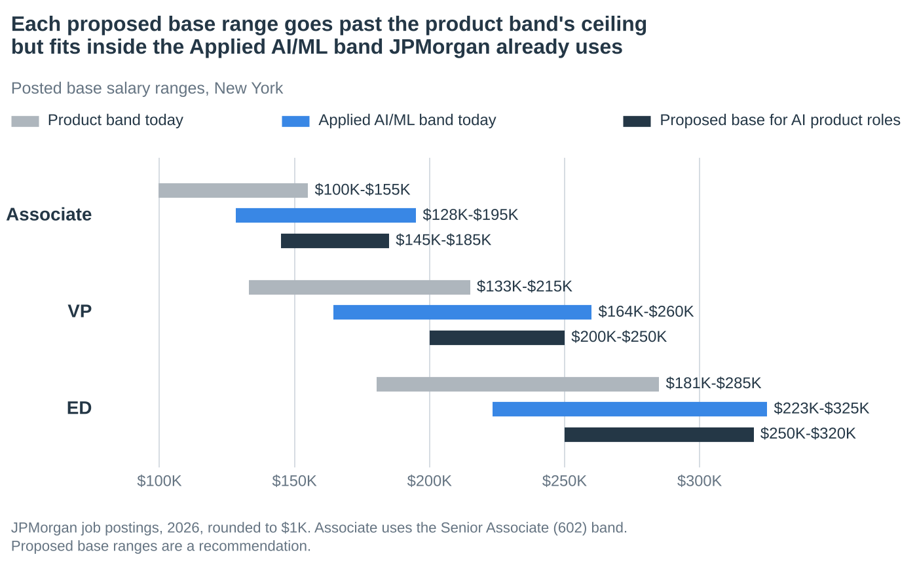
The proposed base ranges exceed the product ceiling by $30,000 to $35,000. All three fit inside the Applied AI/ML band. The request is therefore to re-map a role family to a band the firm already uses, not to create a new one.

5. Who can take them
Thirteen of the seventeen other employers charted report higher product manager pay than JPMorgan, and at least seven pay double. The closest fits are the AI labs' new finance teams, New York's finance AI startups and the AI product teams at Goldman Sachs and BlackRock.
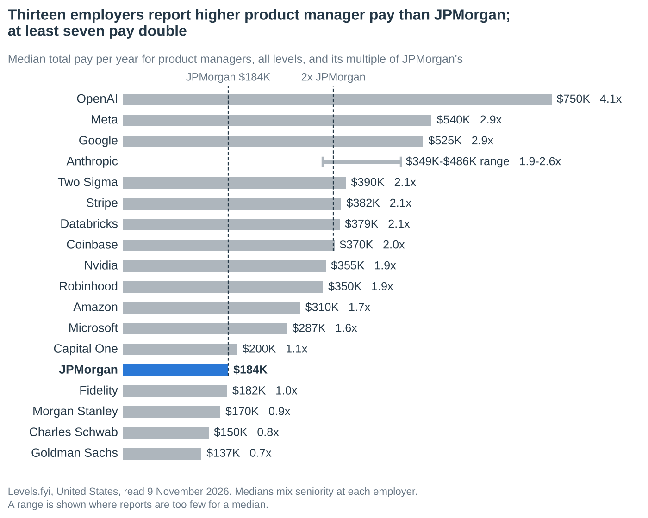
Medians mix seniority, so this chart shows where the market sits. Section 6 gives the like-for-like comparison.
Group | Who | Pay signal | Why a Private Bank AI product owner fits
AI labs | OpenAI, Anthropic | Product base $266K–$530K; reported totals $349K–$750K | Both launched finance products in September 2026, both hire in New York, and both now give employees ways to sell stock.
Big Tech | Google, Meta, Amazon, Microsoft, Nvidia | Median total $287K–$540K; Google posts $192K–$278K base plus 20% bonus for senior agent PMs in New York | The largest pool of product seats. AI product skill transfers directly, and several agent roles are New York based.
Finance AI startups | Rogo, Hebbia, AlphaSense | Base $169K–$320K plus equity | New York based and building AI for bankers and investors. Rogo calls finance experience a strong plus.
Wealth AI and fintech | Savvy Wealth, Altruist, FINNY, Jump, Robinhood, Stripe, Ramp, Wealthfront | Base $170K–$325K plus equity | They build the advisor and client AI the Private Bank builds in-house. Former advisors with product skill are a direct fit.
Asset managers and banks with AI bands | Goldman Sachs, BlackRock, Morgan Stanley, Schwab | VP–level base topping out at $215K–$280K, plus bonus | Same regulated setting and the same titles, with AI product priced above general product.
Bank and wealth peers, general product | Morgan Stanley, Fidelity, Schwab, Bank of America | Median total 0.8 to 1.0 times JPMorgan's; base ranges overlap | Pay is not the draw. These are the comparators that make the current band look fair.

6. The gap, level by level
At the matching level, technology employers pay 1.3 to 2.0 times JPMorgan's reported total. Bank and wealth peers pay 0.6 to 1.1 times, which is why the product band looks fair when it is measured against banks alone.
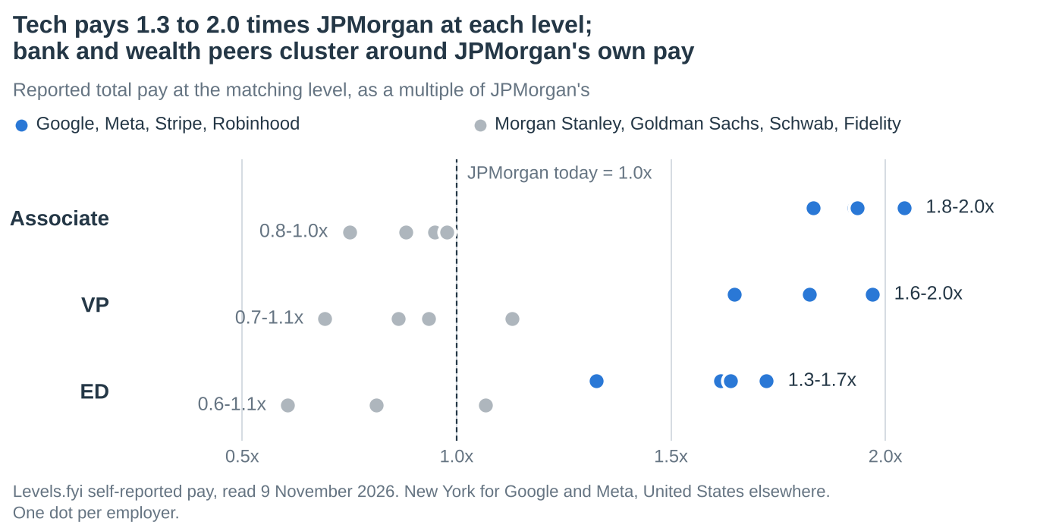
JPMorgan level | JPMorgan today | Google, New York | Meta, New York | Stripe | Robinhood | Gap to Google and Meta average
Associate (Senior Associate 602) | $136K | L4 $278K | L4 $249K | L2 $263K | L4 $262K | $128K
VP | $211K | L5 $383K | L5 $415K | L3 $384K | L5 $347K | $188K
ED | $345K | L6 $594K | L6 $565K | L4 $557K | L6 $457K | $235K

JPMorgan level | JPMorgan today | Morgan Stanley | Goldman Sachs | Charles Schwab | Fidelity
Associate (Senior Associate 602) | $136K | $129K | $133K | PM I $120K | L3 $102K
VP | $211K | $182K | $238K | PM III $146K | L7 $197K
ED | $345K | $368K | Not reported | Lead PM $209K | L8 $280K

Total pay per year, self-reported to Levels.fyi. New York for Google, Meta and JPMorgan's Senior Associate and ED figures; United States elsewhere. [LV01–LV09] [TC04]

Equity drives the difference
A Meta L5 reports about $162K to $170K a year in stock and a Google L5 in New York about $128K. A JPMorgan VP reports none. Base alone still differs: Meta's L5 base averages $222K against about $180K for a JPMorgan VP. [TC02] [LV02] [LV03]

A second view: United States averages
The first research pass recorded US averages, which for Google include first-year stock and sign-on. They run 1% to 11% above the New York medians and tell the same story.
Level | Meta base | Meta stock | Meta bonus | Meta total | Meta 10th–90th percentile | Google total, first-year basis
L4 | $187K | $55K | $21K | $263K | $213K–$305K | $310K
L5 | $222K | $170K | $27K | $419K | $338K–$515K | $413K
L6 | $259K | $273K | $49K | $581K | $350K–$678K | $610K
L7 | $294K | $653K | $85K | $1.03M | $665K–$1.73M | $849K

Google's components are labeled first-year stock and bonus plus sign-on, so they are outside-offer references and not clean recurring pay. [TC01–TC06]

The harsher match
Drop every JPMorgan level one rung to test the mapping. A VP against Google and Meta's L4 in New York is still 15% to 24% behind, and an ED against L5 is 10% to 17% behind.

7. Frontier AI labs
OpenAI and Anthropic set the upper end for unusually capable AI product talent. Both now sell finance products, hire in New York and give employees ways to sell stock. They should inform specialist retention decisions and should not become the reference for every Associate, VP or ED.
Employer and role | Location | Posted base | Relevant scope
OpenAI Product Manager, Financial Services [FB01] | New York, San Francisco | $401K–$530K | Financial workflow products, including wealth management
OpenAI Product Manager, Core Models [FB04] | San Francisco | $347K–$490K | Model requirements, evaluation and the research-to-product interface
OpenAI Product Manager, API Infrastructure [FB03] | San Francisco | $325K–$347K | Privacy, access, billing and enterprise platform systems
OpenAI Product Manager, Technology Vertical [FB02] | San Francisco | $266K–$385K | Enterprise AI products for business users
Anthropic Product Manager, Claude [FB15] | San Francisco, New York, Seattle | $385K–$460K | Core Claude product; posted 9 October 2026
Anthropic Product Manager (Technical), Product Support Experience [FB07] | San Francisco, New York | $385K–$460K | Scaled LLM operational workflows; 7+ years
Anthropic Product Management, Research [FB05] | San Francisco, New York | $305K–$385K | Applied research to product; Python and SQL
Anthropic Product Manager, Enterprise Privacy [FB06] | San Francisco, New York | $305K–$385K | Controls for regulated customers
Anthropic Product Manager, New Markets and Monetization [FB08] | San Francisco | $305K–$385K | Vertical strategy; financial-services experience preferred
Anthropic Product Manager, Revenue Platform [FB16] | New York, San Francisco, Seattle | $305K–$385K | Revenue platform products

Base salary before equity. OpenAI lists equity and eligible performance bonuses in addition. Anthropic describes salary and equity packages. Grant sizes are not public, and no total is estimated from them. [A01]

OpenAI and Anthropic side by side
 | OpenAI | Anthropic
Finance product | ChatGPT for Financial Services, launched 10 September 2026 | Claude for Financial Advisors, announced 14 September 2026
Built with | Morgan Stanley and Evercore as design partners | Schwab as debut custodian; BlackRock, Addepar and Envestnet among partners
Finance footprint | More than 100 former bankers enlisted to train models, including JPMorgan alumni | 40% of its top 50 customers are financial institutions
Product base, posted | $401K–$530K for Product Manager, Financial Services; $266K–$490K on other product postings | $385K–$460K on two postings; $305K–$385K on four others
Reported total pay | Median $750K across levels | $349K–$486K on a thin sample
New York roles beyond product | Financial services sales manager $350K; AI deployment manager $300K | Growth account executive manager $360K–$435K
Employee liquidity | About $7B share buyback in August 2026 at an $852B valuation | Tender offer closed April 2026; S-1 filed 26 October 2026

Finance launches and equity events are from press reports, not company filings. Sales figures are listed pay and may include commission. [C06–C12] [LV10] [LV11] [ADJ01–ADJ04]
- OpenAI's financial services role is the Private Bank job. It builds AI products for finance professionals, wealth management included. Its base floor is 41% above the top of JPMorgan's ED band.
- Wealth is on both roadmaps. Anthropic's advisor product debuts with Schwab, which serves more than 16,000 advisory firms. OpenAI started with bankers and equity researchers and plans to expand beyond them. [C06] [C08]
- Lab equity can now be sold. OpenAI bought back about $7 billion of employee shares in August 2026. Anthropic ran a tender offer, though most staff kept their stock, and has filed to go public. [C10] [C11] [C12]
- Product is not the only door. OpenAI lists a financial services sales manager in New York at $350,000 and an AI deployment manager at $300,000. [ADJ01] [ADJ02]
- Use these roles selectively. A strong AI product manager does not automatically have a credible lab opportunity. For the subset who do, a bank product benchmark materially understates the cost of staying.

8. Big Tech
Google publishes both salary ranges and target bonus percentages, which makes its ladder a useful progression by responsibility.
Google role | Experience asked | Base salary | Target bonus | Base plus target bonus
Product Manager, AI-native Search [FB09] | 3 years | $138K–$197K | 15% | $159K–$227K
Product Manager, AI Developer Platform [FB10] | 5 years | $163K–$236K | 15% | $187K–$271K
Senior Product Manager, Agentic Applications [FB11] | 8 years | $192K–$278K | 20% | $230K–$334K
Group Product Manager, AI Business Transformation [FB12] | 10 years | $240K–$333K | 25% | $300K–$416K
Director, Product Management, Cloud AI and Science [FB13] | 15 years | $281K–$391K | 30% | $365K–$508K

Employer-posted ranges from recent indexed listings; not all are confirmed open. Base plus bonus is arithmetic from disclosed targets, before equity.
- The senior role includes New York and is internal-facing. It covers enterprise agent applications for HR and rewards workflows. That weakens the argument that an internal AI product should be benchmarked below external products.
- Meta posts $249,000–$323,000 in base for product leadership roles. Its reported L5 and L6 totals are in Section 6. [FB14]
- The wider field pays well above JPMorgan's median. Median total pay is $355K at Nvidia, $310K at Amazon and $287K at Microsoft, against $184K at JPMorgan. [C19]

9. Wealth AI startups and fintech
These employers recruit people who can turn financial workflows into working products. Their posted base ranges reach the high $200,000s and low $300,000s before equity.
Employer and role | Location | Posted base | Other pay
Altruist Principal Product Manager, Growth (Hazel AI) [F16] | San Francisco | $250K–$325K | Stock options
Ramp Product Manager, Growth [F08] | New York or San Francisco | $230K–$325K | Equity
Stripe Staff Product Manager, ML Foundations and GenAI [F10] | New York and other US | $214K–$322K | Possible equity and bonus
Hebbia Product Manager [F05] | New York, San Francisco | $180K–$320K | New-hire equity; range spans career levels
Rogo Product Manager, Agents [F04] | New York | $190K–$300K | Equity
Savvy Wealth Product Lead [F07] | New York | $206K–$292K | Equity
Altruist Staff Product Manager, Growth (Hazel AI) [F15] | San Francisco | $200K–$275K | Stock options
Wealthfront Director of Product Management, Growth [F12] | Several, including New York | $238K–$270K | Equity and discretionary bonus
Stripe Product Manager, Global Payouts [F09] | New York | $179K–$268K | Possible equity and bonus
Hebbia Product Manager, Agents [F13] | New York, San Francisco | $180K–$260K | New-hire equity
Robinhood Staff Product Manager, Cortex [F19] | New York, Menlo Park | $191K–$225K | Bonus and equity
Robinhood Staff Product Manager, Banking [F11] | New York, Menlo Park, Washington | $191K–$225K | Bonus and equity
Savvy Wealth Senior Product Manager [F14] | New York | $181K–$221K | Equity
Jump Staff Product Manager, New Product Area [F06] | Remote | $200K–$220K | Equity
AlphaSense Senior Product Manager, AI Workflows [F17] | New York or remote | $169K–$219K | Bonus and equity
FINNY Senior Product Manager [F03] | New York | $180K–$210K | Equity
Savvy Wealth Product Manager [F02] | New York | $170K–$200K | Equity
Addepar Senior Product Manager, AI Platform [F18] | Not captured | $122K–$190K | Bonus and equity
Addepar Product Manager, Early Career, AI Platform [F01] | New York | $83K–$130K | Bonus and equity

- A relevant market extends past $300,000 in base. Altruist, Ramp, Stripe, Hebbia and Rogo all post tops between $300,000 and $325,000. JPMorgan's ED band ends at $285,000.
- Rogo is the sharpest New York case. It hires product managers in New York, calls finance experience a strong plus and tops out at $300,000. It raised $160 million at a $2 billion valuation in April 2026, with J.P. Morgan among its investors. [C13]
- Robinhood is steering its AI assistant toward advice. The Cortex role asks for seven-plus years, three of them on AI products, and points the product toward financial planning and personalized advice.
- These firms have money to hire. Savvy raised $100 million at a $600 million valuation in September 2026 and Farther $150 million in May. Jump raised an $80 million Series B and Zocks $45 million. [C14] [C15]
- Equity needs separate treatment. Postings rarely disclose grant size, vesting, valuation or liquidity, so no annual dollar value is assigned here.
- Early-career roles are counter-evidence. Addepar's early-career AI platform role starts at $83,000. A developing Associate and an independent builder can both work on AI and have very different outside options.

10. Banks, wealth firms and asset managers
The bank evidence is mixed, and the case should say so. General product pay at peers overlaps JPMorgan's. The gap opens where peers have created AI-specific roles.
Employer and role | Location | Posted base | Against JPMorgan's product band
Charles Schwab Sr. AI Platform Product Manager, AI.x [BANK07] | San Francisco | $220K–$280K | VP: starts $5,000 above the ceiling
Goldman Sachs Private Wealth Management, AI Product Management, VP [BANK14] | New York | $160K–$270K | VP: Floor $27,000 higher; ceiling $55,000 higher
Morgan Stanley AI Product Lead, Global Capital Markets, VP [BANK19] | New York | $225K–$250K | VP: starts $10,000 above the ceiling
BlackRock Technical Product Manager, Aladdin AI, VP [BANK17] | New York | $162.5K–$215K | VP: Floor $29,500 higher; same ceiling
BlackRock AI Product Manager, Associate, Aladdin AI [BANK16] | New York | $132.5K–$162.5K | Senior Associate: Floor $32,750 higher; ceiling $7,500 higher
BlackRock Technical Product Manager, AI, Director [BANK18] | New York | $215K–$275K | ED: Floor $34,500 higher; ceiling $10,000 lower
Morgan Stanley Head of Product, AI Development Platform, ED [BANK11] | New York | $195K–$275K | ED: Floor $14,500 higher; ceiling $10,000 lower
Goldman Sachs Asset & Wealth Management, VP, Product Management [BANK15] | New York | $151K–$243K | VP: Floor $18,000 higher; ceiling $28,000 higher
Charles Schwab Senior Manager, Digital Product Management [BANK08] | Texas, Florida, Colorado | $145K–$185K | General product; lower-cost markets
Fidelity Director, Product Management [BANK09] | Boston and other sites | $110K–$222K | Overlaps the VP band
Bank of America AI Products and Transformation Manager [BANK12] | New York | $106K–$165K | Overlaps the Senior Associate band
Fidelity Senior Product Manager, Wallet [BANK10] | Rhode Island and others | $89K–$180K | Mostly below the VP band

- Goldman prices the same job higher. Its Private Wealth AI product role is the closest match to the Private Bank's. The band starts $27,000 above JPMorgan's VP band and ends $55,000 above it.
- BlackRock lifts the floor at every rung. Its three AI product roles start $29,500 to $34,500 above JPMorgan's bands.
- Two peers start above JPMorgan's VP ceiling. Schwab's AI.x role and Morgan Stanley's capital-markets AI lead both start above $215,000, before bonus.
- Not every competitor pays more. Fidelity, Bank of America and Schwab's general product roles overlap or sit below JPMorgan's bands. All of these postings add a bonus that is not published, so total pay cannot be rebuilt from them.

11. Measuring compensation consistently
Use one definition for every comparison. Recurring annual compensation is base salary, plus the annual incentive awarded for that performance year, plus any separately additional recurring long-term award.
- Count deferred compensation once. If part of an annual bonus is deferred into stock, it is still part of the same award. Do not add its later vesting value again.
- Separate recurring and one-time payments. Sign-on, buyouts and special retention awards belong in their own column.
- Separate award value and cash received. They answer different questions.
- Show equity separately. Public-company stock, private-company equity and bank cash are not interchangeable.
- Do not infer undisclosed bonuses. A posting that says a role is eligible for incentives does not establish a percentage.
For actual offers, record three columns: recurring annual cash, annual equity or deferred-award value, and one-time awards. Note whether equity is valued at grant, at current market value or at expected vesting value. A multi-year initial grant is not an annual figure. [M01]
Crowdsourced data is self-reported, covers product managers across specializations and can include sign-on payments. It is directional evidence, not an employer pay band.

12. The proposed compensation policy

Core targets by scope
Level | Scope required | Base | Annual total | Midpoint | Status
Analyst | Early-career delivery and evaluation under guidance | $110K–$140K | $125K–$175K | $150K | Indicative
Associate | Own defined AI features and increasingly independent delivery | $145K–$185K | $180K–$260K | $220K | Proposed
VP | Independently own AI product outcomes and technical trade-offs | $200K–$250K | $300K–$450K | $375K | Proposed
ED | Lead a substantial AI product, platform or product portfolio | $250K–$320K | $450K–$650K | $550K | Proposed
MD | Lead a substantial enterprise AI product organization | $325K–$425K | $700K–$1.1M | $900K | Indicative

Associates: $180K–$260K. The upper part of the range should require more than potential. It should reflect growing independent ownership, credible technical contribution and evidence that the person can take work through deployment and adoption. A narrower execution role can sit lower.
VPs: $300K–$450K. This is the most actionable part of the proposal. The band is for someone who can own a production AI product through discovery, prioritization, technical trade-offs, evaluation, launch and adoption. Use $375K as the planning midpoint and move within the range on responsibility, sustained delivery, technical depth and credible alternatives.
EDs: $450K–$650K. This applies to substantial leadership or platform scope: multiple products, a major shared platform, cross-business decisions or leadership of other product managers. A person with an ED title and narrower scope should not automatically receive the same target.
Analysts and MDs. These figures are indicative and less directly supported. MD roles need individual executive benchmarking, because leadership scope varies too much for a universal band.

Where the targets sit against the market
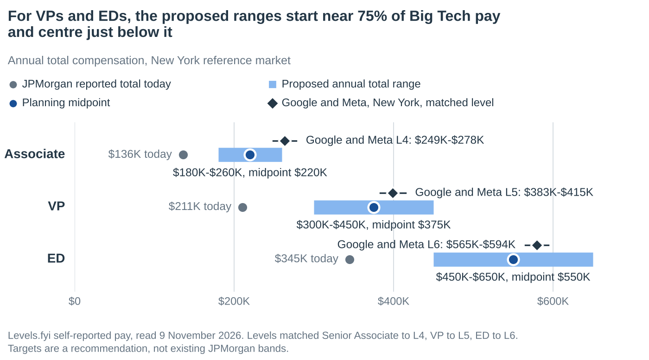
Level | JPMorgan today | Low | Midpoint | High | Google and Meta NY average | Low, midpoint and high as a share of that average
Associate | $136K | $180K | $220K | $260K | $264K | 68% / 83% / 99%
VP | $211K | $300K | $375K | $450K | $399K | 75% / 94% / 113%
ED | $345K | $450K | $550K | $650K | $580K | 78% / 95% / 112%

The midpoint is a planning choice, not a market median. It sits just under level-matched Big Tech pay and well under lab pay. The floor is where the second research pass independently landed: re-banding to Applied AI/ML and adding stock produces about $299K for a VP and $435K for an ED.

Compensation mix
Illustrative midpoint package | Base | Annual incentive, including deferral | Annual total
Associate | $165K | $55K | $220K
VP | $225K | $150K | $375K
ED | $285K | $265K | $550K

These illustrate package design. They are not JPMorgan bonus targets or guaranteed awards. The totals need a deliberate incentive allocation as well as a salary review, and management should decide the balance between fixed pay, variable pay and deferral.

Exceptional builders
An ED with unusually deep engineering capability, ownership of a critical platform and credible lab or top-fintech mobility may justify $650,000–$700,000 or a separately justified package. That example should not become a universal ceiling. Use a targeted market adjustment where the employee is already doing the job, and a promotion where scope has expanded to the next level. Avoid using a one-time payment to disguise a permanent gap.

Set increases from the actual gap
For each person, the proposed adjustment is the positive difference between a justified target and current recurring annual compensation. Someone already appropriately paid needs no automatic increase. Someone with a large gap and critical responsibilities may need far more than a standard merit percentage.

Mapping JPMorgan levels to outside roles
JPMorgan level | Relevant external scope | Evidence of readiness
Analyst | APM or rotational product manager | Scoped analysis, testing and delivery under supervision.
Associate | Product Manager I or experienced APM; some L4 roles | Owns a defined product surface, evaluates outputs and delivers with increasing independence.
VP | Independent or senior product manager; L5, and L6 for the broadest scopes | Owns discovery, roadmap, technical decisions, launch and adoption for an AI product.
ED | Senior, principal, staff or group product manager; L6, and L7 for platform leaders | Owns a substantial platform or several products, with cross-business decisions and measurable outcomes.
MD | Group product manager or director with substantial organizational scope | Leads a material product organization or enterprise mandate, with budget, talent and business outcomes.

This is an analytical mapping, not a validated conversion between employers. A bank VP should be compared by responsibilities, never to a technology company's corporate vice president. HR's own leveling should replace it.

13. How to get there in two steps
The ranges can be reached in two moves. The first uses machinery the firm already has.
Step | What changes | Who | Where it lands
1. Re-map and add stock | Move qualifying AI product roles onto the Applied AI/ML base band and add a recurring stock award. | Everyone who meets the specialist profile | The floor of each range
2. Targeted moves | Raise incentive awards for proven builders after the scope review. | People with documented independent ownership and credible outside options | Toward the midpoint; above it only by individual case

- Why start with the band. It exists, it is published and product-adjacent roles already sit on it. Nothing new has to be created.
- Why add stock. Stock is where technology employers win, and a multi-year award builds retention. The second pass illustrated $20,000, $30,000 and $50,000 a year for Senior Associates, VPs and EDs.
- Why phase. Step 1 addresses the structural gap for the role family. Step 2 keeps the largest awards tied to evidence about the individual.
The sequencing is a suggestion added in consolidation. The first research pass proposed the ranges without phasing.

14. Economics

Cost per person
Level | Reference pay today | To the floor | To the midpoint | To the top
Associate | $136K | $44K | $84K | $124K
VP | $211K | $89K | $164K | $239K
ED | $345K | $105K | $205K | $305K

Reference pay is public, self-reported data, not Private Bank payroll. Replace it in the workbook's Cost model and the figures update.

Budget for an illustrative team
Scenario | What it means | Annual pay uplift | Average per head
Floor | Everyone reaches the bottom of the range | $0.92M | $77K
Custom mix | Everyone reaches the floor; half go on to the midpoint | $1.33M | $111K
Midpoint | Everyone reaches the midpoint | $1.73M | $144K
Top | Everyone reaches the top of the range | $2.54M | $212K

The team is illustrative: 4 Associates, 6 VPs and 2 EDs. It is not the Private Bank's headcount.

The retention test
The first pass's worked example remains the reference. It is deliberately transparent, and none of its inputs is an estimate for this team.
Illustrative input | Amount | Meaning
Five employees with a $75K annual adjustment | $375K a year | Example budget only.
Recruiting and replacing one critical employee | $120K | Assumed incremental cash cost.
Handover and extra team workload | $80K | Assumed incremental cost.
Six months of net delivery impact at $100K a month | $600K | Assumed benefit lost after alternative staffing.
Total modeled cost of one departure | $800K | $120K + $80K + $600K.

One avoided departure exceeds that one-year budget. But the relevant benefit is the reduction in expected losses, not an assumption that a raise certainly prevents a departure. The $375,000 budget needs a 46.9-percentage-point cut in the probability of one departure to break even over a year.
Applied to the illustrative team of 12, the floor scenario needs about 1.2 avoided departures a year to break even on retention alone, and the midpoint about 2.2. That is demanding. The case therefore also rests on recruiting success, delivery speed and product outcomes.

Replacement arrives at market price
If a departing AI product manager is replaced from outside, the new hire is priced against the offers in this document. The seat then costs what the raise would have cost, and the departure cost comes on top. For a VP, the modeled first-year cost of losing the person is about $964K, against $164K to raise them to the midpoint. This is reasoning from the model's assumptions, not a measured result.
As an outside reference, Gallup puts replacement cost at one-half to two times salary, which is $105K to $421K for a VP. It also found that 52% of people who left said their manager or organization could have done something to keep them. The event model is preferred because it uses the team's own inputs. [C05]

Measured business outcomes
A second justification is the product value that stronger retention and recruiting protect. Suitable measures include delivered features, sustained advisor use, verified time saved, service quality, reduced rework and incremental net revenue.
For illustration, 1,000 users saving one additional hour a week across 46 weeks is 46,000 hours of gross capacity. At $100 an hour that is $4.6 million of capacity value. At 25% realization, the modeled value is $1.15 million before incremental operating costs. These are assumptions, not product results or cash savings.
- Count only what the intervention causes. Do not attribute a platform's full benefit to one product manager.
- Do not count the same benefit twice. A delayed release cannot appear in both the departure model and the capacity model.
- Match the horizon. A recurring raise is a recurring cost. Compare it with benefits over the same period.

15. Management request and implementation

The request
- Define an AI product specialist profile. Set out the technical responsibilities, independent ownership and demonstrated delivery required to qualify. Include a route for people whose work spans product management and meaningful engineering.
- Adopt the core target ranges for that profile. $180K–$260K for qualifying Associates, $300K–$450K for independent VPs and $450K–$650K for EDs with substantial platform or portfolio responsibility.
- Re-map qualifying roles to the Applied AI/ML base band and add stock. This is the first step and reaches the floor of each range.
- Review current employees against matched external roles and fund the gaps. Use wealth AI and fintech as central comparators. Add large technology employers where scope aligns, and frontier labs for the smaller group with credible matching capability. Show one-time awards separately.
- Review results after the next compensation and recruiting cycle. Refresh fast-moving external roles at least every six months.

A focused review process
- Document the products owned, technical responsibilities, independent decisions, engineering contribution, portfolio breadth and evidence of adoption. Separate demonstrated work from potential.
- Assemble base, annual incentive including its deferred portion, separately additional long-term awards and one-time payments. The workbook's Team review tab calculates each gap once these are entered.
- Match each person to relevant wealth and fintech roles, then to technology employers and labs where capability makes them credible. Keep location and evidence quality visible.
- Prioritize by pay gap, contribution and the consequence of losing the capability. Apply the rationale consistently across comparable people.
- Set percentile targets only after HR supplies matched survey data or recent offer evidence.

Internal data that would settle the size of the problem
- How many AI product owners does the Private Bank have at each level?
- How many left in the last 24 months, and where did they go?
- Which competing offers were matched, and which were lost?
- How long did the last AI product vacancy stay open, and at what pay was it filled?

What to track afterward
Offer acceptance, regretted departures, vacancies, delivery milestones and compression between incumbent and new-hire pay.

16. Likely objections
Objection | Response
Do we need to match OpenAI or Anthropic? | No. Their finance roles establish a real alternative for a small specialist group. The ranges are sized against Big Tech, fintech and regulated peers.
Do other banks all pay more? | No. General product ranges overlap. The change reflects the broader labor market and the AI product bands that Goldman Sachs, BlackRock, Schwab and Morgan Stanley already post.
We already match our peers. | True for general product pay. Four regulated peers post AI product roles whose ranges start above JPMorgan's for the level.
Levels.fyi is self-reported. | The labs' own postings need no survey: product base ranges of $266K–$530K. JPMorgan's VP band ends at $215K and its ED band at $285K.
The level match flatters the gap. | Drop every JPMorgan level one rung. A VP is still 15%–24% behind Google and Meta's L4, and an ED 10%–17% behind L5.
Tech stock can fall. | Ignore stock and bonus. Meta's L5 base averages $222K against about $180K for a JPMorgan VP.
Can equity be compared with bank cash? | Compare components and timing. Do not treat private equity or a first-year sign-on package as guaranteed recurring cash.
Why not a standard percentage increase? | The right adjustment depends on current pay and actual scope. A uniform uplift overpays some people and leaves the largest gaps open.
Not all of our people could land those jobs. | Then scope the ranges to roles that own AI products, and let the premium follow the evidence.
It breaks parity with other product managers. | The firm already separates AI pay. Applied AI/ML bands sit 14%–29% above product bands, and AI Research product managers are already on the higher band.
This needs a new pay band. | It does not. Every proposed base range fits inside the Applied AI/ML band.
The bank offers stability and brand. | That is why the midpoint sits below Big Tech and far below the labs.

17. How the two research passes were reconciled
The two passes were run independently on the same day. They agree on direction and on most figures. Where they differ, the consolidated files use the figure shown and say why.
Topic | First pass | Second pass | Used here | Why
JPMorgan VP product band, New York | $133,000–$215,000 (postings dated Sep-Nov 2026) | $122,550–$201,000 (earlier postings) | $133,000–$215,000 | Confirmed on several live 2026 postings on 9 Nov. The lower band is the prior cycle.
JPMorgan Senior Associate product band | $99,750–$155,000 | $99,750–$150,000 | $99,750–$155,000 | Current postings confirmed; the lower ceiling is the prior cycle.
JPMorgan ED product band | $180,500–$285,000 | $180,500–$285,000 | $180,500–$285,000 | Both passes agree.
JPMorgan VP reported total | $209,315 (US average) | $207,636 (same page, earlier reading) | $210,633 | Third reading on 9 Nov. The page moves; the highest figure is used so the gap is not overstated.
JPMorgan ED reported total | $344,800 (New York City Area average) | $323,300 (United States) | $344,800 | New York is the reference market, and the higher figure narrows the gap.
Google and Meta level pay | US averages; Google includes first-year stock and sign-on | New York medians | New York medians for gaps; US averages kept as a second view | Medians in the reference market are the cleaner recurring comparison. The two views differ by 1% to 11%.
Internal precedent | Not covered; notes that proposed bases exceed posted product maximums | Applied AI/ML bands sit above product bands at every level | Every proposed base range fits inside the existing Applied AI/ML band | This turns a request for a new band into a re-mapping to an existing one.
Recommendation | Target ranges by scope: VP $300K–$450K, ED $450K–$650K | Re-band to Applied AI/ML plus stock: VP about $299K, ED about $435K | First-pass ranges are the ask; the second-pass numbers are the floor and the mechanism | The second-pass targets land on the bottom of the first-pass ranges, so the two fit together.
Retention economics | Transparent event model: $800K per critical departure, break-even test | Gallup replacement cost of 0.5 to 2 times salary | Event model, with Gallup kept as an outside reference | The event model uses the team's own inputs and avoids a generic multiplier.
AI pay premium evidence | Pave: 25.6% base premium for AI product manager titles | PwC: 62% average wage premium for AI skills; Evident: AI enablement roles up 21% at banks | All three, each with its caveat | Different measures that point the same way.
Hebbia product pay | $180K–$320K (posting spans career levels) | $180K–$260K (Product Manager, Agents) | Both rows kept | Different postings.
Addepar | $83K–$130K (early-career AI platform PM) | $122K–$190K (Senior PM, AI platform) | Both rows kept | Different levels; both are counter-evidence to a universal premium.
Wider field | 39 posted roles and 15 reported-pay rows | 18-employer league table; Goldman and BlackRock AI bands; lab finance launches and liquidity | 71 posted-role rows, 43 reported-pay rows and an 18-employer league table | The first pass is deeper on role scope; the second is wider on who can hire this talent.

First-pass figures re-read on 9 November 2026
Figure | Result
JPMorgan VP product band $133,000–$215,000 | Confirmed on several live postings
Pave 25.6% AI product manager base premium | Confirmed; article dated 24 June 2026, 6,200 employees
Stripe Staff PM, ML Foundations and GenAI $214,300–$321,500 | Confirmed on the employer page
Morgan Stanley Head of Product, AI Development Platform, ED $195K–$275K | Confirmed on a mirror of the employer text
Meta L5 US average $418,866 | Confirmed ($418,865)
JPMorgan ED New York average $344,800 | Confirmed
Anthropic Product Manager (Technical), Product Support Experience $385K–$460K | Confirmed on the employer ATS page
Google Senior PM base $192K–$278K | Consistent with other 2026 Google senior PM postings; the specific page did not expose its range

Eight first-pass figures were re-read. The other first-pass rows keep the source status recorded in the workbook.

18. Method, caveats and sources
Everything here is public data gathered on 9 November 2026. No internal JPMorgan pay data was used. The evidence is a targeted comparison set, not a random sample of the US labor market.
- Posted ranges are what employers advertise, not what people are paid. Employer pages and employer-hosted applicant systems take priority; mirrors and indexed text are labeled in Appendix A. Several postings have since closed.
- Reported pay is self-reported to Levels.fyi and includes base, bonus and annualized stock. It covers all product managers at each employer, not AI roles alone. Samples are thin at Anthropic and Ramp.
- Level matching is an assumption: Senior Associate to L4, VP to L5, ED to L6. HR's own leveling should replace it.
- Location is New York for Google, Meta and JPMorgan's Senior Associate and ED figures, and United States elsewhere. The Schwab AI.x and Altruist roles are in San Francisco.
- The JPMorgan reference figures use the higher available reading at each level, which narrows the gaps.
- Lab finance launches and equity events come from press reports, not company filings. Private-company stock is not freely tradable.
- Less certain items are marked in Appendix A: rows read from search-result text and rows on third-party mirrors.
- Not covered: benefits, pensions, deferred cash schedules, job security and hours.
- Targets, the level mapping and the phasing are analytical judgments, not market measurements.
This consolidation was drafted with AI assistance from two providers, OpenAI and Anthropic. Both are also subjects of the analysis. Their figures come from public postings, Levels.fyi and press reports, and each is linked below so it can be checked.

Appendix A. Posted roles ledger
71 posted roles: 39 from the first pass and 32 added in consolidation. Ranges are base salary unless the workbook says otherwise. Rows marked ADJ, and FB17, are adjacent non-PM roles. Full scope, status and notes for each row are on the workbook's Published roles tab.
ID | Employer and role (linked) | Location | Posted range | Source class
FB01 | OpenAI, Product Manager, Financial Services | San Francisco; New York City | $401K–$530K | Employer page
FB02 | OpenAI, Product Manager, Technology Vertical | San Francisco | $266K–$385K | Employer page
FB03 | OpenAI, Product Manager, API Infrastructure | San Francisco | $325K–$347K | Employer page
FB04 | OpenAI, Product Manager, Core Models | San Francisco | $347K–$490K | Employer page
FB05 | Anthropic, Product Management, Research | San Francisco; New York City | $305K–$385K | Employer page
FB06 | Anthropic, Product Manager, Enterprise Privacy | San Francisco; New York City | $305K–$385K | Employer page
FB07 | Anthropic, Product Manager (Technical), Product Support Experience | San Francisco; New York City | $385K–$460K | Employer page
FB08 | Anthropic, Product Manager, New Markets and Monetization | San Francisco | $305K–$385K | Employer page
FB09 | Google, Product Manager, Search, AI-Native Product Development | Mountain View; New York | $138K–$197K | Indexed employer
FB10 | Google, Product Manager, AI Developer Platform, Google Search | Mountain View; Chicago; New York; Seattle | $163K–$236K | Indexed employer
FB11 | Google, Senior Product Manager, Agentic Applications | New York; San Jose | $192K–$278K | Indexed employer
FB12 | Google, Group Product Manager, AI-enabled Business Transformation | Sunnyvale | $240K–$333K | Indexed employer
FB13 | Google, Director, Product Management, Cloud AI and Science | Sunnyvale; New York; San Francisco | $281K–$391K | Indexed employer
FB14 | Meta, Product Manager (Leadership) | U.S. remote listing | $249K–$323K | Mirrored employer
F01 | Addepar, Product Manager - Early Career, AI Platform | New York, NY | $83K–$130K | Employer page
F02 | Savvy Wealth, Product Manager | NYC Office, hybrid | $170K–$200K | Indexed employer
F03 | FINNY, Senior Product Manager | New York City, on-site | $180K–$210K | Indexed employer
F04 | Rogo, Product Manager | Agents | New York City reference pay | $190K–$300K | Indexed employer
F05 | Hebbia, Product Manager | NYC and San Francisco shown on employer ca… | $180K–$320K | Indexed employer
F06 | Jump, Staff Product Manager, New Product Area | Remote | $200K–$220K | Indexed employer
F07 | Savvy Wealth, Product Lead | NYC Office, hybrid | $206K–$292K | Indexed employer
F08 | Ramp, Product Manager | Growth | New York or San Francisco, at least 2 in-o… | $230K–$325K | Indexed employer
F09 | Stripe, Product Manager, Global Payouts | New York | $178,600–$268K | Indexed employer
F10 | Stripe, Staff Product Manager, ML Foundations and GenAI | NYC / Seattle / South San Francisco / remo… | $214,300–$321.5K | Employer page
F11 | Robinhood, Staff Product Manager, Banking | New York / Menlo Park / Washington DC | $191K–$225K | Employer page
F12 | Wealthfront, Director of Product Management, Growth | Palo Alto / San Francisco / New York / Sea… | $238K–$270K | Indexed employer
BANK01 | JPMorgan Chase, AI Product Associate, Senior Associate | New York, NY | $99,750–$155K | Indexed employer
BANK02 | JPMorgan Chase, Private Bank, Digital Product Strategy - Associate | New York, NY | $99,750–$155K | Indexed employer
BANK03 | JPMorgan Chase, Product Manager, Applied AI and Data Products - Vice President | Jersey City, NJ | $133K–$215K | Indexed employer
BANK04 | JPMorgan Chase, Vice President, Product Manager - Asset Management Client Service Experience - Service Assist (AI Builder) | New York, NY | $133K–$215K | Indexed employer
BANK05 | JPMorgan Chase, Group AI Product Director | New York, NY | $180.5K–$285K | Indexed employer
BANK06 | JPMorgan Chase, Private Bank, Digital Product Manager - Distribution in Kind, Vice President | New York, NY | $133K–$215K | Indexed employer
BANK07 | Charles Schwab, Sr. AI Platform Product Manager, AI.x | San Francisco, CA, onsite | $220K–$280K | Employer page
BANK08 | Charles Schwab, Senior Manager, Digital Product Management | Westlake TX | $145K–$185K | Indexed employer
BANK09 | Fidelity Investments, Director, Product Management | Boston MA | $110K–$222K | Mirrored employer
BANK10 | Fidelity Investments, Senior Product Manager, Wallet | Smithfield RI among locations indicated by… | $89K–$180K | Indexed employer
BANK11 | Morgan Stanley, Head of Product - AI Development Platform - ED | New York, NY | $195K–$275K | Mirrored employer
BANK12 | Bank of America, AI Products and Transformation Manager | New York, NY | $105,700–$164,700 | Indexed employer
BANK13 | Fidelity Investments, Director, Product Manager | Boston MA per secondary search result | $110K–$222K | Mirrored employer
FB15 | Anthropic, Product Manager, Claude | San Francisco; New York City; Seattle | $385K–$460K | Mirrored employer
FB16 | Anthropic, Product Manager, Revenue Platform | New York City; San Francisco; Seattle | $305K–$385K | Employer page
FB17 | Anthropic, Engineering Manager, Vertical AI Products | New York City; San Francisco | $320K–$485K | Employer page
F13 | Hebbia, Product Manager, Agents | New York City; San Francisco | $180K–$260K | Employer page
F14 | Savvy Wealth, Senior Product Manager | New York City | $181K–$221K | Mirrored employer
F15 | Altruist, Staff Product Manager, Growth (Hazel AI) | San Francisco | $200K–$275K | Mirrored employer
F16 | Altruist, Principal Product Manager, Growth (Hazel AI) | San Francisco | $250K–$325K | Mirrored employer
F17 | AlphaSense, Senior Product Manager, AI Workflows | New York City or remote | $169K–$219K | Mirrored employer
F18 | Addepar, Senior Product Manager, AI Platform | Location not captured | $122K–$190K | Mirrored employer
F19 | Robinhood, Staff Product Manager, Cortex | New York City; Menlo Park | $191K–$225K | Mirrored employer
BANK14 | Goldman Sachs, Asset & Wealth Management, Private Wealth Management, AI Product Management, Vice President | New York, NY | $160K–$270K | Mirrored employer
BANK15 | Goldman Sachs, Asset & Wealth Management, Vice President, Product Management | New York, NY | $151K–$243K | Mirrored employer
BANK16 | BlackRock, AI Product Manager, Associate - Aladdin AI | New York, NY | $132.5K–$162.5K | Mirrored employer
BANK17 | BlackRock, Technical Product Manager - Aladdin AI, Vice President | New York, NY | $162.5K–$215K | Mirrored employer
BANK18 | BlackRock, Technical Product Manager, AI - Director | New York, NY | $215K–$275K | Mirrored employer
BANK19 | Morgan Stanley, AI Product Lead, Global Capital Markets, Vice President | New York, NY | $225K–$250K | Mirrored employer
BANK20 | JPMorgan Chase, Product Associate (Data & Analytics), Associate | New York, NY | $82,650–$123K | Mirrored employer
BANK21 | JPMorgan Chase, Senior Product Associate, AI/ML Solutions | New York, NY | $99,750–$150K | Mirrored employer
BANK22 | JPMorgan Chase, AI Product Manager, Infrastructure, Vice President (Chief Data & Analytics Office) | New York, NY | $122,550–$201K | Mirrored employer
BANK23 | JPMorgan Chase, Product Manager, Vice President | New York, NY | $122,550–$201K | Mirrored employer
BANK24 | JPMorgan Chase, Private Bank, Digital Product Manager (AI-enabled), Vice President | Location not captured | $109,250–$201K | Mirrored employer
BANK25 | JPMorgan Chase, Executive Director, Digital Experience Data Product Manager | New York, NY | $180.5K–$285K | Mirrored employer
BANK26 | JPMorgan Chase, Applied AI/ML, Senior Associate | New York, NY | $128,250–$195K | Mirrored employer
BANK27 | JPMorgan Chase, Applied AI ML Lead, Vice President | New York, NY | $164,350–$260K | Mirrored employer
BANK28 | JPMorgan Chase, Applied AI/ML Modeling, Executive Director | New York, NY | $223,250–$325K | Mirrored employer
BANK29 | JPMorgan Chase, AI Research Product Management, Vice President | New York, NY | $156,750–$260K | Indexed employer
BANK30 | JPMorgan Chase, Executive Director, AI Transformation Lead (Asset & Wealth Management) | Jersey City, NJ; New York, NY | $223,250–$325K | Mirrored employer
BANK31 | JPMorgan Chase, AI/ML Engineer, Agentic Private Bank Engineer, Senior Associate | Jersey City, NJ | $128,250–$195K | Mirrored employer
ADJ01 | OpenAI, Sales Manager, Financial Services | New York (remote) | $350K | Mirrored employer
ADJ02 | OpenAI, Manager, AI Deployment - AMER | New York City (hybrid) | $300K | Mirrored employer
ADJ03 | OpenAI, Account Director, Insurance | New York City (hybrid) | $232K–$350K | Mirrored employer
ADJ04 | Anthropic, Manager, Growth Account Executive | New York City (hybrid) | $360K–$435K | Mirrored employer

Appendix B. Reported pay ledger
43 rows of self-reported product manager pay from Levels.fyi, read 9 November 2026. Blank cells were not recorded. Employer names link to the source page.
Employer (linked) | Level | Total | Base | Equity | Bonus | Geography | Metric
Google | L4 Product Manager 1 | $310K | $184K | $86K | $40K | United States | Reported average
Google | L5 Product Manager 2 | $413K | $211K | $168K | $34K | United States | Reported average
Google | L6 Senior PM | $610K | $250K | $314K | $46K | United States | Reported average
Google | L7 Group PM | $849K | $291K | $473K | $84K | United States | Reported average
Meta | L4 Product Manager | $263K | $187K | $55K | $21K | United States | Reported average
Meta | L5 Product Manager | $419K | $222K | $170K | $27K | United States | Reported average
Meta | L6 Product Manager | $581K | $259K | $273K | $49K | United States | Reported average
Meta | L7 Product Manager | $1.03M | $294K | $653K | $85K | United States | Reported average
Stripe | L2 | $263K | $177K | $70K | $16K | United States | Displayed level total
Stripe | L3 | $384K | $232K | $125K | $26K | United States | Displayed level total
Stripe | L4 | $557K | $278K | $211K | $69K | United States | Displayed level total
JPMorgan Chase | Product Manager, Vice President 603 | $209K | $182K | $0 | $27K | United States | Reported average
JPMorgan Chase | Product Manager, Executive Director 604 | $345K | $244K | $8K | $93K | New York City Area | Reported average
Fidelity Investments | Product Manager L8, Director Product Management per Levels taxonomy | $301K | $160K | $68K | $72K | Greater Boston Area | Reported average
Robinhood | L5 | $347K | $200K | $136K | $11K | United States | Reported average
JPMorgan Chase | Product Associate 601 | $116K | $110K |  | $6K | New York City Area | Reported median
JPMorgan Chase | Senior Product Associate 602 (higher of two entries) | $136K | $128K |  | $9K | New York City Area | Reported median
JPMorgan Chase | Senior Product Associate 602 (lower of two entries) | $116K | $113K |  | $2K | New York City Area | Reported median
JPMorgan Chase | Product Manager, Vice President 603 (earlier retrieval, 9 Nov) | $208K | $181K | $0 | $27K | United States | Reported total as displayed
JPMorgan Chase | Product Manager, Vice President 603 (latest retrieval, 9 Nov) | $211K | $180K | $0 | $30K | United States | Reported average
JPMorgan Chase | Product Manager, Executive Director 604 | $323K | $233K | $9K | $81K | United States | Reported total as displayed
Google | APM2 (entry level) | $182K |  |  |  | New York City Area | Reported median
Google | L4 Product Manager 1 | $278K |  |  |  | New York City Area | Reported median
Google | L5 Product Manager 2 | $383K |  | $128K |  | New York City Area | Reported median
Google | L6 Senior PM | $594K |  |  |  | New York City Area | Reported median
Meta | L3 Product Manager | $182K |  |  |  | New York City Area | Reported median
Meta | L4 Product Manager | $249K |  |  |  | New York City Area | Reported median
Meta | L5 Product Manager | $415K |  | $162K |  | New York City Area | Reported median
Meta | L6 Product Manager | $565K |  |  |  | New York City Area | Reported median
Robinhood | L4 | $262K |  |  |  | United States | Reported median
Robinhood | L6 | $457K |  |  |  | United States | Reported median
Ramp | Product Manager | $296K |  | $109K |  | United States | Reported median
Morgan Stanley | Associate | $129K |  |  |  | United States | Reported median
Morgan Stanley | Vice President | $182K |  |  |  | United States | Reported median
Morgan Stanley | Executive Director | $368K |  |  |  | United States | Reported median
Goldman Sachs | Associate | $133K |  |  |  | United States | Reported median
Goldman Sachs | Vice President | $238K |  |  |  | United States | Reported median
Charles Schwab | Product Manager I | $120K |  |  |  | United States | Reported median
Charles Schwab | Product Manager III | $146K |  |  |  | United States | Reported median
Charles Schwab | Lead Product Manager | $209K |  |  |  | United States | Reported median
Fidelity Investments | L3 | $102K |  |  |  | United States | Reported median
Fidelity Investments | L7 | $197K |  |  |  | United States | Reported median
Fidelity Investments | L8 | $280K |  |  |  | United States | Reported median

All-level medians used in the employer chart
Employer (linked) | Group | Median total, all levels | Multiple of JPMorgan
OpenAI | AI lab | $750K | 4.1x
Meta | Big Tech | $540K | 2.9x
Google | Big Tech | $525K | 2.9x
Anthropic | AI lab | $349K–$486K (range) | 1.9–2.6x
Two Sigma | Quant finance | $390K | 2.1x
Stripe | Fintech | $382K | 2.1x
Databricks | Enterprise AI | $379K | 2.1x
Coinbase | Fintech | $370K | 2.0x
Nvidia | Big Tech | $355K | 1.9x
Robinhood | Fintech | $350K | 1.9x
Amazon | Big Tech | $310K | 1.7x
Microsoft | Big Tech | $287K | 1.6x
Capital One | Bank | $200K | 1.1x
JPMorgan | Bank | $184K | 1.0x
Fidelity | Wealth | $182K | 1.0x
Morgan Stanley | Bank | $170K | 0.9x
Charles Schwab | Wealth | $150K | 0.8x
Goldman Sachs | Bank | $137K | 0.7x

Appendix C. Other sources
ID | Source (linked) | Used for | Access note
C01 | PwC 2026 Global AI Jobs Barometer | AI skills wage premium of 62%, up from 57% | Read in full, second pass
C02 | Evident AI Index 2026, via Bloomberg (The Edge) | AI enablement roles up 21% in a year across 50 banks | Read in full, second pass
C03 | InvestmentNews on JPMorgan's AI agents (June 2026) | 20% lift in private banking gross sales; bankers to cover up to 50% more clients | Read in full, second pass
C04 | Fortune on JPMorgan's technology budget | 2026 technology budget of $19.8 billion | Read in full, second pass
C05 | Gallup on the cost of replacing an employee | Replacement cost of one-half to two times salary; 52% of exits preventable | Read in full, second pass
C06 | The Star (Reuters) on ChatGPT for Financial Services | Launch date, design partners, target users | Read in full, second pass
C07 | The Star (Reuters) on Anthropic's finance agents | 40% of top 50 customers are financial institutions | Read in full, second pass
C08 | The Daily Upside on Claude for Financial Advisors | Schwab as debut custodian; wealth-software partners | Read in full, second pass
C09 | Seeking Alpha on OpenAI's banker program | More than 100 former bankers enlisted, including JPMorgan alumni | Read in full, second pass
C10 | Dataconomy on OpenAI's share buyback | About $7B of employee shares at an $852B valuation | Re-read 9 Nov 2026. Press report, not a filing
C11 | TipRanks on Anthropic's tender offer | Tender at $350B pre-money; most staff kept their stock | Re-read 9 Nov 2026. Press report, not a filing
C12 | Tech Insider on Anthropic's IPO filing | S-1 filed 26 October 2026 | Re-read 9 Nov 2026. Press report, not a filing
C13 | Dealroom on Rogo's funding | $160M at a $2B valuation in April 2026; J.P. Morgan among investors | Read in full, second pass
C14 | InvestmentNews on Savvy Wealth and Farther | Savvy raised $100M at a $600M valuation; Farther $150M | Read in full, second pass
C15 | InvestmentNews on Jump and Zocks | Jump $80M Series B; Zocks $45M | Read in full, second pass
C16 | OpenAI Product Manager, Financial Services (investor job board copy) | Role description and base range; matches first-pass row FB01 | Read in full, second pass
C17 | DataInterview compilation of OpenAI product ranges | Eight other OpenAI product postings at $266K-$490K | Secondary compilation
C18 | OpenAI Technical Deployment Lead, Financial Services | New York role asking for 7+ years and financial-services expertise; no range | Read in full, second pass
C19 | Levels.fyi employer pages (league table) | All-level median product pay for 18 employers; URLs are on the Employer league tab | Read 9 Nov 2026; three re-checked the same day
C20 | Indeed listings of JPMorgan product postings | Current VP band $133,000-$215,000 and Senior Associate band $99,750-$155,000 on live postings | Search-result text, 9 Nov 2026
LV01 | Levels.fyi, JPMorgan Chase product manager pay (New York, VP and ED pages) | JPMorgan reported totals by level | Read 9 Nov 2026; the VP page was read three times
LV02 | Levels.fyi, Google product manager pay, New York City Area | Google New York medians by level | Read in full, second pass
LV03 | Levels.fyi, Meta product manager pay, New York City Area | Meta New York medians by level | Read in full, second pass
LV04 | Levels.fyi, Robinhood product manager pay | Robinhood level medians | Read in full, second pass
LV05 | Levels.fyi, Ramp product manager pay | Ramp reported total; thin sample | Read in full, second pass
LV06 | Levels.fyi, Morgan Stanley product manager pay | Morgan Stanley level medians | Read in full, second pass
LV07 | Levels.fyi, Goldman Sachs product manager pay | Goldman Sachs level medians | Read in full, second pass
LV08 | Levels.fyi, Charles Schwab product manager pay | Schwab level medians | Read in full, second pass
LV09 | Levels.fyi, Fidelity Investments product manager pay | Fidelity level medians | Read in full, second pass
LV10 | Levels.fyi, OpenAI product manager pay | Median total $750K across levels | Read in full, second pass
LV11 | Levels.fyi, Anthropic product manager pay | Reported range $349K-$486K; too few reports for a median | Read in full, second pass
P01 | Pave, AI Is Inventing New Jobs (24 June 2026) | 25.6% base premium for AI product manager titles; 6,200 employees; caveat on title inflation | First pass; re-read 9 Nov 2026
P02 | Pave founder's methodology note | States the comparison is normalized by level | First pass; not re-read
A01 | Anthropic careers page | Salary and equity packages | First pass; not re-read
M01 | Levels.fyi Compensation Data Guide | Definitions; bonus may include sign-on | First pass; not re-read
TC01 | Levels.fyi, Meta L4 product manager, United States | Level pay, second view | First pass. Self-reported averages.
TC02 | Levels.fyi, Meta L5 product manager, United States | Level pay, second view | First pass; total re-read 9 Nov 2026.
TC03 | Levels.fyi, Meta L6 product manager, United States | Level pay, second view | First pass. Page varied across retrievals.
TC04 | Levels.fyi, Stripe product manager, United States | Level pay, second view | First pass. Source dated 14 October 2026.
TC05 | Levels.fyi, Google L5 product manager, United States | Level pay, second view | First pass. First-year stock and bonus plus sign-on.
TC06 | Levels.fyi, Google L6 product manager, United States | Level pay, second view | First pass. First-year stock and bonus plus sign-on.

