Install Traceroute 2.1.3 ubuntu
Version 0.1
March 09, 2025

Authors:
Mohammed Khalil mk3441@att.com

Contents
Document Control 3
1 Introduction 4
1.1 Installing 2.1.3 traceroute 4
https://sourceforge.net/projects/traceroute/files/traceroute/traceroute-2.1.3/ 4
1.1.1 Installation Procedure 4
• sudo apt update 4

Document Control
Below are the publication date, author’s initials, and reason for publication for the current and any previous versions of this document.
Version | Publication Date | Author | Reason for Publication
0.1 | 04/09/2025 | MK | Remediation steps

Introduction
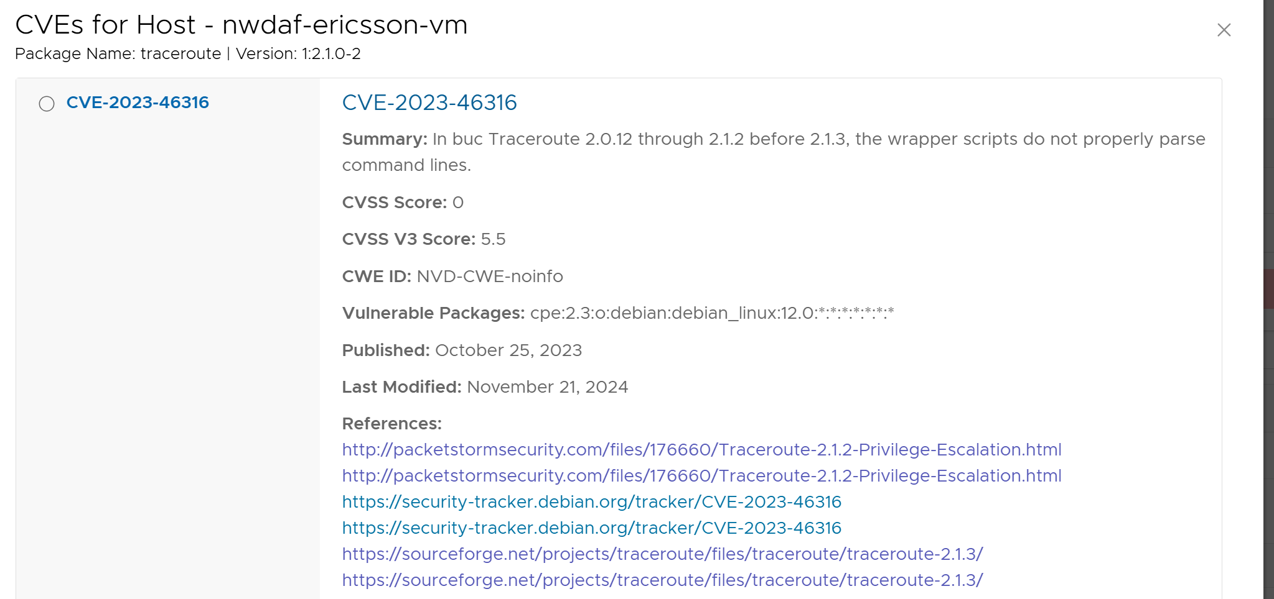

Installing 2.1.3 traceroute

AT&T recommended sight to download traceroute-2.1.6.tar.gz location

https://sourceforge.net/projects/traceroute/files/traceroute/traceroute-2.1.3/

Installation Procedure

sudo apt update
- cd /tmp
- wget https://sourceforge.net/projects/traceroute/files/traceroute/traceroute-2.1.3/traceroute-2.1.6.tar.gz
- tar -xvzf traceroute-2.1.3.tar.gz
- cd traceroute-2.1.3
- ./configure
- make
- sudo make install
- cd traceroute
- cp traceroute /usr/sbin

- run: traceroute –version
Modern traceroute for Linux, version 2.1.3
Copyright (c) 2016 Dmitry Butskoy, License: GPL v2 or any later

acronyms
CSC Communication Service Customer
NWDAF 5G Network Data Analytical Function
AF Application Function
NF Network Function
CSMF Communication Service Management Function
CSP Communication Service Provider
DN Data Network
MNO Mobile Network Operator
NOP Network Operator
NSaaS Network Slice as a Service
NSaasC Network Slice as a Service Customer
NSaaSP Network Slice as a Service Provider
NSMF Network Slice Management Function
NSC Network Slice Customer
NSSMF Network Slice Subnet Management Function
NSP Network Slice Provider
SLA Service Level Agreement
SLS Service Level Specification
TN Transport Network

