Snapshot of old Disk
Version 0.1
March 24, 2025

Authors:
Mohammed Khalil mk3441@att.com

Contents
Document Control 3
1 Introduction 4
1.1 Detailed Procedure 4
1.1.1 Identify the Id of disk in the damaged VM 4
1.1.2 Make a snapshot of old disk 4
1.1.3 Creating a disk from the Snapshot 5
1.1.4 Attach the recovered Disk with your New VM 6
1.1.5 Mounting the new disk into the file system 7
1.2 acronyms 7

Document Control
Below are the publication date, author’s initials, and reason for publication for the current and any previous versions of this document.
Version | Publication Date | Author | Reason for Publication
0.1 | 04/24/2025 | MK | Remediation steps

Introduction
If your VM is damaged and you can’t access this VM, then the procedure in this documents depicts how can you recover the data on the disk associated with the damaged VM

Detailed Procedure

Identify the Id of disk in the damaged VM

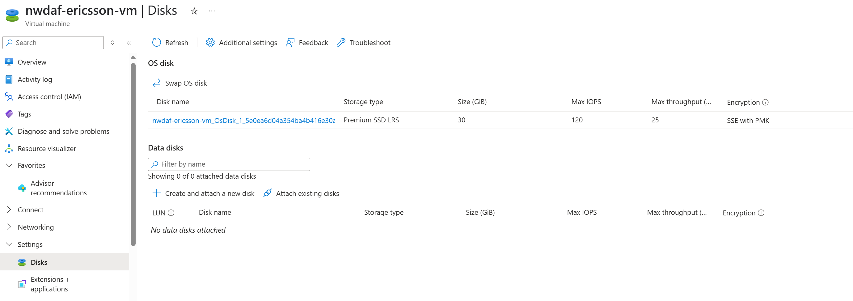

Make a snapshot of old disk

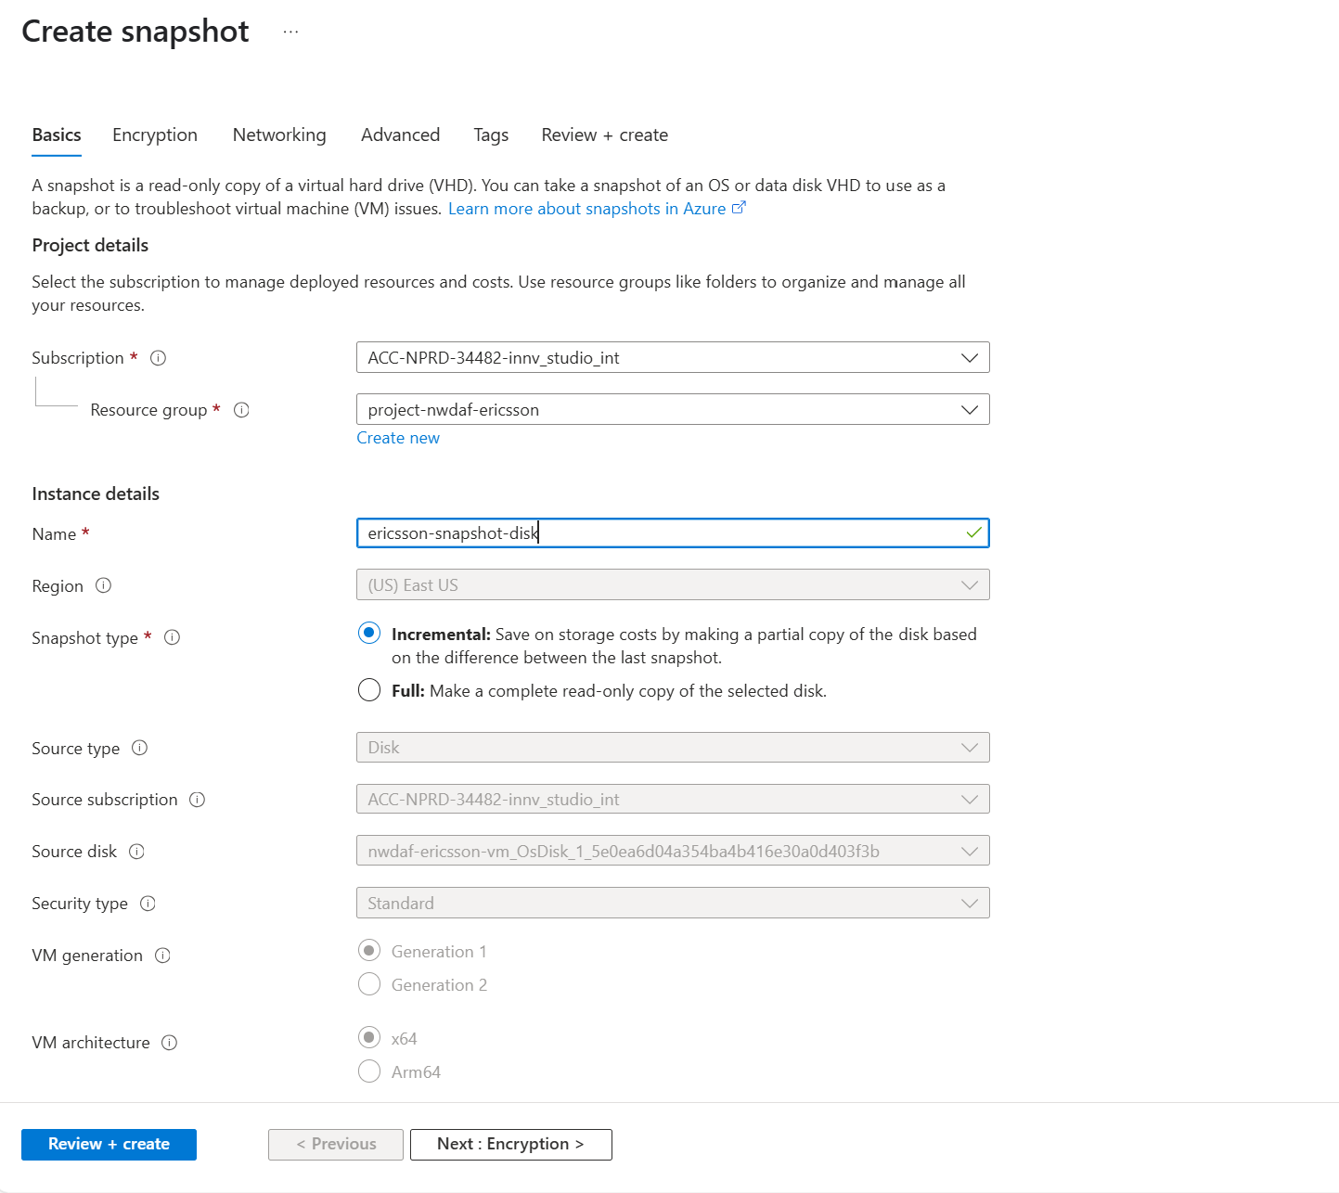
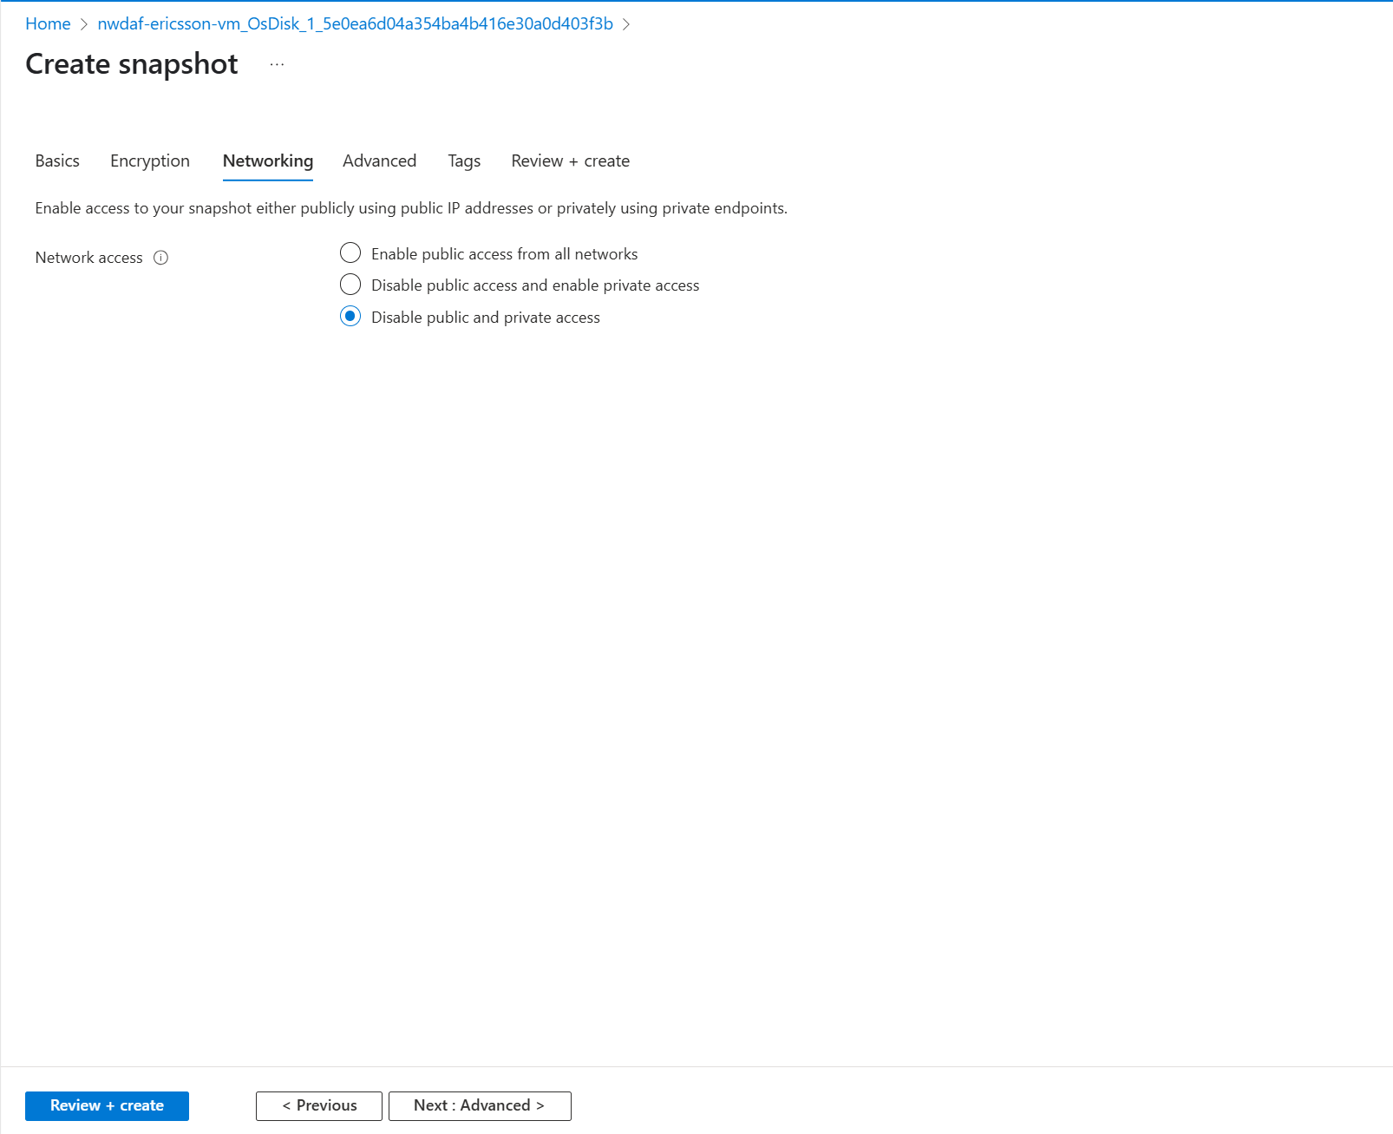
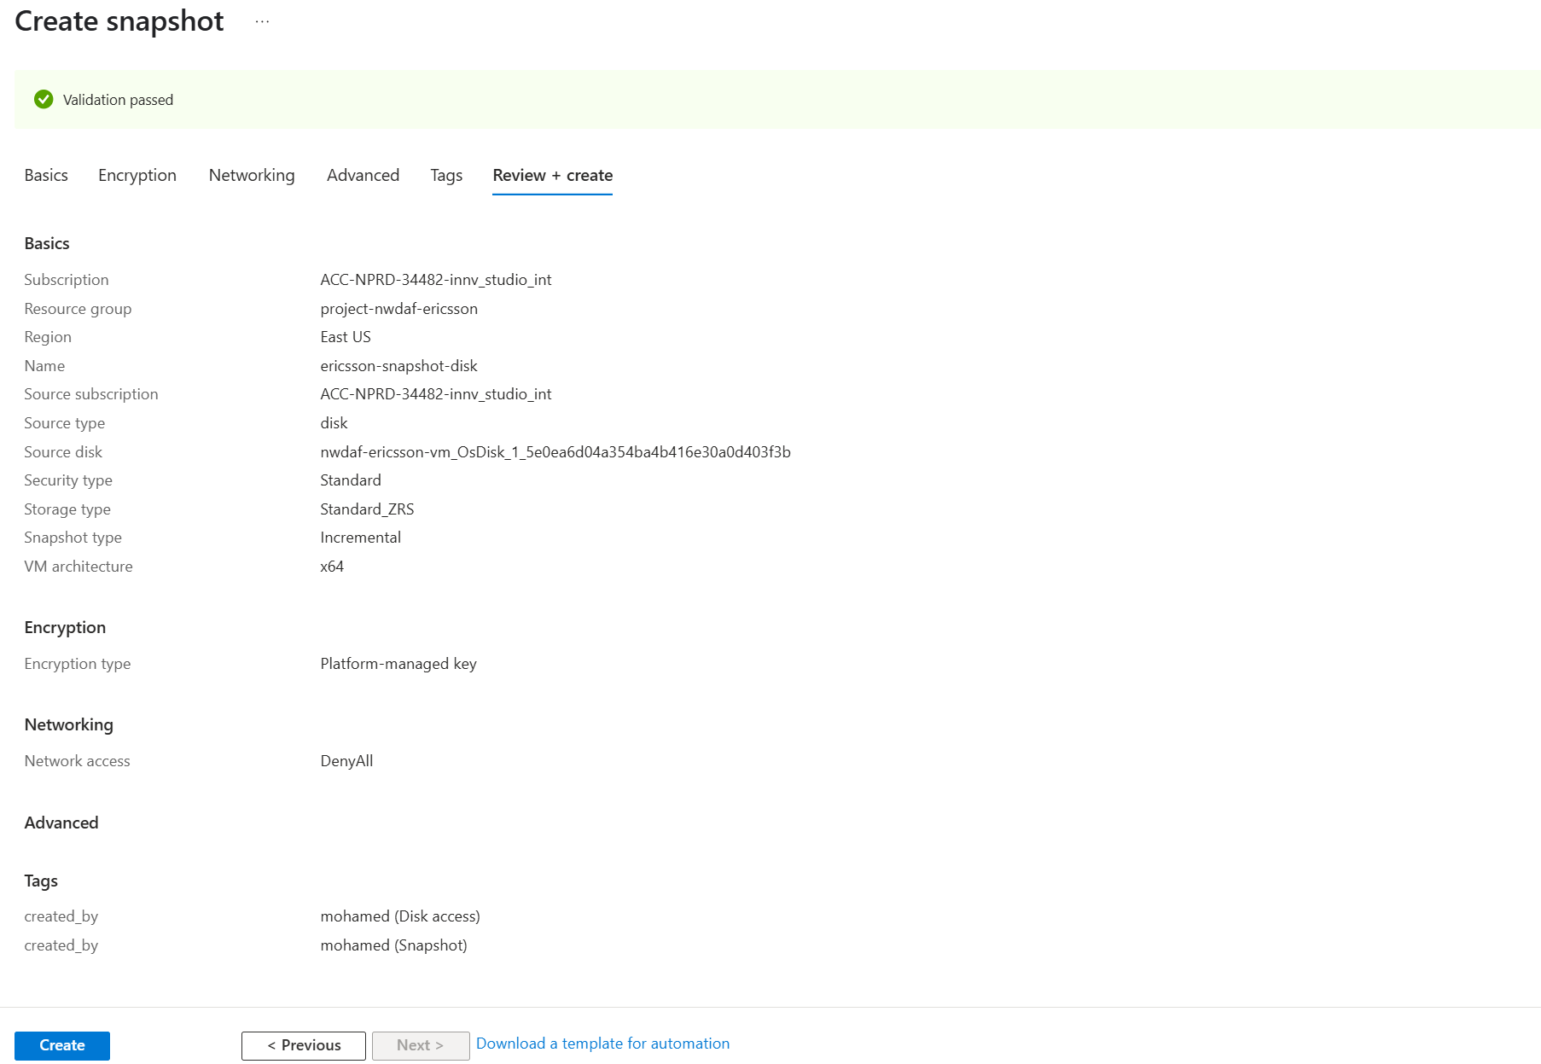

Creating a disk from the Snapshot

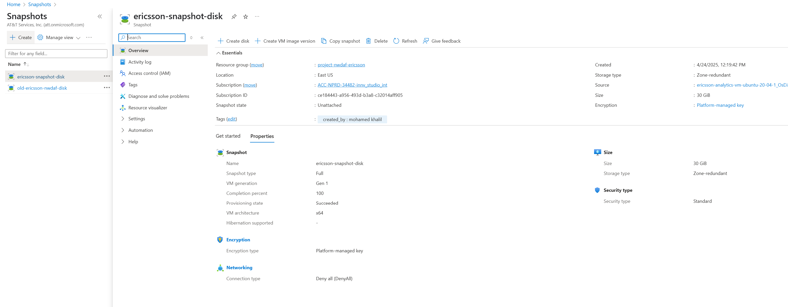
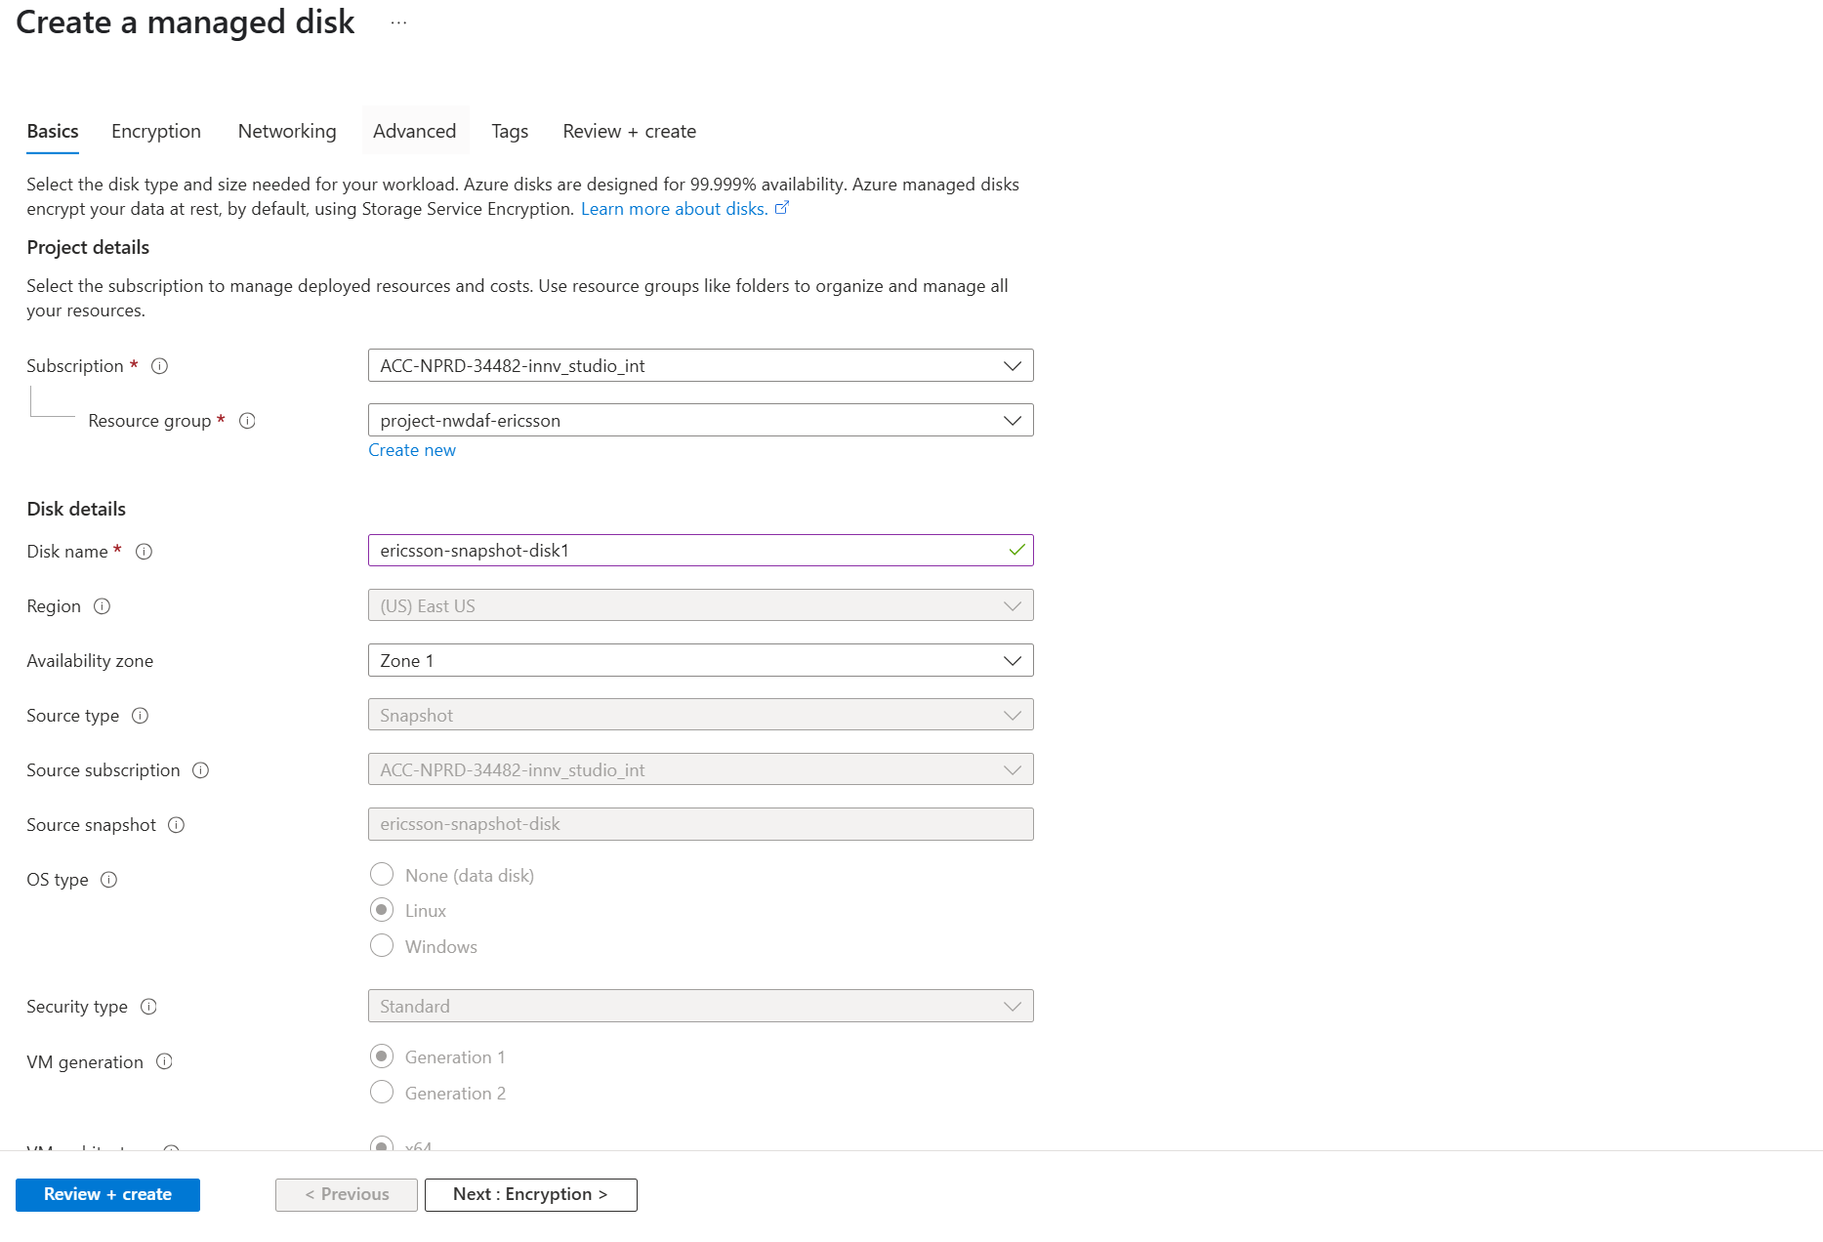
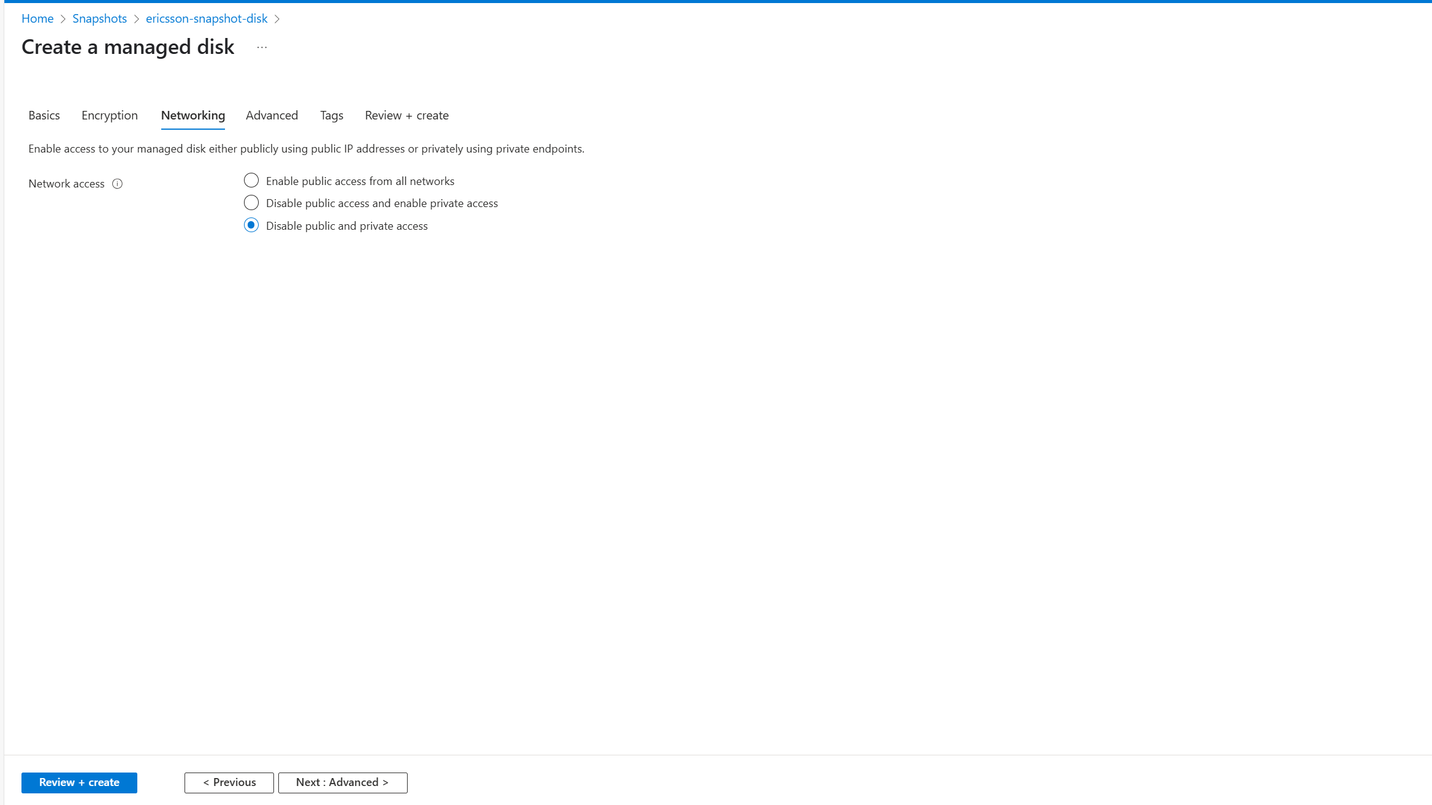
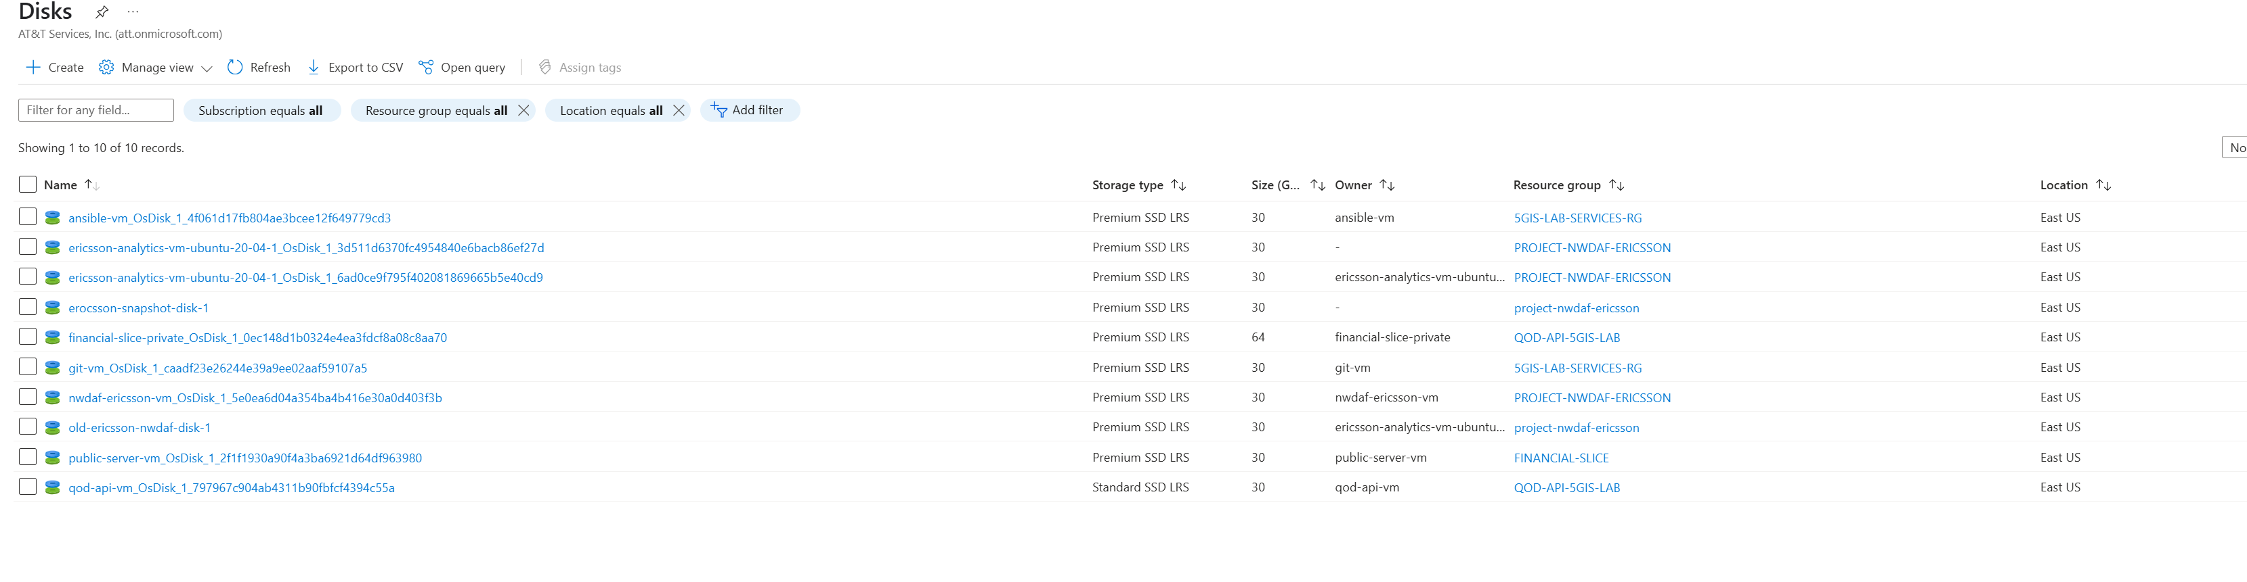

Attach the recovered Disk with your New VM

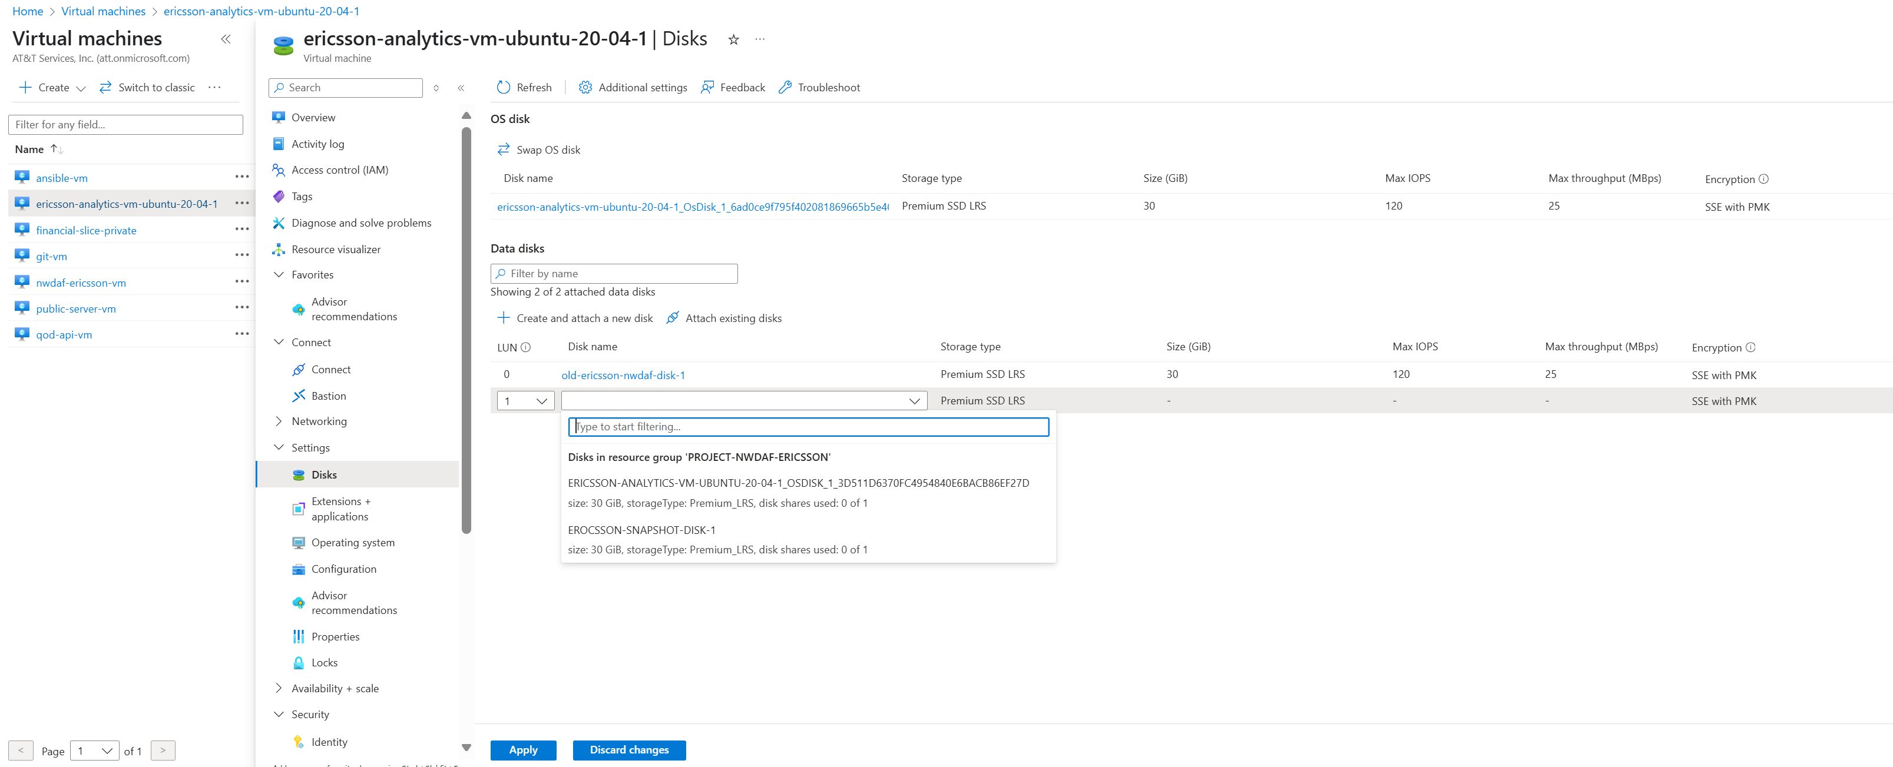

Mounting the new disk into the file system

- lsblk
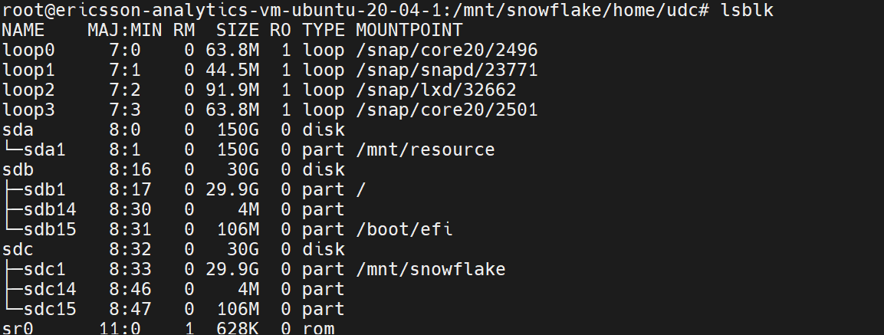
- in my case the recovered disk is sdc1. Mount sdc1 into the subdirectory of the /mnt
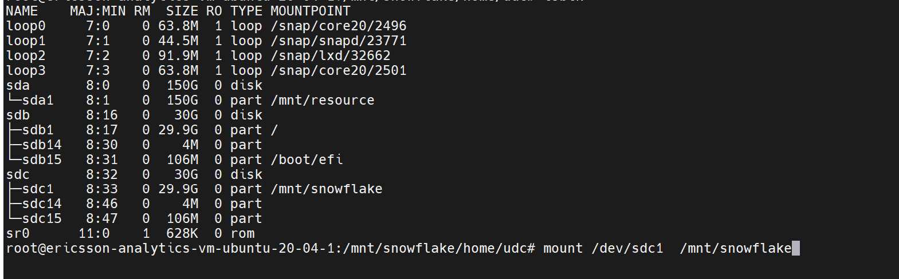

Permanent Mounting in File system

- Find file system label
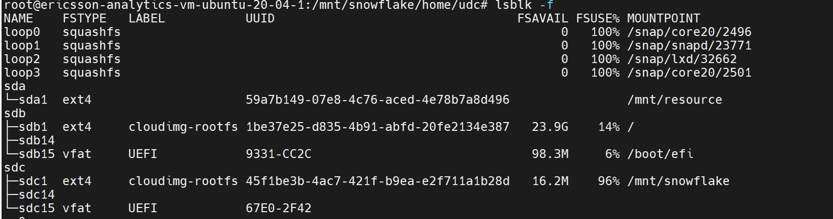

- Add the following sudo vi /etc/fstab

acronyms
CSC Communication Service Customer
NWDAF 5G Network Data Analytical Function
AF Application Function
NF Network Function
CSMF Communication Service Management Function
CSP Communication Service Provider
DN Data Network
MNO Mobile Network Operator
NOP Network Operator
NSaaS Network Slice as a Service
NSaasC Network Slice as a Service Customer
NSaaSP Network Slice as a Service Provider
NSMF Network Slice Management Function
NSC Network Slice Customer
NSSMF Network Slice Subnet Management Function
NSP Network Slice Provider
SLA Service Level Agreement
SLS Service Level Specification
TN Transport Network

