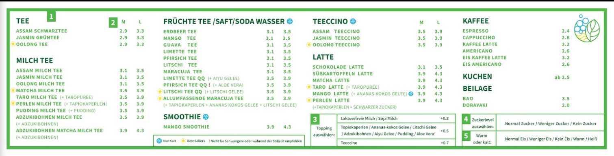

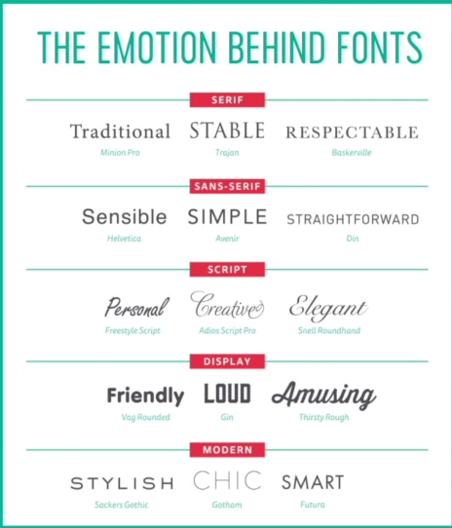

|  |  |  |
| --- | --- | --- |
| TEE | | |
| ASSAM SCHWARZTEE | 2.9 | 3.3 |
| JASMIN GRÜNTEE | 2.9 | 3.3 |
| A OOLONG TEE | 2.9 | 3.3 |
| MILCH TEE | | |
| ASSAM MILCH TEE | 3.1 | 3.5 |
| JASMIN MILCH TEE | 3.1 | 3.5 |
| OOLONG MILCH TEE | 3.1 | 3.5 |
| A MATCHA MILCH TEE | 3.5 | 3.9 |
| TARO MILCH TEE (+TAROPÜREE) | 3.5 | 3.9 |
| A PERLEN MILCH **TEE** (+TAPIOKAPERLEL) | 3.5 | 3.9 |
| PUDDING MILCH **TEE** (+PUDDING) | 3.5 | 3.9 |
| **ADZUKIBOHNEN MILCH** TEE  (+ ADZUKIBOHNEN) | 3.5 | 3.9 |
| **ADZUKIBOHNEN MATCHA** MILCH TEE  (+ ADZUKIBOHNEN) | 3.9 | 4.3 |
| FRÜCHTE TEE /SAFT/SODA WASSER © | | |
| ERDBEER TEE | 3.1 | 3.5 |
| MANGO TEE | 3.1 | 3.5 |
| GUAVA TEE | 3.1 | 3.5 |
| LIMETTE TEE | 3.1 | 3.5 |
| PFIRSICH TEE | 3.1 | 3.5 |
| LITSCHI TEE | 3.1 | 3.5 |
| MARACUJA TEE | 3.1 | 3.5 |
| LIMETTE TEE QQ (+AIYU GELEE) | 3.5 | 3.9 |
| PFIRSICH TEE QQ (+ALOE VERA) | 3.5 | 3.9 |
| A LITSCHI TEE QQ (+LITSCHI GELEE) | 3.5 | 3.9 |
| A ALLUMFASSENDE **MARACUJA TEE**  (+TAPIOKAPERLEL +ANANAS KOKOS GELEE+LITSCHI GELEE) | 3.5 | 3.9 |
| **SMOOTHIE**© | | |
| MANGO SMOOTHIE | 3.9 | 4.3 |
| **TEECCINO**© | | |
| ASSAM TEECCINO | 3.5 | 3.9 |
| JASMIN TEECCINO | 3.5 | 3.9 |
| A OOLONG TEECCINO | 3.5 | 3.9 |
| **LATTE** | | |
| SCHOKOLADE LATTE | 3.1 | 3.5 |
| SÜßKARTOFFELN LATTE | 3.9 | 4.3 |
| MATCHA LATTE | 3.9 | 4.3 |
| A TARO LATTE (+TAROPÜREE) | 3.9 | 4.3 |
| ©MANGO LATTE (+ANANAS KOKOS GELEE) | 3.9 | 4.3 |
| A PERLEN LATTE (+TAPIOKAPERLEL SCHWARZEN ZUCKER) | 3.9 | 4.3 |
| **KAFFEE** | | |
| ESPRESSO |  | 2.4 |
| CAPPUCCINO |  | 2.8 |
| KAFFEE LATTE |  | 3.2 |
| AMERICANO |  | 2.6 |
| EIS KAFFEE LATTE |  | 3.2 |
| EIS AMERICANO |  | 2.6 |
| KUCHEN ab 2.5 | | |
| BEILAGE | | |
| BAO |  | 3.5 |
| DORAYAKI |  | 2.0 |
|  |  |  |
| ©NÜR KALT |  |  |
| A Best Sellers |  |  |
|  |  |  |
| Topping auswahlen: | Laktosefreie Milch / Soja Milch | +0.3 |
| Topiokaperlen / Ananas-kokos Gelee / Litschi **Gelee/** Adzukibohnen / Aiyu Gelee/ Pudding / Aloe Vera! | +0.5 |
| Teeccino | +0.7 |
| Zuckerlevel auswahlen: | Normal Zucker / Weniger Zucker / Kein Zucker | |
| Wann oder kalt: | Normal Eis / Weniger Eis/ Kein Eis / Warm / Heiß | |