Name:
ID:

Department of Economics

Iowa State University

Principles of Macroeconomics

Spring 2010, Midterm 2

Directions: Do Not Open This Booklet Until Told To Do So.

- Print your name and University ID number on this page
- Fill in your name, birth date, and ID on the bubble sheet, and put exam version 1 for special code “K”
- Answer multiple choice questions on the bubble-sheet, and answer the rest of the questions in this book.
- There are 66 points total on the exam.
Multiple choice questions. 2 points each
Answer the following questions on the bubble sheet provided. You will not get credit for your exam unless you fill in the exam version as special code “K” (the version is listed at the bottom of the page).
Use the following to answer question 1:

Figure: Minimum Wage

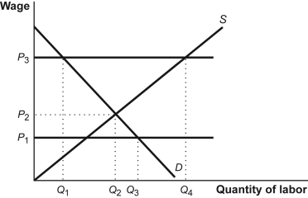

1. | (Figure: Minimum Wage) The binding minimum wage of P3 leads to unemployment of:
 | A) | Q4 – Q1.
 | B) | Q4 – Q2.
 | C) | Q3 – Q2.
 | D) | Q3 – Q1.

2. | An increase in the wealth of households, all other things unchanged, may be expected to result in _______ the aggregate consumption function.
 | A) | a downward shift of
 | B) | no effect on
 | C) | a movement to the right along
 | D) | an upward shift in

3. | The combination of frictional and structural rates of unemployment is called the:
 | A) | natural rate of unemployment.
 | B) | natural rate of employment.
 | C) | cyclical rate of employment.
 | D) | cyclical rate of unemployment.

Use the following to answer question 4:

Table: CPI
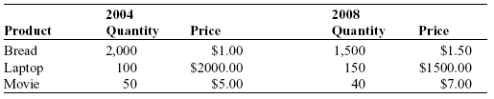

4. | (Table: CPI) Suppose the economy only produces three goods: bread, laptops, and movies. Calculate the CPI of 2008, using 2004 as the base year.
 | A) | 100
 | B) | 95
 | C) | 81.9
 | D) | 75.8

Use the following to answer question 5:

Scenario: Economy of Centralia
Centralia has no trade and no government. GDP = $25 trillion. Consumption Spending = $18 trillion.

5. | (Scenario: The Economy of Centralia) Consider the information on the economy of Centralia. Suppose that there is a new government in Centralia, and it has decided to impose taxes on its citizens in order to spend on infrastructure. Taxes = $2 trillion. Government Spending = Taxes. What is the level of private saving in Centralia now?
 | A) | $5 trillion
 | B) | $18 trillion
 | C) | $7 trillion
 | D) | $11 trillion

6. | Planned investment spending depends on:
 | A) | expected future disposable income.
 | B) | the life-cycle hypothesis.
 | C) | wealth.
 | D) | the market interest rate.

7. | The marginal propensity to consume (MPC) is equal to the change in:
 | A) | consumer spending divided by the change in gross domestic product.
 | B) | disposable income divided by the change in consumer spending.
 | C) | consumer spending divided by the change in investment spending.
 | D) | consumer spending divided by the change in disposable income.

8. | If real GDP grows at an annual rate of 1%, it will double in approximately _______ years.
 | A) | 23
 | B) | 35
 | C) | 70
 | D) | 11

9. | Over the last year, Eli has been working very hard and his employer has taken notice by giving him a 6% raise in his salary. During this last year, overall prices in the economy have increased by 4%. Given this information, Eli's real wage has:
 | A) | increased by 6%.
 | B) | decreased by 4%.
 | C) | stayed constant.
 | D) | increased by 2%.

10. | Samantha is asking her employer for a 5% raise for the coming year. If the inflation rate during the next year is 5.5%, then her real wage will:
 | A) | decrease by .5%.
 | B) | decrease by 5%.
 | C) | increase by .5%.
 | D) | increase by 5%.

11. | Which of the following is an advantage to the recipient country of foreign investment?
 | A) | Foreign companies often bring new technology to the recipient country, and this increases productivity.
 | B) | Foreigners are content to receive lower profits and interest rates than are domestic investors.
 | C) | Foreigners don't expect to receive profits and interest as often as do domestic investors.
 | D) | Domestic firms with foreign investors are exempt from domestic income taxes on a portion of their net income.

12. | When a bond becomes more attractive as an asset due to a rise in the interest rate:
 | A) | people will stop buying bonds and buy other assets.
 | B) | the future price of bonds will fall.
 | C) | the price of stock, a substitute asset, will rise.
 | D) | the price of stock, a substitute asset, will fall.

Use the following to answer question 13:

Table: Calculating GDP
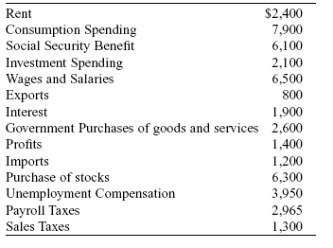

13. | (Table: Calculating GDP) Using the information in the table provided, which of the following is the correct calculation for GDP in 2008?
 | A) | $12,200
 | B) | $21,485
 | C) | $34,085
 | D) | $47,475

14. | Diminishing returns to physical capital means that as more and more physical capital is combined with a fixed amount of human capital with a fixed technology, eventually:
 | A) | aggregate output or real GDP grows.
 | B) | additions to aggregate output or real GDP declines.
 | C) | additions to aggregate output or real GDP increases.
 | D) | aggregate output or real GDP declines.

15. | According to the accelerator principle, a _______ rate of growth in real GDP leads to _______.
 | A) | higher; higher inventory investment
 | B) | higher; higher planned investment spending
 | C) | lower; higher inventory investment
 | D) | lower; lower unplanned inventory investment

Use the following to answer question 16:

Figure: Loanable Funds

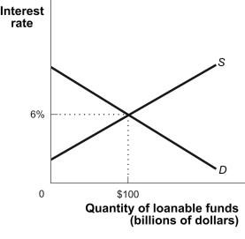

16. | (Figure: Loanable Funds) The accompanying graph shows the market for loanable funds in equilibrium. Which of the following might produce a new equilibrium interest rate of 8% and a new equilibrium quantity of loanable funds of $150?
 | A) | Businesses have become more optimistic about the return on investment spending.
 | B) | There has been an increase in capital inflows from other nations.
 | C) | Consumers have increased consumption as a fraction of disposable income.
 | D) | The federal government has a budget surplus rather than a budget deficit.

17. | An example of a government transfer is a(n):
 | A) | Social Security payment.
 | B) | salary for members of the armed forces.
 | C) | bequest from a deceased relative.
 | D) | expenditure on an interstate highway.

18. | Calculating GDP via the factor payments approach would include payments such as:
 | A) | rents, profits, value added adjustments, and taxes.
 | B) | consumption, investment and government.
 | C) | taxes, wages, interest payments and rents.
 | D) | wages, interest payments, rent and profits.

Use the following to answer question 19:

Table: South Korea Real GDP per Capita
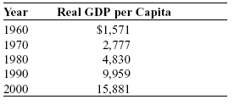

19. | (Table: South Korean Real GDP per Capita) As a percentage of real GDP per capita in 2000, approximately how much did South Korea produce in 1960?
 | A) | 151%
 | B) | 1,011%
 | C) | 15%
 | D) | 10%

20. | Productivity declines when:
 | A) | real GDP growth exceeds population growth.
 | B) | the number or hours worked exceeds the number of workers.
 | C) | population growth exceeds real GDP growth.
 | D) | the ratio of adult civilians employed outside the home rises.

Use the following to answer question 21:

Figure: Labor Market

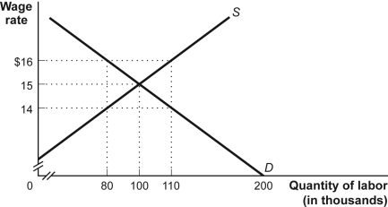

21. | (Figure: Labor Market) The level of employment at the equilibrium wage rate is:
 | A) | 90,000.
 | B) | 80,000.
 | C) | 110,000
 | D) | 100,000.

22. | In the United States, real GDP per capita during the 20th century increased:
 | A) | 3-fold.
 | B) | 6-fold.
 | C) | 10-fold.
 | D) | 2-fold.

23. | Gross domestic product or GDP is:
 | A) | the total dollar value of final goods and services produced in the economy in a given time period.
 | B) | the total dollar value intermediate goods and services produced in the economy in a given time period.
 | C) | the total dollar value of government production in a given time period.
 | D) | the total dollar value of wages paid to producing workers in a given time period.

24. | Looking at past data, one finds that when the unemployment rate has increased, the annual growth rate of real GDP has:
 | A) | no relationship with changes in the unemployment rate.
 | B) | increased.
 | C) | decreased.
 | D) | not changed.

25. | You and a co-worker have been trying to develop a linear equation that describes the local household consumption function. Your co-worker has sent you a very short email that simply says he has finished the project and the consumption function is: C = 100 + .75(YD). Your job is to explain this result to your supervisor. According to this consumption function, what is the marginal propensity to consume?
 | A) | 4
 | B) | 100
 | C) | 0.25
 | D) | 0.75

The next questions are from your homework. Please give short answers and use complete sentences. If you do not explain your answer it will be marked wrong, even if you write down a correct number. Each question is worth 4 points.
- Boris Borrower and Lynn Lender agree that Lynn will lend Boris $10,000 and that Boris will repay the $10,000 with interest in one year. They agree to a nominal interest rate of 8%, reflecting a real interest rate of 3% on the loan and a commonly shared expected inflation rate of 5% over the next year. (2 points each)
  - If the inflation rate is actually 4% over the next year, how does that lower-than-expected inflation rate affect Boris and Lynn? Who is better off?

  - If the actual inflation rate is 7% over the next year, how does that affect Boris and Lynn? Who is better off?

- The United States economy slowed significantly during the beginning of 2008, and policy makers were extremely concerned about growth. To boost the economy, Congress passed an economic relief package that would deliver about $145 billion in direct payments to American families. (The payments were made as rebates to households on their previously paid taxes.) Their objective was to boost the economy by increasing the disposable income of American consumers. (2 points each.)
  - Calculate the initial change in aggregate consumer spending as a consequence of this policy measure, if the marginal propensity to consume (MPC) in the United States is 0.7. Then calculate the resulting change in real GDP arising from the $145 billion in payments.

  - Illustrate the effect on real GDP with the use of a graph depicting the income-expenditure equilibrium.

- In which of the following cases is it more likely for efficiency wages to exist? Why? (1 point for each answer, 1 point for an overall comparison.)
  - Jane and her boss work as a team selling ice cream.
  - Jane sells ice cream without any direct supervision by her boss.
  - Jane speaks Korean and sells ice cream in a neighborhood in which Korean is the primary language. It is difficult to find another worker who speaks Korean.

- The accompanying table shows data from the Penn World Table, Version 6.2, for real GDP per capita (2000 US dollars) in France, Japan, the United Kingdom, and the United States in 1950 and 2004. (2 points each.)
 | 1950 |  | 2004
 | Real GDP per capita | Percentage of US real GDP per capita | Real GDP per capita | Percentage of US real GDP per capita
France | $5,921 |  | $26,168
Japan | 2,188 |  | 24,661
United Kingdom | 8,082 |  | 26,762
United States | 11,233 |  | 36,098

  - Complete the table by filling in the “Percentage of US real GDP per capita” columns.
  - Have these countries converged economically?

