### Always Remember “google is your friend!”

1. Create a variable “x” that has value 5. And another variable “y” that has value 3. Add them and store in z. Print z in the console
2. Create a vector called “tamim” with runs in five matches. The runs are 40, 50, 100, 20, 10,35, 40. Get the average run of tamin in the tournament
3. Create a boxplot of variable tamim. It should like like the following. Which one is the outlier here?

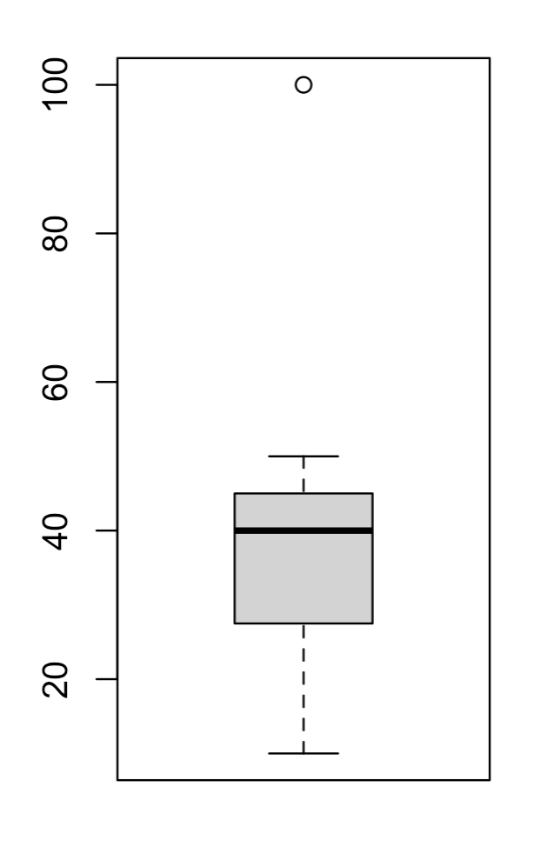

1. Create matrix with number 1 to 100. The matrix should contain 4 columns and 25 rows.
2. Give the 4 column names. “one, two, three, four”. It should look like following

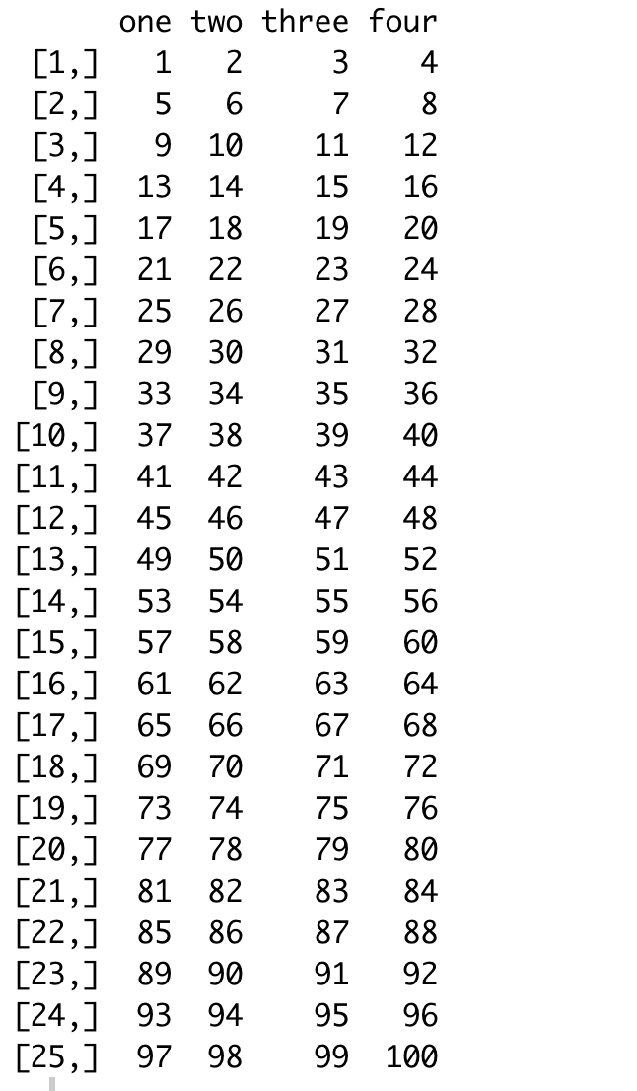

1. Create a data frame that looks like following.

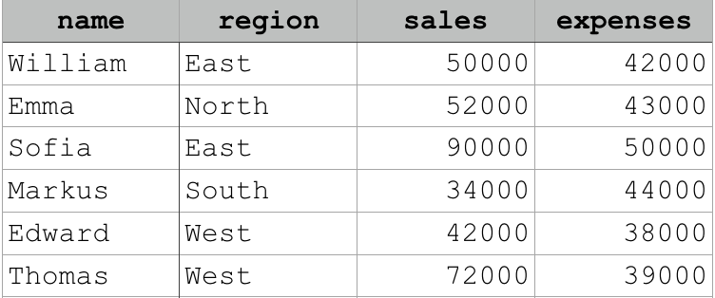

1. Create the following list:

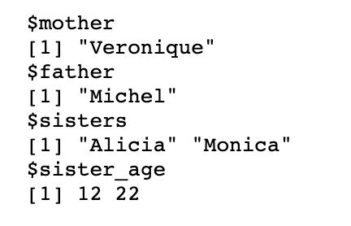

1. Write an if else condition where it says, if x is greater than 0 then print positive, if less than 0 print negative and if x is 0 than print zero and if anything else print please type a new number. Check what the value shows if x <- 5 and x <- 0
2. Create the following data frame:



Convert this data frame into matrix. Such that you get the following output. Check “google” to know how to convert a data frame into matrix. You should get the following output

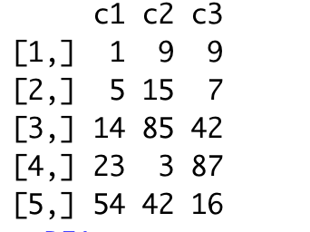

1. Use for loop to get the following output

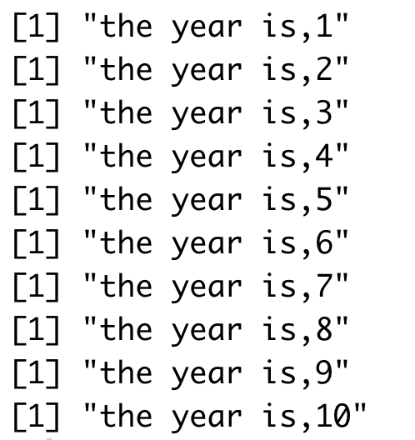

1. Install Bioconductor in R. install Deseq2 package in R. Check the following

<https://www.bioconductor.org/packages/release/bioc/html/DESeq2.html>

1. Load the inbuild “mtcars” data frame and store it as “cars”. If you View the cars you can see that the first column is “mpg” and fourth column is “hp”. Swap this column such that 1st column is “hp” and the fourth column is “mpg”.
2. Make a scatter plot “mpg” vs “hp” and color it based on “gear”. What is the difference when you use factor and when you don’t
3. Load the file “house.csv” in R. you can see that the “aircond” column has 0 or 1. Where 0 means no facility of air-condition and 1 means containing facility of air-condition. Create a new column with “yes” and “no” for each columns.
4. Make a new column titled “New_created_column” which contains “yes” or “no” value which is consistent with 0 and 1 in “aircond” column.
5. Make a boxplot with x axis as room number and y axis as price and compare how difference in price it makes if you have air condition facility or not. Use new_created_column
6. Create a frequency polygon with facet_grid based on “New_created_column”

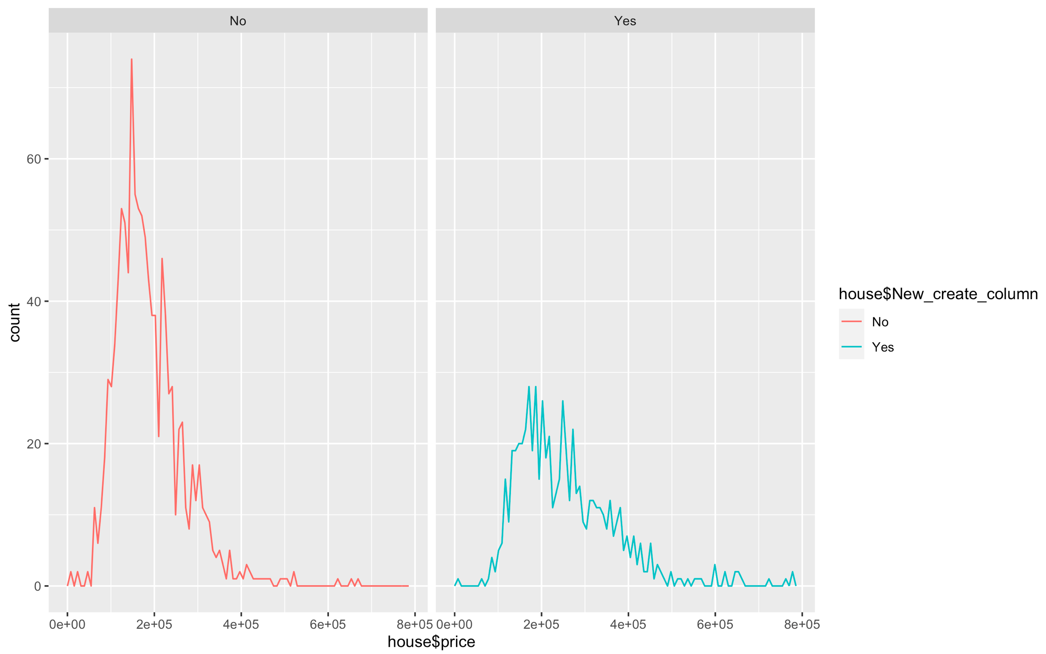

1. Say you have three genes EGFR, FOX1, TF1. You have calculated that in three cell type “cell1, cell2, cell3”. You want to create a matrix where each gene will have a value for each cell type

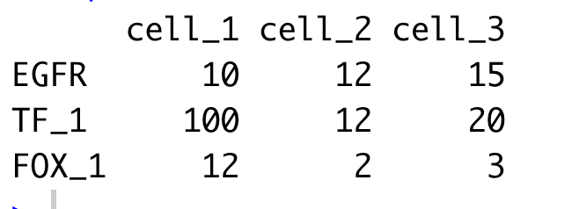

1. Calculate the mean of each row and add it as the fourth column and calculate the row sum and add it as the fifth column
2. Say you have collected some samples from 5 person. You have asked them if they believe in aliens. The response was as follows :

responses <- factor(c("Agree", "Agree", "Strongly Agree", "Disagree", "Agree"))



You want to change is such the the level shows it in following order:



1. Create the following data frame,

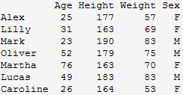

afterwards invert Sex for all individuals. Sothat it shows M in place of F and F in place of M.

1. Create this data frame (make sure you import the variable Working as character and not factor).

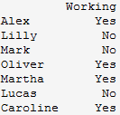

Add this data frame column-wise to the previous one. a) How many rows and columns does the new data frame have? b) What class of data is in each column?

1. Write two string “hello” and “why am I doing this”. Add this two string together and separate by “,”
2. If name_list <- list(a = 1:200, b = “this is a string”, c = “hello”). You will write a code that will add 1 to each element of the first vector of the new list. Also, add a new item z = “newItem” to the list name_list
3. Download the small_counts.txt from the following location

<https://figshare.com/s/1d788fd384d33e913a2a>

1. Read the file in R and save it as small_counts. View the file.
2. Get the following output from the file

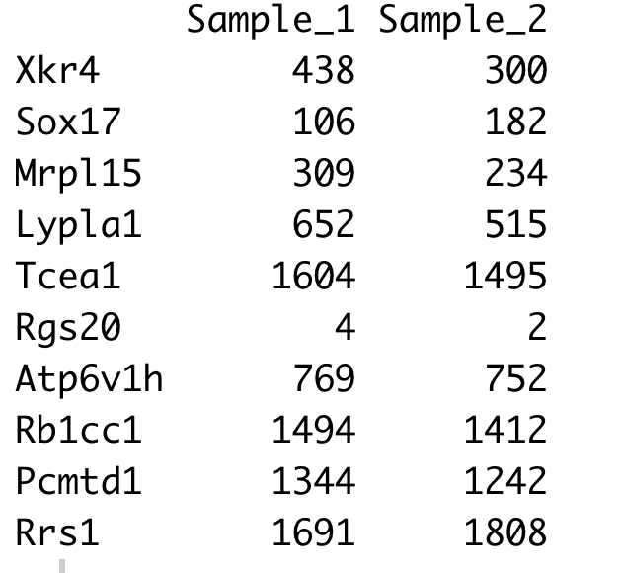

1. Get log of the small_count so that it looks like the following

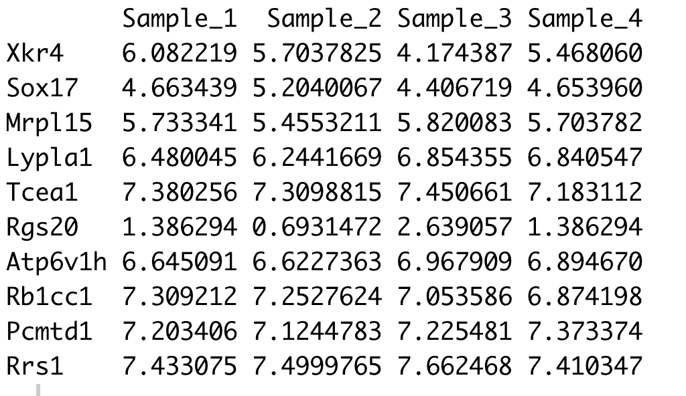

1. Download the “ResultsTable_small.txt” from the following location

<https://figshare.com/s/1d788fd384d33e913a2a>

1. This is a file which contains the gene expression data. The Entrez id is the gene name. You can search Entrez id in google to get more information.Symbol is the gene name. And “logFC” value which means how much more a gene is expressed in treatment condition compared to control condition. Read the file in R and store it as

“results”

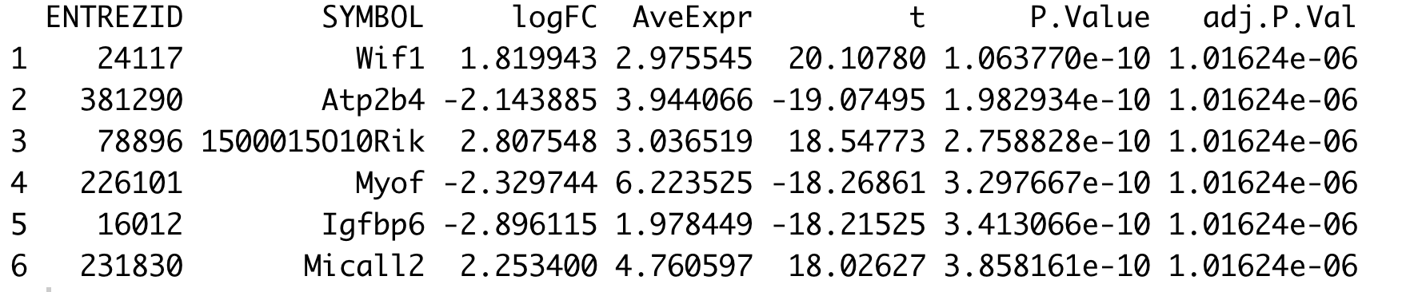

1. Sort the file such thath the genes are orderd in highest to lowest value of “logFC”.

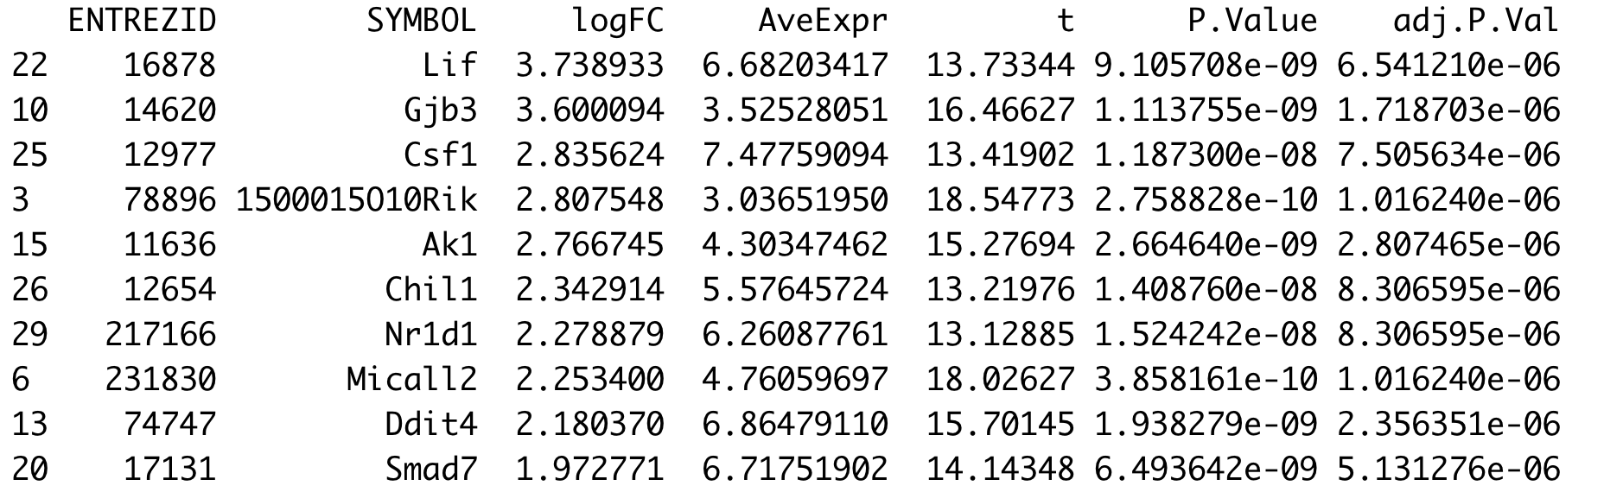

1. See the following figure

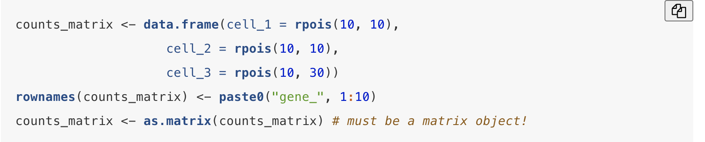

Type the above code in your console and check counts_matrix to see what does it create. What do you think “rpois” comment did here? And try to find what is the difference between paste and paste0. Always remember “google” is your friend

1. Create a heatmap from the using the following file: Explain what was done in each line. Use “##” to comment on your code file in R

Load the file “basketball.csv”. Make sure you change the read.csv location from the following code.

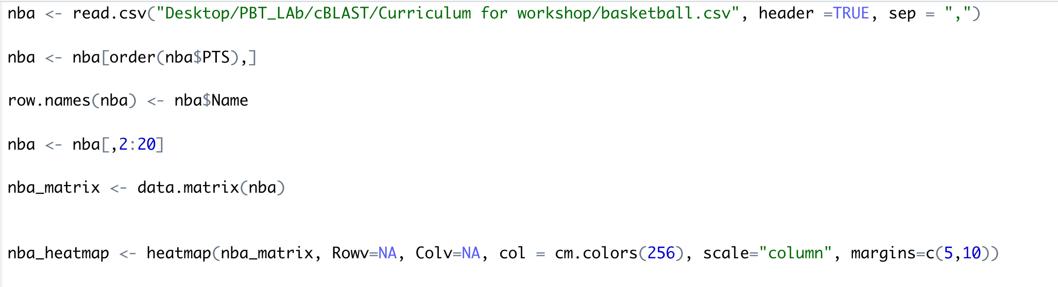

The code will/might show you error!.copy the error and put it in google and see what is the suggestion from the internet. Try to understand and solve the problem. The end of the code will show something like the following:

