**UBC Cycling Network Documentation**

Originally prepared by Melissa Nunes, May 2, 2008, [nunes.melissa.m@gmail.com](mailto:nunes.melissa.m@gmail.com)

Additional Information added at end of document serve as an update log.

<Additional contributors’ info here>

**Purpose**

The purpose of this data is for use by the UBC School of Environmental Health and the UBC Department of Healthcare and Epidemiology in their Cycling Route Planner, and for analysis regarding cycling-related activities.

Description

Nine files make up this dataset:

Coverages

* cyc – Includes designated and alternate cycling routes
* cyc_np – Node points for cyc
* cycmajhwy – Includes designated, alternate, major roads, highways, and expressways
* cycmajhwy_np – node points for cycmajhwy
* cyc_allrds – Includes designated, alternate, major roads, highways, expressways and local roads
* cyc_allrds_np – Node points for cyc_allrds

Shapefiles

* cyc.shp - Includes designated and alternate cycling routes
* cycMajHWY.shp– Includes designated, alternate, major roads, highways, and expressways
* cyc_allRds.shp - Includes designated, alternate, major roads, highways, expressways and local roads

This data originates from three sources:

1. Designated cycling routes were derived from Translink’s 2006-2007 Network Validation Project
2. Alternate cycling routes were queried from Translink’s 2006 Cycling Network
3. Local roads, major roads, and highways were queried from DMTI Spatial’s 2005 CanMap Route Logistics with the following translations
   * Expressway 🡪 Undesignated – Expressway
   * Primary Highway 🡪 Undesignated - Primary Highway
   * Secondary Highway 🡪 There were no records for this road type, so It was left out.
   * Major Road 🡪 Undesignated – Major Road
   * Local Road 🡪 Undesignated – Local Road

**Methods**

The main tasks carried out on this data set are:

1. Verifying traffic flow direction
2. Merging the data sets
3. Correcting topological errors (must have no dangles, must not intersect)

**Verifying Traffic Flow Direction**

Both One ways and directional errors were flagged and corrected for by means of comparison with (1) DMTI’s CanMap data, (2) Translink’s 2006 Cycling Map, (3) Logically – opposing lanes of traffic represented each by a separate line were marked as one way, and (4) in very few cases Google Maps.

For direction to be useful to UBC’s Cycling Route Planner, segments with incorrect FROM-TO node directions were flipped so that real-world direction was represented by as flowing from the FROM node to the TO node.

For route segments that were flipped, attributes that were sensitive to direction (FACIL_L, FACIL_R, PARKING_L, PARKING_R, NNOTE_L, NNOTE_R, FWWIDTH_L, FWWIDTH_R) were also flipped. For all one ways, FACIL_L inherited the values of FACIL_R being that features such as wide curbs or bike lanes usually occur on the right hand side of traffic.

**Merging the Data**

To minimize the duplicate representation of routes existing from all three sources, redundant records existing in the file representing alternate routes, and file sourced from DMTI were removed, giving preference to designated routes (being the most recent), alternate routes, and then DMTI road segments. Since not all of the datasets aligned geographically, this was done by visual interpretation, and many redundant records still exist.

Fig. 1, Fig. 2, and Fig. 3 show the creation in FME workbench 2007 of each of the following three files: cyc.shp, cycMajHWY.shp, and cycAllRds.shp. Green arrowheads represent fields that automatically match destination fields, yellow arrowheads represent fields that are not transferred to the destination dataset. Grey arrows indicate the flow of data from columns with different naming than the destination dataset.

To create cyc.shp, a column (ON_STREET2) indicating whether or not the feature was On-Street or Off-Street needed to be created for the designated route data for input into cyc.shp’s FACIL_TYPE field. This was done by interpreting the values of both FACIL_L and FACIL_R which included On-Street and Off-Street information. Null values were recorded where FACIL_L and FACIL_R contradicted each other.

Columns that were missing from the input datasets were created and filled with appropriate values For example, A SOURCE column was created to indicate the original dataset and A LIGHTING column was created for the alternate route dataset and filled with -999 values, representing null (shapefiles cannot support null values for number fields).

Add mention of nodepoint

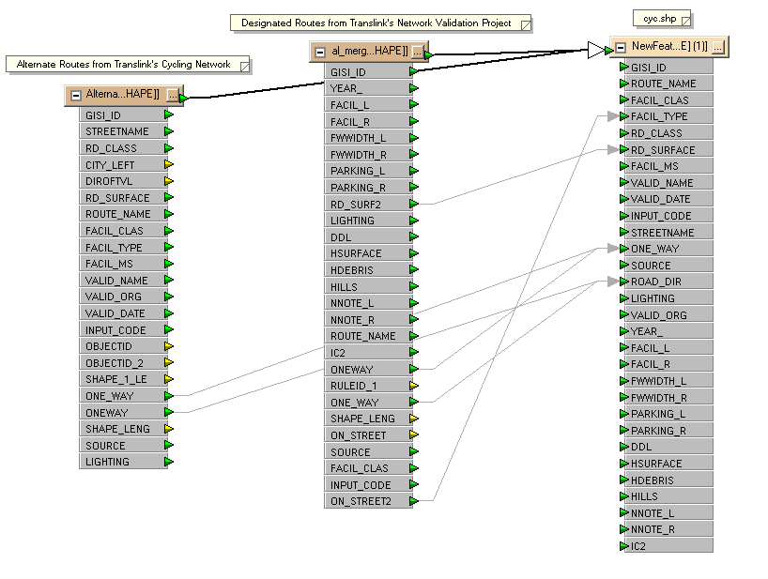

**Fig. 1 Creation of cyc** Green arrowheads represent fields that automatically match destination fields, yellow arrowheads represent fields that are not transferred to the destination dataset. Grey arrows indicate the flow of data from columns with different naming than the destination dataset.

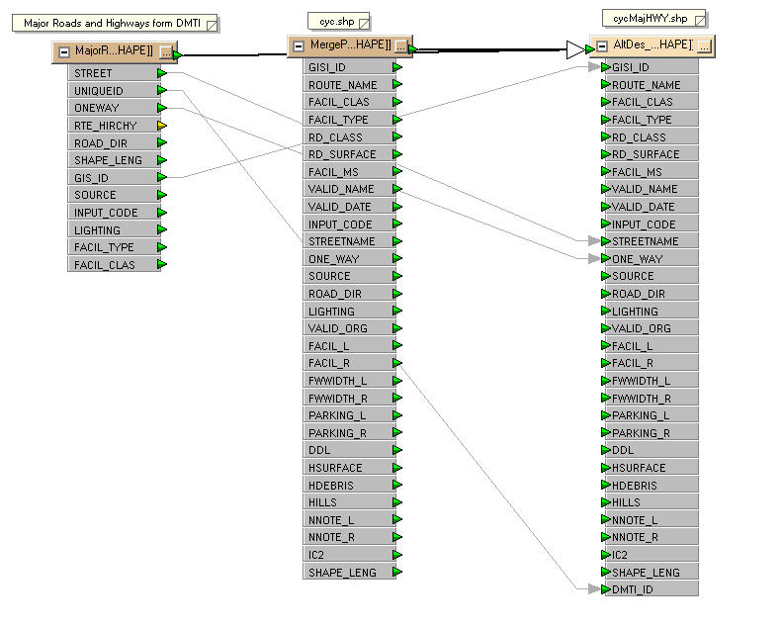

**Fig. 2 Creation of cycMajHWY** Green arrowheads represent fields that automatically match destination fields, yellow arrowheads represent fields that are not transferred to the destination dataset. Grey arrows indicate the flow of data from columns with different naming than the destination dataset.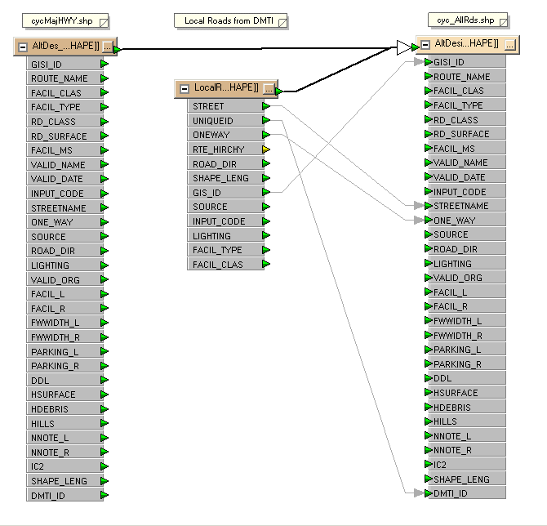

**Fig 3 Creation of Cyc_AllRds** Green arrowheads represent fields that automatically match destination fields, yellow arrowheads represent fields that are not transferred to the destination dataset. Grey arrows indicate the flow of data from columns with different naming than the destination dataset.

**Correcting Topological Errors**

All datasets were checked for dangles (lines that don’t connect to other lines) and intersections (lines that cross where there is no node).

For the cyc data, no-dangle exceptions were visually determined and dangles were corrected by automatically snapping all dangles using a 10m tolerance. Remaining errors were manually corrected with visual interpretation. To correct for intersections, all point errors of the cyc data were dealt with by automatically splitting the corresponding lines. Line errors were subtracted (one of the overlapping lines removed) by visual interpretation.

For the cycMajHWY , and cycAllRds data, dangles were snapped with a 15m tolerance, remaining dangles being ignored. Lines with point errors for from intersections were automatically split, and line errors from intersections were ignored.

**Data Dictionary for cyc, cycMajHWY, and cyc_AllRds.**

*Field descriptions were derived form source data dictionaries where applicable.

|  |  |  |
| --- | --- | --- |
| Attributes | Value | Description |
| GISI_ID  (double, precision 0) | Double | These values link the routes back to the DRA in cases where changes may occur. Manually input routes have values >= 9990000. Routes built off the DRA maintain the DRA GISI_ID of values less than 9990000. |
| ROUTE_NAME  (text –  length 40) | Adanac | A name given to the corresponding cycling route. The field will be blank if unknown. |
| BC Parkway |
| Central Valley Greenway |
| Seaside |
| *Etc.* |
| FACIL_CLAS  (text –  length 40) | Alternate | A route that is commonly used by cyclists, but does not have any special road treatment for cyclists |
| Designated | A route that is designated by the municipalities with some special road and/or traffic light treatment for the convenience of cyclists |
| Undesignated - Expressway |  |
| Undesignated- Major Road |  |
| Undesignated – Primary Highway |  |
| Undesignated – local Road |  |
| FACIL_TYPE  (text –  length 30) | On Street – Striped Bike Lane | Separate travel lanes, identified with a solid white line, designated for the exclusive use of bicycles. Bicycle stencils are painted on the roadway within the bicycle lane at regular intervals. |
| Paved Shoulder | Rural roads without curb and gutter. Bicycles travel on the paved shoulder. |
| On Street – Shared Roadway |  |
| Hybrid Rural Shared |  |
| Signed Route |  |
| On Street | On Street indicates the route is not physically separated from vehicle traffic. |
| Off Street | Off Street indicates the route is somehow physically separated from vehicle traffic. |
| MoTH |  |
| Null |  |
| RD_CLASS1  (text –  length 12) | Arterial |  |
| Collector |
| Local |
| Off Street |
| Ramp |
| Paved |
| Brick |
| Freeway |
| Highway |
| Lane |
| Recreation |
| Strata |
| RD_SURFACE2  (text –  length 6) | Stone |  |
| Lgravl (Loose Gravel) |
| Pgravl (Packed Gravel) |
| Dirt |
| Paved |
| Loose |
| Marked |
| Unknwn |

|  |  |  |
| --- | --- | --- |
| FACIL_MS  (text –  length 15) | Nothing | Nothing |
| Unknown | Unknown |
| VALID_NAME3  (text –  length 30) | Michael Grant | The name of the person who supplies the information for the route or updates the database |
| Gavin Davidson |
| John Smith |
| *Etc.* |
| VALID_ORG3  (text –  length 30) | TransLink | The organization or municipality corresponding to the individual in the valid_name field |
| City of Vancouver |
| Public |
| *Etc.* |
| VALID_DATE3  (date) | Date:  mm/dd/yy | The date the database was updated with the information |
| INPUT_CODE  Sum of the following values4  (short integer, precision 0) | 0 | The line was **not built off the DRA** and was most likely input manually. The GISI_ID must be >= 9990000 and should be unique. |
| 1 | The line was **built off the DRA** and maintains the GISI_ID provided by the DRA. The line remains intact exactly how it is in the DRA. |
| 2 | The line was **built off the DRA and** maintains the GISI_ID provided by the DRA. The line has been **split** into more than one segment each maintaining the same GISI_ID. |
| 4 | The line was **built off the DRA and** maintains the GISI_ID provided by the DRA. The line has been **truncated**. |
| 8 | The line was **built off the DRA and** maintains the GISI_ID provided by the DRA. The line has been **extended**. |
| 16 | The line was **built off the DRA and** maintains the GISI_ID provided by the DRA. The line has been **modified**. |
| -999 | null |
| STREETNAME  (Text – length 40) |  | Name of the street |
| ONE_WAY  (Double) | 0 - Bidirectional | Indicates if traffic along the route flows in one direction or two |
| 1 – One Way |
| SOURCE  (text – length 30) | Al_Combined | Indicates the name of the source file |
| Cycling_Network – alternate rts |
| LFV_route_logistics |
| ROAD_DIR  (Text – length 2) | <> - not one way | Calculated for One_Way values of 1 only |
| TF – traffic flows from TO node to FROM node (value does not occur in this dataset) |
| FT – traffic flows from FROM node to TO node |
| FACIL_L, FACIL_R  (text – length 50) | bike lane (off-street) |  |
| bike lane (on-street) |
| paved shoulder (on-street) |
| wide curb land (on-street) |
| other (on-street) |
| FWWIDTH_L,  FWWIDTH_R  (Short – length 4) | range: 0=25 | Collected in 2006 only  in m? |
| -999 - null |
| PARKING_L, PARKING_R  (Text – length 50) | parking 24 hr (on-street) | *Should only be for on-street segments* |
| parking restricted (on-street) |
| DDL (Short – length 4) | 0 (default) | Directional dividing line - not really collected in 2007, due to poor data collection in 2006 |
| 1- yes |
| -999 - null |
| HSURFACE  (Text – length 4) | 0 (default) | Collected in 2006 only |
| 1- yes |
| -999 - null |
| HDEBRIS  (Text – length 4) | 0 (default) | Collected in 2006 only |
| 1- yes |
| -999 - null |
| HILLS  (Text – length 4) | 0 (default) | Collected in 2006 only |
| 1- yes |
| -999 - null |
| NNOTE_L, NNOTE_R  (Text – length 254) |  | Typically these are notes on the "other" in facil_L/R |
| IC2  (Short – length 4) | 0 | ??? |
| 1 |
| -999 - null |
| DMTI_ID  (Long – length 9) | Unique Identifier | Links records sourced from ‘LFV_route_logistics’ |
| ShapeLengt  (Double) |  | Length or arc |

1 – Definitions for values can be found on the GIS-Innovations website.

2 – Attributes have not yet been confirmed or defined.

3 – The fields valid_name, valid_org, and valid_date were populated with “Melissa Nunes” “BCIT”, and the respective date, since major changes were made to the database. However, this does not indicate that every record had been validated.

4 – Input code is used to determine if and how lines from the DRA have been modified. If the line is not built from the DRA the input code is set to 0 and remains 0 no matter what actions are carried out on it. If it is built from the DRA the input code is set to 1 and whatever action is carried out on it, the corresponding input value is added to it. Thus, if the input code is 1 and the line were split the new value would be 3 (1+2). Then, if the line were extended the input code would become 11 (1+2+8). If the same procedure is carried out on a line more than once, the value is not affected. So if the line were extended again, the value would still be 11. **Input codes were not modified in the updated to the database, and reflect the status of the source data only.**

**Update Information.**

* Updates were made from time to time between May and Dec 2008 to respond to emails that pointed out errors in the data, and also to address the wrongful automatic creation of intersections at overpass underpass situations.

**May 05, 2009 Updates**

Updates were made to incorporate Translink’s updates received April 03, 2009 by Meghan Winters from Polly Ng.

In this file, Facil_clas was represented by DA_R and DA_L (distinguishing Alternate vs Designated). Since the trip planner doesn’t account facilities differing on either side of the road, Facil_clas was updated with DA_R. (Only a handful of records had contradicting values for DA_R and DA_L).

A join based on GISI_ID was created between the most recent prior version of cycling data (Dec 18, 2008), and the updated cycling facilities sent by Translink. Many records didn’t match, and were isolated and updated visually. GISI_IDs larger than 9990000 or equal to 0 were ignored in the join because they are not true unique IDs.

Additional segments that existed in Translink’s updates that didn’t exist in the cycling network, which were typically off street paths, were copied to a separate file for merging, and were formatted and merged with cycling data using FME in a similar fashion to the processes described above. Before merging, these segments were visually edited to make sure connectivity existed (snapped to intersections/intersections created).

Because the “Designated + Alternate Cycling Routes” route type option often returns ‘no direct route’ errors, a visual scan of the dataset was made to spot routes where a segment or two are missing from being coded as cycling routes. These segments were recoded as cycling routes.

Where STREETNAME had empty values, Route_Name was used update STREETNAME.

The following lists attributes that were updated. All others were ignored because they are irrelevant to the cycling planner routing function and would complicate and slow down the updating process significantly.

* FACIL_CLAS
* VALID_NAME
* VALID_DATE
* SOURCE
* SHAPELENGT

Verified Central Valley Greenway effective June 27th, 2009 data.

Added a field called NoBiking . 0 = biking permitted, 1= biking prohibited. This to remove roads where NoBiking = 1 before upload to server. These roads should remain in the original shapefile version of the data however so that it can be used for other purposes like updating the pdf maps associated with the website, and that changes can be easily made.

**November 2009**

Updates similar to those described above were carried out. In addition, all segments that were less than 5m and that were not already classified as ‘designated’ or ‘alternate’, were classified to designated. This was done to increase connectivity in the dataset, and decrease the occurrence of the ‘no direct route’ message.

Facil_class was abandoned in favor of FClassNov09. This was done to track changes to the dataset over time, although not really important. A field called UDnotes was created to describe changes.

A field called OLYMP_INFO was also added sometime between this update and the last to describe Olympic road closures.

**May 2013**

<There appears to be a missing entry in this log, Spring 2010>

Updates to the data were done guided by the following sources:

* The Translink PDF map, overlaid as a georeferenced image
* Screenshots of OpenStreetMap data from [OpencycleMap](http://www.opencyclemap.org/), georeferenced and overlain in ArcMap
* Email feedback (notably, a dangerous section of the Mary Hill Bypass was undesignated)

QA/QC:

* Topology was verified using network analysis (instead of previously using conventional topology tools). This did not account for one ways, but it discovered and resolved a very large amount of errors
* Using network analysis, all major bridges were double checked so that ‘suicide directions’ wouldn’t be given.
* One ways were checked visually. Only a handful required fixing.
* All bridges were checked using the website once the updated data was registered with the website. Not all initially passed. All were fixed, and eventually passed the test.