`

**Jseph**

**Career Objective：**new media

Born：1991-10-01

Mobile：123-456-7890

Email： jianlimoban-ziyuan.com

Address：Beijing China

现 住 址：广东广州市

**Education**

**20XX.9-20XX.6 graduated school / Beijing University profession / new media**

**Main courses:**

Introduction to communication, introduction to new media, network communication, public relations, web design and production, news photography。

**Personal evaluation**

**Master a skill**

**Work experience**

**language skill：**Proficient in English, German, fluent in oral English, normal communication

**professional skill：**Register for a new media senior operator, pass the computer level one exam

**Office skills：**Skilled in using Word, Office office software，Beautify PPT，Make a form

I am a passionate and aggressive marketing specialist with team leadership and problem-solving skills, strong time management skills, strong analytical thinking and planning skills, and strong resistance to stress and adaptability。

**2018.9-Right now Alibaba / Ministry of Commerce position / new media**

**responsibility job：**

Analyze the habits of netizens and effectively complete thematic planning activities；

Collect user feedback, analyze needs, increase attention and fan activity；

Responsible for joint promotion of company products and related channel media。

**2016.9-2018.6 Amazon / Ministry of Commerce position / Operation**

**responsibility job：**

Identify the target users of the product and develop the direction and plan of the product；

Improve the user experience of the product, expand product features and propose ideas。

赠送可编辑小图标

删除此页的方法

EDIT TUTORIAL

**个人：**

**工作：**

**教育：**

**电话：**

**邮箱：**

**地址：**

**方法一：全部选中不需要的内容，按键盘”Delele“键直接删除。**

**方法二：在菜单栏”章节--左边章节导航--选择要删除的章节--删除。（图解如下）**

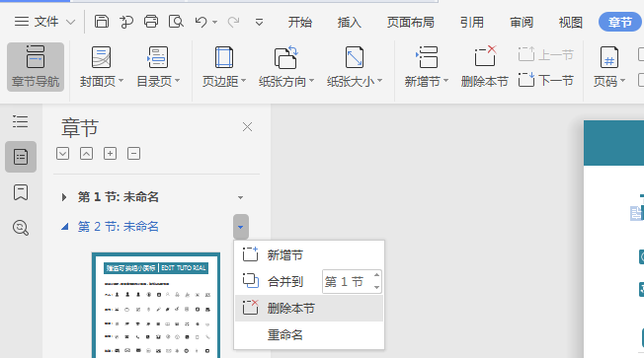

**赠送小图标，可自由修改大小色彩，复制粘贴可使用**