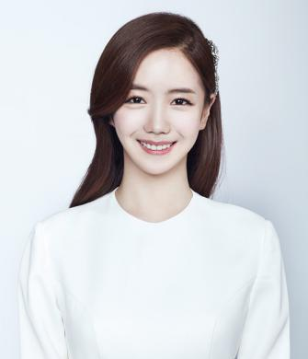

Proficiency in ps, ai, and various office software WPS, PPT/word/excel, etc., English to obtain a certificate of six.

**WORK SKILLS**

**2017/08--2018/02 Design Company Fashion Department - Soft Decoration Designer**

1. The design of the soft decoration scheme, budget, procurement, venue decoration, etc. in the model room, private residence, hotel, clubhouse and so on.

2. Through creativity and design, it reflects the sense of space, practicality, superiority, revolution, and highlights its humanity.

**2016/3--2017/12 Design Company Fashion Department - Soft Decoration Designer**

1. The design of the soft decoration scheme, budget, procurement, venue decoration, etc. in the model room, private residence, hotel, clubhouse and so on.

2. Through creativity and design, it reflects the sense of space, practicality, superiority, revolution, and highlights its humanity.

**2015/3--2014/1 Environmental Art Co., Ltd. Design Department - Master Designer**

1. From conception and drawing to three-dimensional modeling, provide complete design solutions, including physical environment planning, interior space separation, decorative image design, interior supplies and complete facility configuration.

2, through creativity and design, reflecting the sense of space, practicality, superiority, revolutionary, and highlighting its humanity.

**EXPERIENCE**

**2014/09-2018/06 China Academy of Art, New Media Art Design**

主窗体顶端

窗体底端

Major: The root of the phenomenon of cross-border integration, in the final analysis, is to explore and increase the intersection between artistic creation and the audience. Let the original elements that are irrelevant, even contradictory and antagonistic, spark the inspirational sparks and wonderful ideas.

**EDUCATIONS**

Age：23years old

Education：bachelor

TEL：138001380000

E-mail：1008611@QQ.com

Job search intention: Designer

**Jessica**

RESUME

**ABOUT ME**

I am a creative and enterprising girl. I have a certain artistic accomplishment, an aesthetic vision, and good at photography. Positive optimism is my biggest advantage and will not easily admit defeat.



个人简历

**工作技能**

熟练掌握ps、ai、以及各种办公软件WPS：PPT/word/excel 等，英语 获得六级证书

本人是一个有创意,有进取心的女孩. 具有一定的艺术修养，审美眼光，擅长摄影。积极乐观是我最大的优点,不会轻易认输.本人是一个有创意,有进取心的女孩. 具有一定的艺术修养，审美眼光，擅长摄影。积极乐观是我最大的优点,不会轻易认输.

**自我评价**

女/ 23岁 / 广州 / 汉族 / 工作经验三年

**茹佳琳**

电 话：138001380000

邮 箱：1008611@qq.com

应聘：插画设计师

**实践经历**

**2017/08--2018/02 高尚家具有限公司 家居陈列设计师**

工作范围:家具卖场空间规划、色彩设计、家具与配饰品的陈设来完成对室内环境的个性塑造、风格统一.协调解决装饰过程中的各种技术问题。

**2016/03--2017/12 雅典娜装饰设计公司 软装饰设计师**

工作范围:样板间,私人住宅,酒店,会所等场所的软装饰方案设计,预算,采购,场地摆设等等.

阐述规划自己的创意想法，与装修人员达成观念上的协调一致

**2015/03--2014/01 水木年华艺术公司 主案设计师**

从构思、绘图到三维制模等，提供完整的设计方案，包括物理环境规划、室内空间分隔，装饰形象设计，室内用品及成套设施配置等。通过创意与设计，体现设计的空间感，实用性，优越性，革命性，凸显其人性化设计作品。

2018/09-2016/06 英国皇家艺术学院 新媒体艺术设计:硕士

2012/09-2016/06 广州美术学院 新媒体艺术设计:本科

**教育背景**