1. Flow chart
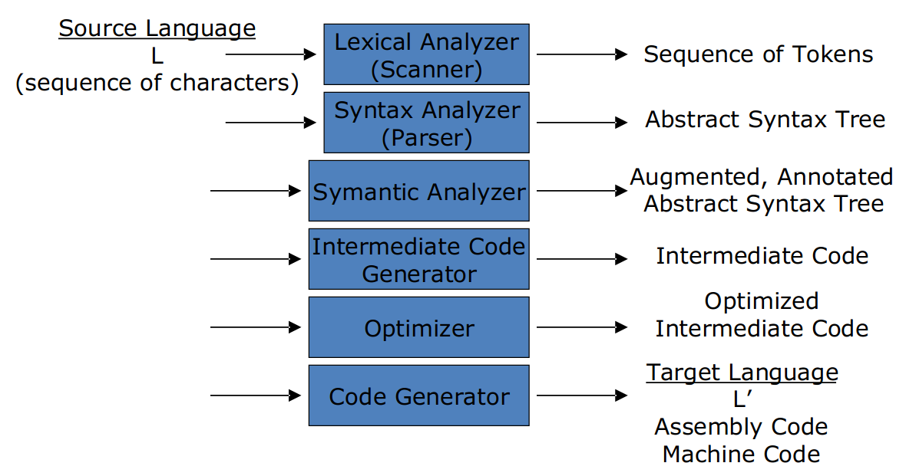
Scanner :
to tokens
Parser :
variables that are multiply declared.
might generate code, or build some intermediate representation of the program such as an abstract-syntax tree
Semantic analyzer:
Checks for (more) "static semantic" errors
Annotate and/or change the abstract syntax tree
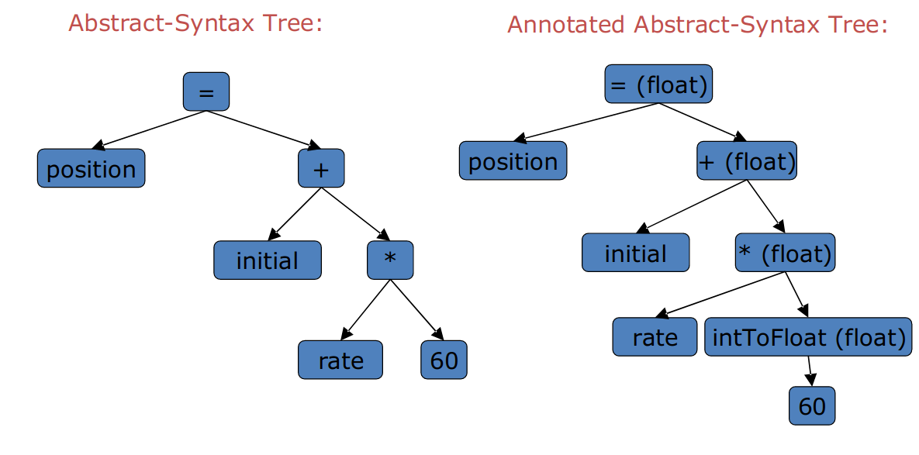
Intermediate Code Generator:
Translates from abstract-syntax tree to intermediate code
One possibility is 3-address code
each instruction involves at most 3 operands
Example:
temp1 = inttofloat(60)
temp2 = rate * temp1
temp3 = initial + temp2
position = temp3
Optimizer :
Tries to improve code to run faster , be smaller and consume less energy
mainly includes；
Constant Propagation
Constant Propagation
Algebraic Simplification
Copy Propagation
Common Sub-expression Elimination
Dead Code Elimination
Loop Invariant Removal
Strength Reduction
Code Generator:
to assembly code

2.Symbol Tables

Keep track of names declared in the program
Separate level for each scope
Used to analyze static symantics:
–Variables should not be declared more than once in a scope
–Variables should not be used before being declared
–Parameter types for methods should match method declaration

3.Programming language basics
Static/Dynamic Distinction
-static : in space(initialized when the program start)
-dynamic: in time(when the code execute this code)
Environments and States
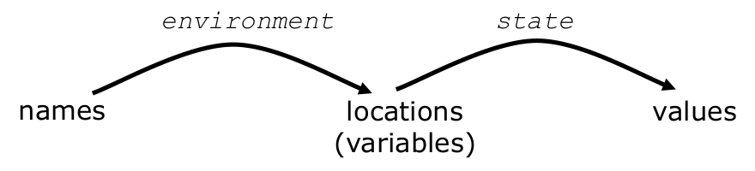
Static Scope and Block Structure
-declaration works in the most sub-block
Explicit Access Control
-class member access control
Dynamic Scope
Parameter Passing
-copy by value
-copy by reference
Aliasing
-refer to the same memory

4.make file
<target> : <dependency list>
<tab><command to satisfy target>
example:
JC = ~/usr/local/jdk/javac
JFLAG = -g

Example.class : Example.java IO.class
$(JC) $JFLAG Example.java

IO.class : IO.java
$(JC) $JFLAG IO.java

clean:
rm -rf *.class
test:
java -cp . Test.class

5. FSA (finite state automata)

RE (regular expression) priority: * > cat > |
NFA (non-deterministic)
DFA (deterministic)

6. RE → NFA
- create a tree from regular expression
- do a post-order Traversal of tree
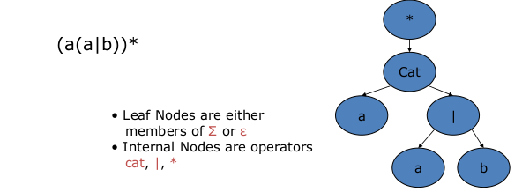
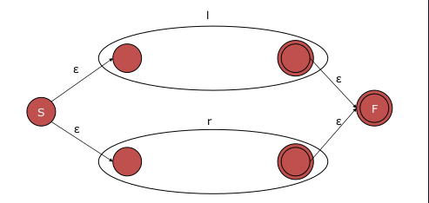
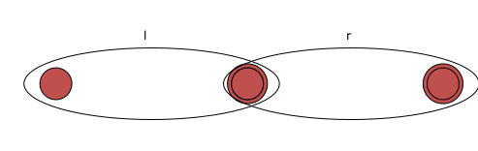
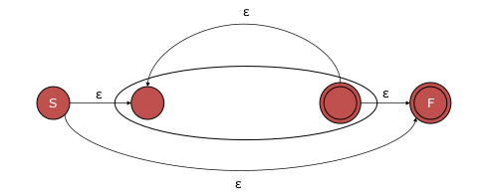

7. NFA → DFA
Initially ε-closure(s) is the only state
in DFA and it is unmarked
While (there is unmarked state T in DFA)
mark T;
for (each input symbol a) {
ε-closure(move(T,a));
if (U not in DFA)
add U unmarked to DFA
transition[T,a]=U;

8. JLEX
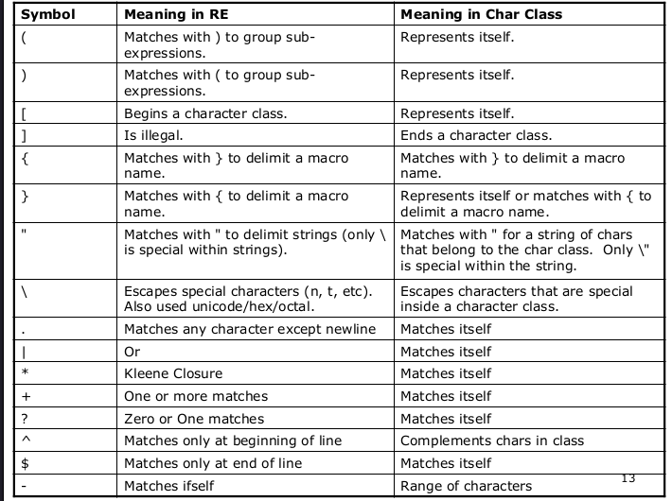
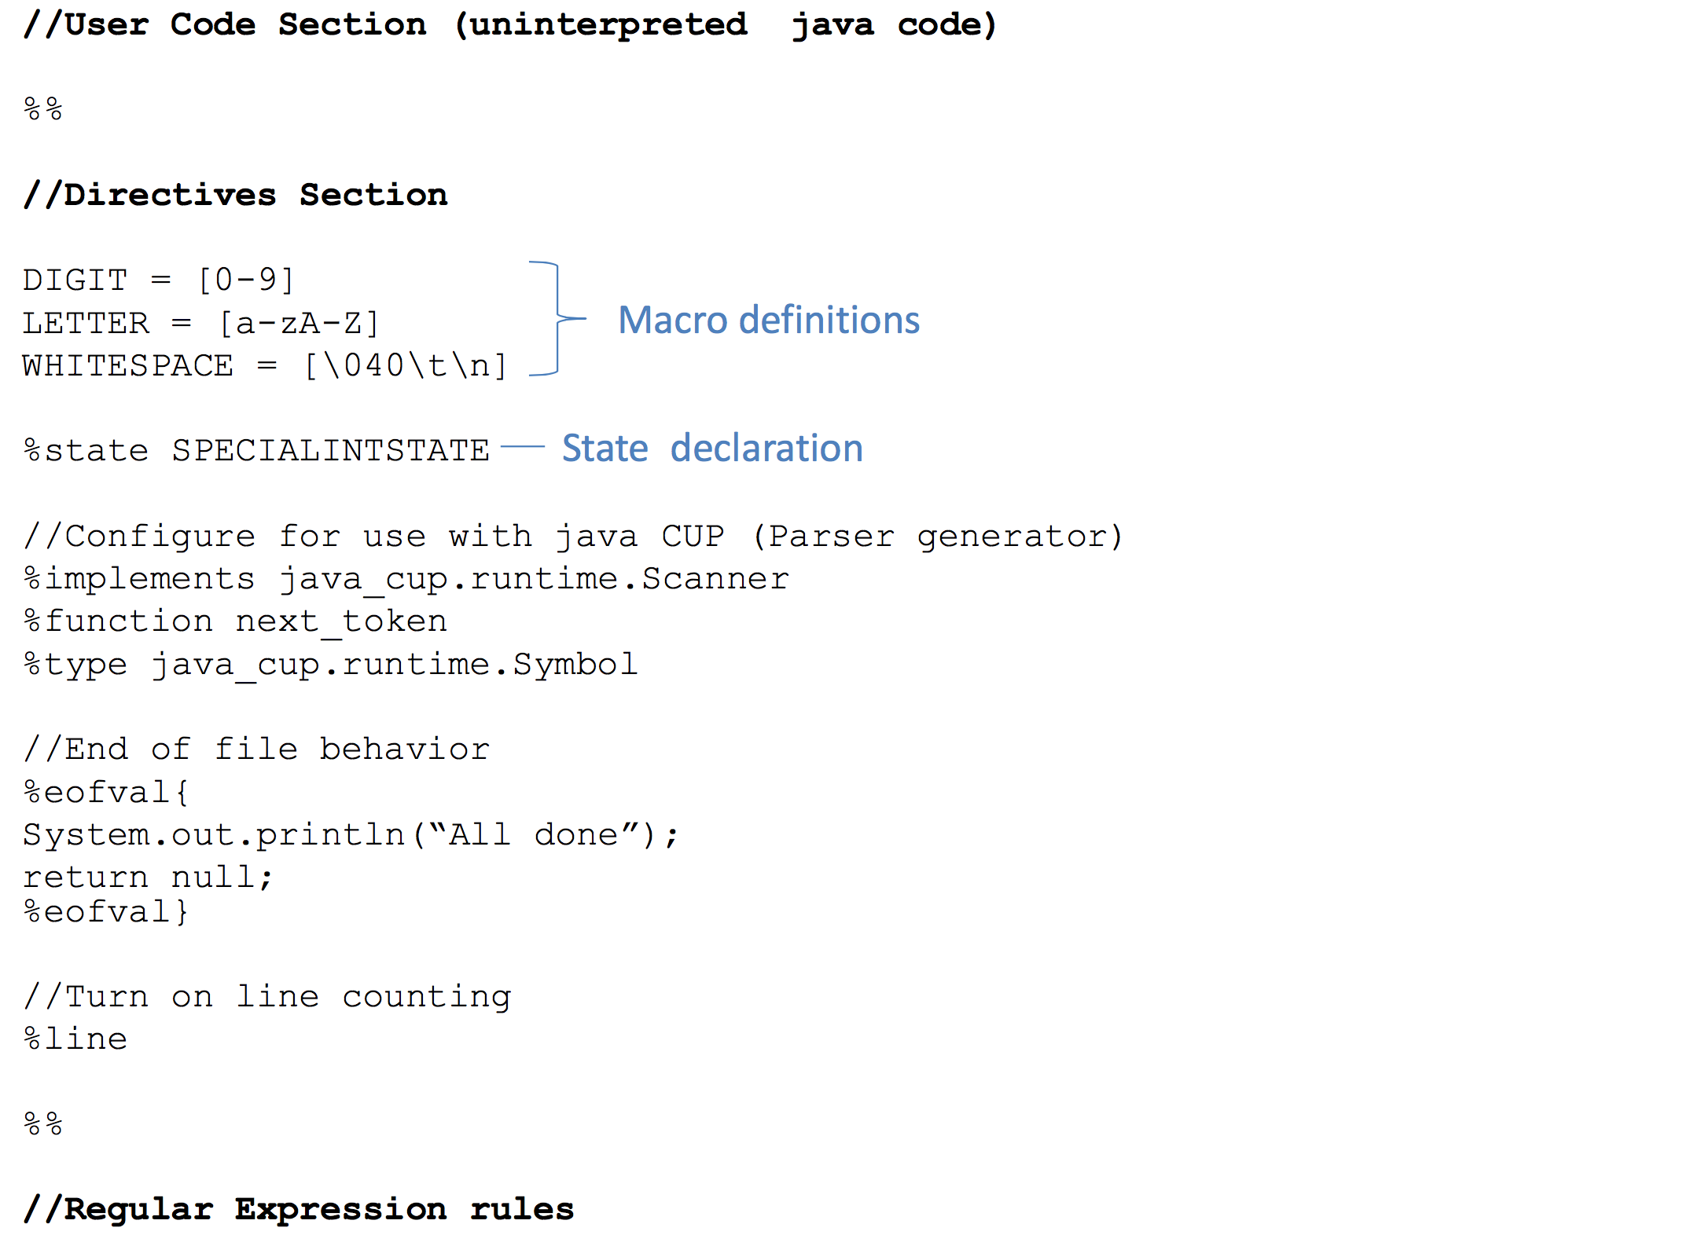

9. The use of ^
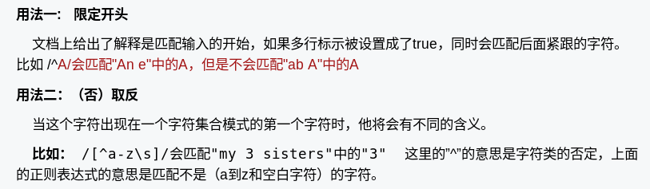
10.CFG
-RE and FSA can not express all languages.
-leftmost and rightmost derivation(parse trees)

11.SDT(syntax-directed translation)
-translation is the value of the input
-translation is a string of ids
-rules can have conditions

12.AST(abstract syntax trees) (nodes based)
-make a parse tree
-use the parse tree to build an AST
-we construct a new node object, which becomes the value of LHS.trans
-populate the node’s fields with the translations of the RHS nonterminals

13.LL
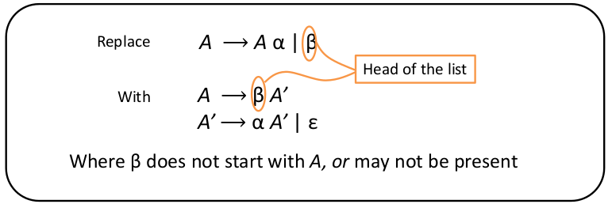
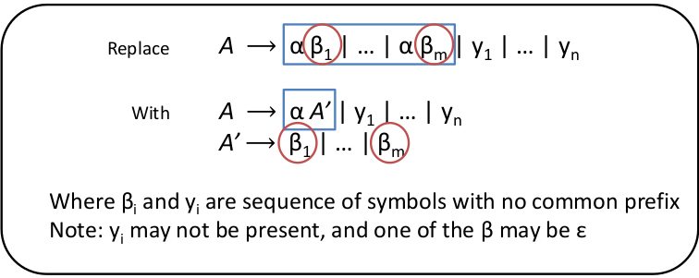
14.CNF(Chomsky Normal Form)
-消除
-合并相同状态
-将终结符设置为非终结符
-将trans 长度大于2的变成长度为2
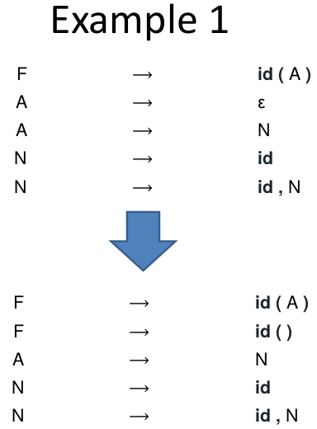
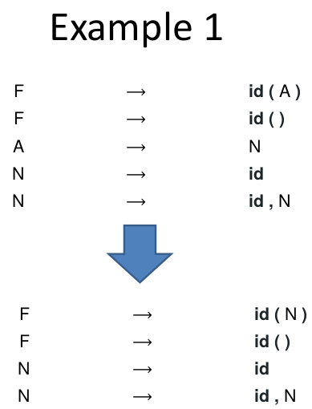
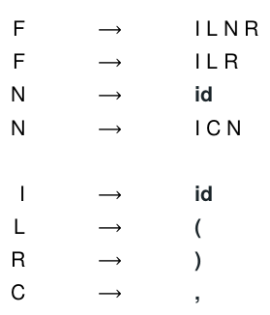
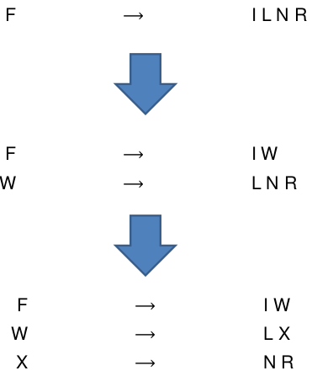
15.CYK
-对每一个长度的子串，找到可以与之相匹配的树，从下往上，如果最后能到S，则找到了匹配字符串的所有生成树。
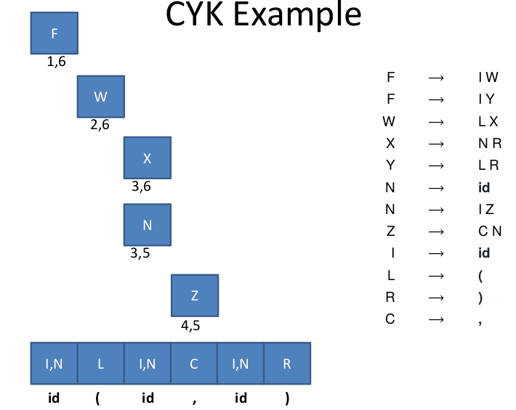
16.Java cup
-input : jlex’s output
-output:
parser.java returns a Symbol whose value field contains the translation of the root non-terminal
sym.java returns each terminal declared in the java cup
