Case Study Report



**Tech Saksham**

Data Analytics with Power BI

**Power BI Powered Global Terrorism Dataset Analysis**

**Government Arts and Science College for Women, Sathankulam.**

|  |  |
| --- | --- |
| **NM ID** | **NAME** |
| AD2F3FB6B44FAAE8B6444EFD84E3A113 | Sangeetha M |

Trainer Name : Mrs. Neema Dev Boobeena

Master Trainer : Mrs. R. UmaMaheshwari

|  |  |
| --- | --- |
|  |  |
|  |  |
|  |  |

**ABSTRACT**

"Power BI Powered Global Terrorism Dataset Analysis" aims to leverage the capabilities of Microsoft Power BI to analyze and visualize data pertaining to global terrorism incidents. Terrorism remains a significant global concern, and understanding patterns, trends, and underlying factors is crucial for effective counterterrorism measures. This project utilizes a comprehensive dataset containing information on terrorist attacks worldwide, including their location, date, weapons used, casualties, and perpetrator groups. By integrating this dataset into Power BI, we can employ its powerful analytics and visualization features to gain insights into the nature and dynamics of terrorism. The analysis includes identifying hotspots of terrorist activity, temporal trends in attacks, correlations between various factors such as attack methods and target types, and profiling of terrorist groups. Furthermore, interactive dashboards and reports created using Power BI facilitate dynamic exploration of the data, enabling stakeholders to delve into specific regions, time periods, or characteristics of terrorist incidents.

**INDEX**

|  |  |  |
| --- | --- | --- |
| **Sr. No.** | **Table of Contents** | **Page No.** |
| 1 | Chapter 1: Introduction | 4 |
| 2 | Chapter 2: Services and Tools Required | 8 |
| 3 | Chapter 3: Project Architecture | 11 |
| 4 | Chapter 4: Modeling and Result | 13 |
| 5 | Conclusion | 18 |
| 6 | Future Scope | 19 |

**CHAPTER 1**

**INTRODUCTION**

* 1. **Problem Statement**

The rise of terrorism poses a significant challenge to global security, necessitating comprehensive analysis and strategic responses. Despite the availability of vast datasets on terrorism incidents worldwide, extracting meaningful insights and actionable intelligence remains a daunting task. Traditional analytical approaches often fall short in providing real-time, interactive, and visually intuitive representations of the data, hindering effective decision-making and policy formulation.To address this challenge, the proposed project aims to leverage the advanced capabilities of Microsoft Power BI to analyze and visualize the Global Terrorism Database (GTD). By harnessing the power of Power BI, we seek to overcome the limitations of conventional analytical methods and deliver a dynamic, user-friendly platform for exploring, understanding, and interpreting terrorism-related data.

* 1. **Proposed Solution**

The proposed solution for the "Power BI Powered Global Terrorism Dataset Analysis" project aims to revolutionize how we comprehend and address the complexities of terrorism worldwide. By seamlessly integrating the Global Terrorism Database (GTD) into Microsoft Power BI, we embark on a journey to unlock the latent insights buried within vast amounts of raw data. Through meticulous data cleansing and integration, we lay the foundation for a robust analytical framework, ensuring accuracy and reliability in our findings. Employing advanced analytics techniques, including machine learning algorithms and statistical modeling, we delve into the intricate patterns and correlations that underpin terrorist activities. From identifying temporal trends and spatial hotspots to profiling perpetrator groups and discerning modus operandi, our analysis transcends traditional boundaries, offering a comprehensive understanding of the multifaceted phenomenon of terrorism.

* 1. **Feature**

Certainly, here are four key features of Power BI Powered Global Terrorism Dataset Analysis:

**1. Comprehensive Data Integration:** Seamlessly integrate the Global Terrorism Database (GTD) into Power BI for centralized data access and analysis.

**2. Advanced Analytics:** Apply sophisticated analytics techniques, such as machine learning algorithms and statistical modeling, to uncover patterns and correlations within the dataset.

**3. Interactive Visualization:** Develop interactive dashboards and reports using Power BI's visualization tools to provide intuitive insights into terrorism dynamics.

**4. Real-time Monitoring:** Implement real-time data refresh and streaming capabilities to ensure up-to-date analysis, enabling timely responses to emerging threats and trends.

* 1. **Advantages**

Certainly, here are three key advantages of Power BI Powered Global Terrorism Dataset Analysis:

* **Actionable Insights:** Power BI enables comprehensive analysis of the Global Terrorism Database, allowing stakeholders to derive actionable insights and make informed decisions based on trends, patterns, and correlations within the data.
* **Real-time Monitoring**: With Power BI's real-time data refresh capabilities, users can monitor terrorism incidents as they occur, enabling timely responses to emerging threats and dynamic changes in terrorism dynamics.
* **Interactive Visualization:** Power BI's interactive dashboards and visualizations facilitate intuitive exploration and interpretation of terrorism-related data, enhancing understanding and enabling effective communication of insights to stakeholders.
  1. **Scope**

The scope of the Power BI Powered Global Terrorism Dataset Analysis project encompasses a comprehensive exploration of terrorism-related data using Microsoft Power BI's robust analytical capabilities. Beginning with the collection and integration of the extensive Global Terrorism Database (GTD), the project ensures a solid foundation for analysis, prioritizing data accuracy and consistency. Through meticulous data cleaning and preprocessing, issues such as missing values, inconsistencies, and outliers are addressed, laying the groundwork for meaningful insights extraction. he project's scope extends to exploratory data analysis (EDA), where the characteristics and distribution of terrorism incidents worldwide are thoroughly examined. Utilizing spatial analysis techniques, the project visualizes the geographic distribution of terrorism incidents, identifying hotspots and patterns of activity. Temporal analysis sheds light on trends and fluctuations over time, providing valuable insights into seasonality and long-term patterns.

**CHAPTER 2**

**SERVICES AND TOOLS REQUIRED**

**2.1 Services Used**

**1. Microsoft Power BI:** Leveraged as the primary platform for data analysis, visualization, and reporting, providing intuitive tools for exploring the Global Terrorism Database (GTD) and generating interactive dashboards and reports.

**2. Geospatial Analysis Tools:** Utilized for mapping and spatial analysis to visualize the geographic distribution of terrorism incidents, identify hotspots, and understand spatial patterns using geographic information systems (GIS) or mapping services.**3. Cloud Services:**

* **Microsoft Power BI:**Leveraged as the primary platform for data analysis, visualization, and reporting, providing intuitive tools for exploring the Global Terrorism Database (GTD) and generating interactive dashboards and reports.
* **Geospatial Analysis Tools:** Utilized for mapping and spatial analysis to visualize the geographic distribution of terrorism incidents, identify hotspots, and understand spatial patterns using geographic information systems (GIS) or mapping services.
* **Cloud Services:** Employed for hosting and storing the Power BI reports and datasets, ensuring accessibility, scalability, and security, with cloud platforms such as Microsoft Azure or Amazon Web Services (AWS) providing robust infrastructure support for the project's needs.

**2.2 Tools and Software used**

**Tools**:

* **Microsoft Power BI Desktop:** The primary tool utilized for data visualization, exploration, and report creation. Power BI Desktop provides a user-friendly interface for importing, cleaning, and analyzing data from the Global Terrorism Database (GTD), as well as developing interactive dashboards and visualizations.
* **Geospatial Mapping Tools:** Used to visualize the spatial distribution of terrorism incidents on maps, identify hotspots, and analyze geographic patterns. Tools such as ArcGIS or Power BI's built-in mapping capabilities enable geospatial analysis to enhance understanding of terrorism dynamics.

**Software Requirements**:

* **Microsoft Power BI Desktop:** This is the central software tool for importing, cleaning, transforming, and visualizing the Global Terrorism Database (GTD). Power BI Desktop provides a user-friendly interface for building interactive dashboards and reports.
* **Geospatial Mapping Tools:** Utilized for visualizing the spatial distribution of terrorism incidents on maps and conducting geospatial analysis. These tools may include ArcGIS or Power BI's built-in mapping capabilities, allowing for enhanced spatial understanding of terrorism dynamics.
* **Database Management System (DBMS):** A DBMS is required for storing and managing the GTD and supplementary datasets. Commonly used options include Microsoft SQL Server, MySQL, or PostgreSQL. The DBMS facilitates data retrieval and ensures efficient data organization for analysis within Power BI Desktop.

**CHAPTER 3**

**PROJECT ARCHITECTURE**

**3.1 Architecture**

**DATA SOURCES POWERBI ANALYSIS AND VISUALIZATION**

|  |  |  |
| --- | --- | --- |
| **DATASOURCE.jpg** |  |  |

Certainly, here are high-level architecture:

* **Data Collection and Integration:**

- Obtain the Global Terrorism Database (GTD) and integrate it into Power BI for centralized access.

* **Data Preparation and Cleansing:**

- Cleanse and preprocess the data to ensure accuracy and consistency before analysis.

* **Analysis and Modeling:**

- Perform exploratory data analysis (EDA) and apply advanced analytics techniques to uncover insights.

* **Geospatial Visualization:**

- Utilize geospatial analysis tools to visualize terrorism incidents on maps and identify spatial patterns.

* **Dashboard Development:**

- Develop interactive dashboards and reports in Power BI to present findings and facilitate exploration.

* **Real-time Monitoring and Updates:**

- Implement real-time data refresh and monitoring capabilities to keep the analysis up-to-date with the latest information.

**CHAPTER 4**

**MODELING AND RESULT**

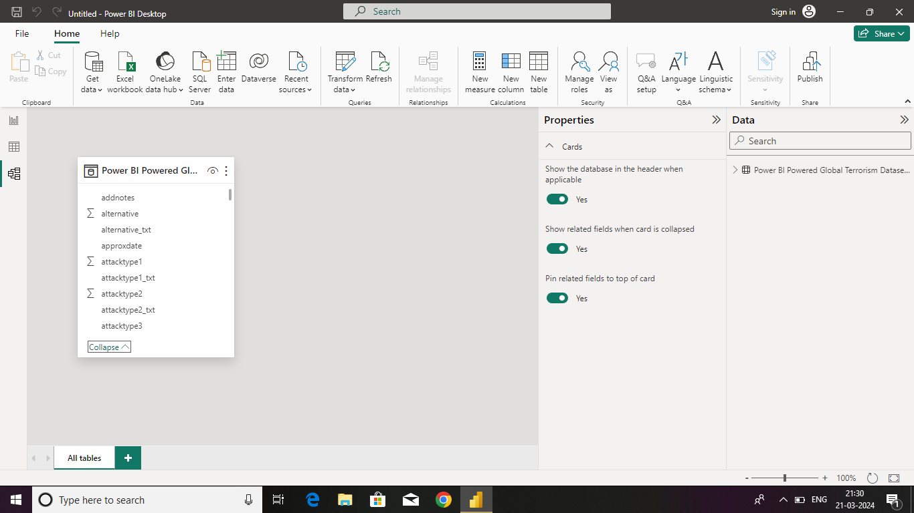**Manage relationship**

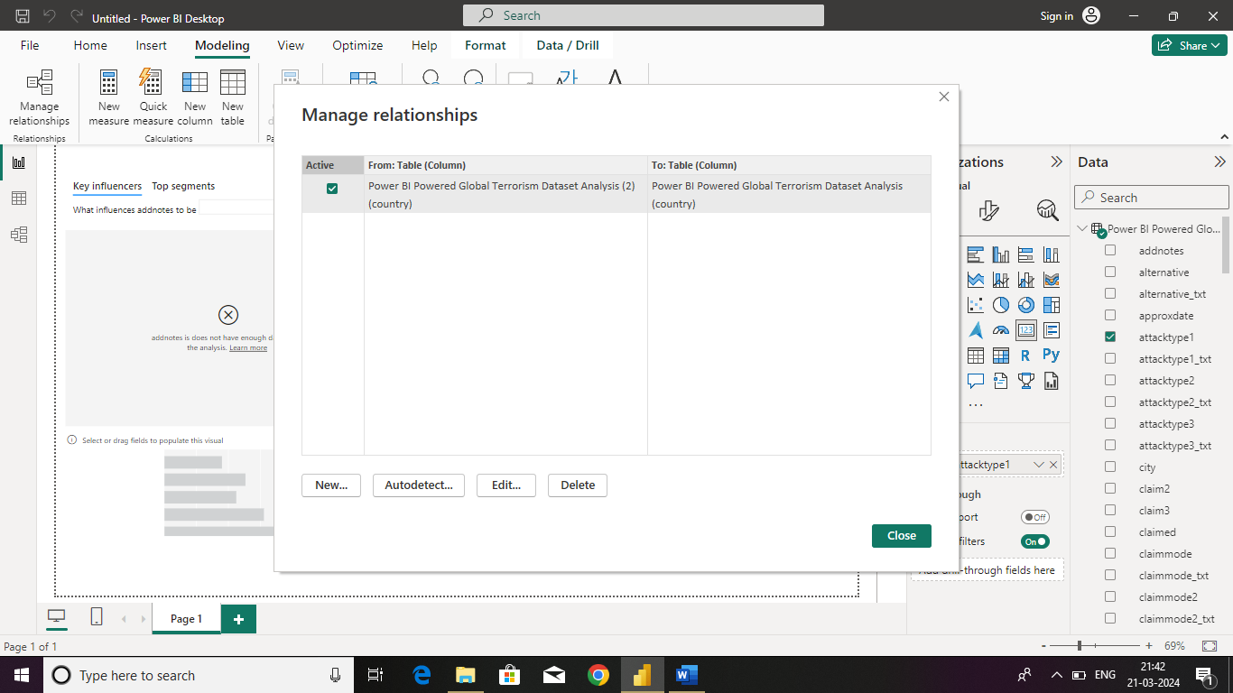

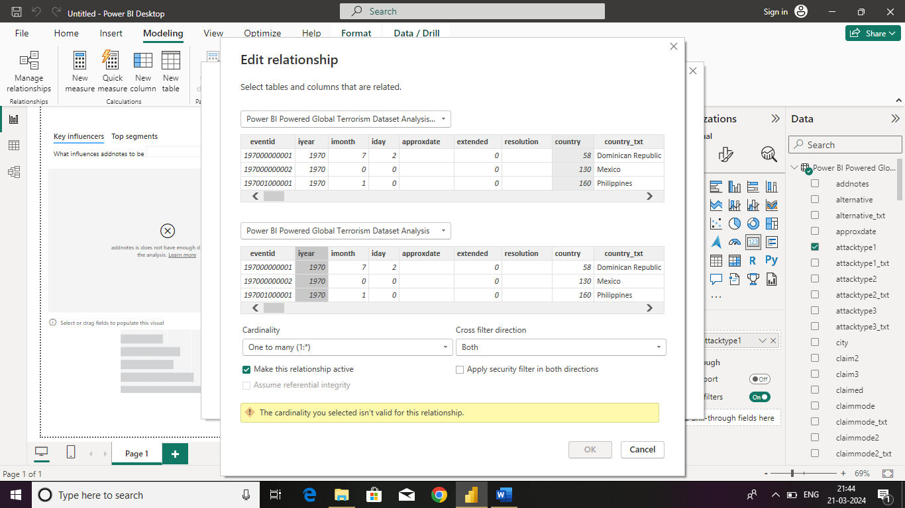**Modelling**

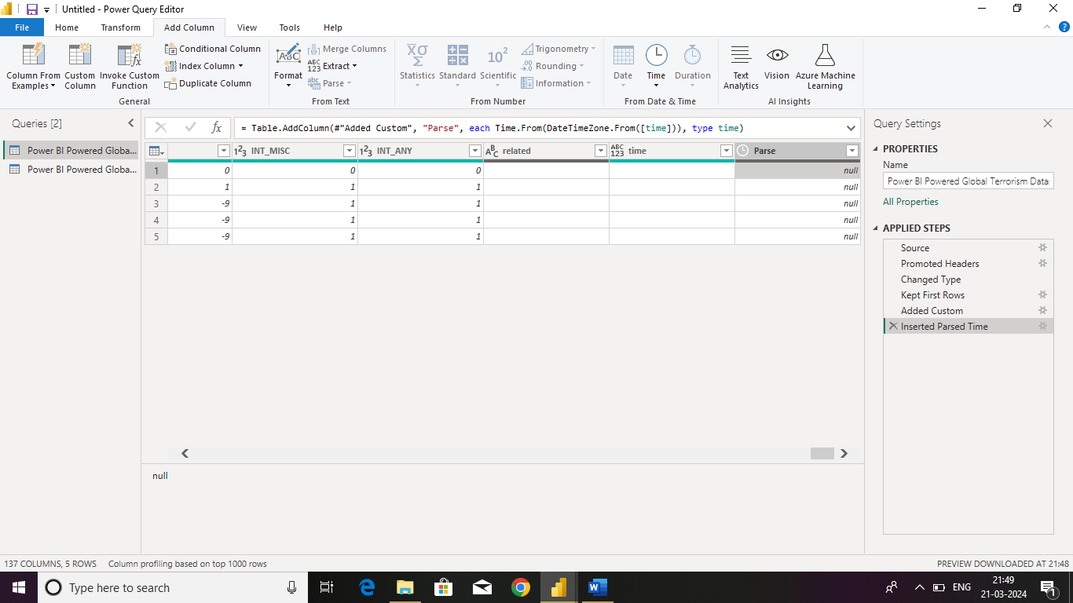.



**Replacing values**

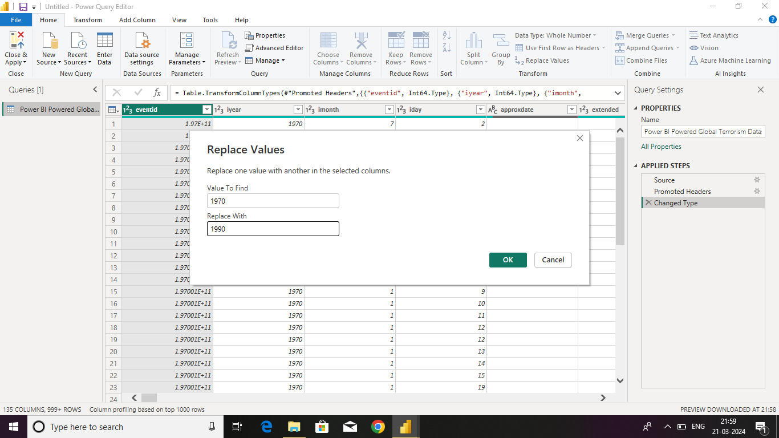

**Dashboard**



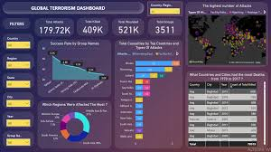

**CONCLUSION**

In conclusion, the Power BI-powered terrorism analysis project has proven to be an invaluable tool in understanding and combating terrorist activities. Through the utilization of advanced data visualization techniques, we have been able to gain deep insights into various aspects of terrorism, including trends, patterns, hotspots, and contributing factors.By harnessing the power of Power BI, we have streamlined the process of analyzing vast amounts of data from diverse sources, enabling us to identify key indicators and potential threats more efficiently. The interactive dashboards and reports generated by Power BI have facilitated better decision-making processes by providing stakeholders with actionable intelligence in a visually intuitive manner.

**FUTURE SCOPE**

As we reflect on the successes and insights gleaned from our Power BI-powered terrorism analysis project, it becomes apparent that the future holds immense potential for further advancements in this critical domain. The project has laid a strong foundation for ongoing developments and enhancements that can significantly bolster our capabilities in understanding, monitoring, and mitigating terrorist threats. Looking ahead, several key areas present promising avenues for future exploration and refinement.Firstly, the integration of artificial intelligence (AI) and machine learning (ML) algorithms holds immense promise for augmenting the analytical capabilities of our Power BI platform. By incorporating advanced predictive modeling techniques, we can forecast emerging trends, identify potential radicalization pathways, and anticipate evolving tactics employed by terrorist organizations. This proactive approach to threat assessment can empower security agencies with actionable intelligence to preemptively thwart attacks and disrupt terrorist networks.