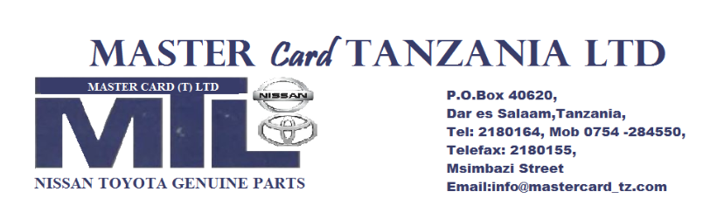

**MASTER CARD**

Ref No MC/TPA/2022 – 23/SP/01 11th March, 2023

Port Manager

Tanzania Port Authority,

**TANGA.**

**RE: TENDER NO AE/016/2022-2023/TA/G/20 FOR SUPPLY OF SPARES PARTS FOR MOTOR VEHICLES UNDER FRAMEWORK CONTRACT.**

SUB: Extension of bid validity period.

We acknowledge receipt of your letter with reference No. QG.185/431/06 dated’’ 10th March, 2023.

We humbly accept extension of the bid validity period up to 30th April, 2023.

Yours Faithfully,

**………………….**

**MR. JAFARI MNETE**

**DIRECTOR**