**By the way, thank you for your attention!**

Firstly, you should run the program!

You will see the menu

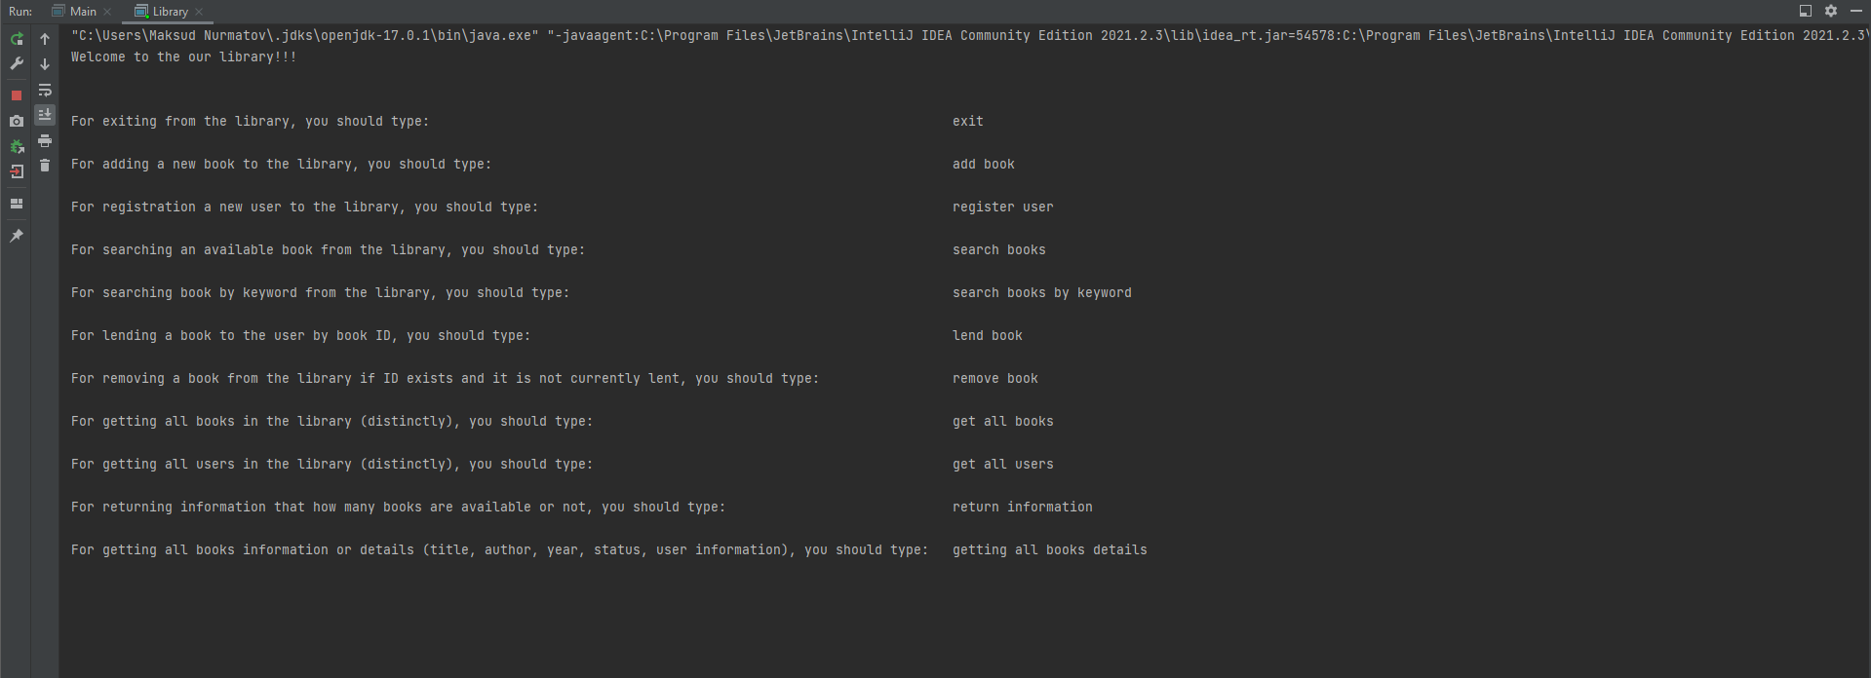

Figure 1.1. The image shows you main menu.

For using the program, you have to type one of the menu item.

1. Library contains books to lend (at the beginning there are no books in the library)

In order to get all books in the library, you have to type ‘get all books’:

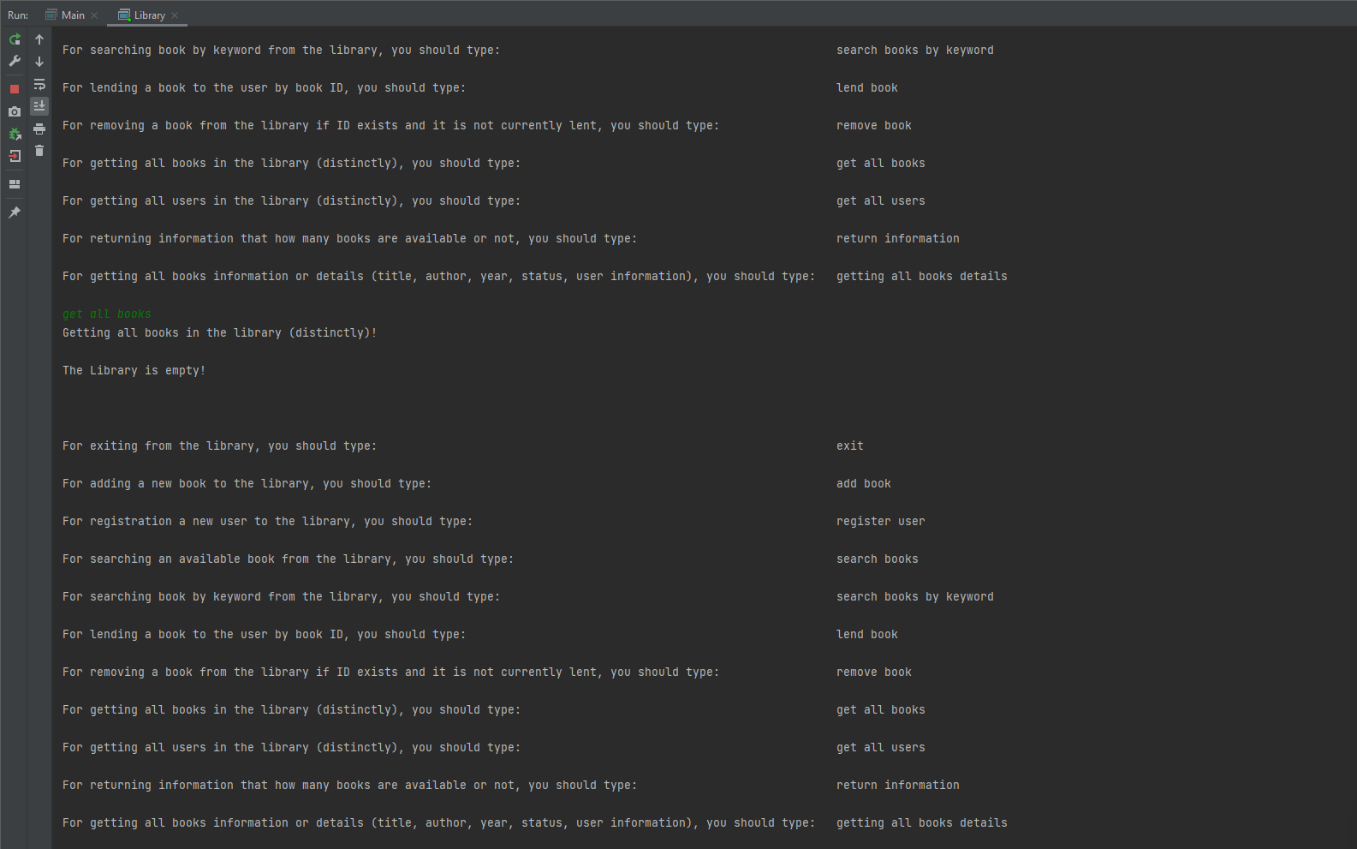

Figure 1.2. The image shows you how to get all books from the library but for the first time, it is empty.

2. Should be possible to add new book to the library. ID should not be passed as argument. ID should be generated inside Library. In order to add a new book to the library, you have to type ‘add book’:

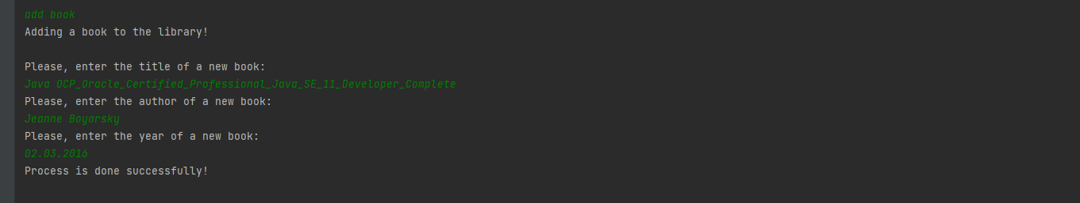

Figure 2.1. The image shows you how to add a new book to the library.

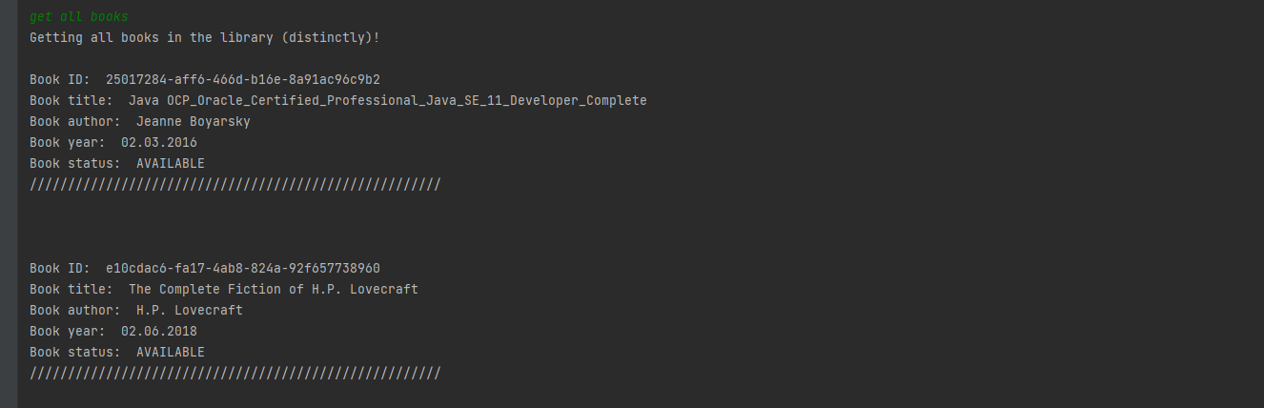

Figure 2.2. The image shows you how to get all books from the library.

3.We can register a new user to the library. In order to add a new user to the library, you have to type ‘register user’:

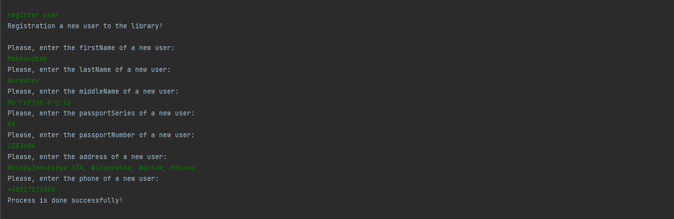

Figure 3.1. The image shows you how to get add a new user to the library.

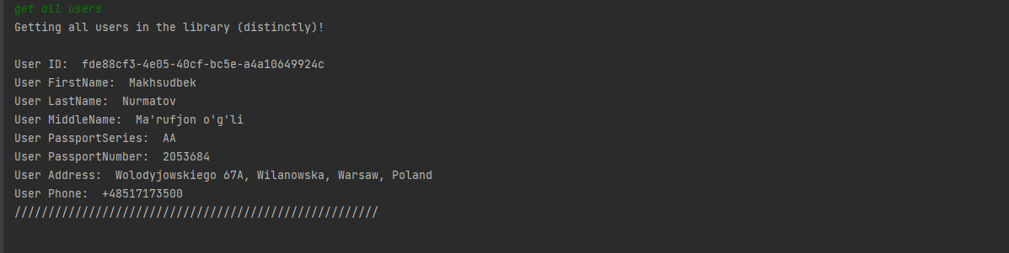

Figure 3.2. The image shows you how to get all users from the library but you have to type ‘get all users’ by yourself.

4. You can also lend a book to the user. For this, you have to type ‘lend book’.by entering userID and bookID, you can lend the book to the user if this book is available:

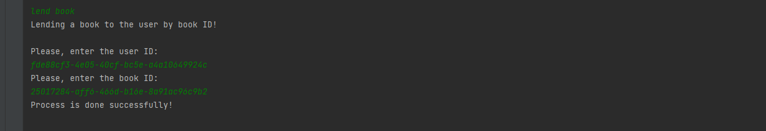

Figure 4.1. The image shows you how to lend a book to a user from the library but you have to type ‘lend book’.

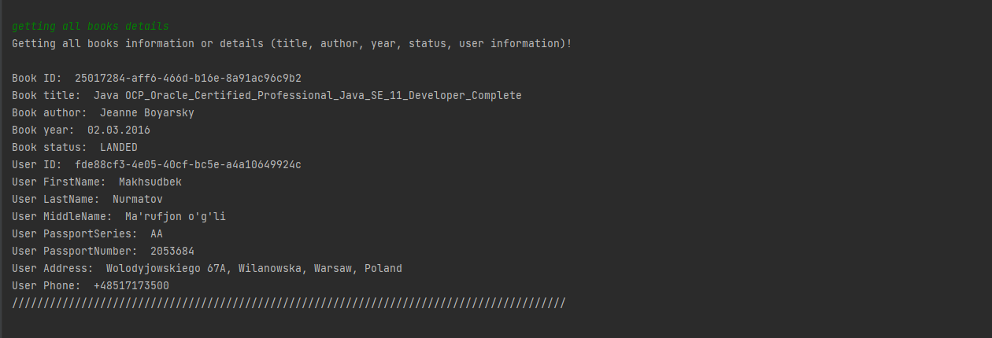

Figure 4.2. The image shows you how to get information about lent user books from the library but you have to type ‘getting all books details’.

5. Should be possible to remove given book from the library (by ID) (such action should be possible only if the book with such ID exists and it is not currently lent). In order to remove given book from the library, you have to choose one of the menu options like ‘remove book’:

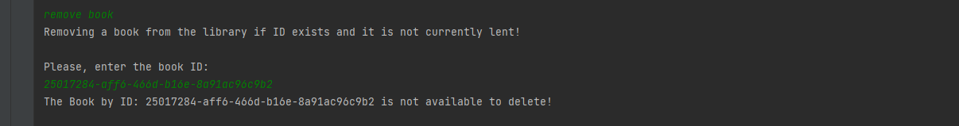

Figure 5.1. The image shows you how to remove given book (by ID) from the library but it is not available to delete because the book is lent.

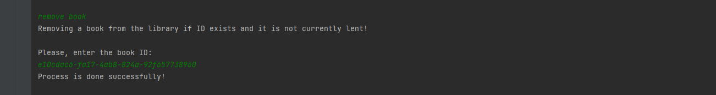

Figure 5.2. The image shows you how to remove given book (by ID) from the library but it is available to delete because the book is not lent.

6. Should allow to search book by title, author, year (also other combinations like title AND author). You have to search books by keyword. You have two options which are with and without combination. In order to do this, you have to type ‘search books by keyword’:

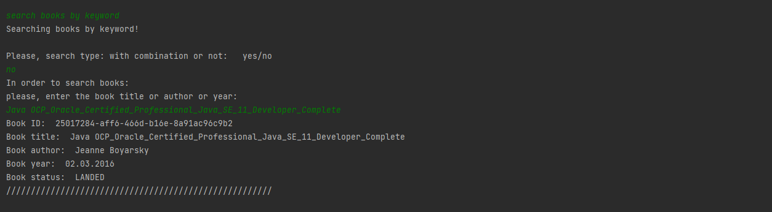

Figure 6.1. The image shows you how to search books by keyword from the library. If you choose ‘no’, you can search by title, author, year.

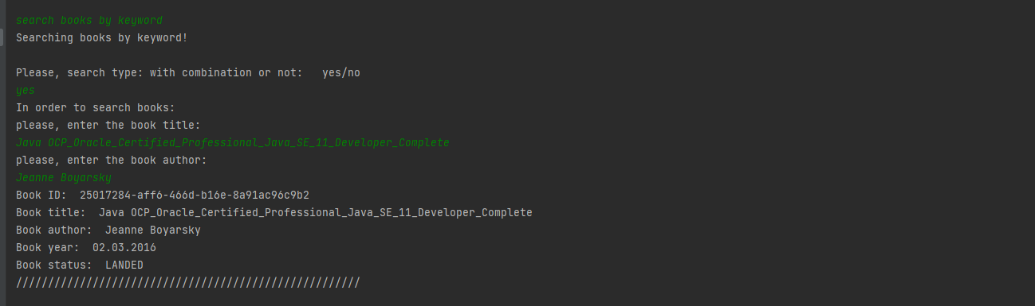

Figure 6.2. The image shows you how to search books by keyword from the library. If you choose ‘yes’, you can search by combination like title and author.