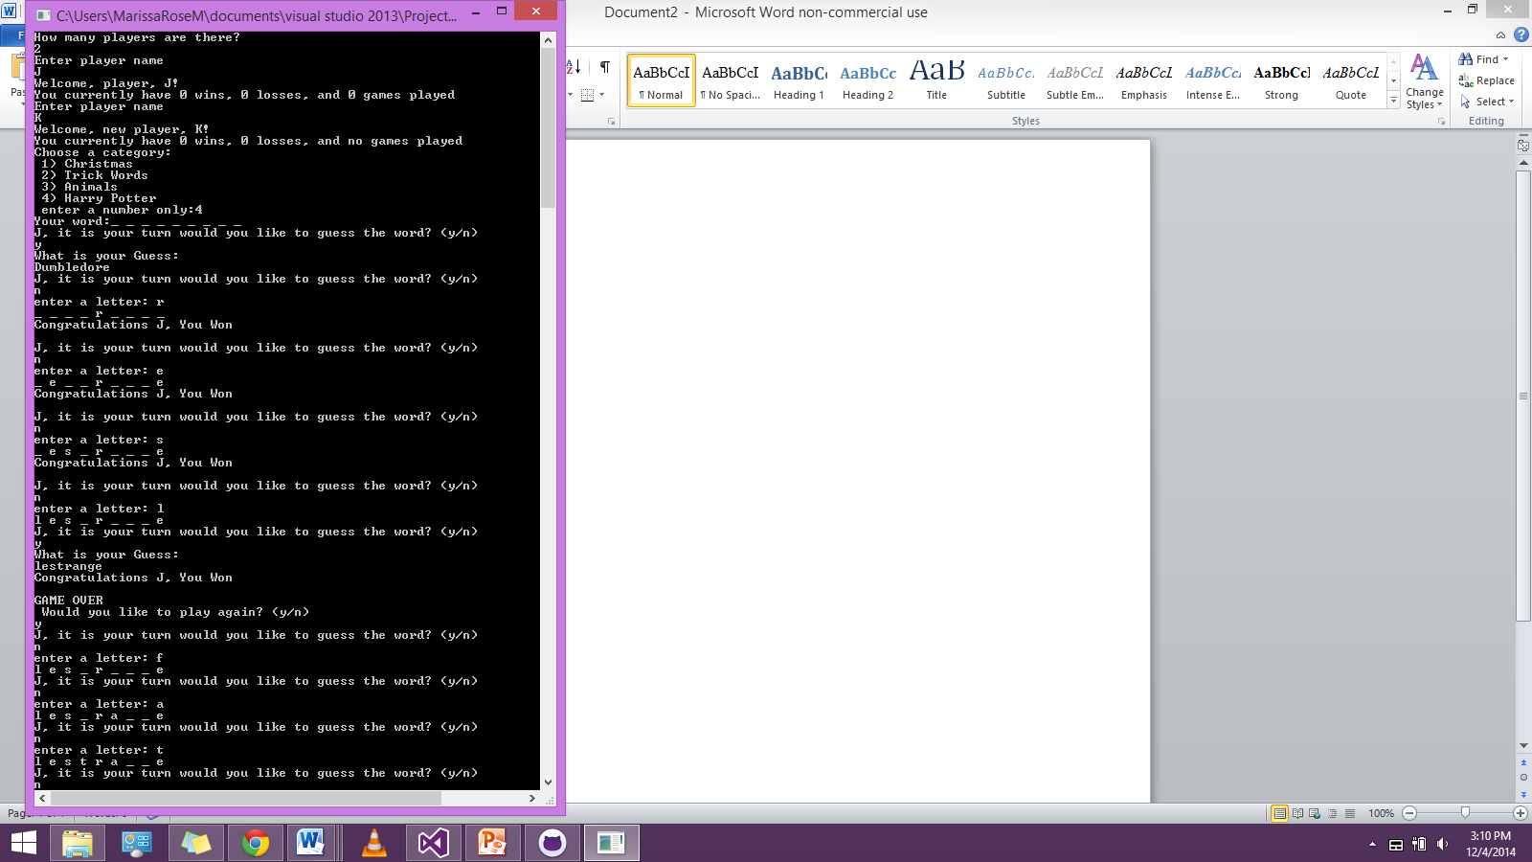 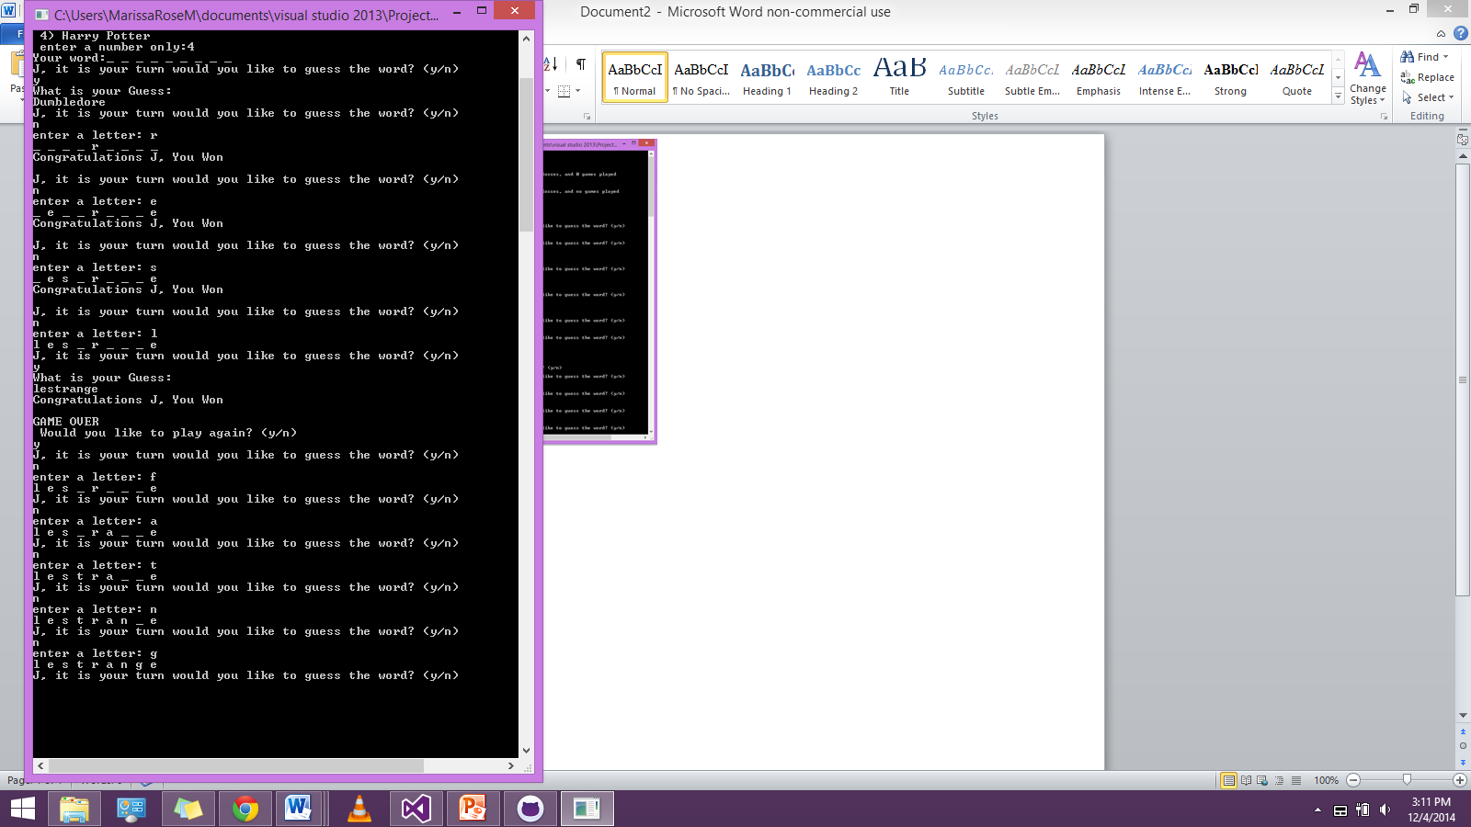

THIS is what happens when I run the game right now, much better, but there are still tons of issues:

* tells you you win the game correctly when using guessWord//done
* does opposite for guessLetter//done
* uses same word when you replay game//semi fixed
* doesn’t exit properly when don’t play again
* doesn’t rotate player ever//done
* doesn’t allow only one player//done
* where does player file store